**Daily Carbon gain estimations for GREAT experiment**

Met data: 15 min VPD, Tair and PPFD measured in each glasshouse room

Physiological parameters:

1. Vcmax and Jmax at 25 $℃$: Estimated for room 1 (18 $℃$), 4 (28.5 $℃$) and 6 (35.5 $℃$) using ACi data. For other rooms (21.5 $℃$, 25 $℃$ and 32.5 $℃$, calculated by fitting a smooth line. (data collection ~40 DAP)
2. Both Vcmax and Jmax were adjusted to seedling age using proportional change of net photosynthesis between 26 DAP and 40 DAP

$$V_{cmax25}\left(d_{i}\right)=V_{cmax25}\left(d_{40}\right)-[(V_{cmax25}\left(d_{40}\right)×\left(\frac{A_{40}-A_{26}}{A_{40}}\right)×\frac{1}{14}×\left(40-d_{i}\right)]$$

$V_{cmax25}\left(d_{i}\right)$: value of Vcmax at 25 $℃$ of a given day (di), : value of Vcmax at 25 $℃$ of 40 DAP, A40 and A26: measured net photosynthetic rates at 26 and 40 DAP.

1. Initial values of Vcmax and Jmax at 25 $℃$: Assumed as equal to the estimated values for plants at 25 $℃$ growth temperature 26 DAP

Same scaling was adopted for Jmax25.

1. Ea, ∆S of Vcmax and Jmax: Estimated for room 1, 4 and 6 using ACi data. For other treatments values were assumed as follows

For room 2 (21.5C): assume room 1 (18C)

For room 3 (25C): assume room 4 (28.5C)

For room 5 (32.5C): assume room 6 (36.5C)

1. g1: estimated from short term Asat measurements
2. alpha: estimated by inverting Farquhar model

Original values of alpha were increased by 50% for all treatments to be fit with observed Asat data at low PAR levels

1. Day respiration: Assume similar to leaf dark respiration (Q10 of 2.1) and with Rdayfrac=0.7
2. Other parameters: default in Photosyn

Parameter values used (Fixed over time)

|  |  |  |  |  |  |  |  |
| --- | --- | --- | --- | --- | --- | --- | --- |
| **Room** | **Tgrowth** | **g1** | **alpha** | **EaV** | **delsV** | **EaJ** | **delsJ** |
| **1** | 18 | 1.58 | 0.18 | 58.87 | 0.629 | 42.75 | 0.631 |
| **2** | 22.5 | 7.70 | 0.20 | 58.87 | 0.629 | 42.75 | 0.631 |
| **3** | 25 | 6.34 | 0.19 | 57.71 | 0.629 | 32.67 | 0.625 |
| **4** | 28.5 | 8.78 | 0.19 | 57.71 | 0.629 | 32.67 | 0.625 |
| **5** | 32.5 | 16.45 | 0.16 | 82.55 | 0.633 | 51.00 | 0.631 |
| **6** | 35.5 | 15.43 | 0.14 | 82.55 | 0.633 | 51.00 | 0.631 |

Assumptions:

1. Provenance differences was not considered in any parameter estimation.
2. Temperature response of day respiration was assumed to be similar as dark respiration (Basal rates and Q10 values were averaged across provenances).

Test the performance of scaling-up. Simulate photosynthesis measurements done at early stage of growth (Short-term temperature response data measured on 2016-02-05). This dataset measured at two PAR levels (100 and 1500)

VPD, CO2, Tleaf and PARi were set to measured values

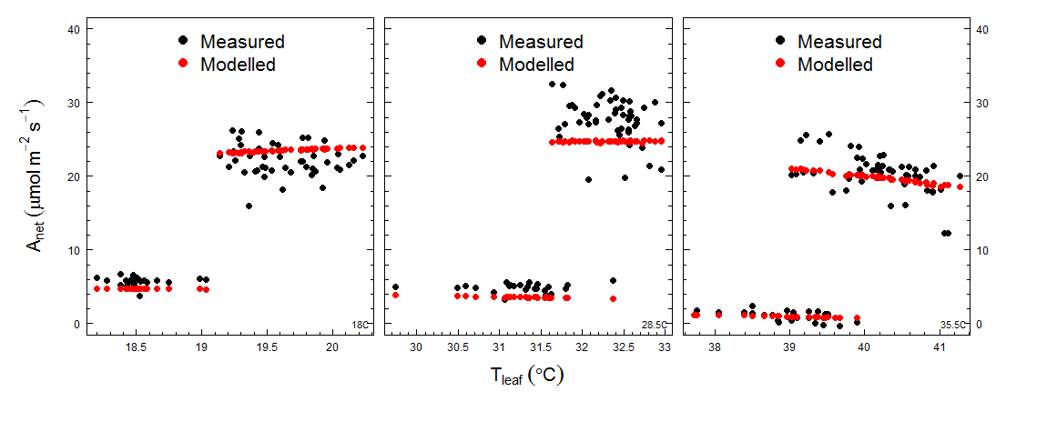

Figure: Measured and modelled net photosynthesis in three growth temperatures. In each panel, lower rates are the low PAR measured/modelled.

Simulate *in situ* photosynthesis measurements done at later stage of growth (*in situ* temperature response data measured on 2016-02-03 & 2016-02-26). This dataset measured at two PAR levels (100 and 1500)

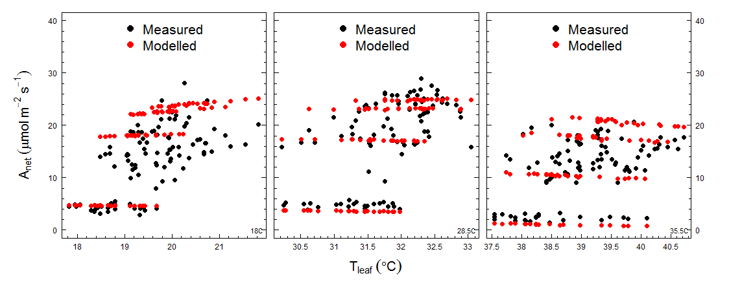

Figure: Measured and modelled net photosynthesis in three growth temperatures (26 DAP). In each panel, lower rates are the low PAR measured/modelled.

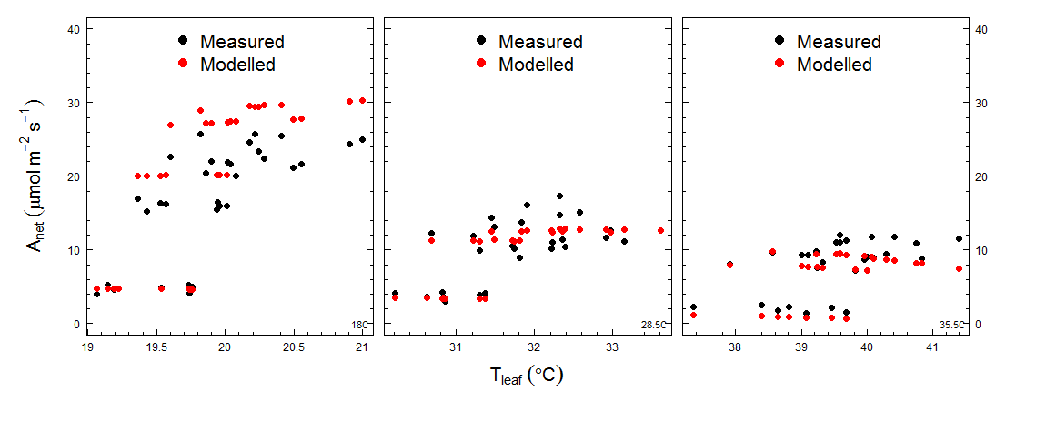

Figure: Measured and modelled net photosynthesis in three growth temperatures. In each panel, lower rates are the low PAR measured/modelled (~45 DAP).

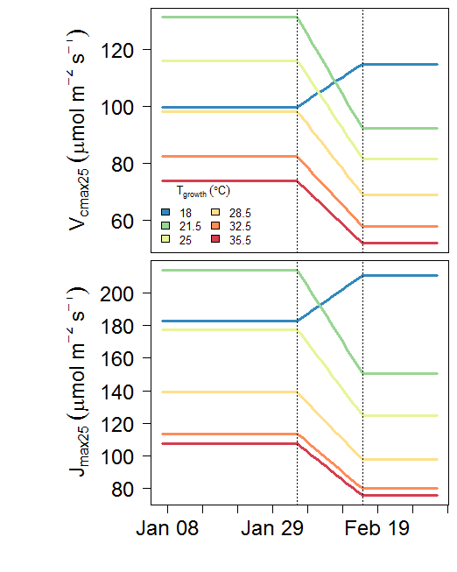

Figure 1: Variation of Vcmax and Jmax at 25 $℃$ with age of seedlings. Dotted lines show the two dates that measurements available.

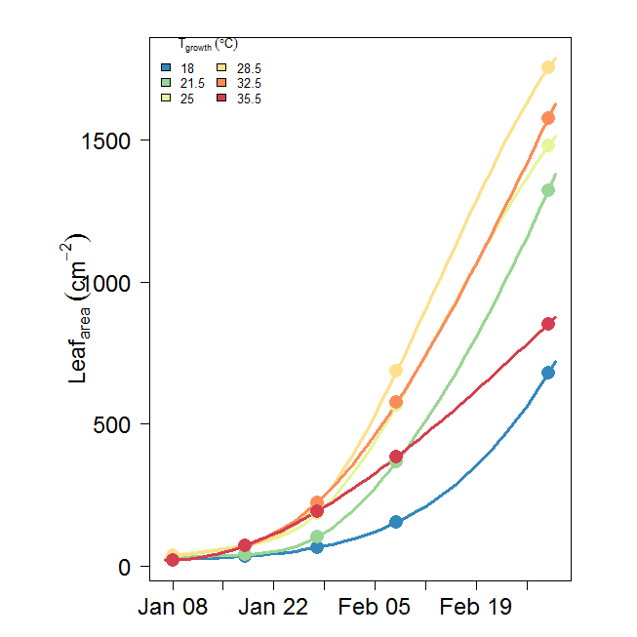

Figure 1: Variation of total seedling Leaf area with age of seedlings. Filled circles showed measurements (modelled)

Comparison of C (g) in final mass vs modelled C (g):

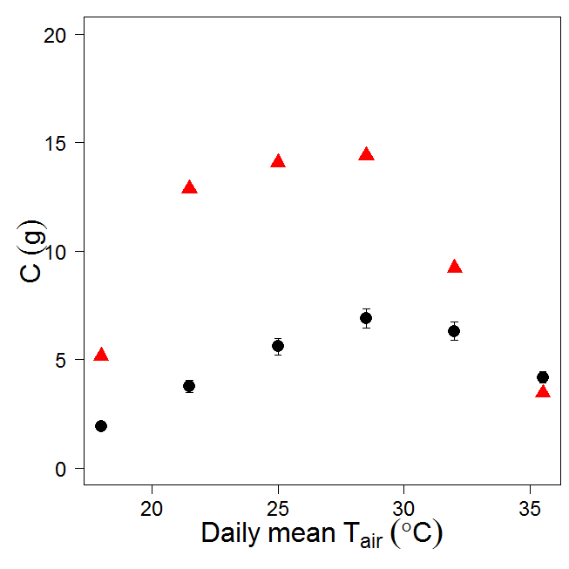

Figure. Carbon content (g) in final mass (black filled circles) and sum of GPP over growth period (red triangles). C in final mass calculated as [ $Σ$ Rm + 1.3 x Final Biomass x 0.47]

Comparison of C (g) in final mass vs modelled C (g): $α×1.5$

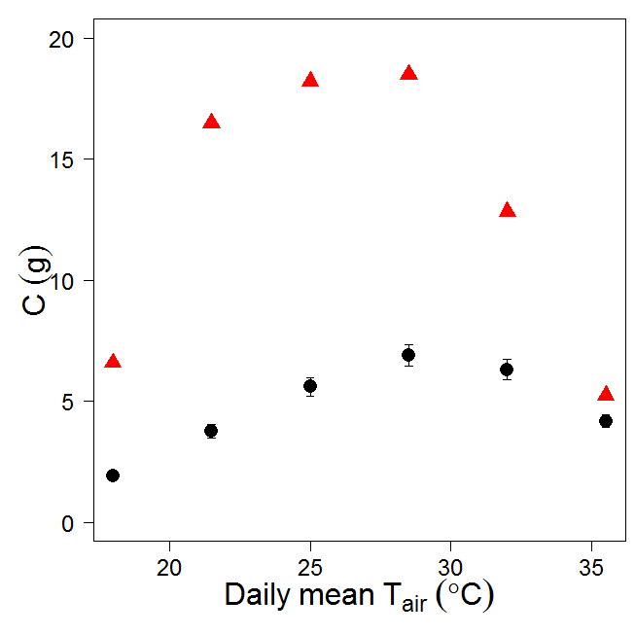

Figure. Carbon content (g) in final mass (black filled circles) and sum of GPP over growth period (red triangles). C in final mass calculated as [ $Σ$ Rm + 1.3 x Final Biomass x 0.47]

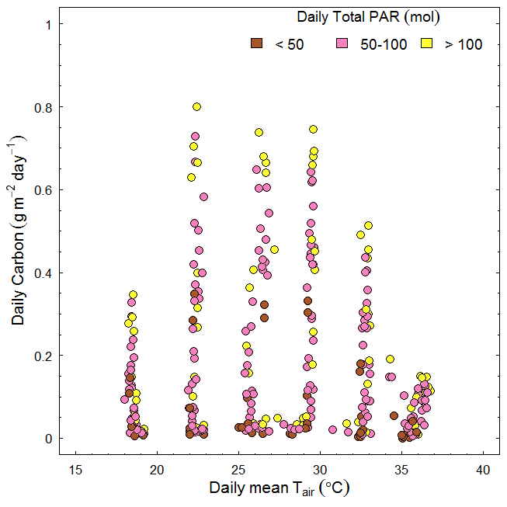

Figure2. Daily total carbon gains for each growth temperature treatments.

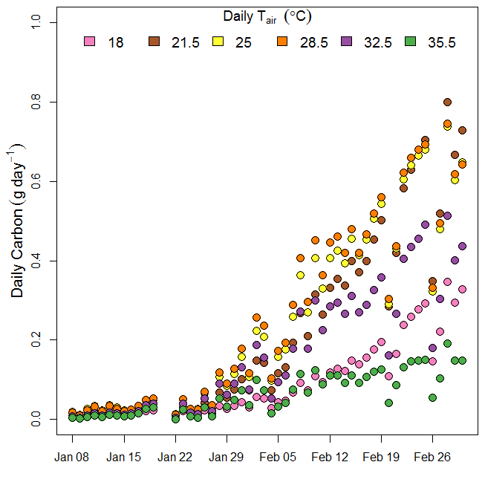

Figure3. Daily carbon gains over the experimental period (51 days from 8th Jan 2016 to 1st March 2016). (Jan 20-Jan 21 Rotation dates)

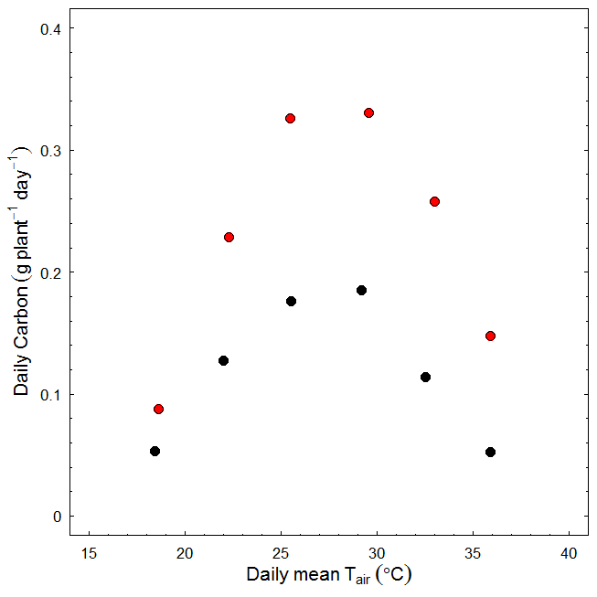

Figure: Temperature response of daily carbon gain in **sunny day (2016-02-02)** and **a cloudy day (2016-02-04).** Peaked at ~28C. Note: Assumed no self-shading

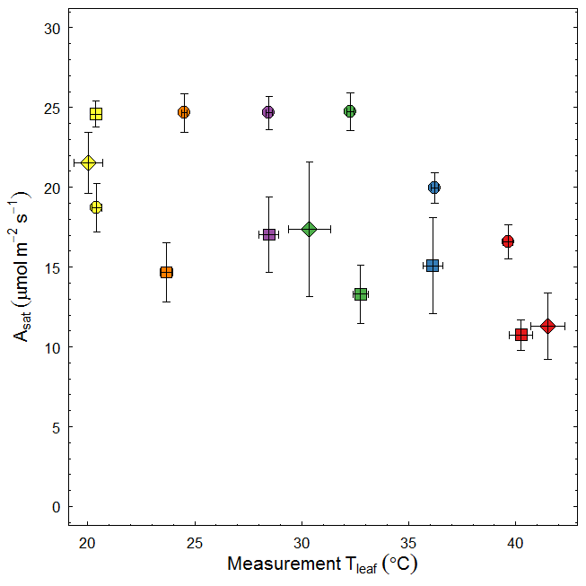

Figure: Photosynthesis vs Temperature relationship of seedlings with different age. Circles: 26 DAP,

diamonds: 40 DAP and squares: ~50 DAP. Colours depict different growth temperatures.

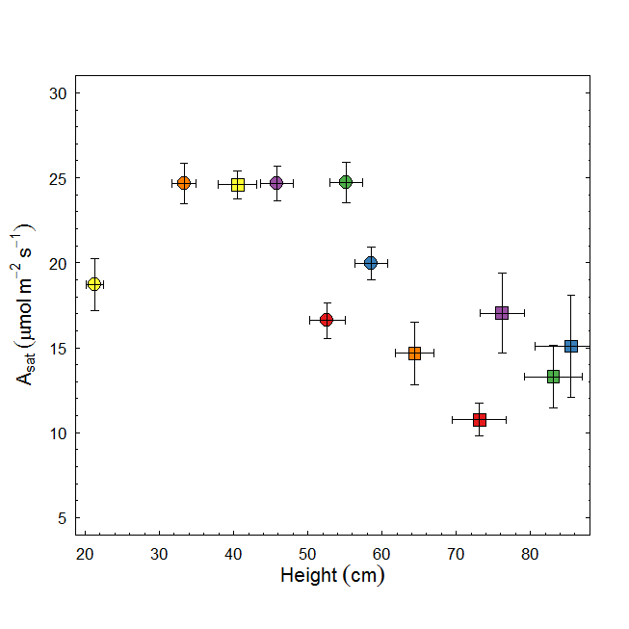

Figure: Photosynthesis vs seedling height relationship of seedlings with different age. Circles: 26 DAP and squares: ~50 DAP. Colours depict different growth temperatures.

**from Drake et al 2017 GCB**

**Fig. S1** Environmental data observed inside six glasshouse bays at Western Sydney University in 2016. Mean daily values of air temperature (Tair; a), relative humidity (RH; b), and vapor pressure deficit (VPD; c) are shown along with hourly averages of incident photosynthetic photon flux density (PPFD; d). Six colors are shown; cool colors reflect low temperature bays while hot colors reflect high temperature bays. PPFD did not differ across bays, so we present the mean PPFD for clarity. Note that there was substantial diurnal variation in T­air­, RH, and VPD that is not evident in these plots of 24-hour averages.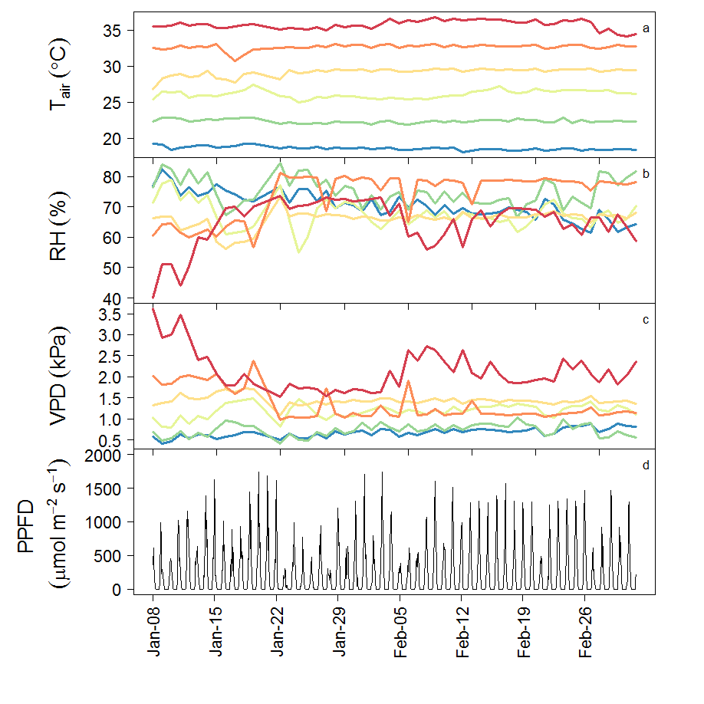

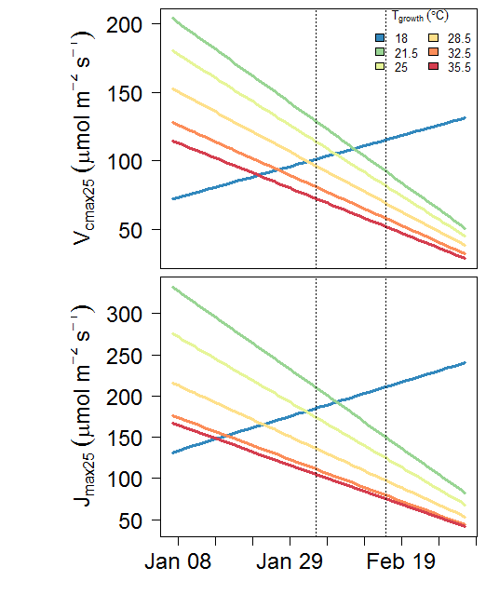

Old scale-up of Vcmax and Jmax

**Linear regression coefficients for leaf area vs self-shading factor**

|  |  |  |  |  |  |
| --- | --- | --- | --- | --- | --- |
|  |  |  | Linear regression coefficients | | |
| Tgrowth | mean self-shading factor | SE | Intercept | Slope | R2 |
| 18 | 0.87 | 0.005 | 0.90 | -0.024 | 0.39 |
| 21.5 | 0.90 | 0.004 | 0.92 | -0.019 | 0.39 |
| 25 | 0.90 | 0.004 | 0.92 | -0.018 | 0.38 |
| 28.5 | 0.90 | 0.003 | 0.92 | -0.016 | 0.40 |
| 32.5 | 0.86 | 0.005 | 0.89 | -0.024 | 0.47 |
| 35.5 | 0.86 | 0.005 | 0.89 | -0.026 | 0.47 |

Variation of self-shading factor with time (with leaf area growth)

