**Daily Carbon gain estimations for GREAT experiment**

Comparison of C (g) in final mass vs modelled C (g):

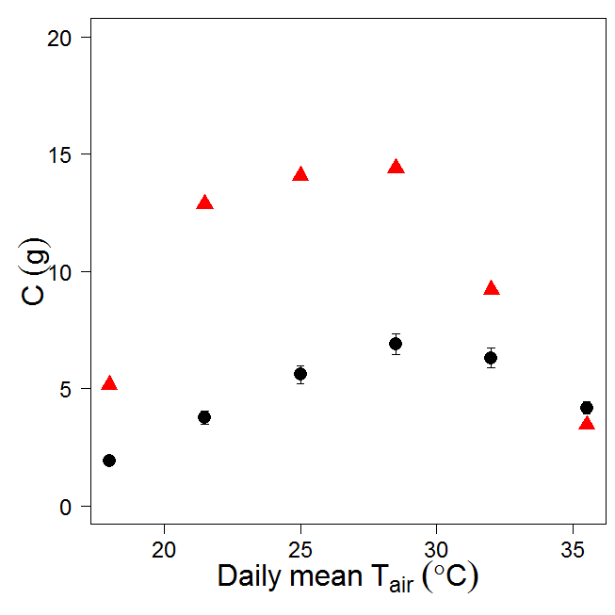

Figure 1. Carbon content (g) in final mass (black filled circles) and sum of GPP over growth period (red triangles). C in final mass calculated as [ $Σ$ Rm + 1.3 x Final Biomass x 0.47]

Comparison of C (g) in final mass vs modelled C (g): $α×1.5$

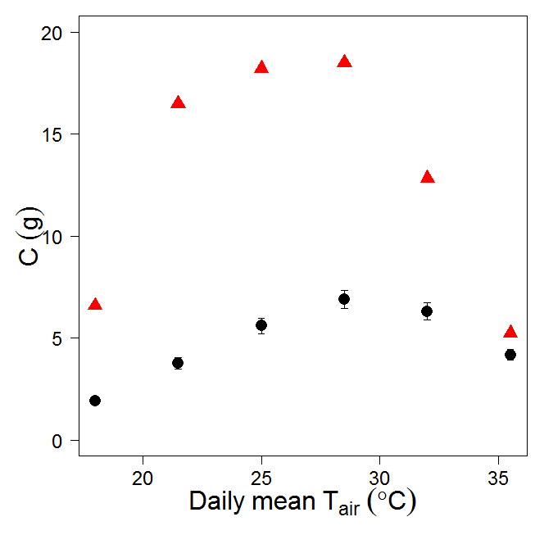

Figure 2. Carbon content (g) in final mass (black filled circles) and sum of GPP over growth period (red triangles). C in final mass calculated as [ Rm + 1.3 x Final Biomass x 0.47]