**Daily Carbon gain estimations for GREAT experiment**

Met data: 15 min VPD, Tair and PPFD measured in each glasshouse room

Physiological parameters:

1. Vcmax and Jmax at 25 $℃$: Estimated for room 1 (18 $℃$), 4 (28.5 $℃$) and 6 (35.5 $℃$) using ACi data. For other rooms (21.5 $℃$, 25 $℃$ and 32.5 $℃$, assumed as follows

For room 2 (21.5C): assume room 1 (18 $℃$)

For room 3 (25C): assume room 4 (28.5 $℃$)

For room 5 (32.5C): assume room 6 (36.5 $℃$)

1. Both Vcmax and Jmax were adjusted to seedling age using proportional change of net photosynthesis between 26 DAP and 40 DAP

$$V_{cmax25}\left(d_{i}\right)=V_{cmax25}\left(d_{40}\right)-[(V_{cmax25}\left(d_{40}\right)×\left(\frac{A_{40}-A_{26}}{A_{40}}\right)×\frac{1}{14}×\left(40-d_{i}\right)]$$

$V_{cmax25}\left(d_{i}\right)$: value of Vcmax at 25 $℃$ of a given day (di), : value of Vcmax at 25 $℃$ of 40 DAP, A40 and A26: measured net photosynthetic rates at 26 and 40 DAP.

1. Initial values of Vcmax and Jmax at 25 $℃$: Assumed as equal to the estimated values for plants at 26 DAP (fixed over 2016-01-08 to 2016-02-03 and 2016-02-16 to end of experiment)

Same scaling was adopted for Jmax25.

1. Ea, ∆S of Vcmax and Jmax: Estimated for room 1, 4 and 6 using ACi data. For other treatments values were assumed as follows

For room 2 (21.5C): assume room 1 (18C)

For room 3 (25C): assume room 4 (28.5C)

For room 5 (32.5C): assume room 6 (36.5C)

1. g1: estimated from short term Asat measurements
2. alpha: estimated by nonlinear regression (best fitted alpha to data at low PAR)
3. Day respiration: Assume similar to leaf dark respiration (Q10 of 2.1) and with Rdayfrac=0.7
4. Other parameters: default in Photosyn

Parameter values used (Fixed over time)

|  |  |  |  |  |  |  |  |
| --- | --- | --- | --- | --- | --- | --- | --- |
| **Room** | **Tgrowth** | **g1** | **alpha** | **EaV** | **delsV** | **EaJ** | **delsJ** |
| **1** | 18 | 1.58 | 0.27 | 58.87 | 0.629 | 42.75 | 0.631 |
| **2** | 22.5 | 7.70 | 0.30 | 58.87 | 0.629 | 42.75 | 0.631 |
| **3** | 25 | 6.34 | 0.31 | 57.71 | 0.629 | 32.67 | 0.625 |
| **4** | 28.5 | 8.78 | **0.36** | 57.71 | 0.629 | 32.67 | 0.625 |
| **5** | 32.5 | 16.45 | 0.31 | 82.55 | 0.633 | 51.00 | 0.631 |
| **6** | 35.5 | 15.43 | 0.29 | 82.55 | 0.633 | 51.00 | 0.631 |

Assumptions:

1. Provenance differences was not considered in any parameter estimation.
2. Temperature response of day respiration was assumed to be similar as dark respiration (Basal rates and Q10 values were averaged across provenances).

Test the model with measured photosynthesis data: in situ photosynthesis measurements

On 03/02/2016

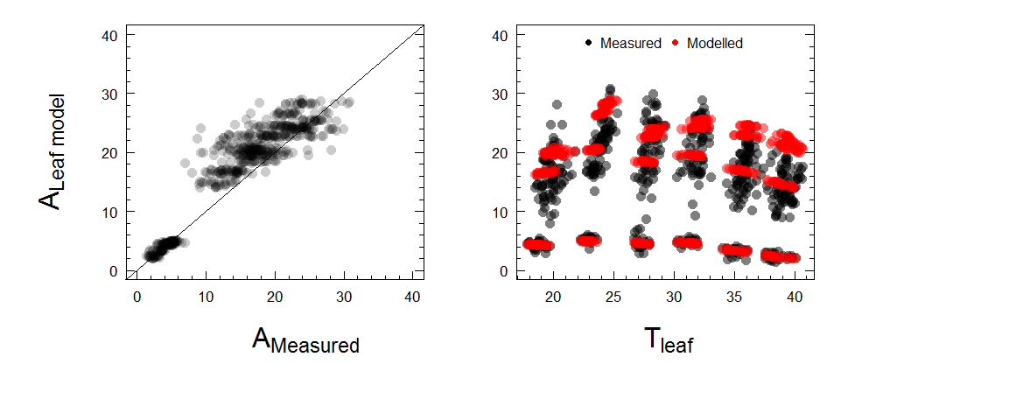

Figure 1. Measured vs modelled *in situ* photosynthesis measurements at different PAR levels. The model over predict photosynthesis at high PAR levels (PAR > 500)

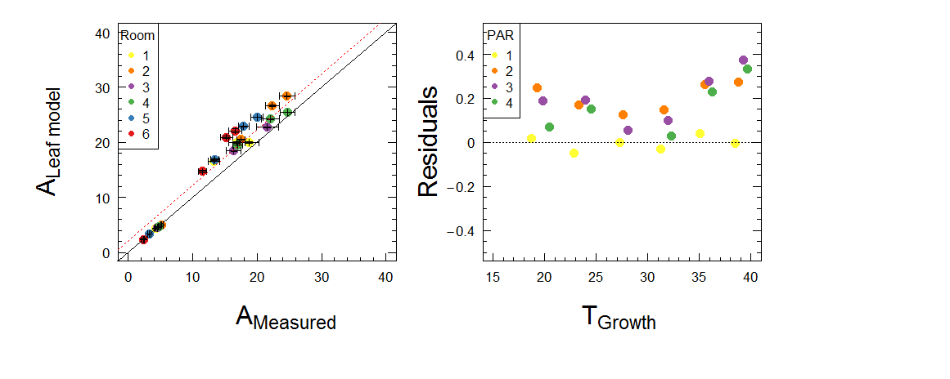

Figure 2. Measured vs modelled *in situ* photosynthesis measurements at different PAR levels (mean of provenances). The model over predict photosynthesis at high PAR levels (PAR > 500). PAR fractions: 1=100, 2=500, 3=1000 and 4=1500.

It’s clear the leaf scale model over predict photosynthesis specially at higher growth temperatures. Over predicted Vcmax25 and Jmax25 values by the scaling method??

Next step: decrease Vcmax25 and Jmax25 by 10% (only values on 2016-02-03)

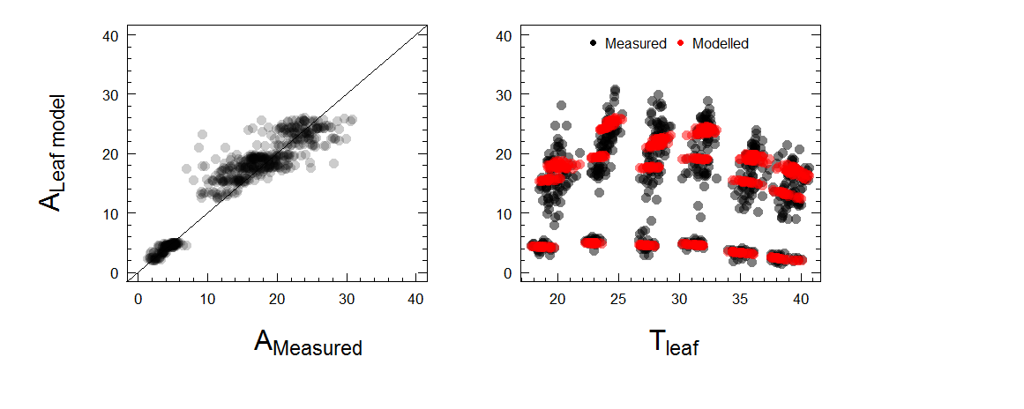Figure 3. Measured vs modelled *in situ* photosynthesis measurements at different PAR levels. Note: decrease Vcmax25 and Jmax25 values by 10% for all growth temperatures

Residuals=(ALeaf model-AMeasured)/AMeasured

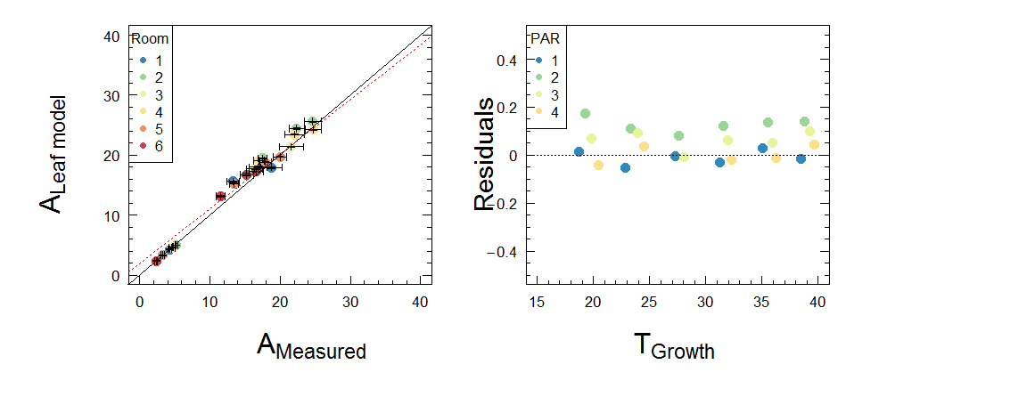Figure 4. Measured vs modelled *in situ* photosynthesis measurements at different PAR levels (mean of provenances). Note: decrease Vcmax25 and Jmax25 values by 10% for all growth temperatures. PAR fractions: 1=100, 2=500, 3=1000 and 4=1500.

Residuals=(ALeaf model-AMeasured)/AMeasured

The leaf model still over predict photosynthesis at higher PAR by ~5-10%, but consistent across growth temperatures.

**Conclusion: Proceed with current parameters but Vcmax25 and Jmax25 values on 2016-02-03 should decrease by 10% and assume similar values for the period 2016-01-08 to 2016-02-03.**

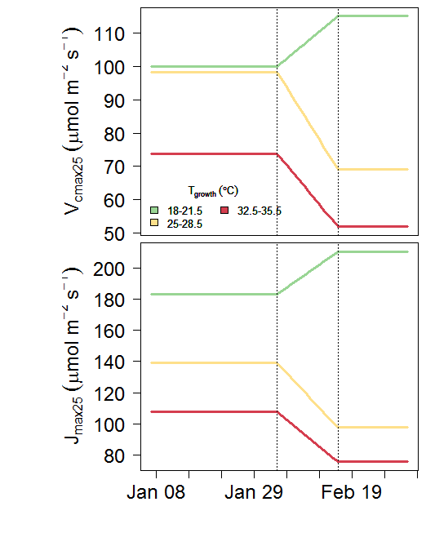

Figure 5: Variation of Vcmax and Jmax at 25 $℃$ with age of seedlings. Dotted lines show the two dates that measurements available.

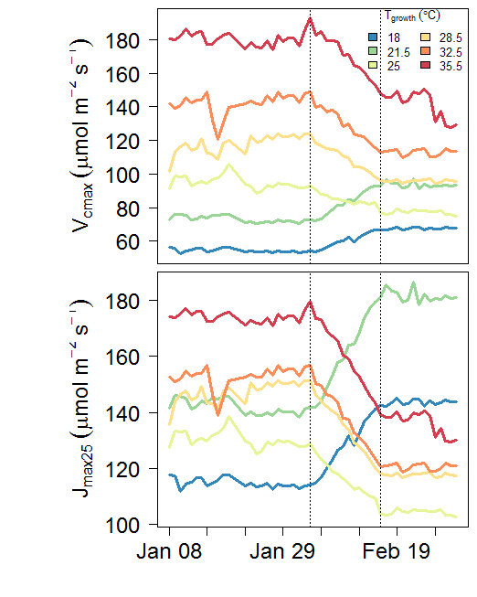

Figure 5.a: Variation of Vcmax and Jmax at growth temperature with time (age of seedlings).

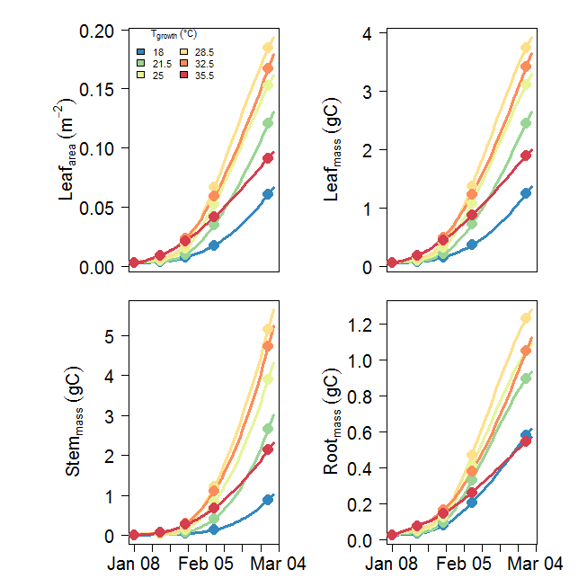

Figure 6: daily leaf area, leaf mass, stem mass and root mass over the experiment period. Solid symbols depict measurements (predictions by Kashif’s models).

Issue: Final mass numbers different from John’s estimates

|  |  |  |  |  |  |
| --- | --- | --- | --- | --- | --- |
| T growth | Leaf mass (gC) | Stem mass (gC) | Root mass (gC) | **total mass (gC)** | **Final mass in John's paper (gDM)** |
| 18 | 1.30 | 0.95 | 0.60 | **2.85** | **2.57** |
| 21.5 | 2.55 | 2.83 | 0.92 | **6.30** | **4.99** |
| 25 | 3.20 | 4.11 | 1.07 | **8.38** | **7.71** |
| 28.5 | 3.83 | 5.40 | 1.26 | **10.49** | **9.03** |
| 32.5 | 3.54 | 4.98 | 1.09 | **9.60** | **7.76** |
| 35.5 | 1.95 | 2.22 | 0.56 | **4.72** | **5.03** |

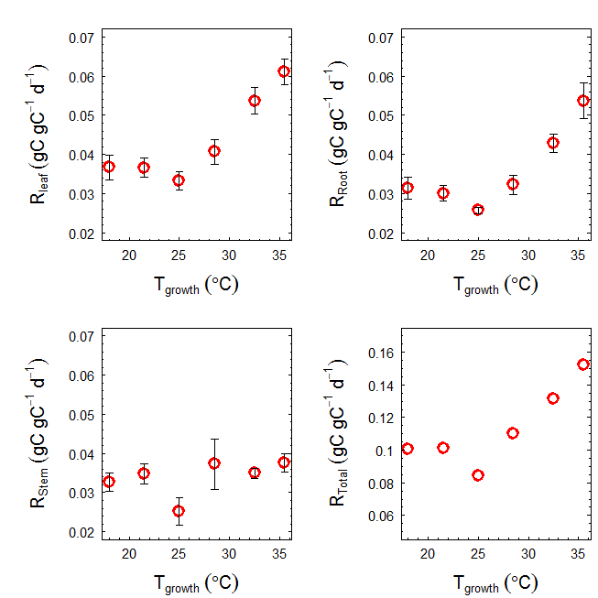

Figure 7: Daily leaf, stem, root respiration rates measured at final harvest (mean across provenances)

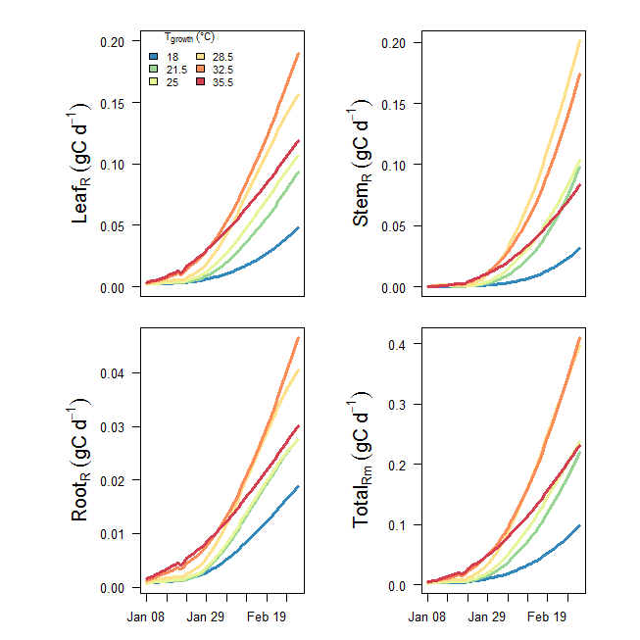

Figure 7: Daily leaf, stem, root respiration rates over the experiment period

Modelled daily carbon for each growth temperature

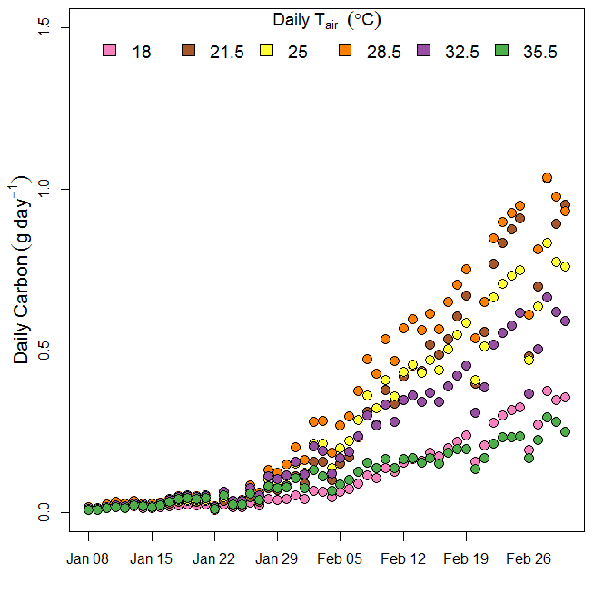

Figure 8. Modelled daily carbon for each growth temperature over experimental period (with self-shading)

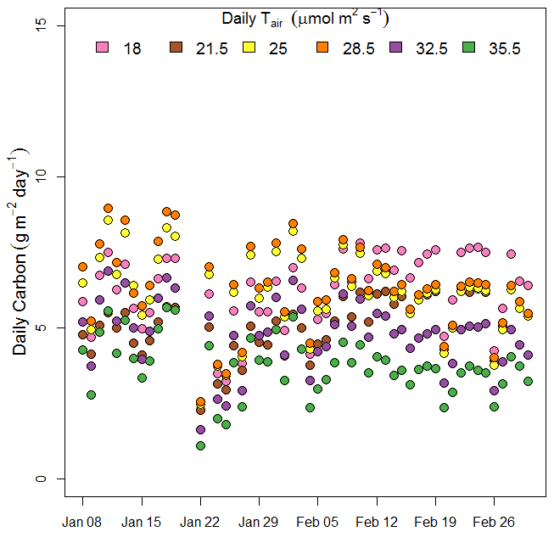

Figure 9. Modelled daily carbon (per m2) for each growth temperature over experimental period

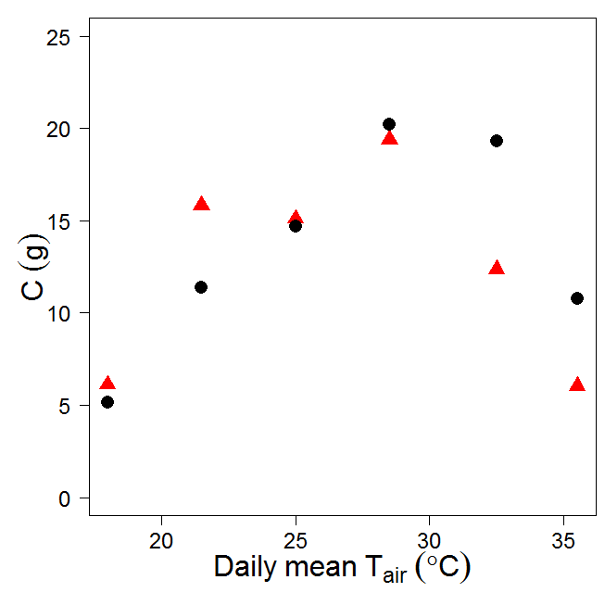

Figure 9. Carbon content (g) in final mass (black filled circles) and sum of GPP over growth period (red triangles). C in final mass calculated as

GPP=[ $Σ$ Rm + 1.3 x (Final Biomass-Initial Biomass)]

|  |  |  |  |  |  |  |  |  |  |  |  |  |  |
| --- | --- | --- | --- | --- | --- | --- | --- | --- | --- | --- | --- | --- | --- |
|  |  |  |  | Final mass data (gC) | | | | |  |  |  |  |  |
| Room | Tair | GPP predicted  (gC) | Total Rm  (gC) | LA (m2) | Leaf mass | Stem mass | Root mass | **total mass** | Initial total mass (gC) | Rm+1.3*∆BM | Rg | storage | **Final mass in John's paper (gDM)** |
| 1 | 18.0 | 6.09 | 1.54 | 0.06 | 1.30 | 0.95 | 0.60 | **2.85** | 0.098 | 5.13 | 0.83 | 0.97 | **2.57** |
| 2 | 21.5 | 15.84 | 3.30 | 0.13 | 2.55 | 2.83 | 0.92 | **6.30** | 0.098 | 11.36 | 1.86 | 4.48 | **4.99** |
| 3 | 25.0 | 15.14 | 3.94 | 0.16 | 3.20 | 4.11 | 1.07 | **8.38** | 0.098 | 14.70 | 2.48 | 0.43 | **7.71** |
| 4 | 28.5 | 19.40 | 6.70 | 0.19 | 3.83 | 5.40 | 1.26 | **10.49** | 0.098 | 20.21 | 3.12 | -0.80 | **9.03** |
| 5 | 32.5 | 12.75 | 6.95 | 0.17 | 3.54 | 4.98 | 1.09 | **9.60** | 0.098 | 19.31 | 2.85 | -6.56 | **7.76** |
| 6 | 35.5 | 6.25 | 4.75 | 0.09 | 1.95 | 2.22 | 0.56 | **4.72** | 0.098 | 10.77 | 1.39 | -4.52 | **5.03** |

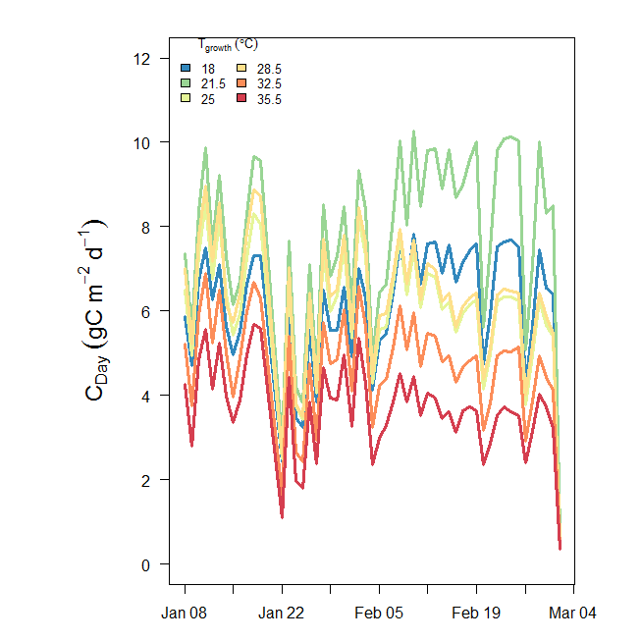

Figure 10. Daily GPP in each of the temperature treatments. Not corrected for self-shading

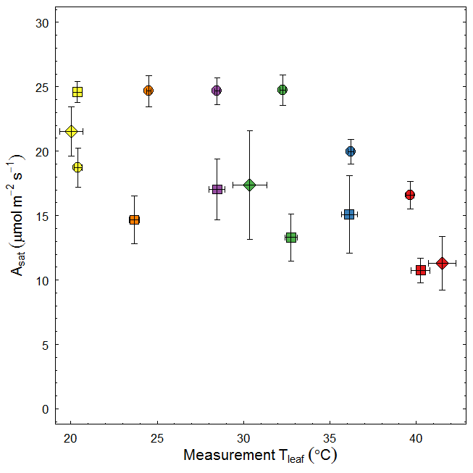

Figure 11: Photosynthesis vs Temperature relationship of seedlings with different age. Circles: 26 DAP,

diamonds: 40 DAP and squares: ~50 DAP. Colours depict different growth temperatures.

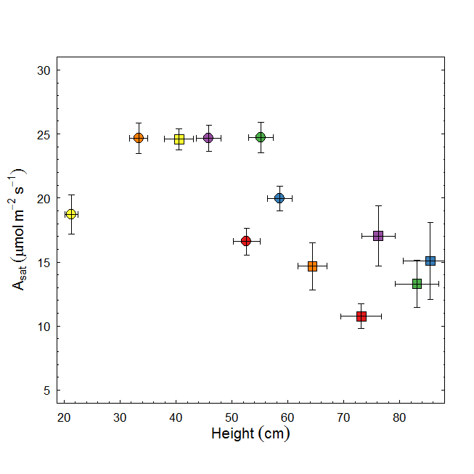

Figure: Photosynthesis vs seedling height relationship of seedlings with different age. Circles: 26 DAP and squares: ~50 DAP. Colours depict different growth temperatures.

**from Drake et al 2017 GCB**

**Fig. S1** Environmental data observed inside six glasshouse bays at Western Sydney University in 2016. Mean daily values of air temperature (Tair; a), relative humidity (RH; b), and vapor pressure deficit (VPD; c) are shown along with hourly averages of incident photosynthetic photon flux density (PPFD; d). Six colors are shown; cool colors reflect low temperature bays while hot colors reflect high temperature bays. PPFD did not differ across bays, so we present the mean PPFD for clarity. Note that there was substantial diurnal variation in T­air­, RH, and VPD that is not evident in these plots of 24-hour averages.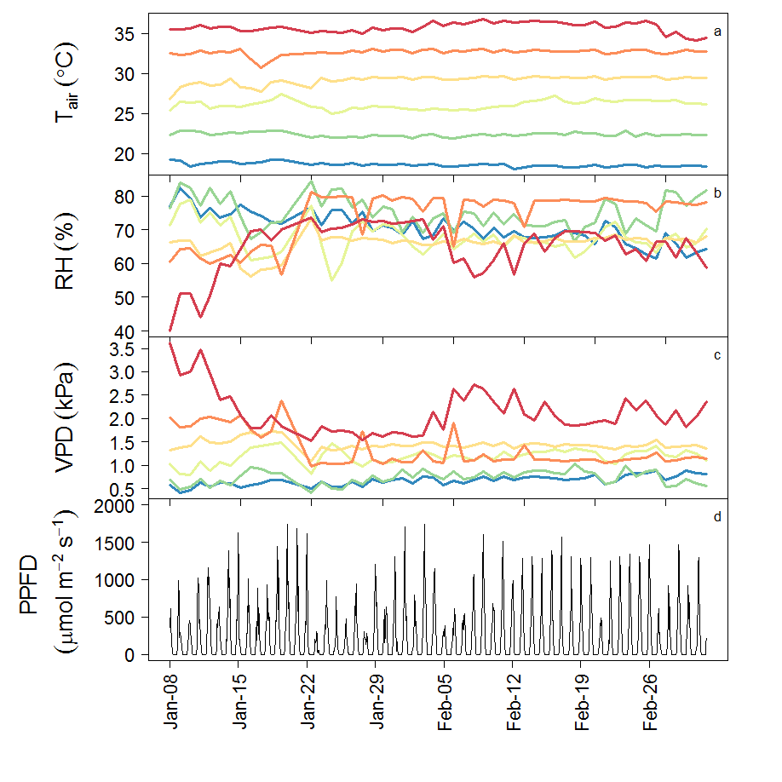

Vcmax and Jmax: Raw data

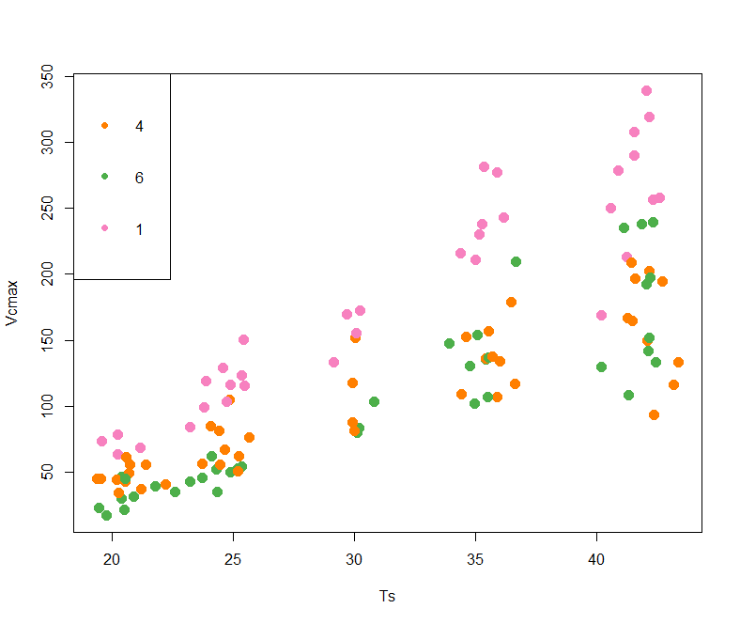

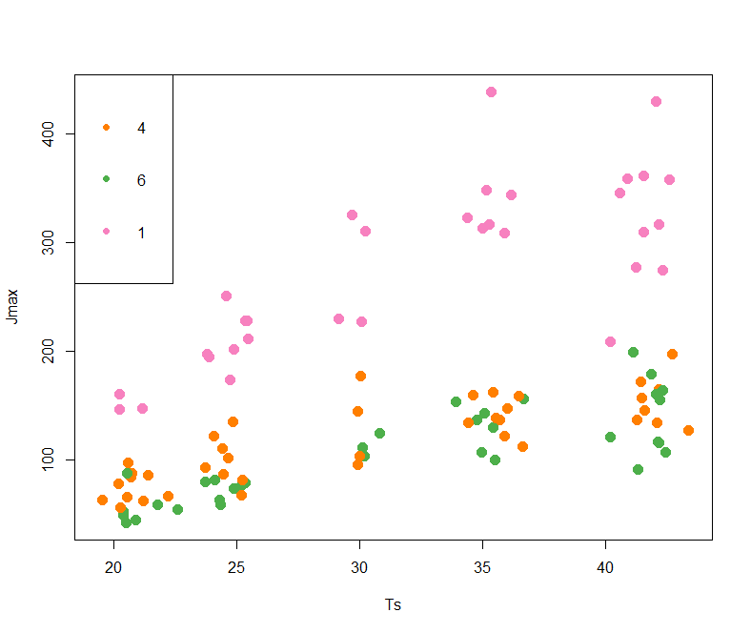

**Linear regression coefficients for leaf area vs self-shading factor**

|  |  |  |  |  |  |
| --- | --- | --- | --- | --- | --- |
|  |  |  | Linear regression coefficients | | |
| Tgrowth | mean self-shading factor | SE | Intercept | Slope | R2 |
| 18 | 0.87 | 0.005 | 0.90 | -0.024 | 0.39 |
| 21.5 | 0.90 | 0.004 | 0.92 | -0.019 | 0.39 |
| 25 | 0.90 | 0.004 | 0.92 | -0.018 | 0.38 |
| 28.5 | 0.90 | 0.003 | 0.92 | -0.016 | 0.40 |
| 32.5 | 0.86 | 0.005 | 0.89 | -0.024 | 0.47 |
| 35.5 | 0.86 | 0.005 | 0.89 | -0.026 | 0.47 |

Variation of self-shading factor with time (with leaf area growth)

