**Daily Carbon gain estimations for GREAT experiment**

Data Census

|  |  |  |
| --- | --- | --- |
| Data Set | Date | Used to estimate |
| Photosynthesis at 4 light levels (100,500,1000,1500) – All Plants- Insitu | 2016/01/02 and 03  (26 ADP) | g1, alpha, Vcmax  to test model fits to all light levels |
| Photosynthesis at 2 light levels (100, 1500) – only room 2 plants – moved to other rooms and measured | 2016/01/05  (28 DAP) | g1 |
| Rdark – T curves: only room 2 plants - moved to other rooms and measured | 2016/01/11  (34 DAP) | Light respiration rate (assumed same to Rdark*0.7) Q10=2.1 |
| ACi-T curves  Warm and Cool prov. Only  Three rooms 18, 28.5 and 35.5 | 2016/01/16 – 26  (40-48 DAP) | JV ratio at growth temperatures  Vcmax25, Jmax25 and T-response parameters (but not used) |
| Photosynthesis at 4 light levels (100,500,1000,1500) – One prov. - Insitu | 2016/01/26  (48 DAP) | alpha, Vcmax  to test model fits to all light levels |
| Respiration components  (leaf, stem, roots) – measured at 25C | 2016/01/17 - 24 | Respiration rates of leaf, stem and roots at growth temperatures |
| Met Data | 15 min VPD, Tair and PPFD measured in each glasshouse room |  |

Parameter estimates

1. g1:



1. alpha and Vcmax

used nls to get best fitted values. (Problem: under estimate alpha)

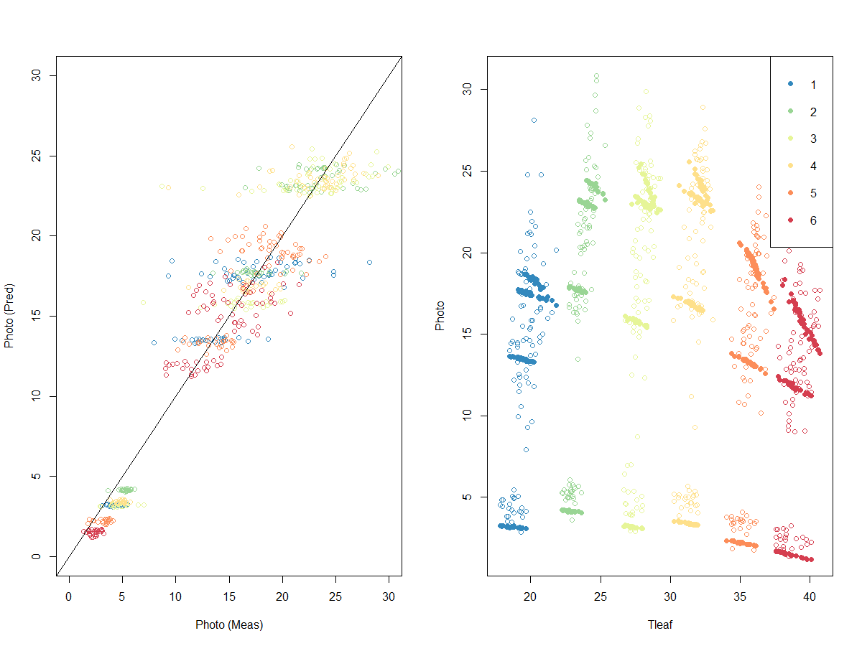

Fig3: Measured and modelled photosynthesis for AQ data in campaign 1. Colours depicts rooms; temperature treatments.

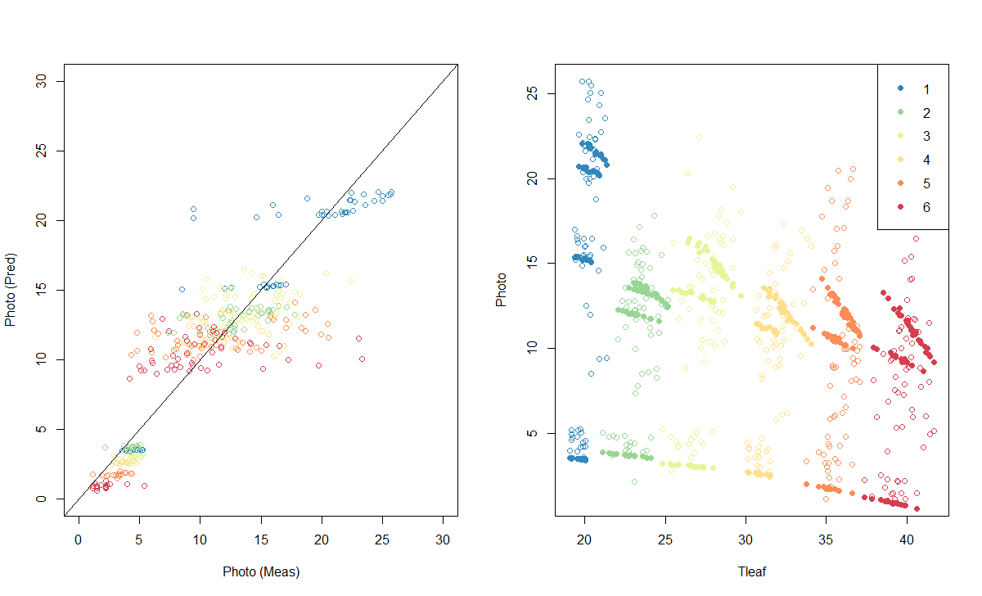

Fig4: Measured and modelled photosynthesis for AQ data in campaign 2. Colours depicts rooms; temperature treatments.

I used estimated Vcmax at two time points to get the time course of Vcmax (and Jmax) as follows.

1. Jan-07 to Feb 02 -> numbers similar to Feb 3 estimates
2. Feb-04 to Feb-25 -> linear decrease assumed
3. Feb-26 to Feb-29 -> numbers similar to Feb 26 estimates
4. Jmax:Vcmax ratio assumed to be fixed over time.

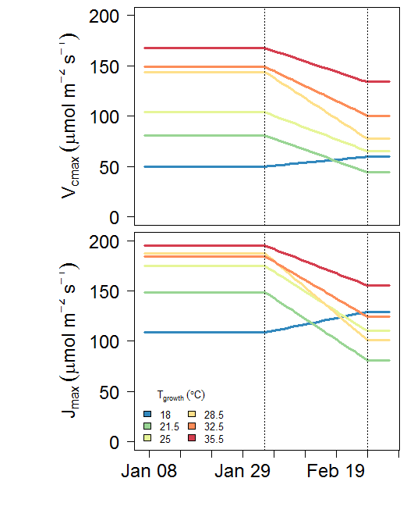

Fig5. Vcmax and Jmax at growth temperatures over the experiment period.

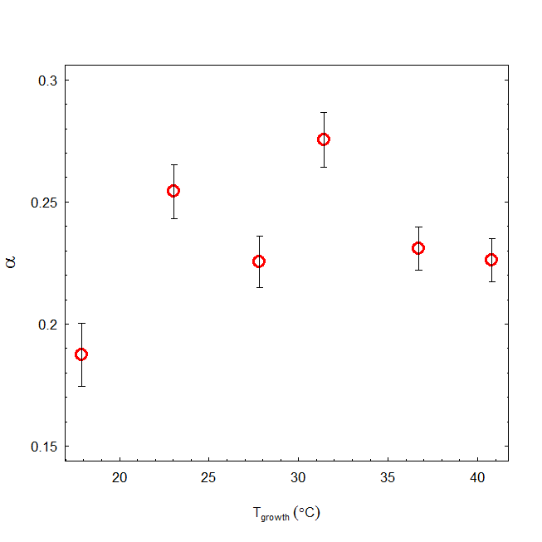

Fig. estimated alpha for different growth temperatures

Test the model against measured photosynthesis

Try A-Q data in Campaign 1 (2016/02/03)

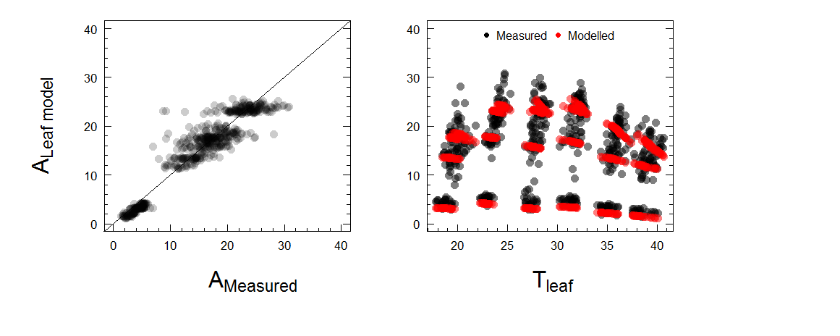

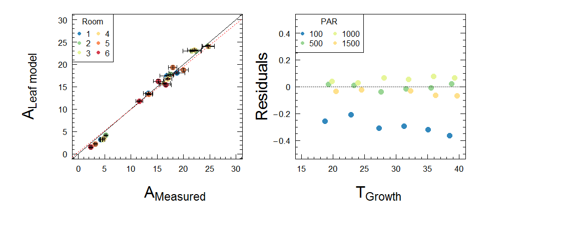

Fig6. Measured and modelled photosynthesis (problem: it under estimate photosynthesis at low PAR). The red line is the regression fit (slope=0.96; R2=0.89; non-significant intercept)

Estimating the total GPP

GPP=[ $Σ$ Rm + 1.3 x (Final Biomass-Initial Biomass)]

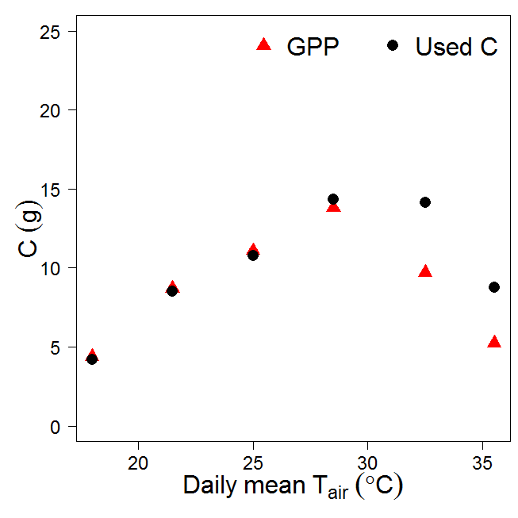

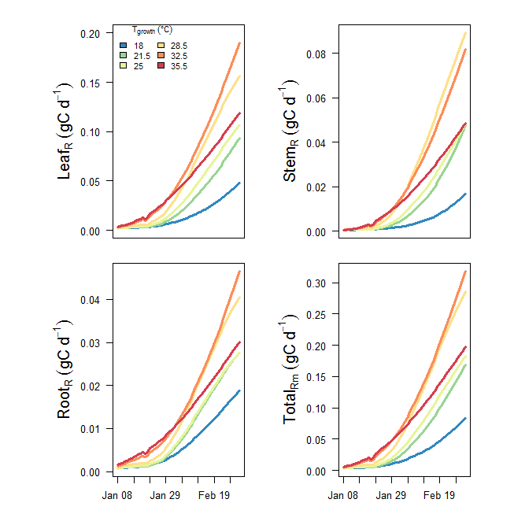

Fig: Estimated daily stem, root and shoot respiration over the experiment period

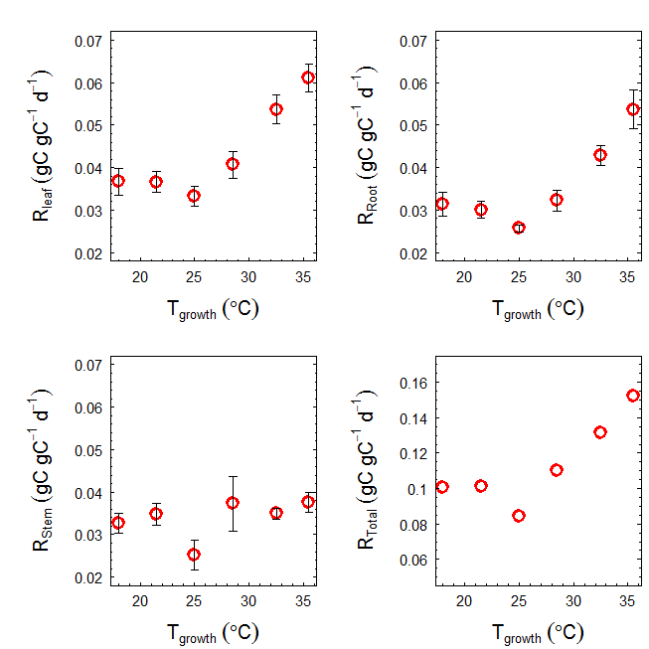

Figure: leaf, stem and root respiration rates measured at final harvest (mean across provenances) used to calculate Rm. Rates assumed similar across experiment period.

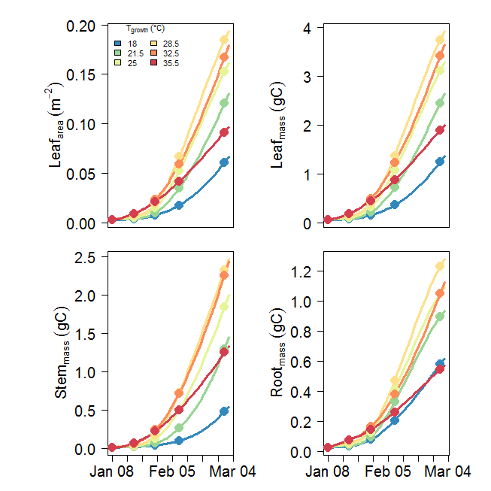

Figure : daily leaf area, leaf mass, stem mass and root mass over the experiment period. Solid symbols depict measurements (predictions by Kashif’s models).



Figure 7: Daily leaf, stem, root respiration rates measured at final harvest (mean across provenances)

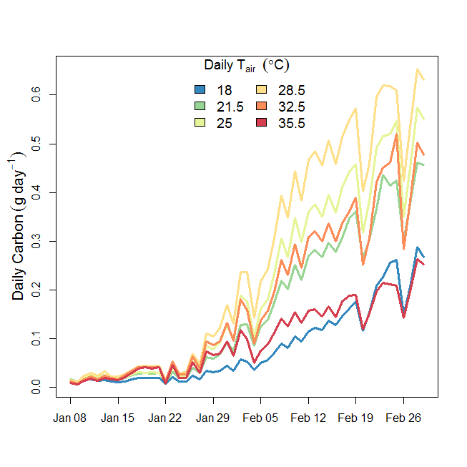

Fig. Modelled daily carbon for each growth temperature over experimental period (with self-shading)

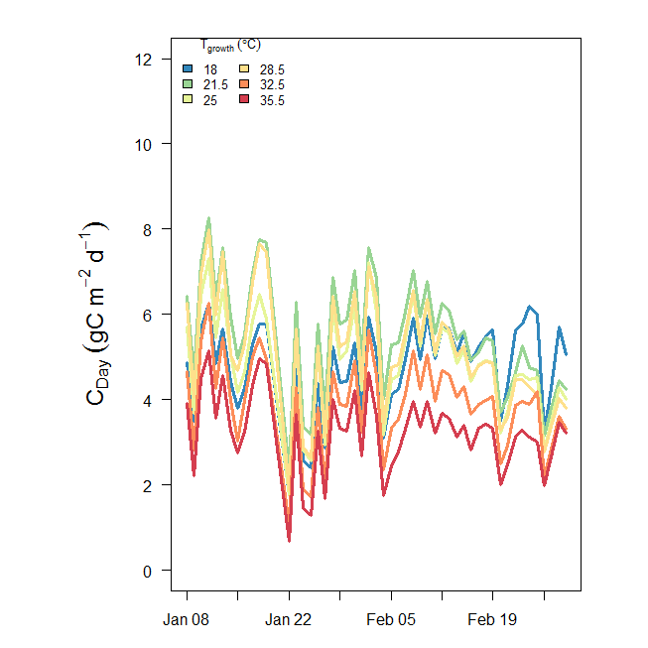

Figure. Modelled daily carbon (per m2) for each growth temperature over experimental period

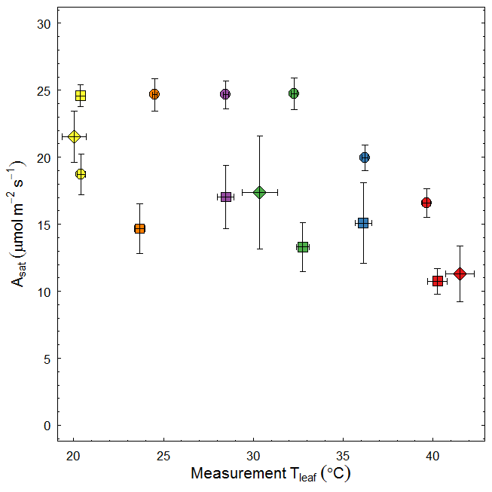

Figure 11: Photosynthesis vs Temperature relationship of seedlings with different age. Circles: 26 DAP, diamonds: 40 DAP and squares: ~50 DAP. Colours depict different growth temperatures.

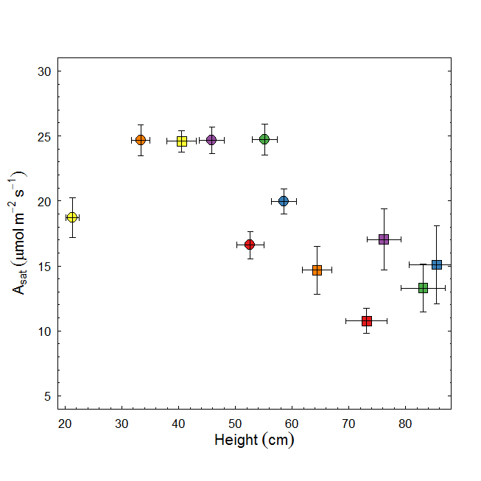

Figure: Photosynthesis vs seedling height relationship of seedlings with different age. Circles: 26 DAP and squares: ~50 DAP. Colours depict different growth temperatures.

**from Drake et al 2017 GCB**

**Fig. S1** Environmental data observed inside six glasshouse bays at Western Sydney University in 2016. Mean daily values of air temperature (Tair; a), relative humidity (RH; b), and vapor pressure deficit (VPD; c) are shown along with hourly averages of incident photosynthetic photon flux density (PPFD; d). Six colors are shown; cool colors reflect low temperature bays while hot colors reflect high temperature bays. PPFD did not differ across bays, so we present the mean PPFD for clarity. Note that there was substantial diurnal variation in T­air­, RH, and VPD that is not evident in these plots of 24-hour averages.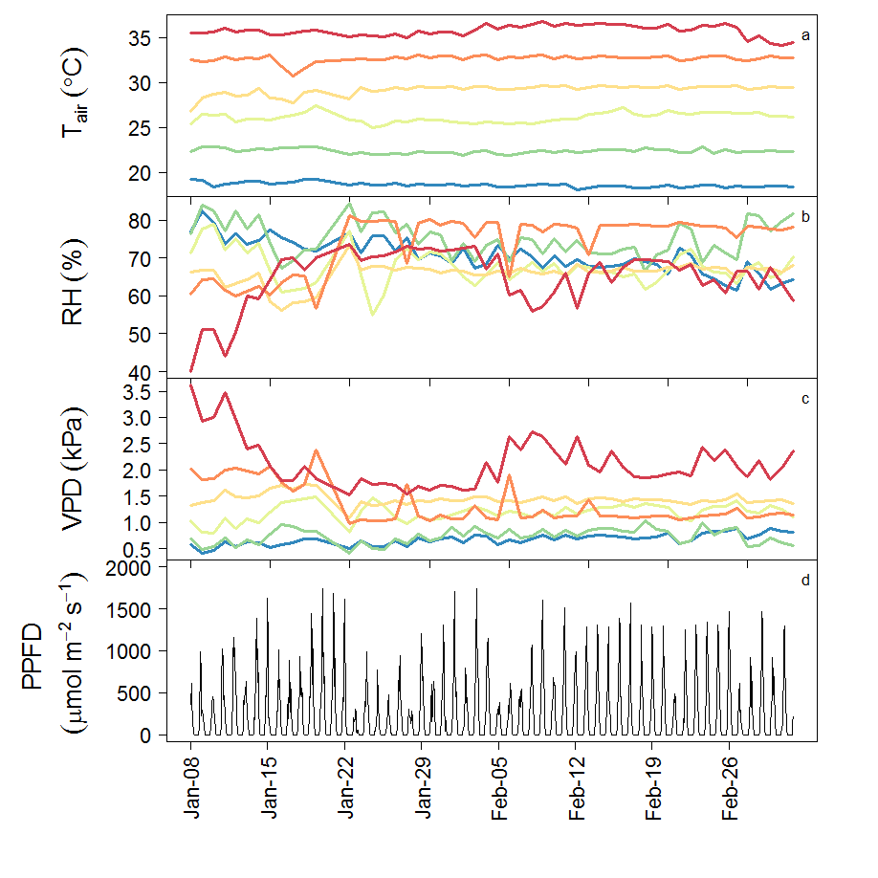

Vcmax and Jmax: Raw data

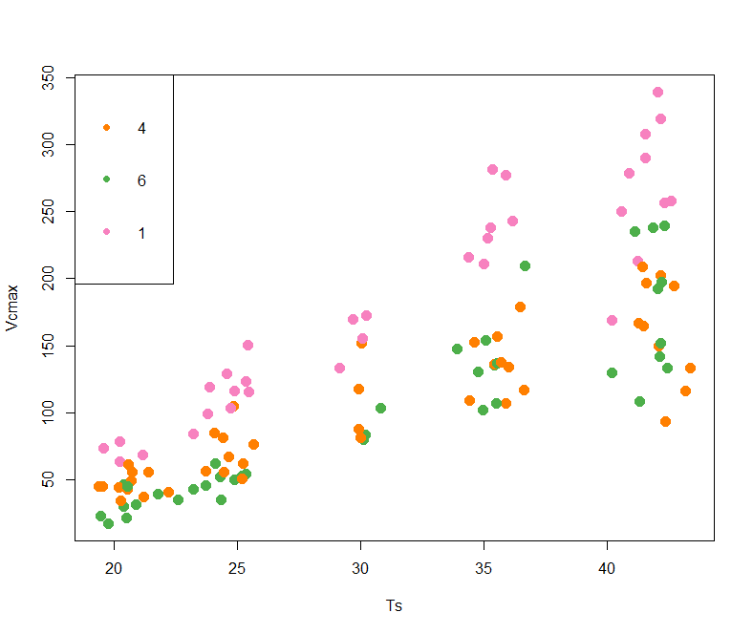

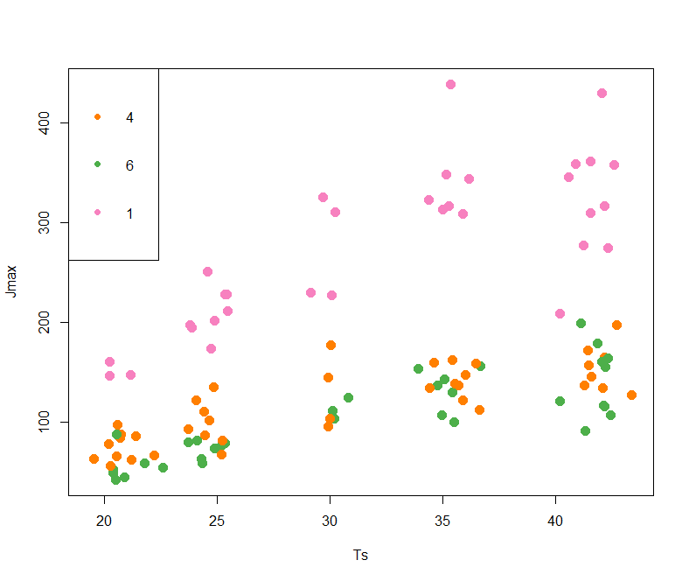

**Linear regression coefficients for leaf area vs self-shading factor**

|  |  |  |  |  |  |
| --- | --- | --- | --- | --- | --- |
|  |  |  | Linear regression coefficients | | |
| Tgrowth | mean self-shading factor | SE | Intercept | Slope | R2 |
| 18 | 0.87 | 0.005 | 0.90 | -0.024 | 0.39 |
| 21.5 | 0.90 | 0.004 | 0.92 | -0.019 | 0.39 |
| 25 | 0.90 | 0.004 | 0.92 | -0.018 | 0.38 |
| 28.5 | 0.90 | 0.003 | 0.92 | -0.016 | 0.40 |
| 32.5 | 0.86 | 0.005 | 0.89 | -0.024 | 0.47 |
| 35.5 | 0.86 | 0.005 | 0.89 | -0.026 | 0.47 |

Variation of self-shading factor with time (with leaf area growth)

