**Temperature response of photosynthesis at different PAR levels: GREAT Experiment.**

1. Measurements from first campaign (2016/02/03): Age of seedlings ~26 days after starting temperature treatments

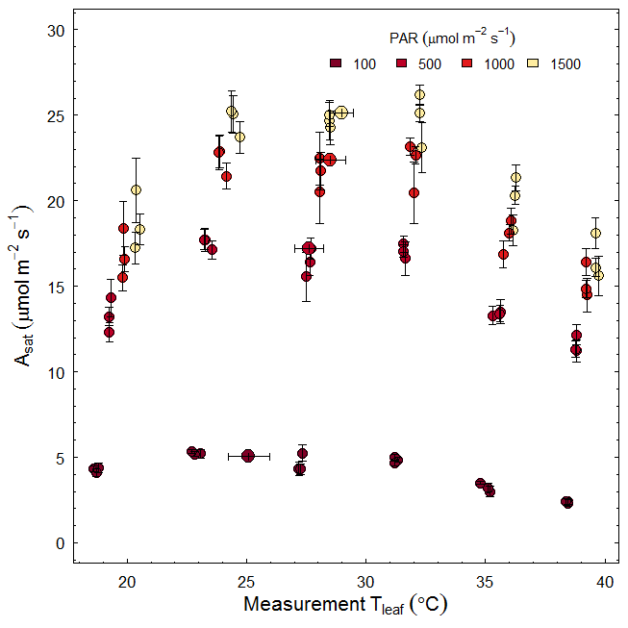

Figure1: Temperature response of leaf net photosynthesis at mid-day in-situ growth temperatures and different PAR levels (i.e. long-term temperature response of photosynthesis). Note each point represent mean photosynthesis of a given provenance (n= 6-8 per provenance; provenances were not shown in different colour as they are not significantly different from each other). Error bars represents 1SE. The thick black circles filled with respective colours depict optimum temperature (horizontal error bars: 95% CI) for photosynthesis (Topt) at different PAR levels (note: Topt for photosynthesis was estimated by fitting non-linear mix models using Provenance as a random variable)

1. Measurements from second campaign (2016/02/26): Age of seedlings ~50 days after starting temperature treatments (Warm-edge provenance only)

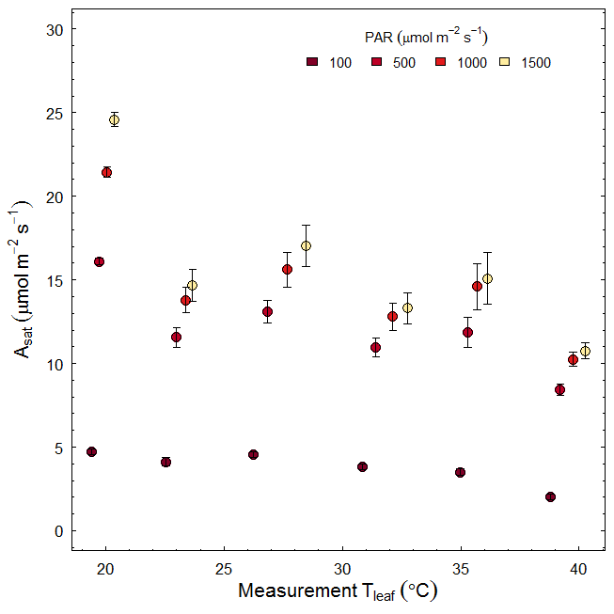

Figure2: Temperature response of leaf net photosynthesis at mid-day in-situ growth temperatures and different PAR levels (i.e. long-term temperature response of photosynthesis). Note **each point represent mean photosynthesis of warm-edge provenance (n= 6-8).** Error bars represents 1SE.

1. Measurements from ACI data campaign (2016/02/16 – 2016/02/26): Age of seedlings ~40-50 days after starting temperature treatments (two provenances only; warm-edge and cold- edge)

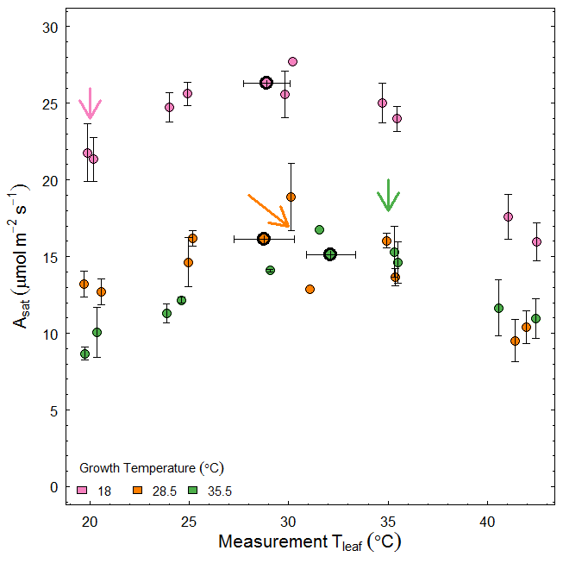

Figure3: Temperature response of leaf net photosynthesis measured at different leaf temperatures and high PAR levels (i.e. short-term temperature response of photosynthesis). Each point represents mean photosynthetic rate of a given provenance (first observation of each ACi curve at [CO2]=400 ppm, averaged across 4-6 replicates). ; provenances were not shown in different colour as they are not significantly different from each other. Error bars represents 1SE. **Arrows in respective colours depicts photosynthesis measured at leaf temperatures which were similar/close to the growth temperature of each glasshouse bay (can be considered as in-situ measurements; long-term temperature response).** The thick black circles filled with respective colours depict optimum temperature (error bars: 95% CI) for photosynthesis (Topt) at different growth temperatures (note: Topt for photosynthesis was estimated by fitting non-linear mix models using Provenance as a random variable)

1. It is clear from above figures that, temperature response of photosynthesis of GREAT seedlings vary with time. If we compare in-situ measurements, in the first campaign, all three provenances grown at lowest growth temperature showed low photosynthetic rates compares to the rates at same growth temperature when measured approximately 3 weeks later (compare figure 1 and 2). This is further confirmed by data from ACi campaign (see coloured arrows). In campaign 1, from Tgrowth 18 to 28.5 (room 1 vs room 4) there is a clear increase in net photosynthetic rate but in later campaigns, it showed a decrease. As a result, photosynthesis rate shows a clear decline (linear??) with growth temperature; no optimum estimated.

1. Further, I plotted data for warm-edge provenance for campaign 1,2 and ACi data for a comparison

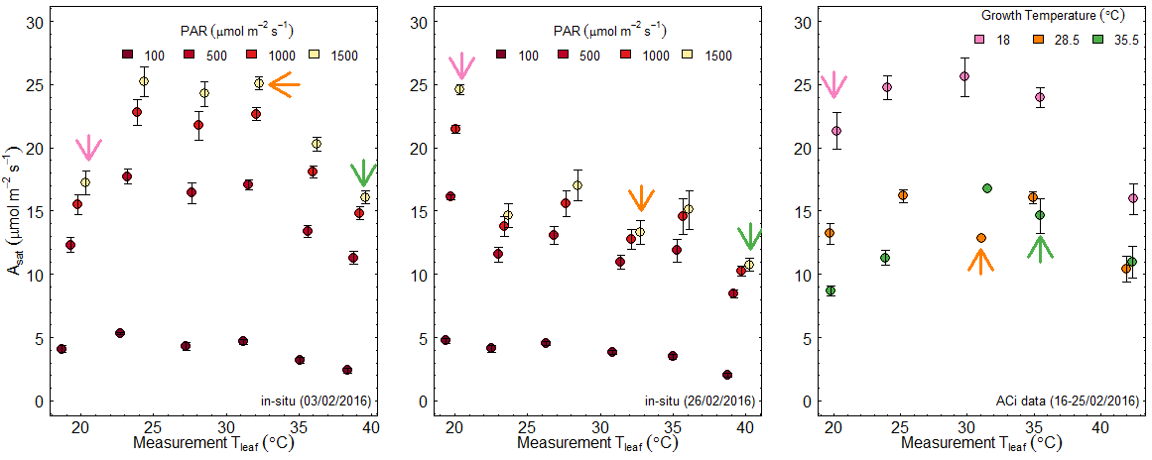

Figure 4: Temperature response of in-situ photosynthesis of warm-edge provenance measured in three campaigns (dates given in each plot). Arrows depicts photosynthetic rates at PAR=1500 in 18, 28.5 and 35.5C growth temperatures.

1. It is quite interesting to see that warm-edge provenance shows better performances when it grows in cooler temperatures when seedling age increases. If we look at photosynthetic biochemical parameters, there were no significant difference between two provenances (warm-edge vs cold-edge) but strong growth temperature effect can be seen (see figure 5-7)

So the decline in in-situ photosynthetic rates can be explained by decrease in photosynthetic capacity with growth temperature. But, I’m quite uncertain why warm-edge provenance has no temperature optimum when measured at a later time point of the experiment.

1. In a separate analysis, I tried to model photosynthesis using Photosyn (planecophys package) and see whether I can reproduce the measured photosynthesis data. It seems that, modelled photosynthesis closely follow the observed measurements for ACi data (at ambient [CO2]. But if showed a big difference for photosynthesis data of campaign 1. See figure 8



Figure 5. Vcmax at 25C for GREAT provenances. ACi curves were measured only in two provenances at three growth temperature. The values given in figure are from fitted peaked Arrhenius model (3-6 replicates per provenance growth temperature treatment).



Figure 6. Jmax at 25C for GREAT provenances. ACi curves were measured only in two provenances at three growth temperature. The values given in figure are from fitted peaked Arrhenius model (3-6 replicates per provenance growth temperature treatment).



Figure 7. Jmax:Vcmax ratio at 25C for GREAT provenances. ACi curves were measured only in two provenances at three growth temperature. The values given in figure are from fitted peaked Arrhenius model (3-6 replicates per provenance growth temperature treatment).

**Photosynthesis model**

First test with ACi data (at ambient CO2 levels~ first observation of each ACi curve)

VPD, CO2, Tleaf and PARi were set to measured values

As Vcmax and Jmax data only measured in rooms 1, 4 and 6, test simulations were done for those data first

Parameter settings for the photosynthesis model

|  |  |  |  |  |  |  |  |  |  |
| --- | --- | --- | --- | --- | --- | --- | --- | --- | --- |
| Room | Tgrowth | alpha | g1 | Vcmax25 | EaV | delsV | Jmax25 | EaJ | delsJ |
| 1 | 18 | 0.18 | 5.38 | 112.70 | 61.94 | 0.629 | 209.66 | 41.84 | 0.631 |
| 4 | 28.5 | 0.19 | 8.89 | 69.06 | 57.71 | 0.629 | 97.80 | 32.67 | 0.625 |
| 6 | 35.5 | 0.14 | 10.33 | 51.90 | 82.55 | 0.633 | 75.60 | 51.00 | 0.631 |

Plot for measured and modelled photosynthesis

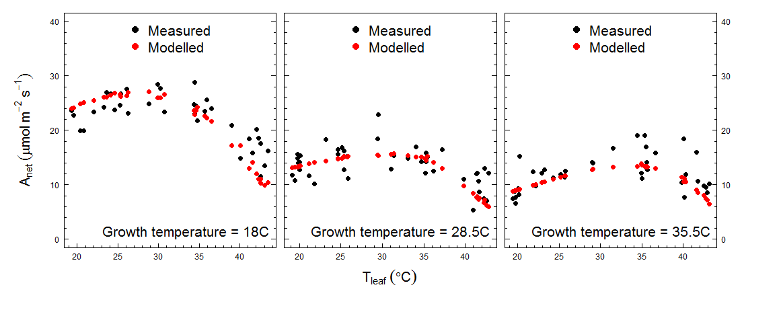

Figure 8. Temperature response of measured and modelled photosynthesis. This is just for testing purpose to see whether the leaf scale model can reproduce the observations. Linear regression between measured and modelled photosynthesis showed a R2= 0.76 (figure bellow)

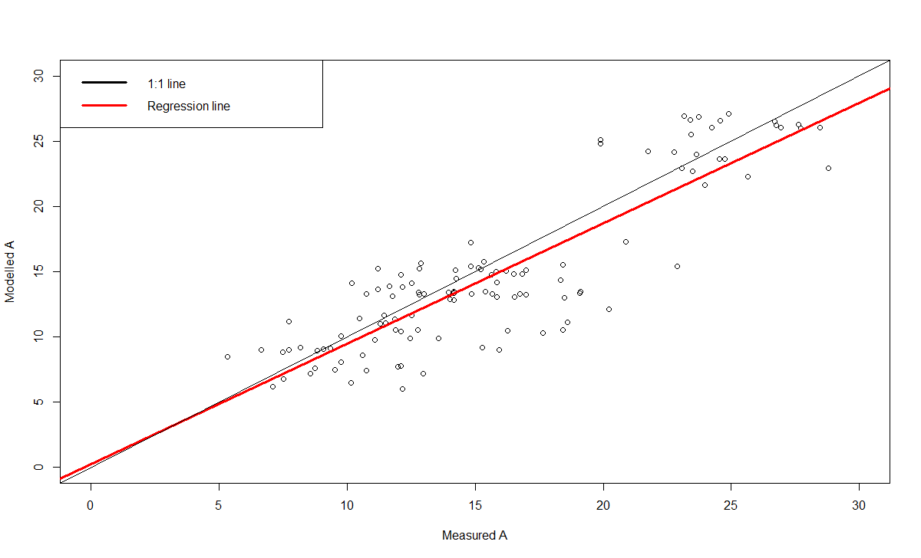

Try to simulate photosynthesis measurements done at early stage of growth (Short-term temperature response data measured on 2016-02-05). This dataset measured at two PAR levels (100 and 1500)

VPD, CO2, Tleaf and PARi were set to measured values. 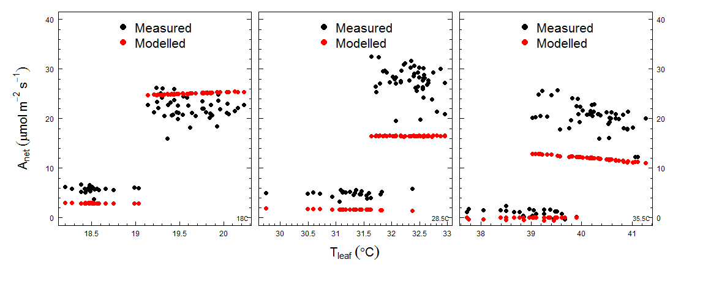

Higher Vcmax and Jmax at 25C values are needed for a close fit (note the lower photosynthesis values are for PAR at 100)

Light response curves at different growth temperatures

