**Daily Carbon gain estimations for GREAT experiment**

Data Census

|  |  |  |
| --- | --- | --- |
| Data Set | Date | Used to estimate |
| Photosynthesis at 4 light levels (100,500,1000,1500) – All Plants- Insitu | 2016/01/02 and 03  (26 ADP) | g1, alpha, Vcmax  to test model fits to all light levels |
| Photosynthesis at 2 light levels (100, 1500) – only room 2 plants – moved to other rooms and measured | 2016/01/05  (28 DAP) | g1 |
| Rdark – T curves: only room 2 plants - moved to other rooms and measured | 2016/01/11  (34 DAP) | Light respiration rate (assumed same to Rdark*0.7) Q10=2.1 |
| ACi-T curves  Warm and Cool prov. Only  Three rooms 18, 28.5 and 35.5 | 2016/01/16 – 26  (40-48 DAP) | JV ratio at growth temperatures  Vcmax25, Jmax25 and T-response parameters (but not used) |
| Photosynthesis at 4 light levels (100,500,1000,1500) – One prov. - Insitu | 2016/01/26  (48 DAP) | alpha, Vcmax  to test model fits to all light levels |
| Respiration components  (leaf, stem, roots) – measured at 25C | 2016/01/17 - 24 | Respiration rates of leaf, stem and roots at growth temperatures |
| Met Data | 15 min VPD, Tair and PPFD measured in each glasshouse room |  |

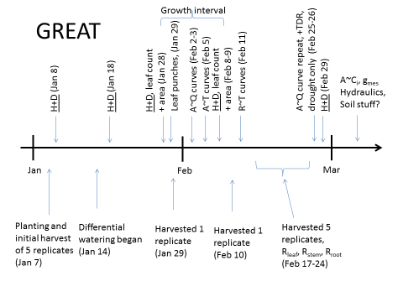

Data and parameter settings

|  |  |  |
| --- | --- | --- |
| **Parameter** | **Source** | **Remarks** |
| Vcmax, alpha and theta | Optimized to fit for the measured photosynthesis data from two campaigns. | Vcmax and Jmax linearly decrease from 2016-02-03 to 2016-02-26  Theta: mean across treatments (due to negative values in some treatments) |
| Jmax | Vcmax × JV ratio |  |
| g1 | Fitted to Photosynthesis measurements (data from in situ measurements) | Super high g1 values?? |
| Rday | Assumed 70% of the leaf respiration rates measured at final harvest | Rates fixed over time. No data to get the time dependency |
| Q10 | Based on Tjoelker et al 2001 $$Q_{10}=3.22-0.046×T_{growth}$$ |  |
| Rdark | Measurements at final harvest at 25C. Used Q10 model to scale to Tgrowth | Rates fixed over time. No data to get the time dependency |
| Biomass data | Harvest data at 4 time points. | Linear interpolation assumed to get the time course |
| Met data | 15 min Tair, VPD, PAR |  |

Fixed parameter values over time

|  |  |  |  |  |  |  |  |
| --- | --- | --- | --- | --- | --- | --- | --- |
| **Room** | **Tgrowth** | **g1** | **g1.se** | **alpha** | **alpha.se** | **theta** | **theta.se** |
| 1 | 18 | 5.53 | 0.90 | 0.31 | 0.07 | 0.09 | 0.65 |
| 2 | 21.5 | 10.73 | 0.86 | 0.35 | 0.04 | 0.40 | 0.26 |
| 3 | 25 | 10.84 | 0.73 | 0.35 | 0.07 | 0.15 | 0.62 |
| 4 | 28.5 | 10.02 | 1.75 | 0.40 | 0.05 | 0.24 | 0.22 |
| 5 | 32 | 18.25 | 1.04 | 0.35 | 0.04 | -0.15 | 0.31 |
| 6 | 35.5 | 29.04 | 4.58 | 0.30 | 0.04 | -0.09 | 0.32 |

Estimation of Vcmax, Jmax and alpha

Use non-linear regression to optimize Vcmax and alpha to fit for the measured Asat data in two campaigns. It seems that the Vcmax and Jmax estimated from ACi curves cannot reproduce Asat data we measured. Also, ACi curves only available for three growth temperatures.

It is clear that the Asat measurements at two campaigns significantly different. Room 1 plants increase their photosynthesis measurements from campaign 1 to 2 and for all other rooms a decrease observed. See the figure. This could be due to sink limitation with increasing temperature (pot effect). At lowest Temperature, plant is small, so no effect of pot size. Due to this effect, I thought that the Vcmax and Jmax too need to vary over time.

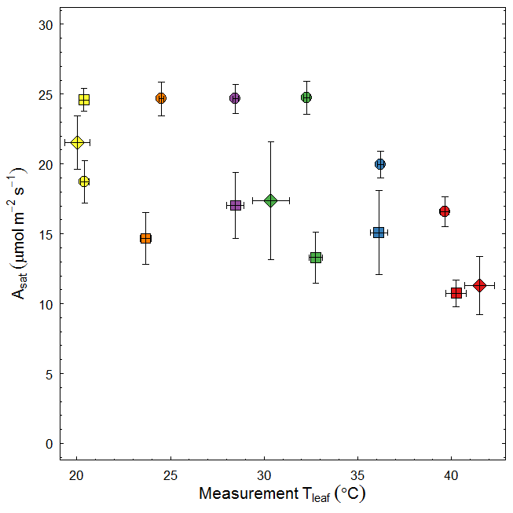

Figure: Photosynthesis vs Temperature relationship of seedlings with different age. Circles: 26 DAP (3-Feb-2016), diamonds: 40 DAP and squares: ~50 DAP (26-Feb-2016). Colours depict different growth temperatures. Data used: in-situ Asat measurements of well-watered seedlings.

I used estimated Vcmax at two time points to get the time course of Vcmax (and Jmax) as follows.

1. Jan-07 to Feb 02 -> numbers similar to Feb 3 estimates
2. Feb-04 to Feb-25 -> linear decrease assumed
3. Feb-26 to Feb-29 -> numbers similar to Feb 26 estimates
4. Jmax:Vcmax ratio assumed to be fixed over time.

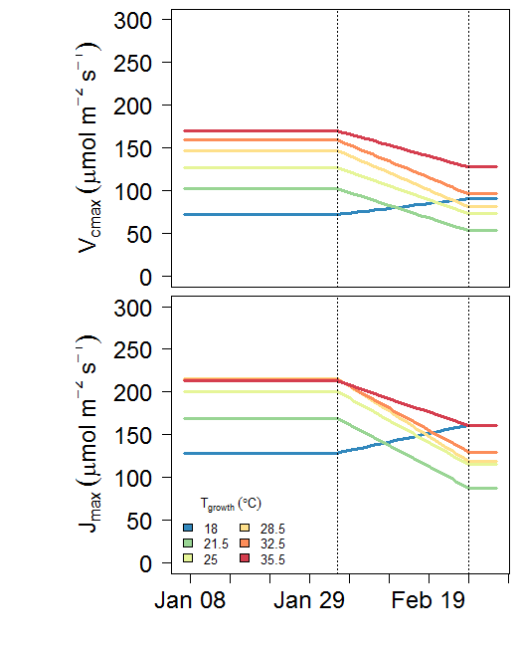

Fig1. Vcmax and Jmax at growth temperatures over the experiment period.

Test the model against measured photosynthesis. It should be clear that the model performs well in all light levels (low vs high)

Try A-Q data in Campaign 1 (2016/02/03)

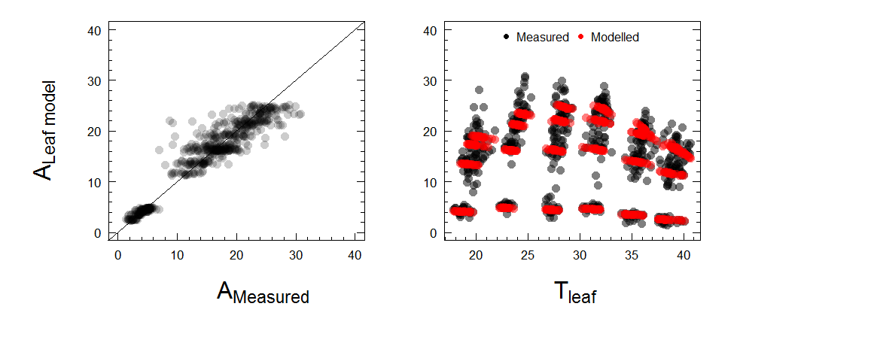

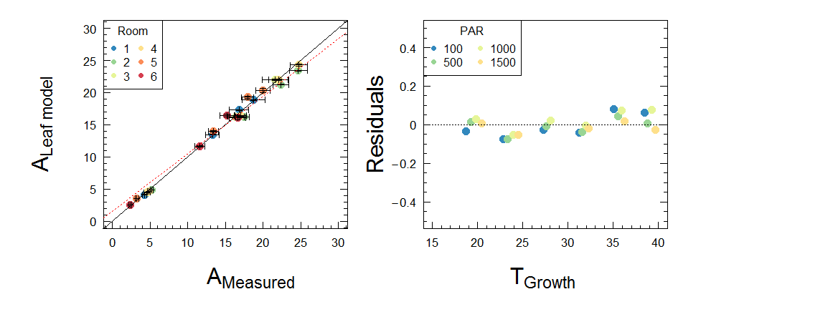

Fig2. Measured and modelled photosynthesis (problem: it under estimate photosynthesis at low PAR). The red line is the regression fit for all data points (*not the averages*) (slope=0.96; intercept=1.6 (significant) R2=0.89)

Other data needed for data assimilation model

1. Daily Leaf, Stem and Root respiration rates over the experiment period

I used leaf, stem and root respiration data measured at final harvest to calculate daily respiration rate at each growth temperature. Here, earlier I assumed Q10=2, but now Q10 also variable with growth temperature according to the simple model of Tjoelker et al 2001. 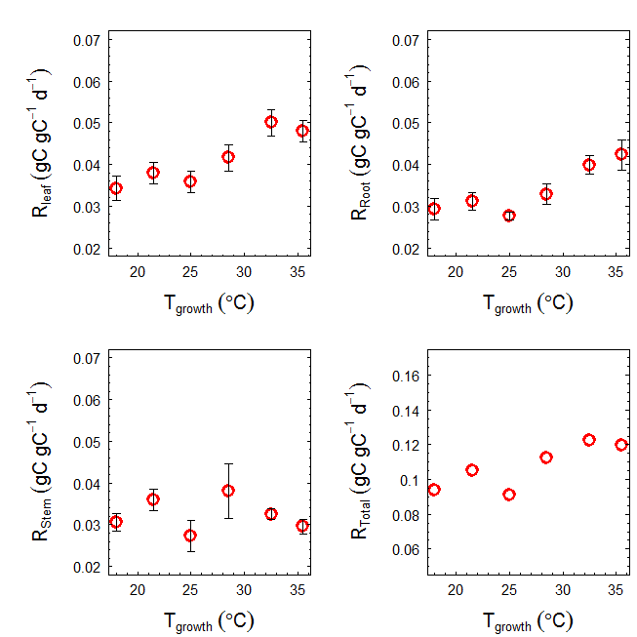

Figure 3: leaf, stem and root respiration rates measured at final harvest (mean across provenances) used to calculate maintenance respiration (Rm). Rates assumed similar across experiment period.

1. Daily leaf area, leaf, stem and root mass over the experiment period

I used harvest data at 4 time points to estimate leaf area, leaf mass, stem mass and root mass. Then I used a smooth curve fitting to get the daily biomass (leaf, stem and root) over the experiment period (see figure). Biomass assumed to be linearly increase between two time points.

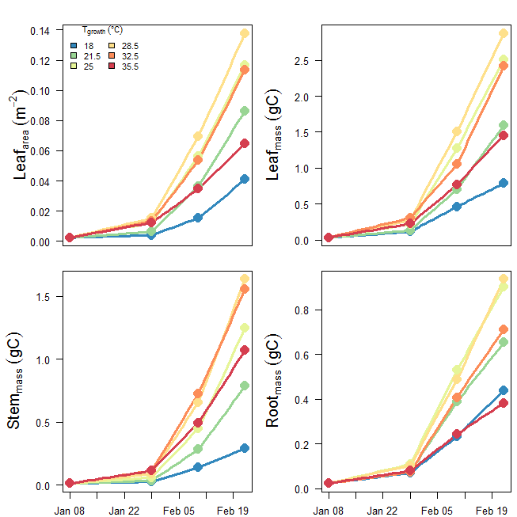

Figure 4: daily leaf area, leaf mass, stem mass and root mass over the experiment period. Solid symbols depict measurements

~~Alternative approach~~

*~~Kashif developed allometric models to calculate leaf, stem and root biomass from height and diameter data measured. So we have height & diameter measurements at five time points, so estimated biomass at each of those time point. Then I used a smooth curve fitting routine to get the daily biomass (leaf, stem and root) over the experiment period (see figure)~~*

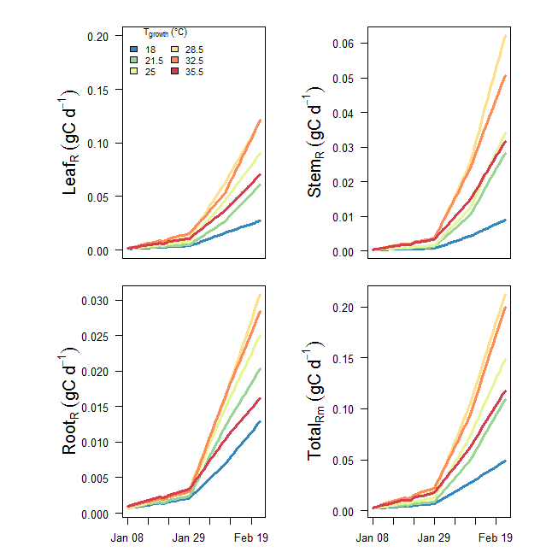

Figure 5: Estimated daily stem, root and shoot respiration over the experiment period (2016-01-08 to 2016-02-22)

Estimating the daily GPP over the experiment period

I used the above parameters (Vcmax, Jmax, alpha and g1) in Photosyn with 15 min glass house met data to calculate GPP, then summed to get the daily total. GPP estimation assumed Rday=0, hence the gross values. As we have daily leaf respiration no need to consider Rday here. Later, I corrected GPP for Rday assuming Rday=70% Rdark and 12h day light. (add 15% of Rdark to GPP)

As the Vcmax and Jmax are at their respective growth temperatures, no need of temperature dependency parameters such as Ea/deltaS.

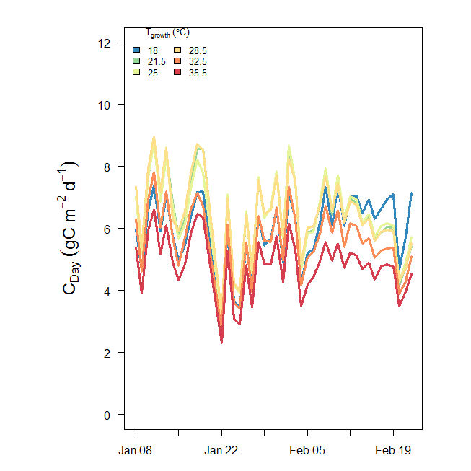

Figure 5. Modelled daily GPP for each growth temperature over experimental period (2016-01-08 to 2016-02-22)

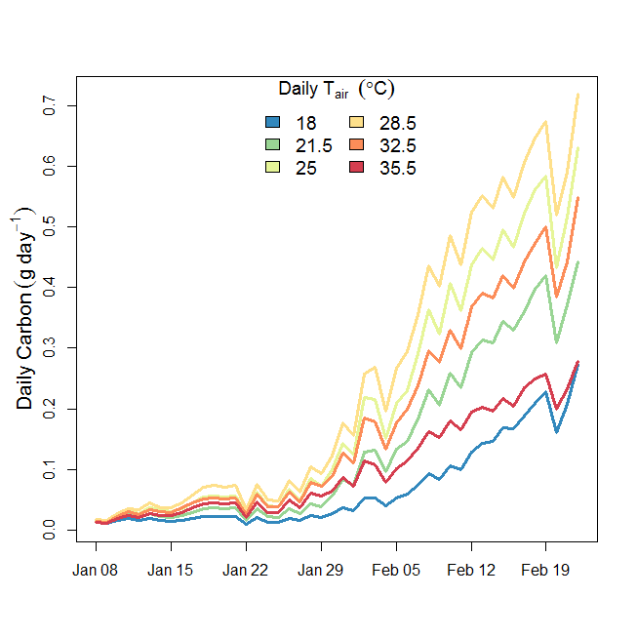

Figure 6. Modelled daily carbon for each growth temperature over experimental period (2016-01-08 to 2016-02-22). (corrected for self-shading). Self shading factor calculated for each growth temperature separately using YplantQMC.

OK. Now we have GPP, maintenance respiration (Rm), seedling mass (stem, leaf and root) over the experiment period. So we can do carbon balancing. But need a value for growth respiration (Rg). I assume Rg as 30% of the total biomass gain (i.e. final biomass-initial biomass). So theoretically,

GPP=[ $Σ$ Rm + 1.3 x (Final Biomass-Initial Biomass)] (plus any leftover GPP; NSC)

As we didn’t observe any turnover of stem or leaf, any excess can be partitioned as stored carbon NSC.

**But, we got a problem here. Not enough carbon to support growth and respiration at higher two temperatures.**

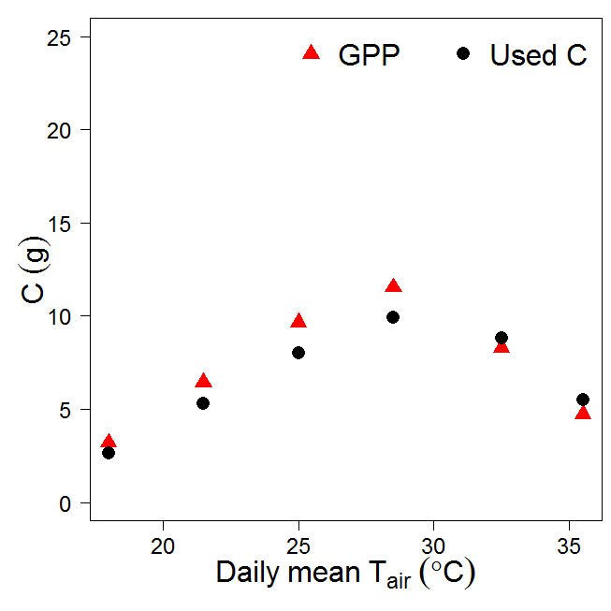

|  |  |  |  |  |  |  |  |
| --- | --- | --- | --- | --- | --- | --- | --- |
| Tair mean | Total GPP (gC) | Total Rm(gC) | Total Rg(gC) | Final Biomass (gC) | Initial Biomass (gC) | =[ $Σ$ Rm + 1.3 x (Final Biomass-Initial Biomass)] (gC) | Surplus/deficit (gC) |
| 18 | 3.20 | 0.77 | 0.44 | 1.52 | 0.07 | 2.66 | 0.55 |
| 21.5 | 6.45 | 1.46 | 0.89 | 3.03 | 0.07 | 5.31 | 1.13 |
| 25 | 9.65 | 2.07 | 1.38 | 4.66 | 0.07 | 8.03 | 1.61 |
| 28.5 | 11.53 | 2.95 | 1.61 | 5.45 | 0.07 | 9.94 | 1.59 |
| 32.5 | 8.29 | 2.80 | 1.39 | 4.68 | 0.07 | 8.80 | **-0.51** |
| 35.5 | 4.73 | 1.82 | 0.85 | 2.91 | 0.07 | 5.51 | **-0.79** |

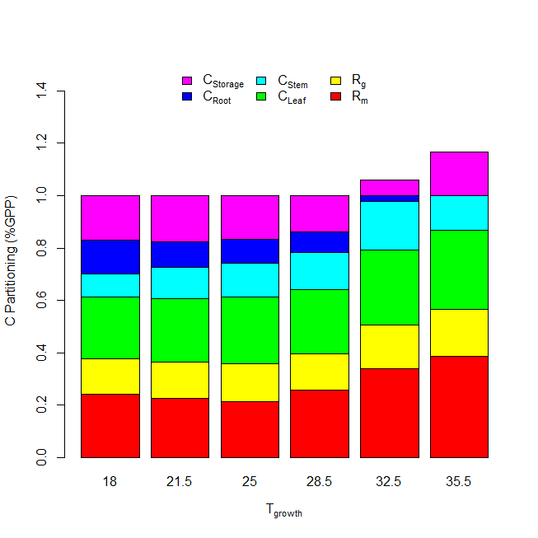

Figure 8. C-Partitioning in different components

Possible reasons for the negative C-balance at higher Tgrowth

1. Underestimation of GPP at higher growth temperatures

This is possibly not the case. Our parameters are derived from data of this experiment and they are optimized to fit for measured photosynthesis at two campaigns. But Jmax is similar for last three growth temperatures??

1. Over estimation of Respiration rates throughout the experiment.

Not much sure. I just played with reducing leaf, stem and root respiration at room 5 and 6. I have to reduce all three rates by app. 50 % to fit for the observed GPP. So this is not possible.

1. Over estimation of biomass

Not sure. I used the harvest data. However, some of the middle harvest purposly selected small seedlings, so it is possible that leaf area at this time points higher than the estimates at higher Tgrowths.

1. Erro in scalling Vcmax and Jmax over time

I tested this assuming Vcmax and Jmax estimated for campaign 1 fixed over time. It apperently overpredict biomass at rooms 1-4, but not help in rooms 5 and 6.

1. Growth respiration: assumption of 30% may not valid at higher Tgrowth.

Can data assimilation model help in correcting for growth respiration??

**from Drake et al 2017 GCB**

**Fig. S1** Environmental data observed inside six glasshouse bays at Western Sydney University in 2016. Mean daily values of air temperature (Tair; a), relative humidity (RH; b), and vapor pressure deficit (VPD; c) are shown along with hourly averages of incident photosynthetic photon flux density (PPFD; d). Six colors are shown; cool colors reflect low temperature bays while hot colors reflect high temperature bays. PPFD did not differ across bays, so we present the mean PPFD for clarity. Note that there was substantial diurnal variation in T­air­, RH, and VPD that is not evident in these plots of 24-hour averages.