**Daily Carbon gain estimations for GREAT experiment**

Data Census

|  |  |  |
| --- | --- | --- |
| Data Set | Date | Used to estimate |
| Photosynthesis at 4 light levels (100,500,1000,1500) – All Plants- Insitu | 2016/01/02 and 03  (26 ADP) | g1, alpha, Vcmax  to test model fits to all light levels |
| Photosynthesis at 2 light levels (100, 1500) – only room 2 plants – moved to other rooms and measured | 2016/01/05  (28 DAP) | g1 |
| Rdark – T curves: only room 2 plants - moved to other rooms and measured | 2016/01/11  (34 DAP) | Light respiration rate (assumed same to Rdark*0.7) Q10=2.1 |
| ACi-T curves  Warm and Cool prov. Only  Three rooms 18, 28.5 and 35.5 | 2016/01/16 – 26  (40-48 DAP) | JV ratio at growth temperatures  Vcmax25, Jmax25 and T-response parameters (but not used) |
| Photosynthesis at 4 light levels (100,500,1000,1500) – One prov. - Insitu | 2016/01/26  (48 DAP) | alpha, Vcmax  to test model fits to all light levels |
| Respiration components  (leaf, stem, roots) – measured at 25C | 2016/01/17 - 24 | Respiration rates of leaf, stem and roots at growth temperatures |
| Met Data | 15 min VPD, Tair and PPFD measured in each glasshouse room |  |

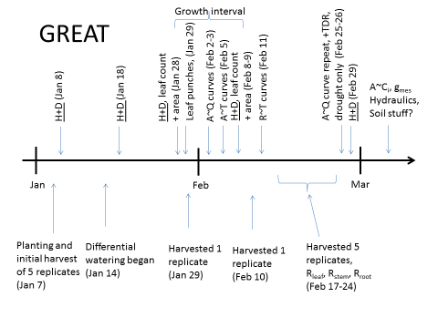

Data and parameter settings

|  |  |  |
| --- | --- | --- |
| **Parameter** | **Source** | **Remarks** |
| Vcmax, alpha and theta | Optimized to fit for the measured photosynthesis data from two campaigns. | Vcmax and Jmax linearly decrease from 2016-02-03 to 2016-02-26  Theta: mean across treatments (due to negative values in some treatments) |
| Jmax | Vcmax × JV ratio |  |
| g1 | Fitted to Photosynthesis measurements (data from in situ measurements) | Super high g1 values?? |
| Rday | Assumed 70% of the leaf respiration rates measured at final harvest | Rates fixed over time. No data to get the time dependency |
| Q10 | Based on Tjoelker et al 2001 $$Q_{10}=3.22-0.046×T_{growth}$$ |  |
| Rdark | Measurements at final harvest at 25C. Used Q10 model to scale to Tgrowth | Rates fixed over time. No data to get the time dependency |
| Biomass data | Harvest data at 4 time points. | Linear interpolation assumed to get the time course |
| Met data | 15 min Tair, VPD, PAR |  |

Fixed parameter values over time

|  |  |  |  |  |  |  |  |
| --- | --- | --- | --- | --- | --- | --- | --- |
| **Room** | **Tgrowth** | **g1** | **g1.se** | **alpha** | **alpha.se** | **theta** | **theta.se** |
| 1 | 18 | 5.53 | 0.90 | 0.31 | 0.07 | 0.30 | 0.50 |
| 2 | 21.5 | 10.73 | 0.86 | 0.34 | 0.04 | 0.59 | 0.17 |
| 3 | 25 | 10.84 | 0.73 | 0.35 | 0.07 | 0.27 | 0.52 |
| 4 | 28.5 | 10.02 | 1.75 | 0.40 | 0.06 | 0.37 | 0.32 |
| 5 | 32 | 18.25 | 1.04 | 0.31 | 0.04 | 0.54 | 0.22 |
| 6 | 35.5 | 29.04 | 4.58 | 0.30 | 0.04 | 0.61 | 0.21 |

Estimation of Vcmax, Jmax and alpha

Use non-linear regression to optimize Vcmax and alpha to fit for the measured Asat data in two campaigns. It seems that the Vcmax and Jmax estimated from ACi curves cannot reproduce Asat data we measured. Also, ACi curves only available for three growth temperatures.

It is clear that the Asat measurements at two campaigns significantly different. Room 1 plants increase their photosynthesis measurements from campaign 1 to 2 and for all other rooms a decrease observed. See the figure. This could be due to sink limitation with increasing temperature (pot effect). At lowest Temperature, plant is small, so no effect of pot size. Due to this effect, I thought that the Vcmax and Jmax too need to vary over time.

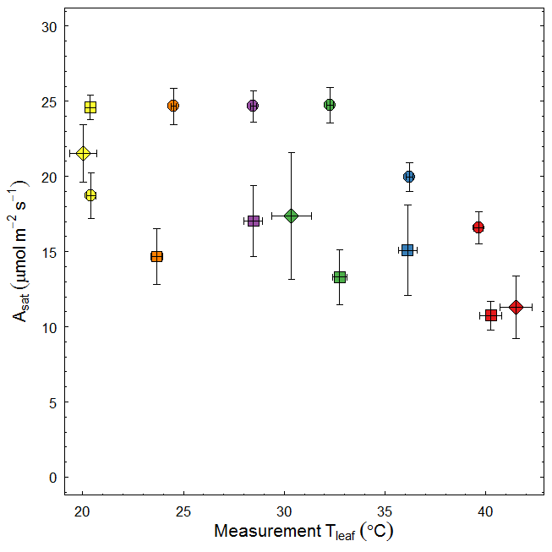

Figure: Photosynthesis vs Temperature relationship of seedlings with different age. Circles: 26 DAP (3-Feb-2016), diamonds: 40 DAP and squares: ~50 DAP (26-Feb-2016). Colours depict different growth temperatures. Data used: in-situ Asat measurements of well-watered seedlings.

I used estimated Vcmax at two time points to get the time course of Vcmax (and Jmax) as follows.

1. Jan-07 to Feb 02 -> numbers similar to Feb 3 estimates
2. Feb-04 to Feb-25 -> linear decrease assumed
3. Feb-26 to Feb-29 -> numbers similar to Feb 26 estimates
4. Jmax:Vcmax ratio assumed to be fixed over time.

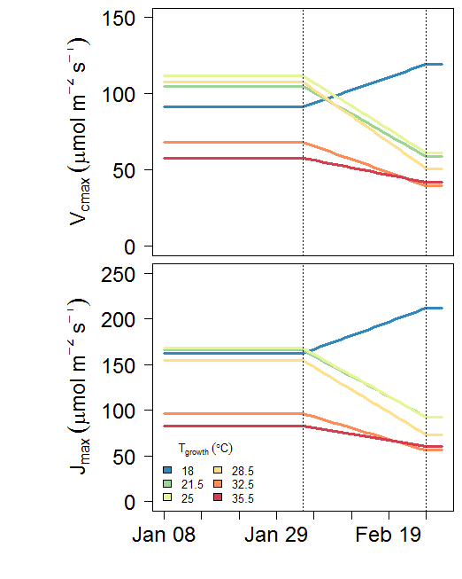

Fig1. Vcmax and Jmax at 25C over the experiment period.

Test the model against measured photosynthesis. It should be clear that the model performs well in all light levels (low vs high)

Try A-Q data in Campaign 1 (2016/02/03)

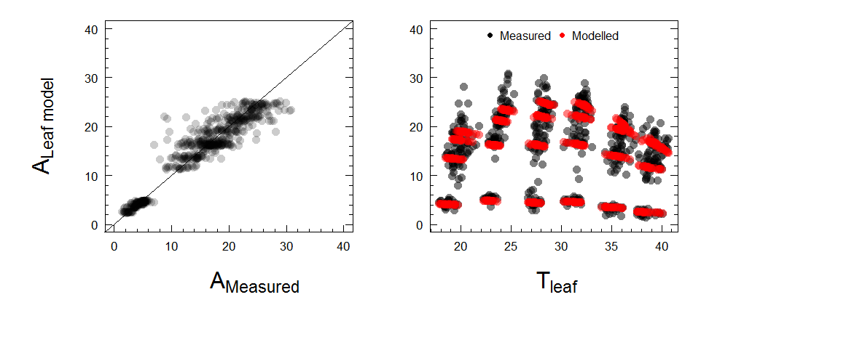

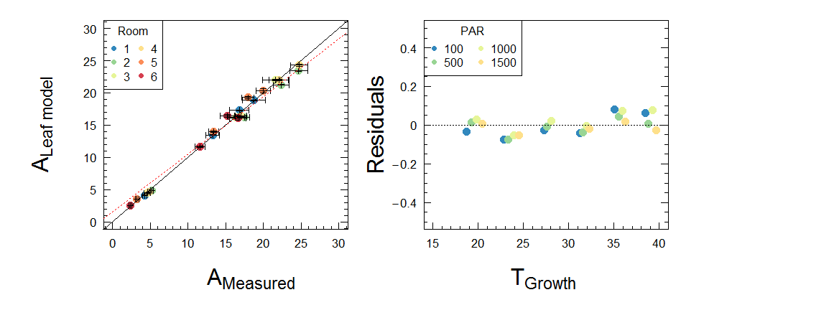

Fig2. Measured and modelled photosynthesis (problem: it under estimate photosynthesis at low PAR). The red line is the regression fit for all data points (*not the averages*) (slope=0.96; intercept=1.6 (significant) R2=0.89)

Other data needed for data assimilation model

1. Daily Leaf, Stem and Root respiration rates over the experiment period

I used leaf, stem and root respiration data measured at final harvest to calculate daily respiration rate at each growth temperature. Here, earlier I assumed Q10=2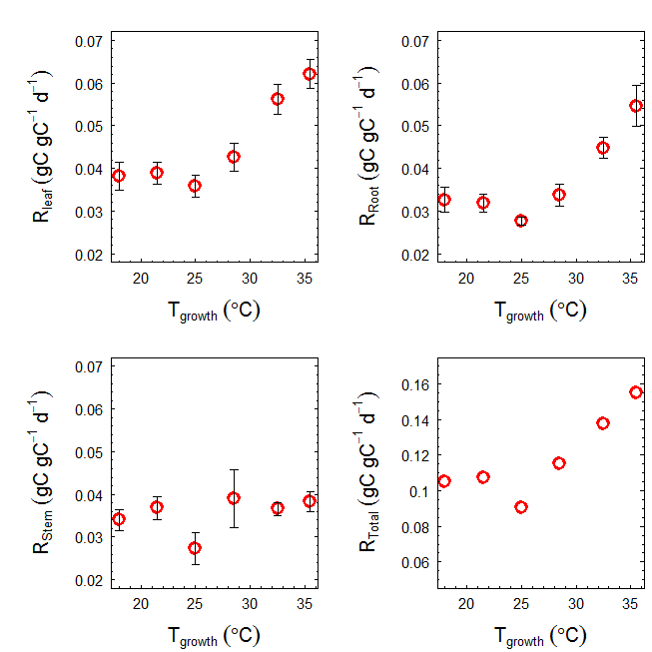

Figure 3: leaf, stem and root respiration rates measured at final harvest (mean across provenances) used to calculate maintenance respiration (Rm). Rates assumed similar across experiment period.

1. Daily leaf area, leaf, stem and root mass over the experiment period

I used allometric models to estimate leaf area, leaf mass, stem mass and root mass. Then I used a smooth curve fitting to get the daily biomass (leaf, stem and root) over the experiment period (see figure).

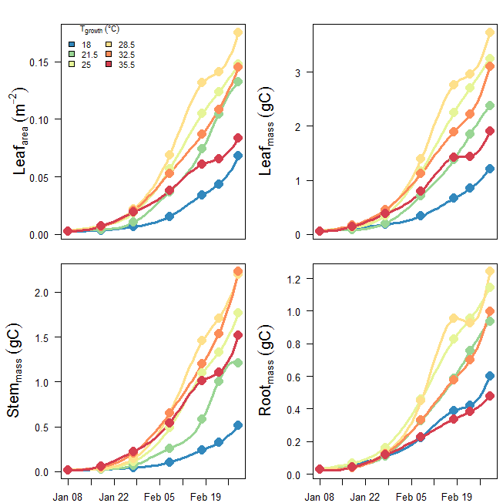

Figure 4: daily leaf area, leaf mass, stem mass and root mass over the experiment period. Solid symbols depict measurements

~~Alternative approach~~

*~~Kashif developed allometric models to calculate leaf, stem and root biomass from height and diameter data measured. So we have height & diameter measurements at five time points, so estimated biomass at each of those time point. Then I used a smooth curve fitting routine to get the daily biomass (leaf, stem and root) over the experiment period (see figure)~~*

Leaf, stem and root maintenance respiration

Measured rates of leaf, stem and root respiration rates at 25C are available for each growth temperature. I used this rates to calculate respiration rates of each component at 15 min interval using 15 min met data and assuming Q10 = 2. During day time (PAR>2 µmon m-2 s-1), leaf respiration reduced by 30% to account for light inhibition of Rdark.

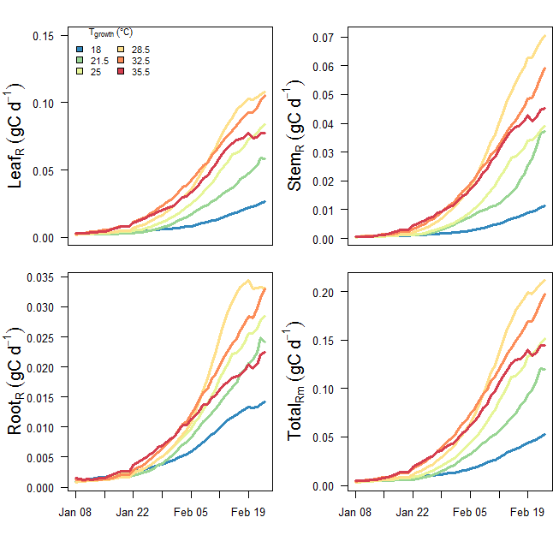

Figure 5: Estimated daily stem, root and shoot respiration over the experiment period (2016-01-08 to 2016-02-22)

Estimating the daily GPP over the experiment period

I used the above parameters (Vcmax, Jmax, alpha and g1) in Photosyn with 15 min glass house met data to calculate GPP, then summed to get the daily total. GPP estimation assumed Rday=0, hence the gross values.

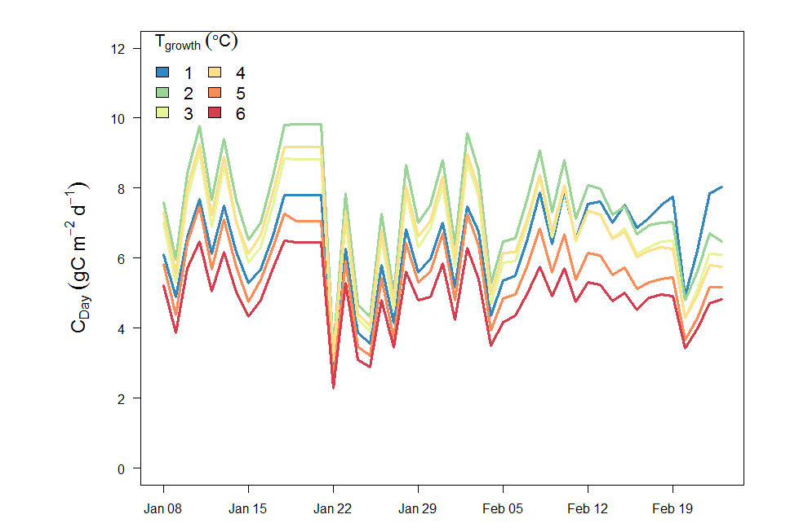

Figure 5. Modelled daily GPP for each growth temperature over experimental period (2016-01-08 to 2016-02-22)

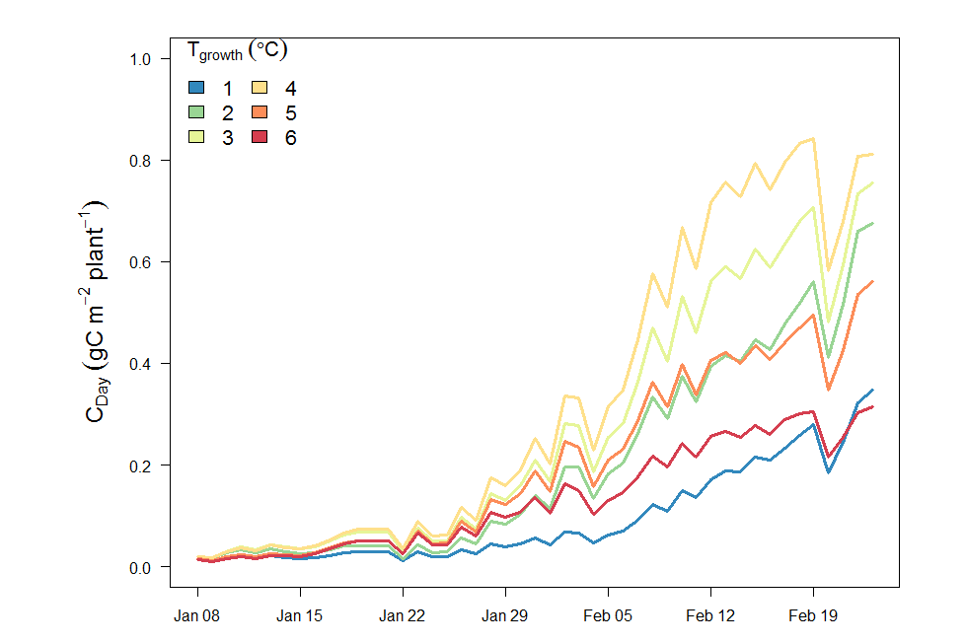

Figure 6. Modelled daily carbon for each growth temperature over experimental period (2016-01-08 to 2016-02-22). (corrected for self-shading). Self shading factor calculated for each growth temperature separately using YplantQMC.

OK. Now we have GPP, maintenance respiration (Rm), seedling mass (stem, leaf and root) over the experiment period. So we can do carbon balancing. But need a value for growth respiration (Rg). I assume Rg as 30% of the total biomass gain (i.e. final biomass-initial biomass).

GPP=[ $Σ$ Rm + 1.3 x (Final Biomass-Initial Biomass)] (plus any leftover GPP; NSC)

As we didn’t observe any turnover of stem or leaf, any excess can be partitioned as stored carbon NSC.

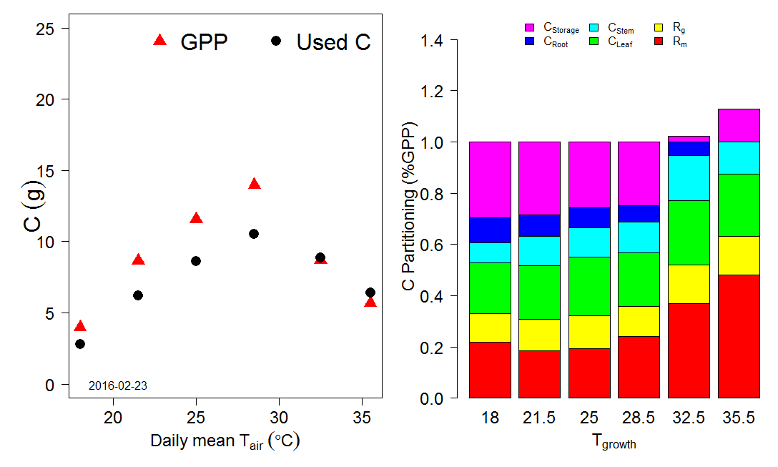

Figure 8. C-Partitioning in different components

Diurnal variation of photosynthesis and daily carbon gain in plants in a typical sunny and cloudy day

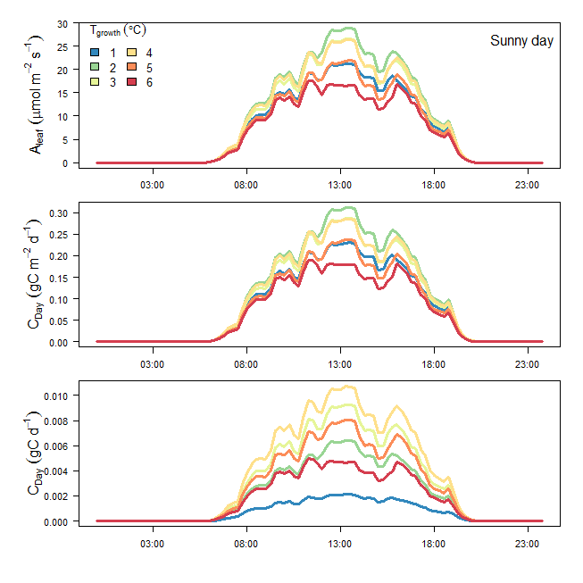

Figure 9. Diurnal variation of photosynthesis and daily carbon gain in plants in a typical sunny and

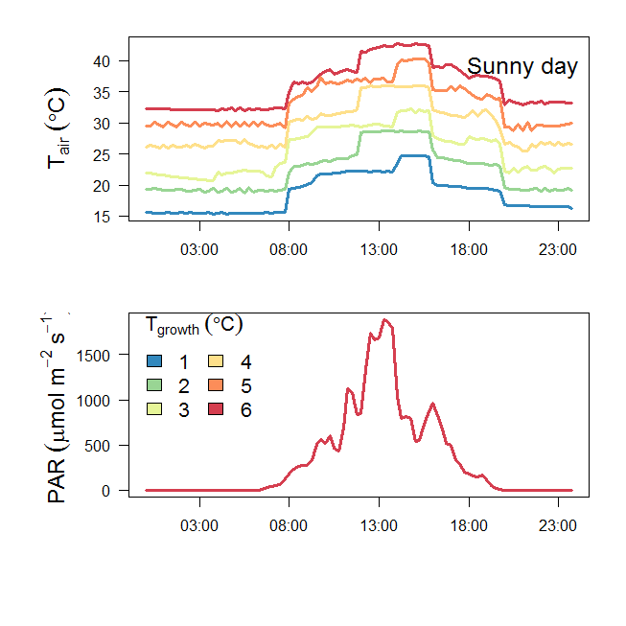

Figure 10. 15 min interval met data (Tair and PAR) in a sunny day

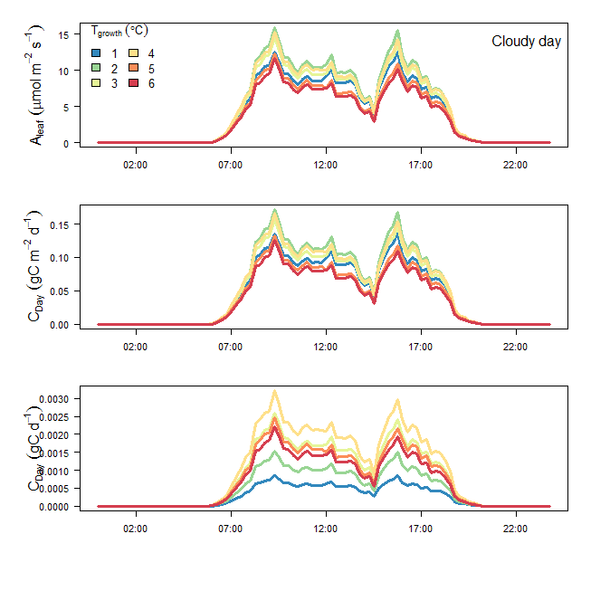

Figure 11 Diurnal variation of photosynthesis and daily carbon gain in plants in a typical cloudy day

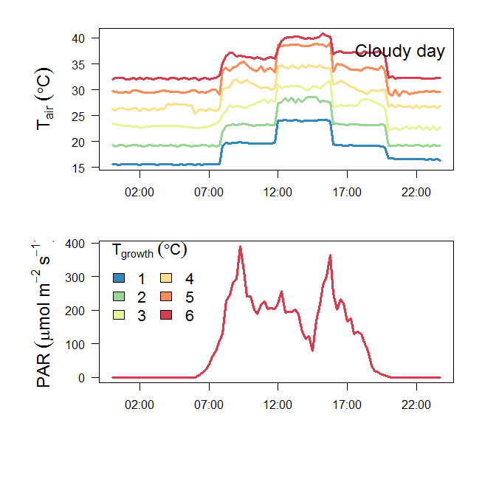

Figure 12. 15 min interval met data (Tair and PAR) in a cloudy day

Environmental data observed inside six glasshouse bays at Western Sydney University in 2016. Mean daily values of air temperature (Tair; a), relative humidity (RH; b), and vapor pressure deficit (VPD; c) are shown along with hourly averages of incident photosynthetic photon flux density (PPFD; d). Six colors are shown; cool colors reflect low temperature bays while hot colors reflect high temperature bays. PPFD did not differ across bays, so we present the mean PPFD for clarity. Note that there was substantial diurnal variation in T­air­, RH, and VPD that is not evident in these plots of 24-hour averages.