1. Login API to get token which will be used in subsequent APIs:

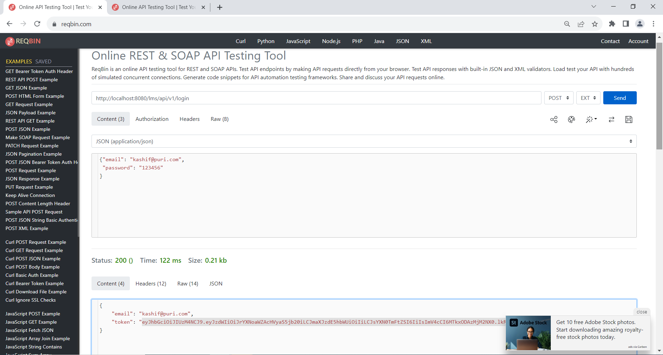

1. Books api is called to list available books, token is passed in header:

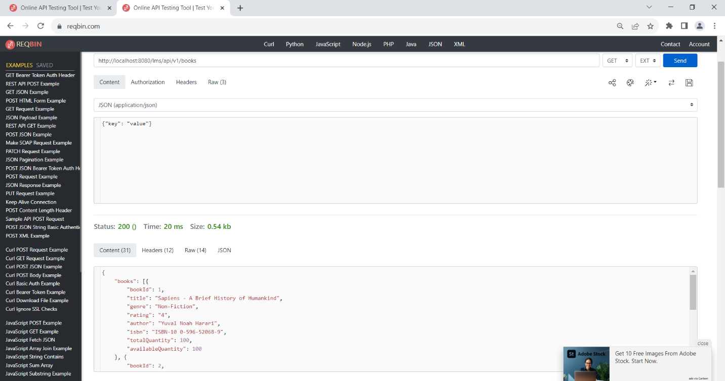

1. Adding a book:

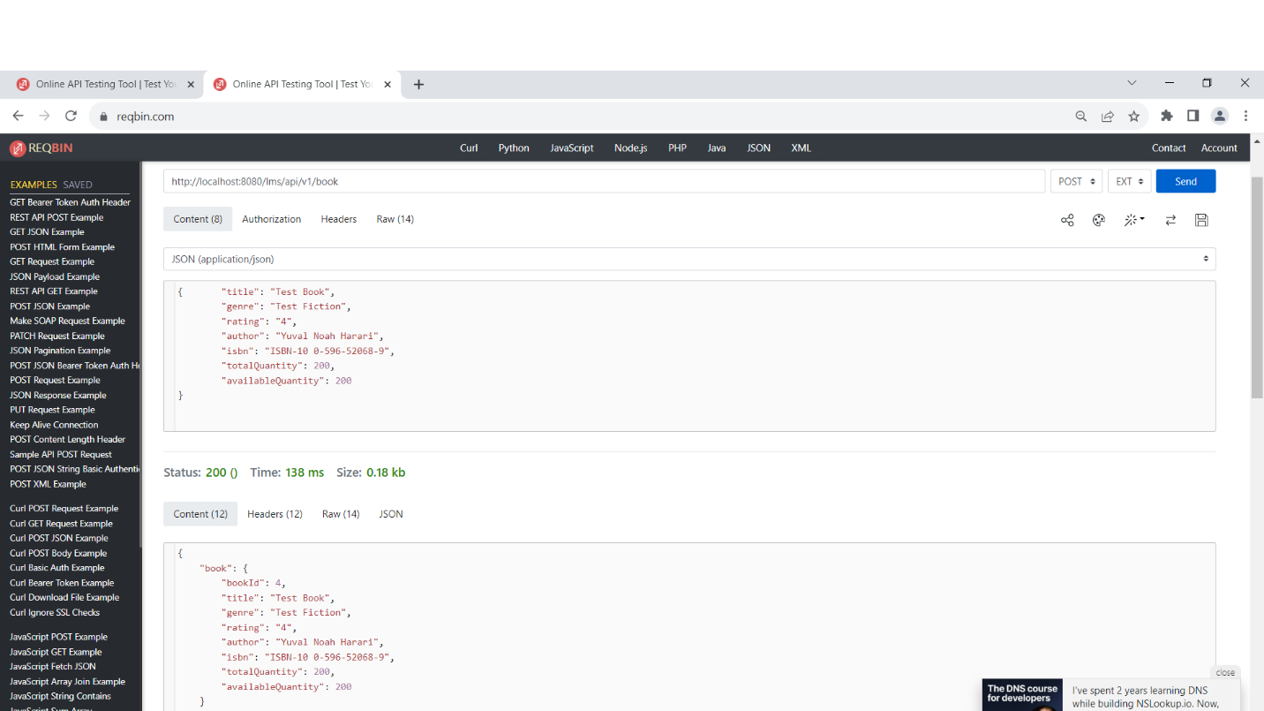

1. Listing book again to see the newly added:

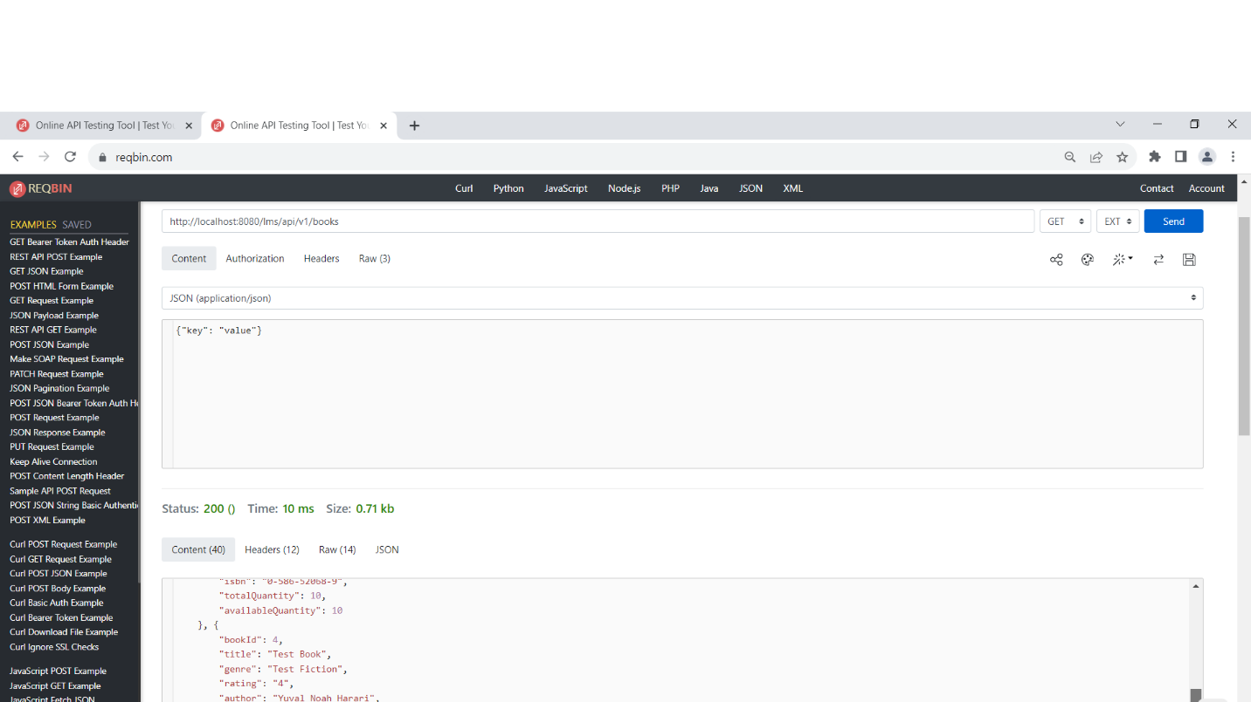

1. Updated Book:

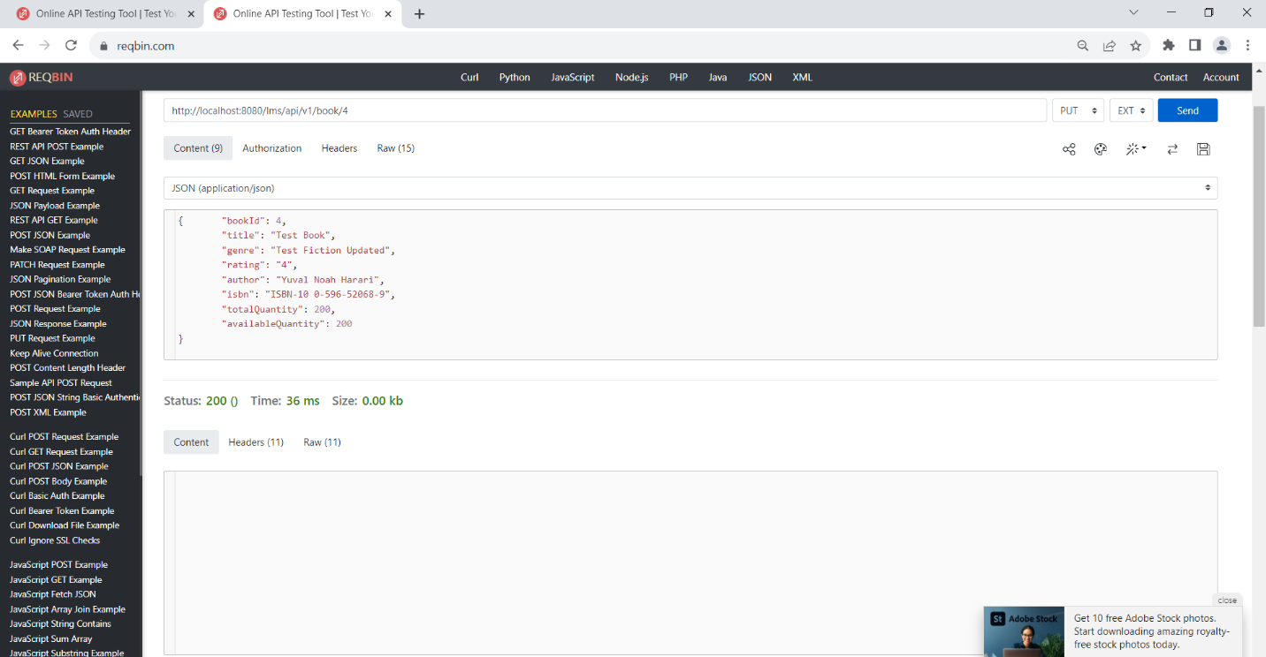

1. Listing book again to see the updated one:

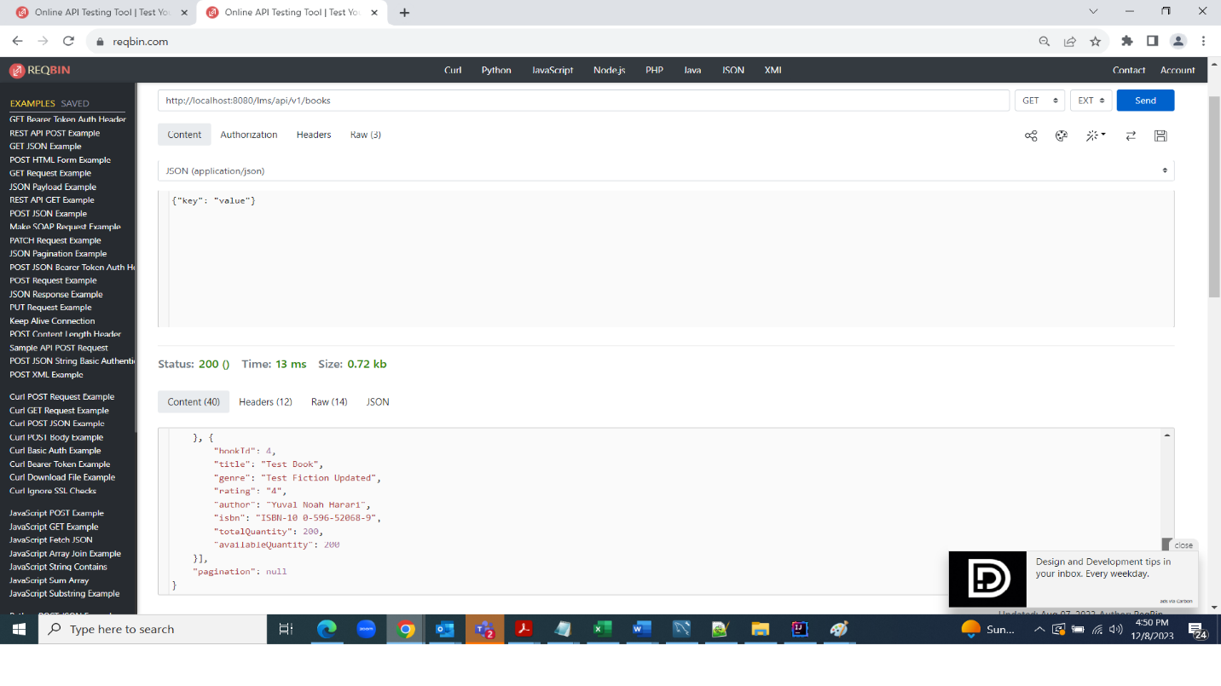

1. Deleting Book:

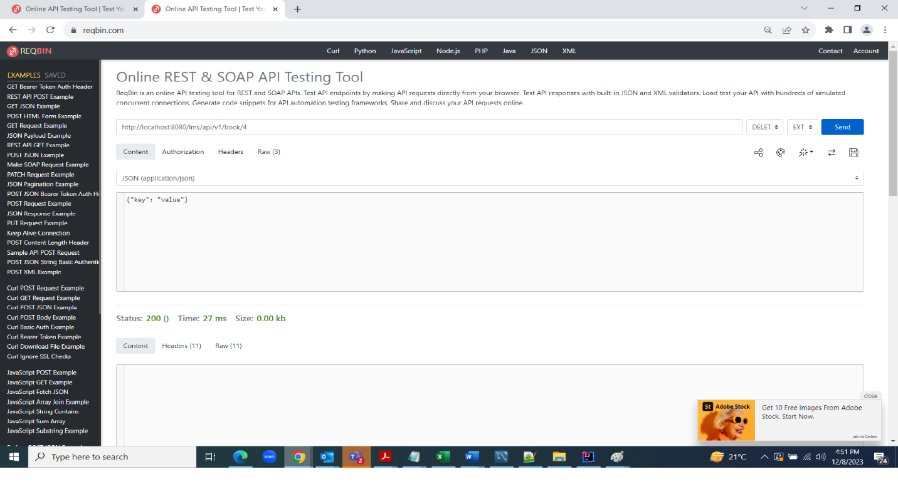

1. Listing book again to see if deleted one is removed (4th one is no more):

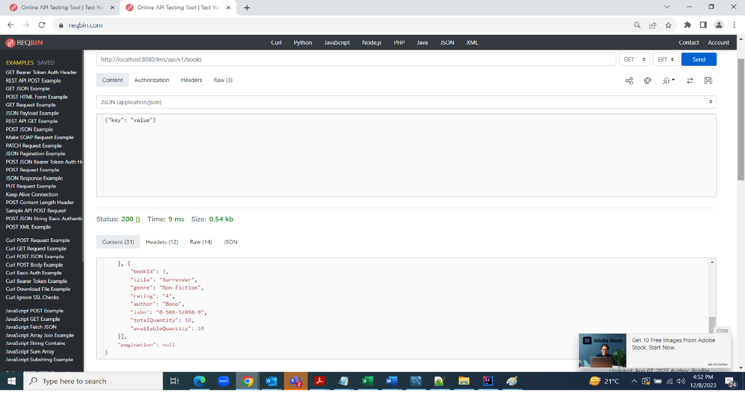

1. Listing patrons:

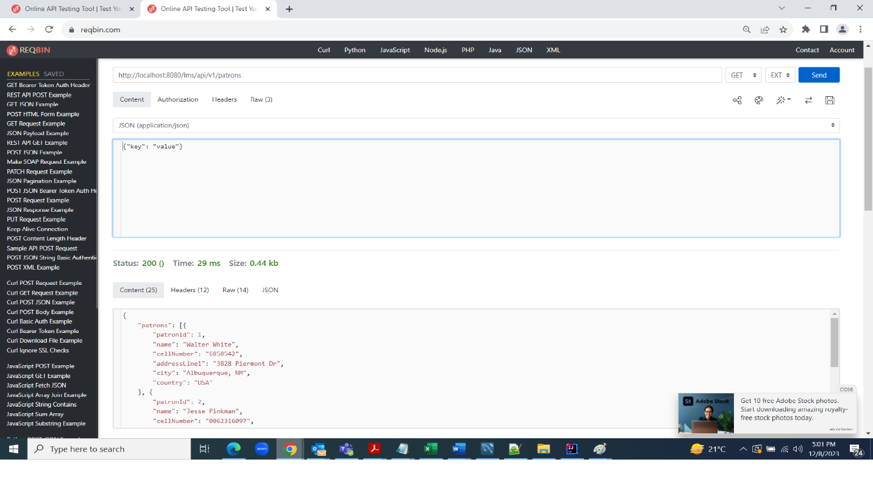

1. Adding patron:

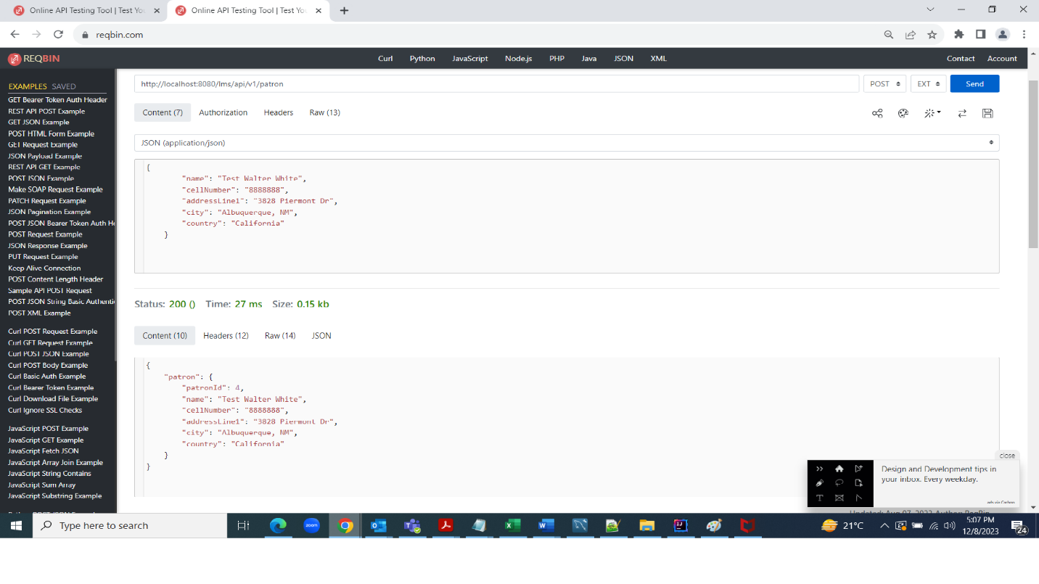

1. Listing patrons again to see newly added:

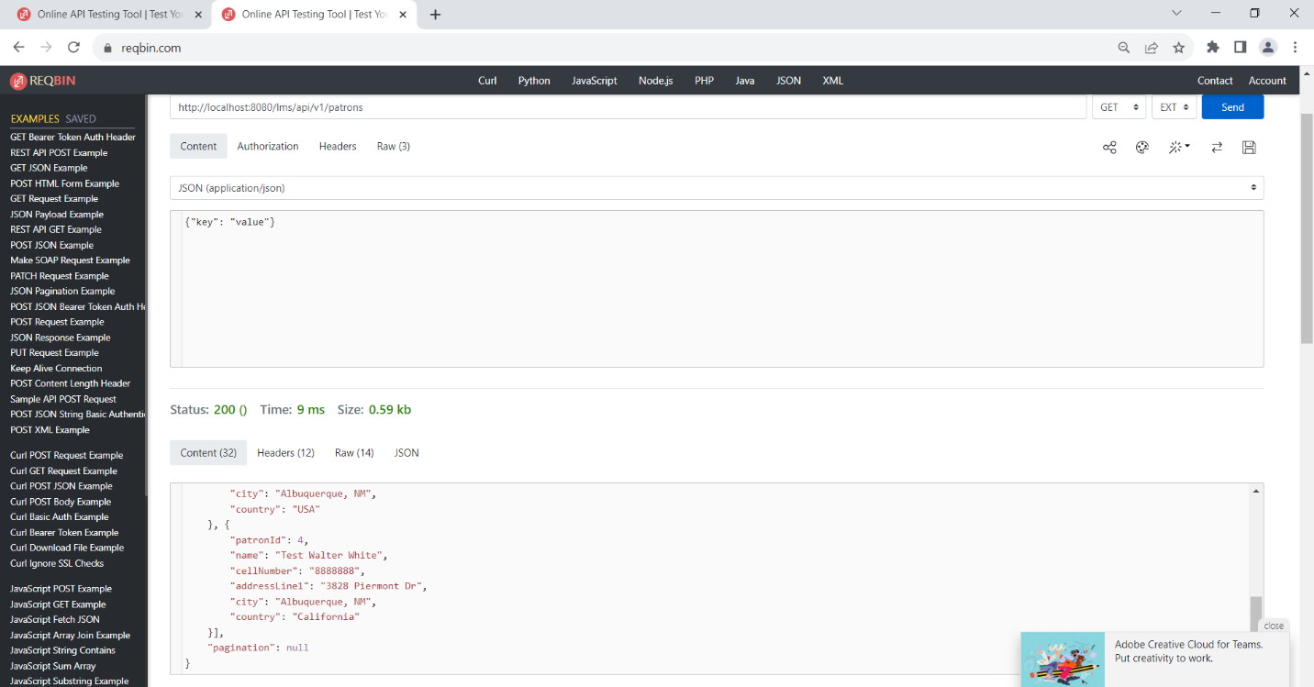

**Patron update and delete works in same manner as above demonstrated for book.**

1. Creating transaction while borrowing a book:

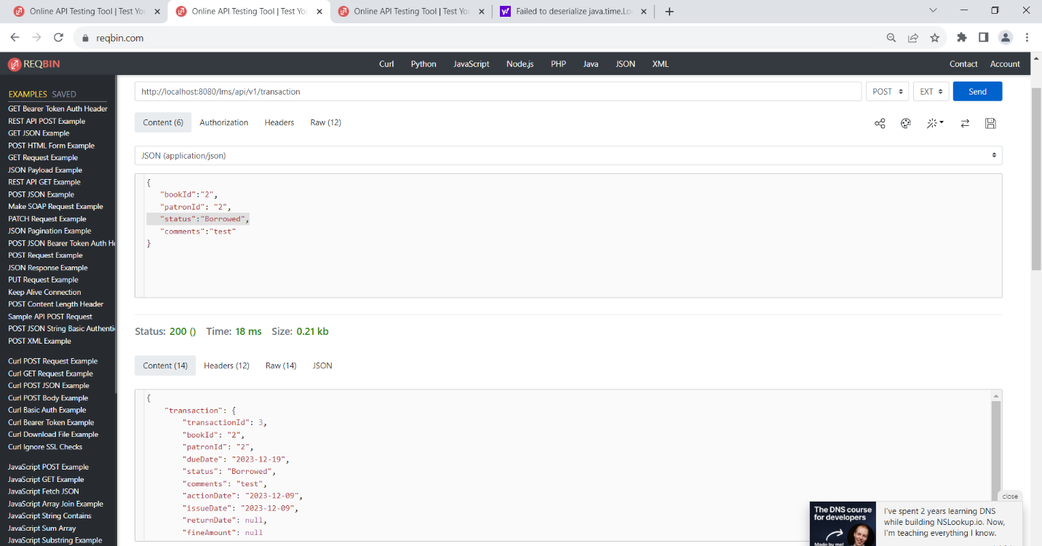

1. Borrowed bookId 2 three times and see the available quantity is reduced:

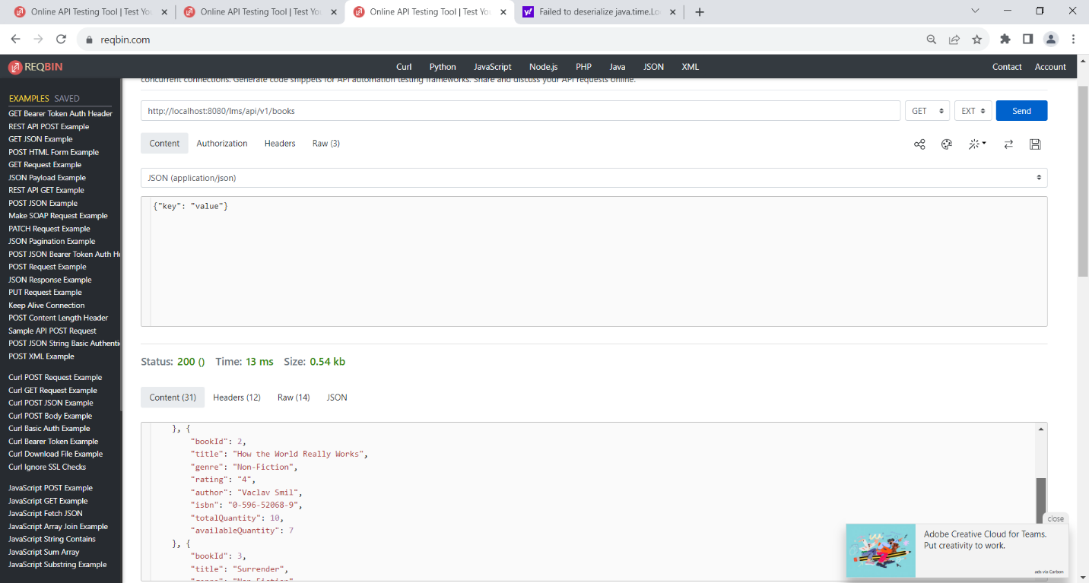

1. Returned book id 2 using put method and quantity is increased:

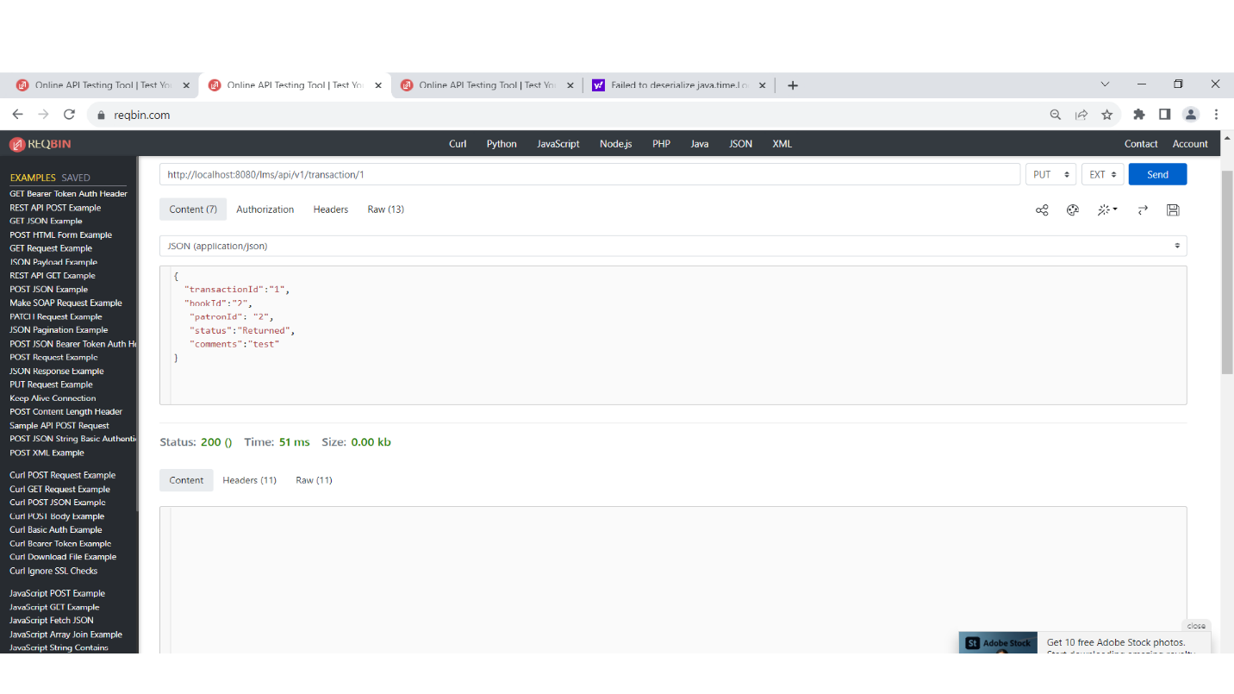

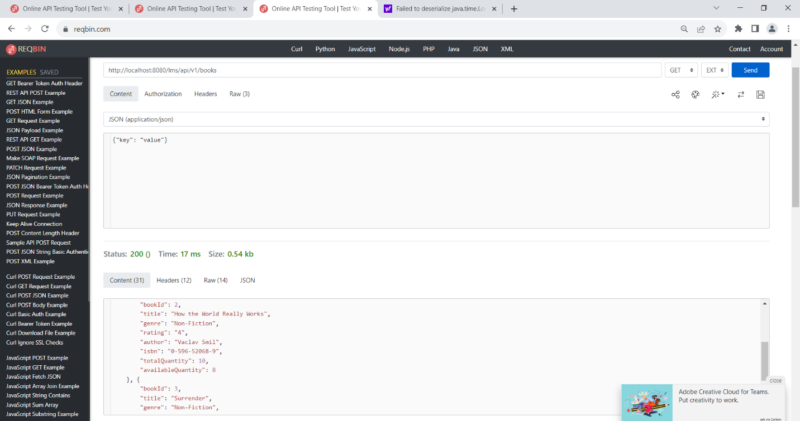

1. Transaction listing:

