UNIT–1: INTRODUCTION TO PYTHON
1. What is Python?
Python is a high-level, interpreted, and general-purpose programming language created by Guido van Rossum in 1991. It is known for its simple syntax, readability, and ease of learning. Python supports multiple programming paradigms such as procedural, object-oriented, and functional programming. It is dynamically typed, meaning variable types are determined at runtime. Python is widely used in web development, data science, artificial intelligence, automation, and software development. It has a large standard library and strong community support.
Code Examples:
print("Hello, Python")
x = 10
y = 20
print(x + y)
print(type(x))

2. Why Python & What Python Can Do?
Theory:
Python is chosen because it reduces development time and increases productivity. Its simple English-like syntax makes it beginner-friendly. Python can automate repetitive tasks, build websites, analyze data, develop machine learning models, and create games. It is platform-independent, meaning Python programs can run on Windows, Linux, and macOS. Python supports integration with other languages like C, C++, and Java. It is open-source and free to use.
Code Examples:
print("Automation with Python")
print(5 * 10)
import mathprint(math.sqrt(25))

3. Python Syntax Compared to Other Languages
Theory:
Python syntax is simpler compared to languages like C, C++, and Java. It does not use semicolons or curly braces. Python uses indentation to define blocks of code. Variable declaration is not required explicitly. Code is shorter and more readable. This reduces syntax errors and improves maintainability.
Code Comparison:
C Language
int a = 5;
printf("%d", a);
Python
a = 5
print(a)

4. Key Differences Between Python 2 and Python 3
Theory:
Python 2 uses print as a statement, while Python 3 uses it as a function. Python 3 supports Unicode by default, whereas Python 2 does not. Division behavior differs in both versions. Python 2 reached end-of-life in 2020. Python 3 is more secure, faster, and actively maintained. Python 3 has better library support.
Feature | Python 2 | Python 3
Print | Statement | Function
Unicode | Limited | Default
Division | Integer | Float

5. Environment Variable in Python Installation
Theory:
Environment variables tell the operating system where Python is installed. Setting the PATH variable allows Python to run from the command prompt. Without it, Python commands will not work globally. It helps in running Python scripts from any directory. Environment variables improve system-wide accessibility. They are set during or after installation.
Command Example:
python --version

6. Python Shell vs IDLE
Theory:
Python Shell is a command-line interface used to execute Python commands interactively. IDLE is Python’s built-in Integrated Development Environment. Shell executes one command at a time. IDLE allows writing, saving, and debugging scripts. IDLE is beginner-friendly and provides syntax highlighting.
Feature | Shell | IDLE
Interface | Command line | GUI
File Save | No | Yes
Debugging | No | Yes

7. Compiler vs Interpreter
Theory:
A compiler translates the entire program at once, while an interpreter translates line by line. Python is an interpreted language. Interpreters detect errors during execution. Compilers produce faster execution after compilation. Interpreted languages are easier to debug. Python uses an interpreter to execute code.
Flow Diagram:
Source Code
↓
Interpreter
↓
Output

8. IDEs and Code Editors for Python
Theory:
IDEs provide complete development tools like debugging, syntax highlighting, and auto-completion. Popular Python IDEs include PyCharm, VS Code, Spyder, and Jupyter Notebook. Code editors are lightweight tools mainly for writing code. IDEs improve productivity and reduce errors. Beginners prefer IDLE or VS Code.
Examples:
PyCharm
VS Code
Jupyter Notebook
Spyder

9. How to Choose an IDE for Python
Theory:
Choose an IDE based on project size and experience level. Beginners should choose simple IDEs like IDLE or VS Code. Data scientists prefer Jupyter Notebook. Web developers prefer PyCharm. IDEs should support debugging and extensions. Performance and system compatibility also matter.

PRACTICAL ACTIVITY

Write Your Name Using print()
print("My name is Ahmed")

LU-3: EXECUTE PYTHON SYNTAX

Python Variables
Theory:
Variables store data values in Python. They do not require explicit data type declaration. Variable names must start with a letter or underscore. Python variables are case-sensitive. Values can be changed during execution. Python uses dynamic typing.
Examples:
x = 10
name = "Ali"
price = 25.5
print(x, name, price)

Python Keywords
Theory:
Keywords are reserved words in Python with predefined meanings. They cannot be used as variable names. Examples include if, else, for, while, True, False. Keywords control program structure. Python provides around 35 keywords.
Example:
import keyword
print(keyword.kwlist)

Python Data Types
Theory:
Data types define the type of data stored in variables. Common types include int, float, string, list, tuple, set, and dictionary. Python automatically assigns data types. Data types help in memory management. They determine allowed operations.
Examples:
a = 10
b = 3.14
c = "Python"
print(type(a), type(b), type(c))

Numeric Types in Python
Theory:
Numeric data types include int, float, and complex. Integers store whole numbers. Floats store decimal values. Complex numbers have real and imaginary parts. These types support mathematical operations. Numeric types are widely used in calculations.
Examples:
x = 5
y = 2.5
z = 2 + 3j
print(x, y, z)

Python Boolean
Theory:
Boolean represents True or False values. It is used in decision-making. Boolean expressions compare values. They are commonly used with if conditions. Boolean results control program flow.
Examples:
a = 10
b = 5
print(a > b)
print(a == b)

Python Operators
Theory:
Operators perform operations on values. Arithmetic operators include +, -, *, /. Comparison operators compare values. Logical operators combine conditions. Assignment operators assign values. Operators are essential for expressions.
Examples:
a = 5
b = 10
print(a + b)
print(a > b)
print(a and b)

PRACTICAL ACTIVITY
a = 5
b = 10
print(a + b)

PYTHON STRINGS

String Syntax
Theory:
Strings are sequences of characters enclosed in quotes. Python supports single, double, and triple quotes. Strings are immutable. They support indexing and slicing. Strings are widely used in text processing.
Examples:
s = "Python"
print(s)
print(s[0])

String Methods
Examples:
text = "python"
print(text.upper())
print(text.lower())
print(text.capitalize())

String Slicing & Negative Indexing
s = "Python"
print(s[1:4])
print(s[-1])
print(s[-3:])

String Concatenation
Practical Activity:
s = "favo"
t = "rite"
print(s + t)

LU-5: CONTROL STRUCTURES (IF STATEMENT)

IF Statement
Theory:
The if statement is used for decision-making. It executes code when a condition is true. Conditions use logical operators. Indentation defines the block. Python also supports if-else and elif. It improves program logic.
Syntax:
if condition:
statement
Flow Diagram:
Start
↓Condition?
↓ Yes
Print Message
↓End

PRACTICAL ACTIVITY
score = 56
if score > 50:
print("You have passed the exams")

LU-6: CONTROL STRUCTURES – ELIF & IF-ELSE

1. ELIF Statement
Theory:
The elif (short for "else if") statement in Python allows you to check multiple conditions sequentially. If the first if condition fails, Python checks the elif condition. If none of the conditions are true, an optional else block can execute. This structure is useful when there are more than two possible outcomes. Proper indentation is required to define blocks. ELIF helps in making programs readable and avoids nested if statements. Logical operators like >, <, == are often used with ELIF conditions.
Syntax:
if condition1:
# execute block1elif condition2:
# execute block2else:
# execute block3
Flow Diagram:
Start
↓
Condition1 True?
↓ Yes → Execute Block1 → End
↓ No
Condition2 True?
↓ Yes → Execute Block2 → End
↓ No → Execute Else Block → End
Practical Activity:
score = 56if score > 50:
print("You have Passed")elif score > 40:
print("You have Failed but Keep Trying!")else:
print("Better luck next time")

2. IF-ELSE Statement
Theory:
The if-else statement is used to execute one block of code if a condition is true and another block if it is false. It simplifies decision-making with only two possible outcomes. Nested if-else allows multiple layers of decision-making. The pass statement is used as a placeholder for future code. Indentation is important. Logical operators can be used to make complex conditions. This structure is foundational for Python programming.
Practical Activity:
score = 56if score > 50:
print("You Loss")else:
print("You Win")
Example of Nested IF-ELSE with pass:
a = 10
b = 20if a > b:
print("a is greater")else:
if a == b:
pass # Future code can be added here
else:
print("b is greater")

LU-8: LISTS IN PYTHON
Theory:
Lists are ordered, mutable collections in Python that can store multiple items of different data types. Items are enclosed in square brackets []. Lists support indexing, slicing, and negative indexing. You can add, remove, or modify elements. Built-in methods like append(), insert(), pop(), and remove() make lists versatile. Lists are widely used in data storage and manipulation. Length of the list can be determined using len().
Examples:
# Declaration
FruitBasket = ["apple", "banana", "cherry"]
# Access elementsprint(FruitBasket[0]) # appleprint(FruitBasket[-1]) # cherry
# Modify element
FruitBasket[1] = "mango"print(FruitBasket)
# List methods
FruitBasket.append("kiwi")print(FruitBasket)
Practical Activity:
FruitBasket = ["apple", "banana", "cherry"]print(FruitBasket[1]) # Output: banana

LU-9: TUPLES IN PYTHON
Theory:
Tuples are ordered and immutable collections in Python. Items are enclosed in parentheses (). Once created, elements cannot be changed. Tuples support indexing, slicing, and negative indexing. Tuples are faster than lists and are used for fixed data. You can access elements, find length, and use tuple methods like count() and index(). Tuples are useful for data integrity and performance.
Examples:
# Declaration
FruitBasket = ("apple", "banana", "cherry", "kiwi", "melon", "mango")
# Access elementsprint(FruitBasket[0]) # appleprint(FruitBasket[-1]) # mango
# Slicingprint(FruitBasket[2:5]) # ('cherry', 'kiwi', 'melon')
# Tuple methodsprint(FruitBasket.count("apple"))print(FruitBasket.index("kiwi"))
Practical Activity:
FruitBasket = ("apple", "banana", "cherry", "kiwi", "melon", "mango")print(FruitBasket[-1]) # Output: mango

LU-10: SETS IN PYTHON
Theory:
Sets are unordered collections of unique items in Python, defined using curly braces {}. Sets do not support indexing or slicing. Sets are mutable, meaning items can be added or removed. They are useful for removing duplicates and performing mathematical operations like union, intersection, and difference. Built-in methods include add(), remove(), pop(), and clear(). Sets are widely used for membership testing and eliminating repeated elements.
Examples:
# Declaration
FruitBasket = {"apple", "banana", "cherry", "kiwi", "melon", "mango"}
# Loop through setfor fruit in FruitBasket:
print(fruit)
# Add and remove items
FruitBasket.add("orange")
FruitBasket.remove("banana")
print(FruitBasket)
Practical Activity:
FruitBasket = {"apple", "banana", "cherry", "kiwi", "melon", "mango"}
for fruit in FruitBasket:
print(fruit)

LU-11: DICTIONARIES IN PYTHON
Theory:
Dictionaries are unordered, mutable collections of key-value pairs in Python. Keys must be unique, and values can be any data type. Dictionaries are enclosed in curly braces {}. Items can be accessed using their keys. They support methods like keys(), values(), items(), get(), and update(). Nested dictionaries allow hierarchical data storage. Dictionaries are widely used in real-world applications like JSON data handling.
Examples:
# Declaration
MyCar = {"brand": "Ford", "model": "Mustang", "year": 1964}
# Access valueprint(MyCar["model"]) # Mustangprint(MyCar.get("brand"))
# Modify value
MyCar["year"] = 2020
print(MyCar)
# Add new key-value pair
MyCar["color"] = "Red"
print(MyCar)
# Nested dictionary
MyCars = {
"car1": {"brand": "Ford", "model": "Mustang"},
"car2": {"brand": "Toyota", "model": "Corolla"}
}
print(MyCars["car2"]["model"])
Practical Activity:
MyCar = {"brand": "Ford", "model": "Mustang", "year": 1964}
print(MyCar["model"]) # Output: Mustang

LU-12: WHILE LOOP STRUCTURE

1. WHILE Loop
Theory:
The while loop in Python repeatedly executes a block of code as long as a given condition is true. It is a pre-tested loop, meaning the condition is checked before the loop body runs. You must initialize a counter or control variable before the loop. Use the break statement to exit the loop prematurely. The continue statement skips the current iteration and continues with the next one. Python allows an optional else block to execute when the condition becomes false. While loops are powerful for repetitive tasks but can lead to infinite loops if the condition never becomes false.
Syntax:
while condition:
# statements
# increment or update counterelse:
# optional statements executed when loop ends
Flow Diagram:
Start
↓Check Condition
↓ True → Execute Loop Body → Increment Counter → Back to Condition
↓ False → Execute Else (if exists) → End
Examples:
# Simple while loop
count = 1while count <= 5:
print("Count is", count)
count += 1
# Using break
count = 1while count <= 5:
if count == 3:
break
print(count)
count += 1
# Using continue
count = 0while count < 5:
count += 1
if count == 3:
continue
print(count)
# While with else
count = 1while count <= 3:
print("Count:", count)
count += 1else:
print("Loop ended")
Practical Activity:
FruitBasket = ["apple", "banana", "cherry"]
i = 0while i < len(FruitBasket):
x = FruitBasket[i]
print(x)
i += 1

LU-13: FOR LOOP STRUCTURE

1. FOR Loop
Theory:
The for loop in Python is used to iterate over a sequence (list, string, tuple, dictionary, or range). It executes the loop body for each item in the sequence. You can use break to exit early and continue to skip an iteration. The range() function allows looping over a sequence of numbers with custom start, stop, and step. for loops can be nested to iterate over multi-dimensional structures. The optional else block executes if the loop completes normally. The pass statement acts as a placeholder.
Syntax:
for item in sequence:
# statementselse:
# optional
Flow Diagram:
Start
↓Get Next Item
↓ Item exists? → Execute Loop Body → Back to Get Next
↓ No → Execute Else → End
Examples:
# Loop through a list
fruits = ["apple", "banana", "cherry"]for fruit in fruits:
print(fruit)
# Loop through a stringfor char in "Python":
print(char)
# Using range()for i in range(2, 15, 3):
print(i**2)
# Using breakfor i in range(5):
if i == 3:
break
print(i)
# Using continuefor i in range(5):
if i == 2:
continue
print(i)
Practical Activity:
for i in range(2, 16, 3):
print(i**2)

LU-14: FUNCTIONS IN PYTHON

1. Functions
Theory:
Functions in Python are reusable blocks of code designed to perform a specific task. They allow modular programming, improve readability, and reduce repetition. Functions can take input parameters (arguments) and optionally return a value using return. Python supports default parameters, keyword arguments, arbitrary arguments (*args), and arbitrary keyword arguments (**kwargs). Recursion allows a function to call itself. Lambda functions provide a compact way to write simple functions. The pass statement can be used as a placeholder in function bodies.
Syntax:
def function_name(parameters):
# statements
return value # optional
Flow Diagram:
Start
↓Call Function
↓Execute Function Body
↓Return Value (if any)
↓End
Examples:
# Simple functiondef greet():
print("Hello, Python!")
greet()
# Function with parameterdef square(x):
return x**2
print(square(5))
# Function with default parameterdef multiply(a, b=2):
return a*bprint(multiply(5)) # Uses default b=2
print(multiply(5,3)) # b=3
# Function with arbitrary argumentsdef add(*numbers):
return sum(numbers)
print(add(5, 10, 15))
# Lambda function
square = lambda x: x*5
print(square(5))
print(square(9))
print(square(10))
Practical Activity:
def My_Function(x):
return 5 * x
print(My_Function(5))
print(My_Function(9))
print(My_Function(10))

1. What is Data Science?
Theory:
Data Science is an interdisciplinary field that extracts meaningful insights from structured and unstructured data. It combines techniques from statistics, computer science, and domain expertise. Data Science is used to identify patterns, make predictions, and support decision-making. It plays a critical role in AI by providing data-driven models. Applications include healthcare, finance, e-commerce, and social media. Data Science uses processes like data collection, cleaning, analysis, and visualization.
Practical Activity – Data Architecture Diagram:
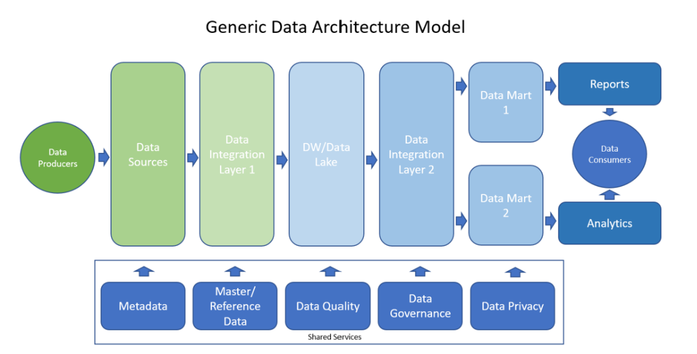

2. Applications of Data Science in AI
Theory:
Data Science enables AI systems to learn from data using machine learning algorithms. AI applications like chatbots, recommendation systems, fraud detection, and autonomous vehicles rely on Data Science. Data Science helps preprocess data, select features, and train models. AI cannot function without high-quality data, making Data Science an integral part. Data Science also aids in predictive modeling and optimization tasks.
Examples:
Predicting customer behavior on e-commerce platforms
Identifying diseases from medical images
Stock market forecasting

3. Types of Data Scientist
Theory:
There are several types of Data Scientists:
Data Engineer: Designs and manages data pipelines and architecture.
Data Analyst: Interprets data and generates insights using visualization.
Machine Learning Engineer: Builds predictive models using ML algorithms.
Research Scientist: Conducts experiments and research in AI and data modeling.
Application:
Data Analysts: Generate reports for business decisions
ML Engineers: Deploy AI systems like recommendation engines
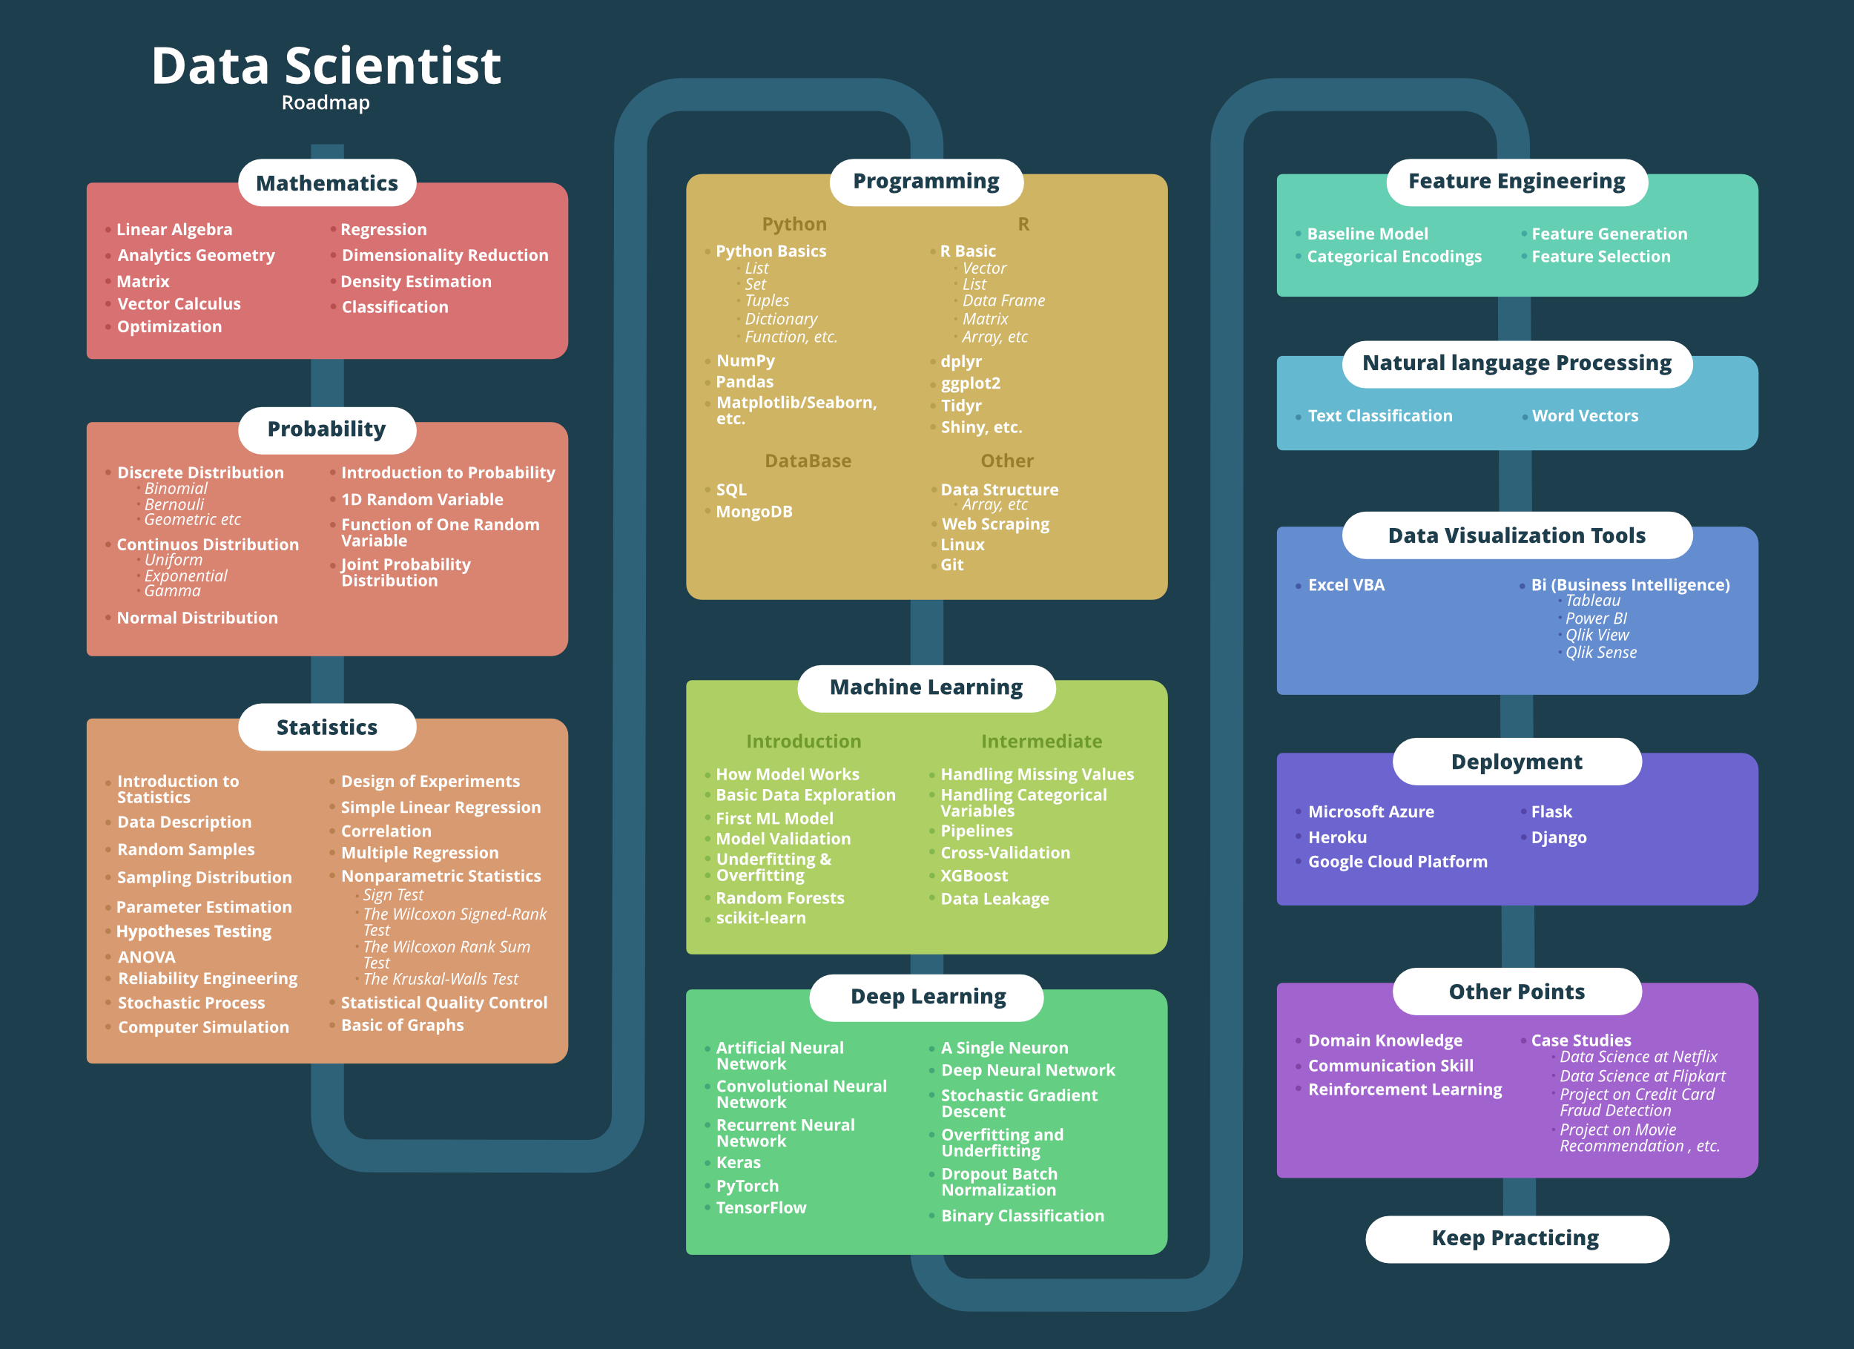

4. Problems Solved by Data Science
Theory:
Data Science can solve various problems:
Predictive problems: Forecasting sales, stock prices
Classification problems: Spam detection, disease diagnosis
Clustering problems: Customer segmentation, market analysis
Recommendation problems: Movie or product recommendations

5. Data Analytics & Architecture
Theory:
Data Analytics: Process of examining data to extract insights. Techniques include descriptive, diagnostic, predictive, and prescriptive analytics.
Data Architecture: The framework that defines data collection, storage, processing, and usage. Helps ensure efficient handling of big data.

LU-2: TOOLS FOR DATA SCIENCE

1. Data Wrangling & Acquisition
Theory:
Data Wrangling involves cleaning and transforming raw data into usable formats. Acquisition is the process of collecting data from multiple sources: databases, CSV, Excel, APIs, web scraping. Sources can be structured, semi-structured, or unstructured.
Examples:
# Using pandas to read Excel data
import pandas as pd
data = pd.read_excel("sales.xlsx")
print(data.head())

2. Types of Data
Theory:
Structured Data: Organized in tables (rows & columns) – e.g., SQL databases
Semi-Structured Data: Partially organized – e.g., JSON, XML
Unstructured Data: Free-form data – e.g., images, videos, text

3. Data Formats & Analysis
Theory:
Common data formats: CSV, JSON, XML, SQL databases. Data analysis involves statistical methods, visualization (charts, graphs), and Excel usage. Data visualization helps identify patterns and trends for decision-making.
Examples:
# Basic visualization with matplotlibimport matplotlib.pyplot as plt
sales = [100, 150, 200]
months = ['Jan', 'Feb', 'Mar']
plt.plot(months, sales)
plt.show()

LU-3: APPLICATIONS OF DATA SCIENCE

1. Data Science in Different Sectors
Theory:
Data Science has widespread applications:
Healthcare: Predict diseases, analyze patient data
Sports: Analyze player performance, strategies
E-commerce (Amazon): Product recommendations, customer behavior
Streaming (Netflix): Movie recommendation, user engagement
Market Analysis: Identify trends, customer segmentation
Practical Activity – Mind Map (Health Care):
Data Science in Health Care
|
+-------------+--------------+
| | |
Predictive Diagnosis Personalized Treatment
Analytics Analysis Patient Monitoring

LU-4: CHARACTERISTICS OF DATA SCIENCE

1. The Three V’s of Data Science
Theory:
Data Science is characterized by the Three V’s:
Volume: Large amounts of data generated daily
Velocity: Speed at which data is generated and processed
Variety: Different types of data – structured, semi-structured, unstructured
Practical Activity – V’s Diagram:
Data Science
+-----+-----+
| | |
Volume Velocity Variety

LU-5: CHALLENGES OF DATA SCIENCE

1. Key Challenges
Theory:
Data Science faces challenges such as:
Data Acquisition: Collecting high-quality data
High Volume & Velocity: Handling large, fast-moving data
Information Storage & Analytics: Efficient storage and processing
Data Security & Privacy: Protecting sensitive information
High Variety & Veracity: Ensuring data consistency and reliability
Ethics: Proper handling and interpretation of data
Practical Activity – Data Acquisition Process Diagram:
Raw Data Sources
↓
Data Collection
↓
Data Cleaning
↓
Data Transformation
↓
Data Storage
↓
Data Analysis
↓
Insights/Decision

LU-6: DOMAINS OF DATA SCIENCE

Domains of Data Science
Data Science is an interdisciplinary field that relies on several core domains to extract meaningful insights from data. These domains ensure that data can be collected, processed, analyzed, and visualized effectively. Statistics provides methods to summarize and interpret data accurately. Data Engineering focuses on designing pipelines and architecture for storing and processing data efficiently. Visualization enables representing data graphically to identify patterns and trends easily. Advanced Computing involves using high-performance computing, machine learning, and AI algorithms to handle complex datasets. Together, these domains form the backbone of modern Data Science projects.

2. Importance of Each Domain
Domain | Purpose / Importance
Statistics | Helps summarize, interpret, and infer insights from raw data.
Data Engineering | Ensures efficient collection, storage, and preprocessing of large-scale data.
Visualization | Allows graphical representation of data for easy interpretation and decision-making.
Advanced Computing | Supports large-scale computation, AI/ML models, and predictive analytics.

3. Practical Activity – Diagram of Domains
Domains of Data Science
|
+--------------+--------------+
| | |
Statistics Data Engineering Visualization
|
Advanced Computing
Description of Diagram:
Statistics: Provides the foundation for data analysis.
Data Engineering: Builds pipelines for data storage and processing.
Visualization: Converts data into graphs, charts, and dashboards.
Advanced Computing: Enables AI/ML, big data analysis, and predictive modeling.

LU-7: PROCESS FLOW OF DATA SCIENCE

1. Process Flow of Data Science
The process flow of Data Science is a structured approach to solving real-world problems using data. It begins with identifying the problem statement, which defines what needs to be solved. Next, the Machine Learning (ML) algorithm suitable for the problem is chosen based on the data type and objective. The selected algorithm is then implemented on the dataset, which may require preprocessing, feature selection, and splitting into training/testing sets. After modeling, the results are analyzed and visualized using graphs and charts to communicate insights effectively. Finally, the insights are used for decision-making or predictions. This flow ensures systematic and reproducible analysis in Data Science projects.

2. Steps in Data Science Process
Step | Description
1. Problem Statement | Define the objective of the analysis (e.g., predict rain based on weather data).
2. Choose ML Algorithm | Select an algorithm (e.g., Logistic Regression, Decision Tree) suitable for prediction or classification.
3. Implement Algorithm | Prepare the dataset and train the model using the selected algorithm.
4. Analyze & Visualize | Evaluate the results and use visualizations like scatter plots, line charts, or ROC curves.

3. Practical Activity – Logistic Regression Plot
Theory:
Logistic Regression is used to predict binary outcomes (e.g., Yes/No, True/False). In this example, it predicts whether it will rain (Yes) or not (No) based on temperature and humidity.
Python Example:
# Import librariesimport pandas as pdimport matplotlib.pyplot as pltfrom sklearn.linear_model import LogisticRegression
# Sample dataset
data = pd.DataFrame({
'Temperature': [30, 25, 28, 22, 35, 20, 18, 33],
'Humidity': [70, 80, 75, 90, 60, 85, 95, 65],
'Rain': [1, 1, 1, 1, 0, 1, 1, 0] # 1 = Rain, 0 = No Rain
})
# Features and target
X = data[['Temperature', 'Humidity']]
y = data['Rain']
# Train logistic regression model
model = LogisticRegression()
model.fit(X, y)
# Predict probability
data['Rain_Prob'] = model.predict_proba(X)[:, 1]
# Plot probability of rain
plt.scatter(data['Temperature'], data['Humidity'], c=data['Rain'], cmap='bwr', s=100)
plt.xlabel('Temperature')
plt.ylabel('Humidity')
plt.title('Logistic Regression: Rain Prediction')
plt.colorbar(label='Rain Probability')
plt.show()

4. Process Flow Diagram of Data Science
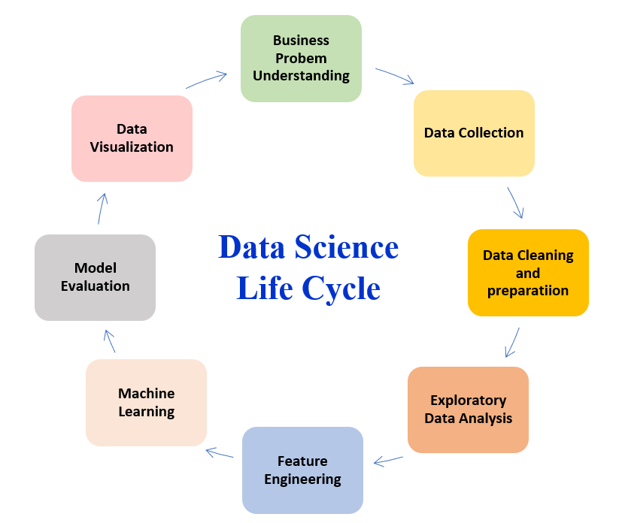
Description:
Problem Statement: Defines the objective
Algorithm Selection: Choose ML approach
Implementation: Train/test model
Visualization: Communicate findings

LU-1: NUMPY LIBRARY

1. Overview of NumPy
Theory (6–7 lines):
NumPy (Numerical Python) is a fundamental Python library for scientific computing. It provides support for multidimensional arrays and matrices, along with a collection of mathematical functions to perform operations on these arrays efficiently. NumPy is highly optimized for speed compared to Python’s native lists. Its features include array indexing, slicing, broadcasting, and linear algebra operations. Structured arrays allow working with complex datasets. NumPy is widely used in data analysis, machine learning, and AI projects.

2. Key Features
Feature | Description
Arrays | Multidimensional, homogeneous data structures
Indexing & Slicing | Access and modify specific elements or sections of arrays
Mathematical Operations | Add, subtract, multiply, divide, and perform statistical functions
Sorting | Built-in methods to sort arrays efficiently
Structured Arrays | Handle datasets with named fields and heterogeneous types

3. Practical Activity – NumPy Operations
Code Example:
# Import NumPy libraryimport numpy as np
# Create a NumPy array
A = np.array([2, 3, 5, 11, 3, 45])
# Basic mathematical operations
print("Sum:", np.sum(A))
print("Mean:", np.mean(A))
print("Max:", np.max(A))
print("Min:", np.min(A))
# Indexing and slicingprint("First element:", A[0])print("Last two elements:", A[-2:])
# Sorting array
sorted_A = np.sort(A)
print("Sorted Array:", sorted_A)

LU-1: PANDAS LIBRARY

1. Overview of Pandas
Theory (6–7 lines):
Pandas is a Python library used for data manipulation and analysis. It provides DataFrame and Series objects, which are highly efficient for handling structured data. Pandas allows importing data from multiple sources, handling missing values, combining datasets, and performing operations on rows and columns. It supports filtering, sorting, grouping, and visualization integration. Pandas is widely used in data preprocessing, cleaning, and analysis for machine learning and AI projects.

2. Key Features
Feature | Description
DataFrame & Series | Table-like and 1D data structures for easy data access
Data Import | Read from CSV, Excel, SQL, JSON, etc.
Data Cleaning | Handle missing data, duplicates, and formatting
Data Manipulation | Filter, sort, append, remove, and reposition data
Integration | Works seamlessly with NumPy, Matplotlib, and Scikit-learn

3. Practical Activity – Pandas Operations
Code Example:
# Import pandas libraryimport pandas as pd
# Load IRIS dataset
url = "https://raw.githubusercontent.com/mwaskom/seaborn-data/master/iris.csv"
iris = pd.read_csv(url)
# Show first 5 rowsprint(iris.head())
# Append a new row
new_row = {'sepal_length':5.1,'sepal_width':3.5,'petal_length':1.4,'petal_width':0.2,'species':'setosa'}
iris = iris.append(new_row, ignore_index=True)
# Remove a column
iris.drop('petal_width', axis=1, inplace=True)
# Reposition column
cols = list(iris.columns)
cols.insert(0, cols.pop(cols.index('species')))
iris = iris[cols]
print(iris.head())

LU-2: MATPLOTLIB LIBRARY

1. Overview of Matplotlib
Theory (6–7 lines):
Matplotlib is a Python library used for data visualization. It can create 2D plots like line plots, scatter plots, bar charts, and histograms, as well as 3D plots. Matplotlib helps in understanding data distribution, trends, and relationships visually. Histograms allow analyzing frequency, while density and contour plots show patterns in data. Multiple subplots allow comparing multiple datasets simultaneously. It integrates seamlessly with Pandas and NumPy.

2. Key Features
Feature | Description
Line & Scatter Plots | Show relationships between variables
Bar & Pie Charts | Represent categorical data visually
Histograms | Show distribution of data
Density & Contour Plots | Represent data density and levels
3D Plotting | Visualize three-dimensional data
Subplots | Plot multiple charts in one figure

3. Practical Activity – Matplotlib Plot
Code Example:
# Import matplotlibimport matplotlib.pyplot as pltimport pandas as pd
# Load IRIS dataset
url = "https://raw.githubusercontent.com/mwaskom/seaborn-data/master/iris.csv"
iris = pd.read_csv(url)
# Bar plot of species count
species_count = iris['species'].value_counts()
species_count.plot(kind='bar', color=['red','green','blue'])
plt.title("Count of Each Iris Species")
plt.xlabel("Species")
plt.ylabel("Count")
plt.show()

LU-3: KERAS LIBRARY

1. Overview of Keras
Theory (6–7 lines):
Keras is a high-level Python library used for building and training deep learning models. It provides a simple interface to define neural networks, compile models, train on data, and evaluate performance. Keras supports loading standard datasets like MNIST, preprocessing inputs and labels, defining model architecture, and using activation functions. Models can be trained using optimizers and loss functions. Keras integrates seamlessly with TensorFlow as a backend and is beginner-friendly for AI and deep learning tasks.

2. Key Features
Feature | Description
Model Architecture | Define layers and neurons for deep learning
Data Preprocessing | Scale and normalize input data, encode labels
Model Compilation | Specify optimizer, loss function, and metrics
Model Training | Fit the model on training data
Model Evaluation | Evaluate performance on test data
Dataset Integration | Load datasets like MNIST, CIFAR-10

3. Practical Activity – Keras Example
Code Example:
# Import Keras librariesfrom keras.datasets import mnistfrom keras.models import Sequentialfrom keras.layers import Dense, Flattenfrom keras.utils import to_categorical
# Load MNIST dataset
(X_train, y_train), (X_test, y_test) = mnist.load_data()
# Pre-process data
X_train = X_train / 255.0
X_test = X_test / 255.0
y_train = to_categorical(y_train)
y_test = to_categorical(y_test)
# Define model architecture
model = Sequential([
Flatten(input_shape=(28,28)),
Dense(128, activation='relu'),
Dense(10, activation='softmax')
])
# Compile model
model.compile(optimizer='adam', loss='categorical_crossentropy', metrics=['accuracy'])
# Fit model
model.fit(X_train, y_train, epochs=5, batch_size=32)
# Evaluate model
loss, accuracy = model.evaluate(X_test, y_test)
print("Test Accuracy:", accuracy)

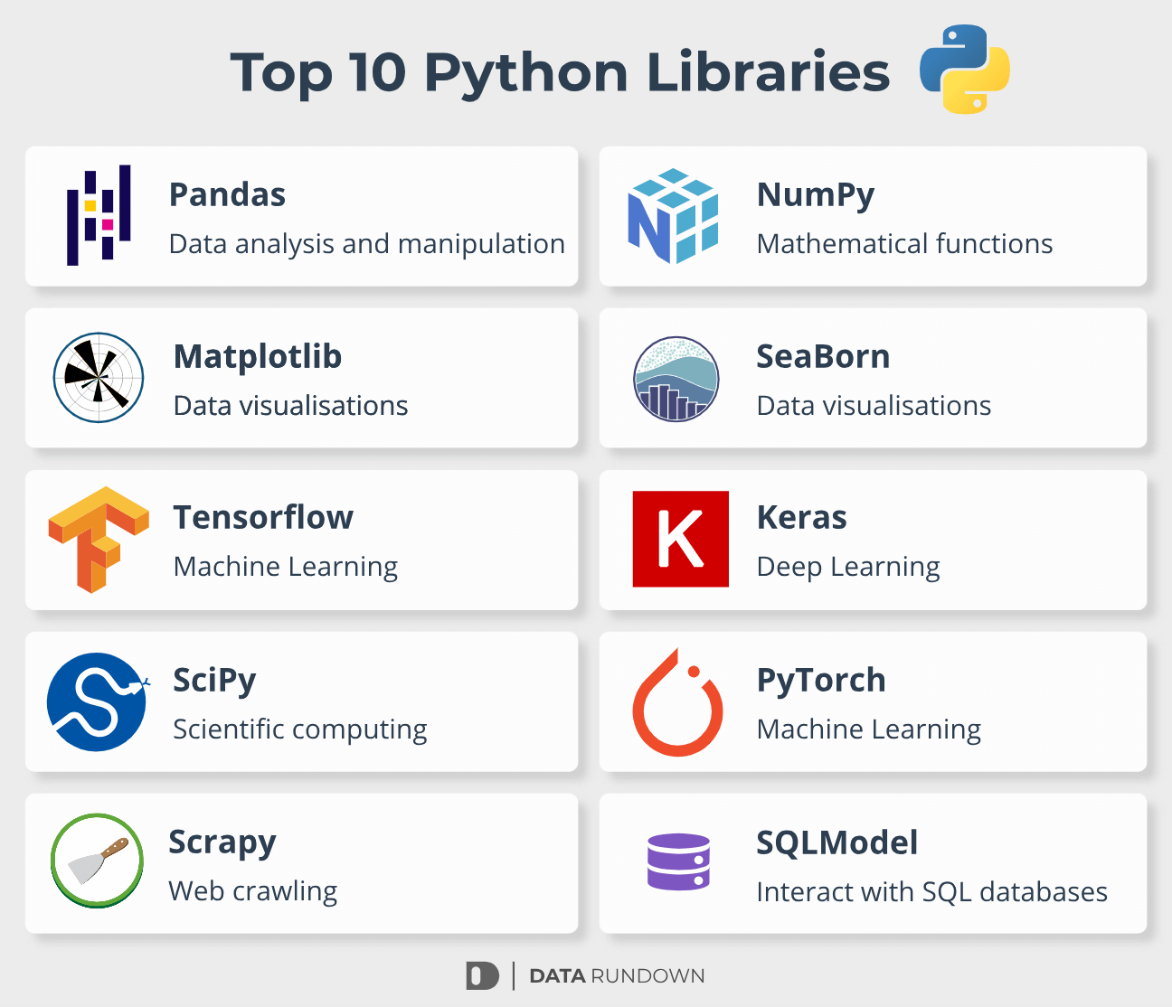

LU-1: FOUNDATION OF AI

1. What is Artificial Intelligence (AI)?
Theory (6–7 lines):
Artificial Intelligence (AI) is a branch of computer science that focuses on building systems capable of performing tasks that normally require human intelligence. AI systems can perceive, reason, learn, and make decisions. It is widely used in healthcare, finance, robotics, autonomous vehicles, and virtual assistants. AI has evolved over decades, from rule-based systems to modern machine learning and deep learning approaches. It combines concepts from computer science, mathematics, neuroscience, and cognitive science to create intelligent machines.

2. History of AI
Key Milestones (Timeline Diagram):
1950s: Turing Test proposed by Alan Turing1956: Term "AI" coined at Dartmouth Conference1960s: Early rule-based systems and robotics1980s: Expert Systems become popular1990s: Machine Learning emerges2010s: Deep Learning and AI applications boom2020s: AI in autonomous vehicles, NLP, and healthcare

3. Biological Concept of Neuron
Theory:
The human neuron receives inputs, processes them, and generates an output. Similarly, in AI, artificial neurons are used in neural networks to process signals and pass information forward.
Diagram:
Input Signals --> Weights --> Summation --> Activation Function --> Output

4. Perceptron (Basic AI Unit)
Theory:
The perceptron is a simple artificial neuron that can make decisions by weighing input signals, summing them, and applying an activation function. It is the building block of neural networks.

5. Types of Artificial Intelligence
Theory:
AI is classified into 4 types based on capabilities:
Type | Description
Reactive Machines | Respond to inputs, no memory (e.g., Chess AI)
Limited Memory | Can use past experiences (e.g., Self-driving cars)
Theory of Mind | Understand emotions, beliefs, intentions (research stage)
Self-awareness | Conscious AI with human-like intelligence (futuristic)
Flow Diagram:
AI Types
├─ Reactive Machines
├─ Limited Memory
├─ Theory of Mind
└─ Self-awareness

6. Turing Test
Steps:
Human interacts with machine and another human through a text interface.
Evaluator cannot see the participants.
If the evaluator cannot distinguish the machine from the human, the AI passes the test.

7. Components of Intelligence
Theory:
Components include perception, reasoning, learning, memory, planning, and problem-solving. These allow AI to mimic human cognitive functions.

8. Difference Between AI, Machine Learning, and Deep Learning
Concept | Description
AI | Broad concept of machines performing human-like tasks
ML | Subset of AI; systems learn from data to improve performance
Deep Learning | Subset of ML; uses neural networks with many layers for complex tasks

LU-2: APPROACHES OF AI

1. Approaches in AI
AI can be approached using multiple methods depending on the problem type. Statistical approach uses probabilities and data patterns. Symbolic approach uses logic and rules. Cognitive simulation mimics human thought processes. Cybernetics and Brain Simulation approaches simulate human brain behavior. AI frameworks and tools like Microsoft Azure Machine Learning and Google Cloud Prediction API provide cloud-based solutions for implementing AI models. Tools for web and mobile machine learning allow easy integration of AI into applications.

2. Key AI Tools
Tool | Purpose
Microsoft Azure ML | Cloud platform for training and deploying models
Google Cloud Prediction API | Machine learning prediction for web/mobile apps
Website ML Frameworks | Integrate AI into websites
Mobile ML Frameworks | Integrate AI into Android/iOS apps
Practical Activity – Mind Map (Website ML Tools):
AI Tools for Website
├─ TensorFlow.js
├─ Brain.js
├─ Microsoft Azure ML
└─ Google Cloud ML

LU-3: DEDUCTION, REASONING, AND PROBLEM SOLVING IN AI

1. Deduction in AI
Theory (6–7 lines):
Deduction is reasoning from general rules to specific cases. AI uses deduction to solve problems by applying rules to known facts. For example, expert systems use rule-based deduction to make decisions.
Example:
Rule: All humans are mortal.Fact: Socrates is a human.Deduction: Socrates is mortal.

2. Reasoning and Problem Solving
Theory:
AI solves problems using search algorithms, optimization techniques, and logical reasoning. Problem-solving involves defining the state, goal, constraints, and searching for a solution.
Diagram – Structure of Reasoning:
Problem Statement ↓
Knowledge Representation
↓
Inference Engine
↓
Solution / Action

3. Search and Optimization
Theory:
AI uses search algorithms like breadth-first search, depth-first search, A* to navigate problem spaces. Optimization techniques find the best solution from all possible solutions.

4. Knowledge Representation
Theory:
Knowledge representation is how AI stores information about the world. Techniques include semantic networks, rules, frames, and ontologies.
Diagram – Knowledge Representation:
Concepts --> Relationships --> Rules --> Facts

5. Agents and Environments
Theory:
AI agents perceive the environment, make decisions, and act to achieve goals. Types of agents: Simple Reflex, Model-based, Goal-based, Utility-based, Learning agents.
Diagram – Agent-Environment Interaction:
Environment --> Sensors --> Agent --> Actuators --> Environment

LU-4: AI GOALS AND AGENTS

1. Goals of AI
Theory (6–7 lines):
The goals of AI are to create intelligent systems capable of perceiving, reasoning, learning, and acting in a way that achieves human-like performance. AI systems aim to solve complex problems, automate tasks, make predictions, and improve decision-making. Goals include developing rational agents, achieving efficiency in computation, handling uncertainty, and improving adaptability. AI strives to mimic cognitive abilities like problem-solving, planning, and understanding language. These goals guide the design and development of AI algorithms and agents.

2. Types of Agents
Agent Type | Description
Simple Reflex Agent | Acts only on current percept; ignores history
Model-Based Agent | Maintains internal state to handle partially observable environments
Goal-Based Agent | Acts to achieve specific goals using planning
Utility-Based Agent | Chooses actions that maximize a performance measure
Learning Agent | Improves performance over time using feedback

3. Agent-Environment Working Model (Practical Activity)
Diagram:
Environment → Sensors → Agent → Actuators → Environment
Detailed Agent Flow Diagram:
+--------------------+
| Environment |
+--------------------+
↓
+--------------------+
| Sensors |
+--------------------+
↓
+--------------------+
| Agent |
| (Decision Making) |
+--------------------+
↓
+--------------------+
| Actuators |
+--------------------+
↓
+--------------------+
| Environment |
+--------------------+

LU-5: SEARCH, PLANNING, AND FUZZY LOGIC

1. Single Agent Path-Finding Problems
Theory (6–7 lines):
Path-finding involves navigating an agent from a start state to a goal state. AI uses search algorithms like Breadth-First Search (BFS), Depth-First Search (DFS), A*, and Greedy Best-First Search to explore possible paths. Planning ensures the agent takes a sequence of actions to achieve a goal efficiently. Fuzzy logic allows handling uncertainty and approximate reasoning. These algorithms are essential in robotics, navigation systems, and game AI.

2. Search Algorithms – Flow / Algorithm Diagrams
Breadth-First Search (BFS) – Practical Activity:
Algorithm BFS:1. Start at root node2. Initialize a queue and enqueue root node3. While queue is not empty:
a. Dequeue node N
b. If N is goal, return success
c. Else, enqueue all children of N4. Repeat until goal found or queue empty
Depth-First Search (DFS) Algorithm:
Algorithm DFS:1. Start at root node2. Initialize a stack and push root node3. While stack is not empty:
a. Pop node N
b. If N is goal, return success
c. Else, push all children of N onto stack4. Repeat until goal found or stack empty
A Search Algorithm:*
Algorithm A*:1. Start at initial node2. Initialize open list with start node3. Repeat:
a. Choose node N with lowest f(n) = g(n)+h(n)
b. If N is goal, return path
c. Else, expand N and add children to open list4. Repeat until goal found
Greedy Best-First Search:
Algorithm Greedy BFS:1. Start at initial node2. Initialize open list with start node3. Repeat:
a. Choose node N with lowest heuristic h(n)
b. If N is goal, return path
c. Else, expand N and add children to open list4. Repeat until goal found
Fuzzy Logic System – Algorithm Flow:
Input → Fuzzification → Rule Base → Inference Engine → Defuzzification → Output

LU-6: AI AREAS AND WORKING STRATEGIES

1. AI Areas
AI has multiple domains where specialized techniques are applied:
Machine Learning (ML): Learning from data to make predictions.
Reinforcement Learning (RL): Learning optimal actions through rewards.
Computer Vision (CV): Interpreting images and videos.
Natural Language Processing (NLP): Understanding and generating human language.
Recommender Systems: Suggesting products or content.
Expert Systems: Decision-making based on rules.
IoT with AI: Intelligent devices with connectivity.
Gaming & Mechanism Design: AI strategies for games and simulations.

2. Working Strategies – Practical Diagrams
Computer Vision Generalized Workflow:
Image Input → Preprocessing → Feature Extraction → Classification / Detection → Output
Machine Learning Strategy:
Data Collection → Preprocessing → Feature Selection → Train Model → Evaluate Model → Prediction
Reinforcement Learning Strategy:
Agent → Action → Environment → Reward → Update Policy → Repeat
NLP Strategy:
Text Input → Tokenization → Embedding / Encoding → Model Processing → Output

LU-7: REAL-WORLD APPLICATIONS OF AI

1. Applications
Theory (6–7 lines):
AI is applied across industries to automate processes, improve efficiency, and provide data-driven insights. Applications include:
Goods Management: Inventory optimization and supply chain automation.
Aviation: Flight planning, maintenance prediction, and autopilot systems.
Education: Personalized learning and student performance analytics.
Healthcare: Disease diagnosis, drug discovery, and patient monitoring.
Heavy Industry: Robotics for manufacturing, predictive maintenance.
Finance: Fraud detection, algorithmic trading, and credit scoring.

2. Practical Activity – Charts
Diagram – AI in Education (Example):
AI Applications in Education
├─ Personalized Learning
├─ Virtual Tutors
├─ Performance Prediction
├─ Adaptive Testing
Diagram – AI in Goods Management:
Goods Management
├─ Inventory Forecasting
├─ Automated Restocking
├─ Supplier Optimization
Diagram – AI in Healthcare:
Healthcare AI
├─ Diagnosis Assistance
├─ Treatment Recommendation
├─ Patient Monitoring

LU-1: Identify Hazards at Workplace

1. Workplace Hazards – Introduction
A workplace hazard is any source, situation, or act that has the potential to cause injury, illness, or damage to property. Hazards may arise from work processes, tools, equipment, materials, or the work environment. Identifying hazards is the first step in preventing accidents and ensuring employee safety. Proper understanding of procedures helps workers recognize risks early. Employers and employees must take appropriate actions to minimize hazards. Effective hazard control improves productivity and creates a safe working environment.

2. Types of Workplace Hazards
Hazard Type | Description | Examples
Physical | Environmental factors causing harm | Noise, heat, radiation, slips
Chemical | Harmful substances | Gases, fumes, acids
Biological | Living organisms | Bacteria, viruses, fungi
Ergonomic | Poor work design | Wrong posture, heavy lifting
Mechanical | Machinery-related risks | Sharp tools, moving parts
Electrical | Electrical exposure | Open wires, faulty equipment

3. Health and Safety Precautions
Health and safety precautions reduce the likelihood of accidents and injuries at the workplace. These include using Personal Protective Equipment (PPE), following standard operating procedures, and maintaining clean work areas. Employees must receive proper training to handle equipment safely. Regular inspections help detect hazards early. Emergency exits and fire safety measures must always remain accessible. Safety awareness promotes a culture of responsibility and prevention.

4. Techniques to Identify Workplace Hazards
Methods:
Workplace inspection
Job Safety Analysis (JSA)
Accident and incident records
Safety audits
Employee feedback
Flow Diagram – Hazard Identification Process:
Work Process Observation
↓
Hazard Identification
↓
Risk Assessment
↓
Control Measures
↓
Monitoring & Review

5. Dealing with Hazards
Hazards should be controlled using a systematic approach to prevent accidents. The hierarchy of hazard control includes elimination, substitution, engineering controls, administrative controls, and PPE. Immediate action should be taken if a hazard poses serious risk. Employees must report hazards promptly to supervisors or safety officers. Proper signage and safety instructions reduce confusion. Continuous monitoring ensures long-term safety.

Practical Activity – LU-1

1. Use Personal Protective Equipment
- Helmet
- Safety gloves
- Safety shoes
- Goggles
- Face mask

2. Identify Potential Hazards
- Wet floors
- Exposed wires
- Improper tool storage
- Poor lighting

3. Actions to Eliminate Hazards
- Clean spills immediately
- Repair faulty equipment
- Use warning signs
- Follow safety procedures

LU-2: Observe Occupational Health and Safety (OHS)

1. Occupational Health and Safety (OHS)
Occupational Health and Safety (OHS) focuses on protecting workers from workplace hazards that may cause injury or illness. It ensures compliance with safety laws, regulations, and guidelines. OHS promotes safe work practices and encourages hazard reporting. Proper safety measures prevent accidents and reduce downtime. Employers are responsible for providing a safe environment. Employees must follow safety rules and use PPE correctly.

2. Safe Working Practices
Key Practices:
- Follow safety instructions
- Use tools correctly
- Avoid unsafe behavior
- Maintain clean workspace
- Follow emergency procedures

3. Identifying and Reporting Hazards
Hazards must be identified before they cause harm. Employees should regularly inspect their work area. Any unsafe condition must be reported immediately. Hazards beyond employee control should be reported to a safety officer. Proper documentation helps track and prevent future incidents. Reporting hazards improves workplace safety for everyone.
Flow Diagram – Safety Reporting Procedure:
Hazard Observed
↓Assess Risk
↓Report to Supervisor / Safety Officer
↓Corrective Action Taken
↓Record & Monitor

4. Personal Protective Equipment (PPE)
Common PPE:
- Helmets
- Gloves
- Safety shoes
- Goggles
- Ear protection
PPE acts as the last line of defense against workplace hazards. Proper fitting ensures maximum protection. PPE must be worn, adjusted, and maintained according to company procedures. Damaged PPE should never be used. Employees must be trained in correct usage. PPE significantly reduces injury severity.

5. Fire-Fighting Methods
Types of Fire Extinguishers:
Fire Type | Extinguisher
Class A | Water
Class B | Foam
Class C | CO₂
Electrical | CO₂ / Dry Powder
Fire Safety Flow Diagram:
Fire Detected
↓
Raise Alarm
↓Use Correct Extinguisher
↓
Evacuate if Needed

Practical Activity – LU-2

1. Perform Work Safely
- Follow safety guidelines
- Use PPE correctly
- Avoid shortcuts

2. Report Hazards and Improvements
- Inform safety officer
- Fill safety report forms

3. Housekeeping
- Store tools properly
- Remove obstructions
- Prevent slip, trip, and fall hazards

LU-1: Identify Hazards at Workplace

1. Workplace Hazards–Introduction
A workplace hazard is anything that has the potential to cause harm, injury, or illness to a worker. Hazards may arise from work processes, tools, equipment, materials, or the work environment. Understanding work procedures helps workers identify risks accurately. Hazards can affect health, safety, and productivity if not controlled. Early identification of hazards prevents accidents and injuries. Both employers and employees share responsibility for workplace safety.

2. Types of Hazards That Cause Harm
Workplace hazards are classified based on the type of risk they pose. Physical hazards include noise, heat, and slippery floors. Chemical hazards involve gases, fumes, and hazardous liquids. Mechanical hazards come from moving machinery and sharp tools. Electrical hazards include exposed wires and faulty equipment. Ergonomic hazards result from poor posture or heavy lifting. Identifying these hazards helps in selecting proper safety controls.
Types of Hazards:
Physical hazards
Chemical hazards
Mechanical hazards
Electrical hazards
Ergonomic hazards
Biological hazards

3. Health and Safety Precautions
Health and safety precautions are measures taken to protect workers from workplace hazards. These include wearing PPE, following safety rules, and using equipment properly. Warning signs and safety instructions help prevent unsafe actions. Regular training increases awareness of hazards. Emergency exits and fire equipment must remain accessible. Safety precautions reduce accidents and improve workplace efficiency.

4. Techniques to Identify Workplace Hazards
Hazards can be identified by observing work activities and inspecting equipment. Reviewing accident records helps identify recurring risks. Job Safety Analysis (JSA) breaks tasks into steps to detect hazards. Safety audits and inspections ensure compliance with safety standards. Worker feedback is valuable for hazard identification. Early detection helps prevent accidents.
Flow Diagram – Hazard Identification Process:
Observe Work Process
↓Identify Hazard
↓Assess Risk
↓Apply Control Measures
↓Review & Monitor

5. Dealing with Hazards to Avoid Accidents
Once hazards are identified, immediate action must be taken to reduce risks. The best method is to eliminate the hazard completely. If elimination is not possible, substitution or engineering controls should be used. Administrative controls and PPE provide additional protection. Hazards must be reported to supervisors. Proper handling prevents injuries and accidents.

Practical Activity – LU-1

1. Use Personal Protective Equipment (PPE)
Safety helmet
Gloves
Safety shoes
Goggles
Face mask

2. Identify Potential Hazards and Risks
Wet or oily floors
Improper tool storage
Exposed electrical wires
Poor lighting

3. Actions to Eliminate Hazards
Clean spills immediately
Repair faulty equipment
Store tools properly
Use warning signs

LU-2: Observe Occupational Health and Safety (OHS)

1. Occupational Health and Safety (OHS)
Occupational Health and Safety (OHS) focuses on protecting workers from workplace injuries and illnesses. It ensures compliance with safety laws, rules, and company guidelines. OHS promotes safe work practices and hazard prevention. Employers must provide a safe working environment. Employees must follow safety procedures. OHS reduces accidents and improves productivity.

2. Working Safely at Workplace
Working safely means following safety rules and using proper protective equipment. Workers must operate tools correctly and avoid unsafe actions. Safety signs and instructions should always be followed. Emergency procedures must be known by all employees. Safe working habits reduce injury risks. Team cooperation improves overall safety.

3. Identifying and Reporting Hazards
Workers must regularly inspect their work area to identify hazards. Hazards within control should be corrected immediately. Serious hazards must be reported to the safety officer. Reporting helps prevent future accidents. Safety documentation records incidents and corrective actions. Proper reporting ensures accountability and safety improvement.
Flow Diagram – Safety Reporting Procedure:
Hazard Identified
↓Assess Risk
↓Report to Supervisor / Safety Officer
↓Corrective Action
↓Record & Monitor

4. Personal Protective Equipment (PPE)
PPE protects workers from hazards when other controls are insufficient. PPE must fit properly to provide maximum protection. Workers must wear PPE according to company rules. PPE should be cleaned and maintained regularly. Damaged PPE must be replaced immediately. Correct PPE use reduces injury severity.

5. Fire-Fighting Methods
Theory (6–7 lines):
Fire safety is essential to protect life and property. Different fires require different extinguishers. Workers must know fire evacuation procedures. Fire alarms must be raised immediately in case of fire. Only trained personnel should use fire extinguishers. Quick response reduces damage and injuries.
Fire Safety Flow Diagram:
Fire Detected
↓
Raise Alarm
↓Use Correct Extinguisher
↓
Evacuate if Required

Practical Activity – LU-2

1. Perform Work Safely
Follow safety instructions
Use PPE properly
Avoid unsafe behavior

2. Report Hazards and Improvements
Inform supervisor
Fill safety report forms

3. Housekeeping
Keep work area clean
Remove obstructions
Store tools properly
Prevent slip, trip, and fall hazards

LU-1: Recognize Occupational Health and Safety on HVAC Systems

1. Introduction to OHS in HVAC Systems
Occupational Health and Safety (OHS) in HVAC systems focuses on protecting workers from hazards during installation, operation, and maintenance. HVAC work involves electrical, mechanical, chemical, and pressure-related risks. Understanding OHS objectives helps prevent accidents and equipment damage. Environmental protection is also important to avoid refrigerant leakage. Proper safety awareness improves system reliability. Following OHS guidelines ensures a safe and healthy workplace.

2. Objectives of OHS & Environmental Protection in HVAC
The main objective of OHS in HVAC is to prevent injuries, illnesses, and accidents. It ensures safe handling of tools, refrigerants, and equipment. Environmental protection aims to prevent ozone depletion and pollution caused by refrigerant leakage. OHS also ensures compliance with safety laws and standards. Proper procedures reduce system failures. Safe practices protect both workers and the environment.

3. Types of Hazards in HVAC Systems
HVAC systems involve multiple hazards that can harm health and safety. Electrical hazards include shock and short circuits. Mechanical hazards arise from moving parts like fans and belts. Pressure hazards occur due to high-pressure refrigerants. Chemical hazards involve refrigerants and cleaning chemicals. Thermal hazards include burns from hot surfaces. Identifying hazards helps prevent accidents.
Common HVAC Hazards:
Electrical shock
High-pressure refrigerants
Moving mechanical parts
Chemical exposure
Fire and explosion risk

4. Pressure Safety Devices in HVAC Systems
Pressure safety devices protect HVAC systems from excessive pressure. A pressure gauge measures system pressure. A safety valve releases excess pressure automatically. A safety diaphragm ruptures to protect the system. A fusible plug melts at high temperature to release pressure. These devices prevent system failure. Regular inspection ensures proper functioning.
Pressure Safety Devices:
Pressure Gauge
Safety Valve
Safety Diaphragm
Fusible Plug

5. HVAC Tools – Types, Use, Maintenance & Limitations
HVAC tools are used for installation, servicing, and troubleshooting. Common tools include manifold gauges, vacuum pumps, leak detectors, and hand tools. Proper use prevents damage and injury. Tools must be cleaned and maintained regularly. Damaged tools should not be used. Each tool has limitations and must be used for its intended purpose only.

6. Use of Personal Protective Equipment (PPE)
PPE protects HVAC technicians from workplace hazards. Safety gloves protect hands from chemicals and sharp edges. Goggles protect eyes from refrigerant splashes. Safety shoes prevent foot injuries. Helmets protect from falling objects. Proper PPE use reduces injury severity and ensures compliance with safety rules.

7. Safe Handling of Refrigerants & Compressor Safeties
Refrigerants can be harmful if mishandled. They must be stored and handled carefully to avoid leaks. Proper ventilation is required during refrigerant charging. Compressor safety devices prevent overheating and overpressure. Safe practices reduce explosion and health risks. Always follow manufacturer guidelines.

8. Hazards of Compression and Absorption Systems
Compression systems involve high pressure and electrical components. Absorption systems involve chemicals and heat sources. Both systems can cause burns, leaks, and pressure hazards. Improper handling can lead to system failure. Safety devices must always be functional. Proper training minimizes risks.

Flow Diagram – HVAC Hazard Identification
HVAC Work Activity ↓
Hazard Identification
↓
Risk Assessment
↓
Safety Controls & PPE
↓
Safe Operation

Practical Activity – LU-1

1. Identify Safety Signs & Symbols
Electrical hazard sign
High-pressure warning
Flammable refrigerant sign
Mandatory PPE sign

2. Use Personal Protective Equipment
Gloves
Goggles
Safety shoes
Helmet

LU-2: Apply Safety in On-Job HVAC Systems

1. Safety Standards in HVAC Workplace
HVAC safety standards ensure safe electrical and mechanical operations. Electrical safety prevents shock and short circuits. Mechanical safety avoids injuries from moving parts. Standards guide proper installation and servicing. Compliance reduces accidents. Safety standards must always be followed during work.

2. Assessing Safety Requirements of On-Job HVAC Systems
Before starting HVAC work, safety requirements must be assessed. This includes checking electrical connections and mechanical stability. Work area hazards must be identified. Proper tools and PPE must be selected. Risk assessment prevents accidents. Safety planning improves efficiency.

3. Safe Installation, Servicing & Troubleshooting
HVAC units must be installed according to safety guidelines. Power must be switched off during servicing. Troubleshooting should be done using proper tools. Unsafe shortcuts must be avoided. Following procedures reduces injury risk. Only trained personnel should perform repairs.

4. Safety Reporting & Documentation
All hazards and incidents must be reported immediately. Safety reports help prevent future accidents. Documentation records corrective actions taken. Reporting improves workplace safety culture. Workers must inform supervisors of serious hazards. Proper records ensure accountability.

5. First Aid & Resuscitation Methods
First aid provides immediate help during accidents. It includes treating cuts, burns, and electric shock. Resuscitation methods like CPR save lives. Quick response reduces injury severity. First aid kits must be available. Workers should know basic first aid.

6. Fire-Fighting Methods
Fire hazards may occur due to electrical faults or refrigerants. Correct fire extinguishers must be used. Fire alarms must be raised immediately. Workers must know evacuation routes. Only trained staff should fight fires. Quick action minimizes damage.

7. Safe Handling of Heavy Loads
HVAC equipment can be heavy and bulky. Incorrect lifting can cause injuries. Proper lifting techniques must be used. Mechanical aids should be used when possible. Team lifting reduces risk. Safe handling prevents muscle strain.

Flow Diagram – Safe HVAC Work Process
Job Assessment
↓
Hazard Identification
↓Use PPE & Tools
↓
Safe Work Execution
↓
Report & Review

Practical Activity – LU-2

1. Perform Work Safely
Follow HVAC safety procedures
Use correct tools
Avoid unsafe actions

2. Use Personal Protective Equipment
Gloves
Goggles
Safety shoes
Helmet

3. Identify Potential Hazards
Electrical faults
Refrigerant leakage
Moving parts
Heavy equipment

