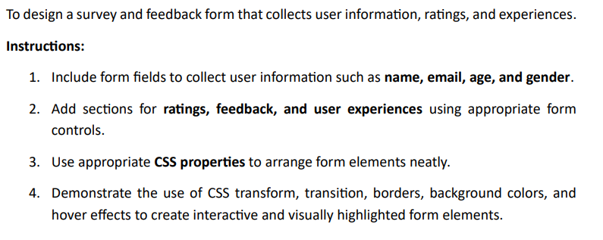
Code
Solution
Task
Name : Mohd Kashif Ansari
Rollno : 25/A04/013
Assignment-12

<!DOCTYPE html>
<html lang="en">
<head>
<meta charset="UTF-8">
<meta name="viewport" content="width=device-width, initial-scale=1.0">
<title>Lab 12 - Survey Form</title>

<style>
/* Basic setup to center the form */
body {
font-family: Arial, sans-serif;
background-color: #f4f4f9;
display: flex;
justify-content: center;
align-items: center;
padding: 40px 0;
min-height: 100vh;
box-sizing: border-box;
}

/* The main form container */
.survey-form {
background-color: #ffffff; /* */
width: 100%;
max-width: 600px;
padding: 30px;
border-radius: 10px; /* */
border: 1px solid #ddd; /* */
box-shadow: 0 4px 15px rgba(0, 0, 0, 0.07);
}

/* Grouping fields like "User Info" or "Feedback" */
fieldset {
border: 1px solid #ccc; /* */
border-radius: 8px;
/* Adjusted padding */
padding: 20px 20px 20px 20px;
margin-bottom: 25px;
}

/* --- MODIFICATION --- */
/* Removed the 'legend' style rule. */
/* Added a style rule for the new <h3> title. */
.fieldset-title {
font-size: 1.2em;
font-weight: bold;
color: #333;
margin-top: 0; /* Sits cleanly at the top */
margin-bottom: 25px; /* Space before the first form item */
}

/* --- Req 3: Neat Arrangement --- */

/* Each Label + Input pair */
.form-group {
margin-bottom: 20px;
}

.form-group label {
display: block;
margin-bottom: 8px;
font-weight: bold;
color: #555;
}

/* Style for text inputs, email, number, select */
.form-control {
width: 100%;
padding: 12px;
font-size: 1em;

/* --- Req 4: Borders, Backgrounds --- */
background-color: #f9f9f9; /* */
border: 2px solid #ddd; /* */
border-radius: 6px;
box-sizing: border-box; /* Important for 100% width */

/* --- Req 4: Transition --- */
transition: border-color 0.3s ease, box-shadow 0.3s ease; /* */
}

/* --- Req 4: Hover/Focus Effects --- */

/* Highlight on focus (when clicked) */
.form-control:focus {
outline: none;
border-color: #007bff; /* */
box-shadow: 0 0 8px rgba(0, 123, 255, 0.25);
}

/* --- Req 1 & 2: Radio & Checkbox Styling --- */

/* Wrapper for radio/checkbox groups */
.choice-group {
display: flex;
flex-direction: column;
gap: 10px;
}

.choice-group label {
font-weight: normal;
display: flex;
align-items: center;
cursor: pointer;
}

.choice-group input {
margin-right: 10px;
}

/* Textarea for feedback */
textarea.form-control {
resize: vertical; /* Allow user to resize vertically */
min-height: 120px;
}

/* --- Req 4: Button Styling (Transform, Transition, Hover) --- */
.submit-button {
width: 100%;
padding: 15px;
font-size: 1.1em;
font-weight: bold;
color: #fff;

background-color: #007bff; /* */
border: none; /* */
border-radius: 6px;
cursor: pointer;

/* --- Req 4: Transition & Transform --- */
transition: background-color 0.3s ease, transform 0.3s ease; /* */
}

.submit-button:hover {
background-color: #0056b3; /* Darker blue on hover */
transform: scale(1.02); /* Slightly larger on hover */
}

</style>
</head>
<body>

<form class="survey-form">

<h1 style="text-align: center; margin-top: 0;">Feedback Form</h1>

<fieldset>
<h3 class="fieldset-title">User Information</h3>

<div class="form-group">
<label for="name">Name</label>
<input type="text" id="name" class="form-control" required>
</div>

<div class="form-group">
<label for="email">Email</label>
<input type="email" id="email" class="form-control" required>
</div>

<div class="form-group">
<label for="age">Age</label>
<input type="number" id="age" class="form-control" min="13">
</div>

<div class="form-group">
<label>Gender</label>
<div class="choice-group">
<label><input type="radio" name="gender" value="male"> Male</label>
<label><input type="radio" name="gender" value="female"> Female</label>
<label><input type="radio" name="gender" value="other"> Other</label>
</div>
</div>

</fieldset>

<fieldset>
<h3 class="fieldset-title">Feedback and Experience</h3>

<div class="form-group">
<label>How would you rate your experience?</label>
<div class="choice-group">
<label><input type="radio" name="rating" value="5"> ⭐⭐⭐⭐⭐ Excellent</label>
<label><input type="radio" name="rating" value="4"> ⭐⭐⭐⭐ Very Good</label>
<label><input type="radio" name="rating" value="3"> ⭐⭐⭐ Good</label>
<label><input type="radio" name="rating" value="2"> ⭐⭐ Fair</label>
<label><input type="radio" name="rating" value="1"> ⭐ Poor</label>
</div>
</div>

<div class="form-group">
<label for="comments">Please share your feedback or experience:</label>
<textarea id="comments" class="form-control" placeholder="Tell us what you think..."></textarea>
</div>

<div class="form-group">
<label>How did you hear about us?</label>
<select id="referral" class="form-control">
<option value="" disabled selected>Select an option</option>
<option value="social">Social Media</option>
<option value="friend">From a Friend</option>
<option value="search">Search Engine</option>
<option value="other">Other</option>
</select>
</div>

</fieldset>

<button type="submit" class="submit-button">Submit Feedback</button>
</form>
</body>
</html>
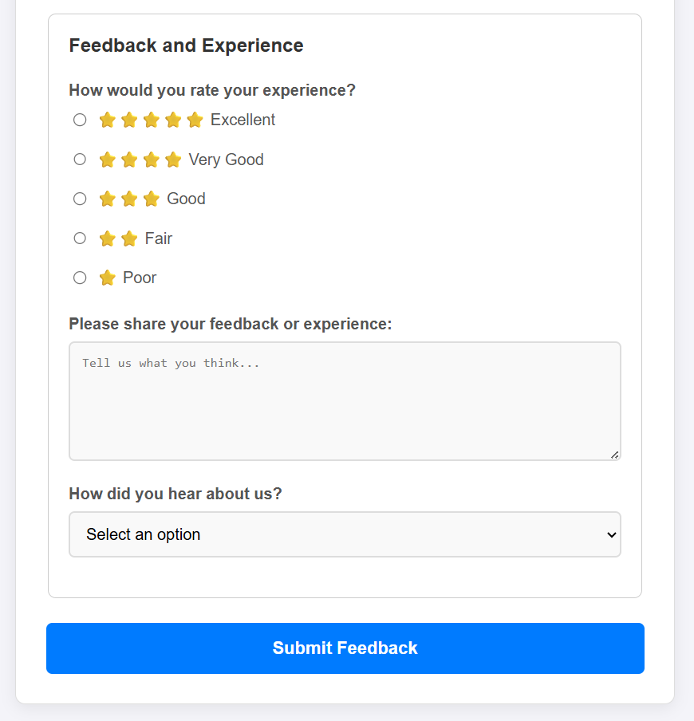
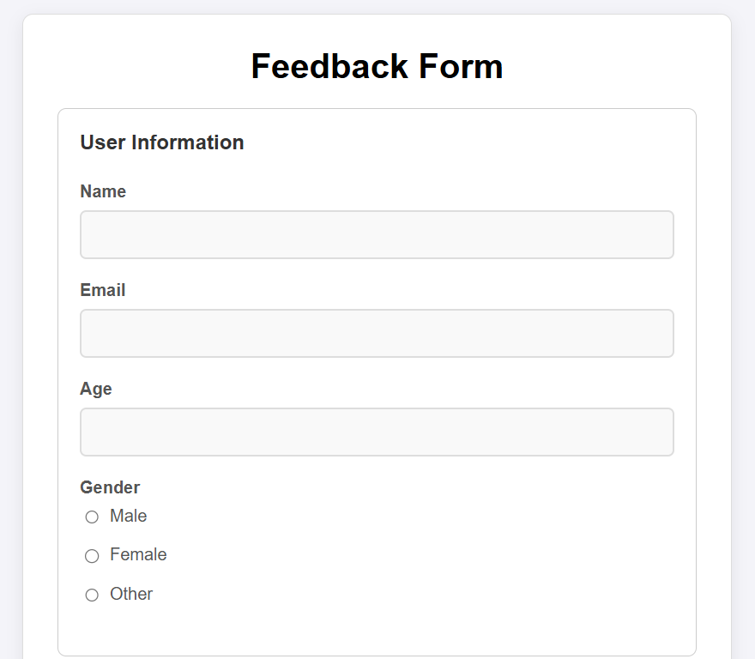
Output

