Teachable Machine Model

Muhammad Kashif haroon

Superior university Lahore

Lahore Pakistan

Bsem-f16-370@superior.edu.pk

***Abstract*— *this report represents the overview of Teachable machine learning and their working. Further the description of real time teachable machine learning systems using image model is discussed which in specialization shows the detect mobile model. there are three model of mobile device are form of working like Opp ,iphone and vivo . In conclusion the working is further discusses and future work directions are given.***

***Keywords— , UML, System Architecture, System Modelling, Rational Rose***

1. INTRODUCTION

.Machine learning is a web-based tool that makes creating machine learning models fast, easy, and accessible to everyone. Usually machine learning algorithms are developed using different frameworks specialized for machine learning, like Pytorch or TensorFlow. For somebody who is not really well versed on machine learning, digging inside the technology needed and understanding all the steps to generate a result from a machine learning algorithm can take a long time. Not only mental energy is needed but also money, because executing the training steps on the cloud can be expensive.

Machine learning increasingly affects our digital lives—from recommending music to translating foreign phrases and crating photo albums. It’s important for everyone using this technology to understand how it works, but doing so isn’t always easy. Machine learning is defined by its ability to “learn” from data without being explicitly programmed, and ML-driven products don’t typically let users peek behind the curtain to see why the system is making the decisions it does. Machine learning can help find your cat photos, but it won’t really tell you how it does so.

Google's Creative Lab released Teachable Machine, a free online experiment that lets you play with machine learning in your web browser, using your webcam as an input to train a machine learning model of your very own and no

programming experience required. The team a collaborative effort by Creative Lab and pair team members, plus friends

from wanted people to get a feel for how machine learning

actually “learns,” and to make the process itself more understandable. With Teachable Machine, people are able to create simple and effective algorithms in the browser that can:

* Identify patterns on images
* Identify patterns on audio
* Identify poses or gestures

1. Teachable machines learning
2. *Background*

Machine learning and artificial intelligence are complex subjects and while you might see them being mentioned every day, you might not necessarily understand how they work.Two years ago, Google launched a site called Teachable Machine, which let you train a simple model using their camera without any code. Now, it’s launching an updated version so you can train more advanced models.

 The earlier version allowed you to train three classes through your camera. The new model, not only lets you define more than three classes, it also allows you to use images, audio clips, pose data, or your own dataset for the training.

Here are some of the most prominent features of the updated Teachable Machine:

* Train a model on image data
* Train a model on audio data
* Train a model on pose data
* Upload your own datasets to train models
* Train more than 3 classes per model
* Disable classes
* Save your TensorFlow.js model
* Download your model
* Deploy your model to use in your own project (websites, apps, physical machines, etc.)

XXX-X-XXXX-XXXX-X/XX/$XX.00 ©20XX IEEE

1. *How its work ?*

Using Teachable Machine is quite simple, just follow a set of easy steps.

* Gather data
* Train your model
* Export your model

You can train an Artificial Intelligence models by recording yourself with your webcam or providing different sets of images or audio. After you trained your model you will be able to use it anywhere you can use TensorFlowJS, TensorFlow Lite or TensorFlow.

To start training the machine, we first have to create different categories, or classes, to teach it with. I’m going to make three classes here.

* Iphone 7
* Iphone 6s
* Opp
* Vivo

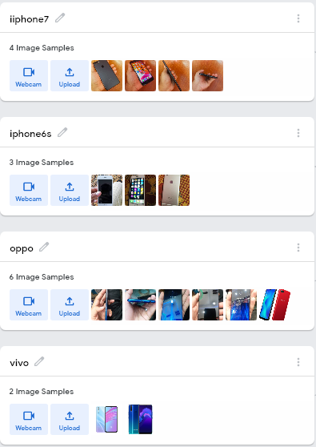

.

Now that I have my classes, I’m going to give each class samples to learn from. In this case, those will just be images of the mobiles — so let’s start with a mobile that’s “Iphone 7.” Then, we’ll do the same with all mobile models:

Now that I have all of my classes ready, I can click train.

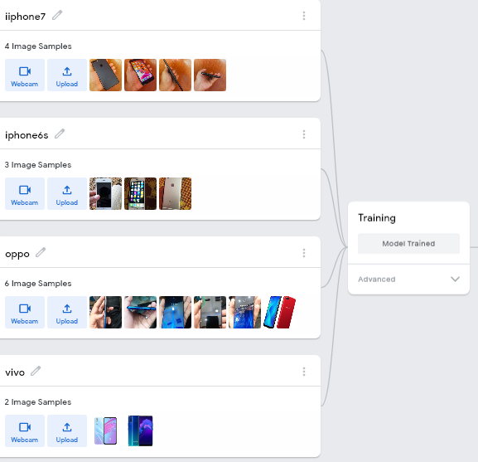

And, over on the right, preview if the model works!

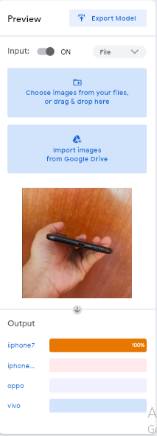

**APPENDIX A**

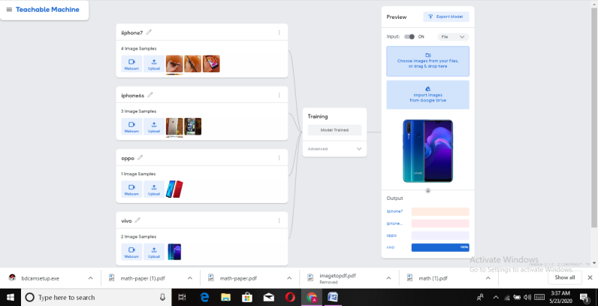

**ACKNOWLEDGMENTS**

I would like to express my deepest appreciation to all those who provided me the possibility to complete this report.  A special gratitude Head of department and my respected teacher, [Dr.Affan jaffar], whose contribution in stimulating suggestions and encouragement,  helped me to coordinate my project especially in writing this report.

CONCLUSION

This Teachable Machine, a project by Google, students use the camera on their device to train a machine through artificial intelligence (AI) to display a GIF, play a sound, or produce a line of speech. Use the site to introduce machine learning to students, and have students start with the tutorial. Kids can work in groups to determine what input (from the camera) should produce which outputs (such as a GIF) . Take the time to discuss what students learned after experimenting, and make connections to other machines like Amazon Alexa. Then, use the numerous extension materials like interactive guides, examples of student experiments, and video explainers to motivate advanced learners or inspire a class just beginning to learn about artificial intelligenc.

REFERENCES

|  |  |
| --- | --- |
| [1] | <https://github.com/users/kashifzain12/projects/2> |
| [2] | <https://github.com/kashifzain12/Teachable-machine-learning-project>. |
| [3] | https://teachablemachine.withgoogle.com/models/P9c_ogpnO/ |
| [4] | <https://teachablemachine.withgoogle.com/train/image/1HtFW5NdXCW2T3dL7aW-uGDahDVQ7gAiG>. |