**Lab 5**

**To Demonstrate the Working of Binary Adders**

***Note: You may draw all the logic diagrams with hand and paste the pictures here or on logicly software with your name, roll number & section mentioned in your workspace. Make sure that all of your connections are clearly visible and distinguishable.***

**Tasks**

1. **Construct a logic circuit for half and full adder with the help of truth table. Also write the Boolean expression for output(s).**

Half Adder

1. Truth Table
2. Boolean Expression (Simplified)

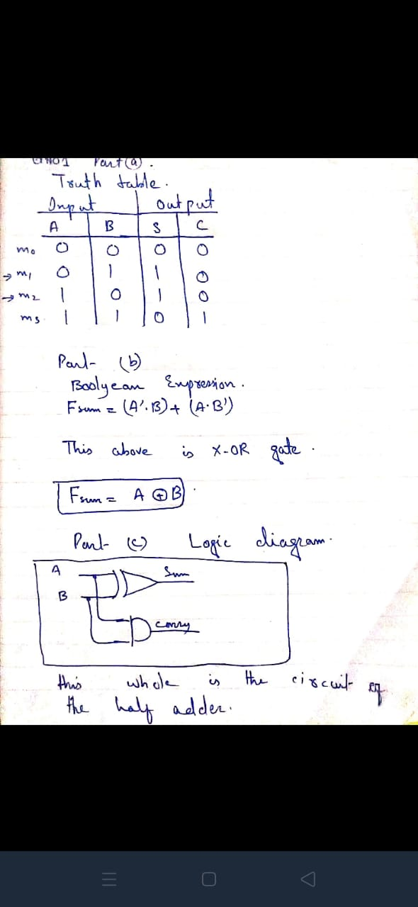

1. Logic Diagram
2. Software Simulation (Show here your results for each combination that gives a high output)

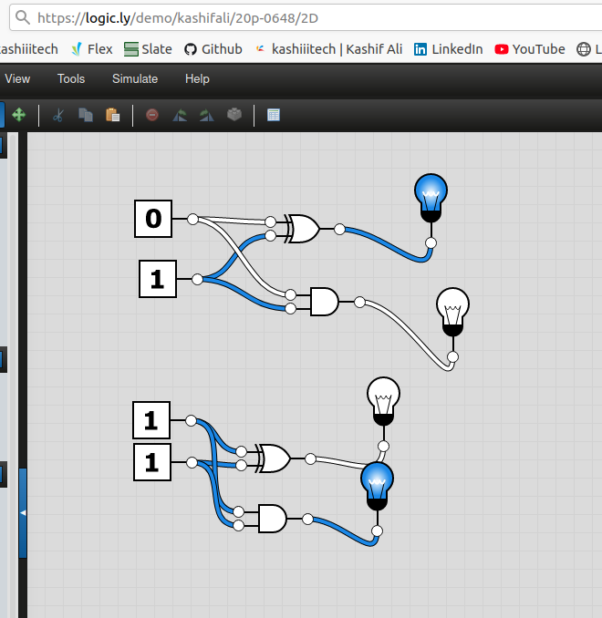

Full Adder

1. Truth Table
2. Boolean Expression (Simplified)
3. 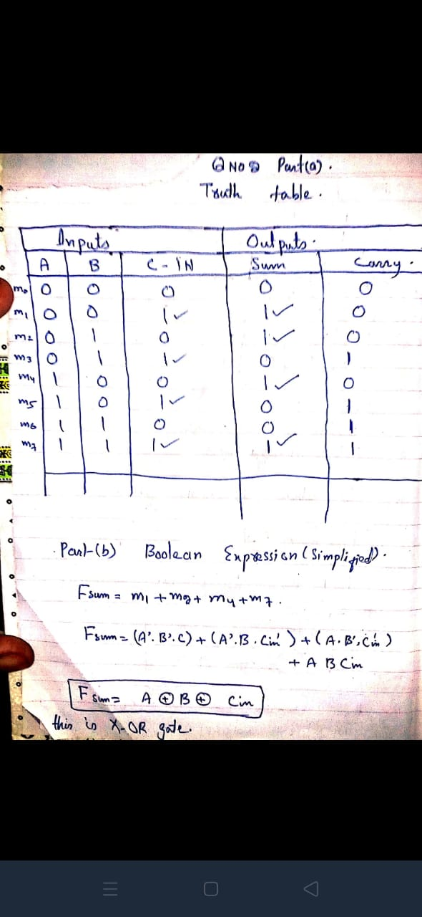Logic Diagram

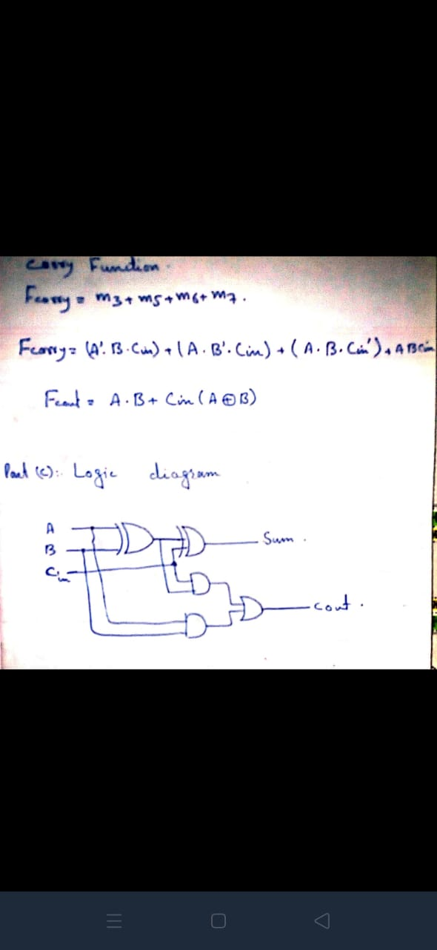

1. Software Simulation (Show here your results for each combination that gives a high output for each output)

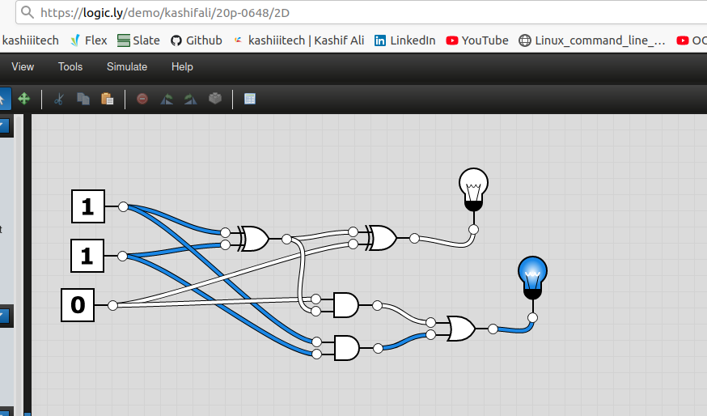

1. **A full adder can be implemented using 2-half adders. Demonstrate the logic diagram for the said circuit. Simulate your circuit for the verification of results.**
2. Logic Diagram of Full Adder using 2-Half Adders

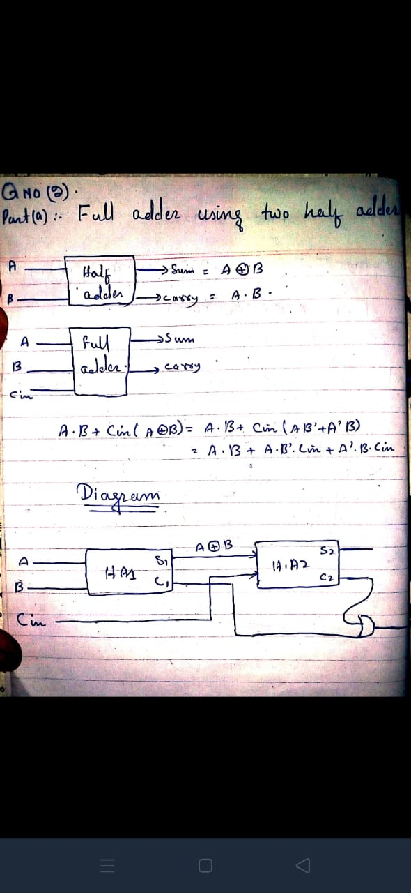

1. Software Simulation (Show here your results for each combination that gives a high output for each output)

