Programming Fundamental
Lab#13
Contents
Header files 2
Using namespace std 2
Syntax 2
Datatype 2
Variables 5
Print /display 6
Input 6

Header files
iostream is the header file which contains all the functions of program like cout, cin etc. and #include tells the preprocessor to include these header file in the program

Using namespace std

Using the using keyword doesn't mean we add functionality, it means we say that we read things by default. If we say using namespace std; then we say: If we come across an object name that doesn't exist in our current namespace, check if there exists a namespace std in which it does exist, and use that object. Thus, it doesn't really add a function, it is the include <iostream> that "loads" cout, cin, endl and all the like.

Syntax
Basic syntax of C program:
- Header file
- Using namespace std
- Main body
#include<iostream>
using namespace std;
int main()
{

return 0;
}

Datatype
All variables use data-type during declaration to restrict the type of data to be stored. Therefore, we can say that data types are used to tell the variables the type of data it can store.
Whenever a variable is defined in C++, the compiler allocates some memory for that variable based on the data-type with which it is declared. Every data type requires different amount of memory.
Primitive Data Types: These data types are built-in or predefined data types and can be used directly by the user to declare variables. example: int, char , float, bool etc. Primitive data types available in C++ are:
  - Integer
  - Character
  - Boolean
  - Floating Point
  - Double Floating Point

Integer:
Keyword used for integer data types is int. Integers typically requires 4 bytes of memory space and ranges from -2147483648 to 2147483647.

Character:
Character data type is used for storing characters. Keyword used for character data type is char. Characters typically requires 1 byte of memory space and ranges from -128 to 127 or 0 to 255.

Boolean:
Boolean data type is used for storing boolean or logical values. A boolean variable can store either true or false. Keyword used for boolean data type is bool.

Floating Point:
Floating Point data type is used for storing single precision floating point values or decimal values. Keyword used for floating point data type is float. Float variables typically requires 4 byte of memory space.

Double Floating Point:
Double Floating Point data type is used for storing double precision floating point values or decimal values. Keyword used for double floating point data type is double. Double variables typically requires 8 byte of memory space.
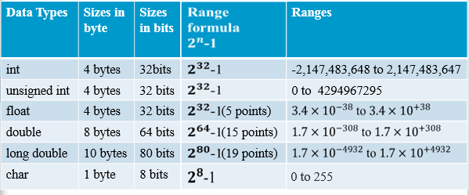

// C++ program to sizes of data types
#include<iostream>
using namespace std;

int main()
{
cout << "Size of char : " << sizeof(char)
<< " byte" << endl;
cout << "Size of int : " << sizeof(int)
<< " bytes" << endl;
cout << "Size of short int : " << sizeof(short int)
<< " bytes" << endl;
cout << "Size of long int : " << sizeof(long int)
<< " bytes" << endl;
cout << "Size of signed long int : " << sizeof(signed long int)
<< " bytes" << endl;
cout << "Size of unsigned long int : " << sizeof(unsigned long int)
<< " bytes" << endl;
cout << "Size of float : " << sizeof(float)
<< " bytes" <<endl;
cout << "Size of double : " << sizeof(double)
<< " bytes" << endl;
cout << "Size of wchar_t : " << sizeof(wchar_t)
<< " bytes" <<endl;

return 0;
}
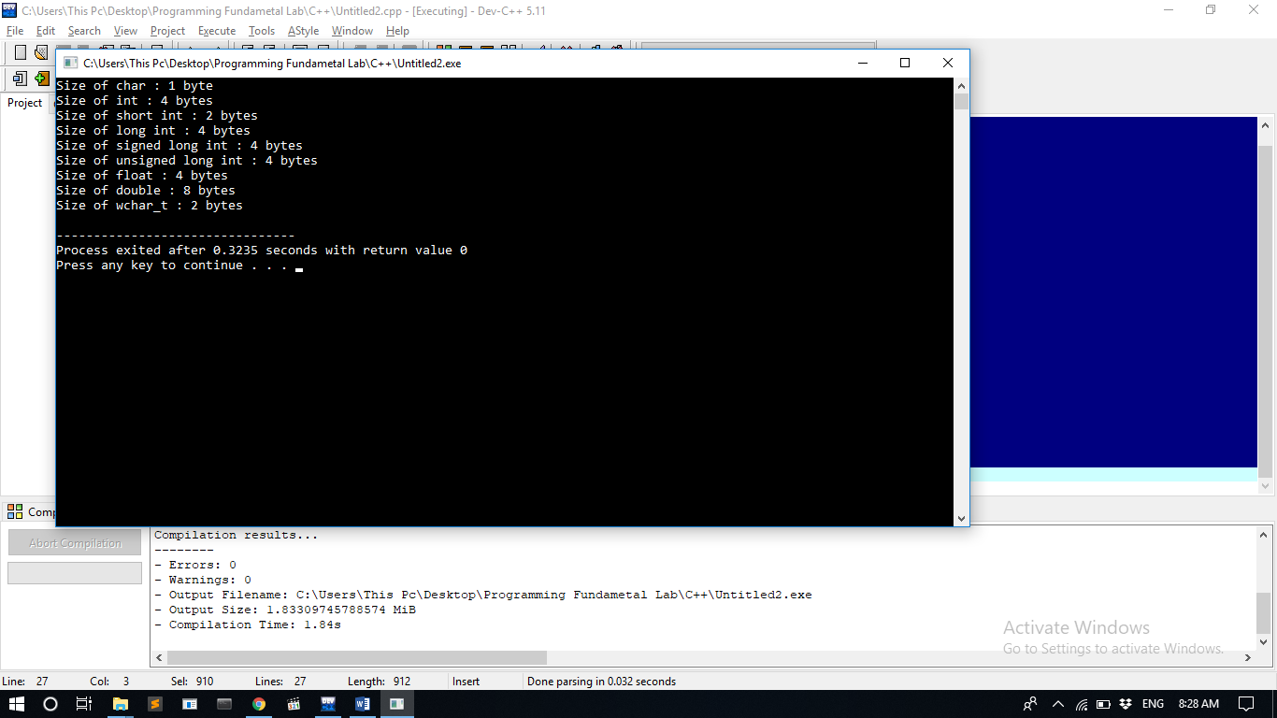

Variables
While declaring a variable you have to explicitly tell the data type with the variable.

int a, b;
float a, b;
double a, b;
float a, b;
bool a, b;
char a, b;
string s; (for string you have to include header file string.h)

// operating with variables

#include <iostream>
using namespace std;

int main ()
{
// declaring variables:
int a, b;
int result;

// assigning value:
a = 5;
b = 2;

// printing :
cout << a<<b;

// terminate the program:
return 0;
}

Print /display
cout command is use to print the message on console screen.
// print out the result:
cout << result;

Input
cin command is use to take input from the user/keyboard.

// input the value of a:
cin>>a;
// operating with variables

#include <iostream>
using namespace std;

int main ()
{
// declaring variables:
int a, b;
int result;

// input
cout<<"enter value of a:";
cin>>a;
cout<<"enter value of b:";
cin>>b;
cout<<"a:"<<a<<endl;
cout<<"b:"<<b<<endl;

return 0;
}

Control Statements
In most of the programs presented above, the statements have been sequential, executed in the order they appear in the main program.
In many programs the values of variables need to be tested, and depending on the result, different statements need to be executed. This facility can be used to select among alternative courses of action. It can also be used to build loops for the repetition of basic actions.

Boolean expressions and relational operators
In C++ the testing of conditions is done using boolean expressions, which yield bool values that are either true or false. The simplest and most common way to construct such an expression is to use the so-called relational operators.
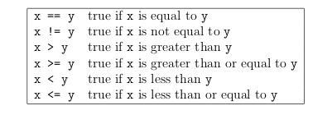

Be careful to avoid mixed-type comparisons. If x is a floating point number and y is an integer the equality tests will not work as expected.
Compound boolean expressions using logical operators
If you need to test more than one relational expression at a time, it is possible to combine the relational expressions using the logical operators.
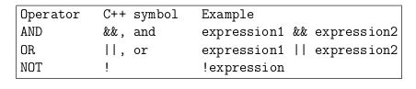

The meaning of these will be illustrated in examples below.
The IF selection control statement
The simplest and most common selection structure is the if statement, which is written in a statement of the form:
if(boolean-expression ) statement ;
The if statement tests for a particular condition (expressed as a boolean expression) and only executes the following statement(s) if the condition is true. An example follows of a fragment of a program that tests if the denominator is not zero before attempting to calculate fraction.
if(total != 0)
fraction = counter/total;
If the value of total is 0, the boolean expression above is false and the statement assigning the value of fraction is ignored.
If a sequence of statements is to be executed, this can be done by making a compound statement or block by enclosing the group of statements in braces.
if(boolean-expression )
{
statements ;
}
An example of this is:
if(total != 0)
{
fraction = counter/total;
cout << "Proportion = " << fraction <<endl;
}

The IF/ELSE selection control statement
Often it is desirable for a program to take one branch if the condition is true and another if it is false. This can be done by using an if/else selection statement:
if(boolean-expression )
statement-1 ;
else
statement-2 ;
Again, if a sequence of statements is to be executed, this is done by making a compound statement by using braces to enclose the sequence:
if(boolean-expression )
{
statements ;
}
else
{
statements ;
}

An example occurs in the following fragment of a program to calculate the roots of a quadratic equation.
// testing for real solutions to a quadratic
d = b*b - 4*a*c;
if(d >= 0.0)
{
// real solutions
root1 = (-b + sqrt(d)) / (2.0*a);
root2 = (-b - sqrt(d)) / (2.0*a);
real_roots = true;
}
else
{
// complex solutions
real = -b / (2.0*a);
imaginary = sqrt(-d) / (2.0*a);
real_roots = false;
}

If the boolean condition is true, i.e. (d ≥ 0), the program calculates the roots of the quadratic as two real numbers. If the boolean condition is false, then a different sequence of statements is executed to calculate the real and imaginary parts of the complex roots. Note that the variable real_roots is of type bool. It is assigned the value true in one of the branches and false in the other.

ELSE IF multiple selection statement

Occasionally a decision has to be made on the value of a variable that has more than two pos-sibilities. This can be done by placing if statements within other if-else constructions. This is commonly known as nesting and a different style of indentation is used to make the multiple-selection functionality much clearer. This is given below:
if(boolean-expression-1 )
statement-1 ;
else if(boolean-expression-2 )
statement-2 ;
.
.
.
else
statement-N ;

For compound statement blocks, braces must be used. Here follows a dull example of ELSE IF multiple selection in use:

// Program to assess the user’s for suitability as a major college donor:
// Find out how many houses are owned:
int howManyHousesSheOwns;
cout << "How many houses do you own?" << endl;
cin >> howManyHousesSheOwns;
// Give feedback
if (howManyHousesSheOwns<=0)
{
cout << "And have you come far today?" << endl;
}
else if (howManyHousesSheOwns<10)
{
cout << "Student hardship funds make a real difference to
many students lives!" << endl;
}
else if (howManyHousesSheOwns<100)
{
cout << "Have I told you about the business park the college
would like to build in the Cotswolds?" << endl;
}
else
{
// I’m speechless!
}

Note that since whitespace outside of strings is irrelevant in C++, you also see formatting like the following, which is entirely equivalent and preferred by many:
// Program to assess the user’s for suitability as a major college donor:
// Find out how many houses are owned:
int howManyHousesSheOwns;
cout << "How many houses do you own?" << endl;
cin >> howManyHousesSheOwns;
// Give feedback
if (howManyHousesSheOwns<=0) {
cout << "And have you come far today?" << endl;
} else if (howManyHousesSheOwns<10) {
cout << "Student hardship funds make a real difference to
many students lives!" << endl;
} else if (howManyHousesSheOwns<100) {
cout << "Have I told you about the business park the college
would like to build in the Cotswolds?" << endl;
} else {
// I’m speechless!
}

SWITCH multiple selection statement
Instead of using multiple if/else statements C++ also provides a special control structure, switch.
For an integer variable x, see footnote 11 , the switch(x) statement tests whether x is equal to the constant values x1, x2, x3, etc. and takes appropriate action. The default option is the action to be taken if the variable does not have any of the values listed.
switch(x )
{
case x1 :
statements1 ;
break;
case x2 :
statements2 ;
break;
case x3 :
statements3 ;
break;
default:
statements4 ;
break;
}
The break statement causes the program to proceed to the first statement after the switch structure. Note that the switch control structure is different to the others in that braces are not required around multiple statements. If you forget to put in one of the break statements, then execution can continue from one case statement into another. Sometimes you intend this to happen, but more often than not it is not intended and a source of many bugs. Be careful to include all the break statements unless you are very sure there are some you do not need.
The following example uses the switch statement to produce a simple calculator that branches depending on the value of the operator being typed in. The operator is read and stored as a character value (char). The values of char variables are specified by enclosing them between single quotes. The program is terminated (return -1) if two numbers are not input or the simple arithmetic operator is not legal. The return value of −1 instead of 0 signals that an error took place.
The variable x must be either an integer type, or one that can evaluate to an integer. In practice this means you can successfully use switch on ints and chars, since single characters are represented by their so-called ASCII code and thus are on an equal footing as integers – indeed are the most basic of the integer types. Do not attempt to use switch on a variable which is a float or a double or a string. It almost certainly won’t work, and even if it appears to work, it could fail at some later point.

// CalculatorSwitch.cc
// Simple arithmetic calculator using switch() selection.
#include <iostream>
using namespace std;
int main()
{
float a, b, result;
char operation;
// Get numbers and mathematical operator from user input
cin >> a >> operation >> b;
// Character constants are enclosed in single quotes
switch(operation)
{
case ’+’:
result = a + b;
break;
case ’-’:
result = a - b;
break;
case ’*’:
result = a * b;
break;
case ’/’:
result = a / b;
break;
default:
cout << "Invalid operation. Program terminated." << endl;
return -1;
}
// Output result
cout << result << endl;
return 0;
}

For loop (Repetition) Structure

The general form of the for statement is:

for (initial statement; loop condition; update statement)
{
Statement;
}

The initial statement, loop condition, and update statement (called for
loop control statements) enclosed within the parentheses control the body (statement) of the for statement.

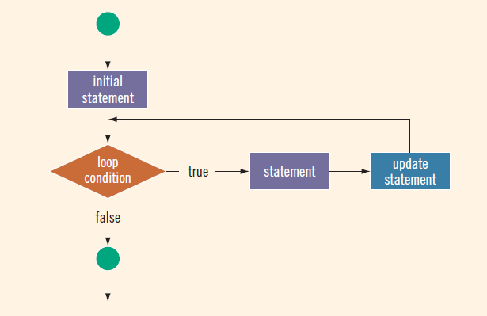

For Example

for (int i = 0; i < 10; i++)
{
cout << i << " ";
}
Sample Run:
0 1 2 3 4 5 6 7 8 9
While Loop (Repetition) Structure
The general form of the while statement is:

while (expression)
{
Statement;
}
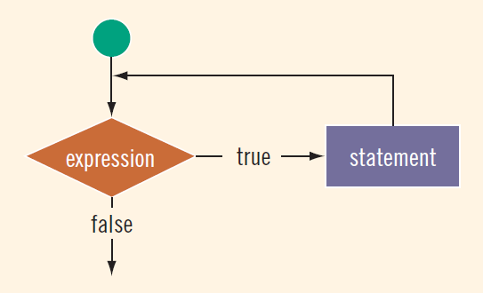
Consider the following C++ program segment: (Assume that i is an int variable.)

For Example
i = 0; //Line 1

while (i <= 20) //Line 2
{
cout << i << " "; //Line 3
i = i + 5; //Line 4
}

Sample Run:
0 5 10 15 20
Do-While Loop (Repetition) Structure
The general form of a do. . .while statement is as follows:
do
{
Statement;
}while (expression);

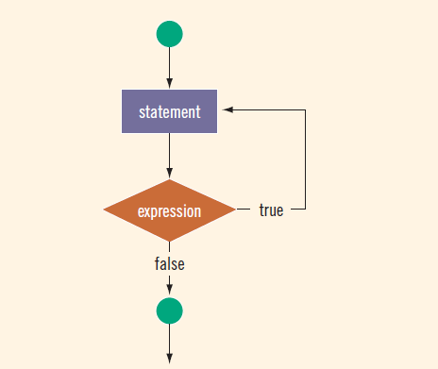

For Example

int i = 25; //Line 1
do //Line 2
{
cout << i << " "; //Line 3
i = i + 5; //Line 4
}
while (i <= 20) ; //Line 4

Sample Run:
25

