**Aim:** The aim of the app is to help college members find a parking spot for their vehicles without a hassle.

**Tools Used:** <https://wireframe.cc/>

**Working of the application:**

1. Only NMIMS members are given login credentials.
2. The user has to login in order to continue further.

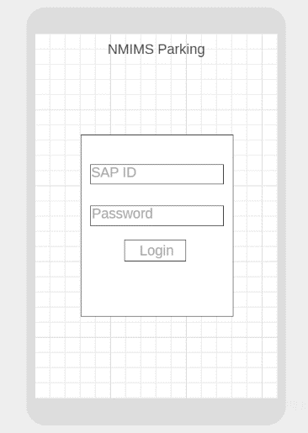

1. Once the user is logged in, the user has an option to choose their vehicle type.

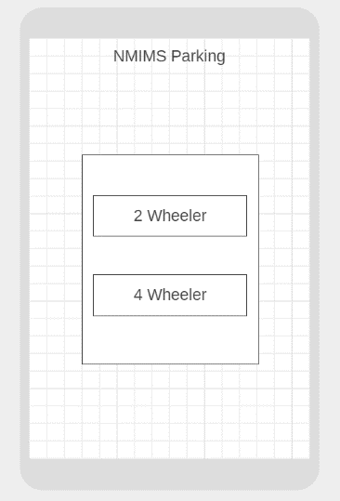

1. The user is shown the summary of parked vehicles and can choose to book a parking spot according to his/her choice.

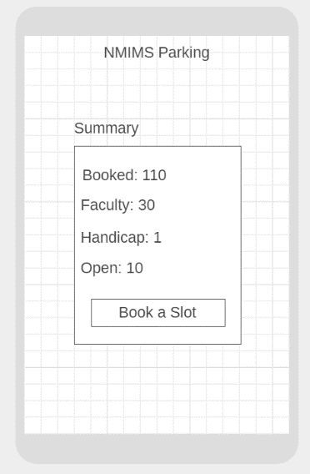

1. The user is shown the direction to the spot via a Google Maps API.

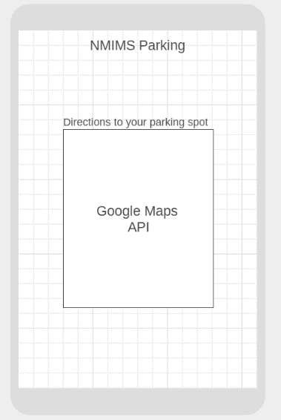

1. The user is shown the location of their parked vehicle and while leaving they must end session so that the parking spot may be shown as available.

