Sherlock: "EasyMoney" - Investigation Writeup

Background
John is an employee at a mid-sized tech company, working as a Senior IT Support Specialist. His passion for finding extra income led him to click on an enticing giveaway link online. When the giveaway yielded nothing, he grew suspicious that something had gone wrong with his machine. Concerned about potential compromise, John reached out to request a formal investigation.

Scope
The investigation was conducted on a forensic copy of the C:\ drive from the compromised system, acquired using KAPE. Fifteen guiding tasks were provided to structure the investigation.

Tools Used

Eric Zimmerman Tools
- EvtxECmd.exe — Event log (.evtx) parsing
- PECmd.exe — Windows Prefetch (.pf) file parsing
- MFTECmd.exe — Master File Table ($MFT) and USN Journal ($J) parsing
- AmcacheParser.exe — Amcache hive parsing
- SrumECmd.exe — SRUM (System Resource Usage Monitor) database parsing
- TimelineExplorer — CSV output viewer and sorter
- Registry Explorer — Registry hive browser

Other Tools
- DB Browser (SQLite) — Browser history database analysis
- Ghidra — Static malware analysis and reverse engineering

Building the Timeline
At the start of the investigation, a timeline of the incident was built using the background story and guiding questions. The following commands were used to collect artifact data from the system:

PECmd.exe -d "C:\Users\Investigate\Desktop\sherlock\EasyMoney\C\Windows\Prefetch" --csv C:\Users\Investigate\Desktop\sherlock\EasyMoney
EvtxECmd.exe -d "C:\Users\Investigate\Desktop\sherlock\EasyMoney\C\Windows\System32\winevt\logs" --csv C:\Users\Investigate\Desktop\sherlock\EasyMoney
MFTECmd.exe -f "C:\Users\Investigate\Desktop\sherlock\EasyMoney\C\$Extend\$J" --csv C:\Users\Investigate\Desktop\sherlock\EasyMoney
MFTECmd.exe -f "C:\Users\Investigate\Desktop\sherlock\EasyMoney\C\$MFT" --csv C:\Users\Investigate\Desktop\sherlock\EasyMoney

The following registry hives were also loaded into Registry Explorer:
C:\Windows\System32\config\DEFAULT
C:\Windows\System32\config\SYSTEM
C:\Windows\System32\config\SOFTWARE
C:\Windows\System32\config\SECURITY
C:\Windows\System32\config\SAM
C:\Users\Administrator\NTUSER.DAT

Investigation Tasks

Task 1 - Time of Malicious Shortcut Execution
Based on the background story, a giveaway-themed file was downloaded and executed by the user. To find the exact execution time, Registry Explorer was used to examine the NTUSER.DAT hive.
Navigating to:
ROOT\SOFTWARE\Microsoft\Windows\CurrentVersion\Explorer\UserAssist
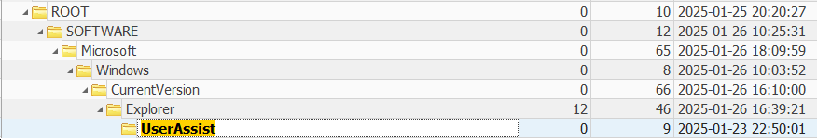
The UserAssist key revealed that a .lnk file named 2025-GiveAways.lnk was executed by the user:
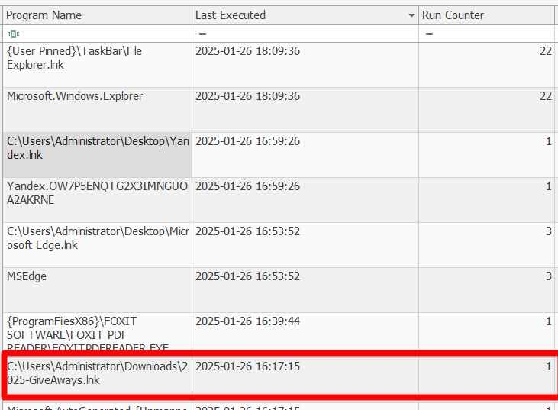
C:\Users\Administrator\Downloads\2025-GiveAways.lnk
Answer: 2025-01-26 16:17:15 (UTC)

Task 2 - Full Path of the Initial Payload
Using the execution timestamp found in Task 1, the $MFT and $J (USN Journal) artifacts were examined for any suspicious file activity in the same timeframe. A file named svch0st.exe was found to have been created shortly after the .lnk execution. The name is a deliberate imitation of the legitimate Windows process svchost.exe — a common attacker technique to avoid suspicion.
The $J file confirmed the file's creation and provided its full path:
Answer: C:\Temp\svch0st.exe

Task 3 - Timestamp of Shell Access
The question hints that the payload established a shell connection to the attacker upon execution. The Last Modified timestamp in the $MFT output for svch0st.exe indicates when it was first executed and a connection was established.
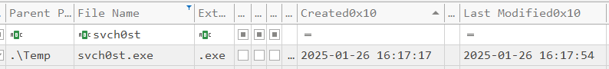
Answer: 2025-01-26 16:17:54 (UTC)

Task 4 - Attacker's Package Enumeration Command
To identify the enumeration command, the parsed event logs (EVTX) were searched for PowerShell activity. The command Get-Package is a well-known attacker technique for enumerating installed software on a Windows system. Filtering the CSV output for this command confirmed its use:
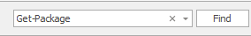
Answer: C:\Windows\System32\WindowsPowerShell\v1.0\powershell.exe -Command Get-Package

Task 5 - Vulnerable Application Identified by Attacker
To answer this question, it was necessary to look ahead in the incident timeline to understand the attacker's objective. Reviewing the event logs for credential-access activity revealed multiple Windows Vault read attempts. Most returned zero credentials, but a small number successfully returned one credential. Examining the first successful read, the responsible executable was identified as part of the Yandex Browser application, and the targeted vault was labeled "Yandex-Browser".
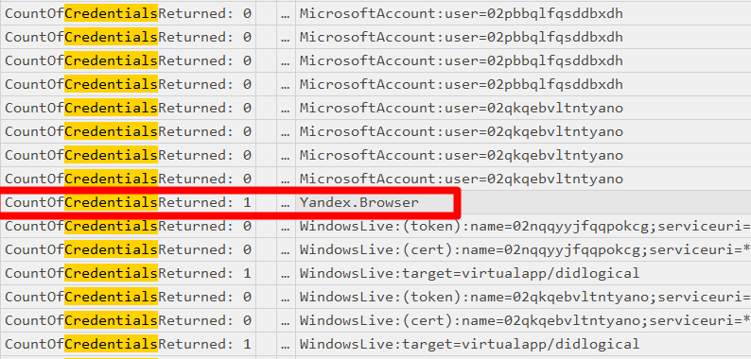
Answer: YandexBrowser

Task 6 - Vulnerable Application Version
To determine the exact version of the installed browser, Registry Explorer was used to examine the NTUSER.DAT hive at the following path:
NTUSER.DAT\Software\Yandex\YandexBrowser
This key contains the YPV (Yandex Package Version) value, which provides the installed version:
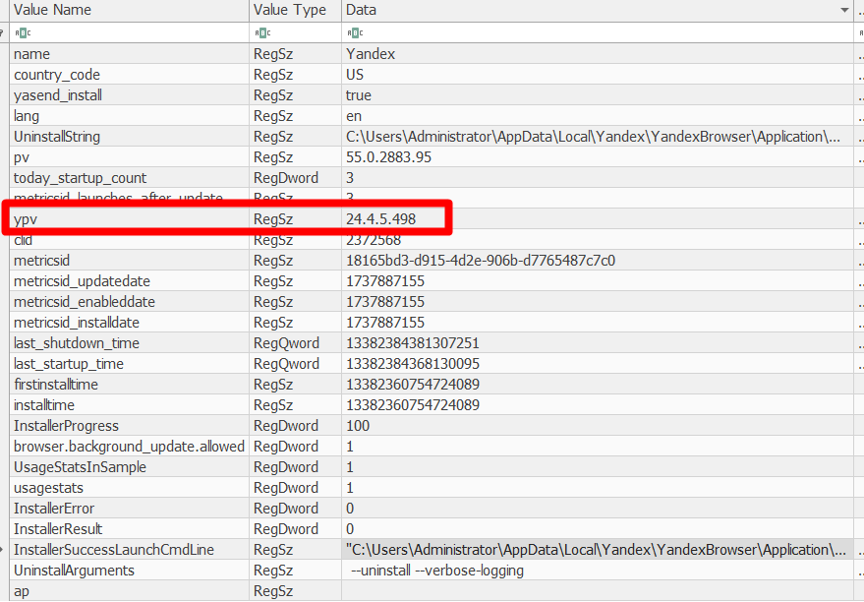
Answer: 24.4.5.498

Task 7 - CVE Associated with the Vulnerability
With the application name and version confirmed, a search was conducted for known vulnerabilities affecting YandexBrowser version 24.4.5.498.
The National Vulnerability Database (NVD) entry at https://nvd.nist.gov/vuln/detail/CVE-2024-6473 describes a DLL Hijacking vulnerability affecting all versions of Yandex Browser for Desktop prior to 24.7.1.380.
The vulnerability is caused by the use of an untrusted search path, allowing an attacker to place a malicious DLL in a directory that the browser loads from.
What is untrusted search path? https://cwe.mitre.org/data/definitions/426.html explain it good.
Answer: CVE-2024-6473

Task 8 - Legitimate Binary Used for Payload Delivery
certutil.exe is a well-known Living-off-the-Land binary (LOLBin) that is commonly abused by attackers to download files while evading detection.
This was confirmed by examining the CryptnetUrlCache - a folder where certutil.exe caches files it downloads, along with their source URLs. The following directories were inspected:
C:\Users\Administrator\AppData\LocalLow\Microsoft\CryptnetUrlCache\MetaData
C:\Users\Administrator\AppData\LocalLow\Microsoft\CryptnetUrlCache\Content
The following PowerShell command was used to extract the download URLs from the metadata files:
Get-ChildItem | ForEach-Object {
$content = Get-Content $_.FullName -Encoding Unicode
if ($content -match "http") {
Write-Host "File: $($_.Name)" -ForegroundColor Cyan
$content | Select-String -Pattern "http[s]?://[^\s]+" -AllMatches | % { $_.Matches.Value }
}
}
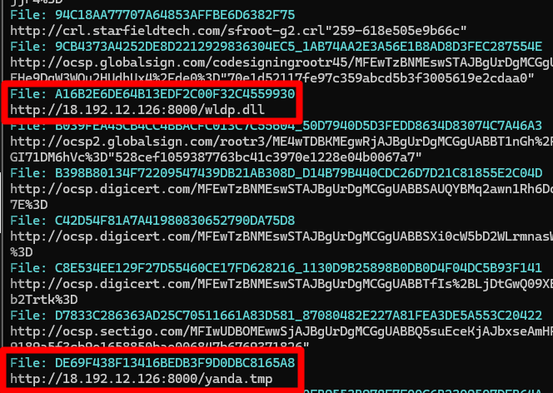
The output revealed two files downloaded from the IP address 18.192.12.126. A reputation check on AbuseIPDB confirmed the IP is associated with an Amazon Web Services (AWS) hosted server being used as a C2 server.
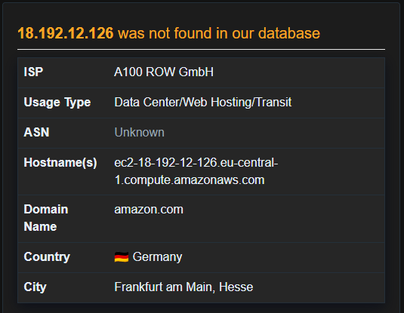
More to that, based on the timeline of the $J file, we see the use of Certutil.exe with the creatin of the suspected payloads:
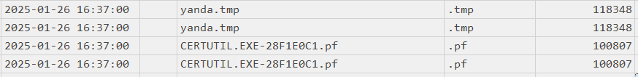
Answer: certutil.exe

Task 9 - Malicious PE File
The previous task identified two files downloaded via certutil.exe. Given that CVE-2024-6473 is a DLL Hijacking vulnerability, the malicious payload is expected to be a DLL. Cross-referencing the downloaded files with the $MFT output confirms that wldp.dll was placed in the YandexBrowser application directory - the exact location the browser searches for DLLs at launch.
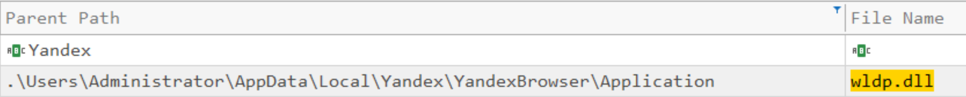
Answer: wldp.dll

Task 10 - SHA-256 Hash of the Malicious File
The malicious wldp.dll was cached in the CryptnetUrlCache Content folder under the filename A16B2E6DE64B13EDF2C00F32C4559930. The SHA-256 hash was obtained using the following PowerShell command:
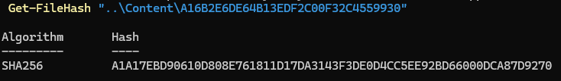
Get-FileHash "..\Content\A16B2E6DE64B13EDF2C00F32C4559930"
Answer: A1A17EBD90610D808E761811D17DA3143F3DE0D4CC5EE92BD66000DCA87D9270

Task 11 - Cumulative Sleep Delays (Milliseconds)
To answer this question, Ghidra was used to statically analyze wldp.dll. After importing the file and running auto-analysis,
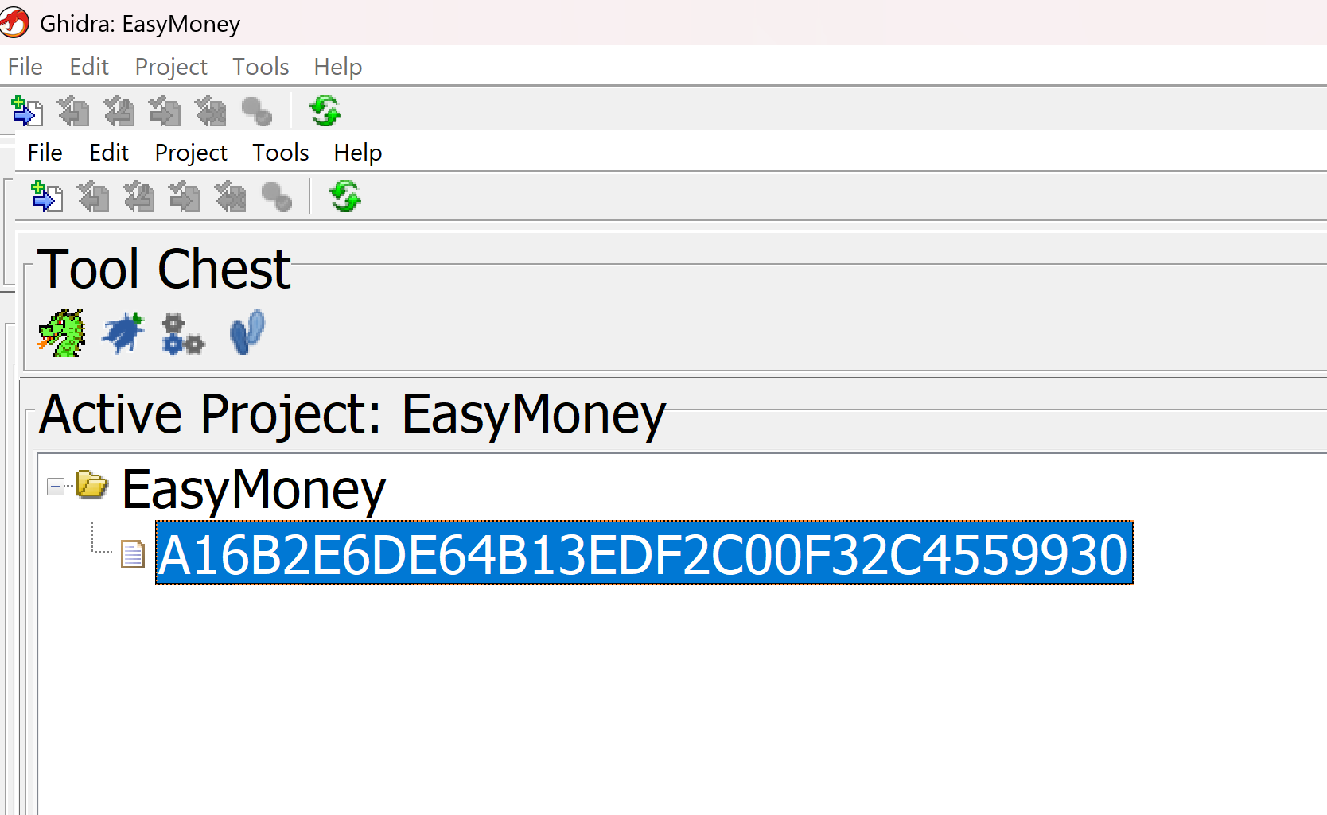
The “Symbol Table” was searched for "Sleep".
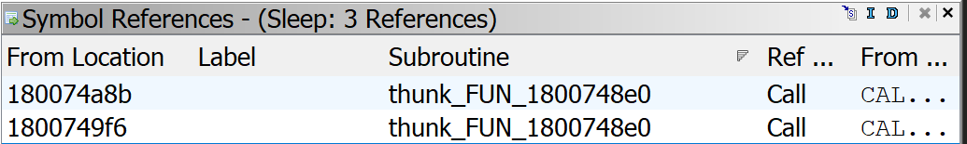
The results showed that the Sleep function from KERNEL32.DLL was called via a thunk wrapper named thunk_FUN_1800748e0.
Two call sites were identified, each loading a hardcoded value into the ECX register before calling Sleep:
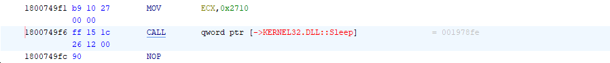
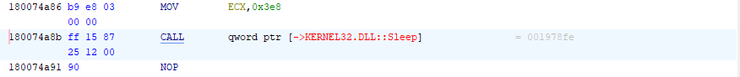
Using the website https://www.rapidtables.com/convert/number/hex-to-decimal.html?x=2710
To convert Hex To Decimal, We need to convert 0x2710 And 0x3E8 to Decimal to get the accurate milliseconds of sleep.
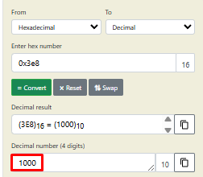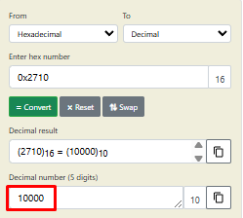
Address | Instruction | Hex Value | Milliseconds
0x1800749F1 | MOV ECX, 0x2710 | 0x2710 | 10,000 ms
0x180074A86 | MOV ECX, 0x3E8 | 0x3E8 | 1,000 ms
 |  | Total: | 11,000 ms

The first Sleep call occurs immediately after CreateProcessW launches browser.exe, giving the browser time to initialize. The second Sleep follows shortly after, allowing the DLL injection into the browser process to complete before the C2 shell becomes active.
Answer: 11,000 milliseconds

Task 12 - Mutex Name
A mutex (mutual exclusion object) is a synchronization mechanism used in programming to ensure that only one instance of a process runs at a time. Malware commonly uses mutexes to prevent multiple copies of itself from running simultaneously.
In Ghidra, the Symbol Table was searched for "Mutex", which revealed a call to CreateMutexW imported from KERNEL32.DLL. Navigating to the call site revealed the following assembly:
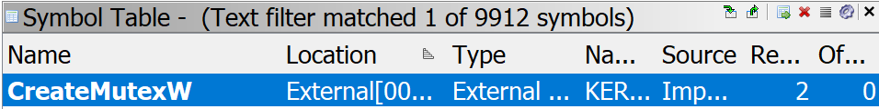
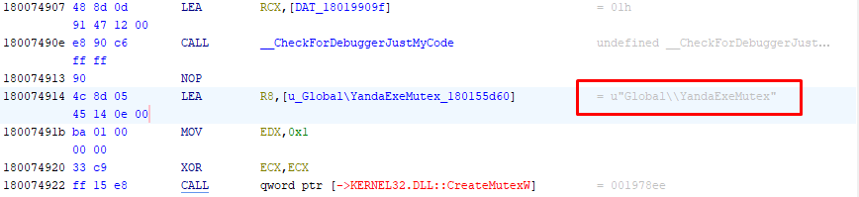
The LEA (Load Effective Address) instruction loads the memory address of the string into register R8, rather than copying the string itself. This is because CreateMutexW expects a pointer to the mutex name, not the name directly.
Answer: Global\\YandaExeMutex

Task 13 - Full Path of the C2 Binary
The CryptnetUrlCache metadata from Task 8 revealed that two files were downloaded from the C2 server: wldp.dll and a second file named yanda.tmp. Two methods were used to find its full path on the system:
Option 1 — $MFT: The Master File Table recorded the full path when the file was written to disk.
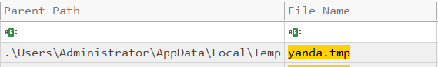
Option 2 — Ghidra: Searching the Defined Strings in wldp.dll (Search → For String → "yanda") revealed the full path hardcoded in the binary.
Answer: C:\Users\Administrator\AppData\Local\Temp\yanda.tmp

Task 14 — C2 Framework
Using the SHA-256 hash of the wldp.dll file (from Task 10), a search was conducted on any.run, which returned an existing sandbox analysis. The analysis identified the implant framework as Sliver.
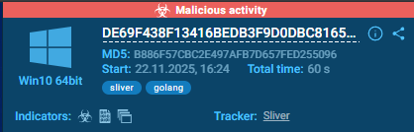
This was further corroborated by static analysis of the binary in Ghidra. The Defined Strings output revealed several Sliver-specific indicators:
- ReconnectInterval protobuf field names - characteristic of Sliver's C2 configuration structure
- lKlZRGX.Envelope - Sliver's internal protobuf message wrapper for C2 communications
- Obfuscated Go package names (e.g., Dzhiga75, qiSH7YAP) - Sliver randomizes package names at compile time
- Supported C2 protocols: mtls, https, tcp, socks5 - all consistent with Sliver's transport options
Answer: Sliver

Task 15 - C2 Server IP Address and Port
The SHA-256 hash of wldp.dll was submitted to VirusTotal. Under the Behavior tab, in the Network Communication section, the C2 server IP address and port were listed as observed connections from sandbox execution.
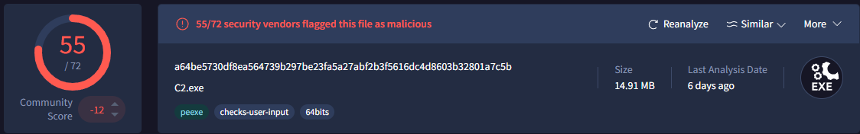
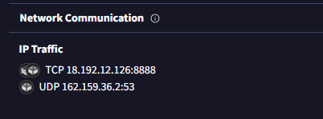
This was also independently confirmed by the CryptnetUrlCache metadata files from Task 8, which recorded the download URLs for both payloads, showing the originating server as 18.192.12.126 on port 8000.
Answer: 18.192.12.126:8888

End of Writeup — Sherlock: EasyMoney

