TASK 1
1. Create a Zip File that is about 1MB, 100MB, and 1GB.
Files should be random sizes between 5k and 10megs before zip operation

- 1MB ZIPPED FILE CREATION
fallocate -l $((1*1024*1024)) zipped1mb.zip
- 1MB ZIPPED FILE CREATION
fallocate -l $((100*1024*1024)) zipped100mb.zip
- 1GB ZIPPED FILE CREATION
fallocate -l $((1000*1024*1024)) zipped1gb.zip

Below is a proof of file size;
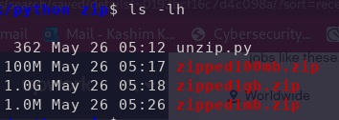

TASK 2
CREATE A PYTHON SCRIPT TO UNZIP FILES
Using Standard Python Library calls Zip the Files and then unzip the files.

Below is a python script to unzip single or multiple files

