Tax Invoice

**Invoice Number:** I2922TE000459893 **PacketID:** 9134997962 **Order Number:** 1175647-5138853-2777501 **Invoice Date:** 15 Jun 2021 **Nature of Transaction:**Inter-State **Order Date:** 15 Jun 2021

**Place of Supply:** MAHARASHTRA **Nature of Supply:** Goods

**Bill to / Ship to: Seller Details:**

# Vaishnavi

Shiv shakti chawl near super modern gas company Wagle I.E. Thane - 400604 MH, India

Tech Connect Retail Pvt Ltd

Survey Numbers 231, 232 and 233,, Soukya Road, Samethanahalli Village, Anugondanahalli Hobli, Hoskote Taluk ., BANGALORE, KARNATAKA-560067

**Customer Type:** Unregistered **GSTIN Number:** 29AAICA4872D1ZK

Qty Gross Amount

Discount Other Charges

Taxable Amount

CGST SGST/ UGST

IGST Cess Total Amount

**BOATHDPH40657142 - boAt BassHeads 220 Orange Tangle-free Wired Earphones with Enhanced Bass &Metal Finish, Size: NO (ONESIZE)**

**HSN: 85183000, 18.0% IGST**

|  |  |  |  |  |
| --- | --- | --- | --- | --- |
| 1 | Rs 999.00 Rs 500.00 | Rs 0.00 Rs 422.88 | Rs 76.12 | Rs 499.00 |
| **TOTAL** | **Rs 999.00 Rs 500.00** | **Rs 0.00 Rs 422.88** | **Rs 76.12** | **Rs 499.00** |

# Tech Connect Retail Pvt Ltd

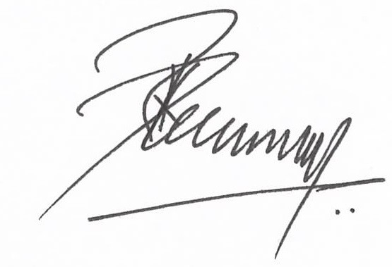

Authorized Signatory

**DECLARATION**

The goods sold as part of this shipment are intended for end-user consumption and are not for retail sale

**Reg Address:** Purchase made on

Tech Connect Retail Pvt Ltd,5A/19,Ground Floor ( Front Portion),Ansari Raod,Daryaganj, , Delhi, Delhi-110002 CIN No. U52100DL2010PTC202600

If you have any questions, feel free to call customer care at **+91 80 6156 1999** or use **Contact Us** section in our App, or log on to [**www.myntra.com/**](http://www.myntra.com/) **contactus**