**Imaging Surface Water in the Mekong River Basin with Multi Scale Remote Sensing**

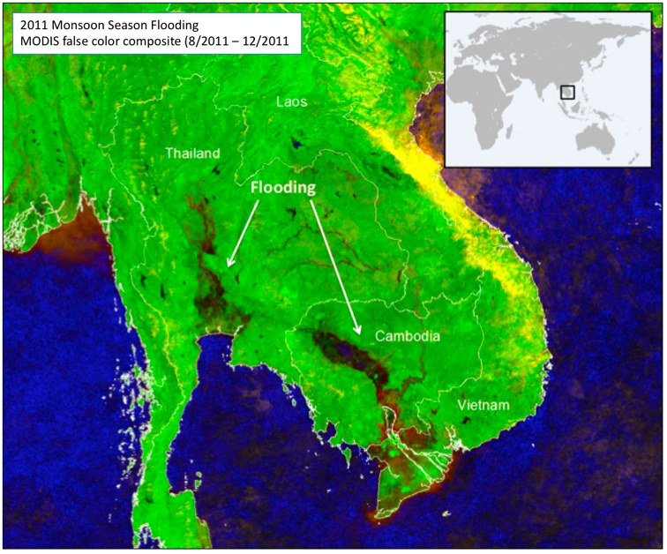

**Funding Agency**: National Geographic

**Grant Amount**: USD $10,000

**Team**

Aakash Ahamed, MSc, Stanford University

Perry Oddo, MSc, NASA Goddard Space Flight Center

Dhyey Bhatpuria, MSc, SEI

John Bolten, PhD, NASA Goddard Space Flight Center

Chippie Kislik, PhD Candidate, UC Berkeley

Thanapon Piman, PhD, SEI

**Study Objectives**

1. Compare surface water extent derived from multiple sensors: (1) drones (cm – m), (2) Landsat / Sentinel (10-30m), (3) MODIS (250m).
2. Image suspended sediment and bank erosion in the Tonle Sap Region.
3. Capture the seasonal cycle, acquiring imagery in monsoon and non-monsoon seasons.
4. [Bonus] Create local Digital Elevation Models using Structure from Motion photogrammetry applied to drone imagery.

**Deliverables**

1. A novel analysis of surface water extent derived from imagery acquired at three spatial scales.
2. All data, analysis code and software, and documentation/materials to replicate the study made available on the web.
3. A white paper or peer reviewed publication describing the acquisition, processing, and classification of surface water extent across three spatial scales.

**Field Sites and Study Dates**

1. 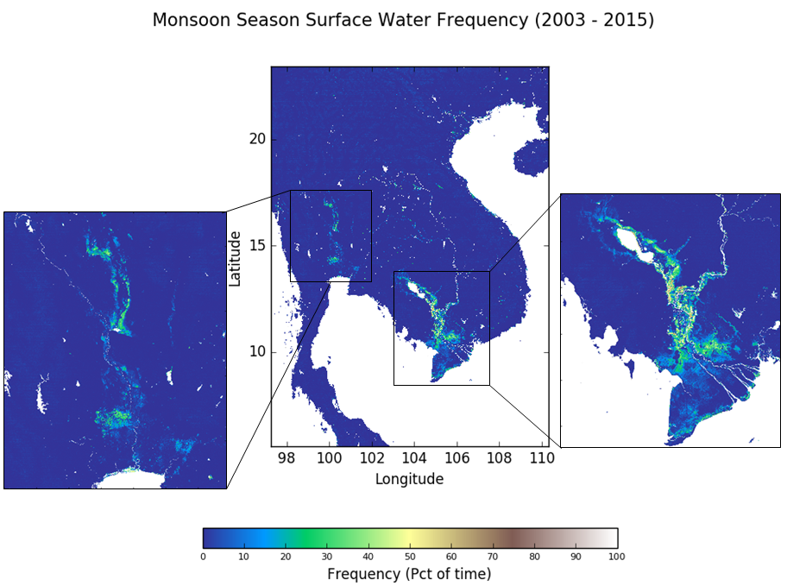Tonle Sap Lake, Cambodia (TBD, TBD)
2. 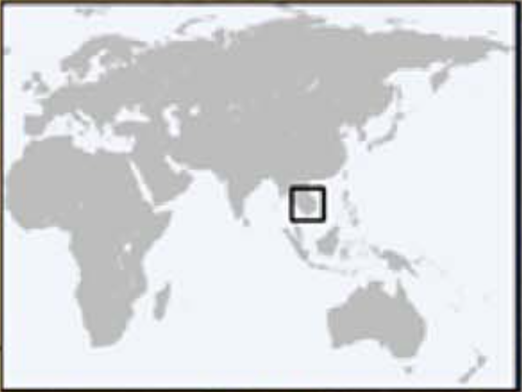Ubon Ratchathani, Thailand (15.268944, 104.985795)
3. Savannakhet, Laos (16.855669, 104.827053)
4. Irawaddy River, Burma (TBD, TBD)

**Supporting Publications:**

Oddo, P. C., Ahamed, A., & Bolten, J. D. (2018). Socioeconomic Impact Evaluation for Near Real-Time Flood Detection in the Lower Mekong River Basin. *Hydrology*, *5*(2), 23.

Ahamed, A., & Bolten, J. D. (2017). A MODIS-based automated flood monitoring system for southeast asia. *International journal of applied earth observation and geoinformation*, *61*, 104-117.

Fayne, J., Bolten, J., Lakshmi, V., & Ahamed, A. (2017). Optical and Physical Methods for Mapping Flooding with Satellite Imagery. In *Remote Sensing of Hydrological Extremes* (pp. 83-103). Springer, Cham.