Airline Passenger Satisfaction
Binary logistic regression driver analysis, with a non-linear benchmark
Kashi Prasad T N | November 2026 | https://github.com/kashiprasadtn/airline-satisfaction-logistic-regression

1. Summary
A binary logistic regression was fitted to 25,976 post-flight survey responses to explain whether a passenger is satisfied (1) or neutral/dissatisfied (0). The model reaches 0.903 test accuracy and 0.966 ROC-AUC, stable across 5-fold cross-validation. Segment variables carry the largest effects. Among controllable items, online boarding and inflight wifi raise the odds of satisfaction about threefold per standard deviation. A gradient-boosting benchmark scores 0.962 accuracy. Most of that gap comes from a step-shaped wifi effect, and encoding ratings as categories recovers about half of it within logistic regression.
Model (test, n = 5,196) | Features | Accuracy | Precision | Recall | Specificity | ROC-AUC
Logistic, complete | 28 | 0.903 | 0.882 | 0.900 | 0.906 | 0.966
Logistic, optimised | 27 | 0.903 | 0.881 | 0.900 | 0.905 | 0.966
Logistic, ratings categorical | 74 | 0.934 | 0.927 | 0.924 | 0.943 | 0.979
Gradient boosting | 27 | 0.962 | 0.966 | 0.947 | 0.974 | 0.994

2. Problem and Data
The business question is which passengers leave satisfied and which parts of the journey drive that outcome. The data has 22 predictors in three groups: passenger and trip attributes (gender, customer type, age, travel type, class, flight distance), 14 service ratings on a 1-5 scale where 0 means not applicable, and departure and arrival delays in minutes. There are 25,976 rows, no duplicates, and 83 missing arrival delays. The class split is 56.1% neutral/dissatisfied and 43.9% satisfied.
Framing. The ratings and the label come from the same post-flight survey, so the model explains satisfaction (a driver analysis) and cannot predict it before a flight.
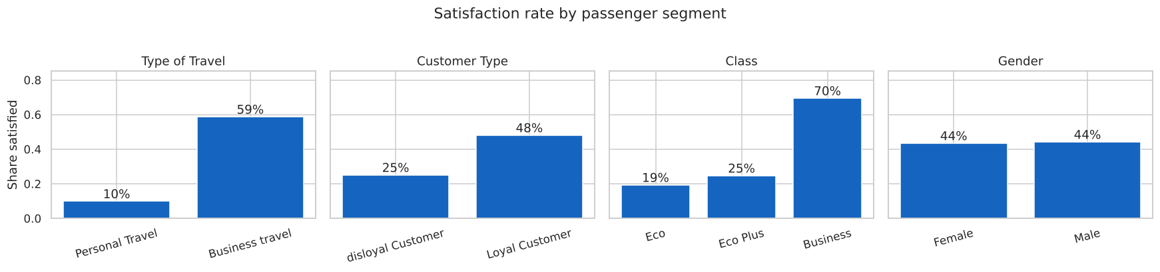
Figure 1. Satisfaction rate by segment

3. Data Quality Findings
- Rating 0 means N/A. The 813 passengers with wifi = 0 are 99.8% satisfied, against 42.1% for those who gave a 1-5 rating. Zeros were recoded as missing and median-imputed. A missing indicator was added for the five ratings with at least 100 N/A rows.
- Delays are near-duplicates (r = 0.965) and extremely skewed (skewness about 7; 56.5% of flights have zero departure delay). A log1p transform was applied.
- Reversed items. Satisfied passengers rate departure/arrival time convenience *lower* than other passengers, and gate location barely differs between the groups.
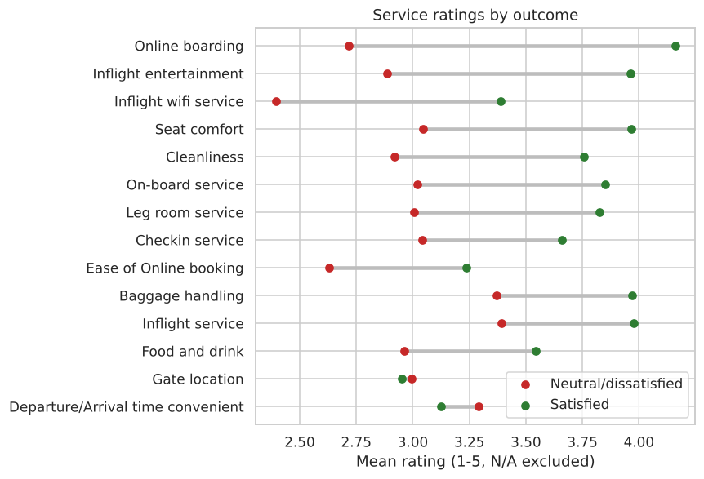
Figure 2. Mean service ratings by outcome (N/A excluded)

4. Method
- Stratified 80/20 split (20,780 / 5,196 rows, random_state = 42).
- A scikit-learn Pipeline holds every fitted step (imputation, log1p, scaling, one-hot encoding with the first level dropped), so cross-validation is leak-free.
- Complete model: LogisticRegression for prediction, plus an unpenalised statsmodels Logit on the same design matrix for odds ratios, 95% CIs and p-values.
- Optimised model: from each numeric pair with |r| > 0.7, drop the feature less correlated with the target; then drop features iteratively while VIF > 5.
- Extensions: a gradient-boosting benchmark (HistGradientBoostingClassifier), a wifi x travel-type cross-tabulation, a logistic model with ratings encoded as categories, and a ranking of controllable drivers.

5. Results

5.1 Complete and optimised models
Complete model: CV accuracy 0.904 ± 0.005, ROC-AUC 0.966 ± 0.003, and McFadden pseudo R² 0.659. The optimisation rules removed only departure delay. With N/A zeros excluded, wifi and online booking correlate below 0.7, and no substantive feature exceeds VIF 5. Performance was unchanged, so the 27-feature model is preferred for simplicity.
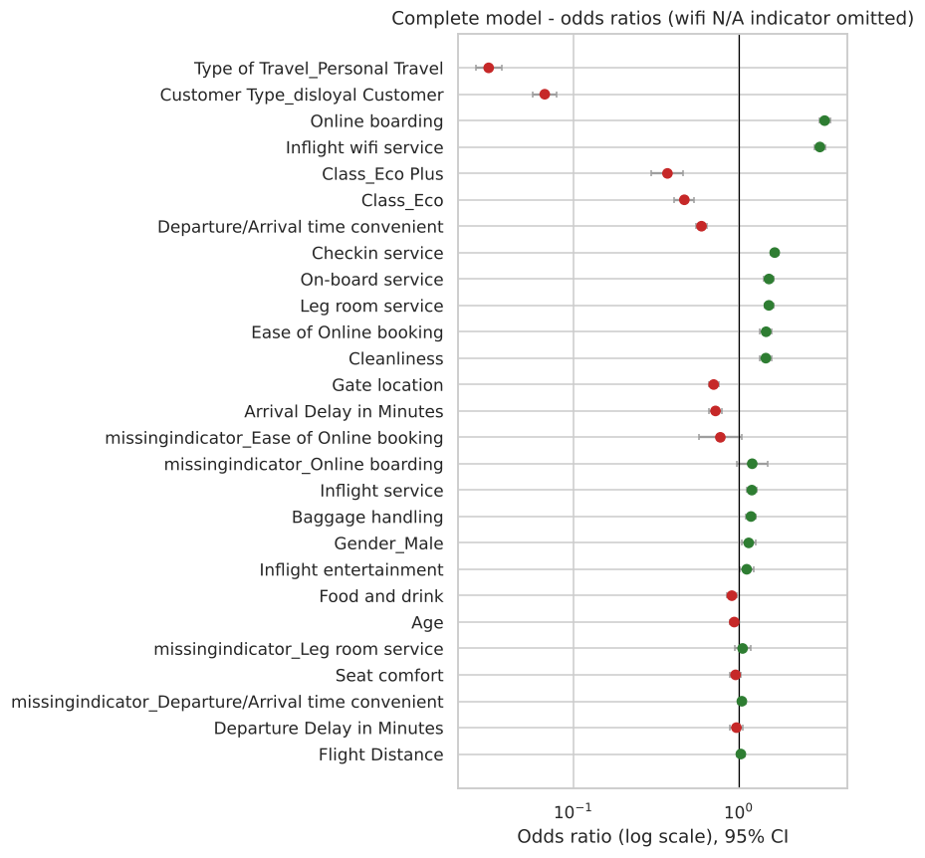
Figure 3. Odds ratios with 95% CI (complete model; numeric features per 1 SD; wifi N/A indicator omitted for scale)

5.2 Drivers
Controllable driver (optimised model) | Odds ratio per 1 SD | 95% CI | p-value
Online boarding | 3.31 | 3.07 - 3.57 | <0.001
Inflight wifi service | 3.10 | 2.86 - 3.36 | <0.001
Check-in service | 1.65 | 1.56 - 1.75 | <0.001
On-board service | 1.52 | 1.42 - 1.63 | <0.001
Leg room service | 1.52 | 1.43 - 1.62 | <0.001
Cleanliness | 1.46 | 1.34 - 1.58 | <0.001
Seat comfort | 0.96 | 0.88 - 1.04 | 0.27
Arrival delay (log) | 0.71 | 0.67 - 0.74 | <0.001
Gate location | 0.71 | 0.66 - 0.76 | <0.001
Departure/arrival time convenient | 0.60 | 0.55 - 0.64 | <0.001

Segment effects are larger still: personal travel has an odds ratio of 0.031 and disloyal customers 0.067. The negative odds ratios for time convenience and gate location match the EDA but have no plausible causal reading. They are reported, not recommended as levers.

5.3 Cost of linearity
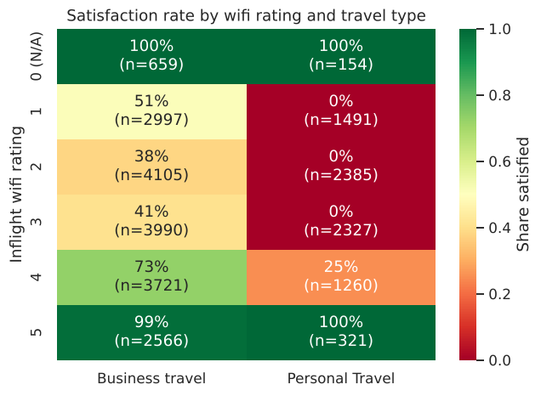
Figure 4. Satisfaction rate by wifi rating and travel type
Gradient boosting reaches 0.962 accuracy against 0.903. The cross-tabulation shows why: personal travellers who rate wifi 1-3 are never satisfied (0 of 6,203), 25% are satisfied at a rating of 4, and all are satisfied at 5 or N/A. A single linear term cannot represent this step. With each rating encoded as a categorical variable, the logistic model reaches 0.934 accuracy and 0.979 ROC-AUC, closing about half the gap while keeping per-level coefficients.
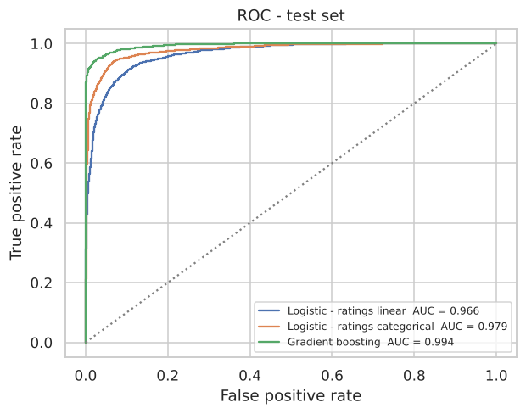
Figure 5. ROC curves on the test set

6. Findings
- Who a passenger is (travel purpose, loyalty, cabin) matters more than any single service item.
- Digital touchpoints lead the controllable levers. Online boarding and wifi each roughly triple the odds of satisfaction per SD; check-in, on-board service and leg room follow at about 1.5x.
- Audit rating scales before modelling. Treating N/A as a zero score would have inverted the wifi effect for 813 passengers.
- Linear does not have to mean linear in the raw score. Categorical encoding captured most of the step effect, so interpretability and accuracy are not a strict trade-off here.

7. Limitations
- Driver analysis only: ratings and the label are collected together after the flight.
- Odds ratios are conditional associations, not causal effects, and two have implausible signs.
- The near-deterministic wifi pattern suggests the dataset is partly synthetic, so the findings describe this dataset rather than airline passengers in general.
- Single sample with no time dimension: the 25,976-row test partition of the public Kaggle dataset.

8. Reproducibility
Python 3.11+, scikit-learn 1.9, statsmodels 0.15, random_state = 42. Running notebooks/airline_satisfaction_logistic_regression.ipynb top to bottom regenerates every figure and table in outputs/ in under a minute.

