Boosting in Practice: AdaBoost, XGBoost and LightGBM
Three boosting algorithms, three business problems, each tested against a simpler or more realistic alternative
Kashi Prasad T N | November 2026 | https://github.com/kashiprasadtn/boosting-adaboost-xgboost-lightgbm

1. Summary
Each project follows the same protocol: choose a primary metric from the business cost of errors, fit a baseline, tune with 5-fold cross-validation on that metric, check for overfitting, and then test the result against an alternative the exercise did not ask for. In all three projects, the alternative changed the conclusion.
Project | Primary metric | Baseline (test) | Tuned (test) | Extension finding
AdaBoost: diamond prices | MAPE | 42.2% | 24.5% | A single depth-3 tree scores 23.2%; gradient boosting on log-price scores 7.0%
XGBoost: insurance charges | MAE (USD) | 2,846 | 2,108 | Linear model + smoker x BMI terms: CV MAE 2,351 vs XGBoost 2,488
LightGBM: bank marketing | ROC-AUC | 0.922 | 0.922 (defaults selected) | Without the leaked duration feature: AUC 0.774, 1.9x top-decile lift

2. AdaBoost: Diamond Prices

Data and metric
53,772 diamonds with carat, cut, colour, clarity, depth percentage, table and x/y/z dimensions. The raw file has two columns named depth, renamed here to depth_pct and z_mm. Price ranges from USD 326 to 18,823 (median 2,401). MAPE is the primary metric because an error of USD 500 matters far more on a USD 1,000 stone than on a USD 15,000 one.

Results
The default AdaBoost (50 depth-3 trees, learning rate 1.0) underfits: train and test MAPE are both about 42%. Tuning over n_estimators, learning_rate and loss selected a learning rate of 0.1 with 50 trees and linear loss, giving test MAPE 24.5% with a 0.06-point gap. Adding trees at the same learning rate made MAPE worse (32.9% with 150 trees). AdaBoost.R2 up-weights large absolute errors, which belong to expensive stones, so each extra round pulls the ensemble towards them.
Model (test set) | MAPE | RMSE (USD) | R²
Baseline AdaBoost | 42.2% | 1,391 | 0.875
Tuned AdaBoost | 24.5% | 1,346 | 0.883
Single tree, depth 3 | 23.2% | 1,389 | 0.876
AdaBoost, depth-6 trees | 17.0% | 903 | 0.947
AdaBoost, depth-10 trees | 10.5% | 622 | 0.975
HistGradientBoosting, log-price | 7.0% | 559 | 0.980

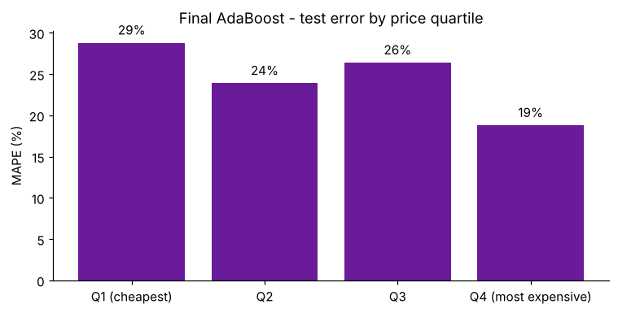
Figure 1. Tuned AdaBoost: test MAPE by price quartile
Finding. With default depth-3 base trees, AdaBoost does not beat a single tree of the same depth. Base-learner capacity, which the grid left fixed, matters far more than the hyperparameters that were tuned. Modelling log-price matches how diamond prices scale and gives the lowest error by a wide margin. Relative error is worst in the cheapest quartile (28.8%).

3. XGBoost: Insurance Charges

Data and metric
1,337 policyholders (one duplicate removed) with age, sex, BMI, children, smoker and region. Smokers are charged 3.8x more on average (USD 32,050 vs 8,441). MAE in dollars is the primary metric, because it reads directly as the size of a mispricing and is less dominated by a few very large claims than RMSE.

Results
Default XGBoost (depth 6) memorises the training data (train MAE USD 489, R² 0.995) and reaches only USD 2,846 and R² 0.850 on the test set. Tuning selected depth 3, learning rate 0.05 and 200 trees (CV MAE USD 2,718). On the test set this gives MAE USD 2,108 and R² 0.917, with no train-test gap. Smoking status carries 89% of the split gain.
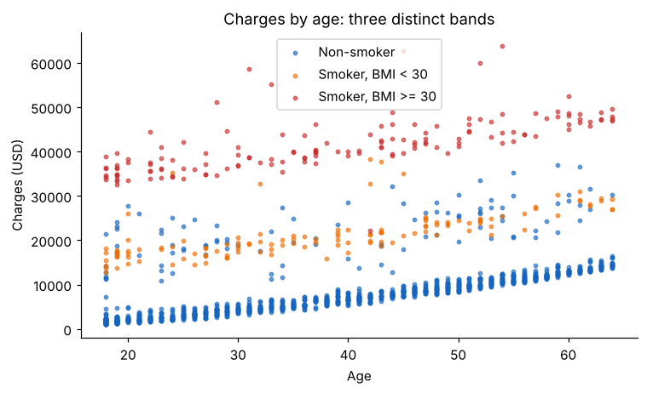
Figure 2. Charges by age form three bands: non-smokers, smokers with BMI < 30, smokers with BMI >= 30
Repeated 5-fold CV (25 fits) | MAE (USD)
Linear regression, raw features | 4,219 ± 222
Linear + smoker x obese, smoker x BMI, age² | 2,351 ± 155
Tuned XGBoost | 2,488 ± 151

Finding. Once the smoker x obesity interaction is written down explicitly, a fully transparent linear model is as accurate as XGBoost, and slightly better on average. The interaction term adds about USD 15,000 a year. For a regulated pricing use case, the linear model is the better choice. The largest errors are among non-smokers (MAE USD 2,166), where some high charges are not explained by any available feature.

4. LightGBM: Bank Marketing

Data and metric
A balanced sample of 11,162 customers (47.4% subscribed) from the UCI Bank Marketing dataset. ROC-AUC is the primary metric, because a campaign team ranks customers and calls from the top of the list.

Results
The baseline reaches a test ROC-AUC of 0.922 (gap 0.047). The 48-combination grid selected exactly LightGBM's defaults, so baseline and tuned models are identical. The duration feature (call length) accounts for 41% of the split gain. But call length is only known after the call, when the outcome is known too. Subscribers' calls last a median of 426 seconds, against 163 for non-subscribers.
Test set | Accuracy | Precision | Recall | F1 | ROC-AUC
With duration (baseline = tuned) | 0.853 | 0.821 | 0.881 | 0.850 | 0.922
Without duration (re-tuned) | 0.724 | 0.765 | 0.601 | 0.673 | 0.774

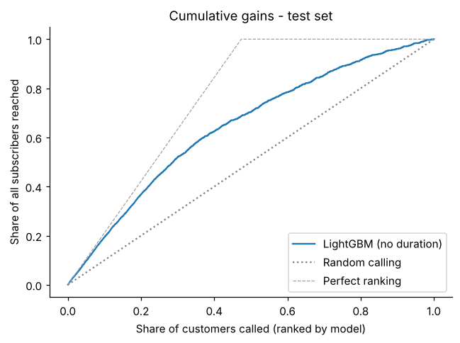
Figure 3. Cumulative gains of the realistic (no-duration) model
Finding. The realistic model's AUC is 0.774, not 0.922. It is still useful: calling the top 10% of the ranked list reaches 19.4% of subscribers (1.9x lift), and the top 30% reaches 51.9%. The data is balanced by design, so probabilities would need recalibrating before use on a real campaign with a lower base rate.

5. Cross-Project Findings
- Tuning results need a reference point. In every project, a simpler model or a single changed assumption mattered more than the tuning grid.
- Overfitting and underfitting both appeared, with different causes. XGBoost's default depth overfits 1,000 rows; AdaBoost's default stumps underfit 50,000.
- Check every feature for whether it is available at prediction time. The most important LightGBM feature could not be used in practice.
- Choose the metric from the business cost of errors. MAPE, MAE and ROC-AUC each led to a different notion of the best model.

6. Limitations
- Single train-test split per project. Repeated CV was used where conclusions depended on small differences.
- Grids are deliberately compact (2-CPU environment).
- Impurity and gain importances are not causal.
- The bank data is a balanced sample; the insurance data is small, with no claims history.

7. Reproducibility
Python 3.11+, scikit-learn 1.9, XGBoost 3.4, LightGBM 4.7, random_state = 42. Each notebook regenerates its outputs/ folder when run top to bottom.

