Customer Segmentation with Hierarchical Clustering
RFM segmentation of an online retailer's customers: linkage comparison and robustness check
Kashi Prasad T N | November 2026 | https://github.com/kashiprasadtn/customer-segmentation-hierarchical-clustering

1. Summary
4,338 customers of a UK online gift wholesaler were segmented by Recency, Frequency and Monetary value (RFM) with agglomerative hierarchical clustering. With log-scaled features and Ward linkage, four segments emerge: Champions, Loyal regulars, Lapsing and Lost / one-off. The Champions are 8% of customers, generate 52.6% of revenue, and are stable across methods. The Lapsing segment holds 26.6% of revenue and is the main reactivation opportunity. Single and average linkage collapse into one giant cluster, so method choice matters more than the algorithm itself.

2. Data
The UCI Online Retail dataset has 541,909 transaction lines (December 2010 to December 2011). Removed: lines without a CustomerID (24.9%), cancellations (1.7%), non-positive quantity (2.0%) or price (0.5%), and exact duplicates (1.0%). That leaves 392,657 lines from 4,338 customers. The UK accounts for 82% of revenue.

3. Method
- RFM per customer: days since last purchase (from the day after the final transaction), number of distinct invoices, and total spend.
- Skew treatment: frequency and monetary skewness of 12.1 and 19.3 were reduced with log(1 + x), followed by standardisation. Raw min-max scaling was kept for comparison.
- Agglomerative clustering with single, complete, average and Ward linkage, compared on cophenetic correlation and cluster sizes at k = 4.
- Number of segments chosen from silhouette scores (k = 2 to 8) and dendrogram merge gaps.
- Segments profiled, named and cross-checked against K-Means with the Adjusted Rand Index.

4. Results

4.1 Linkage comparison
Linkage | Scaling | Cophenetic r | Sizes at k = 4 | Largest share
Single | log + std | 0.488 | 4,333 / 3 / 1 / 1 | 99.9%
Complete | log + std | 0.577 | 2,467 / 1,820 / 47 / 4 | 56.9%
Average | log + std | 0.676 | 4,290 / 44 / 3 / 1 | 98.9%
Ward | log + std | 0.610 | 1,716 / 1,517 / 762 / 343 | 39.6%
Ward | raw min-max | 0.813 | 1,965 / 1,184 / 605 / 584 | 45.3%

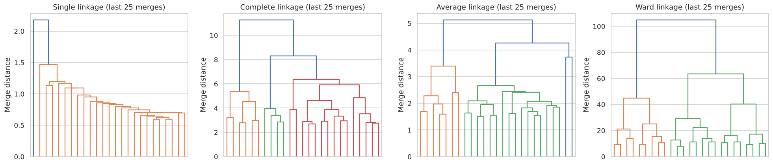
Figure 1. Truncated dendrograms (last 25 merges) for each linkage
Single linkage shows the typical chaining staircase. Higher cophenetic correlation on raw data mostly reflects how faithfully the tree preserves distances to extreme customers, not how useful the segments are. Ward on log-scaled data gives the most balanced and interpretable partition.

4.2 Number of segments
The silhouette score is highest at k = 2 (0.404) and flat at about 0.28 for k = 3 to 5. k = 4 was chosen because it isolates a small, high-value segment without lowering the silhouette. It is a business-driven choice within a statistically flat range.

4.3 Segment profiles
Segment | Customers | Recency | Orders | Spend (GBP) | Revenue share
Champions | 343 (8%) | 9 | 15 | 6,127 | 52.6%
Loyal regulars | 762 (18%) | 8 | 5 | 1,452 | 15.5%
Lapsing | 1,517 (35%) | 67 | 3 | 1,021 | 26.6%
Lost / one-off | 1,716 (40%) | 117 | 1 | 252 | 5.2%

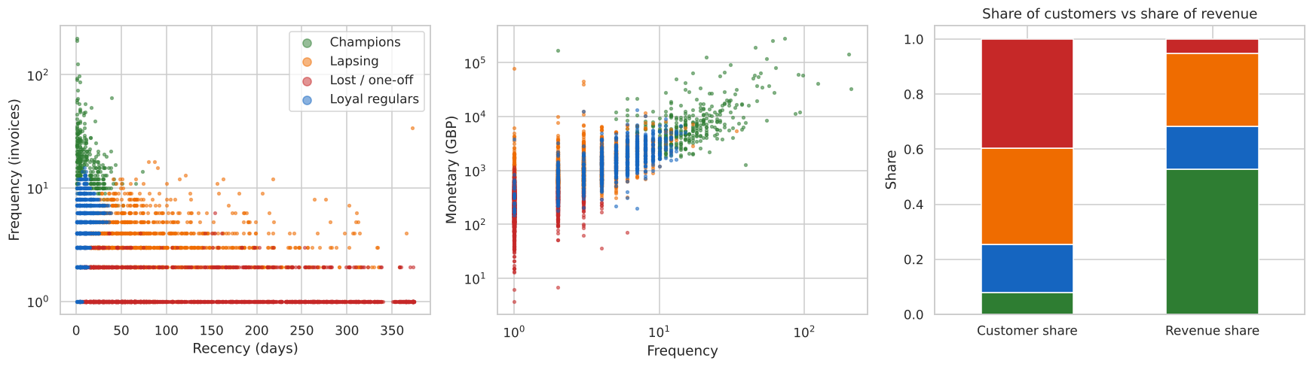
Figure 2. Segments in RFM space, and share of customers vs share of revenue (medians shown in the table)

4.4 Robustness
K-Means with the same k agrees only moderately with Ward (ARI 0.43) and has a higher silhouette (0.337). The Champions segment is robust (340 of 343 customers map to one K-Means cluster), while the boundaries between the other segments depend on the method. Revenue concentration is steep: the top 1% of customers generate 31.8% of revenue, the top 5% generate 50.4%, and the top 20% generate 74.7%.

5. Recommendations
- Champions: dedicated account management and early warning on any drop in order frequency. A few dozen accounts carry a third of revenue.
- Lapsing: targeted reactivation, since these customers have bought several times and still represent a quarter of revenue.
- Loyal regulars: cross-sell and volume incentives to move them towards Champion behaviour.
- Lost / one-off: low-cost automated contact only.

6. Limitations
- A single year from one mostly wholesale UK retailer.
- 25% of transaction lines lack a CustomerID and are excluded.
- RFM ignores margin, product mix and returns.
- Below the Champions, segments are method-dependent.

