Predicting Employee Retention
An interpretable logistic regression attrition-risk model for HR
Kashi Prasad T N | November 2026 | https://github.com/kashiprasadtn/employee-retention-logistic-regression

1. Summary
A logistic regression model was built on 74,498 employee records to estimate each employee's probability of leaving. After RFE and statsmodels checks, the final model uses 15 categorical predictors. All are highly significant, and every VIF is at most 1.2. On a held-out validation set of 22,350 employees, it reaches 0.734 accuracy and 0.825 ROC-AUC at a 0.48 cut-off, matching training performance, and its probabilities are well calibrated across risk deciles.
Metric (cut-off 0.48) | Train | Validation
Accuracy | 0.740 | 0.734
Sensitivity (leavers caught) | 0.735 | 0.732
Specificity | 0.745 | 0.735
Precision | 0.722 | 0.714
ROC-AUC | 0.826 | 0.825

2. Problem Statement
A mid-sized technology company faces high turnover, which disrupts projects and raises recruitment costs. Exit interviews are reactive. HR needs a proactive estimate of attrition risk for each employee, and an understanding of its drivers, to target retention efforts.

3. Data and Cleaning
- 74,610 records and 24 columns covering demographics, job, compensation, performance, workplace sentiment and attrition (47.5% left).
- Removed 112 exact duplicate rows, leaving 74,498.
- Repaired mis-decoded apostrophes in the education labels (Bachelor's, Master's).
- Distance from Home (2.6%) and Company Tenure (3.2%) had missing values. These were imputed with training-set medians after the split. Missing tenure was associated with lower attrition (37% vs 48%).
- Data-quality flag: for 84% of rows, Years at Company exceeds Company Tenure. Both cannot be correct, which suggests synthetic data.

4. EDA Highlights (training set)
The numeric features correlate only weakly with attrition (|r| ≤ 0.09). Categorical features carry the signal. The largest gaps in attrition rate are by job level (entry 63% vs senior 20%), marital status (single 67% vs married 36%), remote work (on-site 53% vs remote 25%), education (PhD 24%) and work-life balance (poor 60% vs excellent 36%). Validation-set distributions match the training set (all KS statistics below 0.01).
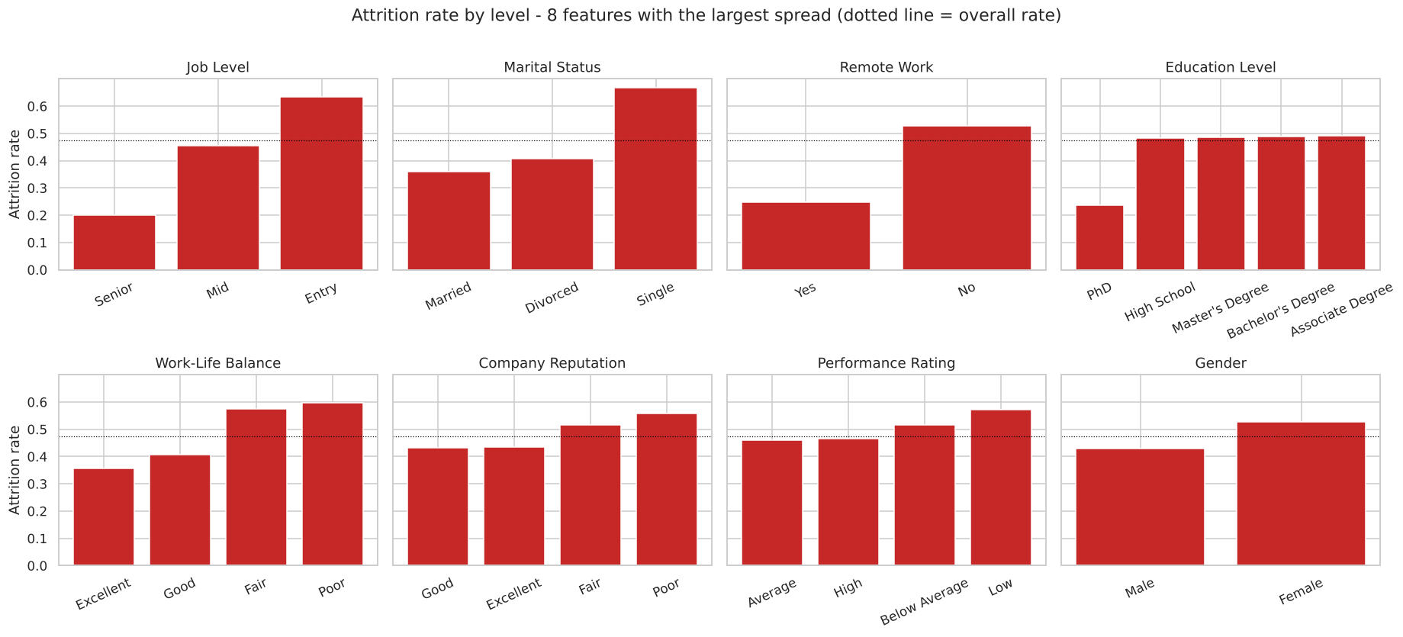
Figure 1. Attrition rate by level for the eight features with the largest spread

5. Model Building
- Binary columns encoded 0/1; multi-level categoricals one-hot encoded with the first level dropped (41 predictors).
- Numeric features standardised (fitted on train).
- RFE selected 15 features, all categorical dummies.
- statsmodels Binomial GLM with iterative pruning while p > 0.05 or VIF > 5. No feature needed removal (largest p = 1.8e-26, largest VIF = 1.20).
- Cut-off chosen where sensitivity equals specificity on training data: 0.48.
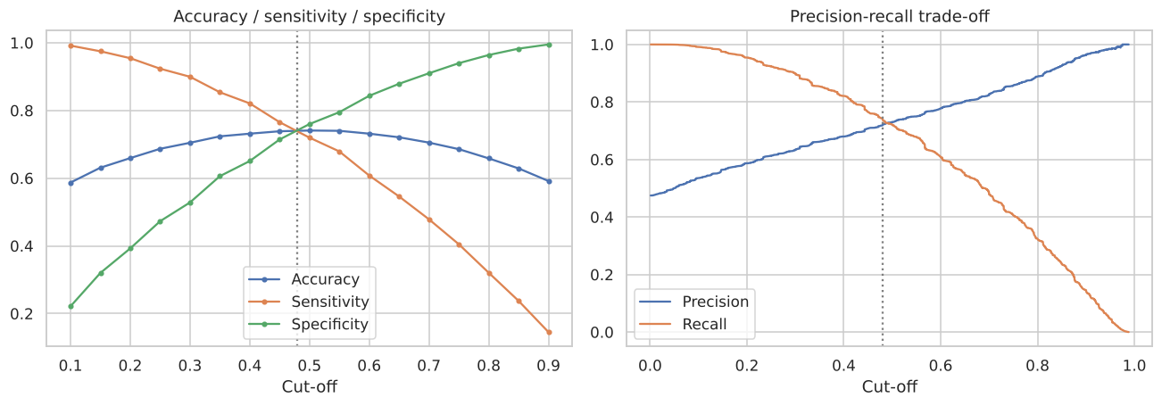
Figure 2. Cut-off selection: accuracy, sensitivity, specificity and precision-recall trade-off

6. Drivers of Attrition
Feature (reference level) | Odds ratio | 95% CI
Job level: Senior (Entry) | 0.08 | 0.07 - 0.09
Remote work: Yes | 0.18 | 0.17 - 0.19
Education: PhD (Associate) | 0.21 | 0.18 - 0.23
Job level: Mid (Entry) | 0.38 | 0.37 - 0.40
Gender: Male (Female) | 0.56 | 0.54 - 0.59
Overtime: Yes | 1.41 | 1.35 - 1.48
Job satisfaction: Low (High) | 1.61 | 1.50 - 1.72
Job satisfaction: Very High (High) | 1.62 | 1.54 - 1.71
Performance: Low (Average) | 1.75 | 1.59 - 1.93
Company reputation: Poor (Excellent) | 2.11 | 1.99 - 2.22
Work-life balance: Fair (Excellent) | 2.93 | 2.79 - 3.08
Work-life balance: Poor (Excellent) | 3.40 | 3.19 - 3.63
Marital status: Single (Divorced) | 5.40 | 5.15 - 5.66

Job level, remote work and work-life balance can be influenced by HR policy. The fact that very high satisfaction raises the odds as much as low satisfaction is not plausible, and it mirrors the raw data, which again suggests synthetic data.

7. Validation and Use
On validation, the model catches 7,766 of 10,611 leavers (73.2%) with 73.5% specificity, nearly identical to training. Against benchmarks, an L2 logistic regression on all 41 features reaches AUC 0.840 and gradient boosting 0.847. The 15-feature model gives up about 0.02 AUC for a short, defensible driver list.
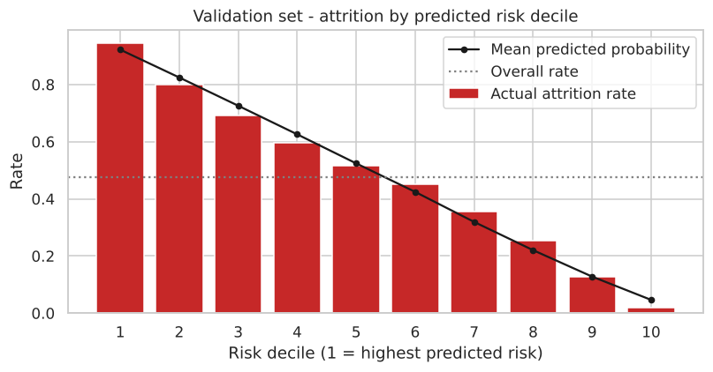
Figure 3. Actual vs predicted attrition by risk decile (validation)
Predicted and actual rates agree within about 4 points in every decile. The top decile has 94.5% actual attrition and the bottom decile 1.8%. Retention effort focused on the top 30% of employees by risk would reach 51% of all leavers.

8. Recommendations
- Prioritise entry-level and single employees in the top risk deciles for stay interviews and career-path conversations.
- Expand remote and hybrid options. Remote work is the strongest controllable protective factor (OR 0.18).
- Treat poor or fair work-life balance and overtime as early-warning signals in engagement surveys.
- Do not use gender or marital status for decisions about individuals. Refit without them and run a fairness audit before deployment.

9. Limitations
- Indicators of synthetic data (inconsistent tenure fields, non-monotonic satisfaction effect).
- A snapshot with no time-to-event information.
- Median imputation removes a small missingness signal.

