Aerial Image Segmentation: Fuzzy C-Means vs K-Means
What soft cluster memberships add to a colour-based land-cover segmentation
Kashi Prasad T N | November 2026 | https://github.com/kashiprasadtn/image-segmentation-fuzzy-c-means

1. Summary
The 40,000 pixels of an aerial photograph were clustered by colour with K-Means (hard assignment) and Fuzzy C-Means (soft membership). Once FCM memberships are hardened, the two segmentations agree on 99.25% of pixels at three clusters. FCM's distinctive contribution is an uncertainty map: 10.9% of pixels have no dominant class (maximum membership below 0.6). These pixels lie on land-cover boundaries and are where the two methods disagree.

2. Method
Fuzzy C-Means minimises J = Σᵢ Σⱼ uᵢⱼᵐ · ‖xᵢ − cⱼ‖², the sum of membership-weighted squared distances, where each pixel's memberships uᵢⱼ sum to 1. It alternates between computing centroids as membership-weighted means and updating memberships from relative distances. The fuzzifier m (> 1) controls softness: as m approaches 1 the method behaves like K-Means. The fuzzy partition coefficient (FPC), the mean of squared memberships, measures crispness on a scale from 1/c to 1.
- Pixels reshaped to a 40,000 x 3 RGB matrix.
- Number of clusters assessed with K-Means inertia, the silhouette score (5,000-pixel sample) and the FCM partition coefficient for 2 to 8 clusters.
- Both methods run at 3 and 5 clusters. FCM labels aligned to K-Means labels by Hungarian matching on the contingency table.
- Membership maps produced, with ambiguous pixels defined as maximum membership below 0.6.
- Fuzzifier swept from 1.25 to 3.0.

3. Choosing the Number of Clusters
Clusters | Inertia drop | Silhouette (K-Means) | FCM partition coefficient
2 | - | 0.573 | 0.832
3 | 44.3% | 0.488 | 0.745
4 | 31.4% | 0.442 | 0.684
5 | 28.1% | 0.439 | 0.657
6 | 20.1% | 0.406 | 0.617

The silhouette and partition coefficient both decline steadily, as expected for continuous colour data. The largest inertia drop is at three clusters, which also gives an interpretable split: dark tree cover and shadow (28% of pixels), mid-tone fields and scrub (36%), and bright bare soil and paths (36%).

4. Results
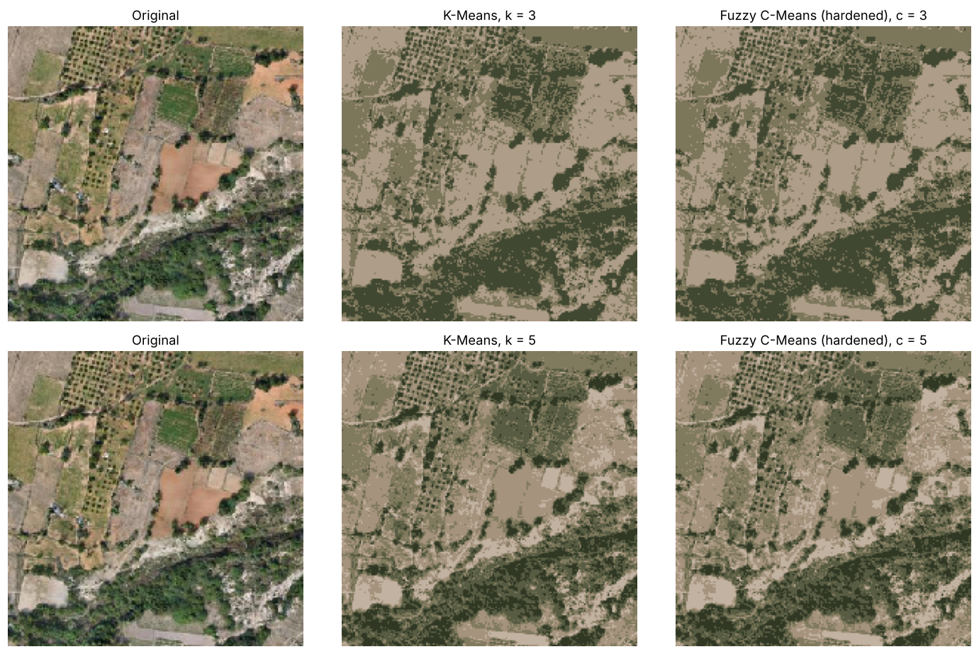
Figure 1. Segmentations painted with centroid colours: K-Means vs hardened FCM at 3 and 5 clusters
Hard-label agreement is 99.25% at three clusters (299 pixels differ) and 97.7% at five (916 pixels).
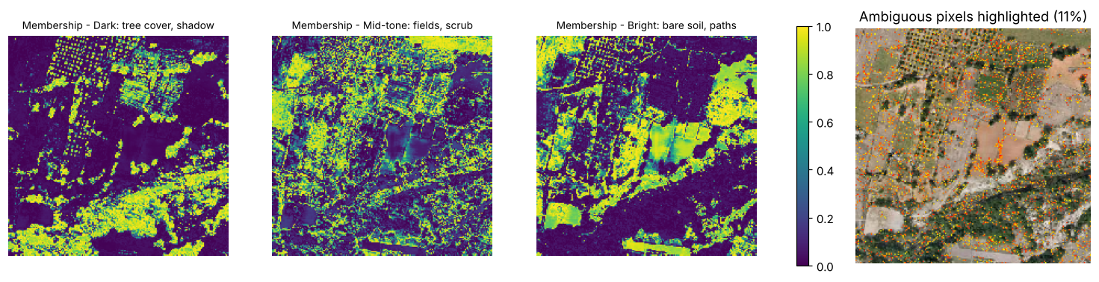
Figure 2. FCM membership maps and ambiguous pixels (max membership < 0.6)
Ambiguous pixels follow field boundaries, orchard rows and the scrub-to-bare-ground transition. Where K-Means and FCM disagree, the mean maximum membership is 0.49, against 0.83 where they agree. The membership values identify the pixels a hard classifier is most likely to get wrong.
Fuzzifier m | Partition coefficient | Ambiguous pixels | Agreement with K-Means
1.25 | 0.951 | 2.0% | 99.5%
1.5 | 0.893 | 4.3% | 99.4%
2.0 | 0.745 | 10.9% | 99.3%
2.5 | 0.615 | 20.7% | 99.0%
3.0 | 0.526 | 34.7% | 98.6%

5. Findings
- For segmentation alone, Fuzzy C-Means and K-Means are practically equivalent on this image.
- FCM's value is a pixel-level confidence map that marks mixed and boundary pixels, which is useful for directing manual review or higher-resolution acquisition.
- The fuzzifier controls the size of that review set (2% to 35% of pixels) without altering the segmentation.

6. Limitations
- Colour features only, with no texture or spatial context.
- No ground-truth land-cover labels; results are agreement and uncertainty, not accuracy.
- A single 200 x 200 image of unknown provenance.

