K-Means Clustering: Census Districts and Car Segments
Choosing K from several criteria, interpreting centroids and checking stability
Kashi Prasad T N | November 2026 | https://github.com/kashiprasadtn/kmeans-clustering-census-cars

1. Summary
K-Means was applied to two datasets with a common protocol: standardise the features, choose K from inertia, the silhouette score and interpretability together, report centroids in original units, and test stability across 20 random seeds with the Adjusted Rand Index (ARI). Both segmentations are highly reproducible (mean ARI of 0.995 or more). The census profiles are only moderately separated (silhouette 0.28), while the car segments are well separated (0.45).

2. Method: K-Means
K-Means alternates between assigning each point to its nearest centroid and moving each centroid to the mean of its points, which minimises the within-cluster sum of squares (WCSS). Because it uses Euclidean distance, features on large scales would dominate, so all features were standardised. K-Means assumes compact, roughly spherical clusters, and the result depends on initialisation; both points are checked below.

3. Census Districts
640 districts across 35 states and union territories, with four indicators: literacy rate, women per 1,000 men, share with primary education only, and share aged below 29. Literacy and youth share are strongly negatively correlated (r = -0.71).
K | WCSS | Drop from K-1 | Silhouette
2 | 1,720 | - | 0.300
3 | 1,413 | 307 | 0.275
4 | 1,150 | 263 | 0.280
5 | 1,028 | 121 | 0.247
6 | 922 | 106 | 0.236

K = 4 was selected: it is the last large WCSS drop, it has a local silhouette peak, and every cluster is large enough to interpret (the smallest has 114 districts).
Profile | Districts | Literacy | F per 1,000 M | Primary-only | Aged < 29
Low literacy, young | 242 | 53% | 938 | 15% | 63%
High literacy, female-majority | 156 | 71% | 1,003 | 17% | 52%
High literacy, male-skewed | 114 | 68% | 876 | 15% | 58%
Average literacy, high primary-only share | 128 | 66% | 950 | 23% | 60%

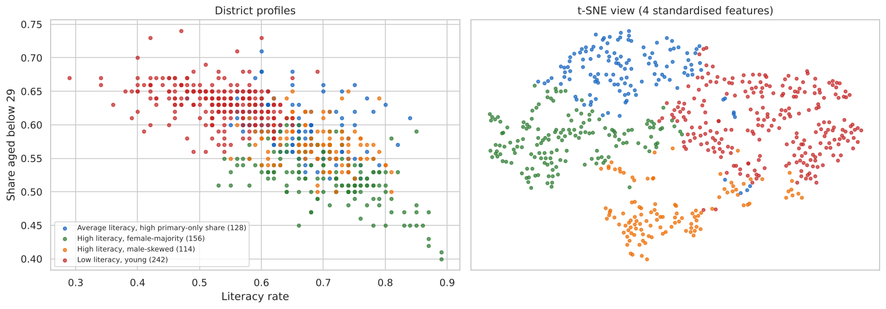
Figure 1. District profiles: literacy vs youth share, and a t-SNE view
Without any geographic input, the profiles reproduce known regional patterns. Low literacy and young populations dominate in Uttar Pradesh, Madhya Pradesh, Bihar and Rajasthan. High literacy with a female majority is concentrated in the southern states. Male-skewed gender ratios lead in Haryana and Punjab. Uttar Pradesh, Maharashtra, Odisha, Karnataka and Assam each span three or four profiles. Stability across seeds is high (mean ARI 0.995, minimum 0.975).

4. Car Segments
205 cars described by engine size, horsepower and city and highway mileage. 94 rows repeat another car's specification, leaving 111 distinct points. Following the exercise, K-Means used random initialisation (random_state 9001, n_init 10), and K was set to the value with the largest drop in inertia.
K | Inertia | Drop from K-1 | Silhouette
2 | 385.2 | - | 0.471
3 | 234.5 | 150.8 | 0.454
4 | 174.1 | 60.3 | 0.434
5 | 137.3 | 36.8 | 0.429

Segment | Cars | Engine size | Horsepower | City mpg | Highway mpg
Economy | 61 | 95 | 67 | 33 | 39
Mainstream | 98 | 120 | 99 | 24 | 29
Performance | 46 | 183 | 164 | 18 | 23

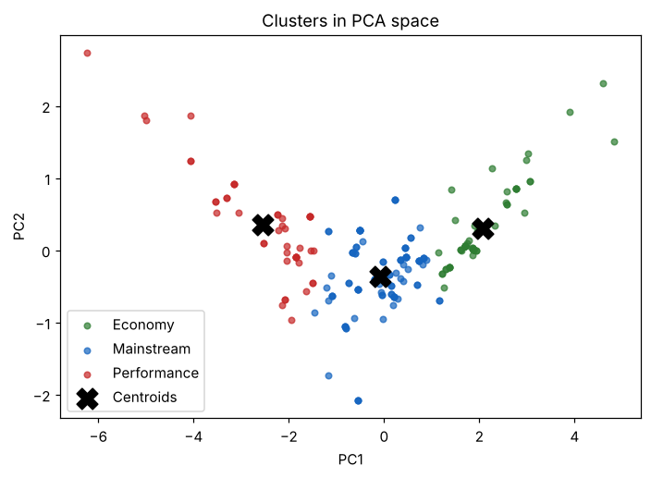
Figure 2. Car segments in PCA space (PC1 + PC2 = 95.2% of variance)
PC1 alone carries 83.7% of the variance: engine size and horsepower load negatively and both mileage figures positively. The cars therefore lie along a single size-versus-efficiency axis, and the three segments cut it into bands. Stability is very high (mean ARI 0.998).

5. Findings
- Choosing K from several criteria gave a defensible choice in both cases. The silhouette alone would have chosen K = 2 for both datasets, which is less useful in practice.
- High stability does not imply sharp separation. The census profiles are reproducible but describe a continuum.
- Centroids reported in original units turn clusters into actionable segment descriptions.

6. Limitations
- Four features per dataset; districts are not weighted by population.
- K-Means assumes spherical clusters of similar size; the census groups have soft boundaries.
- The car data includes many duplicate specifications and lacks price, body type and brand.

