Loan Approval Prediction with Random Forest
Baseline vs tuned Random Forest, benchmarked against a one-line credit-history rule
Kashi Prasad T N | November 2026 | https://github.com/kashiprasadtn/loan-approval-random-forest

1. Summary
A Random Forest classifier was trained to predict loan approval (1) or rejection (0) from 11 applicant, income, loan and property attributes on 480 applications. Tuning removed most of the baseline model's overfitting and raised test F0.5 from 0.843 to 0.857. A benchmark the exercise did not ask for changes the picture: the rule approve if Credit_History = 1 matches the tuned forest on F0.5, F1 and accuracy under repeated cross-validation. The forest's measurable advantage is ranking quality (ROC-AUC 0.764 vs 0.702), which makes it useful as an adjustable risk score rather than as a better yes/no classifier.
Model (test set, n = 96) | Accuracy | Precision | Recall | Specificity | F0.5 | ROC-AUC
Credit-history rule | 0.833 | 0.821 | 0.970 | 0.533 | 0.847 | 0.752
Baseline Random Forest | 0.792 | 0.838 | 0.864 | 0.633 | 0.843 | 0.801
Tuned Random Forest | 0.823 | 0.845 | 0.909 | 0.633 | 0.857 | 0.795

2. Problem and Data
The target is loan status: 1 = approved, 0 = rejected. The dataset has 480 rows and 11 predictors (gender, marital status, dependents, education, self-employment, applicant income, co-applicant income, loan amount, loan term, credit history, property area), with no missing values or duplicates. The data is a 480-row version of the public Loan Prediction practice dataset (Dream Housing Finance), provided through upGrad coursework.
- Class balance: 332 approved (69.2%), 148 rejected (30.8%).
- Applicants without a credit history are approved 10% of the time (7 of 70); applicants with one are approved 79% of the time (325 of 410).
- Incomes are heavily right-skewed (applicant income median 3,859, maximum 81,000). Tree models do not need this corrected.
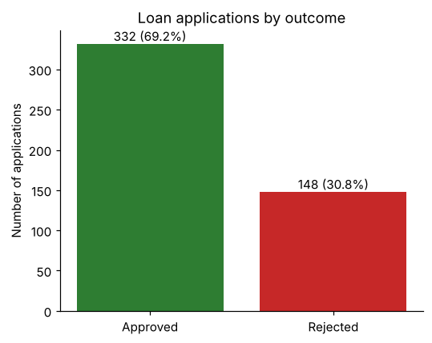
Figure 1. Class distribution

3. Method

3.1 Choice of evaluation metric
The primary metric is F0.5 on the approved class. For a lender, approving an application that should have been rejected (a false positive) costs more than declining a good one. F0.5 weights precision twice as heavily as recall. Unlike precision alone, it still penalises a model that rejects nearly everyone. Accuracy, precision, recall, specificity, F1 and ROC-AUC are reported alongside it.

3.2 Pipeline
- Stratified 80/20 train-test split (384 / 96 rows, random_state = 42).
- Encoding fitted on the training set only. Binary columns are mapped to 0/1, Dependents to an ordinal integer (3+ becomes 3), and Property_Area is one-hot encoded. The test set is re-indexed to the training schema.
- Baseline: RandomForestClassifier with default hyperparameters.
- Tuning: GridSearchCV over n_estimators, max_depth, min_samples_split, min_samples_leaf and class_weight (144 combinations), using stratified 5-fold CV with F0.5 scoring.
- Evaluation on the held-out test set, then four checks beyond the exercise: a one-rule benchmark, repeated stratified CV (5 folds x 10 repeats), a threshold analysis on out-of-fold training probabilities, and permutation importance on the test set.

4. Results

4.1 Baseline vs tuned
Metric | Baseline train | Baseline test | Tuned train | Tuned test
Accuracy | 1.000 | 0.792 | 0.883 | 0.823
Precision | 1.000 | 0.838 | 0.867 | 0.845
Recall | 1.000 | 0.864 | 0.981 | 0.909
F1 | 1.000 | 0.851 | 0.921 | 0.876
F0.5 | 1.000 | 0.843 | 0.888 | 0.857
Specificity | 1.000 | 0.633 | 0.661 | 0.633
ROC-AUC | 1.000 | 0.801 | 0.980 | 0.795
F0.5 train-test gap | 0.157 |  | 0.031

The baseline memorises the training data (all metrics 1.000). The best grid configuration differs from the defaults only in min_samples_split = 10, which reduces the F0.5 gap fivefold. The top five grid configurations score within 0.002 of each other, inside the cross-validation standard deviation of about 0.03, so the tuning surface is flat.
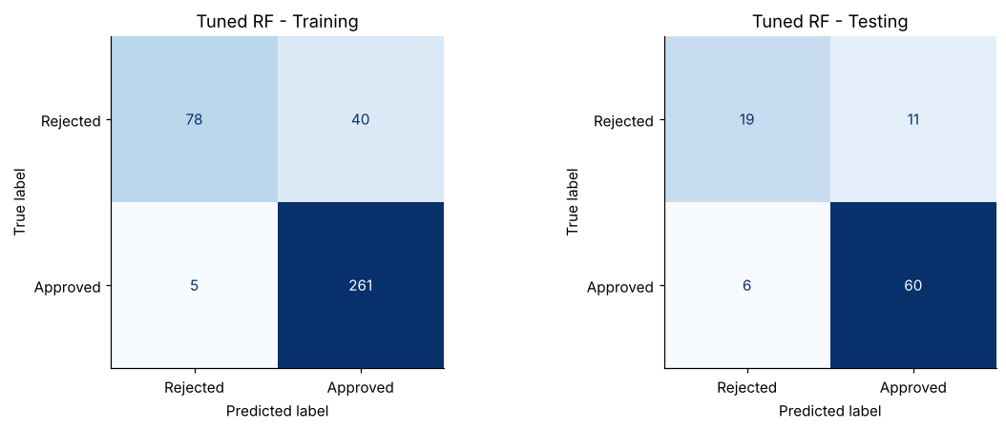
Figure 2. Tuned model confusion matrices. On the test set it rejects 19 of 30 applications that should be rejected and approves 60 of 66 good ones.
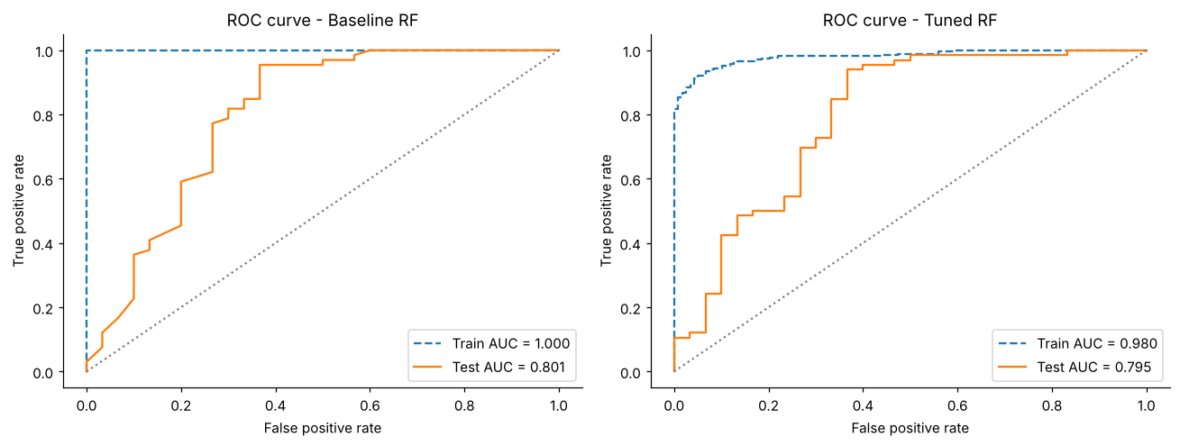
Figure 3. ROC curves. Probability ranking still overfits after tuning (train AUC 0.980, test 0.795).

4.2 Stability under repeated cross-validation (50 fits)
Metric | Baseline RF | Tuned RF | Credit-history rule
F0.5 | 0.823 ± 0.027 | 0.827 ± 0.028 | 0.825 ± 0.025
F1 | 0.858 ± 0.025 | 0.872 ± 0.021 | 0.876 ± 0.019
Accuracy | 0.788 ± 0.037 | 0.804 ± 0.035 | 0.808 ± 0.032
ROC-AUC | 0.759 ± 0.064 | 0.764 ± 0.058 | 0.702 ± 0.049

4.3 Decision threshold
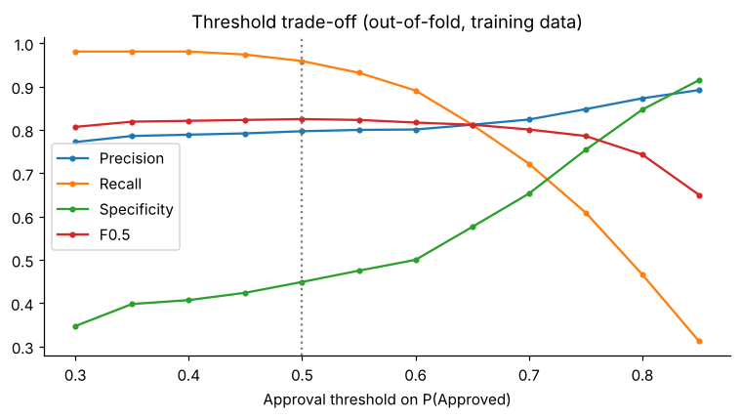
Figure 4. Out-of-fold threshold trade-off on training data
At the default 0.50 threshold the model approves 83% of applicants, with specificity 0.449. At 0.75, precision rises to 0.848 and specificity to 0.754, but only half of applicants are approved and recall falls to 0.609. The threshold moves outcomes far more than any hyperparameter in the grid.

4.4 What drives the predictions
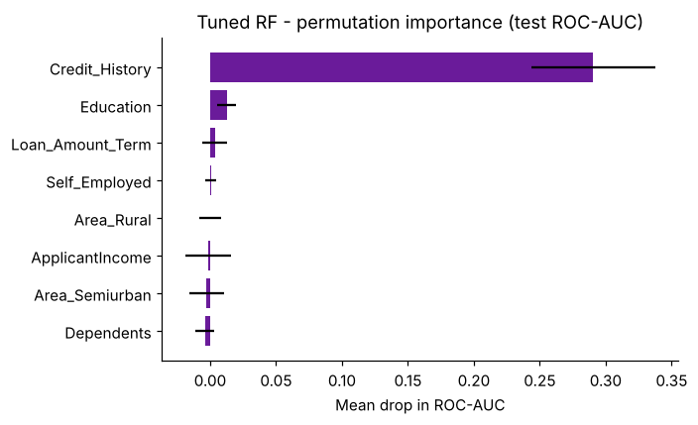
Figure 5. Permutation importance on the test set (drop in ROC-AUC, 30 repeats)
Shuffling Credit_History lowers test ROC-AUC by 0.29. Every other feature's effect is within one standard deviation of zero. Impurity importance ranked ApplicantIncome and LoanAmount second and third; on unseen data they add nothing measurable. This is the known bias of impurity importance towards continuous features.

5. Findings
- Tuning fixed overfitting but did not create new signal. The F0.5 gap fell from 0.157 to 0.031, while repeated-CV F0.5 moved only from 0.823 to 0.827.
- On classification metrics, the model is equivalent to a one-line rule. Credit history carries almost all the predictive information in this dataset.
- The forest's value is the probability score. Its ROC-AUC is 0.06 higher than the rule's, so applicants can be ranked and the approval threshold set to a stated risk appetite, which a binary rule cannot support.
- Impurity-based importance was misleading here. Permutation importance on test data should be the default when explaining tree models.

6. Limitations
- Small sample: 480 rows, with only 96 in the test set and 30 rejected applications in it. One misclassification moves test accuracy by about 1 percentage point.
- The data appears to be a complete-case subset of the public 614-row dataset. If rows with missing values were dropped, that may have introduced selection bias.
- Gender and marital status are used as model inputs. They contribute nothing measurable here, but a production lending model would require a fair-lending review before using them.
- Probabilities are not calibrated, and the threshold analysis assumes no explicit cost matrix.
- There is no external or time-based validation.

7. Reproducibility
Python 3.11+, scikit-learn 1.9, pandas 3.0, random_state = 42 throughout. Running notebooks/loan_approval_random_forest.ipynb from top to bottom regenerates every figure and metrics file in outputs/. The full run takes about 2 minutes on a laptop.

