Predictive Maintenance: Multiclass Random Forest
Classifying machine failure modes from sensor data, and why physics features beat tuning
Kashi Prasad T N | November 2026 | https://github.com/kashiprasadtn/machine-maintenance-random-forest

1. Summary
A random forest was trained to classify 10,000 machine records into six classes: no failure, plus five failure modes. Hyperparameter tuning with class weighting improved macro-F1 only from 0.521 to 0.555. Adding three physically meaningful features (mechanical power, the process-air temperature difference, and tool strain) raised it to 0.647. Recall reached 97-100% for the three deterministic failure modes, and false alarms fell from 92 to 5. Tool-wear and random failures cannot be predicted from the available sensors.
Model (test, n = 3,000) | Macro-F1 | Heat | Power | Overstrain | Tool wear | Random | Alert precision
Always 'No Failure' | 0.164 | 0% | 0% | 0% | 0% | 0% | -
Default random forest | 0.521 | 71% | 64% | 57% | 0% | 0% | 0.853
Tuned RF, raw features | 0.555 | 79% | 79% | 83% | 29% | 0% | 0.449
Tuned RF + physics features | 0.647 | 97% | 100% | 100% | 0% | 0% | 0.945

2. Problem and Data
Each record holds the machine's quality grade (L/M/H), air and process temperature, rotational speed, torque and tool wear, plus a failure flag and failure type. A typed prediction tells maintenance which intervention is needed: cooling, load management or tool replacement. The data is highly imbalanced, with 96.5% of rows labelled 'No Failure' and the smallest class (random failures) having only 18 rows. Twenty-seven rows have a binary flag that contradicts their type; the failure type is used as the label.
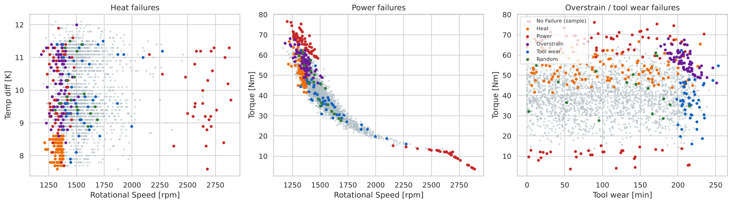
Figure 1. Failure modes in raw feature space

3. Method
- Stratified 70/30 split on failure type.
- Primary metric: macro-F1, which weights each failure mode equally. Per-class recall is reported because missed failures are the costly error.
- Baselines: a fully grown decision tree and a default random forest on the raw features.
- Tuning: GridSearchCV (5-fold, macro-F1) over max_depth, min_samples_leaf, max_features and class_weight.
- Physics features: Power = Torque x RPM x 2π/60; Temp diff = process - air temperature; Strain = tool wear x torque. Then re-tuned with the same grid.

4. Results
Both baselines reproduce the training data perfectly and generalise poorly to the minority classes. Tuning on raw features selected class weighting, which raised overstrain recall to 83% and tool-wear recall to 29%. The cost was 92 false alarms, and accuracy fell to 95.9%. With physics features, the best model needed no class weighting and reached a CV macro-F1 of 0.654 (test 0.647) and 99.2% accuracy.
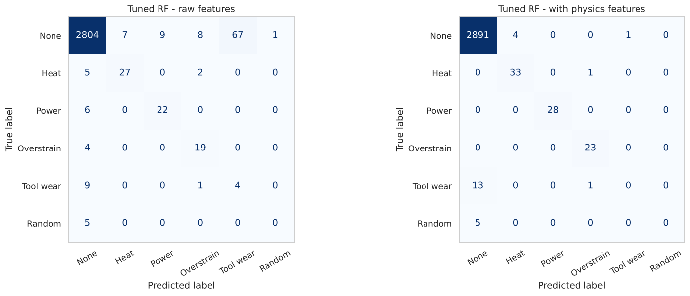
Figure 2. Confusion matrices: tuned RF with raw features vs with physics features
Power (0.29), strain (0.24) and temperature difference (0.07) make up 60% of feature importance; rotational speed (0.26) remains important because it feeds both the heat rule and power. As an alert system, the final model catches 82.7% of failures (86 of 104) with 94.5% precision.

5. Findings
- Domain knowledge improved the model more than tuning. The failure mechanisms are products and differences of raw signals. Trees approximate these poorly with axis-aligned splits but use them directly once they are supplied.
- Heat, power and overstrain failures are detected almost perfectly, with very few false alarms.
- Tool-wear and random failures are not predictable here. Tool-wear failures occur at a random point between about 200 and 240 minutes of wear (45 failures among 790 machines in that window). That points to scheduled tool replacement rather than prediction.
- Accuracy is the wrong metric: a model that never predicts failure scores 96.5%.

6. Limitations
- AI4I 2020 is a synthetic dataset with rule-based failure modes, which favours exact physics features. Gains on real sensor data would be smaller.
- Minority classes are small (5-34 test cases), so per-class recall is noisy.
- Snapshot data with no temporal sequence, so remaining useful life cannot be modelled.

7. Reproducibility
Python 3.11+, scikit-learn 1.9, random_state = 42. Running notebooks/machine_maintenance_random_forest.ipynb regenerates every figure and table in outputs/.

