Netflix Content Strategy Analytics
PySpark ETL, SQL layer and Streamlit dashboard for catalogue strategy
Kashi Prasad T N | November 2026 | https://github.com/kashiprasadtn/netflix-content-strategy-analytics

1. Summary
An end-to-end pipeline turns the public Netflix catalogue (8,807 titles, snapshot to 25 September 2021) into analysis-ready tables, a validated SQL layer and an interactive dashboard. The analysis shows the catalogue growing to a peak of 2,014 additions in 2019, shifting towards TV, and relying increasingly on older licensed titles. It also shows comedy, romance and family content gaining share while documentaries and international movies lost share. On the engineering side, anchoring content age to the snapshot date corrects a freshness KPI that a runtime clock had reduced from 64.2% to 6.7%.

2. Pipeline
- Input: first-stage cleaned catalogue with one row per title x genre (19,304 rows, 8,807 titles). The ETL can also start from the raw Kaggle file.
- PySpark ETL (notebook 01): quality audit, repair of 22 rows with values shifted into the rating column, snapshot-anchored features (content age, recency, release-to-addition lag, audience group, parsed duration), and five integrity checks.
- Outputs: titles.csv (one row per title), title_genres.csv (one row per title x genre) and kpis.json.
- SQL layer: a MySQL 8 schema with LOAD DATA, and portable KPI queries cross-checked against pandas on SQLite (all checks pass).
- Dashboard: Streamlit + Plotly with type, year, country and audience filters across four tabs. It reads CSVs by default, or MySQL with credentials from environment variables.

3. Data Engineering Findings
Issue | Effect | Treatment
Genre explosion (2.19 rows per title) | COUNT(*) after a genre join returns 19,303 rows for 8,806 titles | Separate title and title-genre tables; COUNT(DISTINCT) for title KPIs
Runtime-based content age | 'Recent' share 6.7% in 2026 instead of 64.2%, and it drifts each year | Age measured against the snapshot date (latest date_added)
22 shifted source rows | Cast names, years and durations appear as ratings | 3 durations recovered; ratings set to 'Unknown' and flagged
9.4% of titles without a country | Would distort country shares | Excluded from country charts and labelled

4. Content Strategy Findings

4.1 Growth and mix
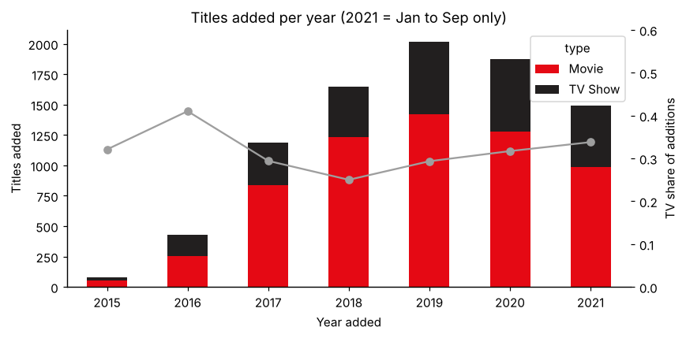
Figure 1. Titles added per year and TV share of additions
Additions rose from 81 titles in 2015 to 2,014 in 2019. The TV share of additions fell to 25% in 2018, then climbed to 34% by 2021.

4.2 Freshness
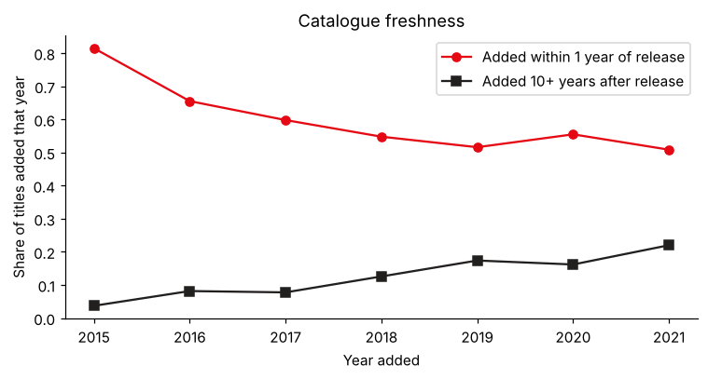
Figure 2. Share of additions released within 1 year vs 10+ years earlier
The share of titles added within a year of release fell from 82% (2015) to 51% (2021), while additions of titles 10 or more years old rose from 4% to 22%.

4.3 Genres
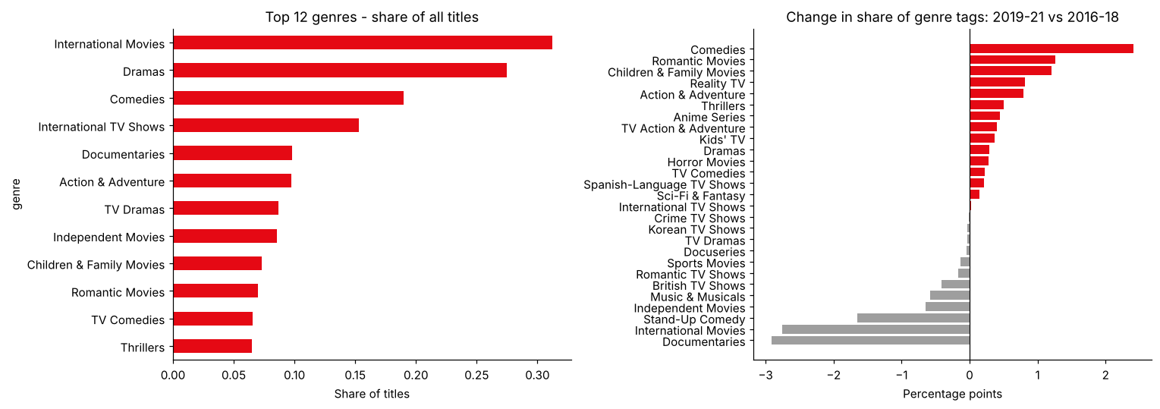
Figure 3. Top genres and change in genre share, 2019-21 vs 2016-18
International Movies (31%), Dramas (28%) and Comedies (19%) lead. In 2019-21, Comedies (+2.4 points), Romantic Movies (+1.3) and Children & Family Movies (+1.2) gained share of new genre tags, while Documentaries (-2.9), International Movies (-2.8) and Stand-Up Comedy (-1.7) lost share.

4.4 Geography and audience
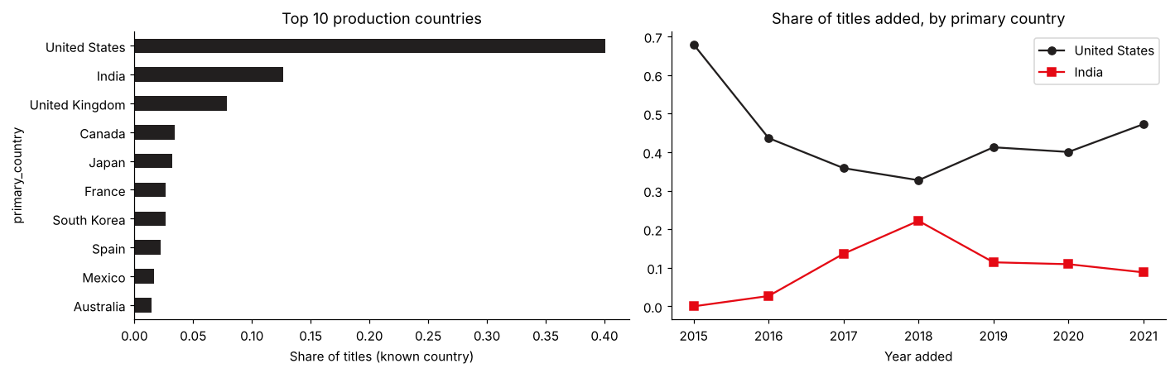
Figure 4. Top production countries and US / India share of additions
The US (40%) and India (13%) account for 53% of titles with a known country, and the top 10 countries for 78%. India's share of additions peaked at 22% in 2018 and fell to 9% by 2021, as the US share recovered to 47%. The catalogue is adult-skewed (TV-MA 36%), and TV has more kids-and-family content than film (30% vs 21%).

5. Recommendations
- Track freshness with snapshot-anchored metrics. A runtime clock makes trend KPIs unreliable.
- Watch the growing share of 10+-year-old additions: it lifts volume but may dilute the 'new on Netflix' proposition.
- Re-examine the documentary and international pipeline, which lost share despite strong absolute numbers.
- Join viewing data before drawing performance conclusions. This catalogue view shows supply, not demand.

6. Limitations
- Catalogue snapshot only, with no viewing, revenue or availability data.
- Removed titles are absent, and 2021 is partial (January to September).
- Primary country is the first listed country, so co-productions are attributed to one country.

