ALLAMA IQBAL OPEN UNIVERSITY
Premium Typed Assignment
General Methods of Teaching
Detail | Course Code: 8601
Detail | Assignment No: 1
Detail | Unit Coverage: Units 1-5
Detail | Program Level: B.Ed (Special Education)
Detail | Formatting Profile: Times New Roman, 14 pt headings, 12 pt body text
Detail | Document Goal: Extended academic response with diagrams, border styling, and premium presentation

Presentation Note
This file has been prepared as a premium typed assignment with extended academic treatment, proper page border styling, inserted diagrams, formal headings, and neat section hierarchy. The content is intentionally expanded so that the assignment remains easy to read while still meeting a high page-length target.

Q.1 Define effective teaching. Discuss the factors contributing to effective teaching.
Answer: The answer below is organized in an academic assignment style, with conceptual explanation, applied discussion, and concise analytical closing comments designed for a neat and extended university submission.
Effective teaching is not limited to finishing the syllabus or speaking confidently in the classroom. In the AIOU perspective, effective teaching means organizing learning in such a way that students understand concepts, stay mentally engaged, improve their performance, and develop useful attitudes, habits, and skills. It is therefore a combination of sound planning, subject command, suitable method, learner participation, continuous assessment, and professional character.
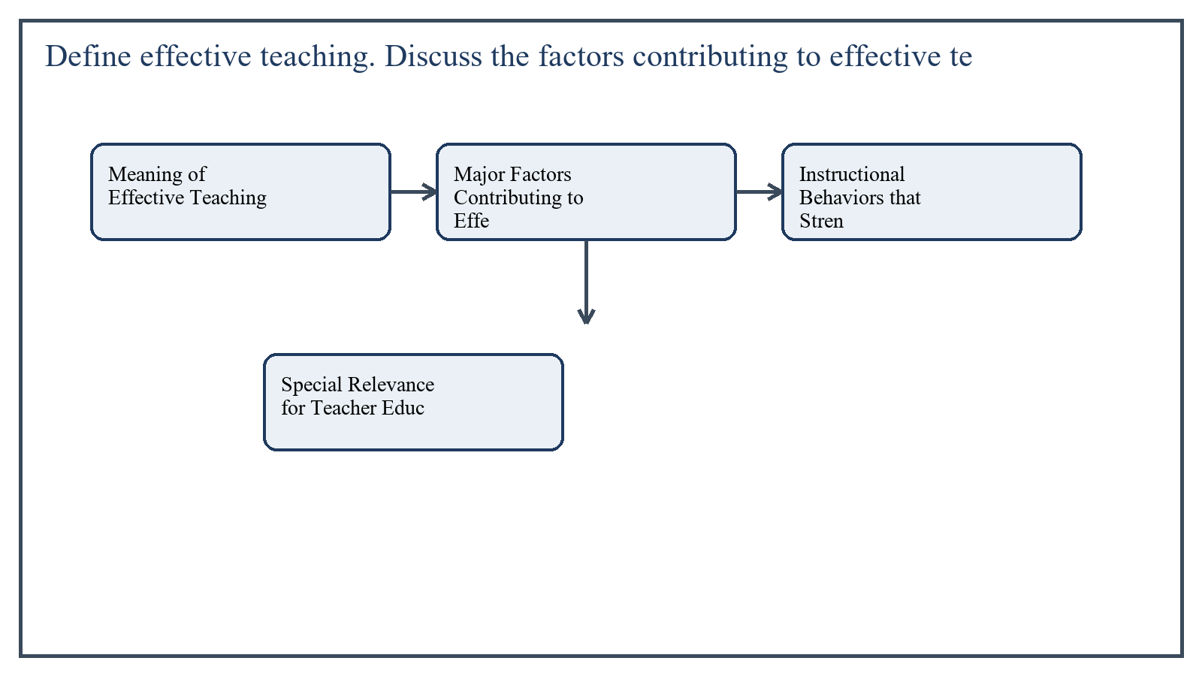
Figure 1: Concept map for Question 1

Meaning of Effective Teaching
Effective teaching can be defined as a purposeful and evidence-based process through which a teacher creates conditions that make learning meaningful, active, and measurable. A teacher is considered effective when his or her teaching brings positive change in the learner's knowledge, understanding, skills, attitudes, and behavior.
The course book also presents effective teaching as something deeper than style alone. A lively manner is useful, but effectiveness is ultimately judged by whether students are actually learning, whether instruction matches objectives, and whether the teacher adapts practice in the light of feedback and classroom realities.
In the context of General Methods of Teaching, the theme of meaning of effective teaching deserves extended attention because assignment-level understanding is expected to move beyond one-line definitions and into explanation, comparison, and application. A strong university answer shows not only what the concept means, but also why it matters, how it appears in practice, and what limitations or challenges may arise when it is implemented in real educational settings.
A mature academic response also connects meaning of effective teaching with classroom realities, institutional culture, and the Pakistani context wherever relevant. This makes the answer more analytical and more useful because it links conceptual understanding with the needs of teachers, learners, administrators, and communities rather than leaving the idea at a purely theoretical level.
From an examination and assignment-writing perspective, the topic of meaning of effective teaching should be handled through clear structure, careful terminology, valid examples, and balanced discussion. The strongest responses usually define the idea, explain its major components, illustrate it through educational examples, and then conclude with a reasoned judgment about its significance, usefulness, or limitations.

Major Factors Contributing to Effective Teaching
The first major factor is clarity of objectives. When the teacher knows what learners should know, do, and value by the end of the lesson, teaching becomes focused. Clear objectives help in choosing methods, examples, questions, activities, and assessment tools.
The second factor is subject-matter mastery. A teacher who understands the content deeply can explain ideas in simple language, answer students' questions, connect new knowledge with previous learning, and prevent misconceptions.
A third factor is knowledge of learners. Effective teaching requires awareness of students' age, background, interest, prior knowledge, pace of learning, and special needs. In a mixed-ability class, the same method may not suit every learner; therefore the teacher must differentiate explanation, support, and practice.
The fourth factor is lesson planning. Planned teaching saves time, improves sequence, and helps the teacher move from introduction to development, practice, and evaluation in an organized way. Good planning also reduces classroom confusion and makes teaching more purposeful.
- Use of appropriate teaching methods such as discussion, demonstration, questioning, problem-solving, and cooperative learning according to the lesson objective.
- Creation of a supportive classroom climate in which students feel respected, safe, and encouraged to participate.
- Use of motivating techniques including relevant examples, praise, curiosity-arousing questions, and meaningful tasks.
- Continuous assessment and feedback so the teacher can identify learning gaps and adjust instruction.
- Professional qualities such as patience, fairness, punctuality, enthusiasm, confidence, and reflective practice.
In the context of General Methods of Teaching, the theme of major factors contributing to effective teaching deserves extended attention because assignment-level understanding is expected to move beyond one-line definitions and into explanation, comparison, and application. A strong university answer shows not only what the concept means, but also why it matters, how it appears in practice, and what limitations or challenges may arise when it is implemented in real educational settings.
A mature academic response also connects major factors contributing to effective teaching with classroom realities, institutional culture, and the Pakistani context wherever relevant. This makes the answer more analytical and more useful because it links conceptual understanding with the needs of teachers, learners, administrators, and communities rather than leaving the idea at a purely theoretical level.
From an examination and assignment-writing perspective, the topic of major factors contributing to effective teaching should be handled through clear structure, careful terminology, valid examples, and balanced discussion. The strongest responses usually define the idea, explain its major components, illustrate it through educational examples, and then conclude with a reasoned judgment about its significance, usefulness, or limitations.

Instructional Behaviors that Strengthen Effectiveness
Research-oriented teaching behavior also contributes to effectiveness. Effective teachers use questioning thoughtfully, give wait time, check understanding, summarize key points, and link the current lesson with earlier concepts. They do not merely lecture; they monitor comprehension throughout the lesson.
Another important factor is the intelligent use of teaching aids and learning resources. Chalkboard work, charts, maps, posters, models, multimedia, and worksheets become effective only when they support the objective and are used at the right moment.
Time management is equally central. Effective teaching requires suitable pacing, a balance between teacher talk and student activity, and protection of academic learning time. When transitions are smooth and instructions are clear, more time is available for real learning.
In the context of General Methods of Teaching, the theme of instructional behaviors that strengthen effectiveness deserves extended attention because assignment-level understanding is expected to move beyond one-line definitions and into explanation, comparison, and application. A strong university answer shows not only what the concept means, but also why it matters, how it appears in practice, and what limitations or challenges may arise when it is implemented in real educational settings.
A mature academic response also connects instructional behaviors that strengthen effectiveness with classroom realities, institutional culture, and the Pakistani context wherever relevant. This makes the answer more analytical and more useful because it links conceptual understanding with the needs of teachers, learners, administrators, and communities rather than leaving the idea at a purely theoretical level.
From an examination and assignment-writing perspective, the topic of instructional behaviors that strengthen effectiveness should be handled through clear structure, careful terminology, valid examples, and balanced discussion. The strongest responses usually define the idea, explain its major components, illustrate it through educational examples, and then conclude with a reasoned judgment about its significance, usefulness, or limitations.

Special Relevance for Teacher Education
For a prospective teacher, effective teaching also includes reflection and improvement. The course book repeatedly implies that teachers should learn from classroom evidence, from colleagues, and from research. This means effective teaching is not a fixed trait; it is a professional practice that can be developed.
In special education contexts, effectiveness additionally requires sensitivity to individual differences, structured instruction, simplified language where needed, reinforcement, and supportive assessment practices. A method that looks impressive but excludes weaker learners cannot be called truly effective.
In the context of General Methods of Teaching, the theme of special relevance for teacher education deserves extended attention because assignment-level understanding is expected to move beyond one-line definitions and into explanation, comparison, and application. A strong university answer shows not only what the concept means, but also why it matters, how it appears in practice, and what limitations or challenges may arise when it is implemented in real educational settings.
A mature academic response also connects special relevance for teacher education with classroom realities, institutional culture, and the Pakistani context wherever relevant. This makes the answer more analytical and more useful because it links conceptual understanding with the needs of teachers, learners, administrators, and communities rather than leaving the idea at a purely theoretical level.
From an examination and assignment-writing perspective, the topic of special relevance for teacher education should be handled through clear structure, careful terminology, valid examples, and balanced discussion. The strongest responses usually define the idea, explain its major components, illustrate it through educational examples, and then conclude with a reasoned judgment about its significance, usefulness, or limitations.

Applied Illustration and Academic Note
For a stronger B.Ed assignment response, the topic above should be linked with classroom life, institutional practice, and the needs of Pakistani learners. This approach makes the response more analytical and demonstrates that the writer understands both theory and application, which is usually appreciated in AIOU-style academic work.
A good response also avoids unsupported claims. Instead, it explains concepts carefully, gives relevant examples, and ends with a short judgment about educational significance. In this way, the answer to 'Define effective teaching. Discuss the factors contributing to effecti...' becomes easier to read, easier to assess, and more academically convincing.

Quick Review Table
Focus Area | Assignment Relevance
Meaning of Effective Teaching | This area helps answer the question on 'Define effective teaching. Discuss the factors contribu...' by providing concept clarity, explanation, and applied educational value.
Major Factors Contributing to Effective Teaching | This area helps answer the question on 'Define effective teaching. Discuss the factors contribu...' by providing concept clarity, explanation, and applied educational value.
Instructional Behaviors that Strengthen Effectiveness | This area helps answer the question on 'Define effective teaching. Discuss the factors contribu...' by providing concept clarity, explanation, and applied educational value.
Special Relevance for Teacher Education | This area helps answer the question on 'Define effective teaching. Discuss the factors contribu...' by providing concept clarity, explanation, and applied educational value.

Critical Reflection
At an advanced level, the topic should not be treated as a fixed formula. Most educational concepts work within particular conditions, and their success often depends on planning quality, learner background, institutional support, and the competence of the teacher or manager using them. A reflective assignment therefore acknowledges strengths while also recognizing practical limitations.

Conclusion
In short, effective teaching is the art and science of producing meaningful learning through planned, learner-centered, and professionally responsible instruction. Its success depends on clear objectives, subject command, knowledge of learners, proper planning, suitable methods, motivation, assessment, and reflective professionalism. When these factors work together, teaching becomes genuinely effective rather than merely routine.

Q.2 Describe the classical models of lesson planning.
Answer: The answer below is organized in an academic assignment style, with conceptual explanation, applied discussion, and concise analytical closing comments designed for a neat and extended university submission.
Lesson planning gives shape to classroom teaching by identifying objectives, content sequence, activities, materials, and assessment. In the AIOU 8601 book, the commonly cited classical models include Gagne's instructional events, Hunter's seven-step model, and the 5E model. Each model attempts to provide a logical flow that moves students from readiness to understanding and application.
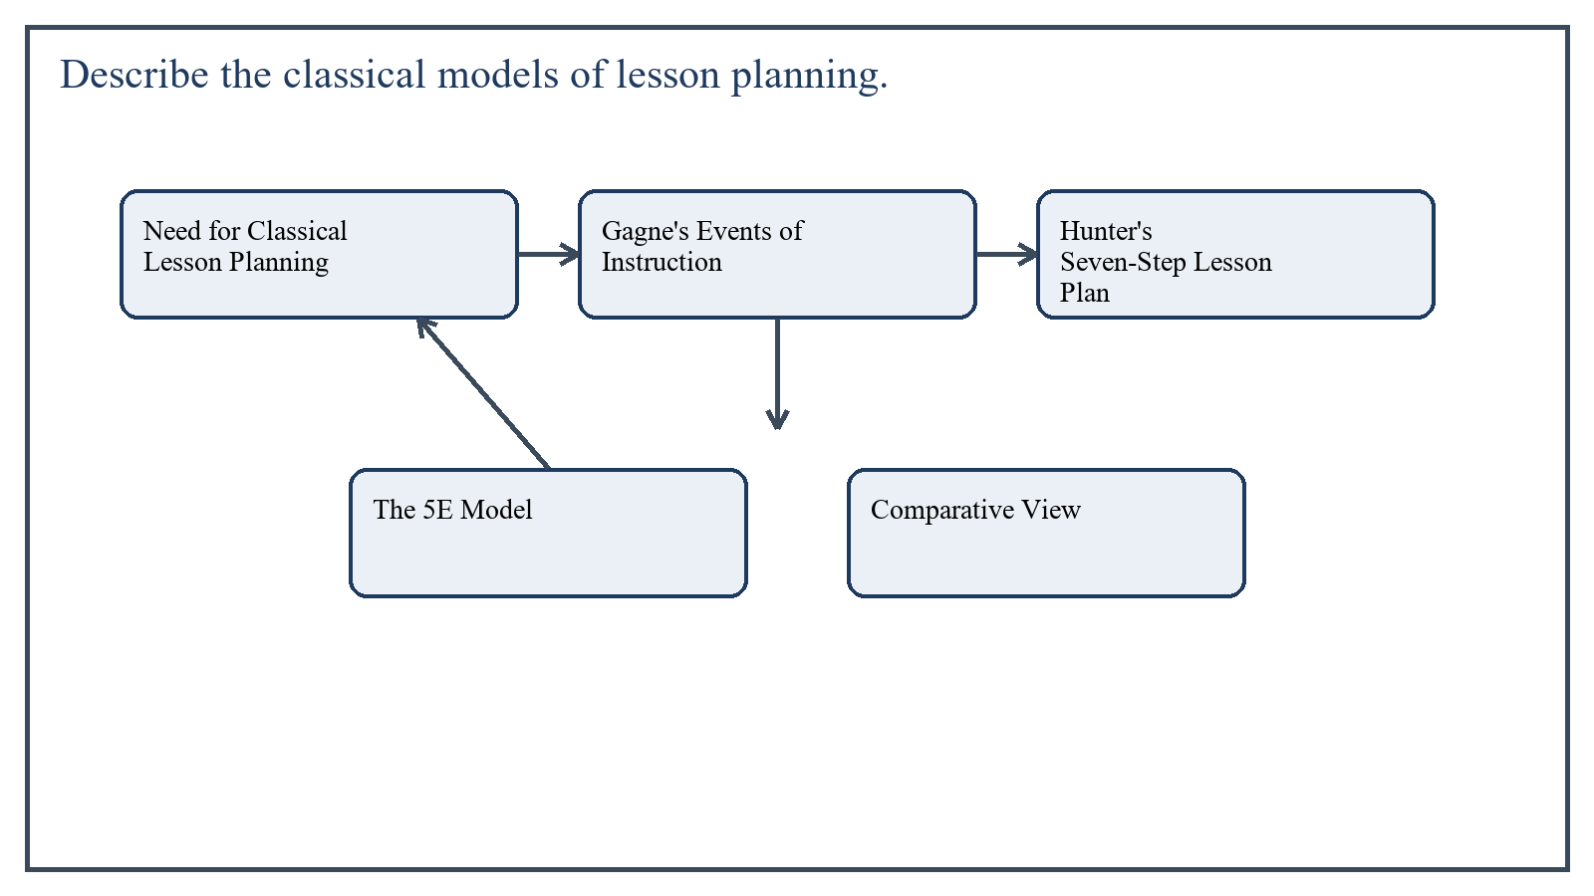
Figure 2: Concept map for Question 2

Need for Classical Lesson Planning Models
Classical lesson planning models are valuable because they save the teacher from random teaching. They provide structure, ensure continuity, help in selecting activities, and improve the chances that students will remain engaged throughout the lesson.
Although teachers may adapt these models according to subject, age level, and classroom conditions, the models remain useful because they represent tested patterns of instruction rather than guesswork.
In the context of General Methods of Teaching, the theme of need for classical lesson planning models deserves extended attention because assignment-level understanding is expected to move beyond one-line definitions and into explanation, comparison, and application. A strong university answer shows not only what the concept means, but also why it matters, how it appears in practice, and what limitations or challenges may arise when it is implemented in real educational settings.
A mature academic response also connects need for classical lesson planning models with classroom realities, institutional culture, and the Pakistani context wherever relevant. This makes the answer more analytical and more useful because it links conceptual understanding with the needs of teachers, learners, administrators, and communities rather than leaving the idea at a purely theoretical level.
From an examination and assignment-writing perspective, the topic of need for classical lesson planning models should be handled through clear structure, careful terminology, valid examples, and balanced discussion. The strongest responses usually define the idea, explain its major components, illustrate it through educational examples, and then conclude with a reasoned judgment about its significance, usefulness, or limitations.

Gagne's Events of Instruction
Robert Gagne proposed a sequence of instructional events that support learning. The model begins by gaining students' attention, because attention is the doorway to learning. It then informs learners of the objectives so that they know what is expected from them.
The teacher next stimulates recall of prior learning, presents the content, provides learning guidance, elicits performance, gives feedback, assesses performance, and finally enhances retention and transfer. This model is powerful because it links psychology and teaching practice.
- Gain attention through a thought-provoking question, visual, short story, or surprising fact.
- Inform learners of objectives so they know the learning target.
- Stimulate recall of previous knowledge to connect old and new learning.
- Present the new content in an organized and understandable way.
- Provide guidance through examples, cues, hints, and demonstrations.
- Elicit performance by asking students to practice or respond.
- Provide feedback immediately to correct errors and reinforce success.
- Assess performance formally or informally.
- Enhance retention and transfer through review, homework, or application tasks.
In the context of General Methods of Teaching, the theme of gagne's events of instruction deserves extended attention because assignment-level understanding is expected to move beyond one-line definitions and into explanation, comparison, and application. A strong university answer shows not only what the concept means, but also why it matters, how it appears in practice, and what limitations or challenges may arise when it is implemented in real educational settings.
A mature academic response also connects gagne's events of instruction with classroom realities, institutional culture, and the Pakistani context wherever relevant. This makes the answer more analytical and more useful because it links conceptual understanding with the needs of teachers, learners, administrators, and communities rather than leaving the idea at a purely theoretical level.
From an examination and assignment-writing perspective, the topic of gagne's events of instruction should be handled through clear structure, careful terminology, valid examples, and balanced discussion. The strongest responses usually define the idea, explain its major components, illustrate it through educational examples, and then conclude with a reasoned judgment about its significance, usefulness, or limitations.

Hunter's Seven-Step Lesson Plan
Madeline Hunter's model is one of the best-known classical models used in teacher education. It offers a practical classroom sequence that many teachers find easy to apply. The model includes anticipatory set, objective and purpose, input, modeling, checking for understanding, guided practice, and independent practice.
Its strength lies in classroom control and clarity. It ensures that the lesson begins with readiness, moves through explanation and demonstration, and ends with practice that gradually transfers responsibility from teacher to student.
- Anticipatory set: prepare students mentally and emotionally for the lesson.
- Objective and purpose: state what students will learn and why it matters.
- Input: present the essential information or concept.
- Modeling: demonstrate the skill, process, or correct answer format.
- Check for understanding: ask questions and observe student responses.
- Guided practice: let students practice with teacher support.
- Independent practice: assign a task that learners can complete on their own.
In the context of General Methods of Teaching, the theme of hunter's seven-step lesson plan deserves extended attention because assignment-level understanding is expected to move beyond one-line definitions and into explanation, comparison, and application. A strong university answer shows not only what the concept means, but also why it matters, how it appears in practice, and what limitations or challenges may arise when it is implemented in real educational settings.
A mature academic response also connects hunter's seven-step lesson plan with classroom realities, institutional culture, and the Pakistani context wherever relevant. This makes the answer more analytical and more useful because it links conceptual understanding with the needs of teachers, learners, administrators, and communities rather than leaving the idea at a purely theoretical level.
From an examination and assignment-writing perspective, the topic of hunter's seven-step lesson plan should be handled through clear structure, careful terminology, valid examples, and balanced discussion. The strongest responses usually define the idea, explain its major components, illustrate it through educational examples, and then conclude with a reasoned judgment about its significance, usefulness, or limitations.

The 5E Model
The 5E model is especially popular in inquiry-oriented and science-related teaching, though it can be used across subjects. The five stages are Engage, Explore, Explain, Elaborate, and Evaluate.
This model is more constructivist than purely teacher-directed plans. It encourages students to investigate, discuss, discover patterns, and apply learning to new situations. Because of this, it is highly suitable where conceptual understanding is more important than rote memorization.
- Engage: stimulate curiosity and activate prior knowledge.
- Explore: let students interact with ideas, materials, or situations.
- Explain: guide students to articulate concepts and receive formal explanation.
- Elaborate: extend understanding through new applications or deeper tasks.
- Evaluate: determine the extent of learning through questions, tasks, or reflection.
In the context of General Methods of Teaching, the theme of the 5e model deserves extended attention because assignment-level understanding is expected to move beyond one-line definitions and into explanation, comparison, and application. A strong university answer shows not only what the concept means, but also why it matters, how it appears in practice, and what limitations or challenges may arise when it is implemented in real educational settings.
A mature academic response also connects the 5e model with classroom realities, institutional culture, and the Pakistani context wherever relevant. This makes the answer more analytical and more useful because it links conceptual understanding with the needs of teachers, learners, administrators, and communities rather than leaving the idea at a purely theoretical level.
From an examination and assignment-writing perspective, the topic of the 5e model should be handled through clear structure, careful terminology, valid examples, and balanced discussion. The strongest responses usually define the idea, explain its major components, illustrate it through educational examples, and then conclude with a reasoned judgment about its significance, usefulness, or limitations.

Comparative View
Gagne's model is systematic and psychologically sequenced, Hunter's model is teacher-friendly and practice-oriented, and the 5E model is inquiry-based and learner-centered. All three models value preparation, clarity, and assessment, but they differ in the degree of student exploration they encourage.
A wise teacher does not treat these models as rigid formulas. Instead, the teacher uses them as professional tools and adapts them according to content, class level, available time, and learners' needs.
In the context of General Methods of Teaching, the theme of comparative view deserves extended attention because assignment-level understanding is expected to move beyond one-line definitions and into explanation, comparison, and application. A strong university answer shows not only what the concept means, but also why it matters, how it appears in practice, and what limitations or challenges may arise when it is implemented in real educational settings.
A mature academic response also connects comparative view with classroom realities, institutional culture, and the Pakistani context wherever relevant. This makes the answer more analytical and more useful because it links conceptual understanding with the needs of teachers, learners, administrators, and communities rather than leaving the idea at a purely theoretical level.
From an examination and assignment-writing perspective, the topic of comparative view should be handled through clear structure, careful terminology, valid examples, and balanced discussion. The strongest responses usually define the idea, explain its major components, illustrate it through educational examples, and then conclude with a reasoned judgment about its significance, usefulness, or limitations.

Applied Illustration and Academic Note
For a stronger B.Ed assignment response, the topic above should be linked with classroom life, institutional practice, and the needs of Pakistani learners. This approach makes the response more analytical and demonstrates that the writer understands both theory and application, which is usually appreciated in AIOU-style academic work.
A good response also avoids unsupported claims. Instead, it explains concepts carefully, gives relevant examples, and ends with a short judgment about educational significance. In this way, the answer to 'Describe the classical models of lesson planning....' becomes easier to read, easier to assess, and more academically convincing.

Quick Review Table
Focus Area | Assignment Relevance
Need for Classical Lesson Planning Models | This area helps answer the question on 'Describe the classical models of lesson planning....' by providing concept clarity, explanation, and applied educational value.
Gagne's Events of Instruction | This area helps answer the question on 'Describe the classical models of lesson planning....' by providing concept clarity, explanation, and applied educational value.
Hunter's Seven-Step Lesson Plan | This area helps answer the question on 'Describe the classical models of lesson planning....' by providing concept clarity, explanation, and applied educational value.
The 5E Model | This area helps answer the question on 'Describe the classical models of lesson planning....' by providing concept clarity, explanation, and applied educational value.

Critical Reflection
At an advanced level, the topic should not be treated as a fixed formula. Most educational concepts work within particular conditions, and their success often depends on planning quality, learner background, institutional support, and the competence of the teacher or manager using them. A reflective assignment therefore acknowledges strengths while also recognizing practical limitations.

Conclusion
Classical lesson planning models remain highly useful because they convert teaching into a deliberate and measurable process. Gagne's events, Hunter's seven steps, and the 5E model each offer a coherent teaching sequence. Together they show that effective lessons require preparation, meaningful presentation, guided participation, and evaluation rather than spontaneous delivery alone.

Q.3 Compare the behavioral and humanistic perspectives on motivation.
Answer: The answer below is organized in an academic assignment style, with conceptual explanation, applied discussion, and concise analytical closing comments designed for a neat and extended university submission.
Motivation explains why learners begin, continue, or withdraw from learning activity. In the AIOU 8601 course, motivation is discussed through several perspectives, among which behavioral and humanistic views are especially important. These two perspectives differ in their assumptions about what drives student behavior, how teachers should respond, and what kind of classroom climate best supports learning.
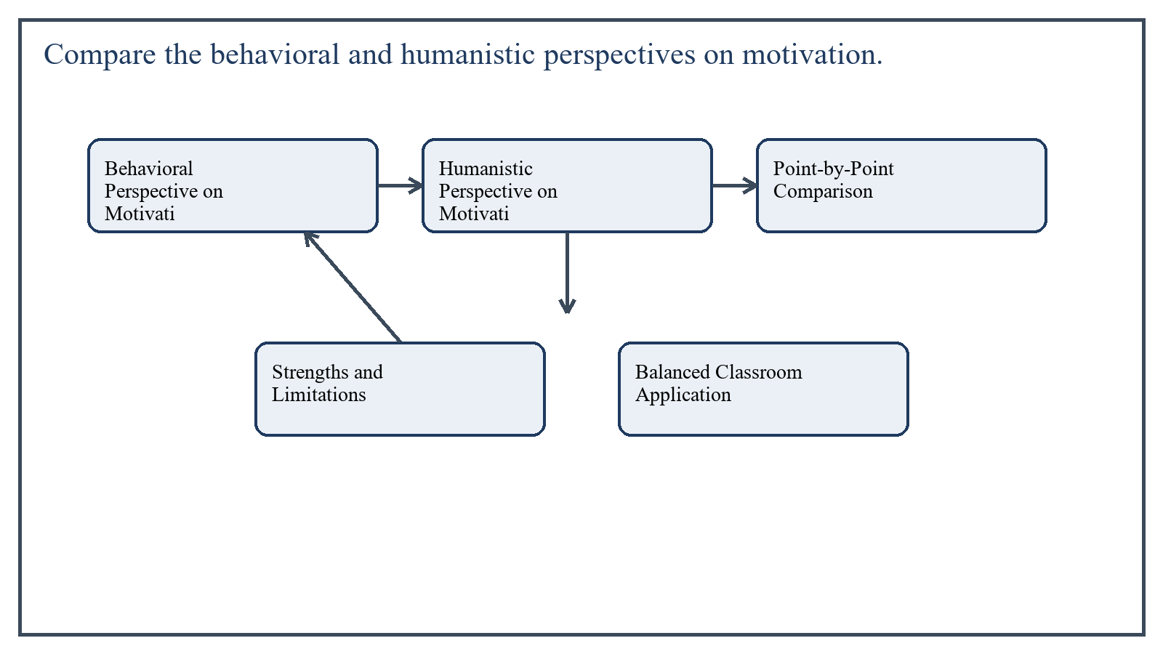
Figure 3: Concept map for Question 3

Behavioral Perspective on Motivation
The behavioral perspective explains motivation mainly in terms of external reinforcement. Students are motivated when desirable behavior is rewarded and undesirable behavior is discouraged. In this view, praise, marks, grades, tokens, privileges, and correction influence the probability that a learner will repeat certain actions.
Behaviorists therefore emphasize observable behavior. Motivation is not treated as a mysterious inner force; rather, it is shaped by consequences. If a student receives positive reinforcement for completing work, participating, or answering correctly, that behavior is likely to increase.
- Focuses on rewards, reinforcement, repetition, and behavior control.
- Assumes motivation can be increased by carefully arranged external conditions.
- Useful for classroom routines, habit formation, attendance, task completion, and behavior management.
In the context of General Methods of Teaching, the theme of behavioral perspective on motivation deserves extended attention because assignment-level understanding is expected to move beyond one-line definitions and into explanation, comparison, and application. A strong university answer shows not only what the concept means, but also why it matters, how it appears in practice, and what limitations or challenges may arise when it is implemented in real educational settings.
A mature academic response also connects behavioral perspective on motivation with classroom realities, institutional culture, and the Pakistani context wherever relevant. This makes the answer more analytical and more useful because it links conceptual understanding with the needs of teachers, learners, administrators, and communities rather than leaving the idea at a purely theoretical level.
From an examination and assignment-writing perspective, the topic of behavioral perspective on motivation should be handled through clear structure, careful terminology, valid examples, and balanced discussion. The strongest responses usually define the idea, explain its major components, illustrate it through educational examples, and then conclude with a reasoned judgment about its significance, usefulness, or limitations.

Humanistic Perspective on Motivation
The humanistic perspective views motivation in relation to the whole person. It is strongly associated with Maslow and Rogers. According to this view, students learn best when their basic needs are respected and when the classroom supports dignity, belonging, self-worth, growth, and self-actualization.
Humanistic educators believe that students are not machines to be controlled by rewards alone. They have feelings, values, aspirations, fears, and a desire for meaning. If a child feels rejected, humiliated, or unsafe, learning suffers even if rewards are present.
- Stresses inner growth, self-concept, choice, respect, and personal meaning.
- Assumes learners move toward development when their psychological needs are met.
- Encourages supportive relationships, empathy, autonomy, and trust.
In the context of General Methods of Teaching, the theme of humanistic perspective on motivation deserves extended attention because assignment-level understanding is expected to move beyond one-line definitions and into explanation, comparison, and application. A strong university answer shows not only what the concept means, but also why it matters, how it appears in practice, and what limitations or challenges may arise when it is implemented in real educational settings.
A mature academic response also connects humanistic perspective on motivation with classroom realities, institutional culture, and the Pakistani context wherever relevant. This makes the answer more analytical and more useful because it links conceptual understanding with the needs of teachers, learners, administrators, and communities rather than leaving the idea at a purely theoretical level.
From an examination and assignment-writing perspective, the topic of humanistic perspective on motivation should be handled through clear structure, careful terminology, valid examples, and balanced discussion. The strongest responses usually define the idea, explain its major components, illustrate it through educational examples, and then conclude with a reasoned judgment about its significance, usefulness, or limitations.

Point-by-Point Comparison
The first major difference lies in the source of motivation. Behaviorism gives central importance to external stimuli such as reward and punishment, whereas humanism stresses internal needs and self-directed growth.
The second difference concerns the teacher's role. In behaviorism, the teacher organizes reinforcement contingencies and shapes behavior. In humanism, the teacher becomes a facilitator who creates a caring environment and helps learners realize their potential.
A third difference is in the goal of teaching. The behavioral approach seeks desired responses and observable performance, while the humanistic approach aims at personal development, confidence, responsibility, and intrinsic interest in learning.
Another difference appears in classroom atmosphere. Behavioral classrooms may be highly structured and controlled. Humanistic classrooms still need structure, but they rely more on dialogue, acceptance, participation, and emotional safety.
In the context of General Methods of Teaching, the theme of point-by-point comparison deserves extended attention because assignment-level understanding is expected to move beyond one-line definitions and into explanation, comparison, and application. A strong university answer shows not only what the concept means, but also why it matters, how it appears in practice, and what limitations or challenges may arise when it is implemented in real educational settings.
A mature academic response also connects point-by-point comparison with classroom realities, institutional culture, and the Pakistani context wherever relevant. This makes the answer more analytical and more useful because it links conceptual understanding with the needs of teachers, learners, administrators, and communities rather than leaving the idea at a purely theoretical level.
From an examination and assignment-writing perspective, the topic of point-by-point comparison should be handled through clear structure, careful terminology, valid examples, and balanced discussion. The strongest responses usually define the idea, explain its major components, illustrate it through educational examples, and then conclude with a reasoned judgment about its significance, usefulness, or limitations.

Strengths and Limitations
The behavioral approach is practical and effective for classroom management, especially with younger learners or where routines and discipline need strengthening. However, if used alone, it may produce dependency on external rewards and may not build deep interest in learning.
The humanistic approach is strong in building confidence, belonging, and intrinsic motivation. It promotes respect and learner dignity. Yet if applied without sufficient structure, it may become too vague or difficult to manage in large classes.
In the context of General Methods of Teaching, the theme of strengths and limitations deserves extended attention because assignment-level understanding is expected to move beyond one-line definitions and into explanation, comparison, and application. A strong university answer shows not only what the concept means, but also why it matters, how it appears in practice, and what limitations or challenges may arise when it is implemented in real educational settings.
A mature academic response also connects strengths and limitations with classroom realities, institutional culture, and the Pakistani context wherever relevant. This makes the answer more analytical and more useful because it links conceptual understanding with the needs of teachers, learners, administrators, and communities rather than leaving the idea at a purely theoretical level.
From an examination and assignment-writing perspective, the topic of strengths and limitations should be handled through clear structure, careful terminology, valid examples, and balanced discussion. The strongest responses usually define the idea, explain its major components, illustrate it through educational examples, and then conclude with a reasoned judgment about its significance, usefulness, or limitations.

Balanced Classroom Application
In actual teaching, a balanced approach is often best. Teachers can use behavioral reinforcement for routines and effort while also building a humanistic climate that supports autonomy, self-respect, and meaningful learning.
For example, a teacher may praise timely completion of work, but at the same time allow students some choice in activities, listen to their ideas, and connect learning to personal goals. This combination makes motivation both manageable and meaningful.
In the context of General Methods of Teaching, the theme of balanced classroom application deserves extended attention because assignment-level understanding is expected to move beyond one-line definitions and into explanation, comparison, and application. A strong university answer shows not only what the concept means, but also why it matters, how it appears in practice, and what limitations or challenges may arise when it is implemented in real educational settings.
A mature academic response also connects balanced classroom application with classroom realities, institutional culture, and the Pakistani context wherever relevant. This makes the answer more analytical and more useful because it links conceptual understanding with the needs of teachers, learners, administrators, and communities rather than leaving the idea at a purely theoretical level.
From an examination and assignment-writing perspective, the topic of balanced classroom application should be handled through clear structure, careful terminology, valid examples, and balanced discussion. The strongest responses usually define the idea, explain its major components, illustrate it through educational examples, and then conclude with a reasoned judgment about its significance, usefulness, or limitations.

Applied Illustration and Academic Note
For a stronger B.Ed assignment response, the topic above should be linked with classroom life, institutional practice, and the needs of Pakistani learners. This approach makes the response more analytical and demonstrates that the writer understands both theory and application, which is usually appreciated in AIOU-style academic work.
A good response also avoids unsupported claims. Instead, it explains concepts carefully, gives relevant examples, and ends with a short judgment about educational significance. In this way, the answer to 'Compare the behavioral and humanistic perspectives on motivation....' becomes easier to read, easier to assess, and more academically convincing.

Quick Review Table
Focus Area | Assignment Relevance
Behavioral Perspective on Motivation | This area helps answer the question on 'Compare the behavioral and humanistic perspectives on m...' by providing concept clarity, explanation, and applied educational value.
Humanistic Perspective on Motivation | This area helps answer the question on 'Compare the behavioral and humanistic perspectives on m...' by providing concept clarity, explanation, and applied educational value.
Point-by-Point Comparison | This area helps answer the question on 'Compare the behavioral and humanistic perspectives on m...' by providing concept clarity, explanation, and applied educational value.
Strengths and Limitations | This area helps answer the question on 'Compare the behavioral and humanistic perspectives on m...' by providing concept clarity, explanation, and applied educational value.

Critical Reflection
At an advanced level, the topic should not be treated as a fixed formula. Most educational concepts work within particular conditions, and their success often depends on planning quality, learner background, institutional support, and the competence of the teacher or manager using them. A reflective assignment therefore acknowledges strengths while also recognizing practical limitations.

Conclusion
Behavioral and humanistic perspectives offer two different but complementary lenses on motivation. Behaviorism explains how external reinforcement shapes learning behavior, while humanism explains how inner needs, dignity, and self-development influence engagement. Effective teachers understand both perspectives and use them wisely according to learners, context, and instructional purpose.

Q.4 Comment on the statement 'Problem-solving Approach is a student-centered approach to teaching'.
Answer: The answer below is organized in an academic assignment style, with conceptual explanation, applied discussion, and concise analytical closing comments designed for a neat and extended university submission.
The statement is valid because the problem-solving approach places learners in an active position rather than treating them as passive receivers of information. In this approach, students face a problem, investigate it, explore possible alternatives, test ideas, and arrive at reasoned conclusions. The teacher guides the process, but the intellectual work is largely done by the learners themselves.
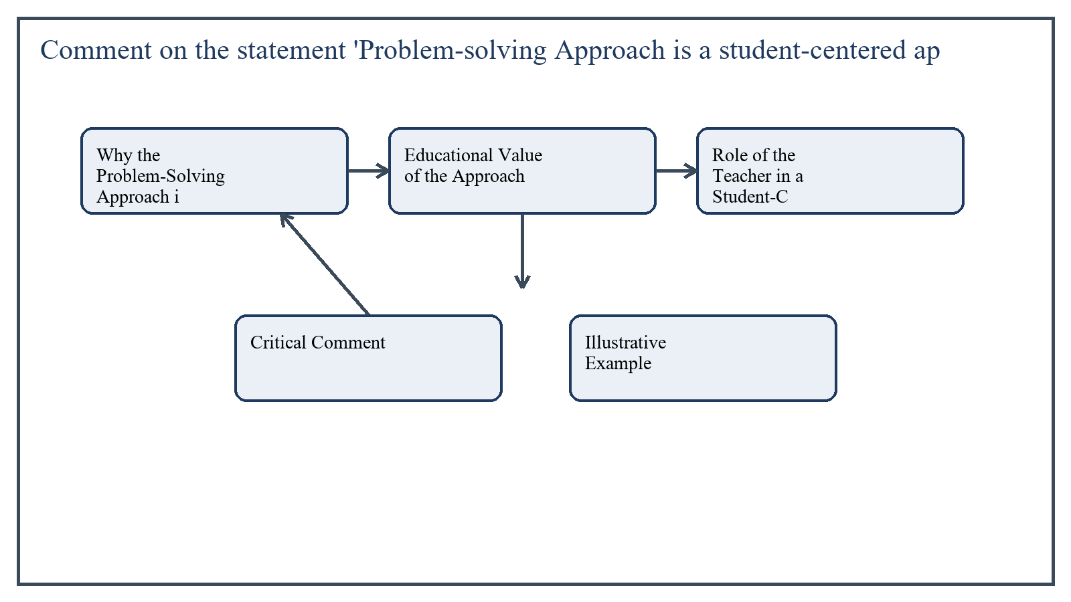
Figure 4: Concept map for Question 4

Why the Problem-Solving Approach is Student-Centered
A teaching approach is student-centered when students are mentally active, ask questions, make decisions, interact with peers, and construct understanding through their own effort. Problem-solving fulfills these conditions. It does not begin with ready-made answers; it begins with a meaningful problem that requires inquiry and thinking.
Students identify what is known, what is unknown, what information is needed, and which strategy may help. This means the center of activity shifts from teacher explanation to learner investigation. Such a shift is the essence of student-centered teaching.
- Students participate in identifying the nature of the problem.
- They gather information from observation, prior knowledge, discussion, or research.
- They compare alternatives and justify their choices.
- They reflect on the effectiveness of the solution and the process used.
In the context of General Methods of Teaching, the theme of why the problem-solving approach is student-centered deserves extended attention because assignment-level understanding is expected to move beyond one-line definitions and into explanation, comparison, and application. A strong university answer shows not only what the concept means, but also why it matters, how it appears in practice, and what limitations or challenges may arise when it is implemented in real educational settings.
A mature academic response also connects why the problem-solving approach is student-centered with classroom realities, institutional culture, and the Pakistani context wherever relevant. This makes the answer more analytical and more useful because it links conceptual understanding with the needs of teachers, learners, administrators, and communities rather than leaving the idea at a purely theoretical level.
From an examination and assignment-writing perspective, the topic of why the problem-solving approach is student-centered should be handled through clear structure, careful terminology, valid examples, and balanced discussion. The strongest responses usually define the idea, explain its major components, illustrate it through educational examples, and then conclude with a reasoned judgment about its significance, usefulness, or limitations.

Educational Value of the Approach
The problem-solving approach develops higher-order thinking. Instead of memorizing isolated facts, students analyze situations, form hypotheses, test evidence, and apply concepts. This strengthens reasoning, creativity, independence, and transfer of learning.
It also improves motivation. When a task is presented as a meaningful challenge rather than a routine exercise, students become more curious and engaged. The method therefore supports both cognitive development and learner interest.
In the context of General Methods of Teaching, the theme of educational value of the approach deserves extended attention because assignment-level understanding is expected to move beyond one-line definitions and into explanation, comparison, and application. A strong university answer shows not only what the concept means, but also why it matters, how it appears in practice, and what limitations or challenges may arise when it is implemented in real educational settings.
A mature academic response also connects educational value of the approach with classroom realities, institutional culture, and the Pakistani context wherever relevant. This makes the answer more analytical and more useful because it links conceptual understanding with the needs of teachers, learners, administrators, and communities rather than leaving the idea at a purely theoretical level.
From an examination and assignment-writing perspective, the topic of educational value of the approach should be handled through clear structure, careful terminology, valid examples, and balanced discussion. The strongest responses usually define the idea, explain its major components, illustrate it through educational examples, and then conclude with a reasoned judgment about its significance, usefulness, or limitations.

Role of the Teacher in a Student-Centered Problem-Solving Class
Student-centered does not mean teacher-free. The teacher remains highly important, but the role changes from information-giver to facilitator, organizer, and guide. The teacher selects appropriate problems, ensures that the difficulty level is suitable, provides resources, monitors progress, and asks probing questions.
A skilled teacher also protects the process from confusion. Students need structure, time limits, criteria, and feedback. Therefore, the success of problem-solving depends on careful planning and sensitive guidance rather than simple withdrawal of teacher authority.
In the context of General Methods of Teaching, the theme of role of the teacher in a student-centered problem-solving class deserves extended attention because assignment-level understanding is expected to move beyond one-line definitions and into explanation, comparison, and application. A strong university answer shows not only what the concept means, but also why it matters, how it appears in practice, and what limitations or challenges may arise when it is implemented in real educational settings.
A mature academic response also connects role of the teacher in a student-centered problem-solving class with classroom realities, institutional culture, and the Pakistani context wherever relevant. This makes the answer more analytical and more useful because it links conceptual understanding with the needs of teachers, learners, administrators, and communities rather than leaving the idea at a purely theoretical level.
From an examination and assignment-writing perspective, the topic of role of the teacher in a student-centered problem-solving class should be handled through clear structure, careful terminology, valid examples, and balanced discussion. The strongest responses usually define the idea, explain its major components, illustrate it through educational examples, and then conclude with a reasoned judgment about its significance, usefulness, or limitations.

Critical Comment
Although the problem-solving approach is student-centered, it is not equally easy to apply in every classroom. Large classes, limited time, weak prior knowledge, rigid examination systems, and shortage of materials may reduce its effectiveness. Some topics also require direct explanation before students can solve related problems independently.
Therefore, the statement should be accepted with a practical qualification: the approach is genuinely student-centered when the problem is meaningful, students are adequately prepared, and the teacher provides structured facilitation. Without these conditions, it can become frustrating rather than empowering.
In the context of General Methods of Teaching, the theme of critical comment deserves extended attention because assignment-level understanding is expected to move beyond one-line definitions and into explanation, comparison, and application. A strong university answer shows not only what the concept means, but also why it matters, how it appears in practice, and what limitations or challenges may arise when it is implemented in real educational settings.
A mature academic response also connects critical comment with classroom realities, institutional culture, and the Pakistani context wherever relevant. This makes the answer more analytical and more useful because it links conceptual understanding with the needs of teachers, learners, administrators, and communities rather than leaving the idea at a purely theoretical level.
From an examination and assignment-writing perspective, the topic of critical comment should be handled through clear structure, careful terminology, valid examples, and balanced discussion. The strongest responses usually define the idea, explain its major components, illustrate it through educational examples, and then conclude with a reasoned judgment about its significance, usefulness, or limitations.

Illustrative Example
Suppose students are asked why a local water source has become unsafe for use. Instead of telling them the answer, the teacher asks them to examine possible causes, collect observations, compare evidence, and suggest remedies. Students may discuss sanitation, waste disposal, drainage, and community behavior. In this process they are learning science, social responsibility, and reasoning together.
In the context of General Methods of Teaching, the theme of illustrative example deserves extended attention because assignment-level understanding is expected to move beyond one-line definitions and into explanation, comparison, and application. A strong university answer shows not only what the concept means, but also why it matters, how it appears in practice, and what limitations or challenges may arise when it is implemented in real educational settings.
A mature academic response also connects illustrative example with classroom realities, institutional culture, and the Pakistani context wherever relevant. This makes the answer more analytical and more useful because it links conceptual understanding with the needs of teachers, learners, administrators, and communities rather than leaving the idea at a purely theoretical level.
From an examination and assignment-writing perspective, the topic of illustrative example should be handled through clear structure, careful terminology, valid examples, and balanced discussion. The strongest responses usually define the idea, explain its major components, illustrate it through educational examples, and then conclude with a reasoned judgment about its significance, usefulness, or limitations.

Applied Illustration and Academic Note
For a stronger B.Ed assignment response, the topic above should be linked with classroom life, institutional practice, and the needs of Pakistani learners. This approach makes the response more analytical and demonstrates that the writer understands both theory and application, which is usually appreciated in AIOU-style academic work.
A good response also avoids unsupported claims. Instead, it explains concepts carefully, gives relevant examples, and ends with a short judgment about educational significance. In this way, the answer to 'Comment on the statement 'Problem-solving Approach is a student-center...' becomes easier to read, easier to assess, and more academically convincing.

Quick Review Table
Focus Area | Assignment Relevance
Why the Problem-Solving Approach is Student-Centered | This area helps answer the question on 'Comment on the statement 'Problem-solving Approach is a...' by providing concept clarity, explanation, and applied educational value.
Educational Value of the Approach | This area helps answer the question on 'Comment on the statement 'Problem-solving Approach is a...' by providing concept clarity, explanation, and applied educational value.
Role of the Teacher in a Student-Centered Problem-Solving Class | This area helps answer the question on 'Comment on the statement 'Problem-solving Approach is a...' by providing concept clarity, explanation, and applied educational value.
Critical Comment | This area helps answer the question on 'Comment on the statement 'Problem-solving Approach is a...' by providing concept clarity, explanation, and applied educational value.

Critical Reflection
At an advanced level, the topic should not be treated as a fixed formula. Most educational concepts work within particular conditions, and their success often depends on planning quality, learner background, institutional support, and the competence of the teacher or manager using them. A reflective assignment therefore acknowledges strengths while also recognizing practical limitations.

Conclusion
The problem-solving approach is rightly called student-centered because it activates learners' thinking, participation, and decision-making. It promotes inquiry, independence, and application of knowledge. However, its success depends on thoughtful teacher guidance, suitable problems, and supportive classroom conditions. When properly managed, it is one of the strongest examples of student-centered teaching.

Q.5 Summarize the main points bearing on the role of the research project. What does your answer suggest regarding the problems faced by researchers in Pakistan?
Answer: The answer below is organized in an academic assignment style, with conceptual explanation, applied discussion, and concise analytical closing comments designed for a neat and extended university submission.
A research project is a systematic attempt to investigate a problem, gather evidence, analyze findings, and present conclusions in a logical form. In teacher education, research projects are important because they train future professionals to observe educational problems critically, use evidence instead of assumption, and recommend improvements on a rational basis.
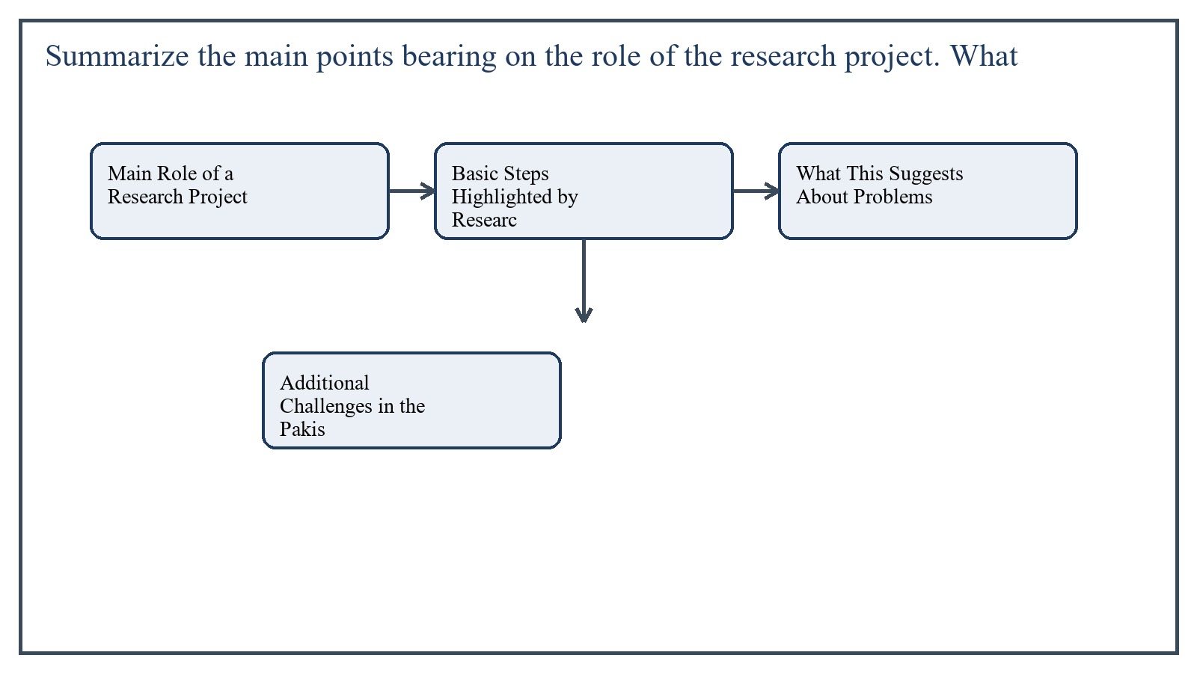
Figure 5: Concept map for Question 5

Main Role of a Research Project
The first major role of a research project is knowledge generation. It helps the researcher move from curiosity to organized inquiry. Instead of relying on hearsay or tradition, the researcher identifies a problem, frames questions, reviews related literature, collects data, and derives conclusions.
The second role is problem diagnosis. In education, many classroom and institutional difficulties remain poorly understood until they are studied systematically. A research project reveals the nature, causes, and extent of a problem and helps distinguish symptoms from root causes.
The third role is decision support. Sound educational planning requires evidence. Research projects provide such evidence to teachers, administrators, and policymakers. Whether the issue concerns attendance, motivation, assessment, curriculum, or classroom management, research helps guide action.
- It develops critical thinking, objectivity, and analytical writing.
- It trains researchers in defining variables, selecting tools, sampling, and interpreting data.
- It improves professional practice because findings can be used to refine teaching methods and institutional procedures.
- It contributes to accountability by making recommendations traceable to evidence rather than opinion.
In the context of General Methods of Teaching, the theme of main role of a research project deserves extended attention because assignment-level understanding is expected to move beyond one-line definitions and into explanation, comparison, and application. A strong university answer shows not only what the concept means, but also why it matters, how it appears in practice, and what limitations or challenges may arise when it is implemented in real educational settings.
A mature academic response also connects main role of a research project with classroom realities, institutional culture, and the Pakistani context wherever relevant. This makes the answer more analytical and more useful because it links conceptual understanding with the needs of teachers, learners, administrators, and communities rather than leaving the idea at a purely theoretical level.
From an examination and assignment-writing perspective, the topic of main role of a research project should be handled through clear structure, careful terminology, valid examples, and balanced discussion. The strongest responses usually define the idea, explain its major components, illustrate it through educational examples, and then conclude with a reasoned judgment about its significance, usefulness, or limitations.

Basic Steps Highlighted by Research Practice
The course material points to standard stages such as identifying the problem, defining the scope, selecting data sources, choosing tools, collecting evidence, analyzing findings, and writing the report carefully. Each stage requires planning and methodological discipline.
A good research project therefore depends not only on a good topic but also on clarity, feasibility, reliability of tools, suitable sample selection, proper scheduling, and honest reporting.
In the context of General Methods of Teaching, the theme of basic steps highlighted by research practice deserves extended attention because assignment-level understanding is expected to move beyond one-line definitions and into explanation, comparison, and application. A strong university answer shows not only what the concept means, but also why it matters, how it appears in practice, and what limitations or challenges may arise when it is implemented in real educational settings.
A mature academic response also connects basic steps highlighted by research practice with classroom realities, institutional culture, and the Pakistani context wherever relevant. This makes the answer more analytical and more useful because it links conceptual understanding with the needs of teachers, learners, administrators, and communities rather than leaving the idea at a purely theoretical level.
From an examination and assignment-writing perspective, the topic of basic steps highlighted by research practice should be handled through clear structure, careful terminology, valid examples, and balanced discussion. The strongest responses usually define the idea, explain its major components, illustrate it through educational examples, and then conclude with a reasoned judgment about its significance, usefulness, or limitations.

What This Suggests About Problems Faced by Researchers in Pakistan
If research projects require clear problems, valid tools, reliable data, proper supervision, and report-writing competence, then the common weaknesses in these areas reveal the difficulties faced by researchers in Pakistan. One major problem is inadequate research training. Many students begin projects with limited command of research design, statistics, referencing, and academic writing.
Another serious issue is limited access to quality literature, journals, databases, and updated library support, especially outside major urban universities. Without a strong literature base, researchers struggle to position their studies properly.
Resource constraints are also significant. Financial limitations, lack of software, transport issues, and shortage of time often make it difficult to conduct large or high-quality field studies. In many cases, data collection becomes rushed and superficial.
Institutional culture can create further obstacles. Sometimes research is treated as a degree requirement rather than a genuine inquiry process. This encourages topic repetition, weak originality, and overdependence on copied material or pre-made formats.
In the context of General Methods of Teaching, the theme of what this suggests about problems faced by researchers in pakistan deserves extended attention because assignment-level understanding is expected to move beyond one-line definitions and into explanation, comparison, and application. A strong university answer shows not only what the concept means, but also why it matters, how it appears in practice, and what limitations or challenges may arise when it is implemented in real educational settings.
A mature academic response also connects what this suggests about problems faced by researchers in pakistan with classroom realities, institutional culture, and the Pakistani context wherever relevant. This makes the answer more analytical and more useful because it links conceptual understanding with the needs of teachers, learners, administrators, and communities rather than leaving the idea at a purely theoretical level.
From an examination and assignment-writing perspective, the topic of what this suggests about problems faced by researchers in pakistan should be handled through clear structure, careful terminology, valid examples, and balanced discussion. The strongest responses usually define the idea, explain its major components, illustrate it through educational examples, and then conclude with a reasoned judgment about its significance, usefulness, or limitations.

Additional Challenges in the Pakistani Context
Another challenge is the gap between research and practice. Even when useful findings are produced, they are not always translated into school improvement, teacher development, or policy revision. This reduces the social value of academic research and discourages serious inquiry.
- Insufficient supervision or overburdened supervisors.
- Difficulty in gaining access to schools, records, and respondents.
- Weak research ethics awareness and the temptation of plagiarism.
- Inconsistent data quality because participants may not respond seriously.
- Poor linkage between research findings and policy implementation.
In the context of General Methods of Teaching, the theme of additional challenges in the pakistani context deserves extended attention because assignment-level understanding is expected to move beyond one-line definitions and into explanation, comparison, and application. A strong university answer shows not only what the concept means, but also why it matters, how it appears in practice, and what limitations or challenges may arise when it is implemented in real educational settings.
A mature academic response also connects additional challenges in the pakistani context with classroom realities, institutional culture, and the Pakistani context wherever relevant. This makes the answer more analytical and more useful because it links conceptual understanding with the needs of teachers, learners, administrators, and communities rather than leaving the idea at a purely theoretical level.
From an examination and assignment-writing perspective, the topic of additional challenges in the pakistani context should be handled through clear structure, careful terminology, valid examples, and balanced discussion. The strongest responses usually define the idea, explain its major components, illustrate it through educational examples, and then conclude with a reasoned judgment about its significance, usefulness, or limitations.

Applied Illustration and Academic Note
For a stronger B.Ed assignment response, the topic above should be linked with classroom life, institutional practice, and the needs of Pakistani learners. This approach makes the response more analytical and demonstrates that the writer understands both theory and application, which is usually appreciated in AIOU-style academic work.
A good response also avoids unsupported claims. Instead, it explains concepts carefully, gives relevant examples, and ends with a short judgment about educational significance. In this way, the answer to 'Summarize the main points bearing on the role of the research project....' becomes easier to read, easier to assess, and more academically convincing.

Quick Review Table
Focus Area | Assignment Relevance
Main Role of a Research Project | This area helps answer the question on 'Summarize the main points bearing on the role of the re...' by providing concept clarity, explanation, and applied educational value.
Basic Steps Highlighted by Research Practice | This area helps answer the question on 'Summarize the main points bearing on the role of the re...' by providing concept clarity, explanation, and applied educational value.
What This Suggests About Problems Faced by Researchers in Pakistan | This area helps answer the question on 'Summarize the main points bearing on the role of the re...' by providing concept clarity, explanation, and applied educational value.
Additional Challenges in the Pakistani Context | This area helps answer the question on 'Summarize the main points bearing on the role of the re...' by providing concept clarity, explanation, and applied educational value.

Critical Reflection
At an advanced level, the topic should not be treated as a fixed formula. Most educational concepts work within particular conditions, and their success often depends on planning quality, learner background, institutional support, and the competence of the teacher or manager using them. A reflective assignment therefore acknowledges strengths while also recognizing practical limitations.

Conclusion
The role of a research project is to investigate problems systematically, generate knowledge, improve practice, and support informed decision-making. At the same time, this ideal exposes the problems researchers in Pakistan often face: weak training, limited resources, poor access to literature, inadequate supervision, plagiarism pressure, and weak research utilization. Strengthening research culture therefore requires not only student effort but also better institutional support, ethics, and academic mentoring.

Extended Revision Appendix
This appendix is included to strengthen the assignment as a premium academic submission. It provides recap notes, revision prompts, and concept reinforcement so the document reads like a complete study-ready submission rather than a short-answer sheet only.

Key Revision Points
- Review the central demand of the question 'Define effective teaching. Discuss the factors contributing to...' and connect definition, explanation, example, and critical comment in one organized response.
- Review the central demand of the question 'Describe the classical models of lesson planning....' and connect definition, explanation, example, and critical comment in one organized response.
- Review the central demand of the question 'Compare the behavioral and humanistic perspectives on motivati...' and connect definition, explanation, example, and critical comment in one organized response.
- Review the central demand of the question 'Comment on the statement 'Problem-solving Approach is a studen...' and connect definition, explanation, example, and critical comment in one organized response.
- Review the central demand of the question 'Summarize the main points bearing on the role of the research ...' and connect definition, explanation, example, and critical comment in one organized response.

Academic Writing Reminders
- Begin each major answer with a clear conceptual opening.
- Use examples to show understanding instead of repeating definitions only.
- Present advantages, limitations, and contextual realities where relevant.
- Close each answer with a short evaluative conclusion.
- Maintain formal and neat language throughout the assignment.

Concept Reinforcement Notes
The question on 'Define effective teaching. Discuss the factors contributing to effective te...' can be revised further by identifying three things: the main concept involved, the educational importance of that concept, and one example from Pakistani classroom or institutional life. This simple method helps transform memorized content into organized written response.
The question on 'Describe the classical models of lesson planning....' can be revised further by identifying three things: the main concept involved, the educational importance of that concept, and one example from Pakistani classroom or institutional life. This simple method helps transform memorized content into organized written response.
The question on 'Compare the behavioral and humanistic perspectives on motivation....' can be revised further by identifying three things: the main concept involved, the educational importance of that concept, and one example from Pakistani classroom or institutional life. This simple method helps transform memorized content into organized written response.
The question on 'Comment on the statement 'Problem-solving Approach is a student-centered ap...' can be revised further by identifying three things: the main concept involved, the educational importance of that concept, and one example from Pakistani classroom or institutional life. This simple method helps transform memorized content into organized written response.
The question on 'Summarize the main points bearing on the role of the research project. What...' can be revised further by identifying three things: the main concept involved, the educational importance of that concept, and one example from Pakistani classroom or institutional life. This simple method helps transform memorized content into organized written response.

Source Base and Assignment Support Notes
The following source base was used to keep the answers aligned with AIOU course structure and the exact question wording. The final language and organization were expanded for presentation quality, page-length target, and assignment readability.
- AIOU Soft Book: General Methods of Teaching (Code 8601), especially the units on effective teaching, lesson planning, motivation, and problem-solving approaches.
- AIOU Spring 2026 assignment sheet for Course 8601.

Extended Analytical Note 1
In extended study of General Methods of Teaching, the issue raised in 'Define effective teaching. Discuss the factors contributing to effective...' may also be explored through definition, theoretical explanation, applied example, classroom implication, institutional implication, and critical reflection. This six-part approach helps a learner produce a more complete answer and also improves the academic appearance of the assignment by showing structure and depth.
Another useful strategy in long-form assignment writing is to move carefully from concept to context. First explain what the idea means, then identify its components, then discuss its relevance in teaching or administration, and finally mention any practical limitation. Such movement gives maturity to the answer and helps the examiner follow the logic without difficulty.
In extended study of General Methods of Teaching, the issue raised in 'Describe the classical models of lesson planning....' may also be explored through definition, theoretical explanation, applied example, classroom implication, institutional implication, and critical reflection. This six-part approach helps a learner produce a more complete answer and also improves the academic appearance of the assignment by showing structure and depth.
Another useful strategy in long-form assignment writing is to move carefully from concept to context. First explain what the idea means, then identify its components, then discuss its relevance in teaching or administration, and finally mention any practical limitation. Such movement gives maturity to the answer and helps the examiner follow the logic without difficulty.
In extended study of General Methods of Teaching, the issue raised in 'Compare the behavioral and humanistic perspectives on motivation....' may also be explored through definition, theoretical explanation, applied example, classroom implication, institutional implication, and critical reflection. This six-part approach helps a learner produce a more complete answer and also improves the academic appearance of the assignment by showing structure and depth.
Another useful strategy in long-form assignment writing is to move carefully from concept to context. First explain what the idea means, then identify its components, then discuss its relevance in teaching or administration, and finally mention any practical limitation. Such movement gives maturity to the answer and helps the examiner follow the logic without difficulty.
In extended study of General Methods of Teaching, the issue raised in 'Comment on the statement 'Problem-solving Approach is a student-centered...' may also be explored through definition, theoretical explanation, applied example, classroom implication, institutional implication, and critical reflection. This six-part approach helps a learner produce a more complete answer and also improves the academic appearance of the assignment by showing structure and depth.
Another useful strategy in long-form assignment writing is to move carefully from concept to context. First explain what the idea means, then identify its components, then discuss its relevance in teaching or administration, and finally mention any practical limitation. Such movement gives maturity to the answer and helps the examiner follow the logic without difficulty.
In extended study of General Methods of Teaching, the issue raised in 'Summarize the main points bearing on the role of the research project. W...' may also be explored through definition, theoretical explanation, applied example, classroom implication, institutional implication, and critical reflection. This six-part approach helps a learner produce a more complete answer and also improves the academic appearance of the assignment by showing structure and depth.
Another useful strategy in long-form assignment writing is to move carefully from concept to context. First explain what the idea means, then identify its components, then discuss its relevance in teaching or administration, and finally mention any practical limitation. Such movement gives maturity to the answer and helps the examiner follow the logic without difficulty.

Extended Analytical Note 2
In extended study of General Methods of Teaching, the issue raised in 'Define effective teaching. Discuss the factors contributing to effective...' may also be explored through definition, theoretical explanation, applied example, classroom implication, institutional implication, and critical reflection. This six-part approach helps a learner produce a more complete answer and also improves the academic appearance of the assignment by showing structure and depth.
Another useful strategy in long-form assignment writing is to move carefully from concept to context. First explain what the idea means, then identify its components, then discuss its relevance in teaching or administration, and finally mention any practical limitation. Such movement gives maturity to the answer and helps the examiner follow the logic without difficulty.
In extended study of General Methods of Teaching, the issue raised in 'Describe the classical models of lesson planning....' may also be explored through definition, theoretical explanation, applied example, classroom implication, institutional implication, and critical reflection. This six-part approach helps a learner produce a more complete answer and also improves the academic appearance of the assignment by showing structure and depth.
Another useful strategy in long-form assignment writing is to move carefully from concept to context. First explain what the idea means, then identify its components, then discuss its relevance in teaching or administration, and finally mention any practical limitation. Such movement gives maturity to the answer and helps the examiner follow the logic without difficulty.
In extended study of General Methods of Teaching, the issue raised in 'Compare the behavioral and humanistic perspectives on motivation....' may also be explored through definition, theoretical explanation, applied example, classroom implication, institutional implication, and critical reflection. This six-part approach helps a learner produce a more complete answer and also improves the academic appearance of the assignment by showing structure and depth.
Another useful strategy in long-form assignment writing is to move carefully from concept to context. First explain what the idea means, then identify its components, then discuss its relevance in teaching or administration, and finally mention any practical limitation. Such movement gives maturity to the answer and helps the examiner follow the logic without difficulty.
In extended study of General Methods of Teaching, the issue raised in 'Comment on the statement 'Problem-solving Approach is a student-centered...' may also be explored through definition, theoretical explanation, applied example, classroom implication, institutional implication, and critical reflection. This six-part approach helps a learner produce a more complete answer and also improves the academic appearance of the assignment by showing structure and depth.
Another useful strategy in long-form assignment writing is to move carefully from concept to context. First explain what the idea means, then identify its components, then discuss its relevance in teaching or administration, and finally mention any practical limitation. Such movement gives maturity to the answer and helps the examiner follow the logic without difficulty.
In extended study of General Methods of Teaching, the issue raised in 'Summarize the main points bearing on the role of the research project. W...' may also be explored through definition, theoretical explanation, applied example, classroom implication, institutional implication, and critical reflection. This six-part approach helps a learner produce a more complete answer and also improves the academic appearance of the assignment by showing structure and depth.
Another useful strategy in long-form assignment writing is to move carefully from concept to context. First explain what the idea means, then identify its components, then discuss its relevance in teaching or administration, and finally mention any practical limitation. Such movement gives maturity to the answer and helps the examiner follow the logic without difficulty.

Extended Analytical Note 3
In extended study of General Methods of Teaching, the issue raised in 'Define effective teaching. Discuss the factors contributing to effective...' may also be explored through definition, theoretical explanation, applied example, classroom implication, institutional implication, and critical reflection. This six-part approach helps a learner produce a more complete answer and also improves the academic appearance of the assignment by showing structure and depth.
Another useful strategy in long-form assignment writing is to move carefully from concept to context. First explain what the idea means, then identify its components, then discuss its relevance in teaching or administration, and finally mention any practical limitation. Such movement gives maturity to the answer and helps the examiner follow the logic without difficulty.
In extended study of General Methods of Teaching, the issue raised in 'Describe the classical models of lesson planning....' may also be explored through definition, theoretical explanation, applied example, classroom implication, institutional implication, and critical reflection. This six-part approach helps a learner produce a more complete answer and also improves the academic appearance of the assignment by showing structure and depth.
Another useful strategy in long-form assignment writing is to move carefully from concept to context. First explain what the idea means, then identify its components, then discuss its relevance in teaching or administration, and finally mention any practical limitation. Such movement gives maturity to the answer and helps the examiner follow the logic without difficulty.
In extended study of General Methods of Teaching, the issue raised in 'Compare the behavioral and humanistic perspectives on motivation....' may also be explored through definition, theoretical explanation, applied example, classroom implication, institutional implication, and critical reflection. This six-part approach helps a learner produce a more complete answer and also improves the academic appearance of the assignment by showing structure and depth.
Another useful strategy in long-form assignment writing is to move carefully from concept to context. First explain what the idea means, then identify its components, then discuss its relevance in teaching or administration, and finally mention any practical limitation. Such movement gives maturity to the answer and helps the examiner follow the logic without difficulty.
In extended study of General Methods of Teaching, the issue raised in 'Comment on the statement 'Problem-solving Approach is a student-centered...' may also be explored through definition, theoretical explanation, applied example, classroom implication, institutional implication, and critical reflection. This six-part approach helps a learner produce a more complete answer and also improves the academic appearance of the assignment by showing structure and depth.
Another useful strategy in long-form assignment writing is to move carefully from concept to context. First explain what the idea means, then identify its components, then discuss its relevance in teaching or administration, and finally mention any practical limitation. Such movement gives maturity to the answer and helps the examiner follow the logic without difficulty.
In extended study of General Methods of Teaching, the issue raised in 'Summarize the main points bearing on the role of the research project. W...' may also be explored through definition, theoretical explanation, applied example, classroom implication, institutional implication, and critical reflection. This six-part approach helps a learner produce a more complete answer and also improves the academic appearance of the assignment by showing structure and depth.
Another useful strategy in long-form assignment writing is to move carefully from concept to context. First explain what the idea means, then identify its components, then discuss its relevance in teaching or administration, and finally mention any practical limitation. Such movement gives maturity to the answer and helps the examiner follow the logic without difficulty.

