ALLAMA IQBAL OPEN UNIVERSITY
Premium Typed Assignment
General Methods of Teaching
Detail | Course Code: 8601
Detail | Assignment No: 2
Detail | Unit Coverage: Units 6-9
Detail | Program Level: B.Ed (Special Education)
Detail | Formatting Profile: Times New Roman, 14 pt headings, 12 pt body text
Detail | Document Goal: Extended academic response with diagrams, border styling, and premium presentation

Presentation Note
This file has been prepared as a premium typed assignment with extended academic treatment, proper page border styling, inserted diagrams, formal headings, and neat section hierarchy. The content is intentionally expanded so that the assignment remains easy to read while still meeting a high page-length target.

Q.1 Distinguish among different types of discussion. Which type do you think is suitable for elementary classes?
Answer: The answer below is organized in an academic assignment style, with conceptual explanation, applied discussion, and concise analytical closing comments designed for a neat and extended university submission.
Discussion is a method in which learners exchange ideas on a topic under the guidance of the teacher. It is valuable because it develops understanding, listening, confidence, and reasoning. However, not all discussion types are equally suitable for all age groups, content areas, or class sizes.
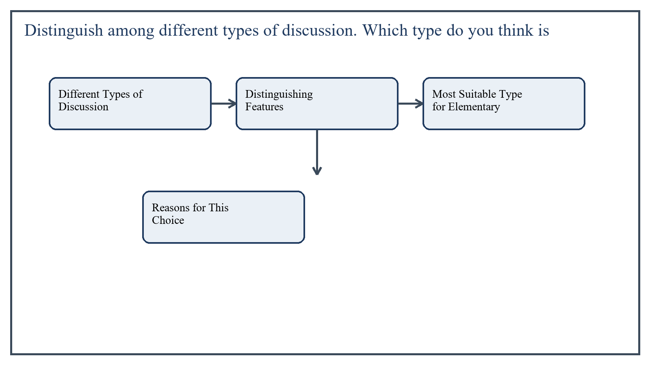
Figure 1: Concept map for Question 1

Different Types of Discussion
One common type is whole-class discussion. In this format the entire class takes part, and the teacher guides the conversation through questions, clarification, and summarizing. It is useful for introducing a topic, checking understanding, and sharing diverse viewpoints.
A second type is small-group discussion. Students are divided into small groups to think through a question, solve a task, or prepare a joint response. This type encourages greater participation because shy students often speak more freely in smaller groups.
A third type is panel discussion, in which a small number of students or invited persons discuss a topic before the class while the audience listens and later asks questions. This is more suitable for mature learners who can manage structured dialogue.
A fourth type is buzz-group discussion. Here students quickly discuss a narrow question in pairs or very small groups for a short time and then report back. It is especially useful for activating attention and involving many students in a short lesson segment.
A fifth type is guided discussion, where the teacher carefully controls the sequence of questions in order to lead students toward specific understanding. This type is helpful when learners are young or the concept is new.
In the context of General Methods of Teaching, the theme of different types of discussion deserves extended attention because assignment-level understanding is expected to move beyond one-line definitions and into explanation, comparison, and application. A strong university answer shows not only what the concept means, but also why it matters, how it appears in practice, and what limitations or challenges may arise when it is implemented in real educational settings.
A mature academic response also connects different types of discussion with classroom realities, institutional culture, and the Pakistani context wherever relevant. This makes the answer more analytical and more useful because it links conceptual understanding with the needs of teachers, learners, administrators, and communities rather than leaving the idea at a purely theoretical level.
From an examination and assignment-writing perspective, the topic of different types of discussion should be handled through clear structure, careful terminology, valid examples, and balanced discussion. The strongest responses usually define the idea, explain its major components, illustrate it through educational examples, and then conclude with a reasoned judgment about its significance, usefulness, or limitations.

Distinguishing Features
- Whole-class discussion offers broad sharing but may allow a few students to dominate.
- Small-group discussion increases participation but requires time and class management.
- Panel discussion promotes depth but suits older students better.
- Buzz-group discussion is brief, energetic, and easy to insert within a normal lesson.
- Guided discussion provides structure and is especially useful for younger learners.
In the context of General Methods of Teaching, the theme of distinguishing features deserves extended attention because assignment-level understanding is expected to move beyond one-line definitions and into explanation, comparison, and application. A strong university answer shows not only what the concept means, but also why it matters, how it appears in practice, and what limitations or challenges may arise when it is implemented in real educational settings.
A mature academic response also connects distinguishing features with classroom realities, institutional culture, and the Pakistani context wherever relevant. This makes the answer more analytical and more useful because it links conceptual understanding with the needs of teachers, learners, administrators, and communities rather than leaving the idea at a purely theoretical level.
From an examination and assignment-writing perspective, the topic of distinguishing features should be handled through clear structure, careful terminology, valid examples, and balanced discussion. The strongest responses usually define the idea, explain its major components, illustrate it through educational examples, and then conclude with a reasoned judgment about its significance, usefulness, or limitations.

Most Suitable Type for Elementary Classes
For elementary classes, guided discussion and short buzz-group discussion are generally the most suitable. Young children need structure, simple questions, limited time, and teacher support. They usually cannot sustain long abstract discussion like older students.
Guided discussion suits elementary learners because the teacher can keep the talk focused, correct misunderstanding immediately, and encourage participation in age-appropriate language. Short pair or buzz discussions are also effective because they let children speak without the pressure of addressing the whole class for too long.
In the context of General Methods of Teaching, the theme of most suitable type for elementary classes deserves extended attention because assignment-level understanding is expected to move beyond one-line definitions and into explanation, comparison, and application. A strong university answer shows not only what the concept means, but also why it matters, how it appears in practice, and what limitations or challenges may arise when it is implemented in real educational settings.
A mature academic response also connects most suitable type for elementary classes with classroom realities, institutional culture, and the Pakistani context wherever relevant. This makes the answer more analytical and more useful because it links conceptual understanding with the needs of teachers, learners, administrators, and communities rather than leaving the idea at a purely theoretical level.
From an examination and assignment-writing perspective, the topic of most suitable type for elementary classes should be handled through clear structure, careful terminology, valid examples, and balanced discussion. The strongest responses usually define the idea, explain its major components, illustrate it through educational examples, and then conclude with a reasoned judgment about its significance, usefulness, or limitations.

Reasons for This Choice
- Elementary learners have shorter attention spans and need brief, focused discussion tasks.
- They learn better when questions are concrete and linked to familiar experiences.
- They benefit from immediate teacher guidance and encouragement.
- Structured interaction helps develop speaking and listening habits gradually.
In the context of General Methods of Teaching, the theme of reasons for this choice deserves extended attention because assignment-level understanding is expected to move beyond one-line definitions and into explanation, comparison, and application. A strong university answer shows not only what the concept means, but also why it matters, how it appears in practice, and what limitations or challenges may arise when it is implemented in real educational settings.
A mature academic response also connects reasons for this choice with classroom realities, institutional culture, and the Pakistani context wherever relevant. This makes the answer more analytical and more useful because it links conceptual understanding with the needs of teachers, learners, administrators, and communities rather than leaving the idea at a purely theoretical level.
From an examination and assignment-writing perspective, the topic of reasons for this choice should be handled through clear structure, careful terminology, valid examples, and balanced discussion. The strongest responses usually define the idea, explain its major components, illustrate it through educational examples, and then conclude with a reasoned judgment about its significance, usefulness, or limitations.

Applied Illustration and Academic Note
For a stronger B.Ed assignment response, the topic above should be linked with classroom life, institutional practice, and the needs of Pakistani learners. This approach makes the response more analytical and demonstrates that the writer understands both theory and application, which is usually appreciated in AIOU-style academic work.
A good response also avoids unsupported claims. Instead, it explains concepts carefully, gives relevant examples, and ends with a short judgment about educational significance. In this way, the answer to 'Distinguish among different types of discussion. Which type do you thi...' becomes easier to read, easier to assess, and more academically convincing.

Quick Review Table
Focus Area | Assignment Relevance
Different Types of Discussion | This area helps answer the question on 'Distinguish among different types of discussion. Which ...' by providing concept clarity, explanation, and applied educational value.
Distinguishing Features | This area helps answer the question on 'Distinguish among different types of discussion. Which ...' by providing concept clarity, explanation, and applied educational value.
Most Suitable Type for Elementary Classes | This area helps answer the question on 'Distinguish among different types of discussion. Which ...' by providing concept clarity, explanation, and applied educational value.
Reasons for This Choice | This area helps answer the question on 'Distinguish among different types of discussion. Which ...' by providing concept clarity, explanation, and applied educational value.

Critical Reflection
At an advanced level, the topic should not be treated as a fixed formula. Most educational concepts work within particular conditions, and their success often depends on planning quality, learner background, institutional support, and the competence of the teacher or manager using them. A reflective assignment therefore acknowledges strengths while also recognizing practical limitations.

Conclusion
Different discussion types serve different purposes, but for elementary classes the most suitable forms are guided discussion and short buzz-group discussion. These formats match children's developmental level by combining participation with structure, clarity, and teacher support. In this way discussion remains lively without becoming confusing or unproductive.

Q.2 Enlist some critical thinking objective(s) for the cooperative learning activity.
Answer: The answer below is organized in an academic assignment style, with conceptual explanation, applied discussion, and concise analytical closing comments designed for a neat and extended university submission.
Cooperative learning becomes educationally powerful when it does more than divide students into groups. It should also develop critical thinking, that is, the ability to analyze, compare, justify, evaluate, and solve problems thoughtfully. For this reason, objectives for cooperative learning should be framed in observable and measurable terms.
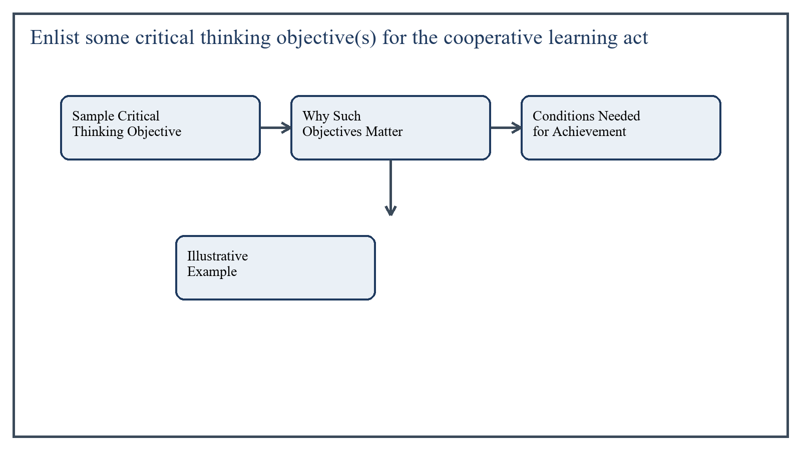
Figure 2: Concept map for Question 2

Sample Critical Thinking Objectives for Cooperative Learning
- Students will identify the main issue in a given problem and distinguish relevant from irrelevant information.
- Students will compare at least two possible solutions and justify which one is stronger on logical grounds.
- Students will analyze causes and effects related to a classroom, social, or scientific situation.
- Students will generate questions that challenge assumptions or incomplete explanations.
- Students will evaluate evidence presented by peers and respond respectfully with reasons.
- Students will synthesize ideas from group members into a shared conclusion or action plan.
- Students will detect bias, weakness, or contradiction in an argument presented during group work.
- Students will reflect on the quality of their own group's reasoning and suggest improvements.
In the context of General Methods of Teaching, the theme of sample critical thinking objectives for cooperative learning deserves extended attention because assignment-level understanding is expected to move beyond one-line definitions and into explanation, comparison, and application. A strong university answer shows not only what the concept means, but also why it matters, how it appears in practice, and what limitations or challenges may arise when it is implemented in real educational settings.
A mature academic response also connects sample critical thinking objectives for cooperative learning with classroom realities, institutional culture, and the Pakistani context wherever relevant. This makes the answer more analytical and more useful because it links conceptual understanding with the needs of teachers, learners, administrators, and communities rather than leaving the idea at a purely theoretical level.
From an examination and assignment-writing perspective, the topic of sample critical thinking objectives for cooperative learning should be handled through clear structure, careful terminology, valid examples, and balanced discussion. The strongest responses usually define the idea, explain its major components, illustrate it through educational examples, and then conclude with a reasoned judgment about its significance, usefulness, or limitations.

Why Such Objectives Matter
These objectives move cooperative learning beyond simple task-sharing. Instead of merely distributing work, students engage in reasoning together. They must listen carefully, judge evidence, examine alternatives, and defend conclusions. This transforms group work into an intellectual activity.
Critical thinking objectives also improve accountability. When objectives specify analyze, justify, evaluate, and synthesize, students understand that they are expected to think deeply rather than copy information from one another.
In the context of General Methods of Teaching, the theme of why such objectives matter deserves extended attention because assignment-level understanding is expected to move beyond one-line definitions and into explanation, comparison, and application. A strong university answer shows not only what the concept means, but also why it matters, how it appears in practice, and what limitations or challenges may arise when it is implemented in real educational settings.
A mature academic response also connects why such objectives matter with classroom realities, institutional culture, and the Pakistani context wherever relevant. This makes the answer more analytical and more useful because it links conceptual understanding with the needs of teachers, learners, administrators, and communities rather than leaving the idea at a purely theoretical level.
From an examination and assignment-writing perspective, the topic of why such objectives matter should be handled through clear structure, careful terminology, valid examples, and balanced discussion. The strongest responses usually define the idea, explain its major components, illustrate it through educational examples, and then conclude with a reasoned judgment about its significance, usefulness, or limitations.

Conditions Needed for Achievement
- Tasks should be open enough to allow more than one idea or solution.
- Questions should require explanation, not just recall.
- Roles such as summarizer, questioner, checker, and reporter can support deeper thinking.
- The teacher should monitor interaction and ask probing questions where reasoning is weak.
In the context of General Methods of Teaching, the theme of conditions needed for achievement deserves extended attention because assignment-level understanding is expected to move beyond one-line definitions and into explanation, comparison, and application. A strong university answer shows not only what the concept means, but also why it matters, how it appears in practice, and what limitations or challenges may arise when it is implemented in real educational settings.
A mature academic response also connects conditions needed for achievement with classroom realities, institutional culture, and the Pakistani context wherever relevant. This makes the answer more analytical and more useful because it links conceptual understanding with the needs of teachers, learners, administrators, and communities rather than leaving the idea at a purely theoretical level.
From an examination and assignment-writing perspective, the topic of conditions needed for achievement should be handled through clear structure, careful terminology, valid examples, and balanced discussion. The strongest responses usually define the idea, explain its major components, illustrate it through educational examples, and then conclude with a reasoned judgment about its significance, usefulness, or limitations.

Illustrative Example
If a group is studying waste management in the community, students may be asked to identify major causes, compare solutions such as awareness campaigns and recycling bins, and defend which option would be more practical in their locality. Such a task directly engages critical thinking within cooperative learning.
In the context of General Methods of Teaching, the theme of illustrative example deserves extended attention because assignment-level understanding is expected to move beyond one-line definitions and into explanation, comparison, and application. A strong university answer shows not only what the concept means, but also why it matters, how it appears in practice, and what limitations or challenges may arise when it is implemented in real educational settings.
A mature academic response also connects illustrative example with classroom realities, institutional culture, and the Pakistani context wherever relevant. This makes the answer more analytical and more useful because it links conceptual understanding with the needs of teachers, learners, administrators, and communities rather than leaving the idea at a purely theoretical level.
From an examination and assignment-writing perspective, the topic of illustrative example should be handled through clear structure, careful terminology, valid examples, and balanced discussion. The strongest responses usually define the idea, explain its major components, illustrate it through educational examples, and then conclude with a reasoned judgment about its significance, usefulness, or limitations.

Applied Illustration and Academic Note
For a stronger B.Ed assignment response, the topic above should be linked with classroom life, institutional practice, and the needs of Pakistani learners. This approach makes the response more analytical and demonstrates that the writer understands both theory and application, which is usually appreciated in AIOU-style academic work.
A good response also avoids unsupported claims. Instead, it explains concepts carefully, gives relevant examples, and ends with a short judgment about educational significance. In this way, the answer to 'Enlist some critical thinking objective(s) for the cooperative learnin...' becomes easier to read, easier to assess, and more academically convincing.

Quick Review Table
Focus Area | Assignment Relevance
Sample Critical Thinking Objectives for Cooperative Learning | This area helps answer the question on 'Enlist some critical thinking objective(s) for the coop...' by providing concept clarity, explanation, and applied educational value.
Why Such Objectives Matter | This area helps answer the question on 'Enlist some critical thinking objective(s) for the coop...' by providing concept clarity, explanation, and applied educational value.
Conditions Needed for Achievement | This area helps answer the question on 'Enlist some critical thinking objective(s) for the coop...' by providing concept clarity, explanation, and applied educational value.
Illustrative Example | This area helps answer the question on 'Enlist some critical thinking objective(s) for the coop...' by providing concept clarity, explanation, and applied educational value.

Critical Reflection
At an advanced level, the topic should not be treated as a fixed formula. Most educational concepts work within particular conditions, and their success often depends on planning quality, learner background, institutional support, and the competence of the teacher or manager using them. A reflective assignment therefore acknowledges strengths while also recognizing practical limitations.

Conclusion
Critical thinking objectives in cooperative learning should target analysis, comparison, judgment, synthesis, and reflection. When these objectives are clearly written and supported by suitable tasks, cooperative learning becomes a strong method for developing thoughtful, responsible, and evidence-based learners.

Q.3 Elaborate on the components of presentation skills with examples.
Answer: The answer below is organized in an academic assignment style, with conceptual explanation, applied discussion, and concise analytical closing comments designed for a neat and extended university submission.
Presentation skills are the abilities that help a speaker communicate ideas clearly, confidently, and effectively before an audience. For a teacher, these skills are not optional because teaching itself involves explanation, demonstration, questioning, and audience engagement. Good presentation skills improve comprehension, maintain attention, and make classroom communication more professional.
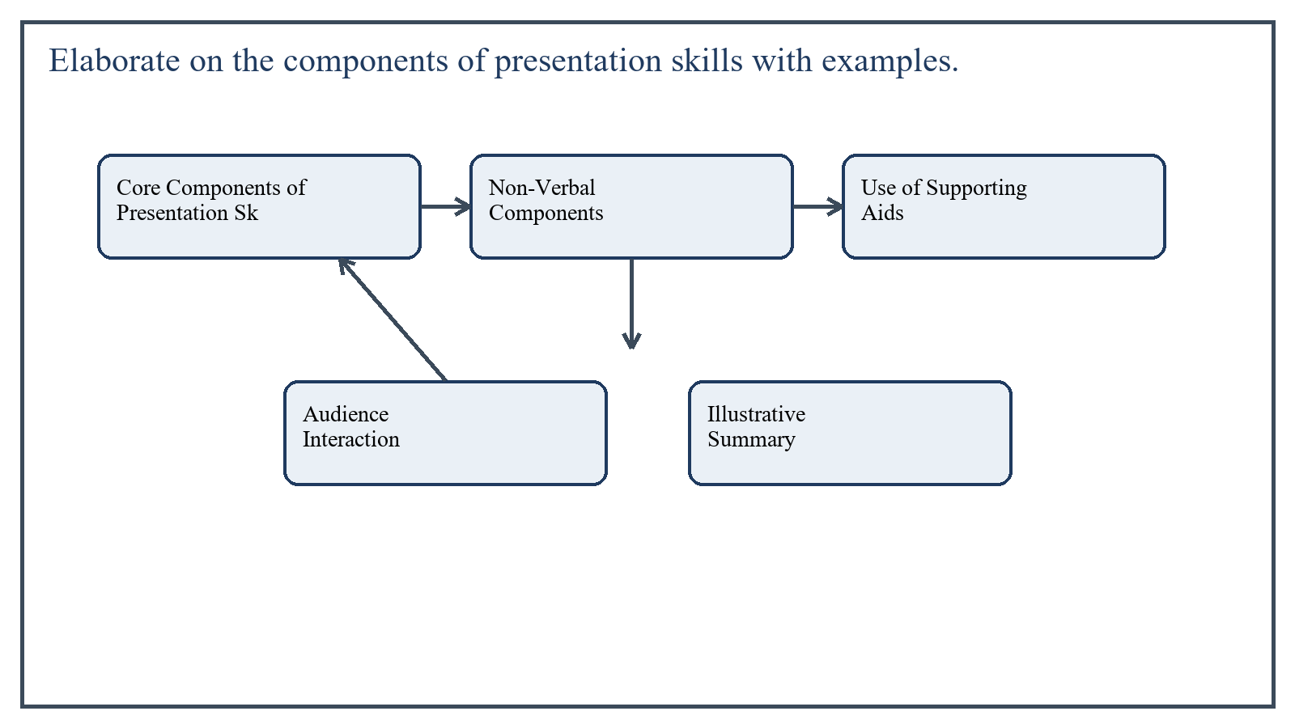
Figure 3: Concept map for Question 3

Core Components of Presentation Skills
The first component is content organization. A good presentation has a clear introduction, logical body, and concise conclusion. Ideas should move in sequence so the audience can follow them easily. For example, a teacher presenting the water cycle should begin with the basic concept, then explain evaporation, condensation, and precipitation in order, and finally summarize the cycle.
The second component is clarity of language. The presenter should use simple, accurate, audience-appropriate language. Unnecessary jargon, very long sentences, or vague wording weakens the message. In a classroom, clarity means explaining ideas in words students can understand while still keeping the concept accurate.
The third component is voice control. Audible speech, proper pace, suitable pause, emphasis, and variation in tone help the listener remain attentive. A flat voice can make even good content seem dull, while a well-modulated voice highlights key points and creates interest.
In the context of General Methods of Teaching, the theme of core components of presentation skills deserves extended attention because assignment-level understanding is expected to move beyond one-line definitions and into explanation, comparison, and application. A strong university answer shows not only what the concept means, but also why it matters, how it appears in practice, and what limitations or challenges may arise when it is implemented in real educational settings.
A mature academic response also connects core components of presentation skills with classroom realities, institutional culture, and the Pakistani context wherever relevant. This makes the answer more analytical and more useful because it links conceptual understanding with the needs of teachers, learners, administrators, and communities rather than leaving the idea at a purely theoretical level.
From an examination and assignment-writing perspective, the topic of core components of presentation skills should be handled through clear structure, careful terminology, valid examples, and balanced discussion. The strongest responses usually define the idea, explain its major components, illustrate it through educational examples, and then conclude with a reasoned judgment about its significance, usefulness, or limitations.

Non-Verbal Components
Body language is another major component. Eye contact, posture, facial expression, gestures, and movement all influence how the message is received. A speaker who avoids eye contact or appears nervous may reduce audience confidence, while a calm and open posture increases credibility.
Confidence and poise are closely linked with body language. Confidence does not mean artificial showmanship; it means preparedness, self-control, and respectful command of the situation. For example, a trainee teacher who stands steadily, looks at students, and explains step by step appears more effective than one who reads every line from paper.
In the context of General Methods of Teaching, the theme of non-verbal components deserves extended attention because assignment-level understanding is expected to move beyond one-line definitions and into explanation, comparison, and application. A strong university answer shows not only what the concept means, but also why it matters, how it appears in practice, and what limitations or challenges may arise when it is implemented in real educational settings.
A mature academic response also connects non-verbal components with classroom realities, institutional culture, and the Pakistani context wherever relevant. This makes the answer more analytical and more useful because it links conceptual understanding with the needs of teachers, learners, administrators, and communities rather than leaving the idea at a purely theoretical level.
From an examination and assignment-writing perspective, the topic of non-verbal components should be handled through clear structure, careful terminology, valid examples, and balanced discussion. The strongest responses usually define the idea, explain its major components, illustrate it through educational examples, and then conclude with a reasoned judgment about its significance, usefulness, or limitations.

Use of Supporting Aids
Visual aids, charts, slides, board work, models, and handouts are also part of presentation skill. These supports should strengthen understanding rather than distract from it. A map in geography, a diagram in biology, or a timeline in history can make an explanation clearer and more memorable.
However, the presenter must know how to use aids properly. Reading every line from a slide or crowding the board with untidy writing weakens presentation quality. The aid should support the speaker, not replace the speaker.
In the context of General Methods of Teaching, the theme of use of supporting aids deserves extended attention because assignment-level understanding is expected to move beyond one-line definitions and into explanation, comparison, and application. A strong university answer shows not only what the concept means, but also why it matters, how it appears in practice, and what limitations or challenges may arise when it is implemented in real educational settings.
A mature academic response also connects use of supporting aids with classroom realities, institutional culture, and the Pakistani context wherever relevant. This makes the answer more analytical and more useful because it links conceptual understanding with the needs of teachers, learners, administrators, and communities rather than leaving the idea at a purely theoretical level.
From an examination and assignment-writing perspective, the topic of use of supporting aids should be handled through clear structure, careful terminology, valid examples, and balanced discussion. The strongest responses usually define the idea, explain its major components, illustrate it through educational examples, and then conclude with a reasoned judgment about its significance, usefulness, or limitations.

Audience Interaction
An effective presentation is not a one-way delivery. Interaction through questions, quick checks, small tasks, and examples keeps the audience mentally present. In classroom teaching, asking students to predict an answer or explain a step turns a presentation into active learning.
Time management is equally essential. A good presenter gives enough time to important points without becoming repetitive. Finishing too early may suggest poor preparation, while overshooting time may leave the audience tired and confused.
In the context of General Methods of Teaching, the theme of audience interaction deserves extended attention because assignment-level understanding is expected to move beyond one-line definitions and into explanation, comparison, and application. A strong university answer shows not only what the concept means, but also why it matters, how it appears in practice, and what limitations or challenges may arise when it is implemented in real educational settings.
A mature academic response also connects audience interaction with classroom realities, institutional culture, and the Pakistani context wherever relevant. This makes the answer more analytical and more useful because it links conceptual understanding with the needs of teachers, learners, administrators, and communities rather than leaving the idea at a purely theoretical level.
From an examination and assignment-writing perspective, the topic of audience interaction should be handled through clear structure, careful terminology, valid examples, and balanced discussion. The strongest responses usually define the idea, explain its major components, illustrate it through educational examples, and then conclude with a reasoned judgment about its significance, usefulness, or limitations.

Illustrative Summary
- Organization: beginning, development, and conclusion.
- Language: simple, correct, and audience-appropriate expression.
- Voice: audibility, pace, pause, and emphasis.
- Body language: eye contact, posture, gestures, and facial expression.
- Aids: charts, slides, board, models, or handouts used purposefully.
- Interaction: questioning, examples, and response to audience cues.
- Time management: balanced pacing and concise closure.
In the context of General Methods of Teaching, the theme of illustrative summary deserves extended attention because assignment-level understanding is expected to move beyond one-line definitions and into explanation, comparison, and application. A strong university answer shows not only what the concept means, but also why it matters, how it appears in practice, and what limitations or challenges may arise when it is implemented in real educational settings.
A mature academic response also connects illustrative summary with classroom realities, institutional culture, and the Pakistani context wherever relevant. This makes the answer more analytical and more useful because it links conceptual understanding with the needs of teachers, learners, administrators, and communities rather than leaving the idea at a purely theoretical level.
From an examination and assignment-writing perspective, the topic of illustrative summary should be handled through clear structure, careful terminology, valid examples, and balanced discussion. The strongest responses usually define the idea, explain its major components, illustrate it through educational examples, and then conclude with a reasoned judgment about its significance, usefulness, or limitations.

Applied Illustration and Academic Note
For a stronger B.Ed assignment response, the topic above should be linked with classroom life, institutional practice, and the needs of Pakistani learners. This approach makes the response more analytical and demonstrates that the writer understands both theory and application, which is usually appreciated in AIOU-style academic work.
A good response also avoids unsupported claims. Instead, it explains concepts carefully, gives relevant examples, and ends with a short judgment about educational significance. In this way, the answer to 'Elaborate on the components of presentation skills with examples....' becomes easier to read, easier to assess, and more academically convincing.

Quick Review Table
Focus Area | Assignment Relevance
Core Components of Presentation Skills | This area helps answer the question on 'Elaborate on the components of presentation skills with...' by providing concept clarity, explanation, and applied educational value.
Non-Verbal Components | This area helps answer the question on 'Elaborate on the components of presentation skills with...' by providing concept clarity, explanation, and applied educational value.
Use of Supporting Aids | This area helps answer the question on 'Elaborate on the components of presentation skills with...' by providing concept clarity, explanation, and applied educational value.
Audience Interaction | This area helps answer the question on 'Elaborate on the components of presentation skills with...' by providing concept clarity, explanation, and applied educational value.

Critical Reflection
At an advanced level, the topic should not be treated as a fixed formula. Most educational concepts work within particular conditions, and their success often depends on planning quality, learner background, institutional support, and the competence of the teacher or manager using them. A reflective assignment therefore acknowledges strengths while also recognizing practical limitations.

Conclusion
Presentation skill is a combination of what is said, how it is said, and how the audience is engaged. Its major components include organized content, clear language, controlled voice, suitable body language, effective visual support, interaction, and time management. For teachers, mastering these components improves both classroom communication and professional effectiveness.

Q.4 Critically evaluate different strategies to identify learning difficulties of students.
Answer: The answer below is organized in an academic assignment style, with conceptual explanation, applied discussion, and concise analytical closing comments designed for a neat and extended university submission.
Identifying learning difficulties is a crucial teaching responsibility because many students struggle silently unless the teacher observes them carefully. Learning difficulty does not always mean lack of intelligence; it may arise from weak prior knowledge, language barriers, emotional stress, sensory limitations, poor teaching match, or specific learning disorders. Therefore, identification must be systematic, fair, and evidence-based.
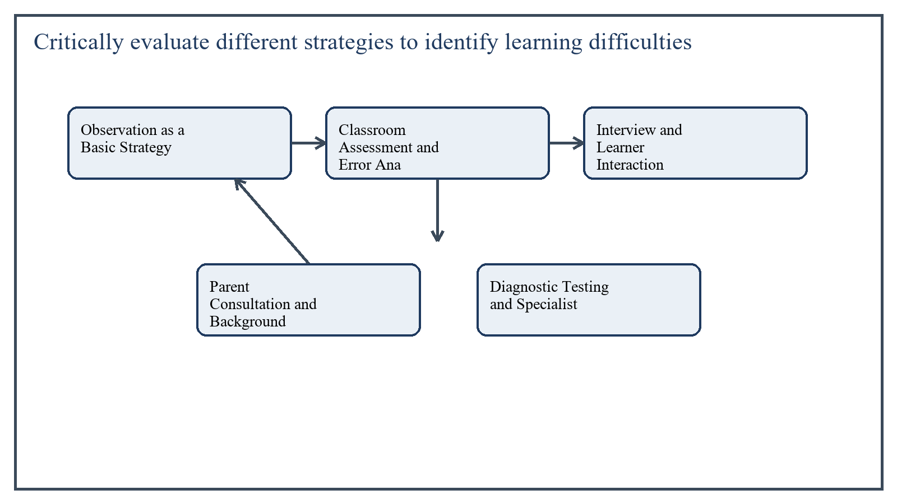
Figure 4: Concept map for Question 4

Observation as a Basic Strategy
Teacher observation is one of the earliest and most useful strategies. Through daily observation, the teacher can note patterns such as slow task completion, difficulty in following instructions, letter reversals, confusion in number work, avoidance of reading, or inability to retain concepts.
Its strength lies in natural classroom context. However, observation alone can be subjective. A teacher may confuse boredom, shyness, or poor attendance with actual learning difficulty. Therefore, observation should be recorded systematically and supported by additional evidence.
In the context of General Methods of Teaching, the theme of observation as a basic strategy deserves extended attention because assignment-level understanding is expected to move beyond one-line definitions and into explanation, comparison, and application. A strong university answer shows not only what the concept means, but also why it matters, how it appears in practice, and what limitations or challenges may arise when it is implemented in real educational settings.
A mature academic response also connects observation as a basic strategy with classroom realities, institutional culture, and the Pakistani context wherever relevant. This makes the answer more analytical and more useful because it links conceptual understanding with the needs of teachers, learners, administrators, and communities rather than leaving the idea at a purely theoretical level.
From an examination and assignment-writing perspective, the topic of observation as a basic strategy should be handled through clear structure, careful terminology, valid examples, and balanced discussion. The strongest responses usually define the idea, explain its major components, illustrate it through educational examples, and then conclude with a reasoned judgment about its significance, usefulness, or limitations.

Classroom Assessment and Error Analysis
Frequent classroom assessment helps identify where the learner is struggling. Short quizzes, oral responses, worksheets, and performance tasks show not only whether the answer is wrong but also what kind of error the student makes. Error analysis can reveal whether the difficulty is conceptual, procedural, language-based, or attention-related.
This strategy is strong because it connects diagnosis directly with instruction. Yet it must be carefully designed. If tests are too difficult, poorly worded, or unrelated to classroom teaching, they may create false impressions about student weakness.
In the context of General Methods of Teaching, the theme of classroom assessment and error analysis deserves extended attention because assignment-level understanding is expected to move beyond one-line definitions and into explanation, comparison, and application. A strong university answer shows not only what the concept means, but also why it matters, how it appears in practice, and what limitations or challenges may arise when it is implemented in real educational settings.
A mature academic response also connects classroom assessment and error analysis with classroom realities, institutional culture, and the Pakistani context wherever relevant. This makes the answer more analytical and more useful because it links conceptual understanding with the needs of teachers, learners, administrators, and communities rather than leaving the idea at a purely theoretical level.
From an examination and assignment-writing perspective, the topic of classroom assessment and error analysis should be handled through clear structure, careful terminology, valid examples, and balanced discussion. The strongest responses usually define the idea, explain its major components, illustrate it through educational examples, and then conclude with a reasoned judgment about its significance, usefulness, or limitations.

Interview and Learner Interaction
Talking to the student is another important strategy. A short interview can uncover whether the learner understands the task, feels anxious, has visual or hearing problems, lacks family support, or is confused by the language of instruction.
This strategy respects the learner's voice, but younger children may not always express their difficulty clearly. For that reason, interviews should be simple, supportive, and combined with other methods.
In the context of General Methods of Teaching, the theme of interview and learner interaction deserves extended attention because assignment-level understanding is expected to move beyond one-line definitions and into explanation, comparison, and application. A strong university answer shows not only what the concept means, but also why it matters, how it appears in practice, and what limitations or challenges may arise when it is implemented in real educational settings.
A mature academic response also connects interview and learner interaction with classroom realities, institutional culture, and the Pakistani context wherever relevant. This makes the answer more analytical and more useful because it links conceptual understanding with the needs of teachers, learners, administrators, and communities rather than leaving the idea at a purely theoretical level.
From an examination and assignment-writing perspective, the topic of interview and learner interaction should be handled through clear structure, careful terminology, valid examples, and balanced discussion. The strongest responses usually define the idea, explain its major components, illustrate it through educational examples, and then conclude with a reasoned judgment about its significance, usefulness, or limitations.

Parent Consultation and Background Information
Parents can provide valuable background about health, attendance, early development, home study habits, or previous school history. Such information helps the teacher see whether the problem is long-standing or recently developed.
The limitation is that parental reports may be incomplete or emotionally biased. Some parents under-report problems due to stigma, while others overstate them due to anxiety. Hence, parent input is useful but not sufficient on its own.
In the context of General Methods of Teaching, the theme of parent consultation and background information deserves extended attention because assignment-level understanding is expected to move beyond one-line definitions and into explanation, comparison, and application. A strong university answer shows not only what the concept means, but also why it matters, how it appears in practice, and what limitations or challenges may arise when it is implemented in real educational settings.
A mature academic response also connects parent consultation and background information with classroom realities, institutional culture, and the Pakistani context wherever relevant. This makes the answer more analytical and more useful because it links conceptual understanding with the needs of teachers, learners, administrators, and communities rather than leaving the idea at a purely theoretical level.
From an examination and assignment-writing perspective, the topic of parent consultation and background information should be handled through clear structure, careful terminology, valid examples, and balanced discussion. The strongest responses usually define the idea, explain its major components, illustrate it through educational examples, and then conclude with a reasoned judgment about its significance, usefulness, or limitations.

Diagnostic Testing and Specialist Referral
Where difficulties persist, diagnostic tests and specialist assessment become important. Psychologists, special educators, speech therapists, or counselors may identify specific issues such as dyslexia, hearing loss, language delay, or attention difficulties. This is especially helpful when the teacher suspects more than ordinary slow learning.
The strength of this strategy is precision; the weakness is access. In many schools, especially in under-resourced settings, specialists and valid diagnostic tools are not readily available. Referral may also take time.
In the context of General Methods of Teaching, the theme of diagnostic testing and specialist referral deserves extended attention because assignment-level understanding is expected to move beyond one-line definitions and into explanation, comparison, and application. A strong university answer shows not only what the concept means, but also why it matters, how it appears in practice, and what limitations or challenges may arise when it is implemented in real educational settings.
A mature academic response also connects diagnostic testing and specialist referral with classroom realities, institutional culture, and the Pakistani context wherever relevant. This makes the answer more analytical and more useful because it links conceptual understanding with the needs of teachers, learners, administrators, and communities rather than leaving the idea at a purely theoretical level.
From an examination and assignment-writing perspective, the topic of diagnostic testing and specialist referral should be handled through clear structure, careful terminology, valid examples, and balanced discussion. The strongest responses usually define the idea, explain its major components, illustrate it through educational examples, and then conclude with a reasoned judgment about its significance, usefulness, or limitations.

Critical Evaluation
The best approach is a layered strategy: observe, assess, analyze errors, talk to the learner, consult parents, and refer when necessary. This prevents over-labeling and helps the teacher respond with suitable remediation rather than punishment or neglect.
- No single strategy is sufficient for identifying learning difficulties accurately.
- Multiple sources of evidence are more reliable than one test or one impression.
- Teachers should distinguish between temporary learning gaps and deeper learning difficulties.
- Identification must lead to support; labeling without intervention is educationally harmful.
In the context of General Methods of Teaching, the theme of critical evaluation deserves extended attention because assignment-level understanding is expected to move beyond one-line definitions and into explanation, comparison, and application. A strong university answer shows not only what the concept means, but also why it matters, how it appears in practice, and what limitations or challenges may arise when it is implemented in real educational settings.
A mature academic response also connects critical evaluation with classroom realities, institutional culture, and the Pakistani context wherever relevant. This makes the answer more analytical and more useful because it links conceptual understanding with the needs of teachers, learners, administrators, and communities rather than leaving the idea at a purely theoretical level.
From an examination and assignment-writing perspective, the topic of critical evaluation should be handled through clear structure, careful terminology, valid examples, and balanced discussion. The strongest responses usually define the idea, explain its major components, illustrate it through educational examples, and then conclude with a reasoned judgment about its significance, usefulness, or limitations.

Applied Illustration and Academic Note
For a stronger B.Ed assignment response, the topic above should be linked with classroom life, institutional practice, and the needs of Pakistani learners. This approach makes the response more analytical and demonstrates that the writer understands both theory and application, which is usually appreciated in AIOU-style academic work.
A good response also avoids unsupported claims. Instead, it explains concepts carefully, gives relevant examples, and ends with a short judgment about educational significance. In this way, the answer to 'Critically evaluate different strategies to identify learning difficul...' becomes easier to read, easier to assess, and more academically convincing.

Quick Review Table
Focus Area | Assignment Relevance
Observation as a Basic Strategy | This area helps answer the question on 'Critically evaluate different strategies to identify le...' by providing concept clarity, explanation, and applied educational value.
Classroom Assessment and Error Analysis | This area helps answer the question on 'Critically evaluate different strategies to identify le...' by providing concept clarity, explanation, and applied educational value.
Interview and Learner Interaction | This area helps answer the question on 'Critically evaluate different strategies to identify le...' by providing concept clarity, explanation, and applied educational value.
Parent Consultation and Background Information | This area helps answer the question on 'Critically evaluate different strategies to identify le...' by providing concept clarity, explanation, and applied educational value.

Critical Reflection
At an advanced level, the topic should not be treated as a fixed formula. Most educational concepts work within particular conditions, and their success often depends on planning quality, learner background, institutional support, and the competence of the teacher or manager using them. A reflective assignment therefore acknowledges strengths while also recognizing practical limitations.

Conclusion
Different strategies for identifying learning difficulties each have value, but each also has limitations. Observation, assessment, interviews, parent consultation, and diagnostic referral should be used together rather than separately. A critical and compassionate teacher collects evidence carefully and uses it to plan support, not merely to classify students.

Q.5 Critically examine the role of maps and posters in making lessons easy and interesting for the learner.
Answer: The answer below is organized in an academic assignment style, with conceptual explanation, applied discussion, and concise analytical closing comments designed for a neat and extended university submission.
Maps and posters are widely used instructional aids because they turn abstract information into visible form. They support explanation, improve memory, and make lessons more concrete. However, their effectiveness depends on relevance, design, timing, and teacher use. Therefore, they should be examined critically rather than praised mechanically.
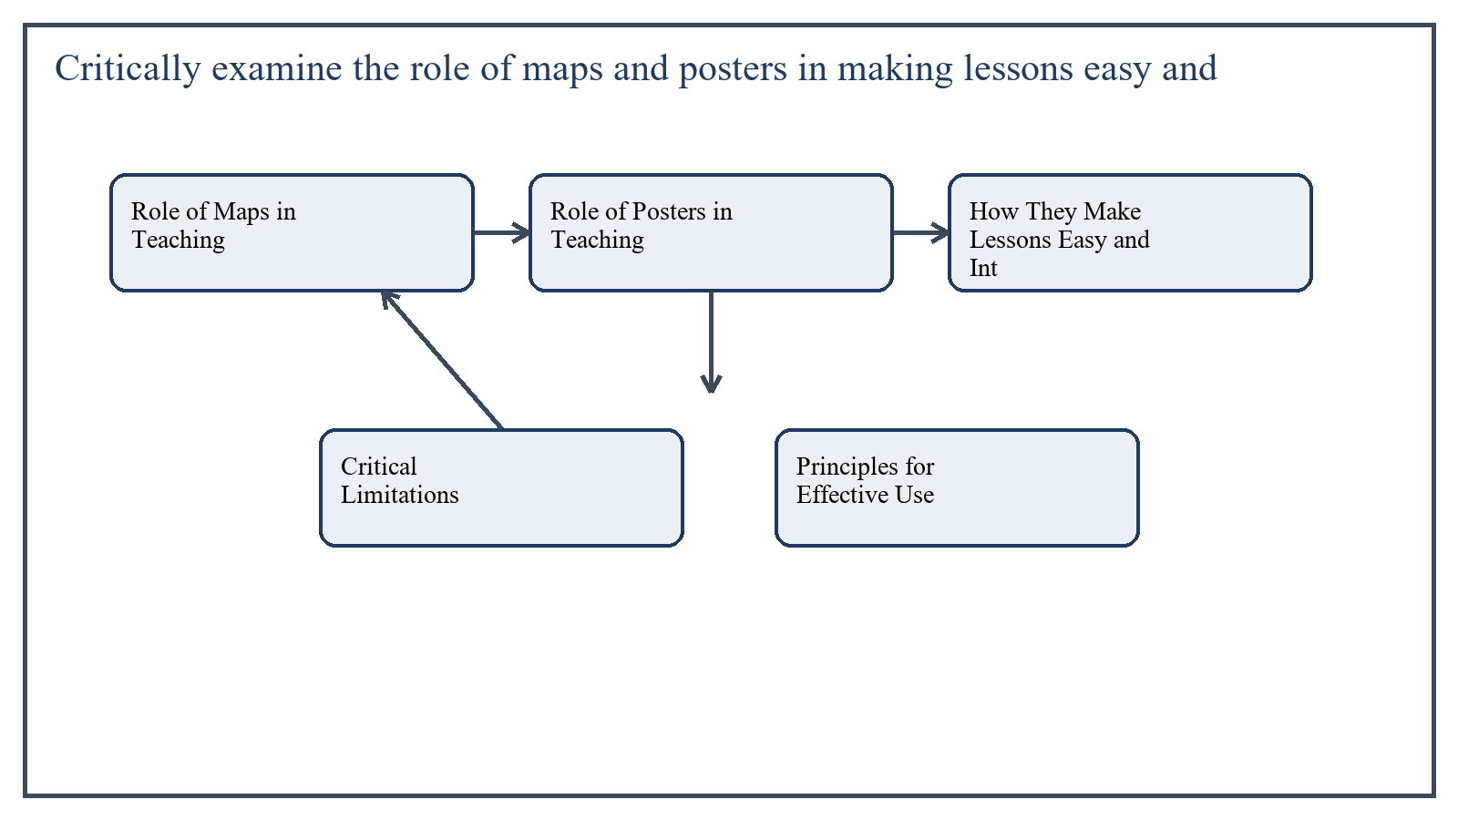
Figure 5: Concept map for Question 5

Role of Maps in Teaching
Maps are especially useful in geography, history, social studies, environmental studies, and even language learning when place and movement matter. They help learners visualize location, distance, direction, distribution, and relationships between places. A lesson on rivers, provinces, trade routes, migration, or climate becomes easier when students can actually see the spatial pattern.
Maps also support active learning. Students can identify places, trace routes, compare regions, or interpret physical and political features. This turns passive listening into visual and analytical engagement.
In the context of General Methods of Teaching, the theme of role of maps in teaching deserves extended attention because assignment-level understanding is expected to move beyond one-line definitions and into explanation, comparison, and application. A strong university answer shows not only what the concept means, but also why it matters, how it appears in practice, and what limitations or challenges may arise when it is implemented in real educational settings.
A mature academic response also connects role of maps in teaching with classroom realities, institutional culture, and the Pakistani context wherever relevant. This makes the answer more analytical and more useful because it links conceptual understanding with the needs of teachers, learners, administrators, and communities rather than leaving the idea at a purely theoretical level.
From an examination and assignment-writing perspective, the topic of role of maps in teaching should be handled through clear structure, careful terminology, valid examples, and balanced discussion. The strongest responses usually define the idea, explain its major components, illustrate it through educational examples, and then conclude with a reasoned judgment about its significance, usefulness, or limitations.

Role of Posters in Teaching
Posters are effective because they combine image, color, words, and emphasis in a compact visual form. They are useful for summarizing rules, illustrating processes, displaying health messages, presenting safety steps, or reinforcing key concepts in a memorable way.
For example, a poster on the parts of a plant, hand-washing steps, sentence structure, or road safety can make learning easier because it provides a constant visual cue. Posters are particularly helpful with younger learners and in classrooms where repeated reinforcement is needed.
In the context of General Methods of Teaching, the theme of role of posters in teaching deserves extended attention because assignment-level understanding is expected to move beyond one-line definitions and into explanation, comparison, and application. A strong university answer shows not only what the concept means, but also why it matters, how it appears in practice, and what limitations or challenges may arise when it is implemented in real educational settings.
A mature academic response also connects role of posters in teaching with classroom realities, institutional culture, and the Pakistani context wherever relevant. This makes the answer more analytical and more useful because it links conceptual understanding with the needs of teachers, learners, administrators, and communities rather than leaving the idea at a purely theoretical level.
From an examination and assignment-writing perspective, the topic of role of posters in teaching should be handled through clear structure, careful terminology, valid examples, and balanced discussion. The strongest responses usually define the idea, explain its major components, illustrate it through educational examples, and then conclude with a reasoned judgment about its significance, usefulness, or limitations.

How They Make Lessons Easy and Interesting
- They reduce abstraction by giving visual form to concepts.
- They attract attention and break the monotony of verbal teaching.
- They support recall because visual memory often lasts longer than verbal memory alone.
- They stimulate questioning, observation, and discussion.
- They help students with weaker reading ability by offering picture-based support.
In the context of General Methods of Teaching, the theme of how they make lessons easy and interesting deserves extended attention because assignment-level understanding is expected to move beyond one-line definitions and into explanation, comparison, and application. A strong university answer shows not only what the concept means, but also why it matters, how it appears in practice, and what limitations or challenges may arise when it is implemented in real educational settings.
A mature academic response also connects how they make lessons easy and interesting with classroom realities, institutional culture, and the Pakistani context wherever relevant. This makes the answer more analytical and more useful because it links conceptual understanding with the needs of teachers, learners, administrators, and communities rather than leaving the idea at a purely theoretical level.
From an examination and assignment-writing perspective, the topic of how they make lessons easy and interesting should be handled through clear structure, careful terminology, valid examples, and balanced discussion. The strongest responses usually define the idea, explain its major components, illustrate it through educational examples, and then conclude with a reasoned judgment about its significance, usefulness, or limitations.

Critical Limitations
Despite these advantages, maps and posters are not automatically effective. A poorly designed poster with too much text, unclear images, or weak contrast may confuse rather than help. Similarly, a map that is too small, outdated, or overloaded with detail may be useless for actual classroom understanding.
Another limitation is overdependence. If the teacher simply points at a poster or hangs maps permanently without interaction, the aid becomes decorative rather than instructional. Visual material must be integrated into teaching through explanation, questions, tasks, and follow-up activity.
They may also fail if they are not age-appropriate. Young children need simple, bold, concrete visuals, while older students can handle more complexity. One poster design cannot fit every classroom level.
In the context of General Methods of Teaching, the theme of critical limitations deserves extended attention because assignment-level understanding is expected to move beyond one-line definitions and into explanation, comparison, and application. A strong university answer shows not only what the concept means, but also why it matters, how it appears in practice, and what limitations or challenges may arise when it is implemented in real educational settings.
A mature academic response also connects critical limitations with classroom realities, institutional culture, and the Pakistani context wherever relevant. This makes the answer more analytical and more useful because it links conceptual understanding with the needs of teachers, learners, administrators, and communities rather than leaving the idea at a purely theoretical level.
From an examination and assignment-writing perspective, the topic of critical limitations should be handled through clear structure, careful terminology, valid examples, and balanced discussion. The strongest responses usually define the idea, explain its major components, illustrate it through educational examples, and then conclude with a reasoned judgment about its significance, usefulness, or limitations.

Principles for Effective Use
- Select maps and posters according to the learning objective.
- Ensure that size, lettering, color, and labeling are clear for all students.
- Introduce the visual at the right moment instead of exposing everything too early.
- Ask students to interpret, identify, compare, or explain what they see.
- Connect the visual aid with textbook content, examples, and assessment.
In the context of General Methods of Teaching, the theme of principles for effective use deserves extended attention because assignment-level understanding is expected to move beyond one-line definitions and into explanation, comparison, and application. A strong university answer shows not only what the concept means, but also why it matters, how it appears in practice, and what limitations or challenges may arise when it is implemented in real educational settings.
A mature academic response also connects principles for effective use with classroom realities, institutional culture, and the Pakistani context wherever relevant. This makes the answer more analytical and more useful because it links conceptual understanding with the needs of teachers, learners, administrators, and communities rather than leaving the idea at a purely theoretical level.
From an examination and assignment-writing perspective, the topic of principles for effective use should be handled through clear structure, careful terminology, valid examples, and balanced discussion. The strongest responses usually define the idea, explain its major components, illustrate it through educational examples, and then conclude with a reasoned judgment about its significance, usefulness, or limitations.

Applied Illustration and Academic Note
For a stronger B.Ed assignment response, the topic above should be linked with classroom life, institutional practice, and the needs of Pakistani learners. This approach makes the response more analytical and demonstrates that the writer understands both theory and application, which is usually appreciated in AIOU-style academic work.
A good response also avoids unsupported claims. Instead, it explains concepts carefully, gives relevant examples, and ends with a short judgment about educational significance. In this way, the answer to 'Critically examine the role of maps and posters in making lessons easy...' becomes easier to read, easier to assess, and more academically convincing.

Quick Review Table
Focus Area | Assignment Relevance
Role of Maps in Teaching | This area helps answer the question on 'Critically examine the role of maps and posters in maki...' by providing concept clarity, explanation, and applied educational value.
Role of Posters in Teaching | This area helps answer the question on 'Critically examine the role of maps and posters in maki...' by providing concept clarity, explanation, and applied educational value.
How They Make Lessons Easy and Interesting | This area helps answer the question on 'Critically examine the role of maps and posters in maki...' by providing concept clarity, explanation, and applied educational value.
Critical Limitations | This area helps answer the question on 'Critically examine the role of maps and posters in maki...' by providing concept clarity, explanation, and applied educational value.

Critical Reflection
At an advanced level, the topic should not be treated as a fixed formula. Most educational concepts work within particular conditions, and their success often depends on planning quality, learner background, institutional support, and the competence of the teacher or manager using them. A reflective assignment therefore acknowledges strengths while also recognizing practical limitations.

Conclusion
Maps and posters play an important role in making lessons easy and interesting because they provide clarity, attention, and visual reinforcement. Yet their value depends on thoughtful selection and active use. When they are relevant, clear, and integrated with questioning and explanation, they become powerful teaching aids; when they are poorly designed or passively displayed, their educational effect becomes weak.

Extended Revision Appendix
This appendix is included to strengthen the assignment as a premium academic submission. It provides recap notes, revision prompts, and concept reinforcement so the document reads like a complete study-ready submission rather than a short-answer sheet only.

Key Revision Points
- Review the central demand of the question 'Distinguish among different types of discussion. Which type do...' and connect definition, explanation, example, and critical comment in one organized response.
- Review the central demand of the question 'Enlist some critical thinking objective(s) for the cooperative...' and connect definition, explanation, example, and critical comment in one organized response.
- Review the central demand of the question 'Elaborate on the components of presentation skills with exampl...' and connect definition, explanation, example, and critical comment in one organized response.
- Review the central demand of the question 'Critically evaluate different strategies to identify learning ...' and connect definition, explanation, example, and critical comment in one organized response.
- Review the central demand of the question 'Critically examine the role of maps and posters in making less...' and connect definition, explanation, example, and critical comment in one organized response.

Academic Writing Reminders
- Begin each major answer with a clear conceptual opening.
- Use examples to show understanding instead of repeating definitions only.
- Present advantages, limitations, and contextual realities where relevant.
- Close each answer with a short evaluative conclusion.
- Maintain formal and neat language throughout the assignment.

Concept Reinforcement Notes
The question on 'Distinguish among different types of discussion. Which type do you think is...' can be revised further by identifying three things: the main concept involved, the educational importance of that concept, and one example from Pakistani classroom or institutional life. This simple method helps transform memorized content into organized written response.
The question on 'Enlist some critical thinking objective(s) for the cooperative learning act...' can be revised further by identifying three things: the main concept involved, the educational importance of that concept, and one example from Pakistani classroom or institutional life. This simple method helps transform memorized content into organized written response.
The question on 'Elaborate on the components of presentation skills with examples....' can be revised further by identifying three things: the main concept involved, the educational importance of that concept, and one example from Pakistani classroom or institutional life. This simple method helps transform memorized content into organized written response.
The question on 'Critically evaluate different strategies to identify learning difficulties ...' can be revised further by identifying three things: the main concept involved, the educational importance of that concept, and one example from Pakistani classroom or institutional life. This simple method helps transform memorized content into organized written response.
The question on 'Critically examine the role of maps and posters in making lessons easy and ...' can be revised further by identifying three things: the main concept involved, the educational importance of that concept, and one example from Pakistani classroom or institutional life. This simple method helps transform memorized content into organized written response.

Source Base and Assignment Support Notes
The following source base was used to keep the answers aligned with AIOU course structure and the exact question wording. The final language and organization were expanded for presentation quality, page-length target, and assignment readability.
- AIOU Soft Book: General Methods of Teaching (Code 8601), especially the units on discussion, cooperative learning, presentation skills, learning difficulties, and instructional aids.
- AIOU Spring 2026 assignment sheet for Course 8601.

Extended Analytical Note 1
In extended study of General Methods of Teaching, the issue raised in 'Distinguish among different types of discussion. Which type do you think...' may also be explored through definition, theoretical explanation, applied example, classroom implication, institutional implication, and critical reflection. This six-part approach helps a learner produce a more complete answer and also improves the academic appearance of the assignment by showing structure and depth.
Another useful strategy in long-form assignment writing is to move carefully from concept to context. First explain what the idea means, then identify its components, then discuss its relevance in teaching or administration, and finally mention any practical limitation. Such movement gives maturity to the answer and helps the examiner follow the logic without difficulty.
In extended study of General Methods of Teaching, the issue raised in 'Enlist some critical thinking objective(s) for the cooperative learning ...' may also be explored through definition, theoretical explanation, applied example, classroom implication, institutional implication, and critical reflection. This six-part approach helps a learner produce a more complete answer and also improves the academic appearance of the assignment by showing structure and depth.
Another useful strategy in long-form assignment writing is to move carefully from concept to context. First explain what the idea means, then identify its components, then discuss its relevance in teaching or administration, and finally mention any practical limitation. Such movement gives maturity to the answer and helps the examiner follow the logic without difficulty.
In extended study of General Methods of Teaching, the issue raised in 'Elaborate on the components of presentation skills with examples....' may also be explored through definition, theoretical explanation, applied example, classroom implication, institutional implication, and critical reflection. This six-part approach helps a learner produce a more complete answer and also improves the academic appearance of the assignment by showing structure and depth.
Another useful strategy in long-form assignment writing is to move carefully from concept to context. First explain what the idea means, then identify its components, then discuss its relevance in teaching or administration, and finally mention any practical limitation. Such movement gives maturity to the answer and helps the examiner follow the logic without difficulty.
In extended study of General Methods of Teaching, the issue raised in 'Critically evaluate different strategies to identify learning difficulti...' may also be explored through definition, theoretical explanation, applied example, classroom implication, institutional implication, and critical reflection. This six-part approach helps a learner produce a more complete answer and also improves the academic appearance of the assignment by showing structure and depth.
Another useful strategy in long-form assignment writing is to move carefully from concept to context. First explain what the idea means, then identify its components, then discuss its relevance in teaching or administration, and finally mention any practical limitation. Such movement gives maturity to the answer and helps the examiner follow the logic without difficulty.
In extended study of General Methods of Teaching, the issue raised in 'Critically examine the role of maps and posters in making lessons easy a...' may also be explored through definition, theoretical explanation, applied example, classroom implication, institutional implication, and critical reflection. This six-part approach helps a learner produce a more complete answer and also improves the academic appearance of the assignment by showing structure and depth.
Another useful strategy in long-form assignment writing is to move carefully from concept to context. First explain what the idea means, then identify its components, then discuss its relevance in teaching or administration, and finally mention any practical limitation. Such movement gives maturity to the answer and helps the examiner follow the logic without difficulty.

Extended Analytical Note 2
In extended study of General Methods of Teaching, the issue raised in 'Distinguish among different types of discussion. Which type do you think...' may also be explored through definition, theoretical explanation, applied example, classroom implication, institutional implication, and critical reflection. This six-part approach helps a learner produce a more complete answer and also improves the academic appearance of the assignment by showing structure and depth.
Another useful strategy in long-form assignment writing is to move carefully from concept to context. First explain what the idea means, then identify its components, then discuss its relevance in teaching or administration, and finally mention any practical limitation. Such movement gives maturity to the answer and helps the examiner follow the logic without difficulty.
In extended study of General Methods of Teaching, the issue raised in 'Enlist some critical thinking objective(s) for the cooperative learning ...' may also be explored through definition, theoretical explanation, applied example, classroom implication, institutional implication, and critical reflection. This six-part approach helps a learner produce a more complete answer and also improves the academic appearance of the assignment by showing structure and depth.
Another useful strategy in long-form assignment writing is to move carefully from concept to context. First explain what the idea means, then identify its components, then discuss its relevance in teaching or administration, and finally mention any practical limitation. Such movement gives maturity to the answer and helps the examiner follow the logic without difficulty.
In extended study of General Methods of Teaching, the issue raised in 'Elaborate on the components of presentation skills with examples....' may also be explored through definition, theoretical explanation, applied example, classroom implication, institutional implication, and critical reflection. This six-part approach helps a learner produce a more complete answer and also improves the academic appearance of the assignment by showing structure and depth.
Another useful strategy in long-form assignment writing is to move carefully from concept to context. First explain what the idea means, then identify its components, then discuss its relevance in teaching or administration, and finally mention any practical limitation. Such movement gives maturity to the answer and helps the examiner follow the logic without difficulty.
In extended study of General Methods of Teaching, the issue raised in 'Critically evaluate different strategies to identify learning difficulti...' may also be explored through definition, theoretical explanation, applied example, classroom implication, institutional implication, and critical reflection. This six-part approach helps a learner produce a more complete answer and also improves the academic appearance of the assignment by showing structure and depth.
Another useful strategy in long-form assignment writing is to move carefully from concept to context. First explain what the idea means, then identify its components, then discuss its relevance in teaching or administration, and finally mention any practical limitation. Such movement gives maturity to the answer and helps the examiner follow the logic without difficulty.
In extended study of General Methods of Teaching, the issue raised in 'Critically examine the role of maps and posters in making lessons easy a...' may also be explored through definition, theoretical explanation, applied example, classroom implication, institutional implication, and critical reflection. This six-part approach helps a learner produce a more complete answer and also improves the academic appearance of the assignment by showing structure and depth.
Another useful strategy in long-form assignment writing is to move carefully from concept to context. First explain what the idea means, then identify its components, then discuss its relevance in teaching or administration, and finally mention any practical limitation. Such movement gives maturity to the answer and helps the examiner follow the logic without difficulty.

Extended Analytical Note 3
In extended study of General Methods of Teaching, the issue raised in 'Distinguish among different types of discussion. Which type do you think...' may also be explored through definition, theoretical explanation, applied example, classroom implication, institutional implication, and critical reflection. This six-part approach helps a learner produce a more complete answer and also improves the academic appearance of the assignment by showing structure and depth.
Another useful strategy in long-form assignment writing is to move carefully from concept to context. First explain what the idea means, then identify its components, then discuss its relevance in teaching or administration, and finally mention any practical limitation. Such movement gives maturity to the answer and helps the examiner follow the logic without difficulty.
In extended study of General Methods of Teaching, the issue raised in 'Enlist some critical thinking objective(s) for the cooperative learning ...' may also be explored through definition, theoretical explanation, applied example, classroom implication, institutional implication, and critical reflection. This six-part approach helps a learner produce a more complete answer and also improves the academic appearance of the assignment by showing structure and depth.
Another useful strategy in long-form assignment writing is to move carefully from concept to context. First explain what the idea means, then identify its components, then discuss its relevance in teaching or administration, and finally mention any practical limitation. Such movement gives maturity to the answer and helps the examiner follow the logic without difficulty.
In extended study of General Methods of Teaching, the issue raised in 'Elaborate on the components of presentation skills with examples....' may also be explored through definition, theoretical explanation, applied example, classroom implication, institutional implication, and critical reflection. This six-part approach helps a learner produce a more complete answer and also improves the academic appearance of the assignment by showing structure and depth.
Another useful strategy in long-form assignment writing is to move carefully from concept to context. First explain what the idea means, then identify its components, then discuss its relevance in teaching or administration, and finally mention any practical limitation. Such movement gives maturity to the answer and helps the examiner follow the logic without difficulty.
In extended study of General Methods of Teaching, the issue raised in 'Critically evaluate different strategies to identify learning difficulti...' may also be explored through definition, theoretical explanation, applied example, classroom implication, institutional implication, and critical reflection. This six-part approach helps a learner produce a more complete answer and also improves the academic appearance of the assignment by showing structure and depth.
Another useful strategy in long-form assignment writing is to move carefully from concept to context. First explain what the idea means, then identify its components, then discuss its relevance in teaching or administration, and finally mention any practical limitation. Such movement gives maturity to the answer and helps the examiner follow the logic without difficulty.
In extended study of General Methods of Teaching, the issue raised in 'Critically examine the role of maps and posters in making lessons easy a...' may also be explored through definition, theoretical explanation, applied example, classroom implication, institutional implication, and critical reflection. This six-part approach helps a learner produce a more complete answer and also improves the academic appearance of the assignment by showing structure and depth.
Another useful strategy in long-form assignment writing is to move carefully from concept to context. First explain what the idea means, then identify its components, then discuss its relevance in teaching or administration, and finally mention any practical limitation. Such movement gives maturity to the answer and helps the examiner follow the logic without difficulty.

Extended Analytical Note 4
In extended study of General Methods of Teaching, the issue raised in 'Distinguish among different types of discussion. Which type do you think...' may also be explored through definition, theoretical explanation, applied example, classroom implication, institutional implication, and critical reflection. This six-part approach helps a learner produce a more complete answer and also improves the academic appearance of the assignment by showing structure and depth.
Another useful strategy in long-form assignment writing is to move carefully from concept to context. First explain what the idea means, then identify its components, then discuss its relevance in teaching or administration, and finally mention any practical limitation. Such movement gives maturity to the answer and helps the examiner follow the logic without difficulty.
In extended study of General Methods of Teaching, the issue raised in 'Enlist some critical thinking objective(s) for the cooperative learning ...' may also be explored through definition, theoretical explanation, applied example, classroom implication, institutional implication, and critical reflection. This six-part approach helps a learner produce a more complete answer and also improves the academic appearance of the assignment by showing structure and depth.
Another useful strategy in long-form assignment writing is to move carefully from concept to context. First explain what the idea means, then identify its components, then discuss its relevance in teaching or administration, and finally mention any practical limitation. Such movement gives maturity to the answer and helps the examiner follow the logic without difficulty.
In extended study of General Methods of Teaching, the issue raised in 'Elaborate on the components of presentation skills with examples....' may also be explored through definition, theoretical explanation, applied example, classroom implication, institutional implication, and critical reflection. This six-part approach helps a learner produce a more complete answer and also improves the academic appearance of the assignment by showing structure and depth.
Another useful strategy in long-form assignment writing is to move carefully from concept to context. First explain what the idea means, then identify its components, then discuss its relevance in teaching or administration, and finally mention any practical limitation. Such movement gives maturity to the answer and helps the examiner follow the logic without difficulty.
In extended study of General Methods of Teaching, the issue raised in 'Critically evaluate different strategies to identify learning difficulti...' may also be explored through definition, theoretical explanation, applied example, classroom implication, institutional implication, and critical reflection. This six-part approach helps a learner produce a more complete answer and also improves the academic appearance of the assignment by showing structure and depth.
Another useful strategy in long-form assignment writing is to move carefully from concept to context. First explain what the idea means, then identify its components, then discuss its relevance in teaching or administration, and finally mention any practical limitation. Such movement gives maturity to the answer and helps the examiner follow the logic without difficulty.
In extended study of General Methods of Teaching, the issue raised in 'Critically examine the role of maps and posters in making lessons easy a...' may also be explored through definition, theoretical explanation, applied example, classroom implication, institutional implication, and critical reflection. This six-part approach helps a learner produce a more complete answer and also improves the academic appearance of the assignment by showing structure and depth.
Another useful strategy in long-form assignment writing is to move carefully from concept to context. First explain what the idea means, then identify its components, then discuss its relevance in teaching or administration, and finally mention any practical limitation. Such movement gives maturity to the answer and helps the examiner follow the logic without difficulty.

