ALLAMA IQBAL OPEN UNIVERSITY
Premium Typed Assignment
Educational Assessment and Evaluation
Detail | Course Code: 8602
Detail | Assignment No: 1
Detail | Unit Coverage: Units 1-5
Detail | Program Level: B.Ed
Detail | Formatting Profile: Times New Roman, 14 pt headings, 12 pt body text
Detail | Document Goal: Extended academic response with diagrams, border styling, and premium presentation

Presentation Note
This file has been prepared as a premium typed assignment with extended academic treatment, proper page border styling, inserted diagrams, formal headings, and neat section hierarchy. The content is intentionally expanded so that the assignment remains easy to read while still meeting a high page-length target.

Q.1 Explain in detail the six key principles of classroom assessment, providing a concrete classroom example for each.
Answer: The answer below is organized in an academic assignment style, with conceptual explanation, applied discussion, and concise analytical closing comments designed for a neat and extended university submission.
Classroom assessment is an integral part of teaching and learning rather than a separate activity conducted only at the end of a unit. The AIOU course book emphasizes that effective assessment should support learning, improve instruction, and provide fair evidence about student progress. Six important principles can be explained in detail as follows.
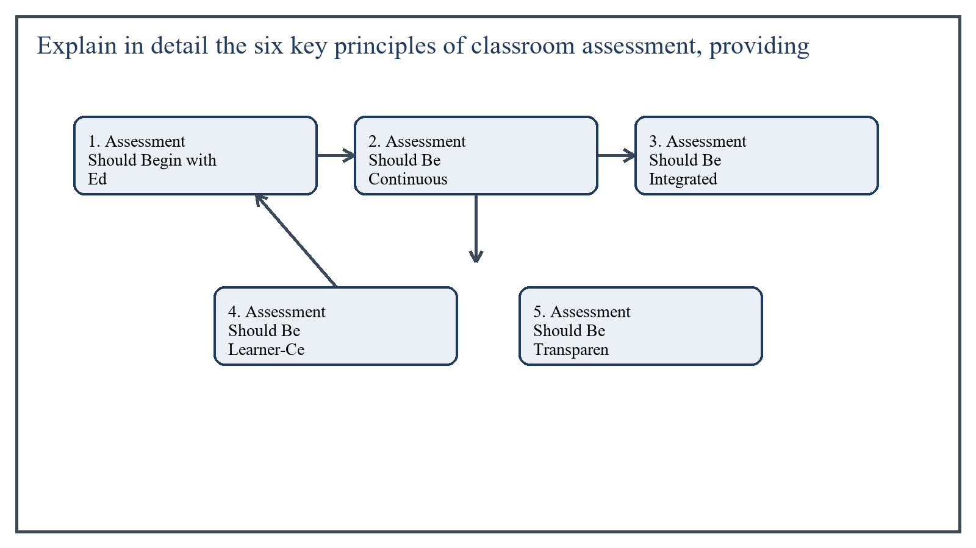
Figure 1: Concept map for Question 1

1. Assessment Should Begin with Educational Goals
The first principle is that assessment must grow directly from educational goals and learning objectives. If the teacher is unclear about what students are expected to learn, the assessment will also become confused. Clear objectives help the teacher decide what evidence to collect and what type of task is suitable.
For example, if the objective in a science class is that students will classify living things according to observable characteristics, then the assessment should ask students to classify specimens or pictures. A vague essay on 'science' would not reflect the objective properly.
In the context of Educational Assessment and Evaluation, the theme of 1. assessment should begin with educational goals deserves extended attention because assignment-level understanding is expected to move beyond one-line definitions and into explanation, comparison, and application. A strong university answer shows not only what the concept means, but also why it matters, how it appears in practice, and what limitations or challenges may arise when it is implemented in real educational settings.
A mature academic response also connects 1. assessment should begin with educational goals with classroom realities, institutional culture, and the Pakistani context wherever relevant. This makes the answer more analytical and more useful because it links conceptual understanding with the needs of teachers, learners, administrators, and communities rather than leaving the idea at a purely theoretical level.
From an examination and assignment-writing perspective, the topic of 1. assessment should begin with educational goals should be handled through clear structure, careful terminology, valid examples, and balanced discussion. The strongest responses usually define the idea, explain its major components, illustrate it through educational examples, and then conclude with a reasoned judgment about its significance, usefulness, or limitations.

2. Assessment Should Be Continuous and Ongoing
The second principle is continuity. Assessment should not appear only in monthly tests or final examinations. Teachers need regular evidence during instruction so they can see whether students are understanding, forgetting, or developing misconceptions.
For example, during a mathematics lesson on fractions, the teacher may use quick oral questions, a short worksheet, and board responses before moving to the next step. These small assessments help the teacher adjust teaching immediately instead of waiting until the end of the chapter.
In the context of Educational Assessment and Evaluation, the theme of 2. assessment should be continuous and ongoing deserves extended attention because assignment-level understanding is expected to move beyond one-line definitions and into explanation, comparison, and application. A strong university answer shows not only what the concept means, but also why it matters, how it appears in practice, and what limitations or challenges may arise when it is implemented in real educational settings.
A mature academic response also connects 2. assessment should be continuous and ongoing with classroom realities, institutional culture, and the Pakistani context wherever relevant. This makes the answer more analytical and more useful because it links conceptual understanding with the needs of teachers, learners, administrators, and communities rather than leaving the idea at a purely theoretical level.
From an examination and assignment-writing perspective, the topic of 2. assessment should be continuous and ongoing should be handled through clear structure, careful terminology, valid examples, and balanced discussion. The strongest responses usually define the idea, explain its major components, illustrate it through educational examples, and then conclude with a reasoned judgment about its significance, usefulness, or limitations.

3. Assessment Should Be Integrated with Instruction
A third principle is that assessment should serve teaching and learning, not dominate them. Assessment is strongest when it is woven into classroom activity. It should inform the teacher about next steps and help students understand their own progress.
A classroom example is a language teacher who listens to students read aloud, notes pronunciation and comprehension issues, and then modifies the next lesson to address those exact weaknesses. Here assessment is functioning as part of instruction rather than as a disconnected event.
In the context of Educational Assessment and Evaluation, the theme of 3. assessment should be integrated with instruction deserves extended attention because assignment-level understanding is expected to move beyond one-line definitions and into explanation, comparison, and application. A strong university answer shows not only what the concept means, but also why it matters, how it appears in practice, and what limitations or challenges may arise when it is implemented in real educational settings.
A mature academic response also connects 3. assessment should be integrated with instruction with classroom realities, institutional culture, and the Pakistani context wherever relevant. This makes the answer more analytical and more useful because it links conceptual understanding with the needs of teachers, learners, administrators, and communities rather than leaving the idea at a purely theoretical level.
From an examination and assignment-writing perspective, the topic of 3. assessment should be integrated with instruction should be handled through clear structure, careful terminology, valid examples, and balanced discussion. The strongest responses usually define the idea, explain its major components, illustrate it through educational examples, and then conclude with a reasoned judgment about its significance, usefulness, or limitations.

4. Assessment Should Be Learner-Centered and Diagnostic
The fourth principle is that classroom assessment should help identify students' strengths and learning difficulties. A good assessment system is diagnostic; it reveals where the learner needs support instead of merely assigning marks.
For instance, if several students fail to solve long-division problems, the teacher should examine whether the difficulty lies in multiplication facts, place value, or interpretation of instructions. In this way assessment becomes a tool for diagnosis and remediation.
In the context of Educational Assessment and Evaluation, the theme of 4. assessment should be learner-centered and diagnostic deserves extended attention because assignment-level understanding is expected to move beyond one-line definitions and into explanation, comparison, and application. A strong university answer shows not only what the concept means, but also why it matters, how it appears in practice, and what limitations or challenges may arise when it is implemented in real educational settings.
A mature academic response also connects 4. assessment should be learner-centered and diagnostic with classroom realities, institutional culture, and the Pakistani context wherever relevant. This makes the answer more analytical and more useful because it links conceptual understanding with the needs of teachers, learners, administrators, and communities rather than leaving the idea at a purely theoretical level.
From an examination and assignment-writing perspective, the topic of 4. assessment should be learner-centered and diagnostic should be handled through clear structure, careful terminology, valid examples, and balanced discussion. The strongest responses usually define the idea, explain its major components, illustrate it through educational examples, and then conclude with a reasoned judgment about its significance, usefulness, or limitations.

5. Assessment Should Be Transparent and Fair
Students should know what is being assessed, why it is being assessed, and how performance will be judged. Transparency reduces anxiety and builds trust. Fairness means that tasks should match what has actually been taught and should not disadvantage students through unclear language or irrelevant difficulty.
A concrete example is providing students with the marking criteria for paragraph writing before they begin the task. If they know that organization, grammar, vocabulary, and relevance will be assessed, they can prepare accordingly and perceive the process as fair.
In the context of Educational Assessment and Evaluation, the theme of 5. assessment should be transparent and fair deserves extended attention because assignment-level understanding is expected to move beyond one-line definitions and into explanation, comparison, and application. A strong university answer shows not only what the concept means, but also why it matters, how it appears in practice, and what limitations or challenges may arise when it is implemented in real educational settings.
A mature academic response also connects 5. assessment should be transparent and fair with classroom realities, institutional culture, and the Pakistani context wherever relevant. This makes the answer more analytical and more useful because it links conceptual understanding with the needs of teachers, learners, administrators, and communities rather than leaving the idea at a purely theoretical level.
From an examination and assignment-writing perspective, the topic of 5. assessment should be transparent and fair should be handled through clear structure, careful terminology, valid examples, and balanced discussion. The strongest responses usually define the idea, explain its major components, illustrate it through educational examples, and then conclude with a reasoned judgment about its significance, usefulness, or limitations.

6. Assessment Should Involve Students and Promote Improvement
The sixth principle is student involvement. Assessment is more powerful when learners reflect on their own work, use feedback, and take responsibility for improvement. This principle connects with self-assessment and peer assessment.
For example, after writing a short essay, students may use a checklist to review whether they included a topic sentence, supporting details, and correct punctuation. Such self-assessment encourages metacognition and gradually develops independent learners.
In the context of Educational Assessment and Evaluation, the theme of 6. assessment should involve students and promote improvement deserves extended attention because assignment-level understanding is expected to move beyond one-line definitions and into explanation, comparison, and application. A strong university answer shows not only what the concept means, but also why it matters, how it appears in practice, and what limitations or challenges may arise when it is implemented in real educational settings.
A mature academic response also connects 6. assessment should involve students and promote improvement with classroom realities, institutional culture, and the Pakistani context wherever relevant. This makes the answer more analytical and more useful because it links conceptual understanding with the needs of teachers, learners, administrators, and communities rather than leaving the idea at a purely theoretical level.
From an examination and assignment-writing perspective, the topic of 6. assessment should involve students and promote improvement should be handled through clear structure, careful terminology, valid examples, and balanced discussion. The strongest responses usually define the idea, explain its major components, illustrate it through educational examples, and then conclude with a reasoned judgment about its significance, usefulness, or limitations.

Overall Significance
These six principles show that classroom assessment is not limited to testing memory. It is a planned, purposeful, learner-sensitive process that begins with objectives, runs continuously, supports teaching, diagnoses difficulties, remains fair, and encourages student participation in improvement.
In the context of Educational Assessment and Evaluation, the theme of overall significance deserves extended attention because assignment-level understanding is expected to move beyond one-line definitions and into explanation, comparison, and application. A strong university answer shows not only what the concept means, but also why it matters, how it appears in practice, and what limitations or challenges may arise when it is implemented in real educational settings.
A mature academic response also connects overall significance with classroom realities, institutional culture, and the Pakistani context wherever relevant. This makes the answer more analytical and more useful because it links conceptual understanding with the needs of teachers, learners, administrators, and communities rather than leaving the idea at a purely theoretical level.
From an examination and assignment-writing perspective, the topic of overall significance should be handled through clear structure, careful terminology, valid examples, and balanced discussion. The strongest responses usually define the idea, explain its major components, illustrate it through educational examples, and then conclude with a reasoned judgment about its significance, usefulness, or limitations.

Applied Illustration and Academic Note
For a stronger B.Ed assignment response, the topic above should be linked with classroom life, institutional practice, and the needs of Pakistani learners. This approach makes the response more analytical and demonstrates that the writer understands both theory and application, which is usually appreciated in AIOU-style academic work.
A good response also avoids unsupported claims. Instead, it explains concepts carefully, gives relevant examples, and ends with a short judgment about educational significance. In this way, the answer to 'Explain in detail the six key principles of classroom assessment, prov...' becomes easier to read, easier to assess, and more academically convincing.

Quick Review Table
Focus Area | Assignment Relevance
1. Assessment Should Begin with Educational Goals | This area helps answer the question on 'Explain in detail the six key principles of classroom a...' by providing concept clarity, explanation, and applied educational value.
2. Assessment Should Be Continuous and Ongoing | This area helps answer the question on 'Explain in detail the six key principles of classroom a...' by providing concept clarity, explanation, and applied educational value.
3. Assessment Should Be Integrated with Instruction | This area helps answer the question on 'Explain in detail the six key principles of classroom a...' by providing concept clarity, explanation, and applied educational value.
4. Assessment Should Be Learner-Centered and Diagnostic | This area helps answer the question on 'Explain in detail the six key principles of classroom a...' by providing concept clarity, explanation, and applied educational value.

Critical Reflection
At an advanced level, the topic should not be treated as a fixed formula. Most educational concepts work within particular conditions, and their success often depends on planning quality, learner background, institutional support, and the competence of the teacher or manager using them. A reflective assignment therefore acknowledges strengths while also recognizing practical limitations.

Conclusion
In detail, the six key principles of classroom assessment are goal orientation, continuity, integration with instruction, diagnostic value, transparency and fairness, and student involvement for improvement. When these principles are applied together, classroom assessment becomes a strong means of improving both teaching quality and student learning outcomes.

Q.2 Critically analyze how Bloom's Taxonomy of educational objectives helps teachers prepare balanced tests, and discuss at least two practical challenges in assessing higher-order thinking skills (evaluate and create) using traditional paper-based tests.
Answer: The answer below is organized in an academic assignment style, with conceptual explanation, applied discussion, and concise analytical closing comments designed for a neat and extended university submission.
Bloom's Taxonomy is one of the most influential frameworks for connecting educational objectives with teaching and assessment. It helps teachers move beyond recall-only tests and build a more balanced representation of learning levels. At the same time, assessing higher-order skills such as evaluation and creation through traditional paper-based tests raises important practical challenges.
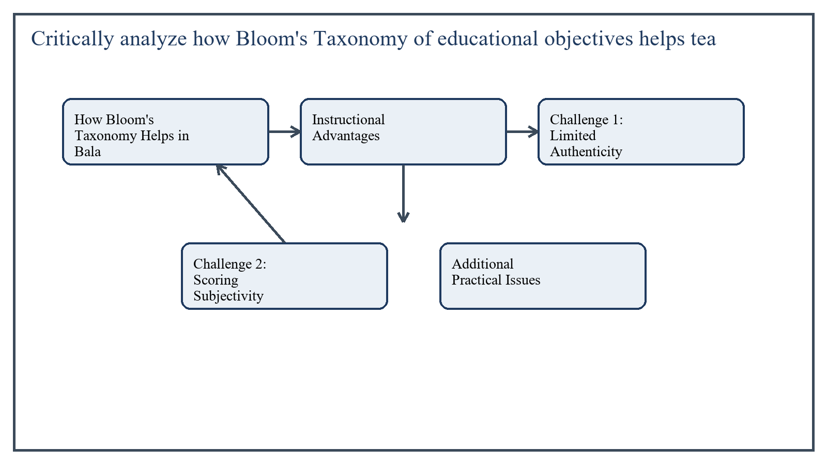
Figure 2: Concept map for Question 2

How Bloom's Taxonomy Helps in Balanced Test Construction
Bloom's Taxonomy classifies cognitive objectives into levels that move from relatively simple thinking to more complex thinking. In its commonly used form, these levels include remembering, understanding, applying, analyzing, evaluating, and creating. By using this hierarchy, the teacher can check whether a test includes only low-level recall items or whether it represents a fuller range of intended learning.
A balanced test is one in which the weight of items reflects both the content taught and the cognitive demand expected. Bloom's framework helps teachers write objectives more precisely, select appropriate verbs, and decide which type of question best measures each level.
For example, a history teacher can use knowledge-level items to ask for dates and names, comprehension items to explain a cause, application items to relate a principle to a new situation, analysis items to compare two events, evaluation items to judge a policy, and creative items to design an alternative solution. This produces a test that is broader and more educationally valid than a recall-heavy paper.
In the context of Educational Assessment and Evaluation, the theme of how bloom's taxonomy helps in balanced test construction deserves extended attention because assignment-level understanding is expected to move beyond one-line definitions and into explanation, comparison, and application. A strong university answer shows not only what the concept means, but also why it matters, how it appears in practice, and what limitations or challenges may arise when it is implemented in real educational settings.
A mature academic response also connects how bloom's taxonomy helps in balanced test construction with classroom realities, institutional culture, and the Pakistani context wherever relevant. This makes the answer more analytical and more useful because it links conceptual understanding with the needs of teachers, learners, administrators, and communities rather than leaving the idea at a purely theoretical level.
From an examination and assignment-writing perspective, the topic of how bloom's taxonomy helps in balanced test construction should be handled through clear structure, careful terminology, valid examples, and balanced discussion. The strongest responses usually define the idea, explain its major components, illustrate it through educational examples, and then conclude with a reasoned judgment about its significance, usefulness, or limitations.

Instructional Advantages
Thus Bloom's Taxonomy serves as a planning tool, a test blueprint aid, and a quality check for instructional balance.
- It helps align test items with stated learning objectives.
- It improves the table of specifications by distributing questions across cognitive levels.
- It discourages overreliance on memory-based questioning.
- It encourages teachers to value understanding, reasoning, and application.
In the context of Educational Assessment and Evaluation, the theme of instructional advantages deserves extended attention because assignment-level understanding is expected to move beyond one-line definitions and into explanation, comparison, and application. A strong university answer shows not only what the concept means, but also why it matters, how it appears in practice, and what limitations or challenges may arise when it is implemented in real educational settings.
A mature academic response also connects instructional advantages with classroom realities, institutional culture, and the Pakistani context wherever relevant. This makes the answer more analytical and more useful because it links conceptual understanding with the needs of teachers, learners, administrators, and communities rather than leaving the idea at a purely theoretical level.
From an examination and assignment-writing perspective, the topic of instructional advantages should be handled through clear structure, careful terminology, valid examples, and balanced discussion. The strongest responses usually define the idea, explain its major components, illustrate it through educational examples, and then conclude with a reasoned judgment about its significance, usefulness, or limitations.

Challenge 1: Limited Authenticity in Paper-Based Evaluation of Higher-Order Thinking
One practical challenge is that evaluation and creation are often best shown in authentic performance, dialogue, project work, investigation, or design tasks. A traditional paper-based test can approximate these processes, but it rarely captures the full richness of real evaluative or creative thinking.
For example, a student may write a strong paragraph claiming to evaluate two teaching methods, but the format may not reveal how deeply the student can question evidence, respond to counterarguments, or apply the judgment in a real situation. Similarly, 'create' on paper may become a short written imitation rather than genuine creation.
In the context of Educational Assessment and Evaluation, the theme of challenge 1: limited authenticity in paper-based evaluation of higher-order thinking deserves extended attention because assignment-level understanding is expected to move beyond one-line definitions and into explanation, comparison, and application. A strong university answer shows not only what the concept means, but also why it matters, how it appears in practice, and what limitations or challenges may arise when it is implemented in real educational settings.
A mature academic response also connects challenge 1: limited authenticity in paper-based evaluation of higher-order thinking with classroom realities, institutional culture, and the Pakistani context wherever relevant. This makes the answer more analytical and more useful because it links conceptual understanding with the needs of teachers, learners, administrators, and communities rather than leaving the idea at a purely theoretical level.
From an examination and assignment-writing perspective, the topic of challenge 1: limited authenticity in paper-based evaluation of higher-order thinking should be handled through clear structure, careful terminology, valid examples, and balanced discussion. The strongest responses usually define the idea, explain its major components, illustrate it through educational examples, and then conclude with a reasoned judgment about its significance, usefulness, or limitations.

Challenge 2: Scoring Subjectivity and Reliability Problems
A second challenge is scoring. Higher-order items usually require open-ended responses such as essays, design plans, or justification of decisions. Such answers can be meaningful, but they are harder to score objectively and consistently than multiple-choice items.
If the scoring rubric is weak, different markers may award different marks to the same answer. This lowers reliability. Teachers may also be influenced by handwriting, language fluency, or overall impression instead of focusing only on the intended cognitive quality.
In the context of Educational Assessment and Evaluation, the theme of challenge 2: scoring subjectivity and reliability problems deserves extended attention because assignment-level understanding is expected to move beyond one-line definitions and into explanation, comparison, and application. A strong university answer shows not only what the concept means, but also why it matters, how it appears in practice, and what limitations or challenges may arise when it is implemented in real educational settings.
A mature academic response also connects challenge 2: scoring subjectivity and reliability problems with classroom realities, institutional culture, and the Pakistani context wherever relevant. This makes the answer more analytical and more useful because it links conceptual understanding with the needs of teachers, learners, administrators, and communities rather than leaving the idea at a purely theoretical level.
From an examination and assignment-writing perspective, the topic of challenge 2: scoring subjectivity and reliability problems should be handled through clear structure, careful terminology, valid examples, and balanced discussion. The strongest responses usually define the idea, explain its major components, illustrate it through educational examples, and then conclude with a reasoned judgment about its significance, usefulness, or limitations.

Additional Practical Issues
- Paper-based higher-order items take more time for students to answer and more time for teachers to mark.
- Large classes make detailed scoring difficult.
- Students with ideas but weaker written expression may perform below their actual thinking ability.
- Examination pressure may push teachers back toward easier recall items.
In the context of Educational Assessment and Evaluation, the theme of additional practical issues deserves extended attention because assignment-level understanding is expected to move beyond one-line definitions and into explanation, comparison, and application. A strong university answer shows not only what the concept means, but also why it matters, how it appears in practice, and what limitations or challenges may arise when it is implemented in real educational settings.
A mature academic response also connects additional practical issues with classroom realities, institutional culture, and the Pakistani context wherever relevant. This makes the answer more analytical and more useful because it links conceptual understanding with the needs of teachers, learners, administrators, and communities rather than leaving the idea at a purely theoretical level.
From an examination and assignment-writing perspective, the topic of additional practical issues should be handled through clear structure, careful terminology, valid examples, and balanced discussion. The strongest responses usually define the idea, explain its major components, illustrate it through educational examples, and then conclude with a reasoned judgment about its significance, usefulness, or limitations.

Critical Position
These limitations do not mean that higher-order thinking should be excluded from written tests. Rather, teachers should use better prompts, detailed rubrics, sample responses, and complementary assessments such as presentations, projects, portfolios, and classroom tasks. Bloom's Taxonomy is strongest when it shapes an assessment system, not only one paper.
In the context of Educational Assessment and Evaluation, the theme of critical position deserves extended attention because assignment-level understanding is expected to move beyond one-line definitions and into explanation, comparison, and application. A strong university answer shows not only what the concept means, but also why it matters, how it appears in practice, and what limitations or challenges may arise when it is implemented in real educational settings.
A mature academic response also connects critical position with classroom realities, institutional culture, and the Pakistani context wherever relevant. This makes the answer more analytical and more useful because it links conceptual understanding with the needs of teachers, learners, administrators, and communities rather than leaving the idea at a purely theoretical level.
From an examination and assignment-writing perspective, the topic of critical position should be handled through clear structure, careful terminology, valid examples, and balanced discussion. The strongest responses usually define the idea, explain its major components, illustrate it through educational examples, and then conclude with a reasoned judgment about its significance, usefulness, or limitations.

Applied Illustration and Academic Note
For a stronger B.Ed assignment response, the topic above should be linked with classroom life, institutional practice, and the needs of Pakistani learners. This approach makes the response more analytical and demonstrates that the writer understands both theory and application, which is usually appreciated in AIOU-style academic work.
A good response also avoids unsupported claims. Instead, it explains concepts carefully, gives relevant examples, and ends with a short judgment about educational significance. In this way, the answer to 'Critically analyze how Bloom's Taxonomy of educational objectives help...' becomes easier to read, easier to assess, and more academically convincing.

Quick Review Table
Focus Area | Assignment Relevance
How Bloom's Taxonomy Helps in Balanced Test Construction | This area helps answer the question on 'Critically analyze how Bloom's Taxonomy of educational ...' by providing concept clarity, explanation, and applied educational value.
Instructional Advantages | This area helps answer the question on 'Critically analyze how Bloom's Taxonomy of educational ...' by providing concept clarity, explanation, and applied educational value.
Challenge 1: Limited Authenticity in Paper-Based Evaluation of Higher-Order Thinking | This area helps answer the question on 'Critically analyze how Bloom's Taxonomy of educational ...' by providing concept clarity, explanation, and applied educational value.
Challenge 2: Scoring Subjectivity and Reliability Problems | This area helps answer the question on 'Critically analyze how Bloom's Taxonomy of educational ...' by providing concept clarity, explanation, and applied educational value.

Critical Reflection
At an advanced level, the topic should not be treated as a fixed formula. Most educational concepts work within particular conditions, and their success often depends on planning quality, learner background, institutional support, and the competence of the teacher or manager using them. A reflective assignment therefore acknowledges strengths while also recognizing practical limitations.

Conclusion
Bloom's Taxonomy helps teachers prepare balanced tests by aligning items with different cognitive levels and by preventing overemphasis on rote recall. However, evaluating and creating through traditional paper-based tests remains challenging because of limited authenticity and scoring subjectivity. Therefore, Bloom's framework should guide broader assessment practice, including both written and performance-based methods.

Q.3 What is standardized testing? Describe the five essential conditions of standardized testing with appropriate real-world examples.
Answer: The answer below is organized in an academic assignment style, with conceptual explanation, applied discussion, and concise analytical closing comments designed for a neat and extended university submission.
Standardized testing refers to testing conducted under uniform and carefully controlled conditions so that scores can be interpreted fairly and compared meaningfully across examinees. The main idea is standardization, which means that test content, administration, scoring, and interpretation are kept consistent for all participants.
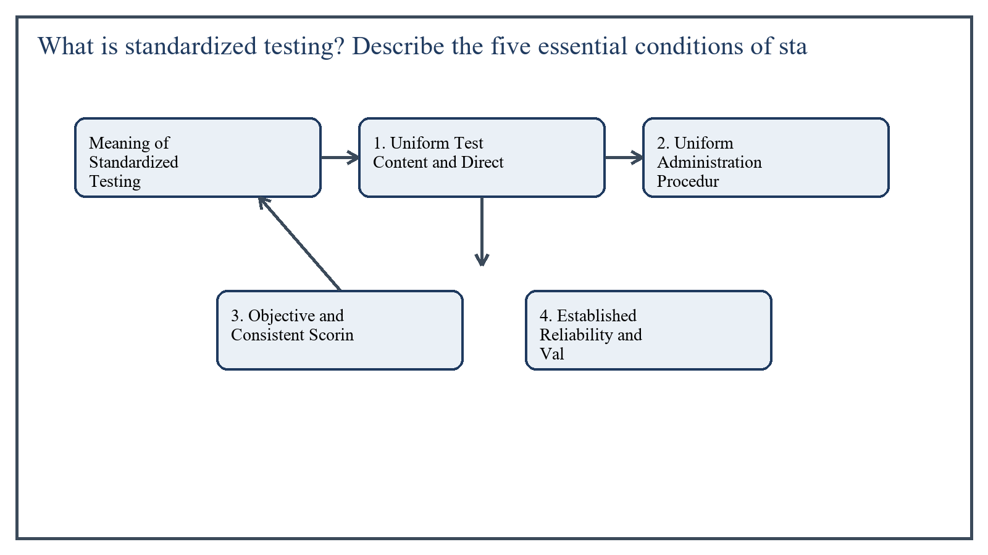
Figure 3: Concept map for Question 3

Meaning of Standardized Testing
A standardized test is not simply a difficult or formal test. It is a test developed, administered, and scored according to established procedures. Its questions are usually field-tested, its directions are fixed, and its scoring and norms are documented. This allows results to carry broader reliability and comparability than ordinary classroom tests.
Examples include national aptitude tests, board examinations with fixed procedures, and large-scale admissions tests where all candidates receive the same instructions, timing, and scoring rules.
In the context of Educational Assessment and Evaluation, the theme of meaning of standardized testing deserves extended attention because assignment-level understanding is expected to move beyond one-line definitions and into explanation, comparison, and application. A strong university answer shows not only what the concept means, but also why it matters, how it appears in practice, and what limitations or challenges may arise when it is implemented in real educational settings.
A mature academic response also connects meaning of standardized testing with classroom realities, institutional culture, and the Pakistani context wherever relevant. This makes the answer more analytical and more useful because it links conceptual understanding with the needs of teachers, learners, administrators, and communities rather than leaving the idea at a purely theoretical level.
From an examination and assignment-writing perspective, the topic of meaning of standardized testing should be handled through clear structure, careful terminology, valid examples, and balanced discussion. The strongest responses usually define the idea, explain its major components, illustrate it through educational examples, and then conclude with a reasoned judgment about its significance, usefulness, or limitations.

1. Uniform Test Content and Directions
The first condition is that all examinees receive the same test content and the same directions. If one group receives easier questions or clearer instructions than another, comparison becomes unfair.
A real-world example is a university admission test in which all candidates across centers receive the same question paper and identical written instructions regarding sections, timing, and answer marking.
In the context of Educational Assessment and Evaluation, the theme of 1. uniform test content and directions deserves extended attention because assignment-level understanding is expected to move beyond one-line definitions and into explanation, comparison, and application. A strong university answer shows not only what the concept means, but also why it matters, how it appears in practice, and what limitations or challenges may arise when it is implemented in real educational settings.
A mature academic response also connects 1. uniform test content and directions with classroom realities, institutional culture, and the Pakistani context wherever relevant. This makes the answer more analytical and more useful because it links conceptual understanding with the needs of teachers, learners, administrators, and communities rather than leaving the idea at a purely theoretical level.
From an examination and assignment-writing perspective, the topic of 1. uniform test content and directions should be handled through clear structure, careful terminology, valid examples, and balanced discussion. The strongest responses usually define the idea, explain its major components, illustrate it through educational examples, and then conclude with a reasoned judgment about its significance, usefulness, or limitations.

2. Uniform Administration Procedures
Standardized testing requires that time limits, seating rules, permitted materials, and invigilator behavior remain consistent. If one room gets extra time or more explanation, results are distorted.
For example, in a board examination, all students may begin at the same official time, use only approved stationery, and follow the same invigilation rules. This is essential for fairness.
In the context of Educational Assessment and Evaluation, the theme of 2. uniform administration procedures deserves extended attention because assignment-level understanding is expected to move beyond one-line definitions and into explanation, comparison, and application. A strong university answer shows not only what the concept means, but also why it matters, how it appears in practice, and what limitations or challenges may arise when it is implemented in real educational settings.
A mature academic response also connects 2. uniform administration procedures with classroom realities, institutional culture, and the Pakistani context wherever relevant. This makes the answer more analytical and more useful because it links conceptual understanding with the needs of teachers, learners, administrators, and communities rather than leaving the idea at a purely theoretical level.
From an examination and assignment-writing perspective, the topic of 2. uniform administration procedures should be handled through clear structure, careful terminology, valid examples, and balanced discussion. The strongest responses usually define the idea, explain its major components, illustrate it through educational examples, and then conclude with a reasoned judgment about its significance, usefulness, or limitations.

3. Objective and Consistent Scoring
The third condition is standardized scoring. Objective items may be machine scored, while open-ended items require scoring keys or rubrics. The aim is to ensure that the same response receives the same score regardless of who checks it.
A practical example is a multiple-choice aptitude test scored through optical mark recognition, or an essay exam in which examiners receive a detailed marking scheme and moderation instructions.
In the context of Educational Assessment and Evaluation, the theme of 3. objective and consistent scoring deserves extended attention because assignment-level understanding is expected to move beyond one-line definitions and into explanation, comparison, and application. A strong university answer shows not only what the concept means, but also why it matters, how it appears in practice, and what limitations or challenges may arise when it is implemented in real educational settings.
A mature academic response also connects 3. objective and consistent scoring with classroom realities, institutional culture, and the Pakistani context wherever relevant. This makes the answer more analytical and more useful because it links conceptual understanding with the needs of teachers, learners, administrators, and communities rather than leaving the idea at a purely theoretical level.
From an examination and assignment-writing perspective, the topic of 3. objective and consistent scoring should be handled through clear structure, careful terminology, valid examples, and balanced discussion. The strongest responses usually define the idea, explain its major components, illustrate it through educational examples, and then conclude with a reasoned judgment about its significance, usefulness, or limitations.

4. Established Reliability and Validity
A test cannot be properly standardized if it is unstable or if it fails to measure what it claims to measure. Therefore, reliability and validity evidence are essential conditions. Reliability ensures consistency of scores, while validity supports the intended interpretation of those scores.
For example, a language proficiency test used for job recruitment should reliably distinguish stronger and weaker candidates and should actually measure language proficiency rather than general intelligence.
In the context of Educational Assessment and Evaluation, the theme of 4. established reliability and validity deserves extended attention because assignment-level understanding is expected to move beyond one-line definitions and into explanation, comparison, and application. A strong university answer shows not only what the concept means, but also why it matters, how it appears in practice, and what limitations or challenges may arise when it is implemented in real educational settings.
A mature academic response also connects 4. established reliability and validity with classroom realities, institutional culture, and the Pakistani context wherever relevant. This makes the answer more analytical and more useful because it links conceptual understanding with the needs of teachers, learners, administrators, and communities rather than leaving the idea at a purely theoretical level.
From an examination and assignment-writing perspective, the topic of 4. established reliability and validity should be handled through clear structure, careful terminology, valid examples, and balanced discussion. The strongest responses usually define the idea, explain its major components, illustrate it through educational examples, and then conclude with a reasoned judgment about its significance, usefulness, or limitations.

5. Norms or Standard Interpretive Framework
A fifth condition is an agreed basis for interpretation, such as norms, percentiles, standard scores, or criterion levels. Without such a framework, the raw score alone may not be meaningful.
For example, in a national achievement test, a score of 72 may be interpreted by comparing it to the average performance of the relevant grade level. This helps teachers, students, and institutions understand whether performance is below, around, or above the expected standard.
In the context of Educational Assessment and Evaluation, the theme of 5. norms or standard interpretive framework deserves extended attention because assignment-level understanding is expected to move beyond one-line definitions and into explanation, comparison, and application. A strong university answer shows not only what the concept means, but also why it matters, how it appears in practice, and what limitations or challenges may arise when it is implemented in real educational settings.
A mature academic response also connects 5. norms or standard interpretive framework with classroom realities, institutional culture, and the Pakistani context wherever relevant. This makes the answer more analytical and more useful because it links conceptual understanding with the needs of teachers, learners, administrators, and communities rather than leaving the idea at a purely theoretical level.
From an examination and assignment-writing perspective, the topic of 5. norms or standard interpretive framework should be handled through clear structure, careful terminology, valid examples, and balanced discussion. The strongest responses usually define the idea, explain its major components, illustrate it through educational examples, and then conclude with a reasoned judgment about its significance, usefulness, or limitations.

Critical Note
Standardized tests are useful for comparability, selection, and large-scale decisions, but they should not be treated as the only indicator of student ability. Many valuable qualities, such as creativity, teamwork, and long-term growth, may require additional classroom-based evidence.
In the context of Educational Assessment and Evaluation, the theme of critical note deserves extended attention because assignment-level understanding is expected to move beyond one-line definitions and into explanation, comparison, and application. A strong university answer shows not only what the concept means, but also why it matters, how it appears in practice, and what limitations or challenges may arise when it is implemented in real educational settings.
A mature academic response also connects critical note with classroom realities, institutional culture, and the Pakistani context wherever relevant. This makes the answer more analytical and more useful because it links conceptual understanding with the needs of teachers, learners, administrators, and communities rather than leaving the idea at a purely theoretical level.
From an examination and assignment-writing perspective, the topic of critical note should be handled through clear structure, careful terminology, valid examples, and balanced discussion. The strongest responses usually define the idea, explain its major components, illustrate it through educational examples, and then conclude with a reasoned judgment about its significance, usefulness, or limitations.

Applied Illustration and Academic Note
For a stronger B.Ed assignment response, the topic above should be linked with classroom life, institutional practice, and the needs of Pakistani learners. This approach makes the response more analytical and demonstrates that the writer understands both theory and application, which is usually appreciated in AIOU-style academic work.
A good response also avoids unsupported claims. Instead, it explains concepts carefully, gives relevant examples, and ends with a short judgment about educational significance. In this way, the answer to 'What is standardized testing? Describe the five essential conditions o...' becomes easier to read, easier to assess, and more academically convincing.

Quick Review Table
Focus Area | Assignment Relevance
Meaning of Standardized Testing | This area helps answer the question on 'What is standardized testing? Describe the five essenti...' by providing concept clarity, explanation, and applied educational value.
1. Uniform Test Content and Directions | This area helps answer the question on 'What is standardized testing? Describe the five essenti...' by providing concept clarity, explanation, and applied educational value.
2. Uniform Administration Procedures | This area helps answer the question on 'What is standardized testing? Describe the five essenti...' by providing concept clarity, explanation, and applied educational value.
3. Objective and Consistent Scoring | This area helps answer the question on 'What is standardized testing? Describe the five essenti...' by providing concept clarity, explanation, and applied educational value.

Critical Reflection
At an advanced level, the topic should not be treated as a fixed formula. Most educational concepts work within particular conditions, and their success often depends on planning quality, learner background, institutional support, and the competence of the teacher or manager using them. A reflective assignment therefore acknowledges strengths while also recognizing practical limitations.

Conclusion
Standardized testing means testing under uniform, pre-established conditions. Its five essential conditions are common content and directions, uniform administration, consistent scoring, evidence of reliability and validity, and a standard interpretive framework. These conditions make standardized tests useful for fair comparison, but they should still be used alongside other assessment methods.

Q.4 Compare the characteristics of essay-type tests and objective-type tests providing two original sample items for each type.
Answer: The answer below is organized in an academic assignment style, with conceptual explanation, applied discussion, and concise analytical closing comments designed for a neat and extended university submission.
Essay-type tests and objective-type tests are both widely used in educational assessment, but they differ in structure, scoring, purpose, and the kind of thinking they make visible. A teacher should understand both forms in order to use them appropriately rather than treating one as universally superior.
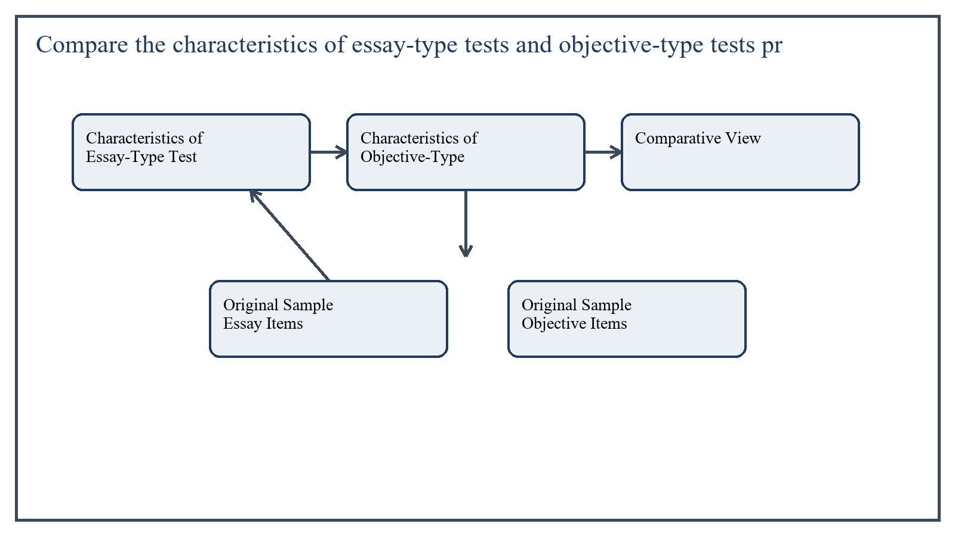
Figure 4: Concept map for Question 4

Characteristics of Essay-Type Tests
Essay-type tests require students to construct their own answers. They may be restricted-response or extended-response. Such tests are useful when the teacher wants to assess organization of ideas, depth of explanation, argument, integration, and written expression.
Essay items are strong in measuring reasoning and the ability to develop a coherent response. However, they take more time to answer and score, and scoring may become less objective unless a good rubric is used.
- Students produce answers in their own words.
- Suitable for explanation, interpretation, analysis, and argument.
- Difficult to score objectively without clear criteria.
- Limited content coverage because fewer questions can be asked.
In the context of Educational Assessment and Evaluation, the theme of characteristics of essay-type tests deserves extended attention because assignment-level understanding is expected to move beyond one-line definitions and into explanation, comparison, and application. A strong university answer shows not only what the concept means, but also why it matters, how it appears in practice, and what limitations or challenges may arise when it is implemented in real educational settings.
A mature academic response also connects characteristics of essay-type tests with classroom realities, institutional culture, and the Pakistani context wherever relevant. This makes the answer more analytical and more useful because it links conceptual understanding with the needs of teachers, learners, administrators, and communities rather than leaving the idea at a purely theoretical level.
From an examination and assignment-writing perspective, the topic of characteristics of essay-type tests should be handled through clear structure, careful terminology, valid examples, and balanced discussion. The strongest responses usually define the idea, explain its major components, illustrate it through educational examples, and then conclude with a reasoned judgment about its significance, usefulness, or limitations.

Characteristics of Objective-Type Tests
Objective-type tests provide a structured response format, such as multiple choice, true-false, matching, or short answer. They are efficient for broader content sampling, easier scoring, and higher scoring consistency.
These tests are particularly useful for measuring knowledge, understanding, recognition, and some types of application if items are well constructed. Their weakness is that they may not always capture the student's reasoning process in depth.
- Answers are selected or supplied in a very limited form.
- Scoring is quick, consistent, and often objective.
- Large content areas can be covered in one test.
- Poorly written items may overemphasize guessing or superficial recognition.
In the context of Educational Assessment and Evaluation, the theme of characteristics of objective-type tests deserves extended attention because assignment-level understanding is expected to move beyond one-line definitions and into explanation, comparison, and application. A strong university answer shows not only what the concept means, but also why it matters, how it appears in practice, and what limitations or challenges may arise when it is implemented in real educational settings.
A mature academic response also connects characteristics of objective-type tests with classroom realities, institutional culture, and the Pakistani context wherever relevant. This makes the answer more analytical and more useful because it links conceptual understanding with the needs of teachers, learners, administrators, and communities rather than leaving the idea at a purely theoretical level.
From an examination and assignment-writing perspective, the topic of characteristics of objective-type tests should be handled through clear structure, careful terminology, valid examples, and balanced discussion. The strongest responses usually define the idea, explain its major components, illustrate it through educational examples, and then conclude with a reasoned judgment about its significance, usefulness, or limitations.

Comparative View
Essay tests are stronger for insight, synthesis, and extended reasoning, while objective tests are stronger for content coverage, reliability of scoring, and administrative efficiency. The wise teacher uses both according to the objective being measured.
For example, if the objective is to define and differentiate concepts quickly across a full unit, objective items may be best. If the objective is to justify a viewpoint or critically examine an educational issue, essay items are more suitable.
In the context of Educational Assessment and Evaluation, the theme of comparative view deserves extended attention because assignment-level understanding is expected to move beyond one-line definitions and into explanation, comparison, and application. A strong university answer shows not only what the concept means, but also why it matters, how it appears in practice, and what limitations or challenges may arise when it is implemented in real educational settings.
A mature academic response also connects comparative view with classroom realities, institutional culture, and the Pakistani context wherever relevant. This makes the answer more analytical and more useful because it links conceptual understanding with the needs of teachers, learners, administrators, and communities rather than leaving the idea at a purely theoretical level.
From an examination and assignment-writing perspective, the topic of comparative view should be handled through clear structure, careful terminology, valid examples, and balanced discussion. The strongest responses usually define the idea, explain its major components, illustrate it through educational examples, and then conclude with a reasoned judgment about its significance, usefulness, or limitations.

Original Sample Essay Items
- Explain how formative assessment improves classroom teaching. Support your answer with two classroom examples.
- Compare cooperative learning and competitive learning. Which one is more suitable for elementary education in your view, and why?
In the context of Educational Assessment and Evaluation, the theme of original sample essay items deserves extended attention because assignment-level understanding is expected to move beyond one-line definitions and into explanation, comparison, and application. A strong university answer shows not only what the concept means, but also why it matters, how it appears in practice, and what limitations or challenges may arise when it is implemented in real educational settings.
A mature academic response also connects original sample essay items with classroom realities, institutional culture, and the Pakistani context wherever relevant. This makes the answer more analytical and more useful because it links conceptual understanding with the needs of teachers, learners, administrators, and communities rather than leaving the idea at a purely theoretical level.
From an examination and assignment-writing perspective, the topic of original sample essay items should be handled through clear structure, careful terminology, valid examples, and balanced discussion. The strongest responses usually define the idea, explain its major components, illustrate it through educational examples, and then conclude with a reasoned judgment about its significance, usefulness, or limitations.

Original Sample Objective Items
- Multiple choice: Which of the following best describes formative assessment? A) It is used only for board examinations. B) It provides feedback during the learning process. C) It replaces instruction with grading. D) It is conducted only once a year. Correct answer: B.
- Matching item: Match the assessment terms with their meanings. Column A: Reliability, Validity, Objective Test, Rubric. Column B: Measures what it intends to measure; scoring guide; consistency of scores; fixed-response test format.
In the context of Educational Assessment and Evaluation, the theme of original sample objective items deserves extended attention because assignment-level understanding is expected to move beyond one-line definitions and into explanation, comparison, and application. A strong university answer shows not only what the concept means, but also why it matters, how it appears in practice, and what limitations or challenges may arise when it is implemented in real educational settings.
A mature academic response also connects original sample objective items with classroom realities, institutional culture, and the Pakistani context wherever relevant. This makes the answer more analytical and more useful because it links conceptual understanding with the needs of teachers, learners, administrators, and communities rather than leaving the idea at a purely theoretical level.
From an examination and assignment-writing perspective, the topic of original sample objective items should be handled through clear structure, careful terminology, valid examples, and balanced discussion. The strongest responses usually define the idea, explain its major components, illustrate it through educational examples, and then conclude with a reasoned judgment about its significance, usefulness, or limitations.

Applied Illustration and Academic Note
For a stronger B.Ed assignment response, the topic above should be linked with classroom life, institutional practice, and the needs of Pakistani learners. This approach makes the response more analytical and demonstrates that the writer understands both theory and application, which is usually appreciated in AIOU-style academic work.
A good response also avoids unsupported claims. Instead, it explains concepts carefully, gives relevant examples, and ends with a short judgment about educational significance. In this way, the answer to 'Compare the characteristics of essay-type tests and objective-type tes...' becomes easier to read, easier to assess, and more academically convincing.

Quick Review Table
Focus Area | Assignment Relevance
Characteristics of Essay-Type Tests | This area helps answer the question on 'Compare the characteristics of essay-type tests and obj...' by providing concept clarity, explanation, and applied educational value.
Characteristics of Objective-Type Tests | This area helps answer the question on 'Compare the characteristics of essay-type tests and obj...' by providing concept clarity, explanation, and applied educational value.
Comparative View | This area helps answer the question on 'Compare the characteristics of essay-type tests and obj...' by providing concept clarity, explanation, and applied educational value.
Original Sample Essay Items | This area helps answer the question on 'Compare the characteristics of essay-type tests and obj...' by providing concept clarity, explanation, and applied educational value.

Critical Reflection
At an advanced level, the topic should not be treated as a fixed formula. Most educational concepts work within particular conditions, and their success often depends on planning quality, learner background, institutional support, and the competence of the teacher or manager using them. A reflective assignment therefore acknowledges strengths while also recognizing practical limitations.

Conclusion
Essay-type and objective-type tests each have distinctive strengths and limitations. Essay tests reveal depth, organization, and reasoning, while objective tests provide broader sampling and more reliable scoring. Effective classroom assessment usually depends on a thoughtful combination of both rather than exclusive dependence on either one.

Q.5 Write a detailed note on the four types of reliability, explaining when each is most appropriate and providing a concrete educational example for each.
Answer: The answer below is organized in an academic assignment style, with conceptual explanation, applied discussion, and concise analytical closing comments designed for a neat and extended university submission.
Reliability refers to the consistency or stability of measurement. A test is reliable when it gives dependable results under appropriate conditions. In educational assessment, reliability is important because teachers and institutions make decisions on the basis of scores. Four commonly discussed types of reliability are particularly useful.
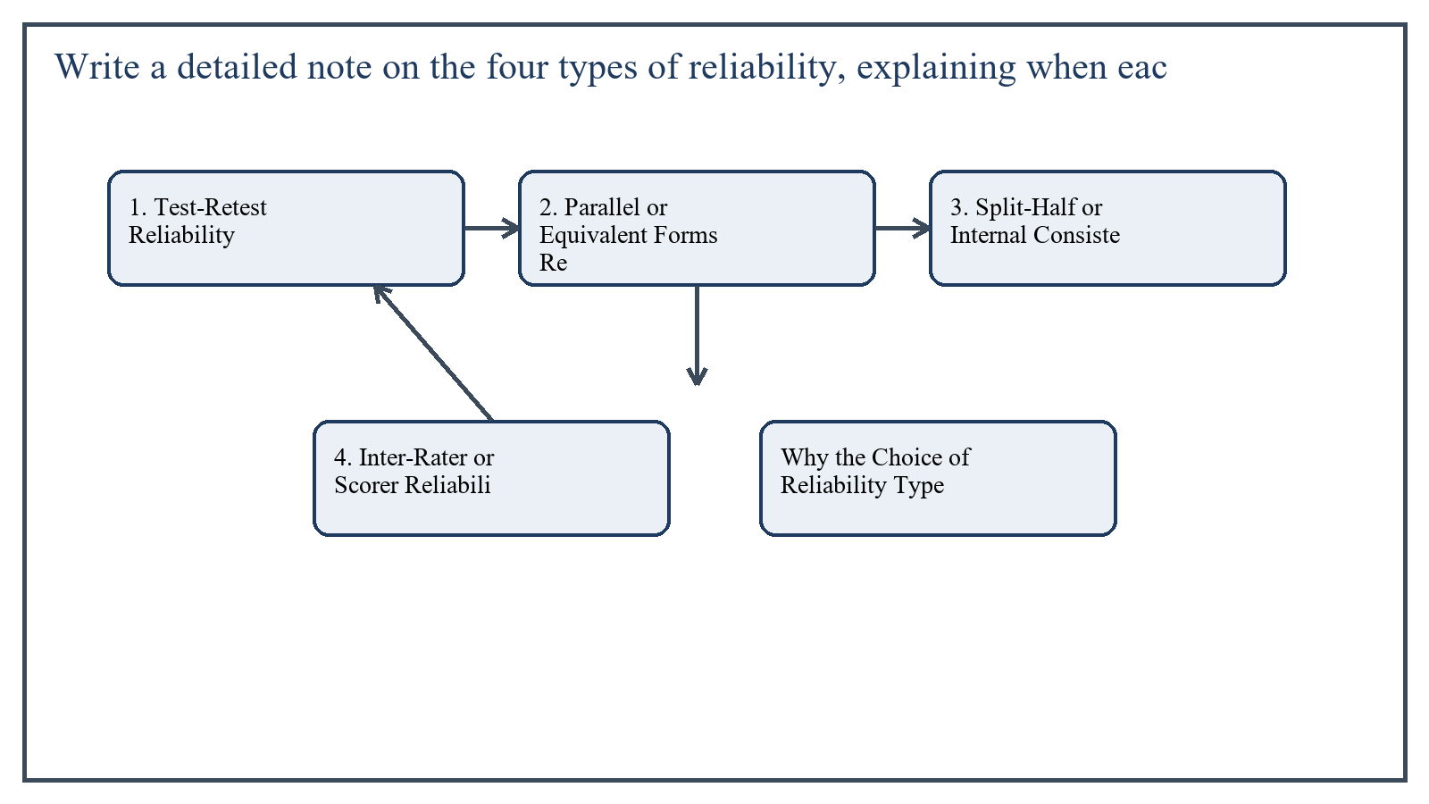
Figure 5: Concept map for Question 5

1. Test-Retest Reliability
Test-retest reliability refers to the consistency of scores when the same test is administered to the same group on two different occasions, provided the trait being measured has not changed significantly. It indicates temporal stability.
This type is most appropriate when the teacher or researcher wants to know whether a measure remains stable over time. It is especially useful for aptitude, general ability, or attitude measures that should not fluctuate sharply in the short term.
Educational example: A study skills inventory is given to a group of B.Ed students in the first week of the month and again two weeks later under similar conditions. If the scores remain highly similar, the instrument shows good test-retest reliability.
In the context of Educational Assessment and Evaluation, the theme of 1. test-retest reliability deserves extended attention because assignment-level understanding is expected to move beyond one-line definitions and into explanation, comparison, and application. A strong university answer shows not only what the concept means, but also why it matters, how it appears in practice, and what limitations or challenges may arise when it is implemented in real educational settings.
A mature academic response also connects 1. test-retest reliability with classroom realities, institutional culture, and the Pakistani context wherever relevant. This makes the answer more analytical and more useful because it links conceptual understanding with the needs of teachers, learners, administrators, and communities rather than leaving the idea at a purely theoretical level.
From an examination and assignment-writing perspective, the topic of 1. test-retest reliability should be handled through clear structure, careful terminology, valid examples, and balanced discussion. The strongest responses usually define the idea, explain its major components, illustrate it through educational examples, and then conclude with a reasoned judgment about its significance, usefulness, or limitations.

2. Parallel or Equivalent Forms Reliability
Equivalent-forms reliability is the consistency of scores across two different versions of the same test that are designed to measure the same objectives at the same level of difficulty. It is useful when reusing the identical paper may create practice effects or security issues.
This type is most appropriate in situations where repeated testing is needed but the exact same form cannot be used. It is valuable in large systems or coaching-sensitive contexts.
Educational example: A mathematics teacher prepares Form A and Form B of a unit test on fractions and decimals. If students perform similarly across both forms, the test shows equivalent-forms reliability.
In the context of Educational Assessment and Evaluation, the theme of 2. parallel or equivalent forms reliability deserves extended attention because assignment-level understanding is expected to move beyond one-line definitions and into explanation, comparison, and application. A strong university answer shows not only what the concept means, but also why it matters, how it appears in practice, and what limitations or challenges may arise when it is implemented in real educational settings.
A mature academic response also connects 2. parallel or equivalent forms reliability with classroom realities, institutional culture, and the Pakistani context wherever relevant. This makes the answer more analytical and more useful because it links conceptual understanding with the needs of teachers, learners, administrators, and communities rather than leaving the idea at a purely theoretical level.
From an examination and assignment-writing perspective, the topic of 2. parallel or equivalent forms reliability should be handled through clear structure, careful terminology, valid examples, and balanced discussion. The strongest responses usually define the idea, explain its major components, illustrate it through educational examples, and then conclude with a reasoned judgment about its significance, usefulness, or limitations.

3. Split-Half or Internal Consistency Reliability
Split-half reliability examines consistency within the test itself by comparing performance on two comparable halves of the same test, such as odd-numbered and even-numbered items. More broadly, internal consistency asks whether the items are working together to measure the same construct.
This type is most appropriate when the teacher wants to estimate reliability from a single administration rather than testing students twice. It is especially practical for classroom tests and achievement tests with many items.
Educational example: A 40-item science test is divided into odd and even items. If students who score high on one half also score high on the other, the test demonstrates acceptable internal consistency.
In the context of Educational Assessment and Evaluation, the theme of 3. split-half or internal consistency reliability deserves extended attention because assignment-level understanding is expected to move beyond one-line definitions and into explanation, comparison, and application. A strong university answer shows not only what the concept means, but also why it matters, how it appears in practice, and what limitations or challenges may arise when it is implemented in real educational settings.
A mature academic response also connects 3. split-half or internal consistency reliability with classroom realities, institutional culture, and the Pakistani context wherever relevant. This makes the answer more analytical and more useful because it links conceptual understanding with the needs of teachers, learners, administrators, and communities rather than leaving the idea at a purely theoretical level.
From an examination and assignment-writing perspective, the topic of 3. split-half or internal consistency reliability should be handled through clear structure, careful terminology, valid examples, and balanced discussion. The strongest responses usually define the idea, explain its major components, illustrate it through educational examples, and then conclude with a reasoned judgment about its significance, usefulness, or limitations.

4. Inter-Rater or Scorer Reliability
Inter-rater reliability refers to the consistency of scores awarded by different examiners or raters. It becomes highly important when responses are open-ended, such as essays, presentations, practical performance, or portfolios.
This type is most appropriate when judgment is involved in scoring. Without inter-rater reliability, two competent students may receive different marks simply because they were checked by different people.
Educational example: Two teachers independently score the same set of essay answers using a common rubric. If their scores are closely aligned, the essay assessment shows good inter-rater reliability.
In the context of Educational Assessment and Evaluation, the theme of 4. inter-rater or scorer reliability deserves extended attention because assignment-level understanding is expected to move beyond one-line definitions and into explanation, comparison, and application. A strong university answer shows not only what the concept means, but also why it matters, how it appears in practice, and what limitations or challenges may arise when it is implemented in real educational settings.
A mature academic response also connects 4. inter-rater or scorer reliability with classroom realities, institutional culture, and the Pakistani context wherever relevant. This makes the answer more analytical and more useful because it links conceptual understanding with the needs of teachers, learners, administrators, and communities rather than leaving the idea at a purely theoretical level.
From an examination and assignment-writing perspective, the topic of 4. inter-rater or scorer reliability should be handled through clear structure, careful terminology, valid examples, and balanced discussion. The strongest responses usually define the idea, explain its major components, illustrate it through educational examples, and then conclude with a reasoned judgment about its significance, usefulness, or limitations.

Why the Choice of Reliability Type Matters
Different assessment situations demand different reliability evidence. A paper-and-pencil objective test may rely more on internal consistency, while an oral presentation requires inter-rater reliability. A large-scale admission test may need both equivalent forms and reliability over time.
Therefore, reliability is not a single number with a single meaning. It is a family of evidence about consistency, and teachers should select the type that matches the assessment purpose.
In the context of Educational Assessment and Evaluation, the theme of why the choice of reliability type matters deserves extended attention because assignment-level understanding is expected to move beyond one-line definitions and into explanation, comparison, and application. A strong university answer shows not only what the concept means, but also why it matters, how it appears in practice, and what limitations or challenges may arise when it is implemented in real educational settings.
A mature academic response also connects why the choice of reliability type matters with classroom realities, institutional culture, and the Pakistani context wherever relevant. This makes the answer more analytical and more useful because it links conceptual understanding with the needs of teachers, learners, administrators, and communities rather than leaving the idea at a purely theoretical level.
From an examination and assignment-writing perspective, the topic of why the choice of reliability type matters should be handled through clear structure, careful terminology, valid examples, and balanced discussion. The strongest responses usually define the idea, explain its major components, illustrate it through educational examples, and then conclude with a reasoned judgment about its significance, usefulness, or limitations.

Applied Illustration and Academic Note
For a stronger B.Ed assignment response, the topic above should be linked with classroom life, institutional practice, and the needs of Pakistani learners. This approach makes the response more analytical and demonstrates that the writer understands both theory and application, which is usually appreciated in AIOU-style academic work.
A good response also avoids unsupported claims. Instead, it explains concepts carefully, gives relevant examples, and ends with a short judgment about educational significance. In this way, the answer to 'Write a detailed note on the four types of reliability, explaining whe...' becomes easier to read, easier to assess, and more academically convincing.

Quick Review Table
Focus Area | Assignment Relevance
1. Test-Retest Reliability | This area helps answer the question on 'Write a detailed note on the four types of reliability,...' by providing concept clarity, explanation, and applied educational value.
2. Parallel or Equivalent Forms Reliability | This area helps answer the question on 'Write a detailed note on the four types of reliability,...' by providing concept clarity, explanation, and applied educational value.
3. Split-Half or Internal Consistency Reliability | This area helps answer the question on 'Write a detailed note on the four types of reliability,...' by providing concept clarity, explanation, and applied educational value.
4. Inter-Rater or Scorer Reliability | This area helps answer the question on 'Write a detailed note on the four types of reliability,...' by providing concept clarity, explanation, and applied educational value.

Critical Reflection
At an advanced level, the topic should not be treated as a fixed formula. Most educational concepts work within particular conditions, and their success often depends on planning quality, learner background, institutional support, and the competence of the teacher or manager using them. A reflective assignment therefore acknowledges strengths while also recognizing practical limitations.

Conclusion
The four important reliability types are test-retest, equivalent forms, internal consistency, and inter-rater reliability. Each serves a different purpose: stability over time, consistency across versions, consistency within the test, and consistency across scorers. Understanding when each type is appropriate helps teachers build assessment systems that are fair, dependable, and professionally defensible.

Extended Revision Appendix
This appendix is included to strengthen the assignment as a premium academic submission. It provides recap notes, revision prompts, and concept reinforcement so the document reads like a complete study-ready submission rather than a short-answer sheet only.

Key Revision Points
- Review the central demand of the question 'Explain in detail the six key principles of classroom assessme...' and connect definition, explanation, example, and critical comment in one organized response.
- Review the central demand of the question 'Critically analyze how Bloom's Taxonomy of educational objecti...' and connect definition, explanation, example, and critical comment in one organized response.
- Review the central demand of the question 'What is standardized testing? Describe the five essential cond...' and connect definition, explanation, example, and critical comment in one organized response.
- Review the central demand of the question 'Compare the characteristics of essay-type tests and objective-...' and connect definition, explanation, example, and critical comment in one organized response.
- Review the central demand of the question 'Write a detailed note on the four types of reliability, explai...' and connect definition, explanation, example, and critical comment in one organized response.

Academic Writing Reminders
- Begin each major answer with a clear conceptual opening.
- Use examples to show understanding instead of repeating definitions only.
- Present advantages, limitations, and contextual realities where relevant.
- Close each answer with a short evaluative conclusion.
- Maintain formal and neat language throughout the assignment.

Concept Reinforcement Notes
The question on 'Explain in detail the six key principles of classroom assessment, providing...' can be revised further by identifying three things: the main concept involved, the educational importance of that concept, and one example from Pakistani classroom or institutional life. This simple method helps transform memorized content into organized written response.
The question on 'Critically analyze how Bloom's Taxonomy of educational objectives helps tea...' can be revised further by identifying three things: the main concept involved, the educational importance of that concept, and one example from Pakistani classroom or institutional life. This simple method helps transform memorized content into organized written response.
The question on 'What is standardized testing? Describe the five essential conditions of sta...' can be revised further by identifying three things: the main concept involved, the educational importance of that concept, and one example from Pakistani classroom or institutional life. This simple method helps transform memorized content into organized written response.
The question on 'Compare the characteristics of essay-type tests and objective-type tests pr...' can be revised further by identifying three things: the main concept involved, the educational importance of that concept, and one example from Pakistani classroom or institutional life. This simple method helps transform memorized content into organized written response.
The question on 'Write a detailed note on the four types of reliability, explaining when eac...' can be revised further by identifying three things: the main concept involved, the educational importance of that concept, and one example from Pakistani classroom or institutional life. This simple method helps transform memorized content into organized written response.

Source Base and Assignment Support Notes
The following source base was used to keep the answers aligned with AIOU course structure and the exact question wording. The final language and organization were expanded for presentation quality, page-length target, and assignment readability.
- AIOU Soft Book: Educational Assessment and Evaluation (Code 8602), especially the units on classroom assessment, objectives, Bloom's taxonomy, standardized testing, objective and essay tests, and reliability.
- AIOU Spring 2026 assignment sheet for Course 8602.

Extended Analytical Note 1
In extended study of Educational Assessment and Evaluation, the issue raised in 'Explain in detail the six key principles of classroom assessment, provid...' may also be explored through definition, theoretical explanation, applied example, classroom implication, institutional implication, and critical reflection. This six-part approach helps a learner produce a more complete answer and also improves the academic appearance of the assignment by showing structure and depth.
Another useful strategy in long-form assignment writing is to move carefully from concept to context. First explain what the idea means, then identify its components, then discuss its relevance in teaching or administration, and finally mention any practical limitation. Such movement gives maturity to the answer and helps the examiner follow the logic without difficulty.
In extended study of Educational Assessment and Evaluation, the issue raised in 'Critically analyze how Bloom's Taxonomy of educational objectives helps ...' may also be explored through definition, theoretical explanation, applied example, classroom implication, institutional implication, and critical reflection. This six-part approach helps a learner produce a more complete answer and also improves the academic appearance of the assignment by showing structure and depth.
Another useful strategy in long-form assignment writing is to move carefully from concept to context. First explain what the idea means, then identify its components, then discuss its relevance in teaching or administration, and finally mention any practical limitation. Such movement gives maturity to the answer and helps the examiner follow the logic without difficulty.
In extended study of Educational Assessment and Evaluation, the issue raised in 'What is standardized testing? Describe the five essential conditions of ...' may also be explored through definition, theoretical explanation, applied example, classroom implication, institutional implication, and critical reflection. This six-part approach helps a learner produce a more complete answer and also improves the academic appearance of the assignment by showing structure and depth.
Another useful strategy in long-form assignment writing is to move carefully from concept to context. First explain what the idea means, then identify its components, then discuss its relevance in teaching or administration, and finally mention any practical limitation. Such movement gives maturity to the answer and helps the examiner follow the logic without difficulty.
In extended study of Educational Assessment and Evaluation, the issue raised in 'Compare the characteristics of essay-type tests and objective-type tests...' may also be explored through definition, theoretical explanation, applied example, classroom implication, institutional implication, and critical reflection. This six-part approach helps a learner produce a more complete answer and also improves the academic appearance of the assignment by showing structure and depth.
Another useful strategy in long-form assignment writing is to move carefully from concept to context. First explain what the idea means, then identify its components, then discuss its relevance in teaching or administration, and finally mention any practical limitation. Such movement gives maturity to the answer and helps the examiner follow the logic without difficulty.
In extended study of Educational Assessment and Evaluation, the issue raised in 'Write a detailed note on the four types of reliability, explaining when ...' may also be explored through definition, theoretical explanation, applied example, classroom implication, institutional implication, and critical reflection. This six-part approach helps a learner produce a more complete answer and also improves the academic appearance of the assignment by showing structure and depth.
Another useful strategy in long-form assignment writing is to move carefully from concept to context. First explain what the idea means, then identify its components, then discuss its relevance in teaching or administration, and finally mention any practical limitation. Such movement gives maturity to the answer and helps the examiner follow the logic without difficulty.

