ALLAMA IQBAL OPEN UNIVERSITY
Premium Typed Assignment
Educational Assessment and Evaluation
Detail | Course Code: 8602
Detail | Assignment No: 2
Detail | Unit Coverage: Units 6-9
Detail | Program Level: B.Ed
Detail | Formatting Profile: Times New Roman, 14 pt headings, 12 pt body text
Detail | Document Goal: Extended academic response with diagrams, border styling, and premium presentation

Presentation Note
This file has been prepared as a premium typed assignment with extended academic treatment, proper page border styling, inserted diagrams, formal headings, and neat section hierarchy. The content is intentionally expanded so that the assignment remains easy to read while still meeting a high page-length target.

Q.1 Why is validity regarded as the most critical feature of meaningful assessment? Explain with examples of what happens when an assessment lacks validity.
Answer: The answer below is organized in an academic assignment style, with conceptual explanation, applied discussion, and concise analytical closing comments designed for a neat and extended university submission.
Validity is regarded as the most critical feature of meaningful assessment because it concerns the central question: does the assessment measure what it is intended to measure, and can the resulting scores support the decisions being made? An assessment may be neatly printed, easy to score, and even reliable, but if it does not measure the intended learning, it fails in its educational purpose.
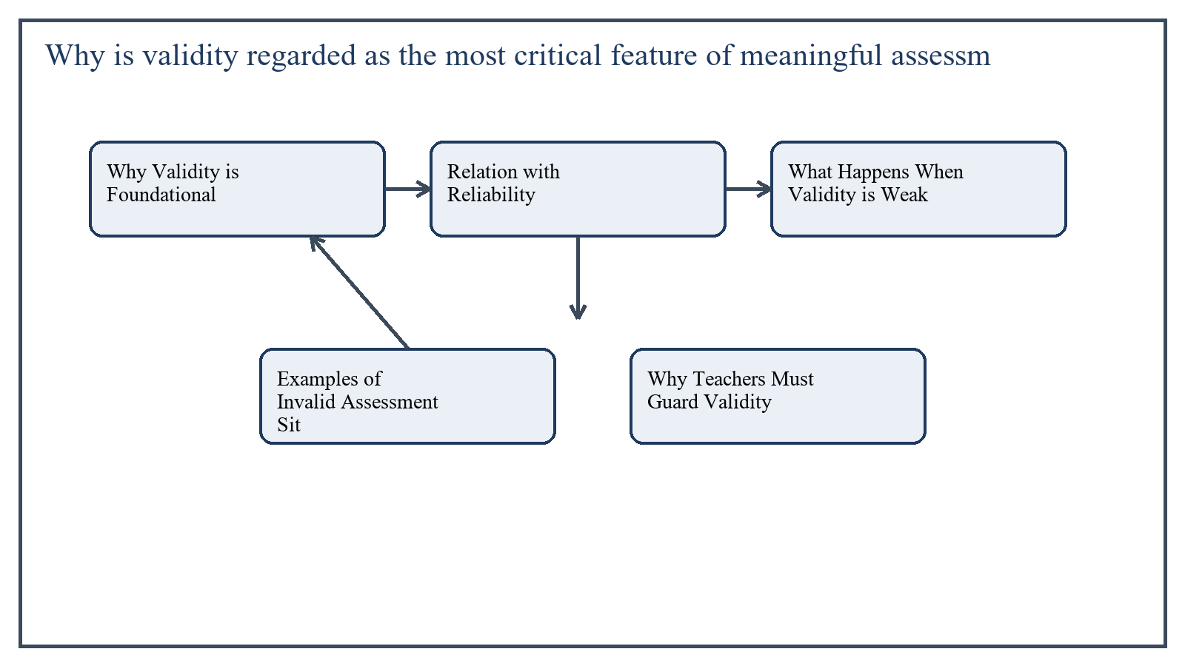
Figure 1: Concept map for Question 1

Why Validity is Foundational
The primary reason validity is central is that assessment exists to support interpretation and decision-making. Teachers use test results to grade students, diagnose weaknesses, provide feedback, place learners into groups, and judge instructional success. If the evidence is invalid, all these decisions may become misleading.
Validity is therefore more than a technical property of a test paper; it is the strength of the argument behind score interpretation. A valid assessment should be aligned with objectives, appropriate for the content, suitable for the learners, and free from major irrelevant influences.
In the context of Educational Assessment and Evaluation, the theme of why validity is foundational deserves extended attention because assignment-level understanding is expected to move beyond one-line definitions and into explanation, comparison, and application. A strong university answer shows not only what the concept means, but also why it matters, how it appears in practice, and what limitations or challenges may arise when it is implemented in real educational settings.
A mature academic response also connects why validity is foundational with classroom realities, institutional culture, and the Pakistani context wherever relevant. This makes the answer more analytical and more useful because it links conceptual understanding with the needs of teachers, learners, administrators, and communities rather than leaving the idea at a purely theoretical level.
From an examination and assignment-writing perspective, the topic of why validity is foundational should be handled through clear structure, careful terminology, valid examples, and balanced discussion. The strongest responses usually define the idea, explain its major components, illustrate it through educational examples, and then conclude with a reasoned judgment about its significance, usefulness, or limitations.

Relation with Reliability
Reliability is necessary, but validity is more important. A test can produce highly consistent scores and still be invalid. For example, a vocabulary-heavy science test may consistently rank students, but if it mainly measures language difficulty rather than science understanding, its use for science achievement decisions is questionable.
In the context of Educational Assessment and Evaluation, the theme of relation with reliability deserves extended attention because assignment-level understanding is expected to move beyond one-line definitions and into explanation, comparison, and application. A strong university answer shows not only what the concept means, but also why it matters, how it appears in practice, and what limitations or challenges may arise when it is implemented in real educational settings.
A mature academic response also connects relation with reliability with classroom realities, institutional culture, and the Pakistani context wherever relevant. This makes the answer more analytical and more useful because it links conceptual understanding with the needs of teachers, learners, administrators, and communities rather than leaving the idea at a purely theoretical level.
From an examination and assignment-writing perspective, the topic of relation with reliability should be handled through clear structure, careful terminology, valid examples, and balanced discussion. The strongest responses usually define the idea, explain its major components, illustrate it through educational examples, and then conclude with a reasoned judgment about its significance, usefulness, or limitations.

What Happens When Validity is Weak
When an assessment lacks validity, student achievement may be misrepresented. A learner can be judged weak in a subject even though the real difficulty lies in reading the question, interpreting vague wording, or guessing the examiner's intention.
Invalid assessment also distorts teaching. If teachers know that exams reward memorization only, they may narrow teaching to rote preparation rather than conceptual understanding. In this way poor validity harms both instruction and learning culture.
- Students may receive unfair grades.
- Parents and institutions may draw false conclusions.
- Placement or promotion decisions may become inaccurate.
- Teachers may teach to the wrong target.
In the context of Educational Assessment and Evaluation, the theme of what happens when validity is weak deserves extended attention because assignment-level understanding is expected to move beyond one-line definitions and into explanation, comparison, and application. A strong university answer shows not only what the concept means, but also why it matters, how it appears in practice, and what limitations or challenges may arise when it is implemented in real educational settings.
A mature academic response also connects what happens when validity is weak with classroom realities, institutional culture, and the Pakistani context wherever relevant. This makes the answer more analytical and more useful because it links conceptual understanding with the needs of teachers, learners, administrators, and communities rather than leaving the idea at a purely theoretical level.
From an examination and assignment-writing perspective, the topic of what happens when validity is weak should be handled through clear structure, careful terminology, valid examples, and balanced discussion. The strongest responses usually define the idea, explain its major components, illustrate it through educational examples, and then conclude with a reasoned judgment about its significance, usefulness, or limitations.

Examples of Invalid Assessment Situations
Example 1: A teacher wants to assess speaking skill in English but gives only a written grammar paper. Even if the paper is reliable, it is not a valid measure of speaking ability because the mode of performance does not match the objective.
Example 2: A mathematics test contains unnecessarily complex language. Students with weak reading comprehension may perform badly even when they understand the mathematics. The scores then reflect reading load as much as mathematical ability.
Example 3: A science practical objective is assessed only through recall-based multiple-choice items. Students who can reproduce facts may score well despite being unable to conduct observation, handle apparatus, or interpret experimental results.
In the context of Educational Assessment and Evaluation, the theme of examples of invalid assessment situations deserves extended attention because assignment-level understanding is expected to move beyond one-line definitions and into explanation, comparison, and application. A strong university answer shows not only what the concept means, but also why it matters, how it appears in practice, and what limitations or challenges may arise when it is implemented in real educational settings.
A mature academic response also connects examples of invalid assessment situations with classroom realities, institutional culture, and the Pakistani context wherever relevant. This makes the answer more analytical and more useful because it links conceptual understanding with the needs of teachers, learners, administrators, and communities rather than leaving the idea at a purely theoretical level.
From an examination and assignment-writing perspective, the topic of examples of invalid assessment situations should be handled through clear structure, careful terminology, valid examples, and balanced discussion. The strongest responses usually define the idea, explain its major components, illustrate it through educational examples, and then conclude with a reasoned judgment about its significance, usefulness, or limitations.

Why Teachers Must Guard Validity
Teachers must guard validity by starting with objectives, selecting appropriate item types, using clear language, ensuring proper content sampling, and checking whether the assessment evidence actually supports the intended conclusion.
In short, validity protects the meaning of scores. Without it, assessment may still produce numbers, but those numbers become educationally misleading.
In the context of Educational Assessment and Evaluation, the theme of why teachers must guard validity deserves extended attention because assignment-level understanding is expected to move beyond one-line definitions and into explanation, comparison, and application. A strong university answer shows not only what the concept means, but also why it matters, how it appears in practice, and what limitations or challenges may arise when it is implemented in real educational settings.
A mature academic response also connects why teachers must guard validity with classroom realities, institutional culture, and the Pakistani context wherever relevant. This makes the answer more analytical and more useful because it links conceptual understanding with the needs of teachers, learners, administrators, and communities rather than leaving the idea at a purely theoretical level.
From an examination and assignment-writing perspective, the topic of why teachers must guard validity should be handled through clear structure, careful terminology, valid examples, and balanced discussion. The strongest responses usually define the idea, explain its major components, illustrate it through educational examples, and then conclude with a reasoned judgment about its significance, usefulness, or limitations.

Applied Illustration and Academic Note
For a stronger B.Ed assignment response, the topic above should be linked with classroom life, institutional practice, and the needs of Pakistani learners. This approach makes the response more analytical and demonstrates that the writer understands both theory and application, which is usually appreciated in AIOU-style academic work.
A good response also avoids unsupported claims. Instead, it explains concepts carefully, gives relevant examples, and ends with a short judgment about educational significance. In this way, the answer to 'Why is validity regarded as the most critical feature of meaningful as...' becomes easier to read, easier to assess, and more academically convincing.

Quick Review Table
Focus Area | Assignment Relevance
Why Validity is Foundational | This area helps answer the question on 'Why is validity regarded as the most critical feature o...' by providing concept clarity, explanation, and applied educational value.
Relation with Reliability | This area helps answer the question on 'Why is validity regarded as the most critical feature o...' by providing concept clarity, explanation, and applied educational value.
What Happens When Validity is Weak | This area helps answer the question on 'Why is validity regarded as the most critical feature o...' by providing concept clarity, explanation, and applied educational value.
Examples of Invalid Assessment Situations | This area helps answer the question on 'Why is validity regarded as the most critical feature o...' by providing concept clarity, explanation, and applied educational value.

Critical Reflection
At an advanced level, the topic should not be treated as a fixed formula. Most educational concepts work within particular conditions, and their success often depends on planning quality, learner background, institutional support, and the competence of the teacher or manager using them. A reflective assignment therefore acknowledges strengths while also recognizing practical limitations.

Conclusion
Validity is the most critical feature of meaningful assessment because it determines whether the assessment evidence can be trusted for interpretation and decision-making. When validity is weak, scores become misleading, teaching is distorted, and students are judged unfairly. For that reason, valid assessment is not merely desirable; it is essential.

Q.2 What general guidelines should teachers follow when constructing essay-type test items? Illustrate each guideline with a suitable example.
Answer: The answer below is organized in an academic assignment style, with conceptual explanation, applied discussion, and concise analytical closing comments designed for a neat and extended university submission.
Essay-type items can measure explanation, interpretation, critical thinking, and integration of ideas, but only when they are carefully constructed. Poorly written essay questions create confusion, encourage irrelevant writing, and reduce scoring reliability. Teachers should therefore follow clear guidelines while constructing such items.
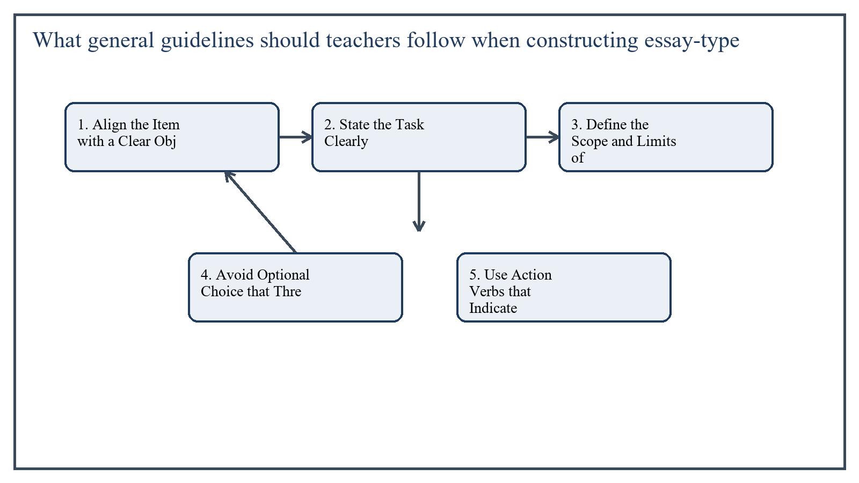
Figure 2: Concept map for Question 2

1. Align the Item with a Clear Objective
An essay question should measure a specific instructional objective rather than a vague general topic. The teacher must know whether the item is intended to assess explanation, comparison, analysis, critique, or application.
Example: Instead of asking 'Write about assessment,' a better item is 'Explain two differences between formative and summative assessment with classroom examples.'
In the context of Educational Assessment and Evaluation, the theme of 1. align the item with a clear objective deserves extended attention because assignment-level understanding is expected to move beyond one-line definitions and into explanation, comparison, and application. A strong university answer shows not only what the concept means, but also why it matters, how it appears in practice, and what limitations or challenges may arise when it is implemented in real educational settings.
A mature academic response also connects 1. align the item with a clear objective with classroom realities, institutional culture, and the Pakistani context wherever relevant. This makes the answer more analytical and more useful because it links conceptual understanding with the needs of teachers, learners, administrators, and communities rather than leaving the idea at a purely theoretical level.
From an examination and assignment-writing perspective, the topic of 1. align the item with a clear objective should be handled through clear structure, careful terminology, valid examples, and balanced discussion. The strongest responses usually define the idea, explain its major components, illustrate it through educational examples, and then conclude with a reasoned judgment about its significance, usefulness, or limitations.

2. State the Task Clearly
The wording of the essay item should make the required response obvious. Ambiguous commands produce uneven answers and weaken fairness.
Example: 'Critically compare objective-type and essay-type tests in terms of content coverage, scoring, and suitability for higher-order learning.' This is clearer than 'Discuss tests.'
In the context of Educational Assessment and Evaluation, the theme of 2. state the task clearly deserves extended attention because assignment-level understanding is expected to move beyond one-line definitions and into explanation, comparison, and application. A strong university answer shows not only what the concept means, but also why it matters, how it appears in practice, and what limitations or challenges may arise when it is implemented in real educational settings.
A mature academic response also connects 2. state the task clearly with classroom realities, institutional culture, and the Pakistani context wherever relevant. This makes the answer more analytical and more useful because it links conceptual understanding with the needs of teachers, learners, administrators, and communities rather than leaving the idea at a purely theoretical level.
From an examination and assignment-writing perspective, the topic of 2. state the task clearly should be handled through clear structure, careful terminology, valid examples, and balanced discussion. The strongest responses usually define the idea, explain its major components, illustrate it through educational examples, and then conclude with a reasoned judgment about its significance, usefulness, or limitations.

3. Define the Scope and Limits of the Response
Students should know the boundaries of the answer. If the response is to be limited to certain aspects, examples, time, or length, that should be indicated.
Example: 'In about 300 words, explain three causes of student absenteeism and suggest one remedy for each.' The scope is better controlled than a limitless prompt.
In the context of Educational Assessment and Evaluation, the theme of 3. define the scope and limits of the response deserves extended attention because assignment-level understanding is expected to move beyond one-line definitions and into explanation, comparison, and application. A strong university answer shows not only what the concept means, but also why it matters, how it appears in practice, and what limitations or challenges may arise when it is implemented in real educational settings.
A mature academic response also connects 3. define the scope and limits of the response with classroom realities, institutional culture, and the Pakistani context wherever relevant. This makes the answer more analytical and more useful because it links conceptual understanding with the needs of teachers, learners, administrators, and communities rather than leaving the idea at a purely theoretical level.
From an examination and assignment-writing perspective, the topic of 3. define the scope and limits of the response should be handled through clear structure, careful terminology, valid examples, and balanced discussion. The strongest responses usually define the idea, explain its major components, illustrate it through educational examples, and then conclude with a reasoned judgment about its significance, usefulness, or limitations.

4. Avoid Optional Choice that Threatens Comparability
Allowing students to answer different essay questions may reduce comparability because some prompts may be easier or better known than others. As far as possible, common questions should be attempted by all students.
Example: It is better to ask all students to analyze the same educational issue than to allow one student to write on motivation and another on curriculum change when the scoring criteria differ in difficulty.
In the context of Educational Assessment and Evaluation, the theme of 4. avoid optional choice that threatens comparability deserves extended attention because assignment-level understanding is expected to move beyond one-line definitions and into explanation, comparison, and application. A strong university answer shows not only what the concept means, but also why it matters, how it appears in practice, and what limitations or challenges may arise when it is implemented in real educational settings.
A mature academic response also connects 4. avoid optional choice that threatens comparability with classroom realities, institutional culture, and the Pakistani context wherever relevant. This makes the answer more analytical and more useful because it links conceptual understanding with the needs of teachers, learners, administrators, and communities rather than leaving the idea at a purely theoretical level.
From an examination and assignment-writing perspective, the topic of 4. avoid optional choice that threatens comparability should be handled through clear structure, careful terminology, valid examples, and balanced discussion. The strongest responses usually define the idea, explain its major components, illustrate it through educational examples, and then conclude with a reasoned judgment about its significance, usefulness, or limitations.

5. Use Action Verbs that Indicate the Expected Cognitive Process
Words like define, compare, justify, analyze, evaluate, and illustrate guide students toward the nature of the expected answer. This improves both clarity and scoring.
Example: 'Evaluate the use of standardized testing in elementary education' is more precise than 'Write your views on testing.'
In the context of Educational Assessment and Evaluation, the theme of 5. use action verbs that indicate the expected cognitive process deserves extended attention because assignment-level understanding is expected to move beyond one-line definitions and into explanation, comparison, and application. A strong university answer shows not only what the concept means, but also why it matters, how it appears in practice, and what limitations or challenges may arise when it is implemented in real educational settings.
A mature academic response also connects 5. use action verbs that indicate the expected cognitive process with classroom realities, institutional culture, and the Pakistani context wherever relevant. This makes the answer more analytical and more useful because it links conceptual understanding with the needs of teachers, learners, administrators, and communities rather than leaving the idea at a purely theoretical level.
From an examination and assignment-writing perspective, the topic of 5. use action verbs that indicate the expected cognitive process should be handled through clear structure, careful terminology, valid examples, and balanced discussion. The strongest responses usually define the idea, explain its major components, illustrate it through educational examples, and then conclude with a reasoned judgment about its significance, usefulness, or limitations.

6. Prepare a Scoring Key or Rubric in Advance
An essay item should be accompanied by a model answer outline or rubric before administration. This improves objectivity and ensures that important points are rewarded consistently.
Example: For an essay on reliability, the teacher may allocate marks for definition, explanation of types, examples, and concluding comparison.
In the context of Educational Assessment and Evaluation, the theme of 6. prepare a scoring key or rubric in advance deserves extended attention because assignment-level understanding is expected to move beyond one-line definitions and into explanation, comparison, and application. A strong university answer shows not only what the concept means, but also why it matters, how it appears in practice, and what limitations or challenges may arise when it is implemented in real educational settings.
A mature academic response also connects 6. prepare a scoring key or rubric in advance with classroom realities, institutional culture, and the Pakistani context wherever relevant. This makes the answer more analytical and more useful because it links conceptual understanding with the needs of teachers, learners, administrators, and communities rather than leaving the idea at a purely theoretical level.
From an examination and assignment-writing perspective, the topic of 6. prepare a scoring key or rubric in advance should be handled through clear structure, careful terminology, valid examples, and balanced discussion. The strongest responses usually define the idea, explain its major components, illustrate it through educational examples, and then conclude with a reasoned judgment about its significance, usefulness, or limitations.

7. Keep the Language Simple and Free from Irrelevant Difficulty
The essay question should assess the intended content, not reading trickiness. Unnecessary complexity in wording may reduce validity.
Example: For middle-level learners, 'Explain why feedback is important in learning' is preferable to a dense, multi-clause version of the same idea.
In the context of Educational Assessment and Evaluation, the theme of 7. keep the language simple and free from irrelevant difficulty deserves extended attention because assignment-level understanding is expected to move beyond one-line definitions and into explanation, comparison, and application. A strong university answer shows not only what the concept means, but also why it matters, how it appears in practice, and what limitations or challenges may arise when it is implemented in real educational settings.
A mature academic response also connects 7. keep the language simple and free from irrelevant difficulty with classroom realities, institutional culture, and the Pakistani context wherever relevant. This makes the answer more analytical and more useful because it links conceptual understanding with the needs of teachers, learners, administrators, and communities rather than leaving the idea at a purely theoretical level.
From an examination and assignment-writing perspective, the topic of 7. keep the language simple and free from irrelevant difficulty should be handled through clear structure, careful terminology, valid examples, and balanced discussion. The strongest responses usually define the idea, explain its major components, illustrate it through educational examples, and then conclude with a reasoned judgment about its significance, usefulness, or limitations.

Applied Illustration and Academic Note
For a stronger B.Ed assignment response, the topic above should be linked with classroom life, institutional practice, and the needs of Pakistani learners. This approach makes the response more analytical and demonstrates that the writer understands both theory and application, which is usually appreciated in AIOU-style academic work.
A good response also avoids unsupported claims. Instead, it explains concepts carefully, gives relevant examples, and ends with a short judgment about educational significance. In this way, the answer to 'What general guidelines should teachers follow when constructing essay...' becomes easier to read, easier to assess, and more academically convincing.

Quick Review Table
Focus Area | Assignment Relevance
1. Align the Item with a Clear Objective | This area helps answer the question on 'What general guidelines should teachers follow when con...' by providing concept clarity, explanation, and applied educational value.
2. State the Task Clearly | This area helps answer the question on 'What general guidelines should teachers follow when con...' by providing concept clarity, explanation, and applied educational value.
3. Define the Scope and Limits of the Response | This area helps answer the question on 'What general guidelines should teachers follow when con...' by providing concept clarity, explanation, and applied educational value.
4. Avoid Optional Choice that Threatens Comparability | This area helps answer the question on 'What general guidelines should teachers follow when con...' by providing concept clarity, explanation, and applied educational value.

Critical Reflection
At an advanced level, the topic should not be treated as a fixed formula. Most educational concepts work within particular conditions, and their success often depends on planning quality, learner background, institutional support, and the competence of the teacher or manager using them. A reflective assignment therefore acknowledges strengths while also recognizing practical limitations.

Conclusion
Teachers should construct essay-type items by aligning them with objectives, writing clear tasks, limiting scope, minimizing unfair choice, using suitable action verbs, preparing scoring rubrics, and keeping language simple. These guidelines improve validity, clarity, and scoring fairness, making essay tests more educationally useful.

Q.3 Describe how nominal, ordinal, interval, and ratio measurement scales are used in assessing student learning, with one classroom example for each.
Answer: The answer below is organized in an academic assignment style, with conceptual explanation, applied discussion, and concise analytical closing comments designed for a neat and extended university submission.
Measurement scales help teachers understand what kind of information a score or category actually represents. The four common scales are nominal, ordinal, interval, and ratio. Each scale has different properties, and each can be used in classroom assessment for different purposes.
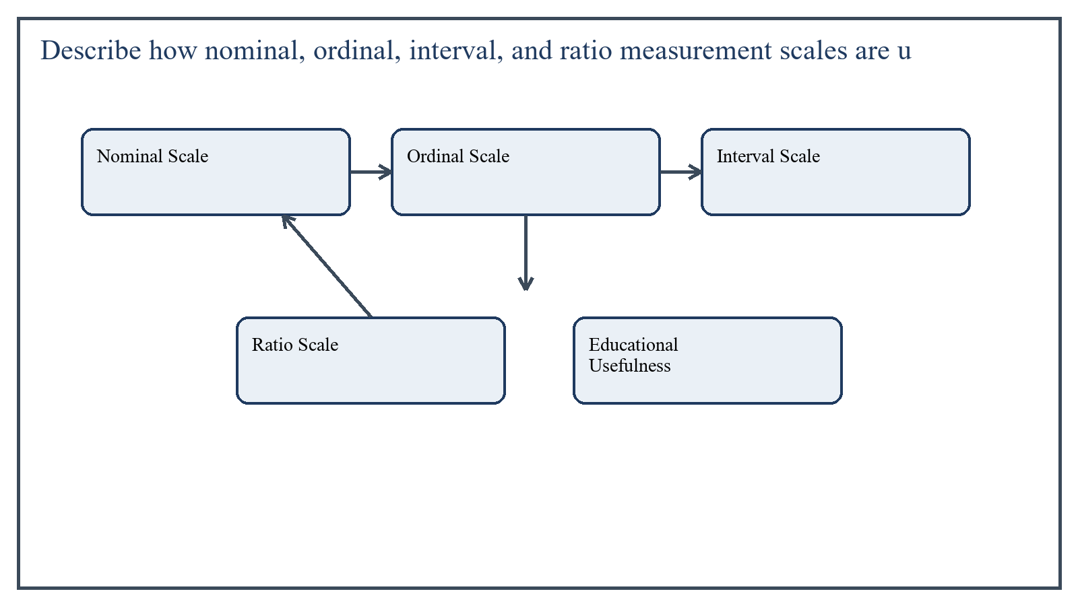
Figure 3: Concept map for Question 3

Nominal Scale
Nominal scale is used for classification into distinct categories without any order of greater or smaller. The categories are simply labels.
In student assessment, nominal scale is useful when grouping students or responses by type. The data tell us which category a student belongs to, but not who is higher or lower.
Classroom example: A teacher records students under categories such as 'completed assignment', 'incomplete assignment', and 'absent'. These are nominal categories because they classify without ranking.
In the context of Educational Assessment and Evaluation, the theme of nominal scale deserves extended attention because assignment-level understanding is expected to move beyond one-line definitions and into explanation, comparison, and application. A strong university answer shows not only what the concept means, but also why it matters, how it appears in practice, and what limitations or challenges may arise when it is implemented in real educational settings.
A mature academic response also connects nominal scale with classroom realities, institutional culture, and the Pakistani context wherever relevant. This makes the answer more analytical and more useful because it links conceptual understanding with the needs of teachers, learners, administrators, and communities rather than leaving the idea at a purely theoretical level.
From an examination and assignment-writing perspective, the topic of nominal scale should be handled through clear structure, careful terminology, valid examples, and balanced discussion. The strongest responses usually define the idea, explain its major components, illustrate it through educational examples, and then conclude with a reasoned judgment about its significance, usefulness, or limitations.

Ordinal Scale
Ordinal scale provides ranking or order, but the exact distance between ranks is not known. It tells us who is above or below whom, but not by how much in equal units.
Teachers often use ordinal scale when rating performance levels or arranging students by position.
Classroom example: A teacher grades oral presentations as Excellent, Good, Satisfactory, and Needs Improvement. These categories are ordered, but the difference between them is not mathematically equal.
In the context of Educational Assessment and Evaluation, the theme of ordinal scale deserves extended attention because assignment-level understanding is expected to move beyond one-line definitions and into explanation, comparison, and application. A strong university answer shows not only what the concept means, but also why it matters, how it appears in practice, and what limitations or challenges may arise when it is implemented in real educational settings.
A mature academic response also connects ordinal scale with classroom realities, institutional culture, and the Pakistani context wherever relevant. This makes the answer more analytical and more useful because it links conceptual understanding with the needs of teachers, learners, administrators, and communities rather than leaving the idea at a purely theoretical level.
From an examination and assignment-writing perspective, the topic of ordinal scale should be handled through clear structure, careful terminology, valid examples, and balanced discussion. The strongest responses usually define the idea, explain its major components, illustrate it through educational examples, and then conclude with a reasoned judgment about its significance, usefulness, or limitations.

Interval Scale
Interval scale has ordered values with equal intervals between scores, but it does not have a true zero point. The differences between scores are meaningful.
In educational measurement, many test scores are treated as interval data because the gap between 60 and 70 is interpreted similarly to the gap between 70 and 80 for many statistical purposes.
Classroom example: A teacher records marks on a 100-point achievement test and compares average performance across sections. The score differences are meaningful, so the data are used as interval scale data.
In the context of Educational Assessment and Evaluation, the theme of interval scale deserves extended attention because assignment-level understanding is expected to move beyond one-line definitions and into explanation, comparison, and application. A strong university answer shows not only what the concept means, but also why it matters, how it appears in practice, and what limitations or challenges may arise when it is implemented in real educational settings.
A mature academic response also connects interval scale with classroom realities, institutional culture, and the Pakistani context wherever relevant. This makes the answer more analytical and more useful because it links conceptual understanding with the needs of teachers, learners, administrators, and communities rather than leaving the idea at a purely theoretical level.
From an examination and assignment-writing perspective, the topic of interval scale should be handled through clear structure, careful terminology, valid examples, and balanced discussion. The strongest responses usually define the idea, explain its major components, illustrate it through educational examples, and then conclude with a reasoned judgment about its significance, usefulness, or limitations.

Ratio Scale
Ratio scale has all the properties of interval scale plus a true zero, meaning the absence of the measured quantity. Because of this, ratio statements become meaningful.
In classroom learning, ratio scale is less common in achievement scoring but can appear in related educational data such as time taken, number of correct words read per minute, or number of books borrowed.
Classroom example: A teacher measures how many correctly solved problems each student completes in 10 minutes. A score of zero means none were solved, so the measure has a true zero and functions as ratio data.
In the context of Educational Assessment and Evaluation, the theme of ratio scale deserves extended attention because assignment-level understanding is expected to move beyond one-line definitions and into explanation, comparison, and application. A strong university answer shows not only what the concept means, but also why it matters, how it appears in practice, and what limitations or challenges may arise when it is implemented in real educational settings.
A mature academic response also connects ratio scale with classroom realities, institutional culture, and the Pakistani context wherever relevant. This makes the answer more analytical and more useful because it links conceptual understanding with the needs of teachers, learners, administrators, and communities rather than leaving the idea at a purely theoretical level.
From an examination and assignment-writing perspective, the topic of ratio scale should be handled through clear structure, careful terminology, valid examples, and balanced discussion. The strongest responses usually define the idea, explain its major components, illustrate it through educational examples, and then conclude with a reasoned judgment about its significance, usefulness, or limitations.

Educational Usefulness
Understanding the scale matters because it affects interpretation and statistical analysis. A teacher should not treat nominal categories like interval scores, nor assume that ordinal labels can support the same mathematical operations as ratio measurements.
In the context of Educational Assessment and Evaluation, the theme of educational usefulness deserves extended attention because assignment-level understanding is expected to move beyond one-line definitions and into explanation, comparison, and application. A strong university answer shows not only what the concept means, but also why it matters, how it appears in practice, and what limitations or challenges may arise when it is implemented in real educational settings.
A mature academic response also connects educational usefulness with classroom realities, institutional culture, and the Pakistani context wherever relevant. This makes the answer more analytical and more useful because it links conceptual understanding with the needs of teachers, learners, administrators, and communities rather than leaving the idea at a purely theoretical level.
From an examination and assignment-writing perspective, the topic of educational usefulness should be handled through clear structure, careful terminology, valid examples, and balanced discussion. The strongest responses usually define the idea, explain its major components, illustrate it through educational examples, and then conclude with a reasoned judgment about its significance, usefulness, or limitations.

Applied Illustration and Academic Note
For a stronger B.Ed assignment response, the topic above should be linked with classroom life, institutional practice, and the needs of Pakistani learners. This approach makes the response more analytical and demonstrates that the writer understands both theory and application, which is usually appreciated in AIOU-style academic work.
A good response also avoids unsupported claims. Instead, it explains concepts carefully, gives relevant examples, and ends with a short judgment about educational significance. In this way, the answer to 'Describe how nominal, ordinal, interval, and ratio measurement scales ...' becomes easier to read, easier to assess, and more academically convincing.

Quick Review Table
Focus Area | Assignment Relevance
Nominal Scale | This area helps answer the question on 'Describe how nominal, ordinal, interval, and ratio meas...' by providing concept clarity, explanation, and applied educational value.
Ordinal Scale | This area helps answer the question on 'Describe how nominal, ordinal, interval, and ratio meas...' by providing concept clarity, explanation, and applied educational value.
Interval Scale | This area helps answer the question on 'Describe how nominal, ordinal, interval, and ratio meas...' by providing concept clarity, explanation, and applied educational value.
Ratio Scale | This area helps answer the question on 'Describe how nominal, ordinal, interval, and ratio meas...' by providing concept clarity, explanation, and applied educational value.

Critical Reflection
At an advanced level, the topic should not be treated as a fixed formula. Most educational concepts work within particular conditions, and their success often depends on planning quality, learner background, institutional support, and the competence of the teacher or manager using them. A reflective assignment therefore acknowledges strengths while also recognizing practical limitations.

Conclusion
Nominal, ordinal, interval, and ratio scales each play a role in assessing student learning. Nominal scale classifies, ordinal scale ranks, interval scale shows equal score differences, and ratio scale adds a true zero. Teachers who understand these scales can collect and interpret student data more accurately and professionally.

Q.4 Define range, variance, and standard deviation as measures of variability. Illustrate each using a hypothetical set of student test scores.
Answer: The answer below is organized in an academic assignment style, with conceptual explanation, applied discussion, and concise analytical closing comments designed for a neat and extended university submission.
Measures of variability show how spread out scores are. Two classes may have the same average score but very different distributions of performance. That is why teachers need not only measures of central tendency but also measures of dispersion such as range, variance, and standard deviation.
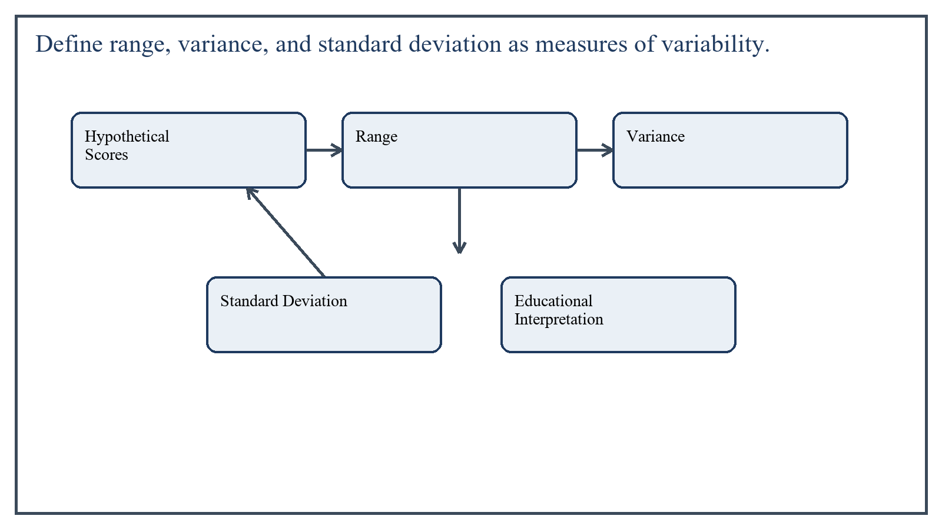
Figure 4: Concept map for Question 4

Hypothetical Scores
Suppose five students obtain the following test scores: 60, 70, 70, 80, and 90. These scores will be used to illustrate the three measures of variability.
In the context of Educational Assessment and Evaluation, the theme of hypothetical scores deserves extended attention because assignment-level understanding is expected to move beyond one-line definitions and into explanation, comparison, and application. A strong university answer shows not only what the concept means, but also why it matters, how it appears in practice, and what limitations or challenges may arise when it is implemented in real educational settings.
A mature academic response also connects hypothetical scores with classroom realities, institutional culture, and the Pakistani context wherever relevant. This makes the answer more analytical and more useful because it links conceptual understanding with the needs of teachers, learners, administrators, and communities rather than leaving the idea at a purely theoretical level.
From an examination and assignment-writing perspective, the topic of hypothetical scores should be handled through clear structure, careful terminology, valid examples, and balanced discussion. The strongest responses usually define the idea, explain its major components, illustrate it through educational examples, and then conclude with a reasoned judgment about its significance, usefulness, or limitations.

Range
Range is the simplest measure of variability. It is the difference between the highest score and the lowest score. It gives a quick idea of the spread of scores, though it uses only two values and ignores the rest of the distribution.
In our example, the highest score is 90 and the lowest score is 60. Therefore, Range = 90 - 60 = 30.
This means the scores are spread across 30 marks from the lowest to the highest performer.
In the context of Educational Assessment and Evaluation, the theme of range deserves extended attention because assignment-level understanding is expected to move beyond one-line definitions and into explanation, comparison, and application. A strong university answer shows not only what the concept means, but also why it matters, how it appears in practice, and what limitations or challenges may arise when it is implemented in real educational settings.
A mature academic response also connects range with classroom realities, institutional culture, and the Pakistani context wherever relevant. This makes the answer more analytical and more useful because it links conceptual understanding with the needs of teachers, learners, administrators, and communities rather than leaving the idea at a purely theoretical level.
From an examination and assignment-writing perspective, the topic of range should be handled through clear structure, careful terminology, valid examples, and balanced discussion. The strongest responses usually define the idea, explain its major components, illustrate it through educational examples, and then conclude with a reasoned judgment about its significance, usefulness, or limitations.

Variance
Variance is the average of the squared deviations from the mean. It shows how far scores tend to move away from the average. Because deviations are squared, negative and positive differences do not cancel each other.
First, find the mean: (60 + 70 + 70 + 80 + 90) / 5 = 74. Now compute deviations from the mean: -14, -4, -4, 6, and 16. Squaring them gives 196, 16, 16, 36, and 256. The total is 520.
If we divide by 5 for a simple classroom illustration, the variance is 520 / 5 = 104. This means the average squared deviation from the mean is 104.
In the context of Educational Assessment and Evaluation, the theme of variance deserves extended attention because assignment-level understanding is expected to move beyond one-line definitions and into explanation, comparison, and application. A strong university answer shows not only what the concept means, but also why it matters, how it appears in practice, and what limitations or challenges may arise when it is implemented in real educational settings.
A mature academic response also connects variance with classroom realities, institutional culture, and the Pakistani context wherever relevant. This makes the answer more analytical and more useful because it links conceptual understanding with the needs of teachers, learners, administrators, and communities rather than leaving the idea at a purely theoretical level.
From an examination and assignment-writing perspective, the topic of variance should be handled through clear structure, careful terminology, valid examples, and balanced discussion. The strongest responses usually define the idea, explain its major components, illustrate it through educational examples, and then conclude with a reasoned judgment about its significance, usefulness, or limitations.

Standard Deviation
Standard deviation is the square root of the variance. It is widely used because it returns the spread to the original score unit rather than squared units.
Using our example, if the variance is 104, then the standard deviation is approximately the square root of 104, which is about 10.20.
This means that, on average, scores tend to lie around 10 marks away from the mean. A larger standard deviation indicates greater spread, while a smaller one indicates greater consistency.
In the context of Educational Assessment and Evaluation, the theme of standard deviation deserves extended attention because assignment-level understanding is expected to move beyond one-line definitions and into explanation, comparison, and application. A strong university answer shows not only what the concept means, but also why it matters, how it appears in practice, and what limitations or challenges may arise when it is implemented in real educational settings.
A mature academic response also connects standard deviation with classroom realities, institutional culture, and the Pakistani context wherever relevant. This makes the answer more analytical and more useful because it links conceptual understanding with the needs of teachers, learners, administrators, and communities rather than leaving the idea at a purely theoretical level.
From an examination and assignment-writing perspective, the topic of standard deviation should be handled through clear structure, careful terminology, valid examples, and balanced discussion. The strongest responses usually define the idea, explain its major components, illustrate it through educational examples, and then conclude with a reasoned judgment about its significance, usefulness, or limitations.

Educational Interpretation
These measures help a teacher judge whether a class is relatively uniform or widely spread in performance. Range gives a quick first look, variance gives a more technical summary of dispersion, and standard deviation offers a practical and interpretable measure of spread around the mean.
In the context of Educational Assessment and Evaluation, the theme of educational interpretation deserves extended attention because assignment-level understanding is expected to move beyond one-line definitions and into explanation, comparison, and application. A strong university answer shows not only what the concept means, but also why it matters, how it appears in practice, and what limitations or challenges may arise when it is implemented in real educational settings.
A mature academic response also connects educational interpretation with classroom realities, institutional culture, and the Pakistani context wherever relevant. This makes the answer more analytical and more useful because it links conceptual understanding with the needs of teachers, learners, administrators, and communities rather than leaving the idea at a purely theoretical level.
From an examination and assignment-writing perspective, the topic of educational interpretation should be handled through clear structure, careful terminology, valid examples, and balanced discussion. The strongest responses usually define the idea, explain its major components, illustrate it through educational examples, and then conclude with a reasoned judgment about its significance, usefulness, or limitations.

Applied Illustration and Academic Note
For a stronger B.Ed assignment response, the topic above should be linked with classroom life, institutional practice, and the needs of Pakistani learners. This approach makes the response more analytical and demonstrates that the writer understands both theory and application, which is usually appreciated in AIOU-style academic work.
A good response also avoids unsupported claims. Instead, it explains concepts carefully, gives relevant examples, and ends with a short judgment about educational significance. In this way, the answer to 'Define range, variance, and standard deviation as measures of variabil...' becomes easier to read, easier to assess, and more academically convincing.

Quick Review Table
Focus Area | Assignment Relevance
Hypothetical Scores | This area helps answer the question on 'Define range, variance, and standard deviation as measu...' by providing concept clarity, explanation, and applied educational value.
Range | This area helps answer the question on 'Define range, variance, and standard deviation as measu...' by providing concept clarity, explanation, and applied educational value.
Variance | This area helps answer the question on 'Define range, variance, and standard deviation as measu...' by providing concept clarity, explanation, and applied educational value.
Standard Deviation | This area helps answer the question on 'Define range, variance, and standard deviation as measu...' by providing concept clarity, explanation, and applied educational value.

Critical Reflection
At an advanced level, the topic should not be treated as a fixed formula. Most educational concepts work within particular conditions, and their success often depends on planning quality, learner background, institutional support, and the competence of the teacher or manager using them. A reflective assignment therefore acknowledges strengths while also recognizing practical limitations.

Conclusion
Range, variance, and standard deviation are all measures of variability, but they differ in depth and usefulness. Range shows the overall spread, variance shows the average squared dispersion from the mean, and standard deviation expresses that dispersion in the original score unit. Together they help teachers understand the pattern of student performance more clearly.

Q.5 Explain in detail the major functions of test scores and progress reports in teaching, learning, and parent-teacher communication.
Answer: The answer below is organized in an academic assignment style, with conceptual explanation, applied discussion, and concise analytical closing comments designed for a neat and extended university submission.
Test scores and progress reports are important educational tools because they communicate evidence about student learning to different stakeholders. Their function is not limited to assigning marks. When used thoughtfully, they support instruction, motivation, self-assessment, planning, and communication between school and home.
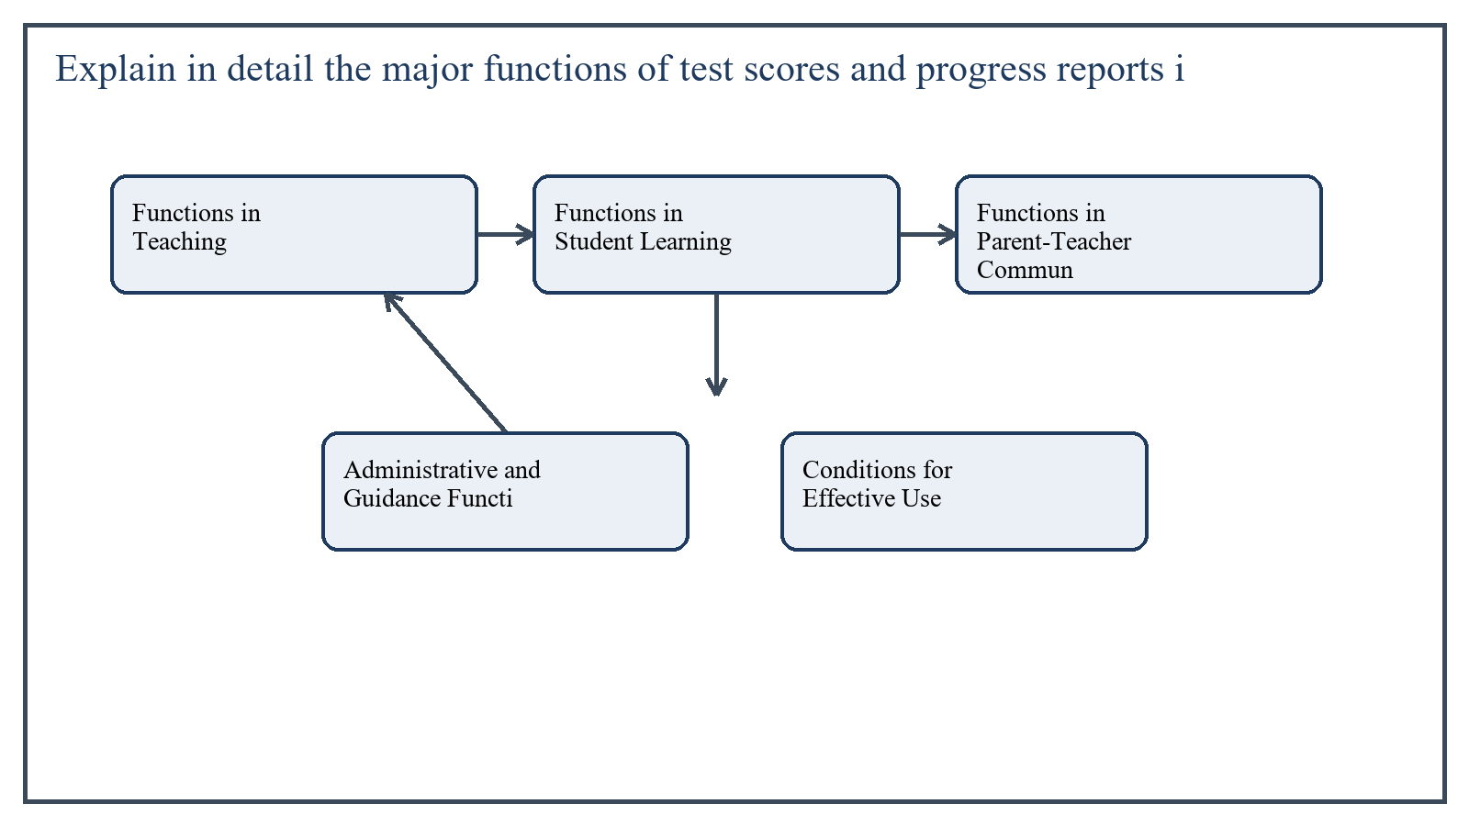
Figure 5: Concept map for Question 5

Functions in Teaching
For teachers, test scores provide feedback on the effectiveness of instruction. They show which objectives have been mastered, which topics remain weak, and whether the chosen methods are producing the desired learning outcomes.
If many students perform poorly on one section, the teacher may infer that the concept needs reteaching, the examples were insufficient, or the instructional sequence was too fast. Thus test scores support diagnosis and instructional adjustment.
In the context of Educational Assessment and Evaluation, the theme of functions in teaching deserves extended attention because assignment-level understanding is expected to move beyond one-line definitions and into explanation, comparison, and application. A strong university answer shows not only what the concept means, but also why it matters, how it appears in practice, and what limitations or challenges may arise when it is implemented in real educational settings.
A mature academic response also connects functions in teaching with classroom realities, institutional culture, and the Pakistani context wherever relevant. This makes the answer more analytical and more useful because it links conceptual understanding with the needs of teachers, learners, administrators, and communities rather than leaving the idea at a purely theoretical level.
From an examination and assignment-writing perspective, the topic of functions in teaching should be handled through clear structure, careful terminology, valid examples, and balanced discussion. The strongest responses usually define the idea, explain its major components, illustrate it through educational examples, and then conclude with a reasoned judgment about its significance, usefulness, or limitations.

Functions in Student Learning
For students, test scores and progress reports provide knowledge of results. They show what has been learned, what still needs attention, and how present effort compares with expected standards.
Well-designed progress reports can also support motivation. When students receive timely and specific feedback, they can set goals, improve habits, and develop self-assessment skills. The report becomes more than a grade sheet; it becomes a guide for growth.
- Shows strengths and weaknesses.
- Promotes self-monitoring and target setting.
- Encourages responsibility when combined with feedback.
- Helps students understand that learning progress is gradual and measurable.
In the context of Educational Assessment and Evaluation, the theme of functions in student learning deserves extended attention because assignment-level understanding is expected to move beyond one-line definitions and into explanation, comparison, and application. A strong university answer shows not only what the concept means, but also why it matters, how it appears in practice, and what limitations or challenges may arise when it is implemented in real educational settings.
A mature academic response also connects functions in student learning with classroom realities, institutional culture, and the Pakistani context wherever relevant. This makes the answer more analytical and more useful because it links conceptual understanding with the needs of teachers, learners, administrators, and communities rather than leaving the idea at a purely theoretical level.
From an examination and assignment-writing perspective, the topic of functions in student learning should be handled through clear structure, careful terminology, valid examples, and balanced discussion. The strongest responses usually define the idea, explain its major components, illustrate it through educational examples, and then conclude with a reasoned judgment about its significance, usefulness, or limitations.

Functions in Parent-Teacher Communication
Parents rely on test scores and progress reports to understand how their child is performing academically and behaviorally. These reports create a structured communication bridge between school and home.
A useful progress report tells parents not only the marks obtained but also the level of achievement, areas of concern, work habits, participation, attendance, and possible support needs. This allows parents to cooperate more effectively with teachers.
For example, if a progress report shows strong oral participation but weak written expression, parents and teachers can jointly plan reading and writing practice at home and school.
In the context of Educational Assessment and Evaluation, the theme of functions in parent-teacher communication deserves extended attention because assignment-level understanding is expected to move beyond one-line definitions and into explanation, comparison, and application. A strong university answer shows not only what the concept means, but also why it matters, how it appears in practice, and what limitations or challenges may arise when it is implemented in real educational settings.
A mature academic response also connects functions in parent-teacher communication with classroom realities, institutional culture, and the Pakistani context wherever relevant. This makes the answer more analytical and more useful because it links conceptual understanding with the needs of teachers, learners, administrators, and communities rather than leaving the idea at a purely theoretical level.
From an examination and assignment-writing perspective, the topic of functions in parent-teacher communication should be handled through clear structure, careful terminology, valid examples, and balanced discussion. The strongest responses usually define the idea, explain its major components, illustrate it through educational examples, and then conclude with a reasoned judgment about its significance, usefulness, or limitations.

Administrative and Guidance Functions
Test scores and reports also serve administrative functions such as promotion, placement, grouping, scholarship decisions, and record keeping. In addition, guidance services may use them to identify students who need remedial support, counseling, or enrichment.
However, these functions should be carried out carefully. A single score should not be used as the sole basis for major decisions, especially if other evidence suggests a broader or more complex picture.
In the context of Educational Assessment and Evaluation, the theme of administrative and guidance functions deserves extended attention because assignment-level understanding is expected to move beyond one-line definitions and into explanation, comparison, and application. A strong university answer shows not only what the concept means, but also why it matters, how it appears in practice, and what limitations or challenges may arise when it is implemented in real educational settings.
A mature academic response also connects administrative and guidance functions with classroom realities, institutional culture, and the Pakistani context wherever relevant. This makes the answer more analytical and more useful because it links conceptual understanding with the needs of teachers, learners, administrators, and communities rather than leaving the idea at a purely theoretical level.
From an examination and assignment-writing perspective, the topic of administrative and guidance functions should be handled through clear structure, careful terminology, valid examples, and balanced discussion. The strongest responses usually define the idea, explain its major components, illustrate it through educational examples, and then conclude with a reasoned judgment about its significance, usefulness, or limitations.

Conditions for Effective Use
- Scores should be based on adequate and valid assessment evidence.
- Reports should be clear, specific, and understandable to parents.
- Feedback should point toward improvement, not only judgment.
- Teachers should explain the meaning and limits of scores where needed.
In the context of Educational Assessment and Evaluation, the theme of conditions for effective use deserves extended attention because assignment-level understanding is expected to move beyond one-line definitions and into explanation, comparison, and application. A strong university answer shows not only what the concept means, but also why it matters, how it appears in practice, and what limitations or challenges may arise when it is implemented in real educational settings.
A mature academic response also connects conditions for effective use with classroom realities, institutional culture, and the Pakistani context wherever relevant. This makes the answer more analytical and more useful because it links conceptual understanding with the needs of teachers, learners, administrators, and communities rather than leaving the idea at a purely theoretical level.
From an examination and assignment-writing perspective, the topic of conditions for effective use should be handled through clear structure, careful terminology, valid examples, and balanced discussion. The strongest responses usually define the idea, explain its major components, illustrate it through educational examples, and then conclude with a reasoned judgment about its significance, usefulness, or limitations.

Applied Illustration and Academic Note
For a stronger B.Ed assignment response, the topic above should be linked with classroom life, institutional practice, and the needs of Pakistani learners. This approach makes the response more analytical and demonstrates that the writer understands both theory and application, which is usually appreciated in AIOU-style academic work.
A good response also avoids unsupported claims. Instead, it explains concepts carefully, gives relevant examples, and ends with a short judgment about educational significance. In this way, the answer to 'Explain in detail the major functions of test scores and progress repo...' becomes easier to read, easier to assess, and more academically convincing.

Quick Review Table
Focus Area | Assignment Relevance
Functions in Teaching | This area helps answer the question on 'Explain in detail the major functions of test scores an...' by providing concept clarity, explanation, and applied educational value.
Functions in Student Learning | This area helps answer the question on 'Explain in detail the major functions of test scores an...' by providing concept clarity, explanation, and applied educational value.
Functions in Parent-Teacher Communication | This area helps answer the question on 'Explain in detail the major functions of test scores an...' by providing concept clarity, explanation, and applied educational value.
Administrative and Guidance Functions | This area helps answer the question on 'Explain in detail the major functions of test scores an...' by providing concept clarity, explanation, and applied educational value.

Critical Reflection
At an advanced level, the topic should not be treated as a fixed formula. Most educational concepts work within particular conditions, and their success often depends on planning quality, learner background, institutional support, and the competence of the teacher or manager using them. A reflective assignment therefore acknowledges strengths while also recognizing practical limitations.

Conclusion
Test scores and progress reports play major functions in teaching, learning, and parent-teacher communication. They guide instruction, support student reflection and motivation, inform parents, and assist administrative and guidance decisions. Their full value appears when they are clear, valid, constructive, and used as part of an ongoing educational dialogue.

Extended Revision Appendix
This appendix is included to strengthen the assignment as a premium academic submission. It provides recap notes, revision prompts, and concept reinforcement so the document reads like a complete study-ready submission rather than a short-answer sheet only.

Key Revision Points
- Review the central demand of the question 'Why is validity regarded as the most critical feature of meani...' and connect definition, explanation, example, and critical comment in one organized response.
- Review the central demand of the question 'What general guidelines should teachers follow when constructi...' and connect definition, explanation, example, and critical comment in one organized response.
- Review the central demand of the question 'Describe how nominal, ordinal, interval, and ratio measurement...' and connect definition, explanation, example, and critical comment in one organized response.
- Review the central demand of the question 'Define range, variance, and standard deviation as measures of ...' and connect definition, explanation, example, and critical comment in one organized response.
- Review the central demand of the question 'Explain in detail the major functions of test scores and progr...' and connect definition, explanation, example, and critical comment in one organized response.

Academic Writing Reminders
- Begin each major answer with a clear conceptual opening.
- Use examples to show understanding instead of repeating definitions only.
- Present advantages, limitations, and contextual realities where relevant.
- Close each answer with a short evaluative conclusion.
- Maintain formal and neat language throughout the assignment.

Concept Reinforcement Notes
The question on 'Why is validity regarded as the most critical feature of meaningful assessm...' can be revised further by identifying three things: the main concept involved, the educational importance of that concept, and one example from Pakistani classroom or institutional life. This simple method helps transform memorized content into organized written response.
The question on 'What general guidelines should teachers follow when constructing essay-type...' can be revised further by identifying three things: the main concept involved, the educational importance of that concept, and one example from Pakistani classroom or institutional life. This simple method helps transform memorized content into organized written response.
The question on 'Describe how nominal, ordinal, interval, and ratio measurement scales are u...' can be revised further by identifying three things: the main concept involved, the educational importance of that concept, and one example from Pakistani classroom or institutional life. This simple method helps transform memorized content into organized written response.
The question on 'Define range, variance, and standard deviation as measures of variability. ...' can be revised further by identifying three things: the main concept involved, the educational importance of that concept, and one example from Pakistani classroom or institutional life. This simple method helps transform memorized content into organized written response.
The question on 'Explain in detail the major functions of test scores and progress reports i...' can be revised further by identifying three things: the main concept involved, the educational importance of that concept, and one example from Pakistani classroom or institutional life. This simple method helps transform memorized content into organized written response.

Source Base and Assignment Support Notes
The following source base was used to keep the answers aligned with AIOU course structure and the exact question wording. The final language and organization were expanded for presentation quality, page-length target, and assignment readability.
- AIOU Soft Book: Educational Assessment and Evaluation (Code 8602), especially the units on validity, essay-item construction, measurement scales, variability, scores, grading, and progress reports.
- AIOU Spring 2026 assignment sheet for Course 8602.

Extended Analytical Note 1
In extended study of Educational Assessment and Evaluation, the issue raised in 'Why is validity regarded as the most critical feature of meaningful asse...' may also be explored through definition, theoretical explanation, applied example, classroom implication, institutional implication, and critical reflection. This six-part approach helps a learner produce a more complete answer and also improves the academic appearance of the assignment by showing structure and depth.
Another useful strategy in long-form assignment writing is to move carefully from concept to context. First explain what the idea means, then identify its components, then discuss its relevance in teaching or administration, and finally mention any practical limitation. Such movement gives maturity to the answer and helps the examiner follow the logic without difficulty.
In extended study of Educational Assessment and Evaluation, the issue raised in 'What general guidelines should teachers follow when constructing essay-t...' may also be explored through definition, theoretical explanation, applied example, classroom implication, institutional implication, and critical reflection. This six-part approach helps a learner produce a more complete answer and also improves the academic appearance of the assignment by showing structure and depth.
Another useful strategy in long-form assignment writing is to move carefully from concept to context. First explain what the idea means, then identify its components, then discuss its relevance in teaching or administration, and finally mention any practical limitation. Such movement gives maturity to the answer and helps the examiner follow the logic without difficulty.
In extended study of Educational Assessment and Evaluation, the issue raised in 'Describe how nominal, ordinal, interval, and ratio measurement scales ar...' may also be explored through definition, theoretical explanation, applied example, classroom implication, institutional implication, and critical reflection. This six-part approach helps a learner produce a more complete answer and also improves the academic appearance of the assignment by showing structure and depth.
Another useful strategy in long-form assignment writing is to move carefully from concept to context. First explain what the idea means, then identify its components, then discuss its relevance in teaching or administration, and finally mention any practical limitation. Such movement gives maturity to the answer and helps the examiner follow the logic without difficulty.
In extended study of Educational Assessment and Evaluation, the issue raised in 'Define range, variance, and standard deviation as measures of variabilit...' may also be explored through definition, theoretical explanation, applied example, classroom implication, institutional implication, and critical reflection. This six-part approach helps a learner produce a more complete answer and also improves the academic appearance of the assignment by showing structure and depth.
Another useful strategy in long-form assignment writing is to move carefully from concept to context. First explain what the idea means, then identify its components, then discuss its relevance in teaching or administration, and finally mention any practical limitation. Such movement gives maturity to the answer and helps the examiner follow the logic without difficulty.
In extended study of Educational Assessment and Evaluation, the issue raised in 'Explain in detail the major functions of test scores and progress report...' may also be explored through definition, theoretical explanation, applied example, classroom implication, institutional implication, and critical reflection. This six-part approach helps a learner produce a more complete answer and also improves the academic appearance of the assignment by showing structure and depth.
Another useful strategy in long-form assignment writing is to move carefully from concept to context. First explain what the idea means, then identify its components, then discuss its relevance in teaching or administration, and finally mention any practical limitation. Such movement gives maturity to the answer and helps the examiner follow the logic without difficulty.

Extended Analytical Note 2
In extended study of Educational Assessment and Evaluation, the issue raised in 'Why is validity regarded as the most critical feature of meaningful asse...' may also be explored through definition, theoretical explanation, applied example, classroom implication, institutional implication, and critical reflection. This six-part approach helps a learner produce a more complete answer and also improves the academic appearance of the assignment by showing structure and depth.
Another useful strategy in long-form assignment writing is to move carefully from concept to context. First explain what the idea means, then identify its components, then discuss its relevance in teaching or administration, and finally mention any practical limitation. Such movement gives maturity to the answer and helps the examiner follow the logic without difficulty.
In extended study of Educational Assessment and Evaluation, the issue raised in 'What general guidelines should teachers follow when constructing essay-t...' may also be explored through definition, theoretical explanation, applied example, classroom implication, institutional implication, and critical reflection. This six-part approach helps a learner produce a more complete answer and also improves the academic appearance of the assignment by showing structure and depth.
Another useful strategy in long-form assignment writing is to move carefully from concept to context. First explain what the idea means, then identify its components, then discuss its relevance in teaching or administration, and finally mention any practical limitation. Such movement gives maturity to the answer and helps the examiner follow the logic without difficulty.
In extended study of Educational Assessment and Evaluation, the issue raised in 'Describe how nominal, ordinal, interval, and ratio measurement scales ar...' may also be explored through definition, theoretical explanation, applied example, classroom implication, institutional implication, and critical reflection. This six-part approach helps a learner produce a more complete answer and also improves the academic appearance of the assignment by showing structure and depth.
Another useful strategy in long-form assignment writing is to move carefully from concept to context. First explain what the idea means, then identify its components, then discuss its relevance in teaching or administration, and finally mention any practical limitation. Such movement gives maturity to the answer and helps the examiner follow the logic without difficulty.
In extended study of Educational Assessment and Evaluation, the issue raised in 'Define range, variance, and standard deviation as measures of variabilit...' may also be explored through definition, theoretical explanation, applied example, classroom implication, institutional implication, and critical reflection. This six-part approach helps a learner produce a more complete answer and also improves the academic appearance of the assignment by showing structure and depth.
Another useful strategy in long-form assignment writing is to move carefully from concept to context. First explain what the idea means, then identify its components, then discuss its relevance in teaching or administration, and finally mention any practical limitation. Such movement gives maturity to the answer and helps the examiner follow the logic without difficulty.
In extended study of Educational Assessment and Evaluation, the issue raised in 'Explain in detail the major functions of test scores and progress report...' may also be explored through definition, theoretical explanation, applied example, classroom implication, institutional implication, and critical reflection. This six-part approach helps a learner produce a more complete answer and also improves the academic appearance of the assignment by showing structure and depth.
Another useful strategy in long-form assignment writing is to move carefully from concept to context. First explain what the idea means, then identify its components, then discuss its relevance in teaching or administration, and finally mention any practical limitation. Such movement gives maturity to the answer and helps the examiner follow the logic without difficulty.

Extended Analytical Note 3
In extended study of Educational Assessment and Evaluation, the issue raised in 'Why is validity regarded as the most critical feature of meaningful asse...' may also be explored through definition, theoretical explanation, applied example, classroom implication, institutional implication, and critical reflection. This six-part approach helps a learner produce a more complete answer and also improves the academic appearance of the assignment by showing structure and depth.
Another useful strategy in long-form assignment writing is to move carefully from concept to context. First explain what the idea means, then identify its components, then discuss its relevance in teaching or administration, and finally mention any practical limitation. Such movement gives maturity to the answer and helps the examiner follow the logic without difficulty.
In extended study of Educational Assessment and Evaluation, the issue raised in 'What general guidelines should teachers follow when constructing essay-t...' may also be explored through definition, theoretical explanation, applied example, classroom implication, institutional implication, and critical reflection. This six-part approach helps a learner produce a more complete answer and also improves the academic appearance of the assignment by showing structure and depth.
Another useful strategy in long-form assignment writing is to move carefully from concept to context. First explain what the idea means, then identify its components, then discuss its relevance in teaching or administration, and finally mention any practical limitation. Such movement gives maturity to the answer and helps the examiner follow the logic without difficulty.
In extended study of Educational Assessment and Evaluation, the issue raised in 'Describe how nominal, ordinal, interval, and ratio measurement scales ar...' may also be explored through definition, theoretical explanation, applied example, classroom implication, institutional implication, and critical reflection. This six-part approach helps a learner produce a more complete answer and also improves the academic appearance of the assignment by showing structure and depth.
Another useful strategy in long-form assignment writing is to move carefully from concept to context. First explain what the idea means, then identify its components, then discuss its relevance in teaching or administration, and finally mention any practical limitation. Such movement gives maturity to the answer and helps the examiner follow the logic without difficulty.
In extended study of Educational Assessment and Evaluation, the issue raised in 'Define range, variance, and standard deviation as measures of variabilit...' may also be explored through definition, theoretical explanation, applied example, classroom implication, institutional implication, and critical reflection. This six-part approach helps a learner produce a more complete answer and also improves the academic appearance of the assignment by showing structure and depth.
Another useful strategy in long-form assignment writing is to move carefully from concept to context. First explain what the idea means, then identify its components, then discuss its relevance in teaching or administration, and finally mention any practical limitation. Such movement gives maturity to the answer and helps the examiner follow the logic without difficulty.
In extended study of Educational Assessment and Evaluation, the issue raised in 'Explain in detail the major functions of test scores and progress report...' may also be explored through definition, theoretical explanation, applied example, classroom implication, institutional implication, and critical reflection. This six-part approach helps a learner produce a more complete answer and also improves the academic appearance of the assignment by showing structure and depth.
Another useful strategy in long-form assignment writing is to move carefully from concept to context. First explain what the idea means, then identify its components, then discuss its relevance in teaching or administration, and finally mention any practical limitation. Such movement gives maturity to the answer and helps the examiner follow the logic without difficulty.

