ALLAMA IQBAL OPEN UNIVERSITY
Premium Typed Assignment
Curriculum Development
Detail | Course Code: 8603
Detail | Assignment No: 1
Detail | Unit Coverage: All Questions Carry Equal Marks
Detail | Program Level: B.Ed 1.5/2.5
Detail | Formatting Profile: Times New Roman, 14 pt headings, 12 pt body text
Detail | Document Goal: Extended academic response with diagrams, border styling, and premium presentation

Presentation Note
This file has been prepared as a premium typed assignment with extended academic treatment, proper page border styling, inserted diagrams, formal headings, and neat section hierarchy. The content is intentionally expanded so that the assignment remains easy to read while still meeting a high page-length target.

Q.1 Critically assess how culture and societal values influence the development of a national curriculum.
Answer: The answer below is organized in an academic assignment style, with conceptual explanation, applied discussion, and concise analytical closing comments designed for a neat and extended university submission.
A national curriculum does not emerge in a cultural vacuum. It reflects the society's beliefs about what kind of citizen it wishes to develop, what knowledge it values, what moral order it wants to preserve, and what future it hopes to build. Therefore, culture and societal values are among the strongest foundations of curriculum development.
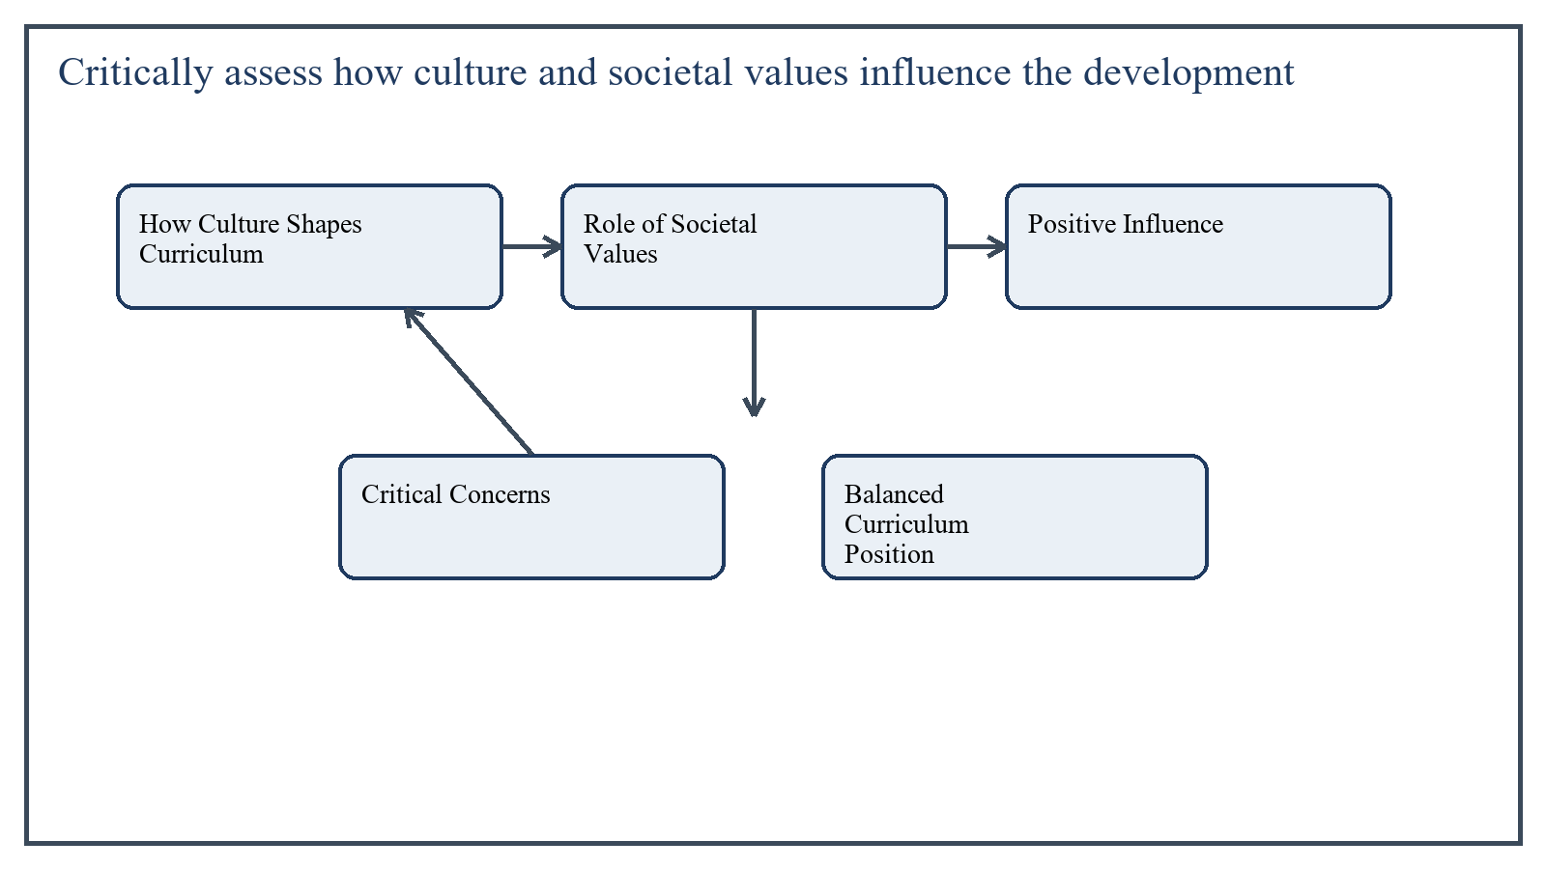
Figure 1: Concept map for Question 1

How Culture Shapes Curriculum
Culture provides the shared language, traditions, symbols, ways of life, and meaning systems of a society. These influence curriculum through the selection of content, the aims of education, the organization of experiences, and the values promoted by schooling.
For example, if a society strongly values collective identity, respect for elders, and moral order, its curriculum is likely to include civic education, moral education, social obligations, and cultural heritage. If innovation and enterprise are socially emphasized, the curriculum may highlight problem-solving, creativity, and entrepreneurship.
In the context of Curriculum Development, the theme of how culture shapes curriculum deserves extended attention because assignment-level understanding is expected to move beyond one-line definitions and into explanation, comparison, and application. A strong university answer shows not only what the concept means, but also why it matters, how it appears in practice, and what limitations or challenges may arise when it is implemented in real educational settings.
A mature academic response also connects how culture shapes curriculum with classroom realities, institutional culture, and the Pakistani context wherever relevant. This makes the answer more analytical and more useful because it links conceptual understanding with the needs of teachers, learners, administrators, and communities rather than leaving the idea at a purely theoretical level.
From an examination and assignment-writing perspective, the topic of how culture shapes curriculum should be handled through clear structure, careful terminology, valid examples, and balanced discussion. The strongest responses usually define the idea, explain its major components, illustrate it through educational examples, and then conclude with a reasoned judgment about its significance, usefulness, or limitations.

Role of Societal Values
Societal values influence what is considered worthwhile knowledge. This affects subject inclusion, textbook tone, examples, language policy, and co-curricular priorities. Values also shape how curriculum defines desirable outcomes such as patriotism, tolerance, productivity, discipline, environmental care, or democratic participation.
In the Pakistani context, values connected with religion, national identity, family cohesion, social responsibility, and citizenship have historically influenced curriculum aims and content selection.
In the context of Curriculum Development, the theme of role of societal values deserves extended attention because assignment-level understanding is expected to move beyond one-line definitions and into explanation, comparison, and application. A strong university answer shows not only what the concept means, but also why it matters, how it appears in practice, and what limitations or challenges may arise when it is implemented in real educational settings.
A mature academic response also connects role of societal values with classroom realities, institutional culture, and the Pakistani context wherever relevant. This makes the answer more analytical and more useful because it links conceptual understanding with the needs of teachers, learners, administrators, and communities rather than leaving the idea at a purely theoretical level.
From an examination and assignment-writing perspective, the topic of role of societal values should be handled through clear structure, careful terminology, valid examples, and balanced discussion. The strongest responses usually define the idea, explain its major components, illustrate it through educational examples, and then conclude with a reasoned judgment about its significance, usefulness, or limitations.

Positive Influence
- Culture makes education meaningful by connecting school learning with lived reality.
- Societal values provide direction for moral and civic development.
- Cultural grounding helps preserve heritage and national cohesion.
- Local relevance improves learner identification with curriculum content.
In the context of Curriculum Development, the theme of positive influence deserves extended attention because assignment-level understanding is expected to move beyond one-line definitions and into explanation, comparison, and application. A strong university answer shows not only what the concept means, but also why it matters, how it appears in practice, and what limitations or challenges may arise when it is implemented in real educational settings.
A mature academic response also connects positive influence with classroom realities, institutional culture, and the Pakistani context wherever relevant. This makes the answer more analytical and more useful because it links conceptual understanding with the needs of teachers, learners, administrators, and communities rather than leaving the idea at a purely theoretical level.
From an examination and assignment-writing perspective, the topic of positive influence should be handled through clear structure, careful terminology, valid examples, and balanced discussion. The strongest responses usually define the idea, explain its major components, illustrate it through educational examples, and then conclude with a reasoned judgment about its significance, usefulness, or limitations.

Critical Concerns
The influence of culture and values is not always neutral or beneficial. A curriculum may become narrow if it presents only one dominant version of culture and silences minority identities, regional diversity, gender concerns, or global perspectives. In such cases, curriculum may reproduce social inequality rather than challenge it.
Another issue is that societies are dynamic, not fixed. If curriculum treats culture as frozen tradition, it may fail to prepare students for contemporary realities such as technology, migration, environmental change, and pluralism. A national curriculum must therefore balance cultural continuity with openness to change.
In the context of Curriculum Development, the theme of critical concerns deserves extended attention because assignment-level understanding is expected to move beyond one-line definitions and into explanation, comparison, and application. A strong university answer shows not only what the concept means, but also why it matters, how it appears in practice, and what limitations or challenges may arise when it is implemented in real educational settings.
A mature academic response also connects critical concerns with classroom realities, institutional culture, and the Pakistani context wherever relevant. This makes the answer more analytical and more useful because it links conceptual understanding with the needs of teachers, learners, administrators, and communities rather than leaving the idea at a purely theoretical level.
From an examination and assignment-writing perspective, the topic of critical concerns should be handled through clear structure, careful terminology, valid examples, and balanced discussion. The strongest responses usually define the idea, explain its major components, illustrate it through educational examples, and then conclude with a reasoned judgment about its significance, usefulness, or limitations.

Balanced Curriculum Position
A sound national curriculum should respect cultural foundations while remaining inclusive, critical, and forward-looking. It should preserve valuable traditions, but it should also promote tolerance, inquiry, gender equity, and the ability to live in a diverse and changing world.
In the context of Curriculum Development, the theme of balanced curriculum position deserves extended attention because assignment-level understanding is expected to move beyond one-line definitions and into explanation, comparison, and application. A strong university answer shows not only what the concept means, but also why it matters, how it appears in practice, and what limitations or challenges may arise when it is implemented in real educational settings.
A mature academic response also connects balanced curriculum position with classroom realities, institutional culture, and the Pakistani context wherever relevant. This makes the answer more analytical and more useful because it links conceptual understanding with the needs of teachers, learners, administrators, and communities rather than leaving the idea at a purely theoretical level.
From an examination and assignment-writing perspective, the topic of balanced curriculum position should be handled through clear structure, careful terminology, valid examples, and balanced discussion. The strongest responses usually define the idea, explain its major components, illustrate it through educational examples, and then conclude with a reasoned judgment about its significance, usefulness, or limitations.

Applied Illustration and Academic Note
For a stronger B.Ed assignment response, the topic above should be linked with classroom life, institutional practice, and the needs of Pakistani learners. This approach makes the response more analytical and demonstrates that the writer understands both theory and application, which is usually appreciated in AIOU-style academic work.
A good response also avoids unsupported claims. Instead, it explains concepts carefully, gives relevant examples, and ends with a short judgment about educational significance. In this way, the answer to 'Critically assess how culture and societal values influence the develo...' becomes easier to read, easier to assess, and more academically convincing.

Quick Review Table
Focus Area | Assignment Relevance
How Culture Shapes Curriculum | This area helps answer the question on 'Critically assess how culture and societal values influ...' by providing concept clarity, explanation, and applied educational value.
Role of Societal Values | This area helps answer the question on 'Critically assess how culture and societal values influ...' by providing concept clarity, explanation, and applied educational value.
Positive Influence | This area helps answer the question on 'Critically assess how culture and societal values influ...' by providing concept clarity, explanation, and applied educational value.
Critical Concerns | This area helps answer the question on 'Critically assess how culture and societal values influ...' by providing concept clarity, explanation, and applied educational value.

Critical Reflection
At an advanced level, the topic should not be treated as a fixed formula. Most educational concepts work within particular conditions, and their success often depends on planning quality, learner background, institutional support, and the competence of the teacher or manager using them. A reflective assignment therefore acknowledges strengths while also recognizing practical limitations.

Conclusion
Culture and societal values strongly influence national curriculum by shaping its aims, content, language, and educational priorities. Their influence is necessary because education must remain socially rooted, yet it must also be critically examined so that the curriculum remains inclusive, adaptive, and just. A strong national curriculum therefore reflects culture without becoming imprisoned by it.

Q.2 Assess the contribution of the 2006 Curriculum Reform in improving subject-specific competencies.
Answer: The answer below is organized in an academic assignment style, with conceptual explanation, applied discussion, and concise analytical closing comments designed for a neat and extended university submission.
The 2006 curriculum reform in Pakistan aimed to move school education toward clearer learning standards, stronger subject focus, and improved relevance to national and global demands. Its contribution can be assessed in terms of how far it clarified competencies, supported modern pedagogy, and encouraged a shift from content accumulation to outcomes-based learning.
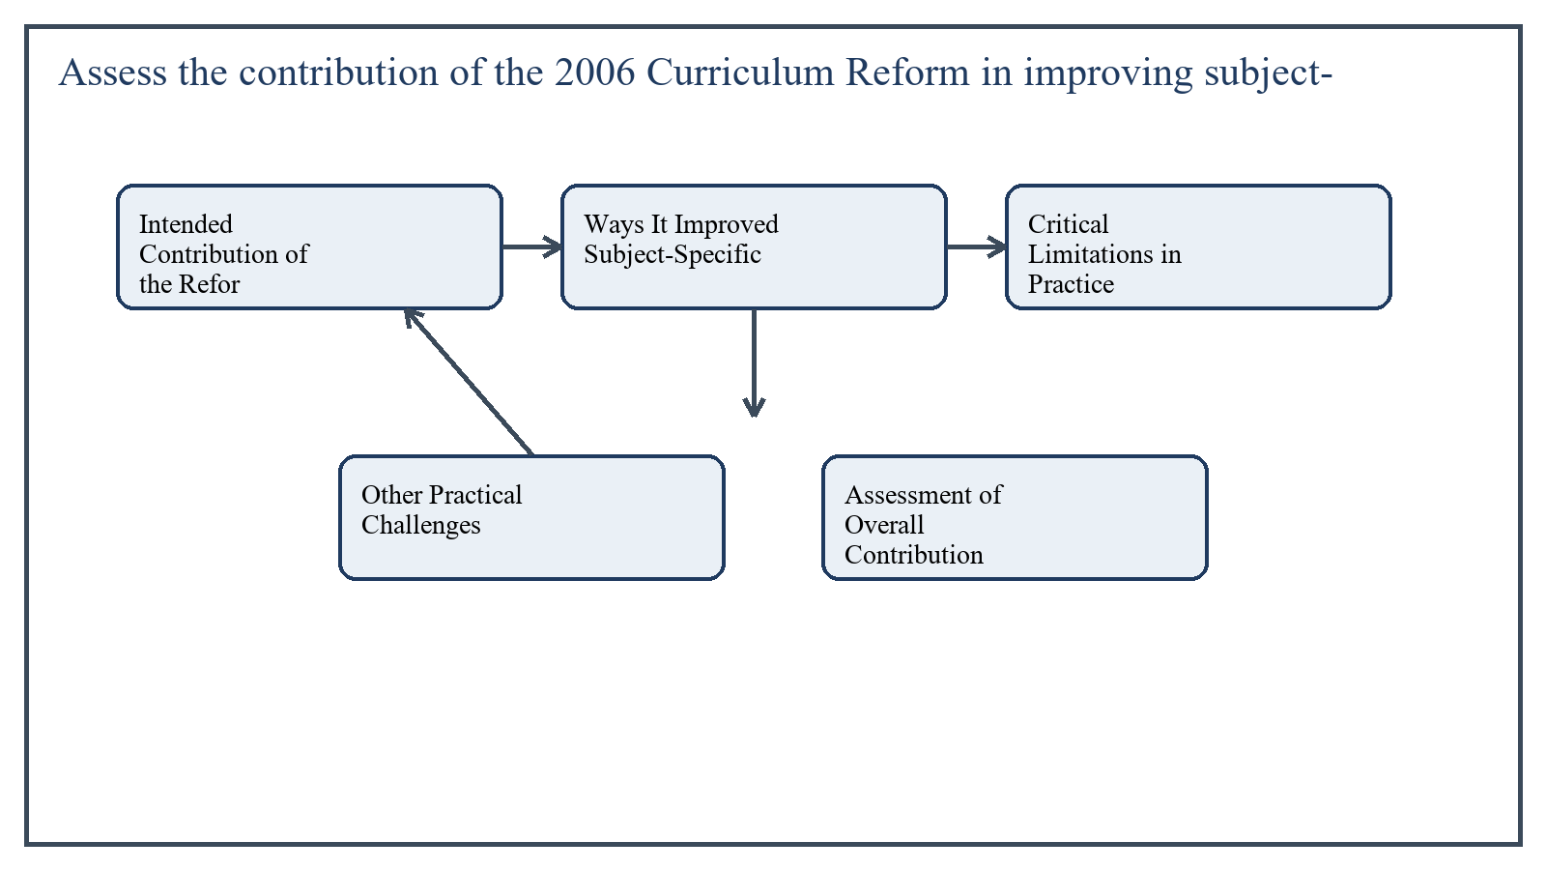
Figure 2: Concept map for Question 2

Intended Contribution of the Reform
One important contribution of the reform was the emphasis on learning outcomes and competencies rather than merely textbook coverage. This helped subject specialists and teachers think more carefully about what learners should actually know and be able to do in language, science, mathematics, social studies, and other areas.
The reform also attempted to modernize curriculum content by updating themes, introducing greater conceptual progression, and improving alignment between class levels. In principle, this supported subject-specific competence by reducing fragmentation and making curriculum sequences more coherent.
In the context of Curriculum Development, the theme of intended contribution of the reform deserves extended attention because assignment-level understanding is expected to move beyond one-line definitions and into explanation, comparison, and application. A strong university answer shows not only what the concept means, but also why it matters, how it appears in practice, and what limitations or challenges may arise when it is implemented in real educational settings.
A mature academic response also connects intended contribution of the reform with classroom realities, institutional culture, and the Pakistani context wherever relevant. This makes the answer more analytical and more useful because it links conceptual understanding with the needs of teachers, learners, administrators, and communities rather than leaving the idea at a purely theoretical level.
From an examination and assignment-writing perspective, the topic of intended contribution of the reform should be handled through clear structure, careful terminology, valid examples, and balanced discussion. The strongest responses usually define the idea, explain its major components, illustrate it through educational examples, and then conclude with a reasoned judgment about its significance, usefulness, or limitations.

Ways It Improved Subject-Specific Competencies
For instance, in science the reform promoted inquiry and understanding of processes; in language it encouraged communication and comprehension; in mathematics it supported conceptual learning rather than rule memorization alone.
- Clarified key competencies expected in major subjects.
- Encouraged movement from rote memorization toward understanding and application.
- Highlighted skills such as communication, inquiry, problem-solving, and interpretation.
- Provided a stronger basis for textbook revision and teacher planning.
In the context of Curriculum Development, the theme of ways it improved subject-specific competencies deserves extended attention because assignment-level understanding is expected to move beyond one-line definitions and into explanation, comparison, and application. A strong university answer shows not only what the concept means, but also why it matters, how it appears in practice, and what limitations or challenges may arise when it is implemented in real educational settings.
A mature academic response also connects ways it improved subject-specific competencies with classroom realities, institutional culture, and the Pakistani context wherever relevant. This makes the answer more analytical and more useful because it links conceptual understanding with the needs of teachers, learners, administrators, and communities rather than leaving the idea at a purely theoretical level.
From an examination and assignment-writing perspective, the topic of ways it improved subject-specific competencies should be handled through clear structure, careful terminology, valid examples, and balanced discussion. The strongest responses usually define the idea, explain its major components, illustrate it through educational examples, and then conclude with a reasoned judgment about its significance, usefulness, or limitations.

Critical Limitations in Practice
Despite these positive intentions, the reform's classroom impact was uneven. One major challenge was the gap between curriculum documents and implementation. Teachers were often not sufficiently trained to translate competency statements into lesson planning, classroom activity, and assessment practice.
Textbooks and examinations also did not always fully support the reform spirit. Where examinations continued to reward recall-heavy responses, teachers naturally remained tied to traditional teaching habits. As a result, subject competencies written in curriculum documents were not always realized in classroom learning.
In the context of Curriculum Development, the theme of critical limitations in practice deserves extended attention because assignment-level understanding is expected to move beyond one-line definitions and into explanation, comparison, and application. A strong university answer shows not only what the concept means, but also why it matters, how it appears in practice, and what limitations or challenges may arise when it is implemented in real educational settings.
A mature academic response also connects critical limitations in practice with classroom realities, institutional culture, and the Pakistani context wherever relevant. This makes the answer more analytical and more useful because it links conceptual understanding with the needs of teachers, learners, administrators, and communities rather than leaving the idea at a purely theoretical level.
From an examination and assignment-writing perspective, the topic of critical limitations in practice should be handled through clear structure, careful terminology, valid examples, and balanced discussion. The strongest responses usually define the idea, explain its major components, illustrate it through educational examples, and then conclude with a reasoned judgment about its significance, usefulness, or limitations.

Other Practical Challenges
- Limited teacher professional development.
- Weak alignment between curriculum, textbooks, and assessment.
- Insufficient classroom resources in many schools.
- Variation in implementation across provinces and school systems.
In the context of Curriculum Development, the theme of other practical challenges deserves extended attention because assignment-level understanding is expected to move beyond one-line definitions and into explanation, comparison, and application. A strong university answer shows not only what the concept means, but also why it matters, how it appears in practice, and what limitations or challenges may arise when it is implemented in real educational settings.
A mature academic response also connects other practical challenges with classroom realities, institutional culture, and the Pakistani context wherever relevant. This makes the answer more analytical and more useful because it links conceptual understanding with the needs of teachers, learners, administrators, and communities rather than leaving the idea at a purely theoretical level.
From an examination and assignment-writing perspective, the topic of other practical challenges should be handled through clear structure, careful terminology, valid examples, and balanced discussion. The strongest responses usually define the idea, explain its major components, illustrate it through educational examples, and then conclude with a reasoned judgment about its significance, usefulness, or limitations.

Assessment of Overall Contribution
The 2006 reform made an important conceptual contribution by clarifying that subject learning should be competency-based, progressive, and more relevant to modern educational needs. However, its practical contribution depended heavily on teacher preparation, textbook quality, and assessment reform.
In the context of Curriculum Development, the theme of assessment of overall contribution deserves extended attention because assignment-level understanding is expected to move beyond one-line definitions and into explanation, comparison, and application. A strong university answer shows not only what the concept means, but also why it matters, how it appears in practice, and what limitations or challenges may arise when it is implemented in real educational settings.
A mature academic response also connects assessment of overall contribution with classroom realities, institutional culture, and the Pakistani context wherever relevant. This makes the answer more analytical and more useful because it links conceptual understanding with the needs of teachers, learners, administrators, and communities rather than leaving the idea at a purely theoretical level.
From an examination and assignment-writing perspective, the topic of assessment of overall contribution should be handled through clear structure, careful terminology, valid examples, and balanced discussion. The strongest responses usually define the idea, explain its major components, illustrate it through educational examples, and then conclude with a reasoned judgment about its significance, usefulness, or limitations.

Applied Illustration and Academic Note
For a stronger B.Ed assignment response, the topic above should be linked with classroom life, institutional practice, and the needs of Pakistani learners. This approach makes the response more analytical and demonstrates that the writer understands both theory and application, which is usually appreciated in AIOU-style academic work.
A good response also avoids unsupported claims. Instead, it explains concepts carefully, gives relevant examples, and ends with a short judgment about educational significance. In this way, the answer to 'Assess the contribution of the 2006 Curriculum Reform in improving sub...' becomes easier to read, easier to assess, and more academically convincing.

Quick Review Table
Focus Area | Assignment Relevance
Intended Contribution of the Reform | This area helps answer the question on 'Assess the contribution of the 2006 Curriculum Reform i...' by providing concept clarity, explanation, and applied educational value.
Ways It Improved Subject-Specific Competencies | This area helps answer the question on 'Assess the contribution of the 2006 Curriculum Reform i...' by providing concept clarity, explanation, and applied educational value.
Critical Limitations in Practice | This area helps answer the question on 'Assess the contribution of the 2006 Curriculum Reform i...' by providing concept clarity, explanation, and applied educational value.
Other Practical Challenges | This area helps answer the question on 'Assess the contribution of the 2006 Curriculum Reform i...' by providing concept clarity, explanation, and applied educational value.

Critical Reflection
At an advanced level, the topic should not be treated as a fixed formula. Most educational concepts work within particular conditions, and their success often depends on planning quality, learner background, institutional support, and the competence of the teacher or manager using them. A reflective assignment therefore acknowledges strengths while also recognizing practical limitations.

Conclusion
The 2006 Curriculum Reform contributed positively by strengthening attention to subject-specific competencies, clearer learning outcomes, and more modern educational expectations. However, its impact was limited wherever implementation remained weak. Therefore, the reform should be seen as a valuable step forward whose full success depended on parallel changes in teacher training, materials, and examination systems.

Q.3 Propose strategies for integrating ethical considerations into curriculum foundations to promote inclusivity.
Answer: The answer below is organized in an academic assignment style, with conceptual explanation, applied discussion, and concise analytical closing comments designed for a neat and extended university submission.
Ethical considerations should be part of curriculum foundations because curriculum is never a neutral technical plan. It makes choices about whose knowledge is included, whose identity is represented, what values are promoted, and what kind of social behavior is considered desirable. If ethics is ignored, curriculum may unintentionally reproduce exclusion, bias, and inequality.
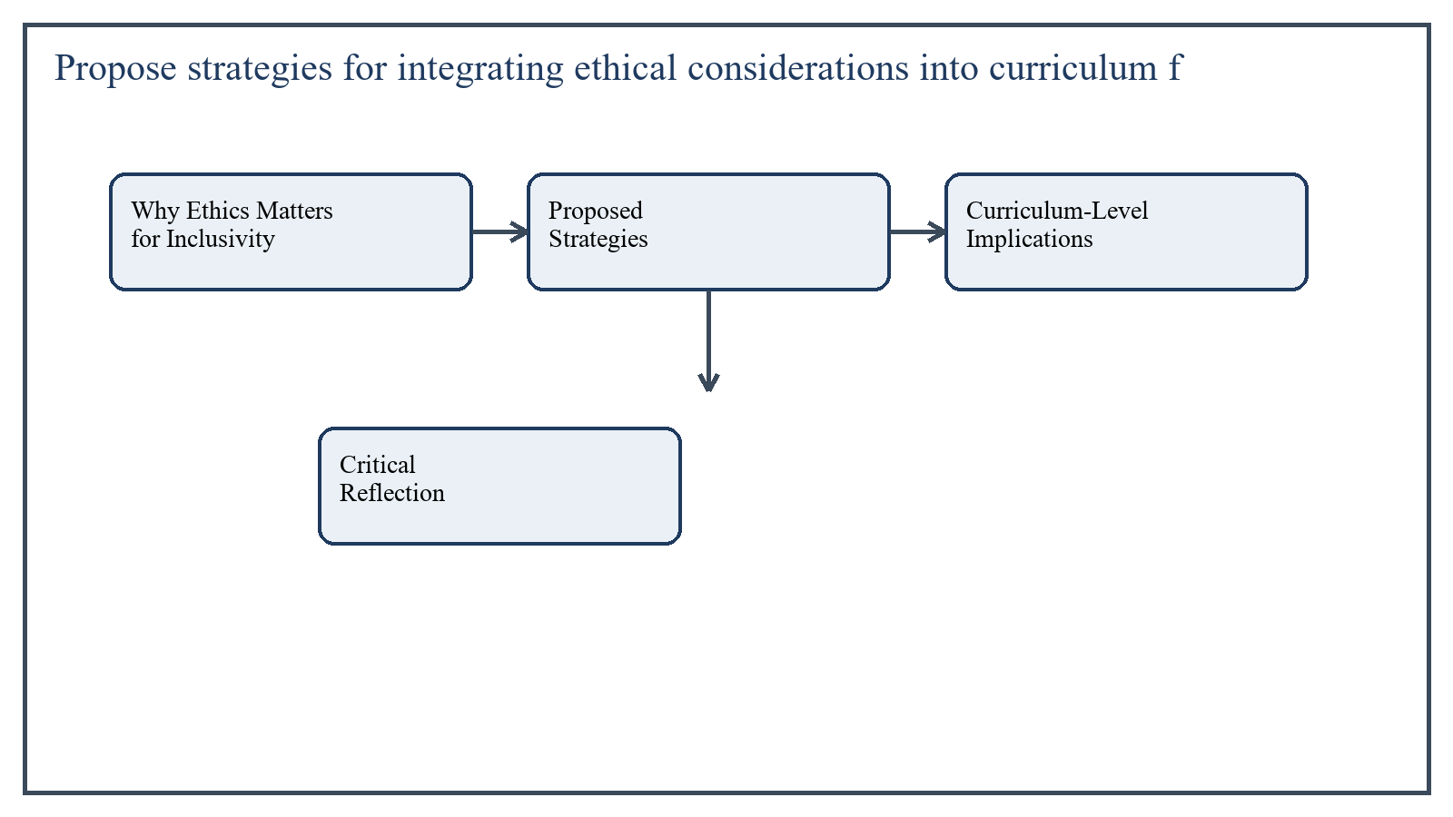
Figure 3: Concept map for Question 3

Why Ethics Matters for Inclusivity
An inclusive curriculum respects human dignity, fairness, diversity, and equal opportunity. Ethical grounding ensures that curriculum does not merely prepare students for exams but also develops socially responsible and morally aware citizens.
In the context of Curriculum Development, the theme of why ethics matters for inclusivity deserves extended attention because assignment-level understanding is expected to move beyond one-line definitions and into explanation, comparison, and application. A strong university answer shows not only what the concept means, but also why it matters, how it appears in practice, and what limitations or challenges may arise when it is implemented in real educational settings.
A mature academic response also connects why ethics matters for inclusivity with classroom realities, institutional culture, and the Pakistani context wherever relevant. This makes the answer more analytical and more useful because it links conceptual understanding with the needs of teachers, learners, administrators, and communities rather than leaving the idea at a purely theoretical level.
From an examination and assignment-writing perspective, the topic of why ethics matters for inclusivity should be handled through clear structure, careful terminology, valid examples, and balanced discussion. The strongest responses usually define the idea, explain its major components, illustrate it through educational examples, and then conclude with a reasoned judgment about its significance, usefulness, or limitations.

Proposed Strategies
- Include dignity, equity, justice, and respect for diversity as explicit curriculum values rather than hidden assumptions.
- Review curriculum content to remove stereotypes related to gender, disability, language, class, region, or religion.
- Ensure that examples, stories, case studies, and historical narratives represent diverse communities fairly.
- Integrate ethical inquiry across subjects so that students examine fairness, responsibility, rights, and consequences in real-life contexts.
- Adopt learner-centered pedagogies that allow voice, participation, and respectful disagreement.
- Provide accommodations and differentiated pathways so that inclusion applies to actual learning access, not only to slogans.
- Train teachers to recognize bias, use respectful language, and create inclusive classroom climates.
In the context of Curriculum Development, the theme of proposed strategies deserves extended attention because assignment-level understanding is expected to move beyond one-line definitions and into explanation, comparison, and application. A strong university answer shows not only what the concept means, but also why it matters, how it appears in practice, and what limitations or challenges may arise when it is implemented in real educational settings.
A mature academic response also connects proposed strategies with classroom realities, institutional culture, and the Pakistani context wherever relevant. This makes the answer more analytical and more useful because it links conceptual understanding with the needs of teachers, learners, administrators, and communities rather than leaving the idea at a purely theoretical level.
From an examination and assignment-writing perspective, the topic of proposed strategies should be handled through clear structure, careful terminology, valid examples, and balanced discussion. The strongest responses usually define the idea, explain its major components, illustrate it through educational examples, and then conclude with a reasoned judgment about its significance, usefulness, or limitations.

Curriculum-Level Implications
At the foundation level, ethical considerations should influence goals, content, pedagogy, and evaluation. Goals should include empathy, social responsibility, and democratic participation. Content should include diverse voices. Pedagogy should avoid humiliation and exclusion. Evaluation should be fair and should not privilege one type of learner unjustly.
In the context of Curriculum Development, the theme of curriculum-level implications deserves extended attention because assignment-level understanding is expected to move beyond one-line definitions and into explanation, comparison, and application. A strong university answer shows not only what the concept means, but also why it matters, how it appears in practice, and what limitations or challenges may arise when it is implemented in real educational settings.
A mature academic response also connects curriculum-level implications with classroom realities, institutional culture, and the Pakistani context wherever relevant. This makes the answer more analytical and more useful because it links conceptual understanding with the needs of teachers, learners, administrators, and communities rather than leaving the idea at a purely theoretical level.
From an examination and assignment-writing perspective, the topic of curriculum-level implications should be handled through clear structure, careful terminology, valid examples, and balanced discussion. The strongest responses usually define the idea, explain its major components, illustrate it through educational examples, and then conclude with a reasoned judgment about its significance, usefulness, or limitations.

Critical Reflection
Inclusivity requires more than adding one chapter on tolerance. If the wider curriculum still marginalizes certain learners or cultures, the ethical message becomes contradictory. Therefore, ethical integration must be systemic and not merely symbolic.
In the context of Curriculum Development, the theme of critical reflection deserves extended attention because assignment-level understanding is expected to move beyond one-line definitions and into explanation, comparison, and application. A strong university answer shows not only what the concept means, but also why it matters, how it appears in practice, and what limitations or challenges may arise when it is implemented in real educational settings.
A mature academic response also connects critical reflection with classroom realities, institutional culture, and the Pakistani context wherever relevant. This makes the answer more analytical and more useful because it links conceptual understanding with the needs of teachers, learners, administrators, and communities rather than leaving the idea at a purely theoretical level.
From an examination and assignment-writing perspective, the topic of critical reflection should be handled through clear structure, careful terminology, valid examples, and balanced discussion. The strongest responses usually define the idea, explain its major components, illustrate it through educational examples, and then conclude with a reasoned judgment about its significance, usefulness, or limitations.

Applied Illustration and Academic Note
For a stronger B.Ed assignment response, the topic above should be linked with classroom life, institutional practice, and the needs of Pakistani learners. This approach makes the response more analytical and demonstrates that the writer understands both theory and application, which is usually appreciated in AIOU-style academic work.
A good response also avoids unsupported claims. Instead, it explains concepts carefully, gives relevant examples, and ends with a short judgment about educational significance. In this way, the answer to 'Propose strategies for integrating ethical considerations into curricu...' becomes easier to read, easier to assess, and more academically convincing.

Quick Review Table
Focus Area | Assignment Relevance
Why Ethics Matters for Inclusivity | This area helps answer the question on 'Propose strategies for integrating ethical consideratio...' by providing concept clarity, explanation, and applied educational value.
Proposed Strategies | This area helps answer the question on 'Propose strategies for integrating ethical consideratio...' by providing concept clarity, explanation, and applied educational value.
Curriculum-Level Implications | This area helps answer the question on 'Propose strategies for integrating ethical consideratio...' by providing concept clarity, explanation, and applied educational value.
Critical Reflection | This area helps answer the question on 'Propose strategies for integrating ethical consideratio...' by providing concept clarity, explanation, and applied educational value.

Critical Reflection
At an advanced level, the topic should not be treated as a fixed formula. Most educational concepts work within particular conditions, and their success often depends on planning quality, learner background, institutional support, and the competence of the teacher or manager using them. A reflective assignment therefore acknowledges strengths while also recognizing practical limitations.

Conclusion
Ethical considerations can be integrated into curriculum foundations by making equity and human dignity explicit, removing biased content, broadening representation, supporting inclusive pedagogy, and training teachers for fair practice. Such strategies promote inclusivity by ensuring that curriculum serves all learners respectfully rather than reproducing existing exclusion.

Q.4 Examine the challenges of aligning curriculum frameworks with international educational standards.
Answer: The answer below is organized in an academic assignment style, with conceptual explanation, applied discussion, and concise analytical closing comments designed for a neat and extended university submission.
Aligning curriculum frameworks with international educational standards can improve quality, comparability, and future readiness. However, the process is not straightforward. International standards often emerge from global expectations, while national curricula must remain responsive to local realities, cultural priorities, language conditions, and resource levels.
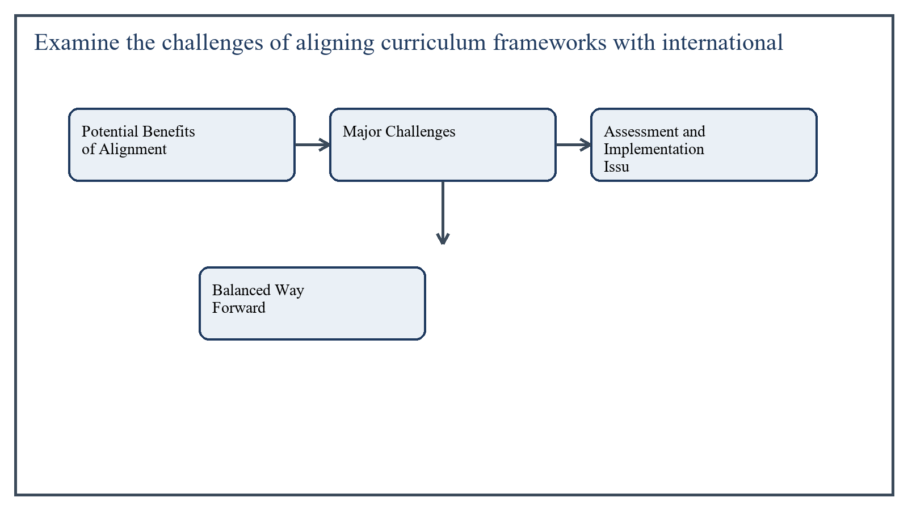
Figure 4: Concept map for Question 4

Potential Benefits of Alignment
International alignment can strengthen curriculum quality by encouraging competency-based learning, critical thinking, measurable outcomes, and benchmarking with wider educational practice. It may also help students compete in a global knowledge economy.
In the context of Curriculum Development, the theme of potential benefits of alignment deserves extended attention because assignment-level understanding is expected to move beyond one-line definitions and into explanation, comparison, and application. A strong university answer shows not only what the concept means, but also why it matters, how it appears in practice, and what limitations or challenges may arise when it is implemented in real educational settings.
A mature academic response also connects potential benefits of alignment with classroom realities, institutional culture, and the Pakistani context wherever relevant. This makes the answer more analytical and more useful because it links conceptual understanding with the needs of teachers, learners, administrators, and communities rather than leaving the idea at a purely theoretical level.
From an examination and assignment-writing perspective, the topic of potential benefits of alignment should be handled through clear structure, careful terminology, valid examples, and balanced discussion. The strongest responses usually define the idea, explain its major components, illustrate it through educational examples, and then conclude with a reasoned judgment about its significance, usefulness, or limitations.

Major Challenges
One major challenge is contextual mismatch. A standard designed for highly resourced systems may assume technology access, small classes, abundant materials, and strong teacher preparation. In many local settings, these conditions do not exist.
Another challenge is curriculum overload. When international expectations are added without reducing existing content, the result can be crowded curricula that are unrealistic for teachers and students.
- Tension between global expectations and local culture or national identity.
- Language barriers when standards are translated into classroom practice.
- Resource limitations that make ambitious standards difficult to implement.
- Teacher capacity gaps in using new pedagogies and assessment approaches.
- Risk of policy borrowing without contextual adaptation.
In the context of Curriculum Development, the theme of major challenges deserves extended attention because assignment-level understanding is expected to move beyond one-line definitions and into explanation, comparison, and application. A strong university answer shows not only what the concept means, but also why it matters, how it appears in practice, and what limitations or challenges may arise when it is implemented in real educational settings.
A mature academic response also connects major challenges with classroom realities, institutional culture, and the Pakistani context wherever relevant. This makes the answer more analytical and more useful because it links conceptual understanding with the needs of teachers, learners, administrators, and communities rather than leaving the idea at a purely theoretical level.
From an examination and assignment-writing perspective, the topic of major challenges should be handled through clear structure, careful terminology, valid examples, and balanced discussion. The strongest responses usually define the idea, explain its major components, illustrate it through educational examples, and then conclude with a reasoned judgment about its significance, usefulness, or limitations.

Assessment and Implementation Issues
Even when curriculum frameworks are updated, examination systems often remain traditional. This creates misalignment between written standards and actual classroom incentives. Teachers may continue teaching for recall-based exams even while curriculum documents emphasize inquiry and analysis.
Implementation also requires phased training, textbook reform, classroom support, and monitoring. Without these, alignment stays on paper.
In the context of Curriculum Development, the theme of assessment and implementation issues deserves extended attention because assignment-level understanding is expected to move beyond one-line definitions and into explanation, comparison, and application. A strong university answer shows not only what the concept means, but also why it matters, how it appears in practice, and what limitations or challenges may arise when it is implemented in real educational settings.
A mature academic response also connects assessment and implementation issues with classroom realities, institutional culture, and the Pakistani context wherever relevant. This makes the answer more analytical and more useful because it links conceptual understanding with the needs of teachers, learners, administrators, and communities rather than leaving the idea at a purely theoretical level.
From an examination and assignment-writing perspective, the topic of assessment and implementation issues should be handled through clear structure, careful terminology, valid examples, and balanced discussion. The strongest responses usually define the idea, explain its major components, illustrate it through educational examples, and then conclude with a reasoned judgment about its significance, usefulness, or limitations.

Balanced Way Forward
The goal should not be blind imitation of international models. Instead, curriculum developers should engage in intelligent adaptation. International standards can serve as reference points, but they must be filtered through local needs, national priorities, cultural context, and realistic implementation planning.
In the context of Curriculum Development, the theme of balanced way forward deserves extended attention because assignment-level understanding is expected to move beyond one-line definitions and into explanation, comparison, and application. A strong university answer shows not only what the concept means, but also why it matters, how it appears in practice, and what limitations or challenges may arise when it is implemented in real educational settings.
A mature academic response also connects balanced way forward with classroom realities, institutional culture, and the Pakistani context wherever relevant. This makes the answer more analytical and more useful because it links conceptual understanding with the needs of teachers, learners, administrators, and communities rather than leaving the idea at a purely theoretical level.
From an examination and assignment-writing perspective, the topic of balanced way forward should be handled through clear structure, careful terminology, valid examples, and balanced discussion. The strongest responses usually define the idea, explain its major components, illustrate it through educational examples, and then conclude with a reasoned judgment about its significance, usefulness, or limitations.

Applied Illustration and Academic Note
For a stronger B.Ed assignment response, the topic above should be linked with classroom life, institutional practice, and the needs of Pakistani learners. This approach makes the response more analytical and demonstrates that the writer understands both theory and application, which is usually appreciated in AIOU-style academic work.
A good response also avoids unsupported claims. Instead, it explains concepts carefully, gives relevant examples, and ends with a short judgment about educational significance. In this way, the answer to 'Examine the challenges of aligning curriculum frameworks with internat...' becomes easier to read, easier to assess, and more academically convincing.

Quick Review Table
Focus Area | Assignment Relevance
Potential Benefits of Alignment | This area helps answer the question on 'Examine the challenges of aligning curriculum framework...' by providing concept clarity, explanation, and applied educational value.
Major Challenges | This area helps answer the question on 'Examine the challenges of aligning curriculum framework...' by providing concept clarity, explanation, and applied educational value.
Assessment and Implementation Issues | This area helps answer the question on 'Examine the challenges of aligning curriculum framework...' by providing concept clarity, explanation, and applied educational value.
Balanced Way Forward | This area helps answer the question on 'Examine the challenges of aligning curriculum framework...' by providing concept clarity, explanation, and applied educational value.

Critical Reflection
At an advanced level, the topic should not be treated as a fixed formula. Most educational concepts work within particular conditions, and their success often depends on planning quality, learner background, institutional support, and the competence of the teacher or manager using them. A reflective assignment therefore acknowledges strengths while also recognizing practical limitations.

Conclusion
Aligning curriculum frameworks with international standards offers important opportunities but also serious challenges. The key difficulties involve contextual mismatch, resource constraints, teacher readiness, and exam misalignment. Successful alignment requires adaptation, not imitation, so that global quality and local relevance can work together.

Q.5 Critically examine the aims of education in Pakistan in relation to national development priorities.
Answer: The answer below is organized in an academic assignment style, with conceptual explanation, applied discussion, and concise analytical closing comments designed for a neat and extended university submission.
The aims of education in Pakistan are closely connected with national development because education is expected to shape citizens, strengthen identity, improve productivity, and support social progress. A critical examination must therefore ask not only what the aims are, but also how well they match contemporary development priorities.
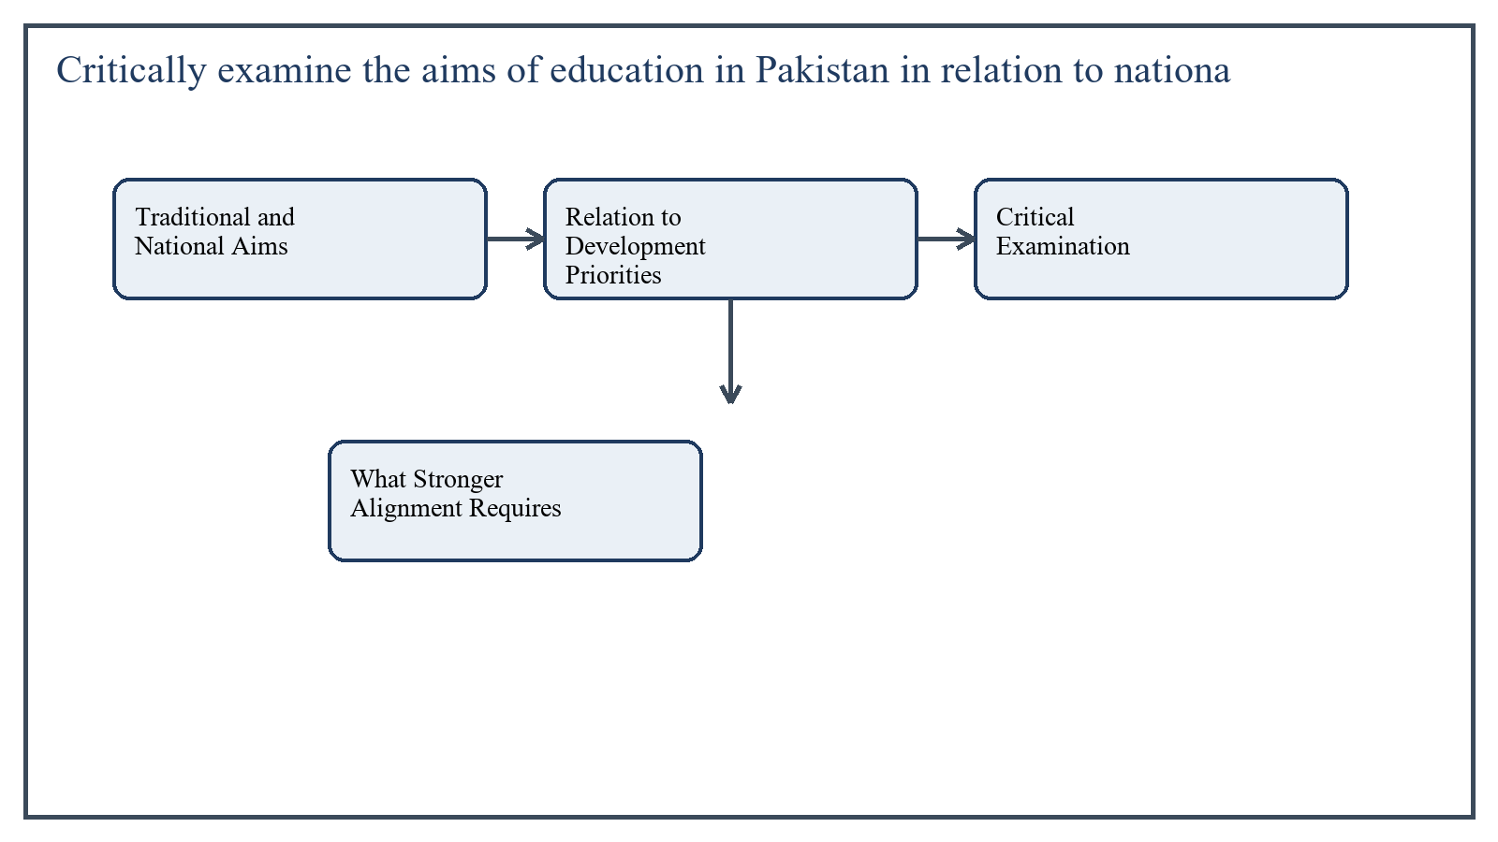
Figure 5: Concept map for Question 5

Traditional and National Aims
Historically, educational aims in Pakistan have included moral development, Islamic values, national integration, citizenship, character formation, and social responsibility. These aims reflect the desire to preserve identity, promote cohesion, and build disciplined citizens.
In the context of Curriculum Development, the theme of traditional and national aims deserves extended attention because assignment-level understanding is expected to move beyond one-line definitions and into explanation, comparison, and application. A strong university answer shows not only what the concept means, but also why it matters, how it appears in practice, and what limitations or challenges may arise when it is implemented in real educational settings.
A mature academic response also connects traditional and national aims with classroom realities, institutional culture, and the Pakistani context wherever relevant. This makes the answer more analytical and more useful because it links conceptual understanding with the needs of teachers, learners, administrators, and communities rather than leaving the idea at a purely theoretical level.
From an examination and assignment-writing perspective, the topic of traditional and national aims should be handled through clear structure, careful terminology, valid examples, and balanced discussion. The strongest responses usually define the idea, explain its major components, illustrate it through educational examples, and then conclude with a reasoned judgment about its significance, usefulness, or limitations.

Relation to Development Priorities
Modern national development priorities require additional emphasis on literacy, employability, scientific thinking, problem-solving, digital competence, social inclusion, and economic productivity. Education must therefore prepare learners not only to be morally grounded but also to contribute meaningfully to social and economic development.
This means curriculum should support human capital development, innovation, health awareness, environmental responsibility, and democratic participation alongside cultural and moral aims.
In the context of Curriculum Development, the theme of relation to development priorities deserves extended attention because assignment-level understanding is expected to move beyond one-line definitions and into explanation, comparison, and application. A strong university answer shows not only what the concept means, but also why it matters, how it appears in practice, and what limitations or challenges may arise when it is implemented in real educational settings.
A mature academic response also connects relation to development priorities with classroom realities, institutional culture, and the Pakistani context wherever relevant. This makes the answer more analytical and more useful because it links conceptual understanding with the needs of teachers, learners, administrators, and communities rather than leaving the idea at a purely theoretical level.
From an examination and assignment-writing perspective, the topic of relation to development priorities should be handled through clear structure, careful terminology, valid examples, and balanced discussion. The strongest responses usually define the idea, explain its major components, illustrate it through educational examples, and then conclude with a reasoned judgment about its significance, usefulness, or limitations.

Critical Examination
A critical issue is imbalance. At times, educational discourse may state broad national aims, but curriculum and assessment practices may still reward memorization more than creativity, skill, or problem-solving. This weakens alignment with development needs.
Another concern is uneven access. If education is a vehicle for national development, then quality gaps across rural and urban areas, gender disparities, and differences between school systems reduce the ability of education to serve the whole nation fairly.
In the context of Curriculum Development, the theme of critical examination deserves extended attention because assignment-level understanding is expected to move beyond one-line definitions and into explanation, comparison, and application. A strong university answer shows not only what the concept means, but also why it matters, how it appears in practice, and what limitations or challenges may arise when it is implemented in real educational settings.
A mature academic response also connects critical examination with classroom realities, institutional culture, and the Pakistani context wherever relevant. This makes the answer more analytical and more useful because it links conceptual understanding with the needs of teachers, learners, administrators, and communities rather than leaving the idea at a purely theoretical level.
From an examination and assignment-writing perspective, the topic of critical examination should be handled through clear structure, careful terminology, valid examples, and balanced discussion. The strongest responses usually define the idea, explain its major components, illustrate it through educational examples, and then conclude with a reasoned judgment about its significance, usefulness, or limitations.

What Stronger Alignment Requires
- Greater focus on foundational literacy and numeracy.
- Integration of technical, digital, and life skills.
- Promotion of critical thinking and responsible citizenship.
- Better teacher preparation and curriculum implementation.
- Alignment between educational aims, textbooks, classroom methods, and examinations.
In the context of Curriculum Development, the theme of what stronger alignment requires deserves extended attention because assignment-level understanding is expected to move beyond one-line definitions and into explanation, comparison, and application. A strong university answer shows not only what the concept means, but also why it matters, how it appears in practice, and what limitations or challenges may arise when it is implemented in real educational settings.
A mature academic response also connects what stronger alignment requires with classroom realities, institutional culture, and the Pakistani context wherever relevant. This makes the answer more analytical and more useful because it links conceptual understanding with the needs of teachers, learners, administrators, and communities rather than leaving the idea at a purely theoretical level.
From an examination and assignment-writing perspective, the topic of what stronger alignment requires should be handled through clear structure, careful terminology, valid examples, and balanced discussion. The strongest responses usually define the idea, explain its major components, illustrate it through educational examples, and then conclude with a reasoned judgment about its significance, usefulness, or limitations.

Applied Illustration and Academic Note
For a stronger B.Ed assignment response, the topic above should be linked with classroom life, institutional practice, and the needs of Pakistani learners. This approach makes the response more analytical and demonstrates that the writer understands both theory and application, which is usually appreciated in AIOU-style academic work.
A good response also avoids unsupported claims. Instead, it explains concepts carefully, gives relevant examples, and ends with a short judgment about educational significance. In this way, the answer to 'Critically examine the aims of education in Pakistan in relation to na...' becomes easier to read, easier to assess, and more academically convincing.

Quick Review Table
Focus Area | Assignment Relevance
Traditional and National Aims | This area helps answer the question on 'Critically examine the aims of education in Pakistan in...' by providing concept clarity, explanation, and applied educational value.
Relation to Development Priorities | This area helps answer the question on 'Critically examine the aims of education in Pakistan in...' by providing concept clarity, explanation, and applied educational value.
Critical Examination | This area helps answer the question on 'Critically examine the aims of education in Pakistan in...' by providing concept clarity, explanation, and applied educational value.
What Stronger Alignment Requires | This area helps answer the question on 'Critically examine the aims of education in Pakistan in...' by providing concept clarity, explanation, and applied educational value.

Critical Reflection
At an advanced level, the topic should not be treated as a fixed formula. Most educational concepts work within particular conditions, and their success often depends on planning quality, learner background, institutional support, and the competence of the teacher or manager using them. A reflective assignment therefore acknowledges strengths while also recognizing practical limitations.

Conclusion
The aims of education in Pakistan remain deeply connected with national development priorities, especially in areas of identity, citizenship, and social responsibility. However, contemporary development also demands stronger emphasis on skills, innovation, inclusion, and employability. A critical view therefore suggests that educational aims must be interpreted dynamically so that national values and modern development needs reinforce rather than compete with one another.

Extended Revision Appendix
This appendix is included to strengthen the assignment as a premium academic submission. It provides recap notes, revision prompts, and concept reinforcement so the document reads like a complete study-ready submission rather than a short-answer sheet only.

Key Revision Points
- Review the central demand of the question 'Critically assess how culture and societal values influence th...' and connect definition, explanation, example, and critical comment in one organized response.
- Review the central demand of the question 'Assess the contribution of the 2006 Curriculum Reform in impro...' and connect definition, explanation, example, and critical comment in one organized response.
- Review the central demand of the question 'Propose strategies for integrating ethical considerations into...' and connect definition, explanation, example, and critical comment in one organized response.
- Review the central demand of the question 'Examine the challenges of aligning curriculum frameworks with ...' and connect definition, explanation, example, and critical comment in one organized response.
- Review the central demand of the question 'Critically examine the aims of education in Pakistan in relati...' and connect definition, explanation, example, and critical comment in one organized response.

Academic Writing Reminders
- Begin each major answer with a clear conceptual opening.
- Use examples to show understanding instead of repeating definitions only.
- Present advantages, limitations, and contextual realities where relevant.
- Close each answer with a short evaluative conclusion.
- Maintain formal and neat language throughout the assignment.

Concept Reinforcement Notes
The question on 'Critically assess how culture and societal values influence the development...' can be revised further by identifying three things: the main concept involved, the educational importance of that concept, and one example from Pakistani classroom or institutional life. This simple method helps transform memorized content into organized written response.
The question on 'Assess the contribution of the 2006 Curriculum Reform in improving subject-...' can be revised further by identifying three things: the main concept involved, the educational importance of that concept, and one example from Pakistani classroom or institutional life. This simple method helps transform memorized content into organized written response.
The question on 'Propose strategies for integrating ethical considerations into curriculum f...' can be revised further by identifying three things: the main concept involved, the educational importance of that concept, and one example from Pakistani classroom or institutional life. This simple method helps transform memorized content into organized written response.
The question on 'Examine the challenges of aligning curriculum frameworks with international...' can be revised further by identifying three things: the main concept involved, the educational importance of that concept, and one example from Pakistani classroom or institutional life. This simple method helps transform memorized content into organized written response.
The question on 'Critically examine the aims of education in Pakistan in relation to nationa...' can be revised further by identifying three things: the main concept involved, the educational importance of that concept, and one example from Pakistani classroom or institutional life. This simple method helps transform memorized content into organized written response.

Source Base and Assignment Support Notes
The following source base was used to keep the answers aligned with AIOU course structure and the exact question wording. The final language and organization were expanded for presentation quality, page-length target, and assignment readability.
- AIOU Soft Book: Curriculum Development (Code 8603) and related AIOU curriculum text 'Curriculum & Instructions' (Code 6406) used for conceptual grounding on curriculum foundations, content selection, social and cultural influences, and curriculum change.
- AIOU Spring 2026 assignment sheet for Course 8603.

Extended Analytical Note 1
In extended study of Curriculum Development, the issue raised in 'Critically assess how culture and societal values influence the developm...' may also be explored through definition, theoretical explanation, applied example, classroom implication, institutional implication, and critical reflection. This six-part approach helps a learner produce a more complete answer and also improves the academic appearance of the assignment by showing structure and depth.
Another useful strategy in long-form assignment writing is to move carefully from concept to context. First explain what the idea means, then identify its components, then discuss its relevance in teaching or administration, and finally mention any practical limitation. Such movement gives maturity to the answer and helps the examiner follow the logic without difficulty.
In extended study of Curriculum Development, the issue raised in 'Assess the contribution of the 2006 Curriculum Reform in improving subje...' may also be explored through definition, theoretical explanation, applied example, classroom implication, institutional implication, and critical reflection. This six-part approach helps a learner produce a more complete answer and also improves the academic appearance of the assignment by showing structure and depth.
Another useful strategy in long-form assignment writing is to move carefully from concept to context. First explain what the idea means, then identify its components, then discuss its relevance in teaching or administration, and finally mention any practical limitation. Such movement gives maturity to the answer and helps the examiner follow the logic without difficulty.
In extended study of Curriculum Development, the issue raised in 'Propose strategies for integrating ethical considerations into curriculu...' may also be explored through definition, theoretical explanation, applied example, classroom implication, institutional implication, and critical reflection. This six-part approach helps a learner produce a more complete answer and also improves the academic appearance of the assignment by showing structure and depth.
Another useful strategy in long-form assignment writing is to move carefully from concept to context. First explain what the idea means, then identify its components, then discuss its relevance in teaching or administration, and finally mention any practical limitation. Such movement gives maturity to the answer and helps the examiner follow the logic without difficulty.
In extended study of Curriculum Development, the issue raised in 'Examine the challenges of aligning curriculum frameworks with internatio...' may also be explored through definition, theoretical explanation, applied example, classroom implication, institutional implication, and critical reflection. This six-part approach helps a learner produce a more complete answer and also improves the academic appearance of the assignment by showing structure and depth.
Another useful strategy in long-form assignment writing is to move carefully from concept to context. First explain what the idea means, then identify its components, then discuss its relevance in teaching or administration, and finally mention any practical limitation. Such movement gives maturity to the answer and helps the examiner follow the logic without difficulty.
In extended study of Curriculum Development, the issue raised in 'Critically examine the aims of education in Pakistan in relation to nati...' may also be explored through definition, theoretical explanation, applied example, classroom implication, institutional implication, and critical reflection. This six-part approach helps a learner produce a more complete answer and also improves the academic appearance of the assignment by showing structure and depth.
Another useful strategy in long-form assignment writing is to move carefully from concept to context. First explain what the idea means, then identify its components, then discuss its relevance in teaching or administration, and finally mention any practical limitation. Such movement gives maturity to the answer and helps the examiner follow the logic without difficulty.

Extended Analytical Note 2
In extended study of Curriculum Development, the issue raised in 'Critically assess how culture and societal values influence the developm...' may also be explored through definition, theoretical explanation, applied example, classroom implication, institutional implication, and critical reflection. This six-part approach helps a learner produce a more complete answer and also improves the academic appearance of the assignment by showing structure and depth.
Another useful strategy in long-form assignment writing is to move carefully from concept to context. First explain what the idea means, then identify its components, then discuss its relevance in teaching or administration, and finally mention any practical limitation. Such movement gives maturity to the answer and helps the examiner follow the logic without difficulty.
In extended study of Curriculum Development, the issue raised in 'Assess the contribution of the 2006 Curriculum Reform in improving subje...' may also be explored through definition, theoretical explanation, applied example, classroom implication, institutional implication, and critical reflection. This six-part approach helps a learner produce a more complete answer and also improves the academic appearance of the assignment by showing structure and depth.
Another useful strategy in long-form assignment writing is to move carefully from concept to context. First explain what the idea means, then identify its components, then discuss its relevance in teaching or administration, and finally mention any practical limitation. Such movement gives maturity to the answer and helps the examiner follow the logic without difficulty.
In extended study of Curriculum Development, the issue raised in 'Propose strategies for integrating ethical considerations into curriculu...' may also be explored through definition, theoretical explanation, applied example, classroom implication, institutional implication, and critical reflection. This six-part approach helps a learner produce a more complete answer and also improves the academic appearance of the assignment by showing structure and depth.
Another useful strategy in long-form assignment writing is to move carefully from concept to context. First explain what the idea means, then identify its components, then discuss its relevance in teaching or administration, and finally mention any practical limitation. Such movement gives maturity to the answer and helps the examiner follow the logic without difficulty.
In extended study of Curriculum Development, the issue raised in 'Examine the challenges of aligning curriculum frameworks with internatio...' may also be explored through definition, theoretical explanation, applied example, classroom implication, institutional implication, and critical reflection. This six-part approach helps a learner produce a more complete answer and also improves the academic appearance of the assignment by showing structure and depth.
Another useful strategy in long-form assignment writing is to move carefully from concept to context. First explain what the idea means, then identify its components, then discuss its relevance in teaching or administration, and finally mention any practical limitation. Such movement gives maturity to the answer and helps the examiner follow the logic without difficulty.
In extended study of Curriculum Development, the issue raised in 'Critically examine the aims of education in Pakistan in relation to nati...' may also be explored through definition, theoretical explanation, applied example, classroom implication, institutional implication, and critical reflection. This six-part approach helps a learner produce a more complete answer and also improves the academic appearance of the assignment by showing structure and depth.
Another useful strategy in long-form assignment writing is to move carefully from concept to context. First explain what the idea means, then identify its components, then discuss its relevance in teaching or administration, and finally mention any practical limitation. Such movement gives maturity to the answer and helps the examiner follow the logic without difficulty.

Extended Analytical Note 3
In extended study of Curriculum Development, the issue raised in 'Critically assess how culture and societal values influence the developm...' may also be explored through definition, theoretical explanation, applied example, classroom implication, institutional implication, and critical reflection. This six-part approach helps a learner produce a more complete answer and also improves the academic appearance of the assignment by showing structure and depth.
Another useful strategy in long-form assignment writing is to move carefully from concept to context. First explain what the idea means, then identify its components, then discuss its relevance in teaching or administration, and finally mention any practical limitation. Such movement gives maturity to the answer and helps the examiner follow the logic without difficulty.
In extended study of Curriculum Development, the issue raised in 'Assess the contribution of the 2006 Curriculum Reform in improving subje...' may also be explored through definition, theoretical explanation, applied example, classroom implication, institutional implication, and critical reflection. This six-part approach helps a learner produce a more complete answer and also improves the academic appearance of the assignment by showing structure and depth.
Another useful strategy in long-form assignment writing is to move carefully from concept to context. First explain what the idea means, then identify its components, then discuss its relevance in teaching or administration, and finally mention any practical limitation. Such movement gives maturity to the answer and helps the examiner follow the logic without difficulty.
In extended study of Curriculum Development, the issue raised in 'Propose strategies for integrating ethical considerations into curriculu...' may also be explored through definition, theoretical explanation, applied example, classroom implication, institutional implication, and critical reflection. This six-part approach helps a learner produce a more complete answer and also improves the academic appearance of the assignment by showing structure and depth.
Another useful strategy in long-form assignment writing is to move carefully from concept to context. First explain what the idea means, then identify its components, then discuss its relevance in teaching or administration, and finally mention any practical limitation. Such movement gives maturity to the answer and helps the examiner follow the logic without difficulty.
In extended study of Curriculum Development, the issue raised in 'Examine the challenges of aligning curriculum frameworks with internatio...' may also be explored through definition, theoretical explanation, applied example, classroom implication, institutional implication, and critical reflection. This six-part approach helps a learner produce a more complete answer and also improves the academic appearance of the assignment by showing structure and depth.
Another useful strategy in long-form assignment writing is to move carefully from concept to context. First explain what the idea means, then identify its components, then discuss its relevance in teaching or administration, and finally mention any practical limitation. Such movement gives maturity to the answer and helps the examiner follow the logic without difficulty.
In extended study of Curriculum Development, the issue raised in 'Critically examine the aims of education in Pakistan in relation to nati...' may also be explored through definition, theoretical explanation, applied example, classroom implication, institutional implication, and critical reflection. This six-part approach helps a learner produce a more complete answer and also improves the academic appearance of the assignment by showing structure and depth.
Another useful strategy in long-form assignment writing is to move carefully from concept to context. First explain what the idea means, then identify its components, then discuss its relevance in teaching or administration, and finally mention any practical limitation. Such movement gives maturity to the answer and helps the examiner follow the logic without difficulty.

Extended Analytical Note 4
In extended study of Curriculum Development, the issue raised in 'Critically assess how culture and societal values influence the developm...' may also be explored through definition, theoretical explanation, applied example, classroom implication, institutional implication, and critical reflection. This six-part approach helps a learner produce a more complete answer and also improves the academic appearance of the assignment by showing structure and depth.
Another useful strategy in long-form assignment writing is to move carefully from concept to context. First explain what the idea means, then identify its components, then discuss its relevance in teaching or administration, and finally mention any practical limitation. Such movement gives maturity to the answer and helps the examiner follow the logic without difficulty.
In extended study of Curriculum Development, the issue raised in 'Assess the contribution of the 2006 Curriculum Reform in improving subje...' may also be explored through definition, theoretical explanation, applied example, classroom implication, institutional implication, and critical reflection. This six-part approach helps a learner produce a more complete answer and also improves the academic appearance of the assignment by showing structure and depth.
Another useful strategy in long-form assignment writing is to move carefully from concept to context. First explain what the idea means, then identify its components, then discuss its relevance in teaching or administration, and finally mention any practical limitation. Such movement gives maturity to the answer and helps the examiner follow the logic without difficulty.
In extended study of Curriculum Development, the issue raised in 'Propose strategies for integrating ethical considerations into curriculu...' may also be explored through definition, theoretical explanation, applied example, classroom implication, institutional implication, and critical reflection. This six-part approach helps a learner produce a more complete answer and also improves the academic appearance of the assignment by showing structure and depth.
Another useful strategy in long-form assignment writing is to move carefully from concept to context. First explain what the idea means, then identify its components, then discuss its relevance in teaching or administration, and finally mention any practical limitation. Such movement gives maturity to the answer and helps the examiner follow the logic without difficulty.
In extended study of Curriculum Development, the issue raised in 'Examine the challenges of aligning curriculum frameworks with internatio...' may also be explored through definition, theoretical explanation, applied example, classroom implication, institutional implication, and critical reflection. This six-part approach helps a learner produce a more complete answer and also improves the academic appearance of the assignment by showing structure and depth.
Another useful strategy in long-form assignment writing is to move carefully from concept to context. First explain what the idea means, then identify its components, then discuss its relevance in teaching or administration, and finally mention any practical limitation. Such movement gives maturity to the answer and helps the examiner follow the logic without difficulty.
In extended study of Curriculum Development, the issue raised in 'Critically examine the aims of education in Pakistan in relation to nati...' may also be explored through definition, theoretical explanation, applied example, classroom implication, institutional implication, and critical reflection. This six-part approach helps a learner produce a more complete answer and also improves the academic appearance of the assignment by showing structure and depth.
Another useful strategy in long-form assignment writing is to move carefully from concept to context. First explain what the idea means, then identify its components, then discuss its relevance in teaching or administration, and finally mention any practical limitation. Such movement gives maturity to the answer and helps the examiner follow the logic without difficulty.

Extended Analytical Note 5
In extended study of Curriculum Development, the issue raised in 'Critically assess how culture and societal values influence the developm...' may also be explored through definition, theoretical explanation, applied example, classroom implication, institutional implication, and critical reflection. This six-part approach helps a learner produce a more complete answer and also improves the academic appearance of the assignment by showing structure and depth.
Another useful strategy in long-form assignment writing is to move carefully from concept to context. First explain what the idea means, then identify its components, then discuss its relevance in teaching or administration, and finally mention any practical limitation. Such movement gives maturity to the answer and helps the examiner follow the logic without difficulty.
In extended study of Curriculum Development, the issue raised in 'Assess the contribution of the 2006 Curriculum Reform in improving subje...' may also be explored through definition, theoretical explanation, applied example, classroom implication, institutional implication, and critical reflection. This six-part approach helps a learner produce a more complete answer and also improves the academic appearance of the assignment by showing structure and depth.
Another useful strategy in long-form assignment writing is to move carefully from concept to context. First explain what the idea means, then identify its components, then discuss its relevance in teaching or administration, and finally mention any practical limitation. Such movement gives maturity to the answer and helps the examiner follow the logic without difficulty.
In extended study of Curriculum Development, the issue raised in 'Propose strategies for integrating ethical considerations into curriculu...' may also be explored through definition, theoretical explanation, applied example, classroom implication, institutional implication, and critical reflection. This six-part approach helps a learner produce a more complete answer and also improves the academic appearance of the assignment by showing structure and depth.
Another useful strategy in long-form assignment writing is to move carefully from concept to context. First explain what the idea means, then identify its components, then discuss its relevance in teaching or administration, and finally mention any practical limitation. Such movement gives maturity to the answer and helps the examiner follow the logic without difficulty.
In extended study of Curriculum Development, the issue raised in 'Examine the challenges of aligning curriculum frameworks with internatio...' may also be explored through definition, theoretical explanation, applied example, classroom implication, institutional implication, and critical reflection. This six-part approach helps a learner produce a more complete answer and also improves the academic appearance of the assignment by showing structure and depth.
Another useful strategy in long-form assignment writing is to move carefully from concept to context. First explain what the idea means, then identify its components, then discuss its relevance in teaching or administration, and finally mention any practical limitation. Such movement gives maturity to the answer and helps the examiner follow the logic without difficulty.
In extended study of Curriculum Development, the issue raised in 'Critically examine the aims of education in Pakistan in relation to nati...' may also be explored through definition, theoretical explanation, applied example, classroom implication, institutional implication, and critical reflection. This six-part approach helps a learner produce a more complete answer and also improves the academic appearance of the assignment by showing structure and depth.
Another useful strategy in long-form assignment writing is to move carefully from concept to context. First explain what the idea means, then identify its components, then discuss its relevance in teaching or administration, and finally mention any practical limitation. Such movement gives maturity to the answer and helps the examiner follow the logic without difficulty.

Extended Analytical Note 6
In extended study of Curriculum Development, the issue raised in 'Critically assess how culture and societal values influence the developm...' may also be explored through definition, theoretical explanation, applied example, classroom implication, institutional implication, and critical reflection. This six-part approach helps a learner produce a more complete answer and also improves the academic appearance of the assignment by showing structure and depth.
Another useful strategy in long-form assignment writing is to move carefully from concept to context. First explain what the idea means, then identify its components, then discuss its relevance in teaching or administration, and finally mention any practical limitation. Such movement gives maturity to the answer and helps the examiner follow the logic without difficulty.
In extended study of Curriculum Development, the issue raised in 'Assess the contribution of the 2006 Curriculum Reform in improving subje...' may also be explored through definition, theoretical explanation, applied example, classroom implication, institutional implication, and critical reflection. This six-part approach helps a learner produce a more complete answer and also improves the academic appearance of the assignment by showing structure and depth.
Another useful strategy in long-form assignment writing is to move carefully from concept to context. First explain what the idea means, then identify its components, then discuss its relevance in teaching or administration, and finally mention any practical limitation. Such movement gives maturity to the answer and helps the examiner follow the logic without difficulty.
In extended study of Curriculum Development, the issue raised in 'Propose strategies for integrating ethical considerations into curriculu...' may also be explored through definition, theoretical explanation, applied example, classroom implication, institutional implication, and critical reflection. This six-part approach helps a learner produce a more complete answer and also improves the academic appearance of the assignment by showing structure and depth.
Another useful strategy in long-form assignment writing is to move carefully from concept to context. First explain what the idea means, then identify its components, then discuss its relevance in teaching or administration, and finally mention any practical limitation. Such movement gives maturity to the answer and helps the examiner follow the logic without difficulty.
In extended study of Curriculum Development, the issue raised in 'Examine the challenges of aligning curriculum frameworks with internatio...' may also be explored through definition, theoretical explanation, applied example, classroom implication, institutional implication, and critical reflection. This six-part approach helps a learner produce a more complete answer and also improves the academic appearance of the assignment by showing structure and depth.
Another useful strategy in long-form assignment writing is to move carefully from concept to context. First explain what the idea means, then identify its components, then discuss its relevance in teaching or administration, and finally mention any practical limitation. Such movement gives maturity to the answer and helps the examiner follow the logic without difficulty.
In extended study of Curriculum Development, the issue raised in 'Critically examine the aims of education in Pakistan in relation to nati...' may also be explored through definition, theoretical explanation, applied example, classroom implication, institutional implication, and critical reflection. This six-part approach helps a learner produce a more complete answer and also improves the academic appearance of the assignment by showing structure and depth.
Another useful strategy in long-form assignment writing is to move carefully from concept to context. First explain what the idea means, then identify its components, then discuss its relevance in teaching or administration, and finally mention any practical limitation. Such movement gives maturity to the answer and helps the examiner follow the logic without difficulty.

