ALLAMA IQBAL OPEN UNIVERSITY
Premium Typed Assignment
Curriculum Development
Detail | Course Code: 8603
Detail | Assignment No: 2
Detail | Unit Coverage: All Questions Carry Equal Marks
Detail | Program Level: B.Ed 1.5/2.5
Detail | Formatting Profile: Times New Roman, 14 pt headings, 12 pt body text
Detail | Document Goal: Extended academic response with diagrams, border styling, and premium presentation

Presentation Note
This file has been prepared as a premium typed assignment with extended academic treatment, proper page border styling, inserted diagrams, formal headings, and neat section hierarchy. The content is intentionally expanded so that the assignment remains easy to read while still meeting a high page-length target.

Q.1 Evaluate the application of Bloom's Taxonomy in setting curriculum goals and suggest alternative approaches for diverse learners.
Answer: The answer below is organized in an academic assignment style, with conceptual explanation, applied discussion, and concise analytical closing comments designed for a neat and extended university submission.
Bloom's Taxonomy is widely used in curriculum development because it helps planners express educational goals in clear cognitive terms. It moves curriculum thinking beyond vague intentions and supports sequencing from simple to complex learning. At the same time, exclusive dependence on Bloom's framework may not fully address the needs of diverse learners.
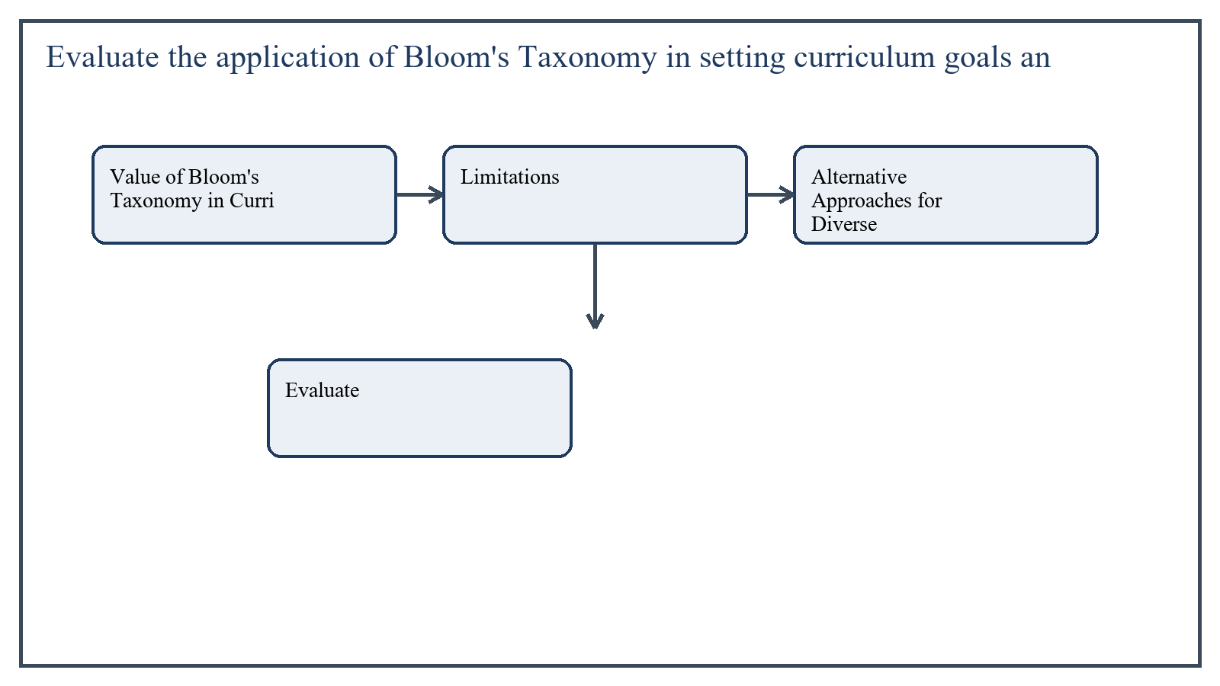
Figure 1: Concept map for Question 1

Value of Bloom's Taxonomy in Curriculum Goal Setting
Bloom's Taxonomy helps curriculum developers classify learning goals across levels such as remembering, understanding, applying, analyzing, evaluating, and creating. This allows goals to be written with greater precision and helps teachers link objectives, learning activities, and assessment tasks.
It is especially useful in preventing curriculum goals from remaining restricted to recall. By encouraging higher-order thinking, the taxonomy supports more balanced learning expectations.
In the context of Curriculum Development, the theme of value of bloom's taxonomy in curriculum goal setting deserves extended attention because assignment-level understanding is expected to move beyond one-line definitions and into explanation, comparison, and application. A strong university answer shows not only what the concept means, but also why it matters, how it appears in practice, and what limitations or challenges may arise when it is implemented in real educational settings.
A mature academic response also connects value of bloom's taxonomy in curriculum goal setting with classroom realities, institutional culture, and the Pakistani context wherever relevant. This makes the answer more analytical and more useful because it links conceptual understanding with the needs of teachers, learners, administrators, and communities rather than leaving the idea at a purely theoretical level.
From an examination and assignment-writing perspective, the topic of value of bloom's taxonomy in curriculum goal setting should be handled through clear structure, careful terminology, valid examples, and balanced discussion. The strongest responses usually define the idea, explain its major components, illustrate it through educational examples, and then conclude with a reasoned judgment about its significance, usefulness, or limitations.

Limitations
Despite its usefulness, Bloom's Taxonomy can become too rigid if treated as a universal ladder through which every learner must move in the same way. Real learning is not always linear, and diverse learners may demonstrate understanding through different paths and forms of expression.
Another limitation is that curriculum goals also include affective, social, cultural, and practical dimensions. If Bloom is used narrowly in the cognitive sense, these broader dimensions may receive less attention.
In the context of Curriculum Development, the theme of limitations deserves extended attention because assignment-level understanding is expected to move beyond one-line definitions and into explanation, comparison, and application. A strong university answer shows not only what the concept means, but also why it matters, how it appears in practice, and what limitations or challenges may arise when it is implemented in real educational settings.
A mature academic response also connects limitations with classroom realities, institutional culture, and the Pakistani context wherever relevant. This makes the answer more analytical and more useful because it links conceptual understanding with the needs of teachers, learners, administrators, and communities rather than leaving the idea at a purely theoretical level.
From an examination and assignment-writing perspective, the topic of limitations should be handled through clear structure, careful terminology, valid examples, and balanced discussion. The strongest responses usually define the idea, explain its major components, illustrate it through educational examples, and then conclude with a reasoned judgment about its significance, usefulness, or limitations.

Alternative Approaches for Diverse Learners
These alternatives do not necessarily replace Bloom's Taxonomy; rather, they complement it by making curriculum goals more accessible and inclusive for learners with different strengths, backgrounds, and needs.
- Universal Design for Learning, which offers multiple means of engagement, representation, and expression.
- Competency-based curriculum design, which focuses on demonstrable performance in varied forms.
- Constructivist approaches that value inquiry, exploration, and meaning-making from learners' contexts.
- Differentiated instruction frameworks that adapt goals, processes, and products to learner readiness and profile.
In the context of Curriculum Development, the theme of alternative approaches for diverse learners deserves extended attention because assignment-level understanding is expected to move beyond one-line definitions and into explanation, comparison, and application. A strong university answer shows not only what the concept means, but also why it matters, how it appears in practice, and what limitations or challenges may arise when it is implemented in real educational settings.
A mature academic response also connects alternative approaches for diverse learners with classroom realities, institutional culture, and the Pakistani context wherever relevant. This makes the answer more analytical and more useful because it links conceptual understanding with the needs of teachers, learners, administrators, and communities rather than leaving the idea at a purely theoretical level.
From an examination and assignment-writing perspective, the topic of alternative approaches for diverse learners should be handled through clear structure, careful terminology, valid examples, and balanced discussion. The strongest responses usually define the idea, explain its major components, illustrate it through educational examples, and then conclude with a reasoned judgment about its significance, usefulness, or limitations.

Applied Illustration and Academic Note
For a stronger B.Ed assignment response, the topic above should be linked with classroom life, institutional practice, and the needs of Pakistani learners. This approach makes the response more analytical and demonstrates that the writer understands both theory and application, which is usually appreciated in AIOU-style academic work.
A good response also avoids unsupported claims. Instead, it explains concepts carefully, gives relevant examples, and ends with a short judgment about educational significance. In this way, the answer to 'Evaluate the application of Bloom's Taxonomy in setting curriculum goa...' becomes easier to read, easier to assess, and more academically convincing.

Quick Review Table
Focus Area | Assignment Relevance
Value of Bloom's Taxonomy in Curriculum Goal Setting | This area helps answer the question on 'Evaluate the application of Bloom's Taxonomy in setting...' by providing concept clarity, explanation, and applied educational value.
Limitations | This area helps answer the question on 'Evaluate the application of Bloom's Taxonomy in setting...' by providing concept clarity, explanation, and applied educational value.
Alternative Approaches for Diverse Learners | This area helps answer the question on 'Evaluate the application of Bloom's Taxonomy in setting...' by providing concept clarity, explanation, and applied educational value.

Critical Reflection
At an advanced level, the topic should not be treated as a fixed formula. Most educational concepts work within particular conditions, and their success often depends on planning quality, learner background, institutional support, and the competence of the teacher or manager using them. A reflective assignment therefore acknowledges strengths while also recognizing practical limitations.

Conclusion
Bloom's Taxonomy remains highly valuable for setting curriculum goals because it clarifies cognitive expectations and supports balance in learning outcomes. However, for diverse learners it should be combined with more flexible and inclusive approaches such as UDL, competency-based design, and differentiated learning. In this way curriculum goals become both intellectually sound and learner-responsive.

Q.2 Design a plan for selecting curriculum content focused on disaster preparedness education.
Answer: The answer below is organized in an academic assignment style, with conceptual explanation, applied discussion, and concise analytical closing comments designed for a neat and extended university submission.
A curriculum plan for disaster preparedness education should equip learners with knowledge, attitudes, and practical skills that reduce risk and improve response. Content selection must therefore be purposeful, age-appropriate, locally relevant, and action-oriented.
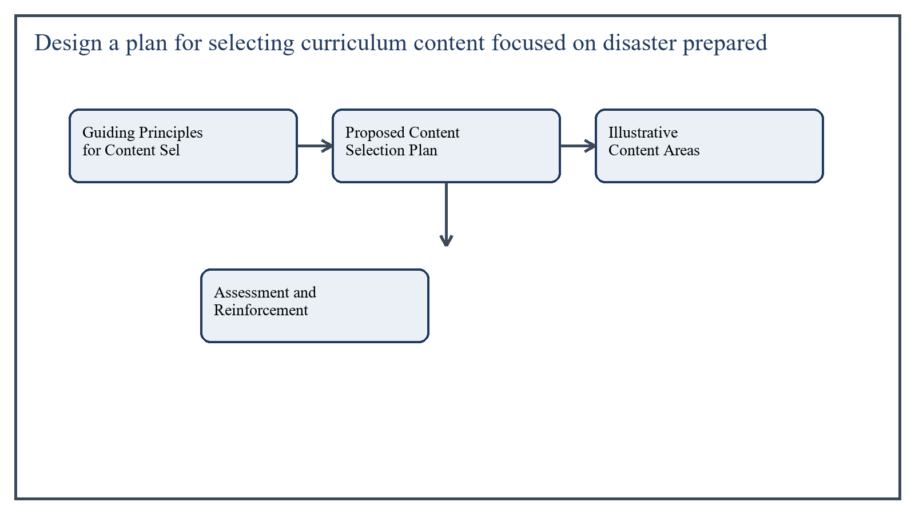
Figure 2: Concept map for Question 2

Guiding Principles for Content Selection
- Relevance to local hazards such as floods, earthquakes, heatwaves, fires, or epidemics.
- Balance between knowledge, skill, attitude, and responsible behavior.
- Developmental appropriateness for the target age group.
- Practical applicability in home, school, and community settings.
In the context of Curriculum Development, the theme of guiding principles for content selection deserves extended attention because assignment-level understanding is expected to move beyond one-line definitions and into explanation, comparison, and application. A strong university answer shows not only what the concept means, but also why it matters, how it appears in practice, and what limitations or challenges may arise when it is implemented in real educational settings.
A mature academic response also connects guiding principles for content selection with classroom realities, institutional culture, and the Pakistani context wherever relevant. This makes the answer more analytical and more useful because it links conceptual understanding with the needs of teachers, learners, administrators, and communities rather than leaving the idea at a purely theoretical level.
From an examination and assignment-writing perspective, the topic of guiding principles for content selection should be handled through clear structure, careful terminology, valid examples, and balanced discussion. The strongest responses usually define the idea, explain its major components, illustrate it through educational examples, and then conclude with a reasoned judgment about its significance, usefulness, or limitations.

Proposed Content Selection Plan
- Identify the main disaster risks affecting the local or national context.
- Define curriculum goals such as awareness, prevention, preparedness, and response.
- Select core concepts: hazard, vulnerability, risk, safety planning, early warning, evacuation, first aid, and community cooperation.
- Organize content progressively from simple awareness to applied safety behavior.
- Include practical activities such as drills, emergency bag planning, route mapping, and role-play.
- Integrate cross-curricular links with science, geography, social studies, health, and civic education.
- Review the selected content with safety experts, teachers, and local stakeholders.
In the context of Curriculum Development, the theme of proposed content selection plan deserves extended attention because assignment-level understanding is expected to move beyond one-line definitions and into explanation, comparison, and application. A strong university answer shows not only what the concept means, but also why it matters, how it appears in practice, and what limitations or challenges may arise when it is implemented in real educational settings.
A mature academic response also connects proposed content selection plan with classroom realities, institutional culture, and the Pakistani context wherever relevant. This makes the answer more analytical and more useful because it links conceptual understanding with the needs of teachers, learners, administrators, and communities rather than leaving the idea at a purely theoretical level.
From an examination and assignment-writing perspective, the topic of proposed content selection plan should be handled through clear structure, careful terminology, valid examples, and balanced discussion. The strongest responses usually define the idea, explain its major components, illustrate it through educational examples, and then conclude with a reasoned judgment about its significance, usefulness, or limitations.

Illustrative Content Areas
At the primary level, content may include recognizing warning signs, safe places, emergency numbers, and simple school evacuation routines. At the middle or secondary level, content may include community risk mapping, basic first aid, misinformation management, and post-disaster psychosocial support awareness.
In the context of Curriculum Development, the theme of illustrative content areas deserves extended attention because assignment-level understanding is expected to move beyond one-line definitions and into explanation, comparison, and application. A strong university answer shows not only what the concept means, but also why it matters, how it appears in practice, and what limitations or challenges may arise when it is implemented in real educational settings.
A mature academic response also connects illustrative content areas with classroom realities, institutional culture, and the Pakistani context wherever relevant. This makes the answer more analytical and more useful because it links conceptual understanding with the needs of teachers, learners, administrators, and communities rather than leaving the idea at a purely theoretical level.
From an examination and assignment-writing perspective, the topic of illustrative content areas should be handled through clear structure, careful terminology, valid examples, and balanced discussion. The strongest responses usually define the idea, explain its major components, illustrate it through educational examples, and then conclude with a reasoned judgment about its significance, usefulness, or limitations.

Assessment and Reinforcement
Because disaster preparedness involves applied behavior, content selection should be linked with performance tasks rather than written knowledge alone. Drills, group planning, scenario response, and reflective discussion should reinforce the curriculum.
In the context of Curriculum Development, the theme of assessment and reinforcement deserves extended attention because assignment-level understanding is expected to move beyond one-line definitions and into explanation, comparison, and application. A strong university answer shows not only what the concept means, but also why it matters, how it appears in practice, and what limitations or challenges may arise when it is implemented in real educational settings.
A mature academic response also connects assessment and reinforcement with classroom realities, institutional culture, and the Pakistani context wherever relevant. This makes the answer more analytical and more useful because it links conceptual understanding with the needs of teachers, learners, administrators, and communities rather than leaving the idea at a purely theoretical level.
From an examination and assignment-writing perspective, the topic of assessment and reinforcement should be handled through clear structure, careful terminology, valid examples, and balanced discussion. The strongest responses usually define the idea, explain its major components, illustrate it through educational examples, and then conclude with a reasoned judgment about its significance, usefulness, or limitations.

Applied Illustration and Academic Note
For a stronger B.Ed assignment response, the topic above should be linked with classroom life, institutional practice, and the needs of Pakistani learners. This approach makes the response more analytical and demonstrates that the writer understands both theory and application, which is usually appreciated in AIOU-style academic work.
A good response also avoids unsupported claims. Instead, it explains concepts carefully, gives relevant examples, and ends with a short judgment about educational significance. In this way, the answer to 'Design a plan for selecting curriculum content focused on disaster pre...' becomes easier to read, easier to assess, and more academically convincing.

Quick Review Table
Focus Area | Assignment Relevance
Guiding Principles for Content Selection | This area helps answer the question on 'Design a plan for selecting curriculum content focused ...' by providing concept clarity, explanation, and applied educational value.
Proposed Content Selection Plan | This area helps answer the question on 'Design a plan for selecting curriculum content focused ...' by providing concept clarity, explanation, and applied educational value.
Illustrative Content Areas | This area helps answer the question on 'Design a plan for selecting curriculum content focused ...' by providing concept clarity, explanation, and applied educational value.
Assessment and Reinforcement | This area helps answer the question on 'Design a plan for selecting curriculum content focused ...' by providing concept clarity, explanation, and applied educational value.

Critical Reflection
At an advanced level, the topic should not be treated as a fixed formula. Most educational concepts work within particular conditions, and their success often depends on planning quality, learner background, institutional support, and the competence of the teacher or manager using them. A reflective assignment therefore acknowledges strengths while also recognizing practical limitations.

Conclusion
A strong disaster preparedness curriculum should be locally relevant, developmentally suitable, and practical. Content should move from awareness to action and should be selected through a structured process that considers hazards, learning goals, applied skills, and community realities. Such planning makes curriculum a real tool for safety rather than a theoretical topic.

Q.3 Develop an assessment rubric to measure alignment between curriculum objectives and learning outcomes.
Answer: The answer below is organized in an academic assignment style, with conceptual explanation, applied discussion, and concise analytical closing comments designed for a neat and extended university submission.
A rubric for measuring alignment between curriculum objectives and learning outcomes should allow teachers or curriculum reviewers to judge whether intended objectives are actually being reflected in student performance. Such a rubric supports curriculum quality assurance and instructional coherence.
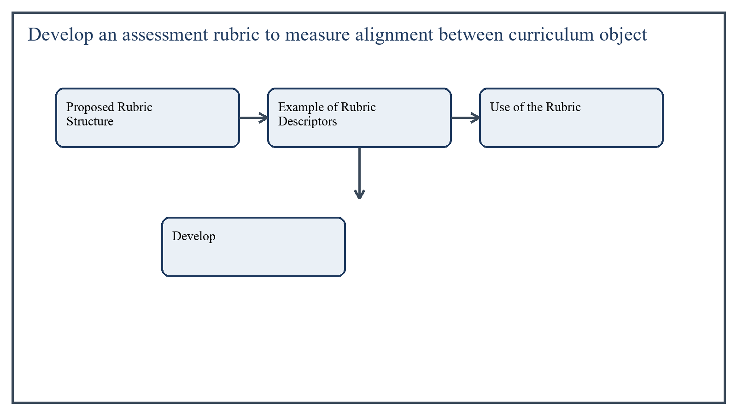
Figure 3: Concept map for Question 3

Proposed Rubric Structure
The rubric can use four performance levels: Excellent Alignment, Good Alignment, Partial Alignment, and Weak Alignment. The following criteria may be used to judge alignment between curriculum objectives and observed learning outcomes.
- Clarity of Objective: Are curriculum objectives specific, observable, and measurable?
- Content Match: Do learning activities and assessed outcomes reflect the stated objective content?
- Cognitive Match: Is the level of student performance consistent with the intended cognitive demand of the objective?
- Evidence Quality: Is there sufficient evidence from student work, assessment, or observation to support the outcome claim?
- Consistency Across Learners: Are outcomes visible across the target learner group rather than in isolated cases only?
In the context of Curriculum Development, the theme of proposed rubric structure deserves extended attention because assignment-level understanding is expected to move beyond one-line definitions and into explanation, comparison, and application. A strong university answer shows not only what the concept means, but also why it matters, how it appears in practice, and what limitations or challenges may arise when it is implemented in real educational settings.
A mature academic response also connects proposed rubric structure with classroom realities, institutional culture, and the Pakistani context wherever relevant. This makes the answer more analytical and more useful because it links conceptual understanding with the needs of teachers, learners, administrators, and communities rather than leaving the idea at a purely theoretical level.
From an examination and assignment-writing perspective, the topic of proposed rubric structure should be handled through clear structure, careful terminology, valid examples, and balanced discussion. The strongest responses usually define the idea, explain its major components, illustrate it through educational examples, and then conclude with a reasoned judgment about its significance, usefulness, or limitations.

Example of Rubric Descriptors
Excellent Alignment means the objective is clearly stated, instruction reflects it directly, students demonstrate the intended level of performance, and evidence is strong and consistent.
Good Alignment means the objective is mostly clear and outcomes reflect it well, though some minor gaps or inconsistencies remain.
Partial Alignment means the relationship between objective and outcome is visible but uneven, weakly measured, or incomplete.
Weak Alignment means objectives are vague or outcomes do not meaningfully represent the intended learning.
In the context of Curriculum Development, the theme of example of rubric descriptors deserves extended attention because assignment-level understanding is expected to move beyond one-line definitions and into explanation, comparison, and application. A strong university answer shows not only what the concept means, but also why it matters, how it appears in practice, and what limitations or challenges may arise when it is implemented in real educational settings.
A mature academic response also connects example of rubric descriptors with classroom realities, institutional culture, and the Pakistani context wherever relevant. This makes the answer more analytical and more useful because it links conceptual understanding with the needs of teachers, learners, administrators, and communities rather than leaving the idea at a purely theoretical level.
From an examination and assignment-writing perspective, the topic of example of rubric descriptors should be handled through clear structure, careful terminology, valid examples, and balanced discussion. The strongest responses usually define the idea, explain its major components, illustrate it through educational examples, and then conclude with a reasoned judgment about its significance, usefulness, or limitations.

Use of the Rubric
Teachers can use this rubric during lesson review, departmental moderation, or curriculum evaluation exercises. It is especially helpful when there is concern that objectives are written formally but are not being realized in student learning.
In the context of Curriculum Development, the theme of use of the rubric deserves extended attention because assignment-level understanding is expected to move beyond one-line definitions and into explanation, comparison, and application. A strong university answer shows not only what the concept means, but also why it matters, how it appears in practice, and what limitations or challenges may arise when it is implemented in real educational settings.
A mature academic response also connects use of the rubric with classroom realities, institutional culture, and the Pakistani context wherever relevant. This makes the answer more analytical and more useful because it links conceptual understanding with the needs of teachers, learners, administrators, and communities rather than leaving the idea at a purely theoretical level.
From an examination and assignment-writing perspective, the topic of use of the rubric should be handled through clear structure, careful terminology, valid examples, and balanced discussion. The strongest responses usually define the idea, explain its major components, illustrate it through educational examples, and then conclude with a reasoned judgment about its significance, usefulness, or limitations.

Applied Illustration and Academic Note
For a stronger B.Ed assignment response, the topic above should be linked with classroom life, institutional practice, and the needs of Pakistani learners. This approach makes the response more analytical and demonstrates that the writer understands both theory and application, which is usually appreciated in AIOU-style academic work.
A good response also avoids unsupported claims. Instead, it explains concepts carefully, gives relevant examples, and ends with a short judgment about educational significance. In this way, the answer to 'Develop an assessment rubric to measure alignment between curriculum o...' becomes easier to read, easier to assess, and more academically convincing.

Quick Review Table
Focus Area | Assignment Relevance
Proposed Rubric Structure | This area helps answer the question on 'Develop an assessment rubric to measure alignment betwe...' by providing concept clarity, explanation, and applied educational value.
Example of Rubric Descriptors | This area helps answer the question on 'Develop an assessment rubric to measure alignment betwe...' by providing concept clarity, explanation, and applied educational value.
Use of the Rubric | This area helps answer the question on 'Develop an assessment rubric to measure alignment betwe...' by providing concept clarity, explanation, and applied educational value.

Critical Reflection
At an advanced level, the topic should not be treated as a fixed formula. Most educational concepts work within particular conditions, and their success often depends on planning quality, learner background, institutional support, and the competence of the teacher or manager using them. A reflective assignment therefore acknowledges strengths while also recognizing practical limitations.

Conclusion
An alignment rubric helps make curriculum quality visible by examining the connection between intended objectives and actual learning outcomes. By focusing on clarity, content match, cognitive level, evidence quality, and consistency, the rubric gives educators a practical tool for improving curriculum implementation and assessment accuracy.

Q.4 Propose a curriculum initiative aligned with the United Nations Sustainable Development Goals (SDGs).
Answer: The answer below is organized in an academic assignment style, with conceptual explanation, applied discussion, and concise analytical closing comments designed for a neat and extended university submission.
A curriculum initiative aligned with the SDGs should connect local education with global responsibility. It should develop knowledge, values, and action related to sustainability, equity, health, environment, and responsible citizenship. A practical initiative can be built around school-based sustainability learning.
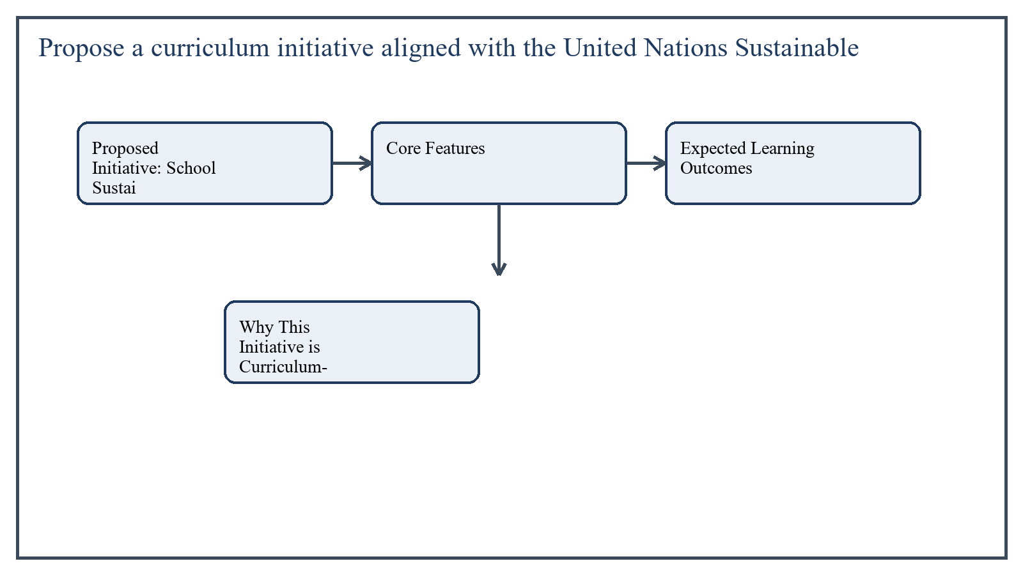
Figure 4: Concept map for Question 4

Proposed Initiative: School Sustainability and Responsible Citizenship Program
This initiative would integrate sustainability themes across grades and subjects while keeping strong links to community life. It would align especially with SDG 4 (quality education), SDG 3 (good health and well-being), SDG 5 (gender equality), SDG 6 (clean water and sanitation), SDG 12 (responsible consumption), and SDG 13 (climate action).
In the context of Curriculum Development, the theme of proposed initiative: school sustainability and responsible citizenship program deserves extended attention because assignment-level understanding is expected to move beyond one-line definitions and into explanation, comparison, and application. A strong university answer shows not only what the concept means, but also why it matters, how it appears in practice, and what limitations or challenges may arise when it is implemented in real educational settings.
A mature academic response also connects proposed initiative: school sustainability and responsible citizenship program with classroom realities, institutional culture, and the Pakistani context wherever relevant. This makes the answer more analytical and more useful because it links conceptual understanding with the needs of teachers, learners, administrators, and communities rather than leaving the idea at a purely theoretical level.
From an examination and assignment-writing perspective, the topic of proposed initiative: school sustainability and responsible citizenship program should be handled through clear structure, careful terminology, valid examples, and balanced discussion. The strongest responses usually define the idea, explain its major components, illustrate it through educational examples, and then conclude with a reasoned judgment about its significance, usefulness, or limitations.

Core Features
- Cross-curricular lessons on water use, waste reduction, climate awareness, health, and social inclusion.
- Project-based learning such as school cleanliness drives, recycling projects, kitchen gardens, and energy-saving campaigns.
- Student leadership groups to monitor sustainability practices in school.
- Community partnerships for awareness sessions and local action.
In the context of Curriculum Development, the theme of core features deserves extended attention because assignment-level understanding is expected to move beyond one-line definitions and into explanation, comparison, and application. A strong university answer shows not only what the concept means, but also why it matters, how it appears in practice, and what limitations or challenges may arise when it is implemented in real educational settings.
A mature academic response also connects core features with classroom realities, institutional culture, and the Pakistani context wherever relevant. This makes the answer more analytical and more useful because it links conceptual understanding with the needs of teachers, learners, administrators, and communities rather than leaving the idea at a purely theoretical level.
From an examination and assignment-writing perspective, the topic of core features should be handled through clear structure, careful terminology, valid examples, and balanced discussion. The strongest responses usually define the idea, explain its major components, illustrate it through educational examples, and then conclude with a reasoned judgment about its significance, usefulness, or limitations.

Expected Learning Outcomes
Students would learn to identify sustainability problems, collect simple data, analyze local needs, propose solutions, and practice responsible behavior. They would also develop cooperation, civic responsibility, and ethical awareness.
In the context of Curriculum Development, the theme of expected learning outcomes deserves extended attention because assignment-level understanding is expected to move beyond one-line definitions and into explanation, comparison, and application. A strong university answer shows not only what the concept means, but also why it matters, how it appears in practice, and what limitations or challenges may arise when it is implemented in real educational settings.
A mature academic response also connects expected learning outcomes with classroom realities, institutional culture, and the Pakistani context wherever relevant. This makes the answer more analytical and more useful because it links conceptual understanding with the needs of teachers, learners, administrators, and communities rather than leaving the idea at a purely theoretical level.
From an examination and assignment-writing perspective, the topic of expected learning outcomes should be handled through clear structure, careful terminology, valid examples, and balanced discussion. The strongest responses usually define the idea, explain its major components, illustrate it through educational examples, and then conclude with a reasoned judgment about its significance, usefulness, or limitations.

Why This Initiative is Curriculum-Worthy
The initiative links curriculum with lived challenges rather than abstract slogans. It makes SDGs understandable at school level and turns learners into informed participants in social improvement.
In the context of Curriculum Development, the theme of why this initiative is curriculum-worthy deserves extended attention because assignment-level understanding is expected to move beyond one-line definitions and into explanation, comparison, and application. A strong university answer shows not only what the concept means, but also why it matters, how it appears in practice, and what limitations or challenges may arise when it is implemented in real educational settings.
A mature academic response also connects why this initiative is curriculum-worthy with classroom realities, institutional culture, and the Pakistani context wherever relevant. This makes the answer more analytical and more useful because it links conceptual understanding with the needs of teachers, learners, administrators, and communities rather than leaving the idea at a purely theoretical level.
From an examination and assignment-writing perspective, the topic of why this initiative is curriculum-worthy should be handled through clear structure, careful terminology, valid examples, and balanced discussion. The strongest responses usually define the idea, explain its major components, illustrate it through educational examples, and then conclude with a reasoned judgment about its significance, usefulness, or limitations.

Applied Illustration and Academic Note
For a stronger B.Ed assignment response, the topic above should be linked with classroom life, institutional practice, and the needs of Pakistani learners. This approach makes the response more analytical and demonstrates that the writer understands both theory and application, which is usually appreciated in AIOU-style academic work.
A good response also avoids unsupported claims. Instead, it explains concepts carefully, gives relevant examples, and ends with a short judgment about educational significance. In this way, the answer to 'Propose a curriculum initiative aligned with the United Nations Sustai...' becomes easier to read, easier to assess, and more academically convincing.

Quick Review Table
Focus Area | Assignment Relevance
Proposed Initiative: School Sustainability and Responsible Citizenship Program | This area helps answer the question on 'Propose a curriculum initiative aligned with the United...' by providing concept clarity, explanation, and applied educational value.
Core Features | This area helps answer the question on 'Propose a curriculum initiative aligned with the United...' by providing concept clarity, explanation, and applied educational value.
Expected Learning Outcomes | This area helps answer the question on 'Propose a curriculum initiative aligned with the United...' by providing concept clarity, explanation, and applied educational value.
Why This Initiative is Curriculum-Worthy | This area helps answer the question on 'Propose a curriculum initiative aligned with the United...' by providing concept clarity, explanation, and applied educational value.

Critical Reflection
At an advanced level, the topic should not be treated as a fixed formula. Most educational concepts work within particular conditions, and their success often depends on planning quality, learner background, institutional support, and the competence of the teacher or manager using them. A reflective assignment therefore acknowledges strengths while also recognizing practical limitations.

Conclusion
A curriculum initiative aligned with the SDGs should be practical, cross-curricular, and community-connected. The proposed School Sustainability and Responsible Citizenship Program offers a realistic model through which learners can connect classroom learning with health, environment, equity, and collective responsibility.

Q.5 Examine how cultural contexts shape curriculum development in two contrasting countries.
Answer: The answer below is organized in an academic assignment style, with conceptual explanation, applied discussion, and concise analytical closing comments designed for a neat and extended university submission.
Curriculum development is shaped by cultural context because each society defines educational purpose through its own history, values, identity, and social expectations. A comparison between two contrasting countries highlights how curriculum is never merely technical; it is socially and culturally constructed.
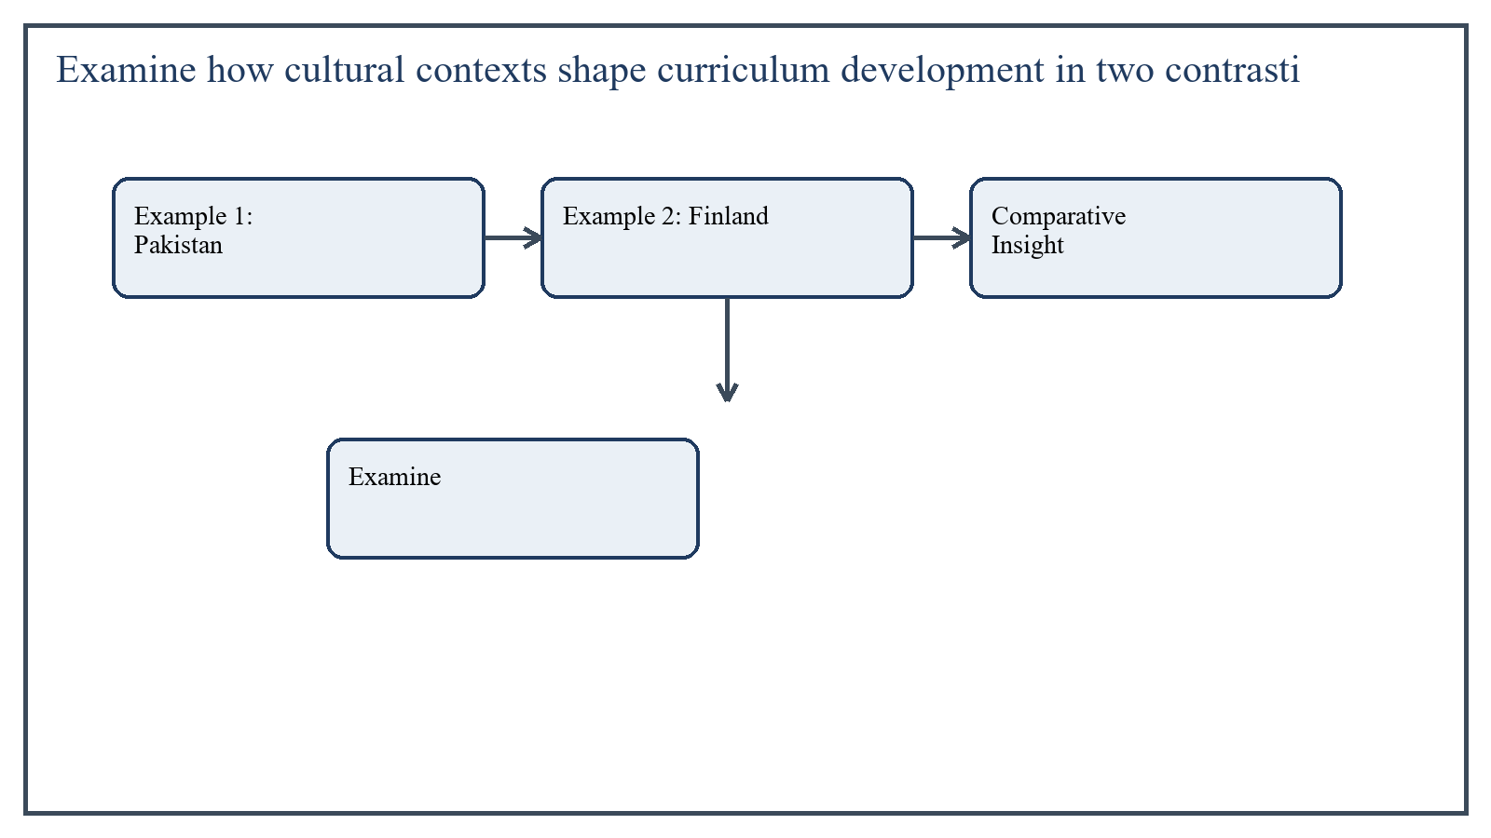
Figure 5: Concept map for Question 5

Example 1: Pakistan
In Pakistan, curriculum is strongly influenced by religion, national identity, social cohesion, citizenship, and state priorities. Cultural values affect language policy, moral education, textbook content, and the place given to heritage, family, and social responsibility.
Curriculum debates often involve how to preserve identity while also addressing modern needs such as technology, critical thinking, and global competitiveness.
In the context of Curriculum Development, the theme of example 1: pakistan deserves extended attention because assignment-level understanding is expected to move beyond one-line definitions and into explanation, comparison, and application. A strong university answer shows not only what the concept means, but also why it matters, how it appears in practice, and what limitations or challenges may arise when it is implemented in real educational settings.
A mature academic response also connects example 1: pakistan with classroom realities, institutional culture, and the Pakistani context wherever relevant. This makes the answer more analytical and more useful because it links conceptual understanding with the needs of teachers, learners, administrators, and communities rather than leaving the idea at a purely theoretical level.
From an examination and assignment-writing perspective, the topic of example 1: pakistan should be handled through clear structure, careful terminology, valid examples, and balanced discussion. The strongest responses usually define the idea, explain its major components, illustrate it through educational examples, and then conclude with a reasoned judgment about its significance, usefulness, or limitations.

Example 2: Finland
In contrast, Finland's curriculum culture is often associated with trust in teachers, learner well-being, equity, inclusion, and integrated competencies. Its curriculum places strong emphasis on collaboration, autonomy, problem-solving, and broad-based skills across disciplines.
The cultural context supports less exam pressure and greater confidence in professionally prepared teachers. This shapes both curriculum design and implementation style.
In the context of Curriculum Development, the theme of example 2: finland deserves extended attention because assignment-level understanding is expected to move beyond one-line definitions and into explanation, comparison, and application. A strong university answer shows not only what the concept means, but also why it matters, how it appears in practice, and what limitations or challenges may arise when it is implemented in real educational settings.
A mature academic response also connects example 2: finland with classroom realities, institutional culture, and the Pakistani context wherever relevant. This makes the answer more analytical and more useful because it links conceptual understanding with the needs of teachers, learners, administrators, and communities rather than leaving the idea at a purely theoretical level.
From an examination and assignment-writing perspective, the topic of example 2: finland should be handled through clear structure, careful terminology, valid examples, and balanced discussion. The strongest responses usually define the idea, explain its major components, illustrate it through educational examples, and then conclude with a reasoned judgment about its significance, usefulness, or limitations.

Comparative Insight
The contrast shows that curriculum grows from different social expectations. In one context, curriculum may carry strong nation-building and moral identity functions; in another, it may foreground learner autonomy, social trust, and flexible competence development.
Neither approach can be understood apart from its cultural environment. This is why direct borrowing of curriculum models without adaptation is often ineffective.
In the context of Curriculum Development, the theme of comparative insight deserves extended attention because assignment-level understanding is expected to move beyond one-line definitions and into explanation, comparison, and application. A strong university answer shows not only what the concept means, but also why it matters, how it appears in practice, and what limitations or challenges may arise when it is implemented in real educational settings.
A mature academic response also connects comparative insight with classroom realities, institutional culture, and the Pakistani context wherever relevant. This makes the answer more analytical and more useful because it links conceptual understanding with the needs of teachers, learners, administrators, and communities rather than leaving the idea at a purely theoretical level.
From an examination and assignment-writing perspective, the topic of comparative insight should be handled through clear structure, careful terminology, valid examples, and balanced discussion. The strongest responses usually define the idea, explain its major components, illustrate it through educational examples, and then conclude with a reasoned judgment about its significance, usefulness, or limitations.

Applied Illustration and Academic Note
For a stronger B.Ed assignment response, the topic above should be linked with classroom life, institutional practice, and the needs of Pakistani learners. This approach makes the response more analytical and demonstrates that the writer understands both theory and application, which is usually appreciated in AIOU-style academic work.
A good response also avoids unsupported claims. Instead, it explains concepts carefully, gives relevant examples, and ends with a short judgment about educational significance. In this way, the answer to 'Examine how cultural contexts shape curriculum development in two cont...' becomes easier to read, easier to assess, and more academically convincing.

Quick Review Table
Focus Area | Assignment Relevance
Example 1: Pakistan | This area helps answer the question on 'Examine how cultural contexts shape curriculum developm...' by providing concept clarity, explanation, and applied educational value.
Example 2: Finland | This area helps answer the question on 'Examine how cultural contexts shape curriculum developm...' by providing concept clarity, explanation, and applied educational value.
Comparative Insight | This area helps answer the question on 'Examine how cultural contexts shape curriculum developm...' by providing concept clarity, explanation, and applied educational value.

Critical Reflection
At an advanced level, the topic should not be treated as a fixed formula. Most educational concepts work within particular conditions, and their success often depends on planning quality, learner background, institutional support, and the competence of the teacher or manager using them. A reflective assignment therefore acknowledges strengths while also recognizing practical limitations.

Conclusion
Cultural contexts shape curriculum development by influencing educational aims, content priorities, pedagogy, and assessment traditions. The contrast between Pakistan and Finland illustrates that curriculum reflects social values, institutional culture, and historical expectations. Therefore, curriculum development must always be culturally informed, even when drawing lessons from international examples.

Extended Revision Appendix
This appendix is included to strengthen the assignment as a premium academic submission. It provides recap notes, revision prompts, and concept reinforcement so the document reads like a complete study-ready submission rather than a short-answer sheet only.

Key Revision Points
- Review the central demand of the question 'Evaluate the application of Bloom's Taxonomy in setting curric...' and connect definition, explanation, example, and critical comment in one organized response.
- Review the central demand of the question 'Design a plan for selecting curriculum content focused on disa...' and connect definition, explanation, example, and critical comment in one organized response.
- Review the central demand of the question 'Develop an assessment rubric to measure alignment between curr...' and connect definition, explanation, example, and critical comment in one organized response.
- Review the central demand of the question 'Propose a curriculum initiative aligned with the United Nation...' and connect definition, explanation, example, and critical comment in one organized response.
- Review the central demand of the question 'Examine how cultural contexts shape curriculum development in ...' and connect definition, explanation, example, and critical comment in one organized response.

Academic Writing Reminders
- Begin each major answer with a clear conceptual opening.
- Use examples to show understanding instead of repeating definitions only.
- Present advantages, limitations, and contextual realities where relevant.
- Close each answer with a short evaluative conclusion.
- Maintain formal and neat language throughout the assignment.

Concept Reinforcement Notes
The question on 'Evaluate the application of Bloom's Taxonomy in setting curriculum goals an...' can be revised further by identifying three things: the main concept involved, the educational importance of that concept, and one example from Pakistani classroom or institutional life. This simple method helps transform memorized content into organized written response.
The question on 'Design a plan for selecting curriculum content focused on disaster prepared...' can be revised further by identifying three things: the main concept involved, the educational importance of that concept, and one example from Pakistani classroom or institutional life. This simple method helps transform memorized content into organized written response.
The question on 'Develop an assessment rubric to measure alignment between curriculum object...' can be revised further by identifying three things: the main concept involved, the educational importance of that concept, and one example from Pakistani classroom or institutional life. This simple method helps transform memorized content into organized written response.
The question on 'Propose a curriculum initiative aligned with the United Nations Sustainable...' can be revised further by identifying three things: the main concept involved, the educational importance of that concept, and one example from Pakistani classroom or institutional life. This simple method helps transform memorized content into organized written response.
The question on 'Examine how cultural contexts shape curriculum development in two contrasti...' can be revised further by identifying three things: the main concept involved, the educational importance of that concept, and one example from Pakistani classroom or institutional life. This simple method helps transform memorized content into organized written response.

Source Base and Assignment Support Notes
The following source base was used to keep the answers aligned with AIOU course structure and the exact question wording. The final language and organization were expanded for presentation quality, page-length target, and assignment readability.
- AIOU Soft Book: Curriculum Development (Code 8603) and related AIOU curriculum text 'Curriculum & Instructions' (Code 6406) for foundations of curriculum, objective setting, content selection, evaluation, and curriculum change.
- AIOU Spring 2026 assignment sheet for Course 8603.

Extended Analytical Note 1
In extended study of Curriculum Development, the issue raised in 'Evaluate the application of Bloom's Taxonomy in setting curriculum goals...' may also be explored through definition, theoretical explanation, applied example, classroom implication, institutional implication, and critical reflection. This six-part approach helps a learner produce a more complete answer and also improves the academic appearance of the assignment by showing structure and depth.
Another useful strategy in long-form assignment writing is to move carefully from concept to context. First explain what the idea means, then identify its components, then discuss its relevance in teaching or administration, and finally mention any practical limitation. Such movement gives maturity to the answer and helps the examiner follow the logic without difficulty.
In extended study of Curriculum Development, the issue raised in 'Design a plan for selecting curriculum content focused on disaster prepa...' may also be explored through definition, theoretical explanation, applied example, classroom implication, institutional implication, and critical reflection. This six-part approach helps a learner produce a more complete answer and also improves the academic appearance of the assignment by showing structure and depth.
Another useful strategy in long-form assignment writing is to move carefully from concept to context. First explain what the idea means, then identify its components, then discuss its relevance in teaching or administration, and finally mention any practical limitation. Such movement gives maturity to the answer and helps the examiner follow the logic without difficulty.
In extended study of Curriculum Development, the issue raised in 'Develop an assessment rubric to measure alignment between curriculum obj...' may also be explored through definition, theoretical explanation, applied example, classroom implication, institutional implication, and critical reflection. This six-part approach helps a learner produce a more complete answer and also improves the academic appearance of the assignment by showing structure and depth.
Another useful strategy in long-form assignment writing is to move carefully from concept to context. First explain what the idea means, then identify its components, then discuss its relevance in teaching or administration, and finally mention any practical limitation. Such movement gives maturity to the answer and helps the examiner follow the logic without difficulty.
In extended study of Curriculum Development, the issue raised in 'Propose a curriculum initiative aligned with the United Nations Sustaina...' may also be explored through definition, theoretical explanation, applied example, classroom implication, institutional implication, and critical reflection. This six-part approach helps a learner produce a more complete answer and also improves the academic appearance of the assignment by showing structure and depth.
Another useful strategy in long-form assignment writing is to move carefully from concept to context. First explain what the idea means, then identify its components, then discuss its relevance in teaching or administration, and finally mention any practical limitation. Such movement gives maturity to the answer and helps the examiner follow the logic without difficulty.
In extended study of Curriculum Development, the issue raised in 'Examine how cultural contexts shape curriculum development in two contra...' may also be explored through definition, theoretical explanation, applied example, classroom implication, institutional implication, and critical reflection. This six-part approach helps a learner produce a more complete answer and also improves the academic appearance of the assignment by showing structure and depth.
Another useful strategy in long-form assignment writing is to move carefully from concept to context. First explain what the idea means, then identify its components, then discuss its relevance in teaching or administration, and finally mention any practical limitation. Such movement gives maturity to the answer and helps the examiner follow the logic without difficulty.

Extended Analytical Note 2
In extended study of Curriculum Development, the issue raised in 'Evaluate the application of Bloom's Taxonomy in setting curriculum goals...' may also be explored through definition, theoretical explanation, applied example, classroom implication, institutional implication, and critical reflection. This six-part approach helps a learner produce a more complete answer and also improves the academic appearance of the assignment by showing structure and depth.
Another useful strategy in long-form assignment writing is to move carefully from concept to context. First explain what the idea means, then identify its components, then discuss its relevance in teaching or administration, and finally mention any practical limitation. Such movement gives maturity to the answer and helps the examiner follow the logic without difficulty.
In extended study of Curriculum Development, the issue raised in 'Design a plan for selecting curriculum content focused on disaster prepa...' may also be explored through definition, theoretical explanation, applied example, classroom implication, institutional implication, and critical reflection. This six-part approach helps a learner produce a more complete answer and also improves the academic appearance of the assignment by showing structure and depth.
Another useful strategy in long-form assignment writing is to move carefully from concept to context. First explain what the idea means, then identify its components, then discuss its relevance in teaching or administration, and finally mention any practical limitation. Such movement gives maturity to the answer and helps the examiner follow the logic without difficulty.
In extended study of Curriculum Development, the issue raised in 'Develop an assessment rubric to measure alignment between curriculum obj...' may also be explored through definition, theoretical explanation, applied example, classroom implication, institutional implication, and critical reflection. This six-part approach helps a learner produce a more complete answer and also improves the academic appearance of the assignment by showing structure and depth.
Another useful strategy in long-form assignment writing is to move carefully from concept to context. First explain what the idea means, then identify its components, then discuss its relevance in teaching or administration, and finally mention any practical limitation. Such movement gives maturity to the answer and helps the examiner follow the logic without difficulty.
In extended study of Curriculum Development, the issue raised in 'Propose a curriculum initiative aligned with the United Nations Sustaina...' may also be explored through definition, theoretical explanation, applied example, classroom implication, institutional implication, and critical reflection. This six-part approach helps a learner produce a more complete answer and also improves the academic appearance of the assignment by showing structure and depth.
Another useful strategy in long-form assignment writing is to move carefully from concept to context. First explain what the idea means, then identify its components, then discuss its relevance in teaching or administration, and finally mention any practical limitation. Such movement gives maturity to the answer and helps the examiner follow the logic without difficulty.
In extended study of Curriculum Development, the issue raised in 'Examine how cultural contexts shape curriculum development in two contra...' may also be explored through definition, theoretical explanation, applied example, classroom implication, institutional implication, and critical reflection. This six-part approach helps a learner produce a more complete answer and also improves the academic appearance of the assignment by showing structure and depth.
Another useful strategy in long-form assignment writing is to move carefully from concept to context. First explain what the idea means, then identify its components, then discuss its relevance in teaching or administration, and finally mention any practical limitation. Such movement gives maturity to the answer and helps the examiner follow the logic without difficulty.

Extended Analytical Note 3
In extended study of Curriculum Development, the issue raised in 'Evaluate the application of Bloom's Taxonomy in setting curriculum goals...' may also be explored through definition, theoretical explanation, applied example, classroom implication, institutional implication, and critical reflection. This six-part approach helps a learner produce a more complete answer and also improves the academic appearance of the assignment by showing structure and depth.
Another useful strategy in long-form assignment writing is to move carefully from concept to context. First explain what the idea means, then identify its components, then discuss its relevance in teaching or administration, and finally mention any practical limitation. Such movement gives maturity to the answer and helps the examiner follow the logic without difficulty.
In extended study of Curriculum Development, the issue raised in 'Design a plan for selecting curriculum content focused on disaster prepa...' may also be explored through definition, theoretical explanation, applied example, classroom implication, institutional implication, and critical reflection. This six-part approach helps a learner produce a more complete answer and also improves the academic appearance of the assignment by showing structure and depth.
Another useful strategy in long-form assignment writing is to move carefully from concept to context. First explain what the idea means, then identify its components, then discuss its relevance in teaching or administration, and finally mention any practical limitation. Such movement gives maturity to the answer and helps the examiner follow the logic without difficulty.
In extended study of Curriculum Development, the issue raised in 'Develop an assessment rubric to measure alignment between curriculum obj...' may also be explored through definition, theoretical explanation, applied example, classroom implication, institutional implication, and critical reflection. This six-part approach helps a learner produce a more complete answer and also improves the academic appearance of the assignment by showing structure and depth.
Another useful strategy in long-form assignment writing is to move carefully from concept to context. First explain what the idea means, then identify its components, then discuss its relevance in teaching or administration, and finally mention any practical limitation. Such movement gives maturity to the answer and helps the examiner follow the logic without difficulty.
In extended study of Curriculum Development, the issue raised in 'Propose a curriculum initiative aligned with the United Nations Sustaina...' may also be explored through definition, theoretical explanation, applied example, classroom implication, institutional implication, and critical reflection. This six-part approach helps a learner produce a more complete answer and also improves the academic appearance of the assignment by showing structure and depth.
Another useful strategy in long-form assignment writing is to move carefully from concept to context. First explain what the idea means, then identify its components, then discuss its relevance in teaching or administration, and finally mention any practical limitation. Such movement gives maturity to the answer and helps the examiner follow the logic without difficulty.
In extended study of Curriculum Development, the issue raised in 'Examine how cultural contexts shape curriculum development in two contra...' may also be explored through definition, theoretical explanation, applied example, classroom implication, institutional implication, and critical reflection. This six-part approach helps a learner produce a more complete answer and also improves the academic appearance of the assignment by showing structure and depth.
Another useful strategy in long-form assignment writing is to move carefully from concept to context. First explain what the idea means, then identify its components, then discuss its relevance in teaching or administration, and finally mention any practical limitation. Such movement gives maturity to the answer and helps the examiner follow the logic without difficulty.

Extended Analytical Note 4
In extended study of Curriculum Development, the issue raised in 'Evaluate the application of Bloom's Taxonomy in setting curriculum goals...' may also be explored through definition, theoretical explanation, applied example, classroom implication, institutional implication, and critical reflection. This six-part approach helps a learner produce a more complete answer and also improves the academic appearance of the assignment by showing structure and depth.
Another useful strategy in long-form assignment writing is to move carefully from concept to context. First explain what the idea means, then identify its components, then discuss its relevance in teaching or administration, and finally mention any practical limitation. Such movement gives maturity to the answer and helps the examiner follow the logic without difficulty.
In extended study of Curriculum Development, the issue raised in 'Design a plan for selecting curriculum content focused on disaster prepa...' may also be explored through definition, theoretical explanation, applied example, classroom implication, institutional implication, and critical reflection. This six-part approach helps a learner produce a more complete answer and also improves the academic appearance of the assignment by showing structure and depth.
Another useful strategy in long-form assignment writing is to move carefully from concept to context. First explain what the idea means, then identify its components, then discuss its relevance in teaching or administration, and finally mention any practical limitation. Such movement gives maturity to the answer and helps the examiner follow the logic without difficulty.
In extended study of Curriculum Development, the issue raised in 'Develop an assessment rubric to measure alignment between curriculum obj...' may also be explored through definition, theoretical explanation, applied example, classroom implication, institutional implication, and critical reflection. This six-part approach helps a learner produce a more complete answer and also improves the academic appearance of the assignment by showing structure and depth.
Another useful strategy in long-form assignment writing is to move carefully from concept to context. First explain what the idea means, then identify its components, then discuss its relevance in teaching or administration, and finally mention any practical limitation. Such movement gives maturity to the answer and helps the examiner follow the logic without difficulty.
In extended study of Curriculum Development, the issue raised in 'Propose a curriculum initiative aligned with the United Nations Sustaina...' may also be explored through definition, theoretical explanation, applied example, classroom implication, institutional implication, and critical reflection. This six-part approach helps a learner produce a more complete answer and also improves the academic appearance of the assignment by showing structure and depth.
Another useful strategy in long-form assignment writing is to move carefully from concept to context. First explain what the idea means, then identify its components, then discuss its relevance in teaching or administration, and finally mention any practical limitation. Such movement gives maturity to the answer and helps the examiner follow the logic without difficulty.
In extended study of Curriculum Development, the issue raised in 'Examine how cultural contexts shape curriculum development in two contra...' may also be explored through definition, theoretical explanation, applied example, classroom implication, institutional implication, and critical reflection. This six-part approach helps a learner produce a more complete answer and also improves the academic appearance of the assignment by showing structure and depth.
Another useful strategy in long-form assignment writing is to move carefully from concept to context. First explain what the idea means, then identify its components, then discuss its relevance in teaching or administration, and finally mention any practical limitation. Such movement gives maturity to the answer and helps the examiner follow the logic without difficulty.

Extended Analytical Note 5
In extended study of Curriculum Development, the issue raised in 'Evaluate the application of Bloom's Taxonomy in setting curriculum goals...' may also be explored through definition, theoretical explanation, applied example, classroom implication, institutional implication, and critical reflection. This six-part approach helps a learner produce a more complete answer and also improves the academic appearance of the assignment by showing structure and depth.
Another useful strategy in long-form assignment writing is to move carefully from concept to context. First explain what the idea means, then identify its components, then discuss its relevance in teaching or administration, and finally mention any practical limitation. Such movement gives maturity to the answer and helps the examiner follow the logic without difficulty.
In extended study of Curriculum Development, the issue raised in 'Design a plan for selecting curriculum content focused on disaster prepa...' may also be explored through definition, theoretical explanation, applied example, classroom implication, institutional implication, and critical reflection. This six-part approach helps a learner produce a more complete answer and also improves the academic appearance of the assignment by showing structure and depth.
Another useful strategy in long-form assignment writing is to move carefully from concept to context. First explain what the idea means, then identify its components, then discuss its relevance in teaching or administration, and finally mention any practical limitation. Such movement gives maturity to the answer and helps the examiner follow the logic without difficulty.
In extended study of Curriculum Development, the issue raised in 'Develop an assessment rubric to measure alignment between curriculum obj...' may also be explored through definition, theoretical explanation, applied example, classroom implication, institutional implication, and critical reflection. This six-part approach helps a learner produce a more complete answer and also improves the academic appearance of the assignment by showing structure and depth.
Another useful strategy in long-form assignment writing is to move carefully from concept to context. First explain what the idea means, then identify its components, then discuss its relevance in teaching or administration, and finally mention any practical limitation. Such movement gives maturity to the answer and helps the examiner follow the logic without difficulty.
In extended study of Curriculum Development, the issue raised in 'Propose a curriculum initiative aligned with the United Nations Sustaina...' may also be explored through definition, theoretical explanation, applied example, classroom implication, institutional implication, and critical reflection. This six-part approach helps a learner produce a more complete answer and also improves the academic appearance of the assignment by showing structure and depth.
Another useful strategy in long-form assignment writing is to move carefully from concept to context. First explain what the idea means, then identify its components, then discuss its relevance in teaching or administration, and finally mention any practical limitation. Such movement gives maturity to the answer and helps the examiner follow the logic without difficulty.
In extended study of Curriculum Development, the issue raised in 'Examine how cultural contexts shape curriculum development in two contra...' may also be explored through definition, theoretical explanation, applied example, classroom implication, institutional implication, and critical reflection. This six-part approach helps a learner produce a more complete answer and also improves the academic appearance of the assignment by showing structure and depth.
Another useful strategy in long-form assignment writing is to move carefully from concept to context. First explain what the idea means, then identify its components, then discuss its relevance in teaching or administration, and finally mention any practical limitation. Such movement gives maturity to the answer and helps the examiner follow the logic without difficulty.

Extended Analytical Note 6
In extended study of Curriculum Development, the issue raised in 'Evaluate the application of Bloom's Taxonomy in setting curriculum goals...' may also be explored through definition, theoretical explanation, applied example, classroom implication, institutional implication, and critical reflection. This six-part approach helps a learner produce a more complete answer and also improves the academic appearance of the assignment by showing structure and depth.
Another useful strategy in long-form assignment writing is to move carefully from concept to context. First explain what the idea means, then identify its components, then discuss its relevance in teaching or administration, and finally mention any practical limitation. Such movement gives maturity to the answer and helps the examiner follow the logic without difficulty.
In extended study of Curriculum Development, the issue raised in 'Design a plan for selecting curriculum content focused on disaster prepa...' may also be explored through definition, theoretical explanation, applied example, classroom implication, institutional implication, and critical reflection. This six-part approach helps a learner produce a more complete answer and also improves the academic appearance of the assignment by showing structure and depth.
Another useful strategy in long-form assignment writing is to move carefully from concept to context. First explain what the idea means, then identify its components, then discuss its relevance in teaching or administration, and finally mention any practical limitation. Such movement gives maturity to the answer and helps the examiner follow the logic without difficulty.
In extended study of Curriculum Development, the issue raised in 'Develop an assessment rubric to measure alignment between curriculum obj...' may also be explored through definition, theoretical explanation, applied example, classroom implication, institutional implication, and critical reflection. This six-part approach helps a learner produce a more complete answer and also improves the academic appearance of the assignment by showing structure and depth.
Another useful strategy in long-form assignment writing is to move carefully from concept to context. First explain what the idea means, then identify its components, then discuss its relevance in teaching or administration, and finally mention any practical limitation. Such movement gives maturity to the answer and helps the examiner follow the logic without difficulty.
In extended study of Curriculum Development, the issue raised in 'Propose a curriculum initiative aligned with the United Nations Sustaina...' may also be explored through definition, theoretical explanation, applied example, classroom implication, institutional implication, and critical reflection. This six-part approach helps a learner produce a more complete answer and also improves the academic appearance of the assignment by showing structure and depth.
Another useful strategy in long-form assignment writing is to move carefully from concept to context. First explain what the idea means, then identify its components, then discuss its relevance in teaching or administration, and finally mention any practical limitation. Such movement gives maturity to the answer and helps the examiner follow the logic without difficulty.
In extended study of Curriculum Development, the issue raised in 'Examine how cultural contexts shape curriculum development in two contra...' may also be explored through definition, theoretical explanation, applied example, classroom implication, institutional implication, and critical reflection. This six-part approach helps a learner produce a more complete answer and also improves the academic appearance of the assignment by showing structure and depth.
Another useful strategy in long-form assignment writing is to move carefully from concept to context. First explain what the idea means, then identify its components, then discuss its relevance in teaching or administration, and finally mention any practical limitation. Such movement gives maturity to the answer and helps the examiner follow the logic without difficulty.

Extended Analytical Note 7
In extended study of Curriculum Development, the issue raised in 'Evaluate the application of Bloom's Taxonomy in setting curriculum goals...' may also be explored through definition, theoretical explanation, applied example, classroom implication, institutional implication, and critical reflection. This six-part approach helps a learner produce a more complete answer and also improves the academic appearance of the assignment by showing structure and depth.
Another useful strategy in long-form assignment writing is to move carefully from concept to context. First explain what the idea means, then identify its components, then discuss its relevance in teaching or administration, and finally mention any practical limitation. Such movement gives maturity to the answer and helps the examiner follow the logic without difficulty.
In extended study of Curriculum Development, the issue raised in 'Design a plan for selecting curriculum content focused on disaster prepa...' may also be explored through definition, theoretical explanation, applied example, classroom implication, institutional implication, and critical reflection. This six-part approach helps a learner produce a more complete answer and also improves the academic appearance of the assignment by showing structure and depth.
Another useful strategy in long-form assignment writing is to move carefully from concept to context. First explain what the idea means, then identify its components, then discuss its relevance in teaching or administration, and finally mention any practical limitation. Such movement gives maturity to the answer and helps the examiner follow the logic without difficulty.
In extended study of Curriculum Development, the issue raised in 'Develop an assessment rubric to measure alignment between curriculum obj...' may also be explored through definition, theoretical explanation, applied example, classroom implication, institutional implication, and critical reflection. This six-part approach helps a learner produce a more complete answer and also improves the academic appearance of the assignment by showing structure and depth.
Another useful strategy in long-form assignment writing is to move carefully from concept to context. First explain what the idea means, then identify its components, then discuss its relevance in teaching or administration, and finally mention any practical limitation. Such movement gives maturity to the answer and helps the examiner follow the logic without difficulty.
In extended study of Curriculum Development, the issue raised in 'Propose a curriculum initiative aligned with the United Nations Sustaina...' may also be explored through definition, theoretical explanation, applied example, classroom implication, institutional implication, and critical reflection. This six-part approach helps a learner produce a more complete answer and also improves the academic appearance of the assignment by showing structure and depth.
Another useful strategy in long-form assignment writing is to move carefully from concept to context. First explain what the idea means, then identify its components, then discuss its relevance in teaching or administration, and finally mention any practical limitation. Such movement gives maturity to the answer and helps the examiner follow the logic without difficulty.
In extended study of Curriculum Development, the issue raised in 'Examine how cultural contexts shape curriculum development in two contra...' may also be explored through definition, theoretical explanation, applied example, classroom implication, institutional implication, and critical reflection. This six-part approach helps a learner produce a more complete answer and also improves the academic appearance of the assignment by showing structure and depth.
Another useful strategy in long-form assignment writing is to move carefully from concept to context. First explain what the idea means, then identify its components, then discuss its relevance in teaching or administration, and finally mention any practical limitation. Such movement gives maturity to the answer and helps the examiner follow the logic without difficulty.

Extended Analytical Note 8
In extended study of Curriculum Development, the issue raised in 'Evaluate the application of Bloom's Taxonomy in setting curriculum goals...' may also be explored through definition, theoretical explanation, applied example, classroom implication, institutional implication, and critical reflection. This six-part approach helps a learner produce a more complete answer and also improves the academic appearance of the assignment by showing structure and depth.
Another useful strategy in long-form assignment writing is to move carefully from concept to context. First explain what the idea means, then identify its components, then discuss its relevance in teaching or administration, and finally mention any practical limitation. Such movement gives maturity to the answer and helps the examiner follow the logic without difficulty.
In extended study of Curriculum Development, the issue raised in 'Design a plan for selecting curriculum content focused on disaster prepa...' may also be explored through definition, theoretical explanation, applied example, classroom implication, institutional implication, and critical reflection. This six-part approach helps a learner produce a more complete answer and also improves the academic appearance of the assignment by showing structure and depth.
Another useful strategy in long-form assignment writing is to move carefully from concept to context. First explain what the idea means, then identify its components, then discuss its relevance in teaching or administration, and finally mention any practical limitation. Such movement gives maturity to the answer and helps the examiner follow the logic without difficulty.
In extended study of Curriculum Development, the issue raised in 'Develop an assessment rubric to measure alignment between curriculum obj...' may also be explored through definition, theoretical explanation, applied example, classroom implication, institutional implication, and critical reflection. This six-part approach helps a learner produce a more complete answer and also improves the academic appearance of the assignment by showing structure and depth.
Another useful strategy in long-form assignment writing is to move carefully from concept to context. First explain what the idea means, then identify its components, then discuss its relevance in teaching or administration, and finally mention any practical limitation. Such movement gives maturity to the answer and helps the examiner follow the logic without difficulty.
In extended study of Curriculum Development, the issue raised in 'Propose a curriculum initiative aligned with the United Nations Sustaina...' may also be explored through definition, theoretical explanation, applied example, classroom implication, institutional implication, and critical reflection. This six-part approach helps a learner produce a more complete answer and also improves the academic appearance of the assignment by showing structure and depth.
Another useful strategy in long-form assignment writing is to move carefully from concept to context. First explain what the idea means, then identify its components, then discuss its relevance in teaching or administration, and finally mention any practical limitation. Such movement gives maturity to the answer and helps the examiner follow the logic without difficulty.
In extended study of Curriculum Development, the issue raised in 'Examine how cultural contexts shape curriculum development in two contra...' may also be explored through definition, theoretical explanation, applied example, classroom implication, institutional implication, and critical reflection. This six-part approach helps a learner produce a more complete answer and also improves the academic appearance of the assignment by showing structure and depth.
Another useful strategy in long-form assignment writing is to move carefully from concept to context. First explain what the idea means, then identify its components, then discuss its relevance in teaching or administration, and finally mention any practical limitation. Such movement gives maturity to the answer and helps the examiner follow the logic without difficulty.

