ALLAMA IQBAL OPEN UNIVERSITY
Premium Typed Assignment
Research Methods in Education
Detail | Course Code: 8604
Detail | Assignment No: 1
Detail | Unit Coverage: Units 1-4
Detail | Program Level: B.Ed
Detail | Formatting Profile: Times New Roman, 14 pt headings, 12 pt body text
Detail | Document Goal: Extended academic response with diagrams, border styling, and premium presentation

Presentation Note
This file has been prepared as a premium typed assignment with extended academic treatment, proper page border styling, inserted diagrams, formal headings, and neat section hierarchy. The content is intentionally expanded so that the assignment remains easy to read while still meeting a high page-length target.

Q.1 Describe different sources of knowledge by giving examples and explain the need and significance of conducting educational research.
Answer: The answer below is organized in an academic assignment style, with conceptual explanation, applied discussion, and concise analytical closing comments designed for a neat and extended university submission.
Human beings acquire knowledge through several sources, but not all sources are equally accurate or dependable. In education, understanding these sources is important because teachers and researchers need to move from casual belief toward systematic inquiry.
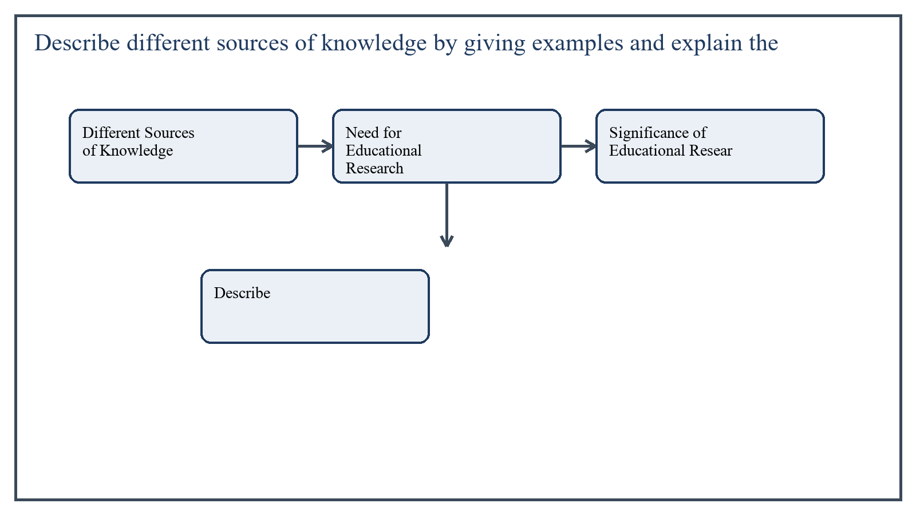
Figure 1: Concept map for Question 1

Different Sources of Knowledge
One source of knowledge is tradition. People often believe or do something because it has been practiced for a long time. For example, a school may continue using a rigid homework system simply because it has always done so. Tradition can preserve useful experience, but it may also continue weak practices without question.
A second source is authority. Knowledge is sometimes accepted because an expert, teacher, religious scholar, or institution says it is correct. For instance, a trainee teacher may adopt a classroom strategy because a senior supervisor recommends it. Authority is helpful, but it should not replace evidence.
A third source is personal experience. Individuals learn from direct interaction with events. A teacher may conclude that group work increases participation because he or she has seen it happen in class. Experience is valuable but may remain limited or biased if not examined carefully.
A fourth source is reasoning. Deductive and inductive thinking help people draw conclusions from principles and evidence. For example, a teacher may infer that frequent feedback improves learning because students perform better after guided correction.
The fifth and strongest source in formal inquiry is scientific research. Here knowledge is generated through systematic observation, data collection, analysis, and verification. This source is more dependable because it reduces guesswork and allows conclusions to be tested.
In the context of Research Methods in Education, the theme of different sources of knowledge deserves extended attention because assignment-level understanding is expected to move beyond one-line definitions and into explanation, comparison, and application. A strong university answer shows not only what the concept means, but also why it matters, how it appears in practice, and what limitations or challenges may arise when it is implemented in real educational settings.
A mature academic response also connects different sources of knowledge with classroom realities, institutional culture, and the Pakistani context wherever relevant. This makes the answer more analytical and more useful because it links conceptual understanding with the needs of teachers, learners, administrators, and communities rather than leaving the idea at a purely theoretical level.
From an examination and assignment-writing perspective, the topic of different sources of knowledge should be handled through clear structure, careful terminology, valid examples, and balanced discussion. The strongest responses usually define the idea, explain its major components, illustrate it through educational examples, and then conclude with a reasoned judgment about its significance, usefulness, or limitations.

Need for Educational Research
Educational research is needed because education deals with human learning, behavior, institutions, curriculum, and policy, all of which are complex and changing. Teachers and administrators cannot depend only on habit or opinion when making decisions.
Research helps identify educational problems accurately. For example, if students are performing poorly in mathematics, research can determine whether the issue lies in teaching method, language, prior knowledge, attendance, or assessment design.
- It helps improve teaching methods and classroom practices.
- It provides evidence for curriculum revision and policy development.
- It supports diagnosis of learner difficulties and institutional issues.
- It encourages objective thinking instead of assumption-based decisions.
In the context of Research Methods in Education, the theme of need for educational research deserves extended attention because assignment-level understanding is expected to move beyond one-line definitions and into explanation, comparison, and application. A strong university answer shows not only what the concept means, but also why it matters, how it appears in practice, and what limitations or challenges may arise when it is implemented in real educational settings.
A mature academic response also connects need for educational research with classroom realities, institutional culture, and the Pakistani context wherever relevant. This makes the answer more analytical and more useful because it links conceptual understanding with the needs of teachers, learners, administrators, and communities rather than leaving the idea at a purely theoretical level.
From an examination and assignment-writing perspective, the topic of need for educational research should be handled through clear structure, careful terminology, valid examples, and balanced discussion. The strongest responses usually define the idea, explain its major components, illustrate it through educational examples, and then conclude with a reasoned judgment about its significance, usefulness, or limitations.

Significance of Educational Research
The significance of educational research lies in its ability to improve the quality of education. It contributes to better planning, more effective instruction, stronger assessment, and informed administration. Research also helps teachers become reflective practitioners rather than routine workers.
Another significant role is innovation. New teaching approaches, technologies, inclusion strategies, and school reforms often emerge from research-based inquiry. In this way research acts as a bridge between theory and practice.
In the context of Research Methods in Education, the theme of significance of educational research deserves extended attention because assignment-level understanding is expected to move beyond one-line definitions and into explanation, comparison, and application. A strong university answer shows not only what the concept means, but also why it matters, how it appears in practice, and what limitations or challenges may arise when it is implemented in real educational settings.
A mature academic response also connects significance of educational research with classroom realities, institutional culture, and the Pakistani context wherever relevant. This makes the answer more analytical and more useful because it links conceptual understanding with the needs of teachers, learners, administrators, and communities rather than leaving the idea at a purely theoretical level.
From an examination and assignment-writing perspective, the topic of significance of educational research should be handled through clear structure, careful terminology, valid examples, and balanced discussion. The strongest responses usually define the idea, explain its major components, illustrate it through educational examples, and then conclude with a reasoned judgment about its significance, usefulness, or limitations.

Applied Illustration and Academic Note
For a stronger B.Ed assignment response, the topic above should be linked with classroom life, institutional practice, and the needs of Pakistani learners. This approach makes the response more analytical and demonstrates that the writer understands both theory and application, which is usually appreciated in AIOU-style academic work.
A good response also avoids unsupported claims. Instead, it explains concepts carefully, gives relevant examples, and ends with a short judgment about educational significance. In this way, the answer to 'Describe different sources of knowledge by giving examples and explain...' becomes easier to read, easier to assess, and more academically convincing.

Quick Review Table
Focus Area | Assignment Relevance
Different Sources of Knowledge | This area helps answer the question on 'Describe different sources of knowledge by giving examp...' by providing concept clarity, explanation, and applied educational value.
Need for Educational Research | This area helps answer the question on 'Describe different sources of knowledge by giving examp...' by providing concept clarity, explanation, and applied educational value.
Significance of Educational Research | This area helps answer the question on 'Describe different sources of knowledge by giving examp...' by providing concept clarity, explanation, and applied educational value.

Critical Reflection
At an advanced level, the topic should not be treated as a fixed formula. Most educational concepts work within particular conditions, and their success often depends on planning quality, learner background, institutional support, and the competence of the teacher or manager using them. A reflective assignment therefore acknowledges strengths while also recognizing practical limitations.

Conclusion
Knowledge comes from tradition, authority, experience, reasoning, and scientific research, but educational research provides the most systematic and reliable path for solving educational problems. Its need and significance lie in improving teaching, learning, planning, and decision-making through evidence rather than assumption.

Q.2 Differentiate between basic and applied research by giving examples and explaining the process of conducting action research to solve educational problems.
Answer: The answer below is organized in an academic assignment style, with conceptual explanation, applied discussion, and concise analytical closing comments designed for a neat and extended university submission.
Basic and applied research both generate knowledge, but they differ in purpose and immediate use. Action research is a more practical and local form of inquiry that directly helps educators solve classroom or school-level problems.
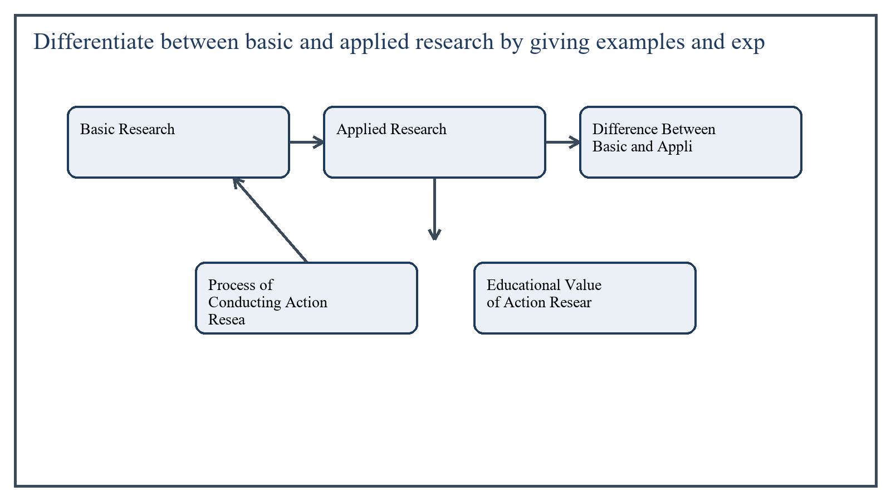
Figure 2: Concept map for Question 2

Basic Research
Basic research is conducted to expand theoretical understanding and build knowledge without necessarily aiming at immediate practical use. Its major purpose is explanation and concept development.
For example, a researcher may study how intrinsic motivation develops across different age groups in order to contribute to educational psychology. The findings may later help practice, but the immediate goal is knowledge generation.
In the context of Research Methods in Education, the theme of basic research deserves extended attention because assignment-level understanding is expected to move beyond one-line definitions and into explanation, comparison, and application. A strong university answer shows not only what the concept means, but also why it matters, how it appears in practice, and what limitations or challenges may arise when it is implemented in real educational settings.
A mature academic response also connects basic research with classroom realities, institutional culture, and the Pakistani context wherever relevant. This makes the answer more analytical and more useful because it links conceptual understanding with the needs of teachers, learners, administrators, and communities rather than leaving the idea at a purely theoretical level.
From an examination and assignment-writing perspective, the topic of basic research should be handled through clear structure, careful terminology, valid examples, and balanced discussion. The strongest responses usually define the idea, explain its major components, illustrate it through educational examples, and then conclude with a reasoned judgment about its significance, usefulness, or limitations.

Applied Research
Applied research focuses on solving a practical problem. It uses scientific methods, but its orientation is toward improvement in real settings such as classrooms, schools, programs, or communities.
For example, a researcher may test whether peer tutoring improves reading achievement among grade five students in a specific district school. The purpose is direct educational improvement.
In the context of Research Methods in Education, the theme of applied research deserves extended attention because assignment-level understanding is expected to move beyond one-line definitions and into explanation, comparison, and application. A strong university answer shows not only what the concept means, but also why it matters, how it appears in practice, and what limitations or challenges may arise when it is implemented in real educational settings.
A mature academic response also connects applied research with classroom realities, institutional culture, and the Pakistani context wherever relevant. This makes the answer more analytical and more useful because it links conceptual understanding with the needs of teachers, learners, administrators, and communities rather than leaving the idea at a purely theoretical level.
From an examination and assignment-writing perspective, the topic of applied research should be handled through clear structure, careful terminology, valid examples, and balanced discussion. The strongest responses usually define the idea, explain its major components, illustrate it through educational examples, and then conclude with a reasoned judgment about its significance, usefulness, or limitations.

Difference Between Basic and Applied Research
- Basic research aims at theory building, while applied research aims at practical problem-solving.
- Basic research contributes to general knowledge, while applied research focuses on immediate use.
- Basic research may be more abstract, while applied research is more context-bound.
In the context of Research Methods in Education, the theme of difference between basic and applied research deserves extended attention because assignment-level understanding is expected to move beyond one-line definitions and into explanation, comparison, and application. A strong university answer shows not only what the concept means, but also why it matters, how it appears in practice, and what limitations or challenges may arise when it is implemented in real educational settings.
A mature academic response also connects difference between basic and applied research with classroom realities, institutional culture, and the Pakistani context wherever relevant. This makes the answer more analytical and more useful because it links conceptual understanding with the needs of teachers, learners, administrators, and communities rather than leaving the idea at a purely theoretical level.
From an examination and assignment-writing perspective, the topic of difference between basic and applied research should be handled through clear structure, careful terminology, valid examples, and balanced discussion. The strongest responses usually define the idea, explain its major components, illustrate it through educational examples, and then conclude with a reasoned judgment about its significance, usefulness, or limitations.

Process of Conducting Action Research
Action research is usually carried out by teachers, heads, or practitioners to improve their own work setting. It begins with identification of a real problem, such as low classroom participation or weak homework completion.
- Identify and define the problem clearly.
- Review relevant ideas or previous practices related to the problem.
- Formulate an action plan or strategy for improvement.
- Collect baseline data through observation, tests, checklists, or interviews.
- Implement the action in the classroom or school setting.
- Collect follow-up data after implementation.
- Analyze the results and reflect on what improved and what still needs change.
- Revise practice and, if needed, begin another cycle.
In the context of Research Methods in Education, the theme of process of conducting action research deserves extended attention because assignment-level understanding is expected to move beyond one-line definitions and into explanation, comparison, and application. A strong university answer shows not only what the concept means, but also why it matters, how it appears in practice, and what limitations or challenges may arise when it is implemented in real educational settings.
A mature academic response also connects process of conducting action research with classroom realities, institutional culture, and the Pakistani context wherever relevant. This makes the answer more analytical and more useful because it links conceptual understanding with the needs of teachers, learners, administrators, and communities rather than leaving the idea at a purely theoretical level.
From an examination and assignment-writing perspective, the topic of process of conducting action research should be handled through clear structure, careful terminology, valid examples, and balanced discussion. The strongest responses usually define the idea, explain its major components, illustrate it through educational examples, and then conclude with a reasoned judgment about its significance, usefulness, or limitations.

Educational Value of Action Research
Action research is especially valuable because it is local, practical, and immediately useful. It empowers teachers to solve their own problems scientifically and to improve instruction through reflection and evidence.
In the context of Research Methods in Education, the theme of educational value of action research deserves extended attention because assignment-level understanding is expected to move beyond one-line definitions and into explanation, comparison, and application. A strong university answer shows not only what the concept means, but also why it matters, how it appears in practice, and what limitations or challenges may arise when it is implemented in real educational settings.
A mature academic response also connects educational value of action research with classroom realities, institutional culture, and the Pakistani context wherever relevant. This makes the answer more analytical and more useful because it links conceptual understanding with the needs of teachers, learners, administrators, and communities rather than leaving the idea at a purely theoretical level.
From an examination and assignment-writing perspective, the topic of educational value of action research should be handled through clear structure, careful terminology, valid examples, and balanced discussion. The strongest responses usually define the idea, explain its major components, illustrate it through educational examples, and then conclude with a reasoned judgment about its significance, usefulness, or limitations.

Applied Illustration and Academic Note
For a stronger B.Ed assignment response, the topic above should be linked with classroom life, institutional practice, and the needs of Pakistani learners. This approach makes the response more analytical and demonstrates that the writer understands both theory and application, which is usually appreciated in AIOU-style academic work.
A good response also avoids unsupported claims. Instead, it explains concepts carefully, gives relevant examples, and ends with a short judgment about educational significance. In this way, the answer to 'Differentiate between basic and applied research by giving examples an...' becomes easier to read, easier to assess, and more academically convincing.

Quick Review Table
Focus Area | Assignment Relevance
Basic Research | This area helps answer the question on 'Differentiate between basic and applied research by giv...' by providing concept clarity, explanation, and applied educational value.
Applied Research | This area helps answer the question on 'Differentiate between basic and applied research by giv...' by providing concept clarity, explanation, and applied educational value.
Difference Between Basic and Applied Research | This area helps answer the question on 'Differentiate between basic and applied research by giv...' by providing concept clarity, explanation, and applied educational value.
Process of Conducting Action Research | This area helps answer the question on 'Differentiate between basic and applied research by giv...' by providing concept clarity, explanation, and applied educational value.

Critical Reflection
At an advanced level, the topic should not be treated as a fixed formula. Most educational concepts work within particular conditions, and their success often depends on planning quality, learner background, institutional support, and the competence of the teacher or manager using them. A reflective assignment therefore acknowledges strengths while also recognizing practical limitations.

Conclusion
Basic research broadens theoretical knowledge, applied research solves practical problems, and action research helps practitioners improve specific educational situations. Together they show that research can serve both knowledge development and direct educational improvement.

Q.3 Differentiate between types of research by purpose and types of research by method and write a detailed note on correlational research.
Answer: The answer below is organized in an academic assignment style, with conceptual explanation, applied discussion, and concise analytical closing comments designed for a neat and extended university submission.
Research can be classified in more than one way. Two common bases are purpose and method. Understanding both classifications helps the student recognize why a study is conducted and how it is carried out.
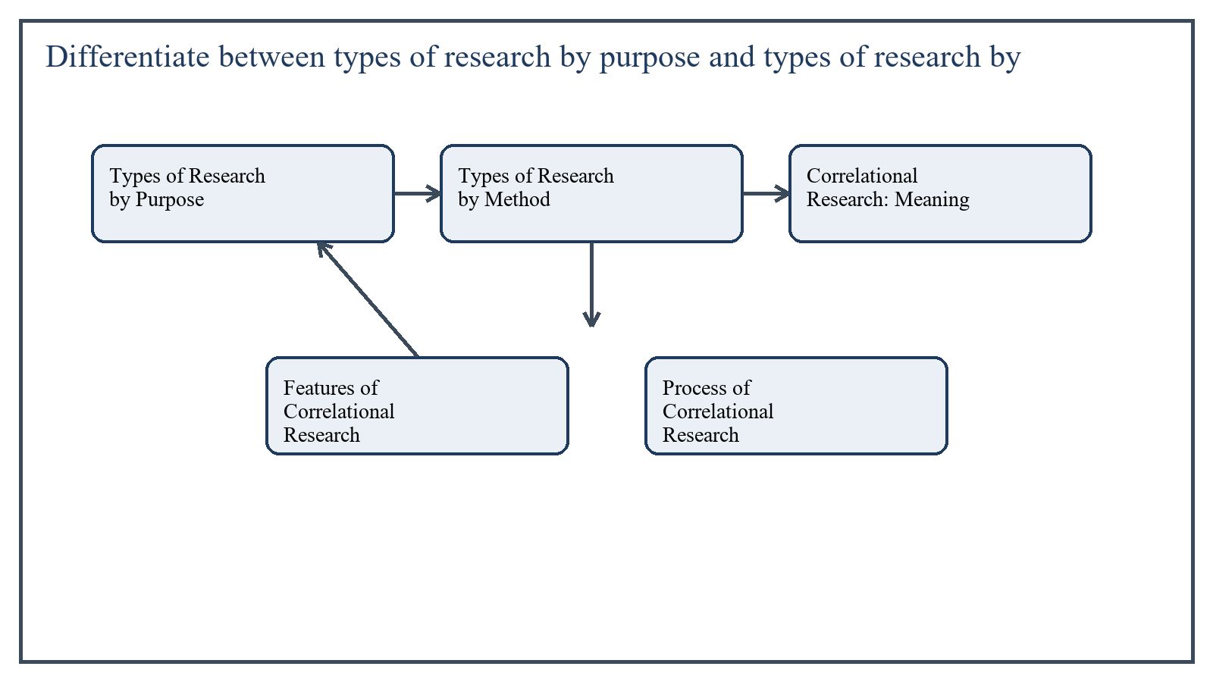
Figure 3: Concept map for Question 3

Types of Research by Purpose
Research by purpose is classified according to the goal or intention of the study. Common examples include basic research, applied research, and action research. In some contexts evaluative research is also included because it examines the worth or effectiveness of a program or policy.
This classification answers the question: why is the study being conducted?
In the context of Research Methods in Education, the theme of types of research by purpose deserves extended attention because assignment-level understanding is expected to move beyond one-line definitions and into explanation, comparison, and application. A strong university answer shows not only what the concept means, but also why it matters, how it appears in practice, and what limitations or challenges may arise when it is implemented in real educational settings.
A mature academic response also connects types of research by purpose with classroom realities, institutional culture, and the Pakistani context wherever relevant. This makes the answer more analytical and more useful because it links conceptual understanding with the needs of teachers, learners, administrators, and communities rather than leaving the idea at a purely theoretical level.
From an examination and assignment-writing perspective, the topic of types of research by purpose should be handled through clear structure, careful terminology, valid examples, and balanced discussion. The strongest responses usually define the idea, explain its major components, illustrate it through educational examples, and then conclude with a reasoned judgment about its significance, usefulness, or limitations.

Types of Research by Method
Research by method is classified according to the procedure or design used to collect and analyze data. Common types include historical research, descriptive research, correlational research, experimental research, survey research, and case study research.
This classification answers the question: how is the study conducted?
In the context of Research Methods in Education, the theme of types of research by method deserves extended attention because assignment-level understanding is expected to move beyond one-line definitions and into explanation, comparison, and application. A strong university answer shows not only what the concept means, but also why it matters, how it appears in practice, and what limitations or challenges may arise when it is implemented in real educational settings.
A mature academic response also connects types of research by method with classroom realities, institutional culture, and the Pakistani context wherever relevant. This makes the answer more analytical and more useful because it links conceptual understanding with the needs of teachers, learners, administrators, and communities rather than leaving the idea at a purely theoretical level.
From an examination and assignment-writing perspective, the topic of types of research by method should be handled through clear structure, careful terminology, valid examples, and balanced discussion. The strongest responses usually define the idea, explain its major components, illustrate it through educational examples, and then conclude with a reasoned judgment about its significance, usefulness, or limitations.

Correlational Research: Meaning
Correlational research examines the relationship between two or more variables. It does not manipulate variables like an experiment. Instead, it studies whether changes in one variable are associated with changes in another.
For example, a researcher may investigate the relationship between study habits and academic achievement, or between teacher feedback and student motivation.
In the context of Research Methods in Education, the theme of correlational research: meaning deserves extended attention because assignment-level understanding is expected to move beyond one-line definitions and into explanation, comparison, and application. A strong university answer shows not only what the concept means, but also why it matters, how it appears in practice, and what limitations or challenges may arise when it is implemented in real educational settings.
A mature academic response also connects correlational research: meaning with classroom realities, institutional culture, and the Pakistani context wherever relevant. This makes the answer more analytical and more useful because it links conceptual understanding with the needs of teachers, learners, administrators, and communities rather than leaving the idea at a purely theoretical level.
From an examination and assignment-writing perspective, the topic of correlational research: meaning should be handled through clear structure, careful terminology, valid examples, and balanced discussion. The strongest responses usually define the idea, explain its major components, illustrate it through educational examples, and then conclude with a reasoned judgment about its significance, usefulness, or limitations.

Features of Correlational Research
A positive correlation means both variables move in the same direction, while a negative correlation means they move in opposite directions. Zero correlation suggests no meaningful relationship.
- It focuses on naturally occurring variables.
- It measures the degree and direction of relationship.
- It does not establish cause-and-effect with certainty.
- It is useful where experimentation is difficult or unethical.
In the context of Research Methods in Education, the theme of features of correlational research deserves extended attention because assignment-level understanding is expected to move beyond one-line definitions and into explanation, comparison, and application. A strong university answer shows not only what the concept means, but also why it matters, how it appears in practice, and what limitations or challenges may arise when it is implemented in real educational settings.
A mature academic response also connects features of correlational research with classroom realities, institutional culture, and the Pakistani context wherever relevant. This makes the answer more analytical and more useful because it links conceptual understanding with the needs of teachers, learners, administrators, and communities rather than leaving the idea at a purely theoretical level.
From an examination and assignment-writing perspective, the topic of features of correlational research should be handled through clear structure, careful terminology, valid examples, and balanced discussion. The strongest responses usually define the idea, explain its major components, illustrate it through educational examples, and then conclude with a reasoned judgment about its significance, usefulness, or limitations.

Process of Correlational Research
- Select the variables to be studied.
- Define them operationally so they can be measured.
- Choose a suitable sample.
- Collect data using valid tools such as tests, scales, questionnaires, or records.
- Compute the correlation coefficient.
- Interpret the direction and strength of the relationship carefully.
In the context of Research Methods in Education, the theme of process of correlational research deserves extended attention because assignment-level understanding is expected to move beyond one-line definitions and into explanation, comparison, and application. A strong university answer shows not only what the concept means, but also why it matters, how it appears in practice, and what limitations or challenges may arise when it is implemented in real educational settings.
A mature academic response also connects process of correlational research with classroom realities, institutional culture, and the Pakistani context wherever relevant. This makes the answer more analytical and more useful because it links conceptual understanding with the needs of teachers, learners, administrators, and communities rather than leaving the idea at a purely theoretical level.
From an examination and assignment-writing perspective, the topic of process of correlational research should be handled through clear structure, careful terminology, valid examples, and balanced discussion. The strongest responses usually define the idea, explain its major components, illustrate it through educational examples, and then conclude with a reasoned judgment about its significance, usefulness, or limitations.

Importance and Limitation
Correlational research is important because it helps researchers identify associations that may guide prediction and further study. It is particularly useful in education, where many variables such as attitude, performance, attendance, and motivation interact with one another.
Its main limitation is that correlation does not prove causation. If two variables are related, it does not necessarily mean one causes the other. A third factor may influence both.
In the context of Research Methods in Education, the theme of importance and limitation deserves extended attention because assignment-level understanding is expected to move beyond one-line definitions and into explanation, comparison, and application. A strong university answer shows not only what the concept means, but also why it matters, how it appears in practice, and what limitations or challenges may arise when it is implemented in real educational settings.
A mature academic response also connects importance and limitation with classroom realities, institutional culture, and the Pakistani context wherever relevant. This makes the answer more analytical and more useful because it links conceptual understanding with the needs of teachers, learners, administrators, and communities rather than leaving the idea at a purely theoretical level.
From an examination and assignment-writing perspective, the topic of importance and limitation should be handled through clear structure, careful terminology, valid examples, and balanced discussion. The strongest responses usually define the idea, explain its major components, illustrate it through educational examples, and then conclude with a reasoned judgment about its significance, usefulness, or limitations.

Applied Illustration and Academic Note
For a stronger B.Ed assignment response, the topic above should be linked with classroom life, institutional practice, and the needs of Pakistani learners. This approach makes the response more analytical and demonstrates that the writer understands both theory and application, which is usually appreciated in AIOU-style academic work.
A good response also avoids unsupported claims. Instead, it explains concepts carefully, gives relevant examples, and ends with a short judgment about educational significance. In this way, the answer to 'Differentiate between types of research by purpose and types of resear...' becomes easier to read, easier to assess, and more academically convincing.

Quick Review Table
Focus Area | Assignment Relevance
Types of Research by Purpose | This area helps answer the question on 'Differentiate between types of research by purpose and ...' by providing concept clarity, explanation, and applied educational value.
Types of Research by Method | This area helps answer the question on 'Differentiate between types of research by purpose and ...' by providing concept clarity, explanation, and applied educational value.
Correlational Research: Meaning | This area helps answer the question on 'Differentiate between types of research by purpose and ...' by providing concept clarity, explanation, and applied educational value.
Features of Correlational Research | This area helps answer the question on 'Differentiate between types of research by purpose and ...' by providing concept clarity, explanation, and applied educational value.

Critical Reflection
At an advanced level, the topic should not be treated as a fixed formula. Most educational concepts work within particular conditions, and their success often depends on planning quality, learner background, institutional support, and the competence of the teacher or manager using them. A reflective assignment therefore acknowledges strengths while also recognizing practical limitations.

Conclusion
Research by purpose explains why a study is carried out, while research by method explains how it is conducted. Correlational research belongs to method-based classification and is valuable for examining relationships among educational variables, though it must be interpreted carefully because relationship is not the same as cause.

Q.4 Describe historical research in your own words and explain the importance and process of conducting historical research.
Answer: The answer below is organized in an academic assignment style, with conceptual explanation, applied discussion, and concise analytical closing comments designed for a neat and extended university submission.
Historical research is the systematic study of past events, ideas, institutions, persons, and developments in order to understand present conditions and future directions. It is not simple storytelling; it is a disciplined attempt to reconstruct and interpret the past on the basis of evidence.
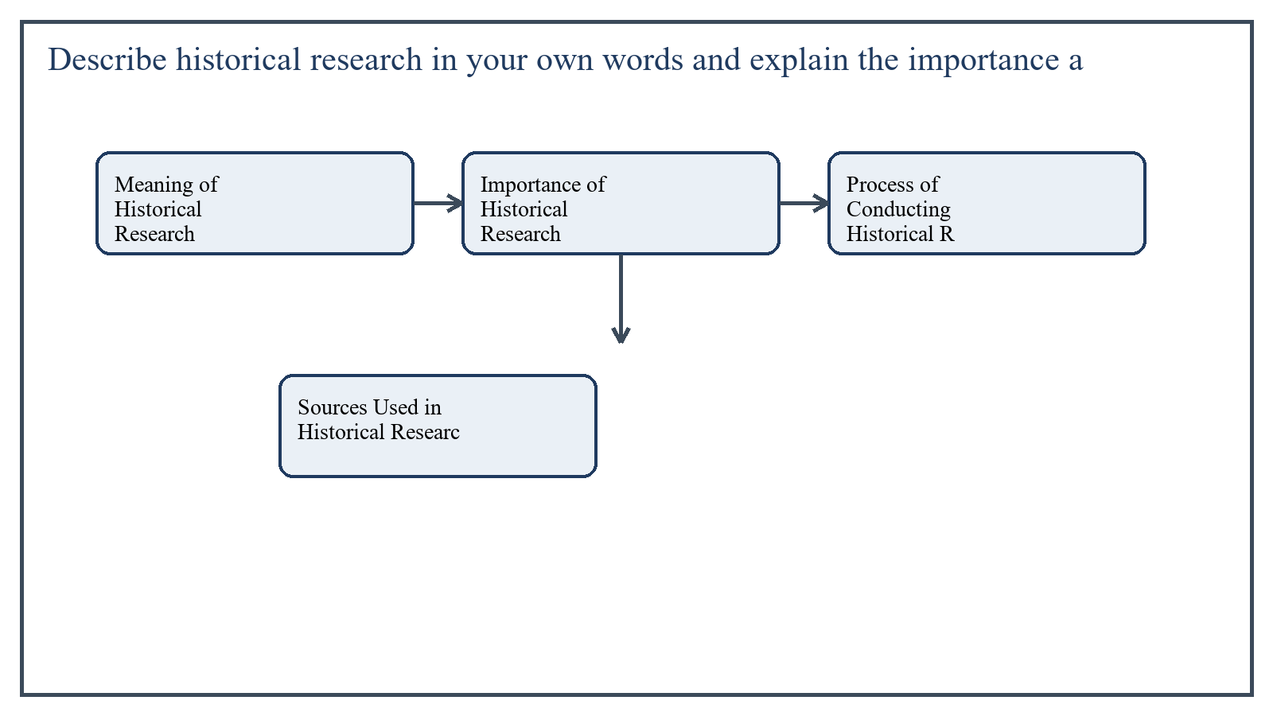
Figure 4: Concept map for Question 4

Meaning of Historical Research
In educational settings, historical research may examine the development of educational policies, curriculum reforms, institutions, teacher education, or social movements related to learning. For example, one may study the evolution of examination systems in Pakistan or the history of female education in a certain province.
In the context of Research Methods in Education, the theme of meaning of historical research deserves extended attention because assignment-level understanding is expected to move beyond one-line definitions and into explanation, comparison, and application. A strong university answer shows not only what the concept means, but also why it matters, how it appears in practice, and what limitations or challenges may arise when it is implemented in real educational settings.
A mature academic response also connects meaning of historical research with classroom realities, institutional culture, and the Pakistani context wherever relevant. This makes the answer more analytical and more useful because it links conceptual understanding with the needs of teachers, learners, administrators, and communities rather than leaving the idea at a purely theoretical level.
From an examination and assignment-writing perspective, the topic of meaning of historical research should be handled through clear structure, careful terminology, valid examples, and balanced discussion. The strongest responses usually define the idea, explain its major components, illustrate it through educational examples, and then conclude with a reasoned judgment about its significance, usefulness, or limitations.

Importance of Historical Research
Historical research is important because present educational systems are shaped by past decisions, values, and conditions. If researchers understand the roots of current policies and practices, they can interpret present issues more intelligently.
- It helps explain the origin and development of educational institutions and ideas.
- It provides lessons from past successes and failures.
- It supports policy understanding by linking current practice with historical context.
- It deepens critical thinking and perspective in educational analysis.
In the context of Research Methods in Education, the theme of importance of historical research deserves extended attention because assignment-level understanding is expected to move beyond one-line definitions and into explanation, comparison, and application. A strong university answer shows not only what the concept means, but also why it matters, how it appears in practice, and what limitations or challenges may arise when it is implemented in real educational settings.
A mature academic response also connects importance of historical research with classroom realities, institutional culture, and the Pakistani context wherever relevant. This makes the answer more analytical and more useful because it links conceptual understanding with the needs of teachers, learners, administrators, and communities rather than leaving the idea at a purely theoretical level.
From an examination and assignment-writing perspective, the topic of importance of historical research should be handled through clear structure, careful terminology, valid examples, and balanced discussion. The strongest responses usually define the idea, explain its major components, illustrate it through educational examples, and then conclude with a reasoned judgment about its significance, usefulness, or limitations.

Process of Conducting Historical Research
- Select and define the historical problem clearly.
- Determine the scope in terms of period, place, and focus.
- Locate relevant sources such as documents, records, letters, reports, minutes, newspapers, and archives.
- Examine source authenticity through external criticism.
- Evaluate source accuracy and meaning through internal criticism.
- Organize the evidence into themes or chronological patterns.
- Interpret the findings and write the report logically.
In the context of Research Methods in Education, the theme of process of conducting historical research deserves extended attention because assignment-level understanding is expected to move beyond one-line definitions and into explanation, comparison, and application. A strong university answer shows not only what the concept means, but also why it matters, how it appears in practice, and what limitations or challenges may arise when it is implemented in real educational settings.
A mature academic response also connects process of conducting historical research with classroom realities, institutional culture, and the Pakistani context wherever relevant. This makes the answer more analytical and more useful because it links conceptual understanding with the needs of teachers, learners, administrators, and communities rather than leaving the idea at a purely theoretical level.
From an examination and assignment-writing perspective, the topic of process of conducting historical research should be handled through clear structure, careful terminology, valid examples, and balanced discussion. The strongest responses usually define the idea, explain its major components, illustrate it through educational examples, and then conclude with a reasoned judgment about its significance, usefulness, or limitations.

Sources Used in Historical Research
Historical research depends on primary and secondary sources. Primary sources include original documents such as official records, diaries, speeches, and archival papers. Secondary sources include books, articles, and reports written later by other scholars.
In the context of Research Methods in Education, the theme of sources used in historical research deserves extended attention because assignment-level understanding is expected to move beyond one-line definitions and into explanation, comparison, and application. A strong university answer shows not only what the concept means, but also why it matters, how it appears in practice, and what limitations or challenges may arise when it is implemented in real educational settings.
A mature academic response also connects sources used in historical research with classroom realities, institutional culture, and the Pakistani context wherever relevant. This makes the answer more analytical and more useful because it links conceptual understanding with the needs of teachers, learners, administrators, and communities rather than leaving the idea at a purely theoretical level.
From an examination and assignment-writing perspective, the topic of sources used in historical research should be handled through clear structure, careful terminology, valid examples, and balanced discussion. The strongest responses usually define the idea, explain its major components, illustrate it through educational examples, and then conclude with a reasoned judgment about its significance, usefulness, or limitations.

Applied Illustration and Academic Note
For a stronger B.Ed assignment response, the topic above should be linked with classroom life, institutional practice, and the needs of Pakistani learners. This approach makes the response more analytical and demonstrates that the writer understands both theory and application, which is usually appreciated in AIOU-style academic work.
A good response also avoids unsupported claims. Instead, it explains concepts carefully, gives relevant examples, and ends with a short judgment about educational significance. In this way, the answer to 'Describe historical research in your own words and explain the importa...' becomes easier to read, easier to assess, and more academically convincing.

Quick Review Table
Focus Area | Assignment Relevance
Meaning of Historical Research | This area helps answer the question on 'Describe historical research in your own words and expl...' by providing concept clarity, explanation, and applied educational value.
Importance of Historical Research | This area helps answer the question on 'Describe historical research in your own words and expl...' by providing concept clarity, explanation, and applied educational value.
Process of Conducting Historical Research | This area helps answer the question on 'Describe historical research in your own words and expl...' by providing concept clarity, explanation, and applied educational value.
Sources Used in Historical Research | This area helps answer the question on 'Describe historical research in your own words and expl...' by providing concept clarity, explanation, and applied educational value.

Critical Reflection
At an advanced level, the topic should not be treated as a fixed formula. Most educational concepts work within particular conditions, and their success often depends on planning quality, learner background, institutional support, and the competence of the teacher or manager using them. A reflective assignment therefore acknowledges strengths while also recognizing practical limitations.

Conclusion
Historical research helps educators understand how past ideas and events influence present educational realities. Its importance lies in explanation, perspective, and policy learning, while its process requires careful problem definition, source evaluation, and evidence-based interpretation.

Q.5 Define different variables related to experimental research and explain the detailed process of designing and conducting an experiment in the field of education.
Answer: The answer below is organized in an academic assignment style, with conceptual explanation, applied discussion, and concise analytical closing comments designed for a neat and extended university submission.
Experimental research is one of the strongest methods for studying cause-and-effect relationships because it involves deliberate manipulation and control. To understand this design properly, students must first understand the variables used in it.
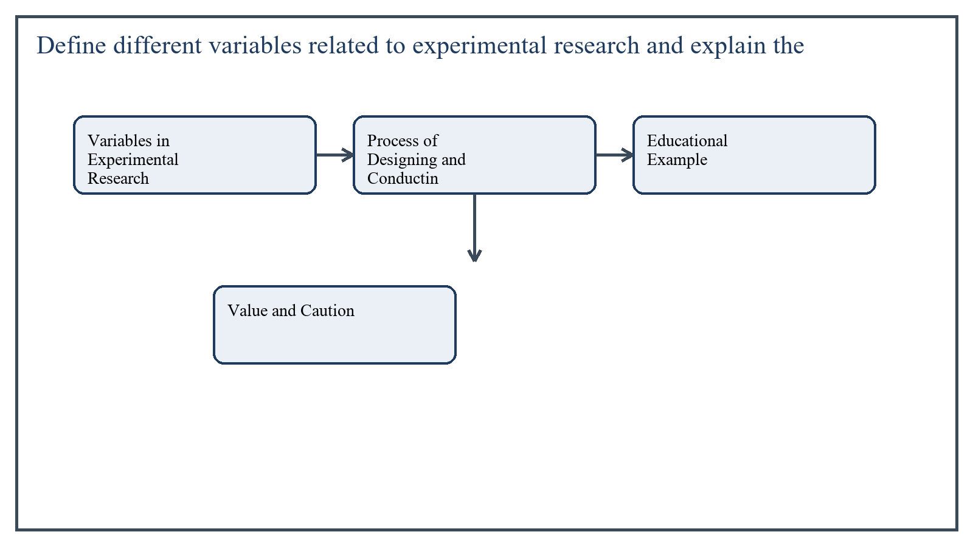
Figure 5: Concept map for Question 5

Variables in Experimental Research
The independent variable is the factor deliberately introduced or changed by the researcher. For example, a new teaching method may be used as the independent variable.
The dependent variable is the outcome that is measured to see the effect of the independent variable. For instance, students' achievement scores may be the dependent variable.
Control variables are factors the researcher attempts to keep constant so that they do not interfere with the results, such as time, content coverage, or classroom conditions.
Extraneous variables are outside factors that may affect the dependent variable unintentionally, such as prior knowledge, motivation, or home support. Researchers try to reduce their influence.
In some studies, moderator variables or intervening variables may also be discussed because they change the strength or pathway of the effect.
In the context of Research Methods in Education, the theme of variables in experimental research deserves extended attention because assignment-level understanding is expected to move beyond one-line definitions and into explanation, comparison, and application. A strong university answer shows not only what the concept means, but also why it matters, how it appears in practice, and what limitations or challenges may arise when it is implemented in real educational settings.
A mature academic response also connects variables in experimental research with classroom realities, institutional culture, and the Pakistani context wherever relevant. This makes the answer more analytical and more useful because it links conceptual understanding with the needs of teachers, learners, administrators, and communities rather than leaving the idea at a purely theoretical level.
From an examination and assignment-writing perspective, the topic of variables in experimental research should be handled through clear structure, careful terminology, valid examples, and balanced discussion. The strongest responses usually define the idea, explain its major components, illustrate it through educational examples, and then conclude with a reasoned judgment about its significance, usefulness, or limitations.

Process of Designing and Conducting an Educational Experiment
- Identify the educational problem and formulate a clear hypothesis.
- Define the independent and dependent variables operationally.
- Select participants and assign them to experimental and control groups if the design requires comparison.
- Ensure both groups are comparable at the start, often through a pretest or matching.
- Administer the treatment or intervention to the experimental group while the control group receives the usual method or an alternative condition.
- Maintain control over time, content, and procedure as far as possible.
- Collect post-test data after the intervention period.
- Analyze results statistically and interpret whether the treatment made a significant difference.
In the context of Research Methods in Education, the theme of process of designing and conducting an educational experiment deserves extended attention because assignment-level understanding is expected to move beyond one-line definitions and into explanation, comparison, and application. A strong university answer shows not only what the concept means, but also why it matters, how it appears in practice, and what limitations or challenges may arise when it is implemented in real educational settings.
A mature academic response also connects process of designing and conducting an educational experiment with classroom realities, institutional culture, and the Pakistani context wherever relevant. This makes the answer more analytical and more useful because it links conceptual understanding with the needs of teachers, learners, administrators, and communities rather than leaving the idea at a purely theoretical level.
From an examination and assignment-writing perspective, the topic of process of designing and conducting an educational experiment should be handled through clear structure, careful terminology, valid examples, and balanced discussion. The strongest responses usually define the idea, explain its major components, illustrate it through educational examples, and then conclude with a reasoned judgment about its significance, usefulness, or limitations.

Educational Example
Suppose a researcher wants to test whether cooperative learning improves science achievement. Two similar groups of students are selected. One group is taught through cooperative learning, while the other is taught through lecture method. After a fixed period, both groups are tested and their results compared.
In the context of Research Methods in Education, the theme of educational example deserves extended attention because assignment-level understanding is expected to move beyond one-line definitions and into explanation, comparison, and application. A strong university answer shows not only what the concept means, but also why it matters, how it appears in practice, and what limitations or challenges may arise when it is implemented in real educational settings.
A mature academic response also connects educational example with classroom realities, institutional culture, and the Pakistani context wherever relevant. This makes the answer more analytical and more useful because it links conceptual understanding with the needs of teachers, learners, administrators, and communities rather than leaving the idea at a purely theoretical level.
From an examination and assignment-writing perspective, the topic of educational example should be handled through clear structure, careful terminology, valid examples, and balanced discussion. The strongest responses usually define the idea, explain its major components, illustrate it through educational examples, and then conclude with a reasoned judgment about its significance, usefulness, or limitations.

Value and Caution
Experimental research is valuable because it provides strong evidence about effectiveness. However, in educational settings full control is often difficult because students differ in background and real classrooms cannot always be manipulated like laboratories. Therefore, careful design and ethical practice are essential.
In the context of Research Methods in Education, the theme of value and caution deserves extended attention because assignment-level understanding is expected to move beyond one-line definitions and into explanation, comparison, and application. A strong university answer shows not only what the concept means, but also why it matters, how it appears in practice, and what limitations or challenges may arise when it is implemented in real educational settings.
A mature academic response also connects value and caution with classroom realities, institutional culture, and the Pakistani context wherever relevant. This makes the answer more analytical and more useful because it links conceptual understanding with the needs of teachers, learners, administrators, and communities rather than leaving the idea at a purely theoretical level.
From an examination and assignment-writing perspective, the topic of value and caution should be handled through clear structure, careful terminology, valid examples, and balanced discussion. The strongest responses usually define the idea, explain its major components, illustrate it through educational examples, and then conclude with a reasoned judgment about its significance, usefulness, or limitations.

Applied Illustration and Academic Note
For a stronger B.Ed assignment response, the topic above should be linked with classroom life, institutional practice, and the needs of Pakistani learners. This approach makes the response more analytical and demonstrates that the writer understands both theory and application, which is usually appreciated in AIOU-style academic work.
A good response also avoids unsupported claims. Instead, it explains concepts carefully, gives relevant examples, and ends with a short judgment about educational significance. In this way, the answer to 'Define different variables related to experimental research and explai...' becomes easier to read, easier to assess, and more academically convincing.

Quick Review Table
Focus Area | Assignment Relevance
Variables in Experimental Research | This area helps answer the question on 'Define different variables related to experimental rese...' by providing concept clarity, explanation, and applied educational value.
Process of Designing and Conducting an Educational Experiment | This area helps answer the question on 'Define different variables related to experimental rese...' by providing concept clarity, explanation, and applied educational value.
Educational Example | This area helps answer the question on 'Define different variables related to experimental rese...' by providing concept clarity, explanation, and applied educational value.
Value and Caution | This area helps answer the question on 'Define different variables related to experimental rese...' by providing concept clarity, explanation, and applied educational value.

Critical Reflection
At an advanced level, the topic should not be treated as a fixed formula. Most educational concepts work within particular conditions, and their success often depends on planning quality, learner background, institutional support, and the competence of the teacher or manager using them. A reflective assignment therefore acknowledges strengths while also recognizing practical limitations.

Conclusion
Experimental research uses variables such as independent, dependent, control, and extraneous variables to study cause and effect. Its detailed process includes hypothesis formulation, group selection, treatment administration, control of conditions, and comparison of outcomes. When carefully designed, it is highly useful for testing educational interventions.

Extended Revision Appendix
This appendix is included to strengthen the assignment as a premium academic submission. It provides recap notes, revision prompts, and concept reinforcement so the document reads like a complete study-ready submission rather than a short-answer sheet only.

Key Revision Points
- Review the central demand of the question 'Describe different sources of knowledge by giving examples and...' and connect definition, explanation, example, and critical comment in one organized response.
- Review the central demand of the question 'Differentiate between basic and applied research by giving exa...' and connect definition, explanation, example, and critical comment in one organized response.
- Review the central demand of the question 'Differentiate between types of research by purpose and types o...' and connect definition, explanation, example, and critical comment in one organized response.
- Review the central demand of the question 'Describe historical research in your own words and explain the...' and connect definition, explanation, example, and critical comment in one organized response.
- Review the central demand of the question 'Define different variables related to experimental research an...' and connect definition, explanation, example, and critical comment in one organized response.

Academic Writing Reminders
- Begin each major answer with a clear conceptual opening.
- Use examples to show understanding instead of repeating definitions only.
- Present advantages, limitations, and contextual realities where relevant.
- Close each answer with a short evaluative conclusion.
- Maintain formal and neat language throughout the assignment.

Concept Reinforcement Notes
The question on 'Describe different sources of knowledge by giving examples and explain the ...' can be revised further by identifying three things: the main concept involved, the educational importance of that concept, and one example from Pakistani classroom or institutional life. This simple method helps transform memorized content into organized written response.
The question on 'Differentiate between basic and applied research by giving examples and exp...' can be revised further by identifying three things: the main concept involved, the educational importance of that concept, and one example from Pakistani classroom or institutional life. This simple method helps transform memorized content into organized written response.
The question on 'Differentiate between types of research by purpose and types of research by...' can be revised further by identifying three things: the main concept involved, the educational importance of that concept, and one example from Pakistani classroom or institutional life. This simple method helps transform memorized content into organized written response.
The question on 'Describe historical research in your own words and explain the importance a...' can be revised further by identifying three things: the main concept involved, the educational importance of that concept, and one example from Pakistani classroom or institutional life. This simple method helps transform memorized content into organized written response.
The question on 'Define different variables related to experimental research and explain the...' can be revised further by identifying three things: the main concept involved, the educational importance of that concept, and one example from Pakistani classroom or institutional life. This simple method helps transform memorized content into organized written response.

Source Base and Assignment Support Notes
The following source base was used to keep the answers aligned with AIOU course structure and the exact question wording. The final language and organization were expanded for presentation quality, page-length target, and assignment readability.
- AIOU Soft Book: Research Methods in Education (Code 8604), especially units on knowledge, educational research, research classifications, historical research, correlational research, and experimental research.
- AIOU Spring 2026 assignment sheet for Course 8604.

Extended Analytical Note 1
In extended study of Research Methods in Education, the issue raised in 'Describe different sources of knowledge by giving examples and explain t...' may also be explored through definition, theoretical explanation, applied example, classroom implication, institutional implication, and critical reflection. This six-part approach helps a learner produce a more complete answer and also improves the academic appearance of the assignment by showing structure and depth.
Another useful strategy in long-form assignment writing is to move carefully from concept to context. First explain what the idea means, then identify its components, then discuss its relevance in teaching or administration, and finally mention any practical limitation. Such movement gives maturity to the answer and helps the examiner follow the logic without difficulty.
In extended study of Research Methods in Education, the issue raised in 'Differentiate between basic and applied research by giving examples and ...' may also be explored through definition, theoretical explanation, applied example, classroom implication, institutional implication, and critical reflection. This six-part approach helps a learner produce a more complete answer and also improves the academic appearance of the assignment by showing structure and depth.
Another useful strategy in long-form assignment writing is to move carefully from concept to context. First explain what the idea means, then identify its components, then discuss its relevance in teaching or administration, and finally mention any practical limitation. Such movement gives maturity to the answer and helps the examiner follow the logic without difficulty.
In extended study of Research Methods in Education, the issue raised in 'Differentiate between types of research by purpose and types of research...' may also be explored through definition, theoretical explanation, applied example, classroom implication, institutional implication, and critical reflection. This six-part approach helps a learner produce a more complete answer and also improves the academic appearance of the assignment by showing structure and depth.
Another useful strategy in long-form assignment writing is to move carefully from concept to context. First explain what the idea means, then identify its components, then discuss its relevance in teaching or administration, and finally mention any practical limitation. Such movement gives maturity to the answer and helps the examiner follow the logic without difficulty.
In extended study of Research Methods in Education, the issue raised in 'Describe historical research in your own words and explain the importanc...' may also be explored through definition, theoretical explanation, applied example, classroom implication, institutional implication, and critical reflection. This six-part approach helps a learner produce a more complete answer and also improves the academic appearance of the assignment by showing structure and depth.
Another useful strategy in long-form assignment writing is to move carefully from concept to context. First explain what the idea means, then identify its components, then discuss its relevance in teaching or administration, and finally mention any practical limitation. Such movement gives maturity to the answer and helps the examiner follow the logic without difficulty.
In extended study of Research Methods in Education, the issue raised in 'Define different variables related to experimental research and explain ...' may also be explored through definition, theoretical explanation, applied example, classroom implication, institutional implication, and critical reflection. This six-part approach helps a learner produce a more complete answer and also improves the academic appearance of the assignment by showing structure and depth.
Another useful strategy in long-form assignment writing is to move carefully from concept to context. First explain what the idea means, then identify its components, then discuss its relevance in teaching or administration, and finally mention any practical limitation. Such movement gives maturity to the answer and helps the examiner follow the logic without difficulty.

Extended Analytical Note 2
In extended study of Research Methods in Education, the issue raised in 'Describe different sources of knowledge by giving examples and explain t...' may also be explored through definition, theoretical explanation, applied example, classroom implication, institutional implication, and critical reflection. This six-part approach helps a learner produce a more complete answer and also improves the academic appearance of the assignment by showing structure and depth.
Another useful strategy in long-form assignment writing is to move carefully from concept to context. First explain what the idea means, then identify its components, then discuss its relevance in teaching or administration, and finally mention any practical limitation. Such movement gives maturity to the answer and helps the examiner follow the logic without difficulty.
In extended study of Research Methods in Education, the issue raised in 'Differentiate between basic and applied research by giving examples and ...' may also be explored through definition, theoretical explanation, applied example, classroom implication, institutional implication, and critical reflection. This six-part approach helps a learner produce a more complete answer and also improves the academic appearance of the assignment by showing structure and depth.
Another useful strategy in long-form assignment writing is to move carefully from concept to context. First explain what the idea means, then identify its components, then discuss its relevance in teaching or administration, and finally mention any practical limitation. Such movement gives maturity to the answer and helps the examiner follow the logic without difficulty.
In extended study of Research Methods in Education, the issue raised in 'Differentiate between types of research by purpose and types of research...' may also be explored through definition, theoretical explanation, applied example, classroom implication, institutional implication, and critical reflection. This six-part approach helps a learner produce a more complete answer and also improves the academic appearance of the assignment by showing structure and depth.
Another useful strategy in long-form assignment writing is to move carefully from concept to context. First explain what the idea means, then identify its components, then discuss its relevance in teaching or administration, and finally mention any practical limitation. Such movement gives maturity to the answer and helps the examiner follow the logic without difficulty.
In extended study of Research Methods in Education, the issue raised in 'Describe historical research in your own words and explain the importanc...' may also be explored through definition, theoretical explanation, applied example, classroom implication, institutional implication, and critical reflection. This six-part approach helps a learner produce a more complete answer and also improves the academic appearance of the assignment by showing structure and depth.
Another useful strategy in long-form assignment writing is to move carefully from concept to context. First explain what the idea means, then identify its components, then discuss its relevance in teaching or administration, and finally mention any practical limitation. Such movement gives maturity to the answer and helps the examiner follow the logic without difficulty.
In extended study of Research Methods in Education, the issue raised in 'Define different variables related to experimental research and explain ...' may also be explored through definition, theoretical explanation, applied example, classroom implication, institutional implication, and critical reflection. This six-part approach helps a learner produce a more complete answer and also improves the academic appearance of the assignment by showing structure and depth.
Another useful strategy in long-form assignment writing is to move carefully from concept to context. First explain what the idea means, then identify its components, then discuss its relevance in teaching or administration, and finally mention any practical limitation. Such movement gives maturity to the answer and helps the examiner follow the logic without difficulty.

Extended Analytical Note 3
In extended study of Research Methods in Education, the issue raised in 'Describe different sources of knowledge by giving examples and explain t...' may also be explored through definition, theoretical explanation, applied example, classroom implication, institutional implication, and critical reflection. This six-part approach helps a learner produce a more complete answer and also improves the academic appearance of the assignment by showing structure and depth.
Another useful strategy in long-form assignment writing is to move carefully from concept to context. First explain what the idea means, then identify its components, then discuss its relevance in teaching or administration, and finally mention any practical limitation. Such movement gives maturity to the answer and helps the examiner follow the logic without difficulty.
In extended study of Research Methods in Education, the issue raised in 'Differentiate between basic and applied research by giving examples and ...' may also be explored through definition, theoretical explanation, applied example, classroom implication, institutional implication, and critical reflection. This six-part approach helps a learner produce a more complete answer and also improves the academic appearance of the assignment by showing structure and depth.
Another useful strategy in long-form assignment writing is to move carefully from concept to context. First explain what the idea means, then identify its components, then discuss its relevance in teaching or administration, and finally mention any practical limitation. Such movement gives maturity to the answer and helps the examiner follow the logic without difficulty.
In extended study of Research Methods in Education, the issue raised in 'Differentiate between types of research by purpose and types of research...' may also be explored through definition, theoretical explanation, applied example, classroom implication, institutional implication, and critical reflection. This six-part approach helps a learner produce a more complete answer and also improves the academic appearance of the assignment by showing structure and depth.
Another useful strategy in long-form assignment writing is to move carefully from concept to context. First explain what the idea means, then identify its components, then discuss its relevance in teaching or administration, and finally mention any practical limitation. Such movement gives maturity to the answer and helps the examiner follow the logic without difficulty.
In extended study of Research Methods in Education, the issue raised in 'Describe historical research in your own words and explain the importanc...' may also be explored through definition, theoretical explanation, applied example, classroom implication, institutional implication, and critical reflection. This six-part approach helps a learner produce a more complete answer and also improves the academic appearance of the assignment by showing structure and depth.
Another useful strategy in long-form assignment writing is to move carefully from concept to context. First explain what the idea means, then identify its components, then discuss its relevance in teaching or administration, and finally mention any practical limitation. Such movement gives maturity to the answer and helps the examiner follow the logic without difficulty.
In extended study of Research Methods in Education, the issue raised in 'Define different variables related to experimental research and explain ...' may also be explored through definition, theoretical explanation, applied example, classroom implication, institutional implication, and critical reflection. This six-part approach helps a learner produce a more complete answer and also improves the academic appearance of the assignment by showing structure and depth.
Another useful strategy in long-form assignment writing is to move carefully from concept to context. First explain what the idea means, then identify its components, then discuss its relevance in teaching or administration, and finally mention any practical limitation. Such movement gives maturity to the answer and helps the examiner follow the logic without difficulty.

Extended Analytical Note 4
In extended study of Research Methods in Education, the issue raised in 'Describe different sources of knowledge by giving examples and explain t...' may also be explored through definition, theoretical explanation, applied example, classroom implication, institutional implication, and critical reflection. This six-part approach helps a learner produce a more complete answer and also improves the academic appearance of the assignment by showing structure and depth.
Another useful strategy in long-form assignment writing is to move carefully from concept to context. First explain what the idea means, then identify its components, then discuss its relevance in teaching or administration, and finally mention any practical limitation. Such movement gives maturity to the answer and helps the examiner follow the logic without difficulty.
In extended study of Research Methods in Education, the issue raised in 'Differentiate between basic and applied research by giving examples and ...' may also be explored through definition, theoretical explanation, applied example, classroom implication, institutional implication, and critical reflection. This six-part approach helps a learner produce a more complete answer and also improves the academic appearance of the assignment by showing structure and depth.
Another useful strategy in long-form assignment writing is to move carefully from concept to context. First explain what the idea means, then identify its components, then discuss its relevance in teaching or administration, and finally mention any practical limitation. Such movement gives maturity to the answer and helps the examiner follow the logic without difficulty.
In extended study of Research Methods in Education, the issue raised in 'Differentiate between types of research by purpose and types of research...' may also be explored through definition, theoretical explanation, applied example, classroom implication, institutional implication, and critical reflection. This six-part approach helps a learner produce a more complete answer and also improves the academic appearance of the assignment by showing structure and depth.
Another useful strategy in long-form assignment writing is to move carefully from concept to context. First explain what the idea means, then identify its components, then discuss its relevance in teaching or administration, and finally mention any practical limitation. Such movement gives maturity to the answer and helps the examiner follow the logic without difficulty.
In extended study of Research Methods in Education, the issue raised in 'Describe historical research in your own words and explain the importanc...' may also be explored through definition, theoretical explanation, applied example, classroom implication, institutional implication, and critical reflection. This six-part approach helps a learner produce a more complete answer and also improves the academic appearance of the assignment by showing structure and depth.
Another useful strategy in long-form assignment writing is to move carefully from concept to context. First explain what the idea means, then identify its components, then discuss its relevance in teaching or administration, and finally mention any practical limitation. Such movement gives maturity to the answer and helps the examiner follow the logic without difficulty.
In extended study of Research Methods in Education, the issue raised in 'Define different variables related to experimental research and explain ...' may also be explored through definition, theoretical explanation, applied example, classroom implication, institutional implication, and critical reflection. This six-part approach helps a learner produce a more complete answer and also improves the academic appearance of the assignment by showing structure and depth.
Another useful strategy in long-form assignment writing is to move carefully from concept to context. First explain what the idea means, then identify its components, then discuss its relevance in teaching or administration, and finally mention any practical limitation. Such movement gives maturity to the answer and helps the examiner follow the logic without difficulty.

Extended Analytical Note 5
In extended study of Research Methods in Education, the issue raised in 'Describe different sources of knowledge by giving examples and explain t...' may also be explored through definition, theoretical explanation, applied example, classroom implication, institutional implication, and critical reflection. This six-part approach helps a learner produce a more complete answer and also improves the academic appearance of the assignment by showing structure and depth.
Another useful strategy in long-form assignment writing is to move carefully from concept to context. First explain what the idea means, then identify its components, then discuss its relevance in teaching or administration, and finally mention any practical limitation. Such movement gives maturity to the answer and helps the examiner follow the logic without difficulty.
In extended study of Research Methods in Education, the issue raised in 'Differentiate between basic and applied research by giving examples and ...' may also be explored through definition, theoretical explanation, applied example, classroom implication, institutional implication, and critical reflection. This six-part approach helps a learner produce a more complete answer and also improves the academic appearance of the assignment by showing structure and depth.
Another useful strategy in long-form assignment writing is to move carefully from concept to context. First explain what the idea means, then identify its components, then discuss its relevance in teaching or administration, and finally mention any practical limitation. Such movement gives maturity to the answer and helps the examiner follow the logic without difficulty.
In extended study of Research Methods in Education, the issue raised in 'Differentiate between types of research by purpose and types of research...' may also be explored through definition, theoretical explanation, applied example, classroom implication, institutional implication, and critical reflection. This six-part approach helps a learner produce a more complete answer and also improves the academic appearance of the assignment by showing structure and depth.
Another useful strategy in long-form assignment writing is to move carefully from concept to context. First explain what the idea means, then identify its components, then discuss its relevance in teaching or administration, and finally mention any practical limitation. Such movement gives maturity to the answer and helps the examiner follow the logic without difficulty.
In extended study of Research Methods in Education, the issue raised in 'Describe historical research in your own words and explain the importanc...' may also be explored through definition, theoretical explanation, applied example, classroom implication, institutional implication, and critical reflection. This six-part approach helps a learner produce a more complete answer and also improves the academic appearance of the assignment by showing structure and depth.
Another useful strategy in long-form assignment writing is to move carefully from concept to context. First explain what the idea means, then identify its components, then discuss its relevance in teaching or administration, and finally mention any practical limitation. Such movement gives maturity to the answer and helps the examiner follow the logic without difficulty.
In extended study of Research Methods in Education, the issue raised in 'Define different variables related to experimental research and explain ...' may also be explored through definition, theoretical explanation, applied example, classroom implication, institutional implication, and critical reflection. This six-part approach helps a learner produce a more complete answer and also improves the academic appearance of the assignment by showing structure and depth.
Another useful strategy in long-form assignment writing is to move carefully from concept to context. First explain what the idea means, then identify its components, then discuss its relevance in teaching or administration, and finally mention any practical limitation. Such movement gives maturity to the answer and helps the examiner follow the logic without difficulty.

