ALLAMA IQBAL OPEN UNIVERSITY
Premium Typed Assignment
Research Methods in Education
Detail | Course Code: 8604
Detail | Assignment No: 2
Detail | Unit Coverage: Units 5-9
Detail | Program Level: B.Ed
Detail | Formatting Profile: Times New Roman, 14 pt headings, 12 pt body text
Detail | Document Goal: Extended academic response with diagrams, border styling, and premium presentation

Presentation Note
This file has been prepared as a premium typed assignment with extended academic treatment, proper page border styling, inserted diagrams, formal headings, and neat section hierarchy. The content is intentionally expanded so that the assignment remains easy to read while still meeting a high page-length target.

Q.1 Differentiate between experimental and descriptive research and explain the different types of descriptive research briefly by giving valid examples.
Answer: The answer below is organized in an academic assignment style, with conceptual explanation, applied discussion, and concise analytical closing comments designed for a neat and extended university submission.
Experimental and descriptive research differ mainly in purpose and design. One tests causal effect through manipulation, while the other describes existing conditions, characteristics, or relationships without experimental control.
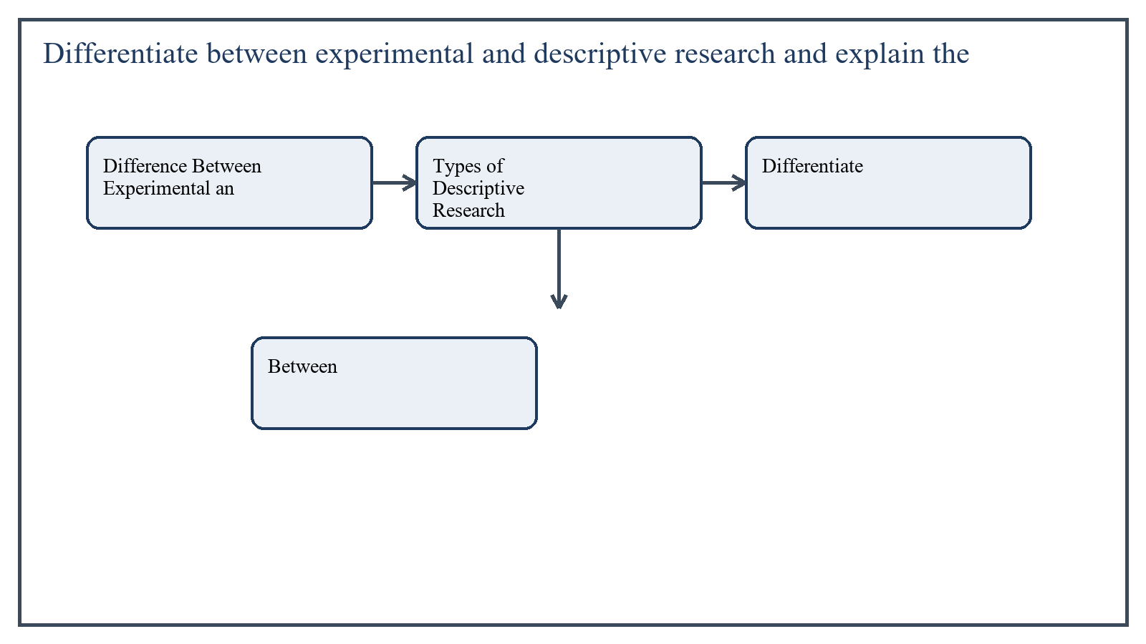
Figure 1: Concept map for Question 1

Difference Between Experimental and Descriptive Research
Experimental research involves manipulation of an independent variable to see its effect on a dependent variable under controlled conditions. It seeks to answer causal questions such as whether a new teaching strategy improves achievement.
Descriptive research, on the other hand, does not manipulate variables. It studies what exists in the present and aims to describe conditions, opinions, practices, traits, or relationships. For example, a study of students' attitudes toward online learning is descriptive.
In the context of Research Methods in Education, the theme of difference between experimental and descriptive research deserves extended attention because assignment-level understanding is expected to move beyond one-line definitions and into explanation, comparison, and application. A strong university answer shows not only what the concept means, but also why it matters, how it appears in practice, and what limitations or challenges may arise when it is implemented in real educational settings.
A mature academic response also connects difference between experimental and descriptive research with classroom realities, institutional culture, and the Pakistani context wherever relevant. This makes the answer more analytical and more useful because it links conceptual understanding with the needs of teachers, learners, administrators, and communities rather than leaving the idea at a purely theoretical level.
From an examination and assignment-writing perspective, the topic of difference between experimental and descriptive research should be handled through clear structure, careful terminology, valid examples, and balanced discussion. The strongest responses usually define the idea, explain its major components, illustrate it through educational examples, and then conclude with a reasoned judgment about its significance, usefulness, or limitations.

Types of Descriptive Research
Survey research collects information from a sample through questionnaires, interviews, or schedules. Example: surveying secondary school teachers about classroom discipline problems.
Case study research examines one person, institution, class, or event in depth. Example: an in-depth study of one inclusive school and its support practices.
Observational research focuses on behavior as it occurs naturally. Example: observing student participation patterns during group work.
Comparative descriptive research compares two or more groups on selected traits. Example: comparing study habits of urban and rural students.
Developmental or trend studies describe change over time without full experimentation. Example: studying change in reading habits across grade levels.
In the context of Research Methods in Education, the theme of types of descriptive research deserves extended attention because assignment-level understanding is expected to move beyond one-line definitions and into explanation, comparison, and application. A strong university answer shows not only what the concept means, but also why it matters, how it appears in practice, and what limitations or challenges may arise when it is implemented in real educational settings.
A mature academic response also connects types of descriptive research with classroom realities, institutional culture, and the Pakistani context wherever relevant. This makes the answer more analytical and more useful because it links conceptual understanding with the needs of teachers, learners, administrators, and communities rather than leaving the idea at a purely theoretical level.
From an examination and assignment-writing perspective, the topic of types of descriptive research should be handled through clear structure, careful terminology, valid examples, and balanced discussion. The strongest responses usually define the idea, explain its major components, illustrate it through educational examples, and then conclude with a reasoned judgment about its significance, usefulness, or limitations.

Applied Illustration and Academic Note
For a stronger B.Ed assignment response, the topic above should be linked with classroom life, institutional practice, and the needs of Pakistani learners. This approach makes the response more analytical and demonstrates that the writer understands both theory and application, which is usually appreciated in AIOU-style academic work.
A good response also avoids unsupported claims. Instead, it explains concepts carefully, gives relevant examples, and ends with a short judgment about educational significance. In this way, the answer to 'Differentiate between experimental and descriptive research and explai...' becomes easier to read, easier to assess, and more academically convincing.

Quick Review Table
Focus Area | Assignment Relevance
Difference Between Experimental and Descriptive Research | This area helps answer the question on 'Differentiate between experimental and descriptive rese...' by providing concept clarity, explanation, and applied educational value.
Types of Descriptive Research | This area helps answer the question on 'Differentiate between experimental and descriptive rese...' by providing concept clarity, explanation, and applied educational value.

Critical Reflection
At an advanced level, the topic should not be treated as a fixed formula. Most educational concepts work within particular conditions, and their success often depends on planning quality, learner background, institutional support, and the competence of the teacher or manager using them. A reflective assignment therefore acknowledges strengths while also recognizing practical limitations.

Conclusion
Experimental research is designed to test cause and effect, while descriptive research is designed to describe and interpret existing reality. The various types of descriptive research provide flexible tools for studying educational conditions without manipulating them.

Q.2 Explain the significance of research tools/instruments for data collection and write detailed notes on any two of the following: questionnaire, interview protocol, achievement test.
Answer: The answer below is organized in an academic assignment style, with conceptual explanation, applied discussion, and concise analytical closing comments designed for a neat and extended university submission.
Research tools or instruments are the practical means through which data are collected. Their significance is very high because even a strong topic and good design can fail if the researcher uses weak or unsuitable instruments.
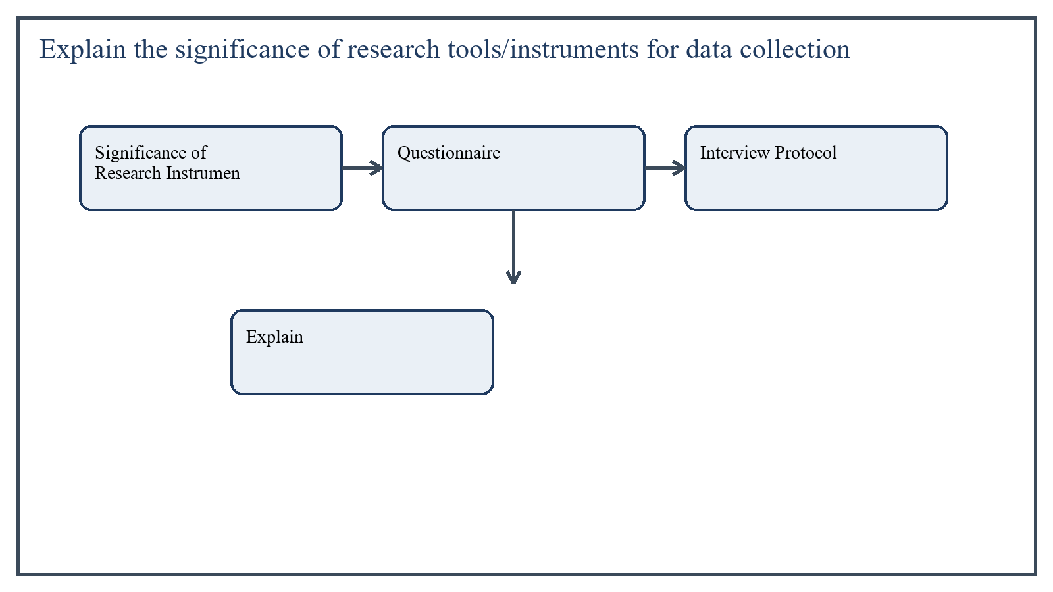
Figure 2: Concept map for Question 2

Significance of Research Instruments
- They convert research objectives into measurable data.
- They influence reliability, validity, and accuracy of findings.
- They help ensure consistency in data collection.
- They determine whether the data truly reflect the problem under study.
In the context of Research Methods in Education, the theme of significance of research instruments deserves extended attention because assignment-level understanding is expected to move beyond one-line definitions and into explanation, comparison, and application. A strong university answer shows not only what the concept means, but also why it matters, how it appears in practice, and what limitations or challenges may arise when it is implemented in real educational settings.
A mature academic response also connects significance of research instruments with classroom realities, institutional culture, and the Pakistani context wherever relevant. This makes the answer more analytical and more useful because it links conceptual understanding with the needs of teachers, learners, administrators, and communities rather than leaving the idea at a purely theoretical level.
From an examination and assignment-writing perspective, the topic of significance of research instruments should be handled through clear structure, careful terminology, valid examples, and balanced discussion. The strongest responses usually define the idea, explain its major components, illustrate it through educational examples, and then conclude with a reasoned judgment about its significance, usefulness, or limitations.

Questionnaire
A questionnaire is a written list of questions used to gather information from respondents. It may include open-ended, closed-ended, rating-scale, or multiple-choice items. It is useful when data are needed from many people in a relatively short time.
The questionnaire is especially effective in survey research because it is economical and can cover a wide sample. However, its success depends on clarity, brevity, relevance, and logical order of questions.
A good questionnaire should avoid ambiguity, double-barreled questions, and unnecessary length. It should also be piloted before final use to check whether respondents understand it properly.
In the context of Research Methods in Education, the theme of questionnaire deserves extended attention because assignment-level understanding is expected to move beyond one-line definitions and into explanation, comparison, and application. A strong university answer shows not only what the concept means, but also why it matters, how it appears in practice, and what limitations or challenges may arise when it is implemented in real educational settings.
A mature academic response also connects questionnaire with classroom realities, institutional culture, and the Pakistani context wherever relevant. This makes the answer more analytical and more useful because it links conceptual understanding with the needs of teachers, learners, administrators, and communities rather than leaving the idea at a purely theoretical level.
From an examination and assignment-writing perspective, the topic of questionnaire should be handled through clear structure, careful terminology, valid examples, and balanced discussion. The strongest responses usually define the idea, explain its major components, illustrate it through educational examples, and then conclude with a reasoned judgment about its significance, usefulness, or limitations.

Interview Protocol
An interview protocol is a planned guide containing the sequence of interview questions, prompts, instructions, and recording arrangements to be followed by the interviewer. It brings structure and consistency to the interview process.
It is especially useful when the researcher wants detailed responses, clarification, or deeper understanding of attitudes and experiences. In educational research, interview protocols are often used with teachers, students, heads, or parents.
A good interview protocol begins with simple and rapport-building questions, moves to core questions, includes optional probes, and ends respectfully. It should align clearly with research objectives and avoid leading or biased wording.
In the context of Research Methods in Education, the theme of interview protocol deserves extended attention because assignment-level understanding is expected to move beyond one-line definitions and into explanation, comparison, and application. A strong university answer shows not only what the concept means, but also why it matters, how it appears in practice, and what limitations or challenges may arise when it is implemented in real educational settings.
A mature academic response also connects interview protocol with classroom realities, institutional culture, and the Pakistani context wherever relevant. This makes the answer more analytical and more useful because it links conceptual understanding with the needs of teachers, learners, administrators, and communities rather than leaving the idea at a purely theoretical level.
From an examination and assignment-writing perspective, the topic of interview protocol should be handled through clear structure, careful terminology, valid examples, and balanced discussion. The strongest responses usually define the idea, explain its major components, illustrate it through educational examples, and then conclude with a reasoned judgment about its significance, usefulness, or limitations.

Applied Illustration and Academic Note
For a stronger B.Ed assignment response, the topic above should be linked with classroom life, institutional practice, and the needs of Pakistani learners. This approach makes the response more analytical and demonstrates that the writer understands both theory and application, which is usually appreciated in AIOU-style academic work.
A good response also avoids unsupported claims. Instead, it explains concepts carefully, gives relevant examples, and ends with a short judgment about educational significance. In this way, the answer to 'Explain the significance of research tools/instruments for data collec...' becomes easier to read, easier to assess, and more academically convincing.

Quick Review Table
Focus Area | Assignment Relevance
Significance of Research Instruments | This area helps answer the question on 'Explain the significance of research tools/instruments ...' by providing concept clarity, explanation, and applied educational value.
Questionnaire | This area helps answer the question on 'Explain the significance of research tools/instruments ...' by providing concept clarity, explanation, and applied educational value.
Interview Protocol | This area helps answer the question on 'Explain the significance of research tools/instruments ...' by providing concept clarity, explanation, and applied educational value.

Critical Reflection
At an advanced level, the topic should not be treated as a fixed formula. Most educational concepts work within particular conditions, and their success often depends on planning quality, learner background, institutional support, and the competence of the teacher or manager using them. A reflective assignment therefore acknowledges strengths while also recognizing practical limitations.

Conclusion
Research tools are significant because they determine the quality of evidence collected. A questionnaire is useful for broader written data collection, while an interview protocol helps gather deeper and more nuanced responses. Proper design of both tools increases the trustworthiness of research findings.

Q.3 Differentiate between probability and non-probability sampling and explain in detail different types of random sampling techniques by giving valid examples.
Answer: The answer below is organized in an academic assignment style, with conceptual explanation, applied discussion, and concise analytical closing comments designed for a neat and extended university submission.
Sampling is the process of selecting a portion of a population for study. The two broad categories are probability sampling and non-probability sampling, and they differ mainly in whether each member of the population has a known chance of selection.
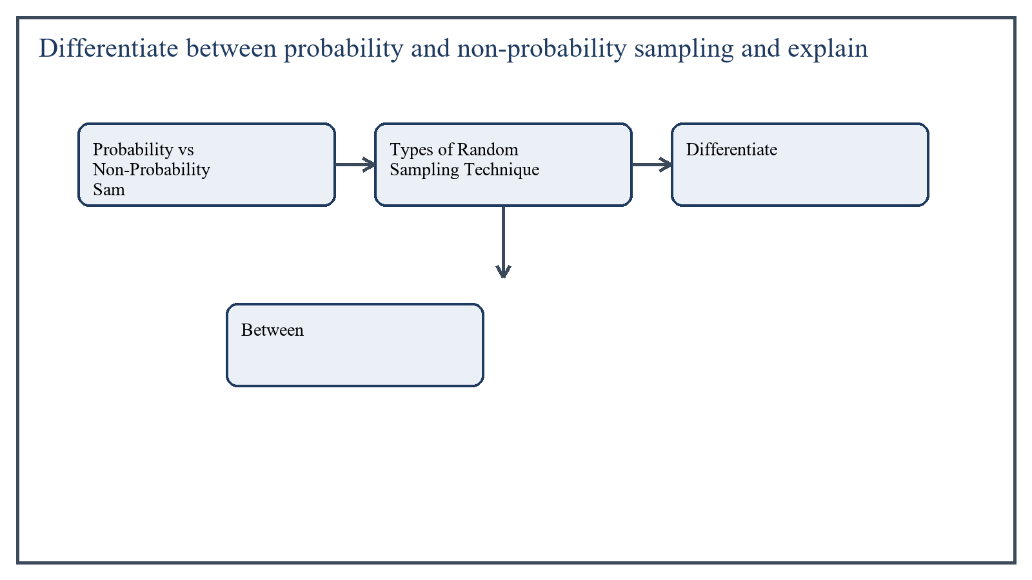
Figure 3: Concept map for Question 3

Probability vs Non-Probability Sampling
In probability sampling, each member of the population has a known and usually equal chance of being selected. This improves representativeness and supports stronger generalization.
In non-probability sampling, selection depends on convenience, judgment, availability, or purpose rather than random chance. It is useful in some practical situations, but it is more vulnerable to bias.
In the context of Research Methods in Education, the theme of probability vs non-probability sampling deserves extended attention because assignment-level understanding is expected to move beyond one-line definitions and into explanation, comparison, and application. A strong university answer shows not only what the concept means, but also why it matters, how it appears in practice, and what limitations or challenges may arise when it is implemented in real educational settings.
A mature academic response also connects probability vs non-probability sampling with classroom realities, institutional culture, and the Pakistani context wherever relevant. This makes the answer more analytical and more useful because it links conceptual understanding with the needs of teachers, learners, administrators, and communities rather than leaving the idea at a purely theoretical level.
From an examination and assignment-writing perspective, the topic of probability vs non-probability sampling should be handled through clear structure, careful terminology, valid examples, and balanced discussion. The strongest responses usually define the idea, explain its major components, illustrate it through educational examples, and then conclude with a reasoned judgment about its significance, usefulness, or limitations.

Types of Random Sampling Techniques
Simple random sampling means every member has an equal chance of selection. Example: selecting 50 student names by lottery from a school enrollment list.
Systematic random sampling means selecting every nth member after a random start. Example: after choosing a random starting point, every 10th student record is selected from a list.
Stratified random sampling means dividing the population into strata such as gender, locality, or grade level and then selecting randomly from each stratum. Example: selecting boys and girls separately so both are properly represented.
Cluster random sampling means selecting whole groups or clusters instead of individual members. Example: choosing four schools randomly from a district and studying all teachers in those selected schools.
Multistage random sampling combines stages of random selection. Example: first selecting districts, then schools within districts, and then students within selected schools.
In the context of Research Methods in Education, the theme of types of random sampling techniques deserves extended attention because assignment-level understanding is expected to move beyond one-line definitions and into explanation, comparison, and application. A strong university answer shows not only what the concept means, but also why it matters, how it appears in practice, and what limitations or challenges may arise when it is implemented in real educational settings.
A mature academic response also connects types of random sampling techniques with classroom realities, institutional culture, and the Pakistani context wherever relevant. This makes the answer more analytical and more useful because it links conceptual understanding with the needs of teachers, learners, administrators, and communities rather than leaving the idea at a purely theoretical level.
From an examination and assignment-writing perspective, the topic of types of random sampling techniques should be handled through clear structure, careful terminology, valid examples, and balanced discussion. The strongest responses usually define the idea, explain its major components, illustrate it through educational examples, and then conclude with a reasoned judgment about its significance, usefulness, or limitations.

Applied Illustration and Academic Note
For a stronger B.Ed assignment response, the topic above should be linked with classroom life, institutional practice, and the needs of Pakistani learners. This approach makes the response more analytical and demonstrates that the writer understands both theory and application, which is usually appreciated in AIOU-style academic work.
A good response also avoids unsupported claims. Instead, it explains concepts carefully, gives relevant examples, and ends with a short judgment about educational significance. In this way, the answer to 'Differentiate between probability and non-probability sampling and exp...' becomes easier to read, easier to assess, and more academically convincing.

Quick Review Table
Focus Area | Assignment Relevance
Probability vs Non-Probability Sampling | This area helps answer the question on 'Differentiate between probability and non-probability s...' by providing concept clarity, explanation, and applied educational value.
Types of Random Sampling Techniques | This area helps answer the question on 'Differentiate between probability and non-probability s...' by providing concept clarity, explanation, and applied educational value.

Critical Reflection
At an advanced level, the topic should not be treated as a fixed formula. Most educational concepts work within particular conditions, and their success often depends on planning quality, learner background, institutional support, and the competence of the teacher or manager using them. A reflective assignment therefore acknowledges strengths while also recognizing practical limitations.

Conclusion
Probability sampling is based on chance and supports better generalization, while non-probability sampling is based on convenience or judgment and is less representative. Different random sampling techniques help researchers choose samples according to population structure and study needs.

Q.4 Define a research proposal and explain the significance and process of developing a good research proposal.
Answer: The answer below is organized in an academic assignment style, with conceptual explanation, applied discussion, and concise analytical closing comments designed for a neat and extended university submission.
A research proposal is a formal written plan that presents what the researcher intends to study, why the study is important, and how it will be conducted. It is essentially a roadmap for the research project.
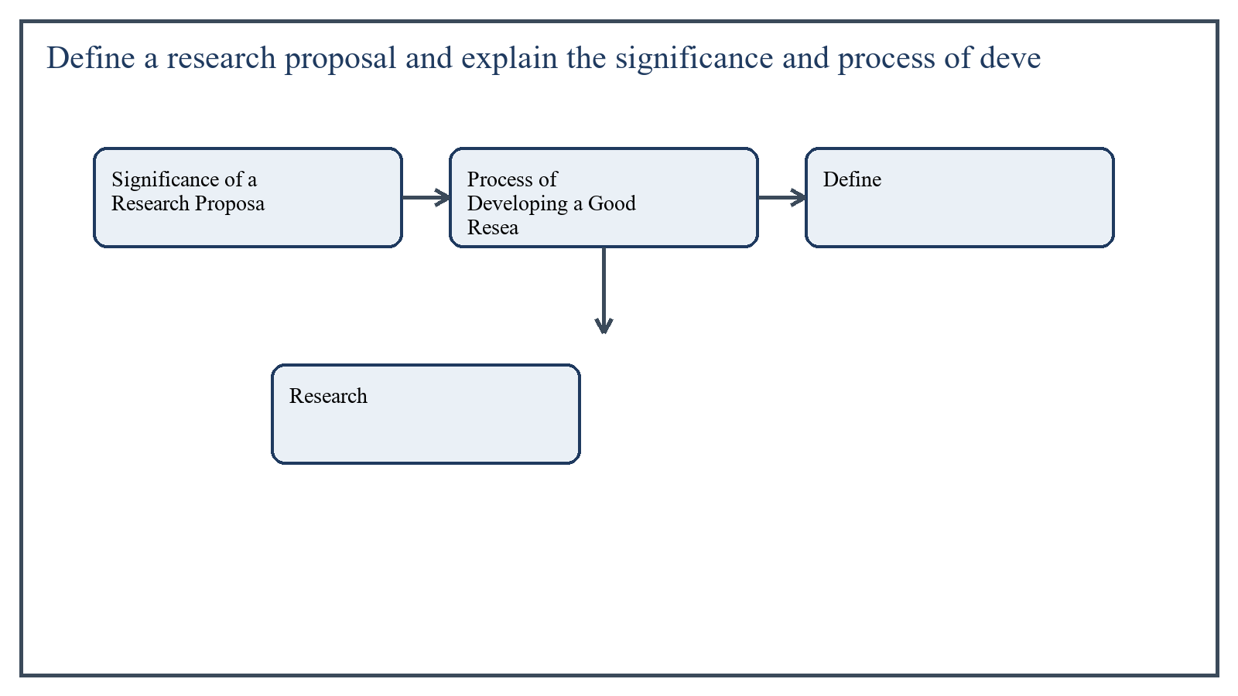
Figure 4: Concept map for Question 4

Significance of a Research Proposal
The proposal is significant because it gives direction and clarity before the actual study begins. It helps the researcher refine the topic, organize thoughts, review the literature, and anticipate methodological requirements.
A good proposal also allows supervisors, committees, or funding bodies to judge whether the study is relevant, feasible, ethical, and academically worthwhile.
In the context of Research Methods in Education, the theme of significance of a research proposal deserves extended attention because assignment-level understanding is expected to move beyond one-line definitions and into explanation, comparison, and application. A strong university answer shows not only what the concept means, but also why it matters, how it appears in practice, and what limitations or challenges may arise when it is implemented in real educational settings.
A mature academic response also connects significance of a research proposal with classroom realities, institutional culture, and the Pakistani context wherever relevant. This makes the answer more analytical and more useful because it links conceptual understanding with the needs of teachers, learners, administrators, and communities rather than leaving the idea at a purely theoretical level.
From an examination and assignment-writing perspective, the topic of significance of a research proposal should be handled through clear structure, careful terminology, valid examples, and balanced discussion. The strongest responses usually define the idea, explain its major components, illustrate it through educational examples, and then conclude with a reasoned judgment about its significance, usefulness, or limitations.

Process of Developing a Good Research Proposal
- Select a clear and researchable topic.
- State the problem and explain its context.
- Write the objectives and, where appropriate, research questions or hypotheses.
- Review relevant literature to show background and gap.
- Describe the methodology including population, sample, tools, and procedure.
- Explain how data will be analyzed.
- Include delimitation, significance, and ethical considerations.
- Prepare a realistic timeline and references.
In the context of Research Methods in Education, the theme of process of developing a good research proposal deserves extended attention because assignment-level understanding is expected to move beyond one-line definitions and into explanation, comparison, and application. A strong university answer shows not only what the concept means, but also why it matters, how it appears in practice, and what limitations or challenges may arise when it is implemented in real educational settings.
A mature academic response also connects process of developing a good research proposal with classroom realities, institutional culture, and the Pakistani context wherever relevant. This makes the answer more analytical and more useful because it links conceptual understanding with the needs of teachers, learners, administrators, and communities rather than leaving the idea at a purely theoretical level.
From an examination and assignment-writing perspective, the topic of process of developing a good research proposal should be handled through clear structure, careful terminology, valid examples, and balanced discussion. The strongest responses usually define the idea, explain its major components, illustrate it through educational examples, and then conclude with a reasoned judgment about its significance, usefulness, or limitations.

Applied Illustration and Academic Note
For a stronger B.Ed assignment response, the topic above should be linked with classroom life, institutional practice, and the needs of Pakistani learners. This approach makes the response more analytical and demonstrates that the writer understands both theory and application, which is usually appreciated in AIOU-style academic work.
A good response also avoids unsupported claims. Instead, it explains concepts carefully, gives relevant examples, and ends with a short judgment about educational significance. In this way, the answer to 'Define a research proposal and explain the significance and process of...' becomes easier to read, easier to assess, and more academically convincing.

Quick Review Table
Focus Area | Assignment Relevance
Significance of a Research Proposal | This area helps answer the question on 'Define a research proposal and explain the significance...' by providing concept clarity, explanation, and applied educational value.
Process of Developing a Good Research Proposal | This area helps answer the question on 'Define a research proposal and explain the significance...' by providing concept clarity, explanation, and applied educational value.

Critical Reflection
At an advanced level, the topic should not be treated as a fixed formula. Most educational concepts work within particular conditions, and their success often depends on planning quality, learner background, institutional support, and the competence of the teacher or manager using them. A reflective assignment therefore acknowledges strengths while also recognizing practical limitations.

Conclusion
A research proposal is the blueprint of the study. Its significance lies in providing clarity, feasibility, and academic direction, while its development process requires careful attention to problem statement, objectives, methodology, and planning.

Q.5 Differentiate between a research proposal and a research report and discuss the main sections/components of a research report.
Answer: The answer below is organized in an academic assignment style, with conceptual explanation, applied discussion, and concise analytical closing comments designed for a neat and extended university submission.
A research proposal and a research report are both important research documents, but they belong to different stages of the research process. One presents the plan before the study, while the other presents the completed work after the study.
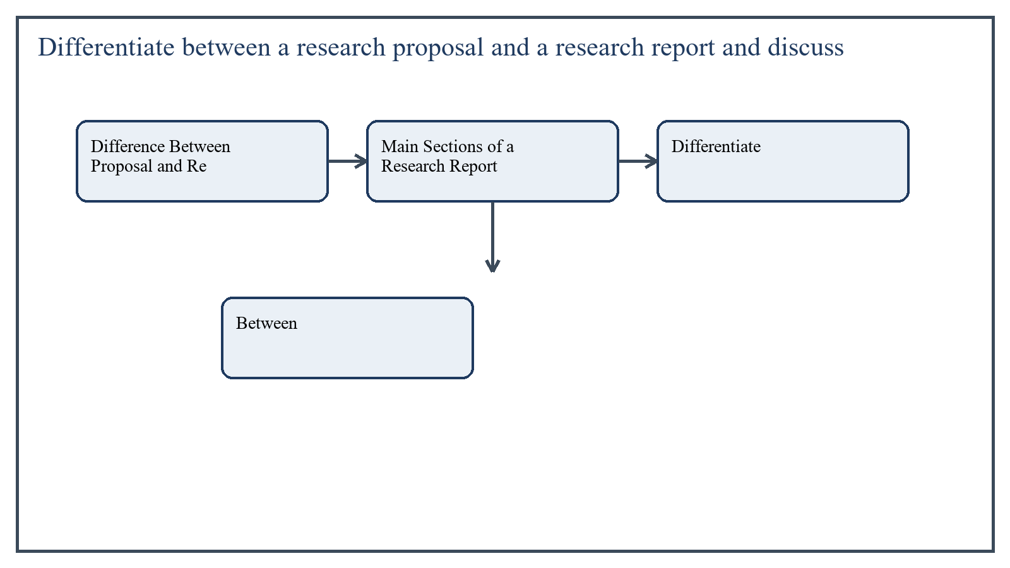
Figure 5: Concept map for Question 5

Difference Between Proposal and Report
A research proposal is written before conducting the study. It explains what the researcher intends to do and how the study will be carried out.
A research report is written after the study is completed. It presents the actual findings, analysis, interpretation, and conclusions of the research.
- Proposal = future plan; report = completed study.
- Proposal seeks approval; report communicates results.
- Proposal contains expected method; report contains actual findings and discussion.
In the context of Research Methods in Education, the theme of difference between proposal and report deserves extended attention because assignment-level understanding is expected to move beyond one-line definitions and into explanation, comparison, and application. A strong university answer shows not only what the concept means, but also why it matters, how it appears in practice, and what limitations or challenges may arise when it is implemented in real educational settings.
A mature academic response also connects difference between proposal and report with classroom realities, institutional culture, and the Pakistani context wherever relevant. This makes the answer more analytical and more useful because it links conceptual understanding with the needs of teachers, learners, administrators, and communities rather than leaving the idea at a purely theoretical level.
From an examination and assignment-writing perspective, the topic of difference between proposal and report should be handled through clear structure, careful terminology, valid examples, and balanced discussion. The strongest responses usually define the idea, explain its major components, illustrate it through educational examples, and then conclude with a reasoned judgment about its significance, usefulness, or limitations.

Main Sections of a Research Report
Each section has a specific purpose. The introduction explains the study background, the methodology shows how the study was conducted, the findings section presents evidence, and the discussion interprets what the results mean in relation to the objectives and earlier literature.
- Title page
- Abstract or summary
- Introduction and statement of the problem
- Objectives, questions, or hypotheses
- Review of literature
- Methodology
- Data analysis and presentation of findings
- Discussion and interpretation
- Conclusion and recommendations
- References and appendices
In the context of Research Methods in Education, the theme of main sections of a research report deserves extended attention because assignment-level understanding is expected to move beyond one-line definitions and into explanation, comparison, and application. A strong university answer shows not only what the concept means, but also why it matters, how it appears in practice, and what limitations or challenges may arise when it is implemented in real educational settings.
A mature academic response also connects main sections of a research report with classroom realities, institutional culture, and the Pakistani context wherever relevant. This makes the answer more analytical and more useful because it links conceptual understanding with the needs of teachers, learners, administrators, and communities rather than leaving the idea at a purely theoretical level.
From an examination and assignment-writing perspective, the topic of main sections of a research report should be handled through clear structure, careful terminology, valid examples, and balanced discussion. The strongest responses usually define the idea, explain its major components, illustrate it through educational examples, and then conclude with a reasoned judgment about its significance, usefulness, or limitations.

Applied Illustration and Academic Note
For a stronger B.Ed assignment response, the topic above should be linked with classroom life, institutional practice, and the needs of Pakistani learners. This approach makes the response more analytical and demonstrates that the writer understands both theory and application, which is usually appreciated in AIOU-style academic work.
A good response also avoids unsupported claims. Instead, it explains concepts carefully, gives relevant examples, and ends with a short judgment about educational significance. In this way, the answer to 'Differentiate between a research proposal and a research report and di...' becomes easier to read, easier to assess, and more academically convincing.

Quick Review Table
Focus Area | Assignment Relevance
Difference Between Proposal and Report | This area helps answer the question on 'Differentiate between a research proposal and a researc...' by providing concept clarity, explanation, and applied educational value.
Main Sections of a Research Report | This area helps answer the question on 'Differentiate between a research proposal and a researc...' by providing concept clarity, explanation, and applied educational value.

Critical Reflection
At an advanced level, the topic should not be treated as a fixed formula. Most educational concepts work within particular conditions, and their success often depends on planning quality, learner background, institutional support, and the competence of the teacher or manager using them. A reflective assignment therefore acknowledges strengths while also recognizing practical limitations.

Conclusion
The proposal and the report are related but not identical. The proposal plans the research, while the report documents and interprets the completed study. A good research report follows a systematic structure so that readers can understand the problem, method, findings, and conclusions clearly.

Extended Revision Appendix
This appendix is included to strengthen the assignment as a premium academic submission. It provides recap notes, revision prompts, and concept reinforcement so the document reads like a complete study-ready submission rather than a short-answer sheet only.

Key Revision Points
- Review the central demand of the question 'Differentiate between experimental and descriptive research an...' and connect definition, explanation, example, and critical comment in one organized response.
- Review the central demand of the question 'Explain the significance of research tools/instruments for dat...' and connect definition, explanation, example, and critical comment in one organized response.
- Review the central demand of the question 'Differentiate between probability and non-probability sampling...' and connect definition, explanation, example, and critical comment in one organized response.
- Review the central demand of the question 'Define a research proposal and explain the significance and pr...' and connect definition, explanation, example, and critical comment in one organized response.
- Review the central demand of the question 'Differentiate between a research proposal and a research repor...' and connect definition, explanation, example, and critical comment in one organized response.

Academic Writing Reminders
- Begin each major answer with a clear conceptual opening.
- Use examples to show understanding instead of repeating definitions only.
- Present advantages, limitations, and contextual realities where relevant.
- Close each answer with a short evaluative conclusion.
- Maintain formal and neat language throughout the assignment.

Concept Reinforcement Notes
The question on 'Differentiate between experimental and descriptive research and explain the...' can be revised further by identifying three things: the main concept involved, the educational importance of that concept, and one example from Pakistani classroom or institutional life. This simple method helps transform memorized content into organized written response.
The question on 'Explain the significance of research tools/instruments for data collection ...' can be revised further by identifying three things: the main concept involved, the educational importance of that concept, and one example from Pakistani classroom or institutional life. This simple method helps transform memorized content into organized written response.
The question on 'Differentiate between probability and non-probability sampling and explain ...' can be revised further by identifying three things: the main concept involved, the educational importance of that concept, and one example from Pakistani classroom or institutional life. This simple method helps transform memorized content into organized written response.
The question on 'Define a research proposal and explain the significance and process of deve...' can be revised further by identifying three things: the main concept involved, the educational importance of that concept, and one example from Pakistani classroom or institutional life. This simple method helps transform memorized content into organized written response.
The question on 'Differentiate between a research proposal and a research report and discuss...' can be revised further by identifying three things: the main concept involved, the educational importance of that concept, and one example from Pakistani classroom or institutional life. This simple method helps transform memorized content into organized written response.

Source Base and Assignment Support Notes
The following source base was used to keep the answers aligned with AIOU course structure and the exact question wording. The final language and organization were expanded for presentation quality, page-length target, and assignment readability.
- AIOU Soft Book: Research Methods in Education (Code 8604), especially units on descriptive research, data collection tools, sampling, research proposal, and research report writing.
- AIOU Spring 2026 assignment sheet for Course 8604.

Extended Analytical Note 1
In extended study of Research Methods in Education, the issue raised in 'Differentiate between experimental and descriptive research and explain ...' may also be explored through definition, theoretical explanation, applied example, classroom implication, institutional implication, and critical reflection. This six-part approach helps a learner produce a more complete answer and also improves the academic appearance of the assignment by showing structure and depth.
Another useful strategy in long-form assignment writing is to move carefully from concept to context. First explain what the idea means, then identify its components, then discuss its relevance in teaching or administration, and finally mention any practical limitation. Such movement gives maturity to the answer and helps the examiner follow the logic without difficulty.
In extended study of Research Methods in Education, the issue raised in 'Explain the significance of research tools/instruments for data collecti...' may also be explored through definition, theoretical explanation, applied example, classroom implication, institutional implication, and critical reflection. This six-part approach helps a learner produce a more complete answer and also improves the academic appearance of the assignment by showing structure and depth.
Another useful strategy in long-form assignment writing is to move carefully from concept to context. First explain what the idea means, then identify its components, then discuss its relevance in teaching or administration, and finally mention any practical limitation. Such movement gives maturity to the answer and helps the examiner follow the logic without difficulty.
In extended study of Research Methods in Education, the issue raised in 'Differentiate between probability and non-probability sampling and expla...' may also be explored through definition, theoretical explanation, applied example, classroom implication, institutional implication, and critical reflection. This six-part approach helps a learner produce a more complete answer and also improves the academic appearance of the assignment by showing structure and depth.
Another useful strategy in long-form assignment writing is to move carefully from concept to context. First explain what the idea means, then identify its components, then discuss its relevance in teaching or administration, and finally mention any practical limitation. Such movement gives maturity to the answer and helps the examiner follow the logic without difficulty.
In extended study of Research Methods in Education, the issue raised in 'Define a research proposal and explain the significance and process of d...' may also be explored through definition, theoretical explanation, applied example, classroom implication, institutional implication, and critical reflection. This six-part approach helps a learner produce a more complete answer and also improves the academic appearance of the assignment by showing structure and depth.
Another useful strategy in long-form assignment writing is to move carefully from concept to context. First explain what the idea means, then identify its components, then discuss its relevance in teaching or administration, and finally mention any practical limitation. Such movement gives maturity to the answer and helps the examiner follow the logic without difficulty.
In extended study of Research Methods in Education, the issue raised in 'Differentiate between a research proposal and a research report and disc...' may also be explored through definition, theoretical explanation, applied example, classroom implication, institutional implication, and critical reflection. This six-part approach helps a learner produce a more complete answer and also improves the academic appearance of the assignment by showing structure and depth.
Another useful strategy in long-form assignment writing is to move carefully from concept to context. First explain what the idea means, then identify its components, then discuss its relevance in teaching or administration, and finally mention any practical limitation. Such movement gives maturity to the answer and helps the examiner follow the logic without difficulty.

Extended Analytical Note 2
In extended study of Research Methods in Education, the issue raised in 'Differentiate between experimental and descriptive research and explain ...' may also be explored through definition, theoretical explanation, applied example, classroom implication, institutional implication, and critical reflection. This six-part approach helps a learner produce a more complete answer and also improves the academic appearance of the assignment by showing structure and depth.
Another useful strategy in long-form assignment writing is to move carefully from concept to context. First explain what the idea means, then identify its components, then discuss its relevance in teaching or administration, and finally mention any practical limitation. Such movement gives maturity to the answer and helps the examiner follow the logic without difficulty.
In extended study of Research Methods in Education, the issue raised in 'Explain the significance of research tools/instruments for data collecti...' may also be explored through definition, theoretical explanation, applied example, classroom implication, institutional implication, and critical reflection. This six-part approach helps a learner produce a more complete answer and also improves the academic appearance of the assignment by showing structure and depth.
Another useful strategy in long-form assignment writing is to move carefully from concept to context. First explain what the idea means, then identify its components, then discuss its relevance in teaching or administration, and finally mention any practical limitation. Such movement gives maturity to the answer and helps the examiner follow the logic without difficulty.
In extended study of Research Methods in Education, the issue raised in 'Differentiate between probability and non-probability sampling and expla...' may also be explored through definition, theoretical explanation, applied example, classroom implication, institutional implication, and critical reflection. This six-part approach helps a learner produce a more complete answer and also improves the academic appearance of the assignment by showing structure and depth.
Another useful strategy in long-form assignment writing is to move carefully from concept to context. First explain what the idea means, then identify its components, then discuss its relevance in teaching or administration, and finally mention any practical limitation. Such movement gives maturity to the answer and helps the examiner follow the logic without difficulty.
In extended study of Research Methods in Education, the issue raised in 'Define a research proposal and explain the significance and process of d...' may also be explored through definition, theoretical explanation, applied example, classroom implication, institutional implication, and critical reflection. This six-part approach helps a learner produce a more complete answer and also improves the academic appearance of the assignment by showing structure and depth.
Another useful strategy in long-form assignment writing is to move carefully from concept to context. First explain what the idea means, then identify its components, then discuss its relevance in teaching or administration, and finally mention any practical limitation. Such movement gives maturity to the answer and helps the examiner follow the logic without difficulty.
In extended study of Research Methods in Education, the issue raised in 'Differentiate between a research proposal and a research report and disc...' may also be explored through definition, theoretical explanation, applied example, classroom implication, institutional implication, and critical reflection. This six-part approach helps a learner produce a more complete answer and also improves the academic appearance of the assignment by showing structure and depth.
Another useful strategy in long-form assignment writing is to move carefully from concept to context. First explain what the idea means, then identify its components, then discuss its relevance in teaching or administration, and finally mention any practical limitation. Such movement gives maturity to the answer and helps the examiner follow the logic without difficulty.

Extended Analytical Note 3
In extended study of Research Methods in Education, the issue raised in 'Differentiate between experimental and descriptive research and explain ...' may also be explored through definition, theoretical explanation, applied example, classroom implication, institutional implication, and critical reflection. This six-part approach helps a learner produce a more complete answer and also improves the academic appearance of the assignment by showing structure and depth.
Another useful strategy in long-form assignment writing is to move carefully from concept to context. First explain what the idea means, then identify its components, then discuss its relevance in teaching or administration, and finally mention any practical limitation. Such movement gives maturity to the answer and helps the examiner follow the logic without difficulty.
In extended study of Research Methods in Education, the issue raised in 'Explain the significance of research tools/instruments for data collecti...' may also be explored through definition, theoretical explanation, applied example, classroom implication, institutional implication, and critical reflection. This six-part approach helps a learner produce a more complete answer and also improves the academic appearance of the assignment by showing structure and depth.
Another useful strategy in long-form assignment writing is to move carefully from concept to context. First explain what the idea means, then identify its components, then discuss its relevance in teaching or administration, and finally mention any practical limitation. Such movement gives maturity to the answer and helps the examiner follow the logic without difficulty.
In extended study of Research Methods in Education, the issue raised in 'Differentiate between probability and non-probability sampling and expla...' may also be explored through definition, theoretical explanation, applied example, classroom implication, institutional implication, and critical reflection. This six-part approach helps a learner produce a more complete answer and also improves the academic appearance of the assignment by showing structure and depth.
Another useful strategy in long-form assignment writing is to move carefully from concept to context. First explain what the idea means, then identify its components, then discuss its relevance in teaching or administration, and finally mention any practical limitation. Such movement gives maturity to the answer and helps the examiner follow the logic without difficulty.
In extended study of Research Methods in Education, the issue raised in 'Define a research proposal and explain the significance and process of d...' may also be explored through definition, theoretical explanation, applied example, classroom implication, institutional implication, and critical reflection. This six-part approach helps a learner produce a more complete answer and also improves the academic appearance of the assignment by showing structure and depth.
Another useful strategy in long-form assignment writing is to move carefully from concept to context. First explain what the idea means, then identify its components, then discuss its relevance in teaching or administration, and finally mention any practical limitation. Such movement gives maturity to the answer and helps the examiner follow the logic without difficulty.
In extended study of Research Methods in Education, the issue raised in 'Differentiate between a research proposal and a research report and disc...' may also be explored through definition, theoretical explanation, applied example, classroom implication, institutional implication, and critical reflection. This six-part approach helps a learner produce a more complete answer and also improves the academic appearance of the assignment by showing structure and depth.
Another useful strategy in long-form assignment writing is to move carefully from concept to context. First explain what the idea means, then identify its components, then discuss its relevance in teaching or administration, and finally mention any practical limitation. Such movement gives maturity to the answer and helps the examiner follow the logic without difficulty.

Extended Analytical Note 4
In extended study of Research Methods in Education, the issue raised in 'Differentiate between experimental and descriptive research and explain ...' may also be explored through definition, theoretical explanation, applied example, classroom implication, institutional implication, and critical reflection. This six-part approach helps a learner produce a more complete answer and also improves the academic appearance of the assignment by showing structure and depth.
Another useful strategy in long-form assignment writing is to move carefully from concept to context. First explain what the idea means, then identify its components, then discuss its relevance in teaching or administration, and finally mention any practical limitation. Such movement gives maturity to the answer and helps the examiner follow the logic without difficulty.
In extended study of Research Methods in Education, the issue raised in 'Explain the significance of research tools/instruments for data collecti...' may also be explored through definition, theoretical explanation, applied example, classroom implication, institutional implication, and critical reflection. This six-part approach helps a learner produce a more complete answer and also improves the academic appearance of the assignment by showing structure and depth.
Another useful strategy in long-form assignment writing is to move carefully from concept to context. First explain what the idea means, then identify its components, then discuss its relevance in teaching or administration, and finally mention any practical limitation. Such movement gives maturity to the answer and helps the examiner follow the logic without difficulty.
In extended study of Research Methods in Education, the issue raised in 'Differentiate between probability and non-probability sampling and expla...' may also be explored through definition, theoretical explanation, applied example, classroom implication, institutional implication, and critical reflection. This six-part approach helps a learner produce a more complete answer and also improves the academic appearance of the assignment by showing structure and depth.
Another useful strategy in long-form assignment writing is to move carefully from concept to context. First explain what the idea means, then identify its components, then discuss its relevance in teaching or administration, and finally mention any practical limitation. Such movement gives maturity to the answer and helps the examiner follow the logic without difficulty.
In extended study of Research Methods in Education, the issue raised in 'Define a research proposal and explain the significance and process of d...' may also be explored through definition, theoretical explanation, applied example, classroom implication, institutional implication, and critical reflection. This six-part approach helps a learner produce a more complete answer and also improves the academic appearance of the assignment by showing structure and depth.
Another useful strategy in long-form assignment writing is to move carefully from concept to context. First explain what the idea means, then identify its components, then discuss its relevance in teaching or administration, and finally mention any practical limitation. Such movement gives maturity to the answer and helps the examiner follow the logic without difficulty.
In extended study of Research Methods in Education, the issue raised in 'Differentiate between a research proposal and a research report and disc...' may also be explored through definition, theoretical explanation, applied example, classroom implication, institutional implication, and critical reflection. This six-part approach helps a learner produce a more complete answer and also improves the academic appearance of the assignment by showing structure and depth.
Another useful strategy in long-form assignment writing is to move carefully from concept to context. First explain what the idea means, then identify its components, then discuss its relevance in teaching or administration, and finally mention any practical limitation. Such movement gives maturity to the answer and helps the examiner follow the logic without difficulty.

Extended Analytical Note 5
In extended study of Research Methods in Education, the issue raised in 'Differentiate between experimental and descriptive research and explain ...' may also be explored through definition, theoretical explanation, applied example, classroom implication, institutional implication, and critical reflection. This six-part approach helps a learner produce a more complete answer and also improves the academic appearance of the assignment by showing structure and depth.
Another useful strategy in long-form assignment writing is to move carefully from concept to context. First explain what the idea means, then identify its components, then discuss its relevance in teaching or administration, and finally mention any practical limitation. Such movement gives maturity to the answer and helps the examiner follow the logic without difficulty.
In extended study of Research Methods in Education, the issue raised in 'Explain the significance of research tools/instruments for data collecti...' may also be explored through definition, theoretical explanation, applied example, classroom implication, institutional implication, and critical reflection. This six-part approach helps a learner produce a more complete answer and also improves the academic appearance of the assignment by showing structure and depth.
Another useful strategy in long-form assignment writing is to move carefully from concept to context. First explain what the idea means, then identify its components, then discuss its relevance in teaching or administration, and finally mention any practical limitation. Such movement gives maturity to the answer and helps the examiner follow the logic without difficulty.
In extended study of Research Methods in Education, the issue raised in 'Differentiate between probability and non-probability sampling and expla...' may also be explored through definition, theoretical explanation, applied example, classroom implication, institutional implication, and critical reflection. This six-part approach helps a learner produce a more complete answer and also improves the academic appearance of the assignment by showing structure and depth.
Another useful strategy in long-form assignment writing is to move carefully from concept to context. First explain what the idea means, then identify its components, then discuss its relevance in teaching or administration, and finally mention any practical limitation. Such movement gives maturity to the answer and helps the examiner follow the logic without difficulty.
In extended study of Research Methods in Education, the issue raised in 'Define a research proposal and explain the significance and process of d...' may also be explored through definition, theoretical explanation, applied example, classroom implication, institutional implication, and critical reflection. This six-part approach helps a learner produce a more complete answer and also improves the academic appearance of the assignment by showing structure and depth.
Another useful strategy in long-form assignment writing is to move carefully from concept to context. First explain what the idea means, then identify its components, then discuss its relevance in teaching or administration, and finally mention any practical limitation. Such movement gives maturity to the answer and helps the examiner follow the logic without difficulty.
In extended study of Research Methods in Education, the issue raised in 'Differentiate between a research proposal and a research report and disc...' may also be explored through definition, theoretical explanation, applied example, classroom implication, institutional implication, and critical reflection. This six-part approach helps a learner produce a more complete answer and also improves the academic appearance of the assignment by showing structure and depth.
Another useful strategy in long-form assignment writing is to move carefully from concept to context. First explain what the idea means, then identify its components, then discuss its relevance in teaching or administration, and finally mention any practical limitation. Such movement gives maturity to the answer and helps the examiner follow the logic without difficulty.

Extended Analytical Note 6
In extended study of Research Methods in Education, the issue raised in 'Differentiate between experimental and descriptive research and explain ...' may also be explored through definition, theoretical explanation, applied example, classroom implication, institutional implication, and critical reflection. This six-part approach helps a learner produce a more complete answer and also improves the academic appearance of the assignment by showing structure and depth.
Another useful strategy in long-form assignment writing is to move carefully from concept to context. First explain what the idea means, then identify its components, then discuss its relevance in teaching or administration, and finally mention any practical limitation. Such movement gives maturity to the answer and helps the examiner follow the logic without difficulty.
In extended study of Research Methods in Education, the issue raised in 'Explain the significance of research tools/instruments for data collecti...' may also be explored through definition, theoretical explanation, applied example, classroom implication, institutional implication, and critical reflection. This six-part approach helps a learner produce a more complete answer and also improves the academic appearance of the assignment by showing structure and depth.
Another useful strategy in long-form assignment writing is to move carefully from concept to context. First explain what the idea means, then identify its components, then discuss its relevance in teaching or administration, and finally mention any practical limitation. Such movement gives maturity to the answer and helps the examiner follow the logic without difficulty.
In extended study of Research Methods in Education, the issue raised in 'Differentiate between probability and non-probability sampling and expla...' may also be explored through definition, theoretical explanation, applied example, classroom implication, institutional implication, and critical reflection. This six-part approach helps a learner produce a more complete answer and also improves the academic appearance of the assignment by showing structure and depth.
Another useful strategy in long-form assignment writing is to move carefully from concept to context. First explain what the idea means, then identify its components, then discuss its relevance in teaching or administration, and finally mention any practical limitation. Such movement gives maturity to the answer and helps the examiner follow the logic without difficulty.
In extended study of Research Methods in Education, the issue raised in 'Define a research proposal and explain the significance and process of d...' may also be explored through definition, theoretical explanation, applied example, classroom implication, institutional implication, and critical reflection. This six-part approach helps a learner produce a more complete answer and also improves the academic appearance of the assignment by showing structure and depth.
Another useful strategy in long-form assignment writing is to move carefully from concept to context. First explain what the idea means, then identify its components, then discuss its relevance in teaching or administration, and finally mention any practical limitation. Such movement gives maturity to the answer and helps the examiner follow the logic without difficulty.
In extended study of Research Methods in Education, the issue raised in 'Differentiate between a research proposal and a research report and disc...' may also be explored through definition, theoretical explanation, applied example, classroom implication, institutional implication, and critical reflection. This six-part approach helps a learner produce a more complete answer and also improves the academic appearance of the assignment by showing structure and depth.
Another useful strategy in long-form assignment writing is to move carefully from concept to context. First explain what the idea means, then identify its components, then discuss its relevance in teaching or administration, and finally mention any practical limitation. Such movement gives maturity to the answer and helps the examiner follow the logic without difficulty.

Extended Analytical Note 7
In extended study of Research Methods in Education, the issue raised in 'Differentiate between experimental and descriptive research and explain ...' may also be explored through definition, theoretical explanation, applied example, classroom implication, institutional implication, and critical reflection. This six-part approach helps a learner produce a more complete answer and also improves the academic appearance of the assignment by showing structure and depth.
Another useful strategy in long-form assignment writing is to move carefully from concept to context. First explain what the idea means, then identify its components, then discuss its relevance in teaching or administration, and finally mention any practical limitation. Such movement gives maturity to the answer and helps the examiner follow the logic without difficulty.
In extended study of Research Methods in Education, the issue raised in 'Explain the significance of research tools/instruments for data collecti...' may also be explored through definition, theoretical explanation, applied example, classroom implication, institutional implication, and critical reflection. This six-part approach helps a learner produce a more complete answer and also improves the academic appearance of the assignment by showing structure and depth.
Another useful strategy in long-form assignment writing is to move carefully from concept to context. First explain what the idea means, then identify its components, then discuss its relevance in teaching or administration, and finally mention any practical limitation. Such movement gives maturity to the answer and helps the examiner follow the logic without difficulty.
In extended study of Research Methods in Education, the issue raised in 'Differentiate between probability and non-probability sampling and expla...' may also be explored through definition, theoretical explanation, applied example, classroom implication, institutional implication, and critical reflection. This six-part approach helps a learner produce a more complete answer and also improves the academic appearance of the assignment by showing structure and depth.
Another useful strategy in long-form assignment writing is to move carefully from concept to context. First explain what the idea means, then identify its components, then discuss its relevance in teaching or administration, and finally mention any practical limitation. Such movement gives maturity to the answer and helps the examiner follow the logic without difficulty.
In extended study of Research Methods in Education, the issue raised in 'Define a research proposal and explain the significance and process of d...' may also be explored through definition, theoretical explanation, applied example, classroom implication, institutional implication, and critical reflection. This six-part approach helps a learner produce a more complete answer and also improves the academic appearance of the assignment by showing structure and depth.
Another useful strategy in long-form assignment writing is to move carefully from concept to context. First explain what the idea means, then identify its components, then discuss its relevance in teaching or administration, and finally mention any practical limitation. Such movement gives maturity to the answer and helps the examiner follow the logic without difficulty.
In extended study of Research Methods in Education, the issue raised in 'Differentiate between a research proposal and a research report and disc...' may also be explored through definition, theoretical explanation, applied example, classroom implication, institutional implication, and critical reflection. This six-part approach helps a learner produce a more complete answer and also improves the academic appearance of the assignment by showing structure and depth.
Another useful strategy in long-form assignment writing is to move carefully from concept to context. First explain what the idea means, then identify its components, then discuss its relevance in teaching or administration, and finally mention any practical limitation. Such movement gives maturity to the answer and helps the examiner follow the logic without difficulty.

Extended Analytical Note 8
In extended study of Research Methods in Education, the issue raised in 'Differentiate between experimental and descriptive research and explain ...' may also be explored through definition, theoretical explanation, applied example, classroom implication, institutional implication, and critical reflection. This six-part approach helps a learner produce a more complete answer and also improves the academic appearance of the assignment by showing structure and depth.
Another useful strategy in long-form assignment writing is to move carefully from concept to context. First explain what the idea means, then identify its components, then discuss its relevance in teaching or administration, and finally mention any practical limitation. Such movement gives maturity to the answer and helps the examiner follow the logic without difficulty.
In extended study of Research Methods in Education, the issue raised in 'Explain the significance of research tools/instruments for data collecti...' may also be explored through definition, theoretical explanation, applied example, classroom implication, institutional implication, and critical reflection. This six-part approach helps a learner produce a more complete answer and also improves the academic appearance of the assignment by showing structure and depth.
Another useful strategy in long-form assignment writing is to move carefully from concept to context. First explain what the idea means, then identify its components, then discuss its relevance in teaching or administration, and finally mention any practical limitation. Such movement gives maturity to the answer and helps the examiner follow the logic without difficulty.
In extended study of Research Methods in Education, the issue raised in 'Differentiate between probability and non-probability sampling and expla...' may also be explored through definition, theoretical explanation, applied example, classroom implication, institutional implication, and critical reflection. This six-part approach helps a learner produce a more complete answer and also improves the academic appearance of the assignment by showing structure and depth.
Another useful strategy in long-form assignment writing is to move carefully from concept to context. First explain what the idea means, then identify its components, then discuss its relevance in teaching or administration, and finally mention any practical limitation. Such movement gives maturity to the answer and helps the examiner follow the logic without difficulty.
In extended study of Research Methods in Education, the issue raised in 'Define a research proposal and explain the significance and process of d...' may also be explored through definition, theoretical explanation, applied example, classroom implication, institutional implication, and critical reflection. This six-part approach helps a learner produce a more complete answer and also improves the academic appearance of the assignment by showing structure and depth.
Another useful strategy in long-form assignment writing is to move carefully from concept to context. First explain what the idea means, then identify its components, then discuss its relevance in teaching or administration, and finally mention any practical limitation. Such movement gives maturity to the answer and helps the examiner follow the logic without difficulty.
In extended study of Research Methods in Education, the issue raised in 'Differentiate between a research proposal and a research report and disc...' may also be explored through definition, theoretical explanation, applied example, classroom implication, institutional implication, and critical reflection. This six-part approach helps a learner produce a more complete answer and also improves the academic appearance of the assignment by showing structure and depth.
Another useful strategy in long-form assignment writing is to move carefully from concept to context. First explain what the idea means, then identify its components, then discuss its relevance in teaching or administration, and finally mention any practical limitation. Such movement gives maturity to the answer and helps the examiner follow the logic without difficulty.

Extended Analytical Note 9
In extended study of Research Methods in Education, the issue raised in 'Differentiate between experimental and descriptive research and explain ...' may also be explored through definition, theoretical explanation, applied example, classroom implication, institutional implication, and critical reflection. This six-part approach helps a learner produce a more complete answer and also improves the academic appearance of the assignment by showing structure and depth.
Another useful strategy in long-form assignment writing is to move carefully from concept to context. First explain what the idea means, then identify its components, then discuss its relevance in teaching or administration, and finally mention any practical limitation. Such movement gives maturity to the answer and helps the examiner follow the logic without difficulty.
In extended study of Research Methods in Education, the issue raised in 'Explain the significance of research tools/instruments for data collecti...' may also be explored through definition, theoretical explanation, applied example, classroom implication, institutional implication, and critical reflection. This six-part approach helps a learner produce a more complete answer and also improves the academic appearance of the assignment by showing structure and depth.
Another useful strategy in long-form assignment writing is to move carefully from concept to context. First explain what the idea means, then identify its components, then discuss its relevance in teaching or administration, and finally mention any practical limitation. Such movement gives maturity to the answer and helps the examiner follow the logic without difficulty.
In extended study of Research Methods in Education, the issue raised in 'Differentiate between probability and non-probability sampling and expla...' may also be explored through definition, theoretical explanation, applied example, classroom implication, institutional implication, and critical reflection. This six-part approach helps a learner produce a more complete answer and also improves the academic appearance of the assignment by showing structure and depth.
Another useful strategy in long-form assignment writing is to move carefully from concept to context. First explain what the idea means, then identify its components, then discuss its relevance in teaching or administration, and finally mention any practical limitation. Such movement gives maturity to the answer and helps the examiner follow the logic without difficulty.
In extended study of Research Methods in Education, the issue raised in 'Define a research proposal and explain the significance and process of d...' may also be explored through definition, theoretical explanation, applied example, classroom implication, institutional implication, and critical reflection. This six-part approach helps a learner produce a more complete answer and also improves the academic appearance of the assignment by showing structure and depth.
Another useful strategy in long-form assignment writing is to move carefully from concept to context. First explain what the idea means, then identify its components, then discuss its relevance in teaching or administration, and finally mention any practical limitation. Such movement gives maturity to the answer and helps the examiner follow the logic without difficulty.
In extended study of Research Methods in Education, the issue raised in 'Differentiate between a research proposal and a research report and disc...' may also be explored through definition, theoretical explanation, applied example, classroom implication, institutional implication, and critical reflection. This six-part approach helps a learner produce a more complete answer and also improves the academic appearance of the assignment by showing structure and depth.
Another useful strategy in long-form assignment writing is to move carefully from concept to context. First explain what the idea means, then identify its components, then discuss its relevance in teaching or administration, and finally mention any practical limitation. Such movement gives maturity to the answer and helps the examiner follow the logic without difficulty.

Extended Analytical Note 10
In extended study of Research Methods in Education, the issue raised in 'Differentiate between experimental and descriptive research and explain ...' may also be explored through definition, theoretical explanation, applied example, classroom implication, institutional implication, and critical reflection. This six-part approach helps a learner produce a more complete answer and also improves the academic appearance of the assignment by showing structure and depth.
Another useful strategy in long-form assignment writing is to move carefully from concept to context. First explain what the idea means, then identify its components, then discuss its relevance in teaching or administration, and finally mention any practical limitation. Such movement gives maturity to the answer and helps the examiner follow the logic without difficulty.
In extended study of Research Methods in Education, the issue raised in 'Explain the significance of research tools/instruments for data collecti...' may also be explored through definition, theoretical explanation, applied example, classroom implication, institutional implication, and critical reflection. This six-part approach helps a learner produce a more complete answer and also improves the academic appearance of the assignment by showing structure and depth.
Another useful strategy in long-form assignment writing is to move carefully from concept to context. First explain what the idea means, then identify its components, then discuss its relevance in teaching or administration, and finally mention any practical limitation. Such movement gives maturity to the answer and helps the examiner follow the logic without difficulty.
In extended study of Research Methods in Education, the issue raised in 'Differentiate between probability and non-probability sampling and expla...' may also be explored through definition, theoretical explanation, applied example, classroom implication, institutional implication, and critical reflection. This six-part approach helps a learner produce a more complete answer and also improves the academic appearance of the assignment by showing structure and depth.
Another useful strategy in long-form assignment writing is to move carefully from concept to context. First explain what the idea means, then identify its components, then discuss its relevance in teaching or administration, and finally mention any practical limitation. Such movement gives maturity to the answer and helps the examiner follow the logic without difficulty.
In extended study of Research Methods in Education, the issue raised in 'Define a research proposal and explain the significance and process of d...' may also be explored through definition, theoretical explanation, applied example, classroom implication, institutional implication, and critical reflection. This six-part approach helps a learner produce a more complete answer and also improves the academic appearance of the assignment by showing structure and depth.
Another useful strategy in long-form assignment writing is to move carefully from concept to context. First explain what the idea means, then identify its components, then discuss its relevance in teaching or administration, and finally mention any practical limitation. Such movement gives maturity to the answer and helps the examiner follow the logic without difficulty.
In extended study of Research Methods in Education, the issue raised in 'Differentiate between a research proposal and a research report and disc...' may also be explored through definition, theoretical explanation, applied example, classroom implication, institutional implication, and critical reflection. This six-part approach helps a learner produce a more complete answer and also improves the academic appearance of the assignment by showing structure and depth.
Another useful strategy in long-form assignment writing is to move carefully from concept to context. First explain what the idea means, then identify its components, then discuss its relevance in teaching or administration, and finally mention any practical limitation. Such movement gives maturity to the answer and helps the examiner follow the logic without difficulty.

