ALLAMA IQBAL OPEN UNIVERSITY
Premium Typed Assignment
Educational Leadership and Management
Detail | Course Code: 8605
Detail | Assignment No: 1
Detail | Unit Coverage: Units 1-4
Detail | Program Level: B.Ed
Detail | Formatting Profile: Times New Roman, 14 pt headings, 12 pt body text
Detail | Document Goal: Extended academic response with diagrams, border styling, and premium presentation

Presentation Note
This file has been prepared as a premium typed assignment with extended academic treatment, proper page border styling, inserted diagrams, formal headings, and neat section hierarchy. The content is intentionally expanded so that the assignment remains easy to read while still meeting a high page-length target.

Q.1 Discuss the fundamental principles of Islamic administration. And explain how administrators in Pakistani institutions are following these principles.
Answer: The answer below is organized in an academic assignment style, with conceptual explanation, applied discussion, and concise analytical closing comments designed for a neat and extended university submission.
Islamic administration is based on moral responsibility, justice, accountability, and service to humanity. It does not treat authority as a privilege for domination, but as an amanah or trust that must be exercised with honesty and fairness.
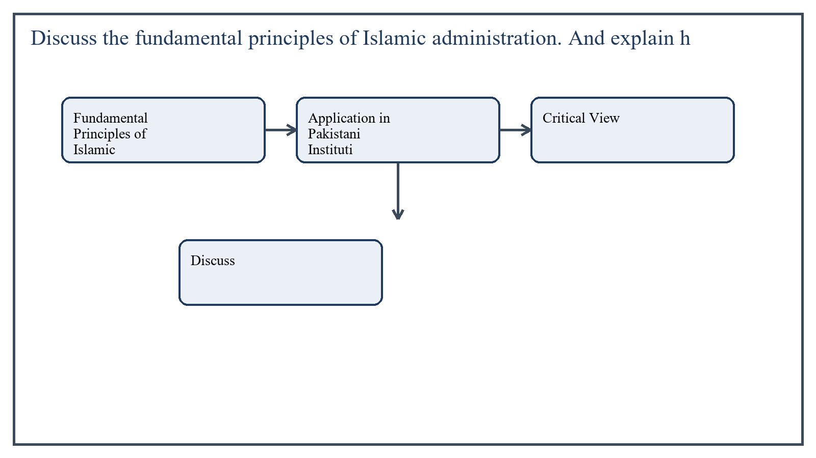
Figure 1: Concept map for Question 1

Fundamental Principles of Islamic Administration
These principles make Islamic administration deeply ethical. A leader is expected to be truthful, transparent, and humble, and to avoid favoritism, exploitation, and corruption.
- Amanah: authority is a trust and must be used responsibly.
- Adl: justice and fairness in decisions, distribution, and treatment.
- Shura: consultation with relevant people before important decisions.
- Accountability: leaders remain answerable to Allah and society.
- Equality and dignity: people should be treated with respect regardless of status.
- Welfare orientation: administration should serve collective good, not personal interest.
In the context of Educational Leadership and Management, the theme of fundamental principles of islamic administration deserves extended attention because assignment-level understanding is expected to move beyond one-line definitions and into explanation, comparison, and application. A strong university answer shows not only what the concept means, but also why it matters, how it appears in practice, and what limitations or challenges may arise when it is implemented in real educational settings.
A mature academic response also connects fundamental principles of islamic administration with classroom realities, institutional culture, and the Pakistani context wherever relevant. This makes the answer more analytical and more useful because it links conceptual understanding with the needs of teachers, learners, administrators, and communities rather than leaving the idea at a purely theoretical level.
From an examination and assignment-writing perspective, the topic of fundamental principles of islamic administration should be handled through clear structure, careful terminology, valid examples, and balanced discussion. The strongest responses usually define the idea, explain its major components, illustrate it through educational examples, and then conclude with a reasoned judgment about its significance, usefulness, or limitations.

Application in Pakistani Institutions
In many Pakistani institutions, these principles are visible to some extent in practices such as committee decision-making, distribution of duties, welfare measures, and moral expectations from administrators.
For example, school heads often consult staff on timetables, annual planning, and events, which reflects shura. Rules about fair admissions, discipline, and staff conduct also show attempts to uphold justice and accountability.
In the context of Educational Leadership and Management, the theme of application in pakistani institutions deserves extended attention because assignment-level understanding is expected to move beyond one-line definitions and into explanation, comparison, and application. A strong university answer shows not only what the concept means, but also why it matters, how it appears in practice, and what limitations or challenges may arise when it is implemented in real educational settings.
A mature academic response also connects application in pakistani institutions with classroom realities, institutional culture, and the Pakistani context wherever relevant. This makes the answer more analytical and more useful because it links conceptual understanding with the needs of teachers, learners, administrators, and communities rather than leaving the idea at a purely theoretical level.
From an examination and assignment-writing perspective, the topic of application in pakistani institutions should be handled through clear structure, careful terminology, valid examples, and balanced discussion. The strongest responses usually define the idea, explain its major components, illustrate it through educational examples, and then conclude with a reasoned judgment about its significance, usefulness, or limitations.

Critical View
However, practice is uneven. In some institutions, favoritism, political pressure, delay in decision-making, and weak accountability reduce the true spirit of Islamic administration. Therefore, while the principles are widely acknowledged, their actual implementation still needs strengthening.
In the context of Educational Leadership and Management, the theme of critical view deserves extended attention because assignment-level understanding is expected to move beyond one-line definitions and into explanation, comparison, and application. A strong university answer shows not only what the concept means, but also why it matters, how it appears in practice, and what limitations or challenges may arise when it is implemented in real educational settings.
A mature academic response also connects critical view with classroom realities, institutional culture, and the Pakistani context wherever relevant. This makes the answer more analytical and more useful because it links conceptual understanding with the needs of teachers, learners, administrators, and communities rather than leaving the idea at a purely theoretical level.
From an examination and assignment-writing perspective, the topic of critical view should be handled through clear structure, careful terminology, valid examples, and balanced discussion. The strongest responses usually define the idea, explain its major components, illustrate it through educational examples, and then conclude with a reasoned judgment about its significance, usefulness, or limitations.

Applied Illustration and Academic Note
For a stronger B.Ed assignment response, the topic above should be linked with classroom life, institutional practice, and the needs of Pakistani learners. This approach makes the response more analytical and demonstrates that the writer understands both theory and application, which is usually appreciated in AIOU-style academic work.
A good response also avoids unsupported claims. Instead, it explains concepts carefully, gives relevant examples, and ends with a short judgment about educational significance. In this way, the answer to 'Discuss the fundamental principles of Islamic administration. And expl...' becomes easier to read, easier to assess, and more academically convincing.

Quick Review Table
Focus Area | Assignment Relevance
Fundamental Principles of Islamic Administration | This area helps answer the question on 'Discuss the fundamental principles of Islamic administr...' by providing concept clarity, explanation, and applied educational value.
Application in Pakistani Institutions | This area helps answer the question on 'Discuss the fundamental principles of Islamic administr...' by providing concept clarity, explanation, and applied educational value.
Critical View | This area helps answer the question on 'Discuss the fundamental principles of Islamic administr...' by providing concept clarity, explanation, and applied educational value.

Critical Reflection
At an advanced level, the topic should not be treated as a fixed formula. Most educational concepts work within particular conditions, and their success often depends on planning quality, learner background, institutional support, and the competence of the teacher or manager using them. A reflective assignment therefore acknowledges strengths while also recognizing practical limitations.

Conclusion
Islamic administration is grounded in trust, justice, consultation, accountability, and public welfare. Pakistani administrators often recognize these principles, but the extent of real implementation varies. Stronger commitment to ethical leadership is needed to bring institutional practice closer to these ideals.

Q.2 Management functions and administration functions are often considered the same. Differentiate among the functions of management and administration with the help of examples.
Answer: The answer below is organized in an academic assignment style, with conceptual explanation, applied discussion, and concise analytical closing comments designed for a neat and extended university submission.
Management and administration are closely related, but they are not exactly the same. Administration is usually concerned with policy direction and broad decision-making, while management focuses more on implementing plans and running day-to-day operations.
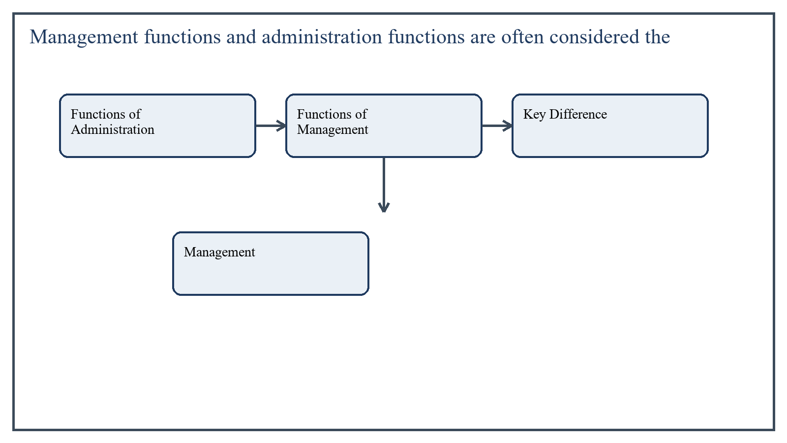
Figure 2: Concept map for Question 2

Functions of Administration
Administration usually deals with setting goals, framing policies, approving programs, and making major institutional decisions. In education, it may include policy formation, long-term planning, and coordination with higher authorities.
For example, deciding school expansion policy or approving the annual development plan is largely administrative in nature.
In the context of Educational Leadership and Management, the theme of functions of administration deserves extended attention because assignment-level understanding is expected to move beyond one-line definitions and into explanation, comparison, and application. A strong university answer shows not only what the concept means, but also why it matters, how it appears in practice, and what limitations or challenges may arise when it is implemented in real educational settings.
A mature academic response also connects functions of administration with classroom realities, institutional culture, and the Pakistani context wherever relevant. This makes the answer more analytical and more useful because it links conceptual understanding with the needs of teachers, learners, administrators, and communities rather than leaving the idea at a purely theoretical level.
From an examination and assignment-writing perspective, the topic of functions of administration should be handled through clear structure, careful terminology, valid examples, and balanced discussion. The strongest responses usually define the idea, explain its major components, illustrate it through educational examples, and then conclude with a reasoned judgment about its significance, usefulness, or limitations.

Functions of Management
Management focuses on planning work execution, organizing resources, directing staff, supervising implementation, solving operational problems, and evaluating daily performance.
For example, preparing staff duty rosters, arranging classrooms, monitoring attendance, and ensuring smooth examination conduct are management functions.
In the context of Educational Leadership and Management, the theme of functions of management deserves extended attention because assignment-level understanding is expected to move beyond one-line definitions and into explanation, comparison, and application. A strong university answer shows not only what the concept means, but also why it matters, how it appears in practice, and what limitations or challenges may arise when it is implemented in real educational settings.
A mature academic response also connects functions of management with classroom realities, institutional culture, and the Pakistani context wherever relevant. This makes the answer more analytical and more useful because it links conceptual understanding with the needs of teachers, learners, administrators, and communities rather than leaving the idea at a purely theoretical level.
From an examination and assignment-writing perspective, the topic of functions of management should be handled through clear structure, careful terminology, valid examples, and balanced discussion. The strongest responses usually define the idea, explain its major components, illustrate it through educational examples, and then conclude with a reasoned judgment about its significance, usefulness, or limitations.

Key Difference
- Administration decides what is to be done; management decides how it will be done.
- Administration is broader and policy-oriented; management is operational and execution-oriented.
- Administration often works at higher decision levels; management functions more directly at implementation level.
In the context of Educational Leadership and Management, the theme of key difference deserves extended attention because assignment-level understanding is expected to move beyond one-line definitions and into explanation, comparison, and application. A strong university answer shows not only what the concept means, but also why it matters, how it appears in practice, and what limitations or challenges may arise when it is implemented in real educational settings.
A mature academic response also connects key difference with classroom realities, institutional culture, and the Pakistani context wherever relevant. This makes the answer more analytical and more useful because it links conceptual understanding with the needs of teachers, learners, administrators, and communities rather than leaving the idea at a purely theoretical level.
From an examination and assignment-writing perspective, the topic of key difference should be handled through clear structure, careful terminology, valid examples, and balanced discussion. The strongest responses usually define the idea, explain its major components, illustrate it through educational examples, and then conclude with a reasoned judgment about its significance, usefulness, or limitations.

Applied Illustration and Academic Note
For a stronger B.Ed assignment response, the topic above should be linked with classroom life, institutional practice, and the needs of Pakistani learners. This approach makes the response more analytical and demonstrates that the writer understands both theory and application, which is usually appreciated in AIOU-style academic work.
A good response also avoids unsupported claims. Instead, it explains concepts carefully, gives relevant examples, and ends with a short judgment about educational significance. In this way, the answer to 'Management functions and administration functions are often considered...' becomes easier to read, easier to assess, and more academically convincing.

Quick Review Table
Focus Area | Assignment Relevance
Functions of Administration | This area helps answer the question on 'Management functions and administration functions are o...' by providing concept clarity, explanation, and applied educational value.
Functions of Management | This area helps answer the question on 'Management functions and administration functions are o...' by providing concept clarity, explanation, and applied educational value.
Key Difference | This area helps answer the question on 'Management functions and administration functions are o...' by providing concept clarity, explanation, and applied educational value.

Critical Reflection
At an advanced level, the topic should not be treated as a fixed formula. Most educational concepts work within particular conditions, and their success often depends on planning quality, learner background, institutional support, and the competence of the teacher or manager using them. A reflective assignment therefore acknowledges strengths while also recognizing practical limitations.

Conclusion
Administration and management are interconnected but distinct. Administration provides policy direction and institutional goals, while management turns those decisions into practical action. Educational institutions need both for smooth and purposeful functioning.

Q.3 Human resource management and financial management are essential components of any organization. As a manager, how you will manage human resources and financial resources?
Answer: The answer below is organized in an academic assignment style, with conceptual explanation, applied discussion, and concise analytical closing comments designed for a neat and extended university submission.
Human and financial resources are central to institutional success. A good manager must ensure that people are motivated and competent, while finances are planned, controlled, and used transparently.
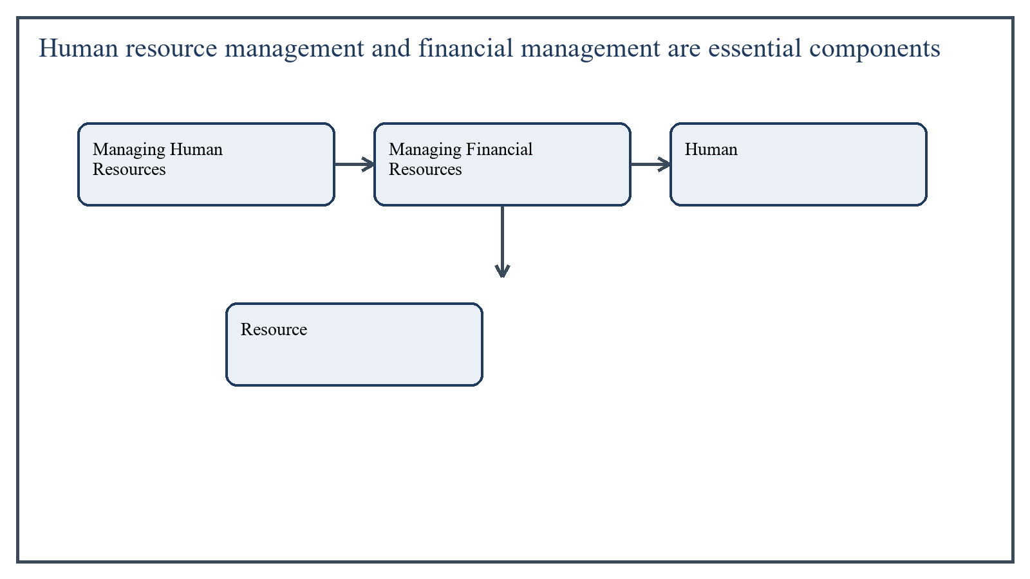
Figure 3: Concept map for Question 3

Managing Human Resources
As a manager, I would treat staff as the most important institutional asset. Effective human resource management means placing the right person in the right role, maintaining morale, and creating a culture of accountability and support.
- Select staff on merit and according to institutional need.
- Define duties clearly and avoid role confusion.
- Encourage teamwork, communication, and mutual respect.
- Provide professional development and performance feedback.
- Recognize good work and address conflicts fairly.
In the context of Educational Leadership and Management, the theme of managing human resources deserves extended attention because assignment-level understanding is expected to move beyond one-line definitions and into explanation, comparison, and application. A strong university answer shows not only what the concept means, but also why it matters, how it appears in practice, and what limitations or challenges may arise when it is implemented in real educational settings.
A mature academic response also connects managing human resources with classroom realities, institutional culture, and the Pakistani context wherever relevant. This makes the answer more analytical and more useful because it links conceptual understanding with the needs of teachers, learners, administrators, and communities rather than leaving the idea at a purely theoretical level.
From an examination and assignment-writing perspective, the topic of managing human resources should be handled through clear structure, careful terminology, valid examples, and balanced discussion. The strongest responses usually define the idea, explain its major components, illustrate it through educational examples, and then conclude with a reasoned judgment about its significance, usefulness, or limitations.

Managing Financial Resources
Financial management requires planning, honesty, and prioritization. Educational funds should be allocated to areas such as staffing, materials, maintenance, and student support according to actual needs rather than personal preference.
- Prepare a realistic budget according to priorities.
- Ensure transparent spending and proper record keeping.
- Monitor income and expenditure regularly.
- Prevent waste and misuse through controls and approval procedures.
- Use available funds in ways that directly support learning and institutional goals.
In the context of Educational Leadership and Management, the theme of managing financial resources deserves extended attention because assignment-level understanding is expected to move beyond one-line definitions and into explanation, comparison, and application. A strong university answer shows not only what the concept means, but also why it matters, how it appears in practice, and what limitations or challenges may arise when it is implemented in real educational settings.
A mature academic response also connects managing financial resources with classroom realities, institutional culture, and the Pakistani context wherever relevant. This makes the answer more analytical and more useful because it links conceptual understanding with the needs of teachers, learners, administrators, and communities rather than leaving the idea at a purely theoretical level.
From an examination and assignment-writing perspective, the topic of managing financial resources should be handled through clear structure, careful terminology, valid examples, and balanced discussion. The strongest responses usually define the idea, explain its major components, illustrate it through educational examples, and then conclude with a reasoned judgment about its significance, usefulness, or limitations.

Applied Illustration and Academic Note
For a stronger B.Ed assignment response, the topic above should be linked with classroom life, institutional practice, and the needs of Pakistani learners. This approach makes the response more analytical and demonstrates that the writer understands both theory and application, which is usually appreciated in AIOU-style academic work.
A good response also avoids unsupported claims. Instead, it explains concepts carefully, gives relevant examples, and ends with a short judgment about educational significance. In this way, the answer to 'Human resource management and financial management are essential compo...' becomes easier to read, easier to assess, and more academically convincing.

Quick Review Table
Focus Area | Assignment Relevance
Managing Human Resources | This area helps answer the question on 'Human resource management and financial management are ...' by providing concept clarity, explanation, and applied educational value.
Managing Financial Resources | This area helps answer the question on 'Human resource management and financial management are ...' by providing concept clarity, explanation, and applied educational value.

Critical Reflection
At an advanced level, the topic should not be treated as a fixed formula. Most educational concepts work within particular conditions, and their success often depends on planning quality, learner background, institutional support, and the competence of the teacher or manager using them. A reflective assignment therefore acknowledges strengths while also recognizing practical limitations.

Conclusion
A good manager handles human resources through fair staffing, motivation, development, and supervision, and manages finances through planning, accountability, and wise allocation. Balanced management of both resources is necessary for institutional effectiveness.

Q.4 Critically examine the techniques of supervision. Also explore which techniques are mostly to be used by our supervisor and why.
Answer: The answer below is organized in an academic assignment style, with conceptual explanation, applied discussion, and concise analytical closing comments designed for a neat and extended university submission.
Supervision is an important educational function aimed at improving teaching and institutional effectiveness. Its techniques vary according to purpose, context, and style of leadership, and their value depends on how they are used.
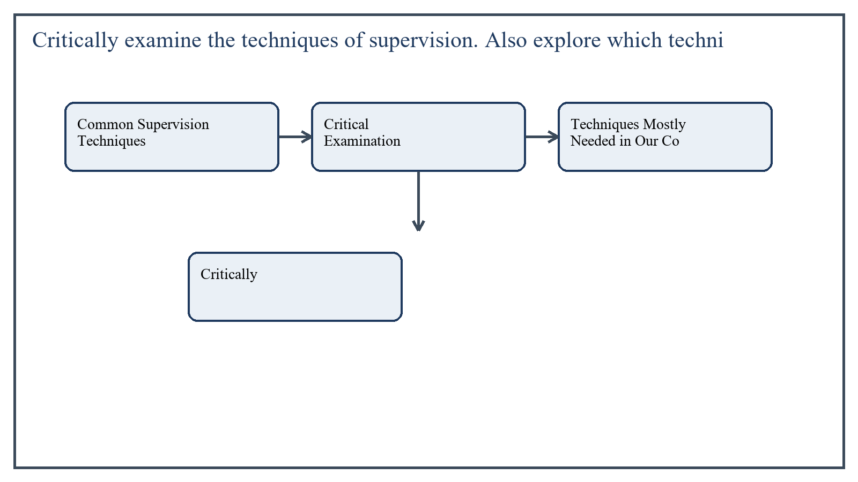
Figure 4: Concept map for Question 4

Common Supervision Techniques
Classroom observation is one of the most common techniques. The supervisor observes teaching directly and later provides feedback. This is useful because it connects supervision with real classroom practice.
Conference technique involves face-to-face discussion between supervisor and teacher to reflect on problems, strengths, and improvement areas. It supports professional growth through dialogue.
Demonstration teaching is another technique in which a skilled teacher or supervisor models effective teaching practice. It is helpful when teachers need practical guidance rather than abstract advice.
Workshop and group discussion techniques are also important because they address shared professional needs collectively.
In the context of Educational Leadership and Management, the theme of common supervision techniques deserves extended attention because assignment-level understanding is expected to move beyond one-line definitions and into explanation, comparison, and application. A strong university answer shows not only what the concept means, but also why it matters, how it appears in practice, and what limitations or challenges may arise when it is implemented in real educational settings.
A mature academic response also connects common supervision techniques with classroom realities, institutional culture, and the Pakistani context wherever relevant. This makes the answer more analytical and more useful because it links conceptual understanding with the needs of teachers, learners, administrators, and communities rather than leaving the idea at a purely theoretical level.
From an examination and assignment-writing perspective, the topic of common supervision techniques should be handled through clear structure, careful terminology, valid examples, and balanced discussion. The strongest responses usually define the idea, explain its major components, illustrate it through educational examples, and then conclude with a reasoned judgment about its significance, usefulness, or limitations.

Critical Examination
Observation is powerful, but if used only for fault-finding, it creates fear. Conferences are constructive, but they require communication skill and trust. Demonstrations are useful, though they may become less effective if they are unrealistic or disconnected from local classroom conditions.
In the context of Educational Leadership and Management, the theme of critical examination deserves extended attention because assignment-level understanding is expected to move beyond one-line definitions and into explanation, comparison, and application. A strong university answer shows not only what the concept means, but also why it matters, how it appears in practice, and what limitations or challenges may arise when it is implemented in real educational settings.
A mature academic response also connects critical examination with classroom realities, institutional culture, and the Pakistani context wherever relevant. This makes the answer more analytical and more useful because it links conceptual understanding with the needs of teachers, learners, administrators, and communities rather than leaving the idea at a purely theoretical level.
From an examination and assignment-writing perspective, the topic of critical examination should be handled through clear structure, careful terminology, valid examples, and balanced discussion. The strongest responses usually define the idea, explain its major components, illustrate it through educational examples, and then conclude with a reasoned judgment about its significance, usefulness, or limitations.

Techniques Mostly Needed in Our Context
In our educational context, supportive classroom observation, post-observation conference, and workshop-based supervision are among the most suitable techniques. These are needed because many teachers require practical feedback, encouragement, and professional development rather than only inspection.
Supervisors should use these techniques because they improve teaching while maintaining dignity and cooperation. In many institutions, teachers are more likely to improve when supervision is developmental rather than punitive.
In the context of Educational Leadership and Management, the theme of techniques mostly needed in our context deserves extended attention because assignment-level understanding is expected to move beyond one-line definitions and into explanation, comparison, and application. A strong university answer shows not only what the concept means, but also why it matters, how it appears in practice, and what limitations or challenges may arise when it is implemented in real educational settings.
A mature academic response also connects techniques mostly needed in our context with classroom realities, institutional culture, and the Pakistani context wherever relevant. This makes the answer more analytical and more useful because it links conceptual understanding with the needs of teachers, learners, administrators, and communities rather than leaving the idea at a purely theoretical level.
From an examination and assignment-writing perspective, the topic of techniques mostly needed in our context should be handled through clear structure, careful terminology, valid examples, and balanced discussion. The strongest responses usually define the idea, explain its major components, illustrate it through educational examples, and then conclude with a reasoned judgment about its significance, usefulness, or limitations.

Applied Illustration and Academic Note
For a stronger B.Ed assignment response, the topic above should be linked with classroom life, institutional practice, and the needs of Pakistani learners. This approach makes the response more analytical and demonstrates that the writer understands both theory and application, which is usually appreciated in AIOU-style academic work.
A good response also avoids unsupported claims. Instead, it explains concepts carefully, gives relevant examples, and ends with a short judgment about educational significance. In this way, the answer to 'Critically examine the techniques of supervision. Also explore which t...' becomes easier to read, easier to assess, and more academically convincing.

Quick Review Table
Focus Area | Assignment Relevance
Common Supervision Techniques | This area helps answer the question on 'Critically examine the techniques of supervision. Also ...' by providing concept clarity, explanation, and applied educational value.
Critical Examination | This area helps answer the question on 'Critically examine the techniques of supervision. Also ...' by providing concept clarity, explanation, and applied educational value.
Techniques Mostly Needed in Our Context | This area helps answer the question on 'Critically examine the techniques of supervision. Also ...' by providing concept clarity, explanation, and applied educational value.

Critical Reflection
At an advanced level, the topic should not be treated as a fixed formula. Most educational concepts work within particular conditions, and their success often depends on planning quality, learner background, institutional support, and the competence of the teacher or manager using them. A reflective assignment therefore acknowledges strengths while also recognizing practical limitations.

Conclusion
Supervision techniques such as observation, conference, demonstration, and workshops all have value, but their effectiveness depends on how they are applied. In our context, supportive and improvement-oriented supervision techniques are most useful because they strengthen teaching without creating unnecessary fear or resistance.

Q.5 Define Project. What are the necessary things for planning a project in an educational setting?
Answer: The answer below is organized in an academic assignment style, with conceptual explanation, applied discussion, and concise analytical closing comments designed for a neat and extended university submission.
A project is a planned and organized set of activities designed to achieve specific objectives within a defined period, budget, and scope. In education, projects may focus on infrastructure, learning improvement, teacher training, technology integration, or community involvement.
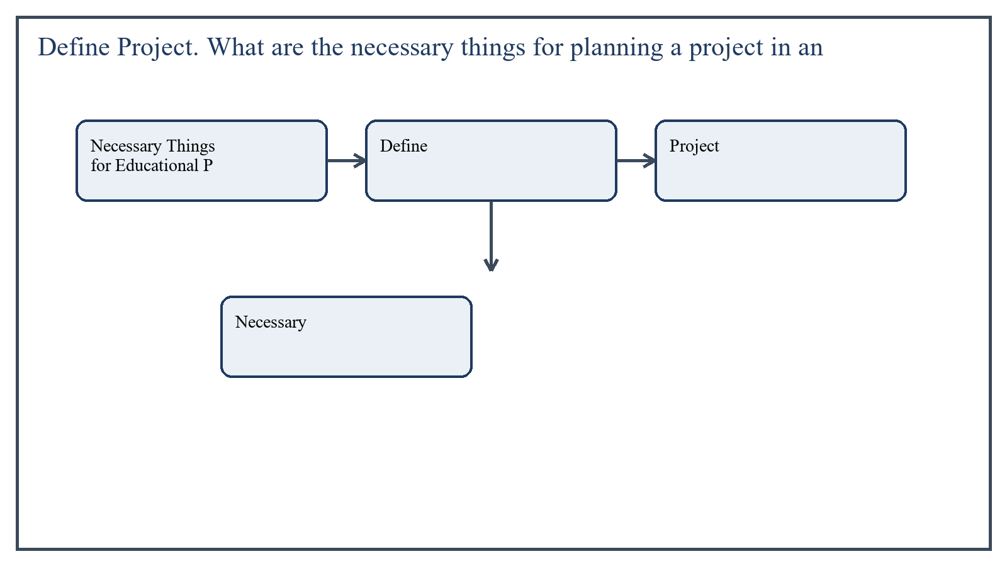
Figure 5: Concept map for Question 5

Necessary Things for Educational Project Planning
A well-planned project should begin with a real educational need, such as low reading levels or shortage of science equipment. Objectives should then be stated clearly, activities arranged logically, and responsibilities assigned carefully.
- Clear statement of need or problem
- Specific and achievable objectives
- Defined target group and beneficiaries
- Detailed activities and implementation steps
- Time schedule and work plan
- Human, material, and financial resource requirements
- Monitoring and evaluation mechanism
- Risk assessment and sustainability planning
In the context of Educational Leadership and Management, the theme of necessary things for educational project planning deserves extended attention because assignment-level understanding is expected to move beyond one-line definitions and into explanation, comparison, and application. A strong university answer shows not only what the concept means, but also why it matters, how it appears in practice, and what limitations or challenges may arise when it is implemented in real educational settings.
A mature academic response also connects necessary things for educational project planning with classroom realities, institutional culture, and the Pakistani context wherever relevant. This makes the answer more analytical and more useful because it links conceptual understanding with the needs of teachers, learners, administrators, and communities rather than leaving the idea at a purely theoretical level.
From an examination and assignment-writing perspective, the topic of necessary things for educational project planning should be handled through clear structure, careful terminology, valid examples, and balanced discussion. The strongest responses usually define the idea, explain its major components, illustrate it through educational examples, and then conclude with a reasoned judgment about its significance, usefulness, or limitations.

Applied Illustration and Academic Note
For a stronger B.Ed assignment response, the topic above should be linked with classroom life, institutional practice, and the needs of Pakistani learners. This approach makes the response more analytical and demonstrates that the writer understands both theory and application, which is usually appreciated in AIOU-style academic work.
A good response also avoids unsupported claims. Instead, it explains concepts carefully, gives relevant examples, and ends with a short judgment about educational significance. In this way, the answer to 'Define Project. What are the necessary things for planning a project i...' becomes easier to read, easier to assess, and more academically convincing.

Quick Review Table
Focus Area | Assignment Relevance
Necessary Things for Educational Project Planning | This area helps answer the question on 'Define Project. What are the necessary things for plann...' by providing concept clarity, explanation, and applied educational value.

Critical Reflection
At an advanced level, the topic should not be treated as a fixed formula. Most educational concepts work within particular conditions, and their success often depends on planning quality, learner background, institutional support, and the competence of the teacher or manager using them. A reflective assignment therefore acknowledges strengths while also recognizing practical limitations.

Conclusion
An educational project is a purposeful and time-bound plan for improvement. Good planning requires clear objectives, proper resource estimation, scheduling, implementation strategy, and evaluation. Without these elements, project work may become confused and ineffective.

Extended Revision Appendix
This appendix is included to strengthen the assignment as a premium academic submission. It provides recap notes, revision prompts, and concept reinforcement so the document reads like a complete study-ready submission rather than a short-answer sheet only.

Key Revision Points
- Review the central demand of the question 'Discuss the fundamental principles of Islamic administration. ...' and connect definition, explanation, example, and critical comment in one organized response.
- Review the central demand of the question 'Management functions and administration functions are often co...' and connect definition, explanation, example, and critical comment in one organized response.
- Review the central demand of the question 'Human resource management and financial management are essenti...' and connect definition, explanation, example, and critical comment in one organized response.
- Review the central demand of the question 'Critically examine the techniques of supervision. Also explore...' and connect definition, explanation, example, and critical comment in one organized response.
- Review the central demand of the question 'Define Project. What are the necessary things for planning a p...' and connect definition, explanation, example, and critical comment in one organized response.

Academic Writing Reminders
- Begin each major answer with a clear conceptual opening.
- Use examples to show understanding instead of repeating definitions only.
- Present advantages, limitations, and contextual realities where relevant.
- Close each answer with a short evaluative conclusion.
- Maintain formal and neat language throughout the assignment.

Concept Reinforcement Notes
The question on 'Discuss the fundamental principles of Islamic administration. And explain h...' can be revised further by identifying three things: the main concept involved, the educational importance of that concept, and one example from Pakistani classroom or institutional life. This simple method helps transform memorized content into organized written response.
The question on 'Management functions and administration functions are often considered the ...' can be revised further by identifying three things: the main concept involved, the educational importance of that concept, and one example from Pakistani classroom or institutional life. This simple method helps transform memorized content into organized written response.
The question on 'Human resource management and financial management are essential components...' can be revised further by identifying three things: the main concept involved, the educational importance of that concept, and one example from Pakistani classroom or institutional life. This simple method helps transform memorized content into organized written response.
The question on 'Critically examine the techniques of supervision. Also explore which techni...' can be revised further by identifying three things: the main concept involved, the educational importance of that concept, and one example from Pakistani classroom or institutional life. This simple method helps transform memorized content into organized written response.
The question on 'Define Project. What are the necessary things for planning a project in an ...' can be revised further by identifying three things: the main concept involved, the educational importance of that concept, and one example from Pakistani classroom or institutional life. This simple method helps transform memorized content into organized written response.

Source Base and Assignment Support Notes
The following source base was used to keep the answers aligned with AIOU course structure and the exact question wording. The final language and organization were expanded for presentation quality, page-length target, and assignment readability.
- AIOU Soft Book: Educational Leadership and Management (Code 8605), especially units on Islamic administration, management and administration, resource management, supervision, and project planning.
- AIOU Spring 2026 assignment sheet for Course 8605.

Extended Analytical Note 1
In extended study of Educational Leadership and Management, the issue raised in 'Discuss the fundamental principles of Islamic administration. And explai...' may also be explored through definition, theoretical explanation, applied example, classroom implication, institutional implication, and critical reflection. This six-part approach helps a learner produce a more complete answer and also improves the academic appearance of the assignment by showing structure and depth.
Another useful strategy in long-form assignment writing is to move carefully from concept to context. First explain what the idea means, then identify its components, then discuss its relevance in teaching or administration, and finally mention any practical limitation. Such movement gives maturity to the answer and helps the examiner follow the logic without difficulty.
In extended study of Educational Leadership and Management, the issue raised in 'Management functions and administration functions are often considered t...' may also be explored through definition, theoretical explanation, applied example, classroom implication, institutional implication, and critical reflection. This six-part approach helps a learner produce a more complete answer and also improves the academic appearance of the assignment by showing structure and depth.
Another useful strategy in long-form assignment writing is to move carefully from concept to context. First explain what the idea means, then identify its components, then discuss its relevance in teaching or administration, and finally mention any practical limitation. Such movement gives maturity to the answer and helps the examiner follow the logic without difficulty.
In extended study of Educational Leadership and Management, the issue raised in 'Human resource management and financial management are essential compone...' may also be explored through definition, theoretical explanation, applied example, classroom implication, institutional implication, and critical reflection. This six-part approach helps a learner produce a more complete answer and also improves the academic appearance of the assignment by showing structure and depth.
Another useful strategy in long-form assignment writing is to move carefully from concept to context. First explain what the idea means, then identify its components, then discuss its relevance in teaching or administration, and finally mention any practical limitation. Such movement gives maturity to the answer and helps the examiner follow the logic without difficulty.
In extended study of Educational Leadership and Management, the issue raised in 'Critically examine the techniques of supervision. Also explore which tec...' may also be explored through definition, theoretical explanation, applied example, classroom implication, institutional implication, and critical reflection. This six-part approach helps a learner produce a more complete answer and also improves the academic appearance of the assignment by showing structure and depth.
Another useful strategy in long-form assignment writing is to move carefully from concept to context. First explain what the idea means, then identify its components, then discuss its relevance in teaching or administration, and finally mention any practical limitation. Such movement gives maturity to the answer and helps the examiner follow the logic without difficulty.
In extended study of Educational Leadership and Management, the issue raised in 'Define Project. What are the necessary things for planning a project in ...' may also be explored through definition, theoretical explanation, applied example, classroom implication, institutional implication, and critical reflection. This six-part approach helps a learner produce a more complete answer and also improves the academic appearance of the assignment by showing structure and depth.
Another useful strategy in long-form assignment writing is to move carefully from concept to context. First explain what the idea means, then identify its components, then discuss its relevance in teaching or administration, and finally mention any practical limitation. Such movement gives maturity to the answer and helps the examiner follow the logic without difficulty.

Extended Analytical Note 2
In extended study of Educational Leadership and Management, the issue raised in 'Discuss the fundamental principles of Islamic administration. And explai...' may also be explored through definition, theoretical explanation, applied example, classroom implication, institutional implication, and critical reflection. This six-part approach helps a learner produce a more complete answer and also improves the academic appearance of the assignment by showing structure and depth.
Another useful strategy in long-form assignment writing is to move carefully from concept to context. First explain what the idea means, then identify its components, then discuss its relevance in teaching or administration, and finally mention any practical limitation. Such movement gives maturity to the answer and helps the examiner follow the logic without difficulty.
In extended study of Educational Leadership and Management, the issue raised in 'Management functions and administration functions are often considered t...' may also be explored through definition, theoretical explanation, applied example, classroom implication, institutional implication, and critical reflection. This six-part approach helps a learner produce a more complete answer and also improves the academic appearance of the assignment by showing structure and depth.
Another useful strategy in long-form assignment writing is to move carefully from concept to context. First explain what the idea means, then identify its components, then discuss its relevance in teaching or administration, and finally mention any practical limitation. Such movement gives maturity to the answer and helps the examiner follow the logic without difficulty.
In extended study of Educational Leadership and Management, the issue raised in 'Human resource management and financial management are essential compone...' may also be explored through definition, theoretical explanation, applied example, classroom implication, institutional implication, and critical reflection. This six-part approach helps a learner produce a more complete answer and also improves the academic appearance of the assignment by showing structure and depth.
Another useful strategy in long-form assignment writing is to move carefully from concept to context. First explain what the idea means, then identify its components, then discuss its relevance in teaching or administration, and finally mention any practical limitation. Such movement gives maturity to the answer and helps the examiner follow the logic without difficulty.
In extended study of Educational Leadership and Management, the issue raised in 'Critically examine the techniques of supervision. Also explore which tec...' may also be explored through definition, theoretical explanation, applied example, classroom implication, institutional implication, and critical reflection. This six-part approach helps a learner produce a more complete answer and also improves the academic appearance of the assignment by showing structure and depth.
Another useful strategy in long-form assignment writing is to move carefully from concept to context. First explain what the idea means, then identify its components, then discuss its relevance in teaching or administration, and finally mention any practical limitation. Such movement gives maturity to the answer and helps the examiner follow the logic without difficulty.
In extended study of Educational Leadership and Management, the issue raised in 'Define Project. What are the necessary things for planning a project in ...' may also be explored through definition, theoretical explanation, applied example, classroom implication, institutional implication, and critical reflection. This six-part approach helps a learner produce a more complete answer and also improves the academic appearance of the assignment by showing structure and depth.
Another useful strategy in long-form assignment writing is to move carefully from concept to context. First explain what the idea means, then identify its components, then discuss its relevance in teaching or administration, and finally mention any practical limitation. Such movement gives maturity to the answer and helps the examiner follow the logic without difficulty.

Extended Analytical Note 3
In extended study of Educational Leadership and Management, the issue raised in 'Discuss the fundamental principles of Islamic administration. And explai...' may also be explored through definition, theoretical explanation, applied example, classroom implication, institutional implication, and critical reflection. This six-part approach helps a learner produce a more complete answer and also improves the academic appearance of the assignment by showing structure and depth.
Another useful strategy in long-form assignment writing is to move carefully from concept to context. First explain what the idea means, then identify its components, then discuss its relevance in teaching or administration, and finally mention any practical limitation. Such movement gives maturity to the answer and helps the examiner follow the logic without difficulty.
In extended study of Educational Leadership and Management, the issue raised in 'Management functions and administration functions are often considered t...' may also be explored through definition, theoretical explanation, applied example, classroom implication, institutional implication, and critical reflection. This six-part approach helps a learner produce a more complete answer and also improves the academic appearance of the assignment by showing structure and depth.
Another useful strategy in long-form assignment writing is to move carefully from concept to context. First explain what the idea means, then identify its components, then discuss its relevance in teaching or administration, and finally mention any practical limitation. Such movement gives maturity to the answer and helps the examiner follow the logic without difficulty.
In extended study of Educational Leadership and Management, the issue raised in 'Human resource management and financial management are essential compone...' may also be explored through definition, theoretical explanation, applied example, classroom implication, institutional implication, and critical reflection. This six-part approach helps a learner produce a more complete answer and also improves the academic appearance of the assignment by showing structure and depth.
Another useful strategy in long-form assignment writing is to move carefully from concept to context. First explain what the idea means, then identify its components, then discuss its relevance in teaching or administration, and finally mention any practical limitation. Such movement gives maturity to the answer and helps the examiner follow the logic without difficulty.
In extended study of Educational Leadership and Management, the issue raised in 'Critically examine the techniques of supervision. Also explore which tec...' may also be explored through definition, theoretical explanation, applied example, classroom implication, institutional implication, and critical reflection. This six-part approach helps a learner produce a more complete answer and also improves the academic appearance of the assignment by showing structure and depth.
Another useful strategy in long-form assignment writing is to move carefully from concept to context. First explain what the idea means, then identify its components, then discuss its relevance in teaching or administration, and finally mention any practical limitation. Such movement gives maturity to the answer and helps the examiner follow the logic without difficulty.
In extended study of Educational Leadership and Management, the issue raised in 'Define Project. What are the necessary things for planning a project in ...' may also be explored through definition, theoretical explanation, applied example, classroom implication, institutional implication, and critical reflection. This six-part approach helps a learner produce a more complete answer and also improves the academic appearance of the assignment by showing structure and depth.
Another useful strategy in long-form assignment writing is to move carefully from concept to context. First explain what the idea means, then identify its components, then discuss its relevance in teaching or administration, and finally mention any practical limitation. Such movement gives maturity to the answer and helps the examiner follow the logic without difficulty.

Extended Analytical Note 4
In extended study of Educational Leadership and Management, the issue raised in 'Discuss the fundamental principles of Islamic administration. And explai...' may also be explored through definition, theoretical explanation, applied example, classroom implication, institutional implication, and critical reflection. This six-part approach helps a learner produce a more complete answer and also improves the academic appearance of the assignment by showing structure and depth.
Another useful strategy in long-form assignment writing is to move carefully from concept to context. First explain what the idea means, then identify its components, then discuss its relevance in teaching or administration, and finally mention any practical limitation. Such movement gives maturity to the answer and helps the examiner follow the logic without difficulty.
In extended study of Educational Leadership and Management, the issue raised in 'Management functions and administration functions are often considered t...' may also be explored through definition, theoretical explanation, applied example, classroom implication, institutional implication, and critical reflection. This six-part approach helps a learner produce a more complete answer and also improves the academic appearance of the assignment by showing structure and depth.
Another useful strategy in long-form assignment writing is to move carefully from concept to context. First explain what the idea means, then identify its components, then discuss its relevance in teaching or administration, and finally mention any practical limitation. Such movement gives maturity to the answer and helps the examiner follow the logic without difficulty.
In extended study of Educational Leadership and Management, the issue raised in 'Human resource management and financial management are essential compone...' may also be explored through definition, theoretical explanation, applied example, classroom implication, institutional implication, and critical reflection. This six-part approach helps a learner produce a more complete answer and also improves the academic appearance of the assignment by showing structure and depth.
Another useful strategy in long-form assignment writing is to move carefully from concept to context. First explain what the idea means, then identify its components, then discuss its relevance in teaching or administration, and finally mention any practical limitation. Such movement gives maturity to the answer and helps the examiner follow the logic without difficulty.
In extended study of Educational Leadership and Management, the issue raised in 'Critically examine the techniques of supervision. Also explore which tec...' may also be explored through definition, theoretical explanation, applied example, classroom implication, institutional implication, and critical reflection. This six-part approach helps a learner produce a more complete answer and also improves the academic appearance of the assignment by showing structure and depth.
Another useful strategy in long-form assignment writing is to move carefully from concept to context. First explain what the idea means, then identify its components, then discuss its relevance in teaching or administration, and finally mention any practical limitation. Such movement gives maturity to the answer and helps the examiner follow the logic without difficulty.
In extended study of Educational Leadership and Management, the issue raised in 'Define Project. What are the necessary things for planning a project in ...' may also be explored through definition, theoretical explanation, applied example, classroom implication, institutional implication, and critical reflection. This six-part approach helps a learner produce a more complete answer and also improves the academic appearance of the assignment by showing structure and depth.
Another useful strategy in long-form assignment writing is to move carefully from concept to context. First explain what the idea means, then identify its components, then discuss its relevance in teaching or administration, and finally mention any practical limitation. Such movement gives maturity to the answer and helps the examiner follow the logic without difficulty.

Extended Analytical Note 5
In extended study of Educational Leadership and Management, the issue raised in 'Discuss the fundamental principles of Islamic administration. And explai...' may also be explored through definition, theoretical explanation, applied example, classroom implication, institutional implication, and critical reflection. This six-part approach helps a learner produce a more complete answer and also improves the academic appearance of the assignment by showing structure and depth.
Another useful strategy in long-form assignment writing is to move carefully from concept to context. First explain what the idea means, then identify its components, then discuss its relevance in teaching or administration, and finally mention any practical limitation. Such movement gives maturity to the answer and helps the examiner follow the logic without difficulty.
In extended study of Educational Leadership and Management, the issue raised in 'Management functions and administration functions are often considered t...' may also be explored through definition, theoretical explanation, applied example, classroom implication, institutional implication, and critical reflection. This six-part approach helps a learner produce a more complete answer and also improves the academic appearance of the assignment by showing structure and depth.
Another useful strategy in long-form assignment writing is to move carefully from concept to context. First explain what the idea means, then identify its components, then discuss its relevance in teaching or administration, and finally mention any practical limitation. Such movement gives maturity to the answer and helps the examiner follow the logic without difficulty.
In extended study of Educational Leadership and Management, the issue raised in 'Human resource management and financial management are essential compone...' may also be explored through definition, theoretical explanation, applied example, classroom implication, institutional implication, and critical reflection. This six-part approach helps a learner produce a more complete answer and also improves the academic appearance of the assignment by showing structure and depth.
Another useful strategy in long-form assignment writing is to move carefully from concept to context. First explain what the idea means, then identify its components, then discuss its relevance in teaching or administration, and finally mention any practical limitation. Such movement gives maturity to the answer and helps the examiner follow the logic without difficulty.
In extended study of Educational Leadership and Management, the issue raised in 'Critically examine the techniques of supervision. Also explore which tec...' may also be explored through definition, theoretical explanation, applied example, classroom implication, institutional implication, and critical reflection. This six-part approach helps a learner produce a more complete answer and also improves the academic appearance of the assignment by showing structure and depth.
Another useful strategy in long-form assignment writing is to move carefully from concept to context. First explain what the idea means, then identify its components, then discuss its relevance in teaching or administration, and finally mention any practical limitation. Such movement gives maturity to the answer and helps the examiner follow the logic without difficulty.
In extended study of Educational Leadership and Management, the issue raised in 'Define Project. What are the necessary things for planning a project in ...' may also be explored through definition, theoretical explanation, applied example, classroom implication, institutional implication, and critical reflection. This six-part approach helps a learner produce a more complete answer and also improves the academic appearance of the assignment by showing structure and depth.
Another useful strategy in long-form assignment writing is to move carefully from concept to context. First explain what the idea means, then identify its components, then discuss its relevance in teaching or administration, and finally mention any practical limitation. Such movement gives maturity to the answer and helps the examiner follow the logic without difficulty.

Extended Analytical Note 6
In extended study of Educational Leadership and Management, the issue raised in 'Discuss the fundamental principles of Islamic administration. And explai...' may also be explored through definition, theoretical explanation, applied example, classroom implication, institutional implication, and critical reflection. This six-part approach helps a learner produce a more complete answer and also improves the academic appearance of the assignment by showing structure and depth.
Another useful strategy in long-form assignment writing is to move carefully from concept to context. First explain what the idea means, then identify its components, then discuss its relevance in teaching or administration, and finally mention any practical limitation. Such movement gives maturity to the answer and helps the examiner follow the logic without difficulty.
In extended study of Educational Leadership and Management, the issue raised in 'Management functions and administration functions are often considered t...' may also be explored through definition, theoretical explanation, applied example, classroom implication, institutional implication, and critical reflection. This six-part approach helps a learner produce a more complete answer and also improves the academic appearance of the assignment by showing structure and depth.
Another useful strategy in long-form assignment writing is to move carefully from concept to context. First explain what the idea means, then identify its components, then discuss its relevance in teaching or administration, and finally mention any practical limitation. Such movement gives maturity to the answer and helps the examiner follow the logic without difficulty.
In extended study of Educational Leadership and Management, the issue raised in 'Human resource management and financial management are essential compone...' may also be explored through definition, theoretical explanation, applied example, classroom implication, institutional implication, and critical reflection. This six-part approach helps a learner produce a more complete answer and also improves the academic appearance of the assignment by showing structure and depth.
Another useful strategy in long-form assignment writing is to move carefully from concept to context. First explain what the idea means, then identify its components, then discuss its relevance in teaching or administration, and finally mention any practical limitation. Such movement gives maturity to the answer and helps the examiner follow the logic without difficulty.
In extended study of Educational Leadership and Management, the issue raised in 'Critically examine the techniques of supervision. Also explore which tec...' may also be explored through definition, theoretical explanation, applied example, classroom implication, institutional implication, and critical reflection. This six-part approach helps a learner produce a more complete answer and also improves the academic appearance of the assignment by showing structure and depth.
Another useful strategy in long-form assignment writing is to move carefully from concept to context. First explain what the idea means, then identify its components, then discuss its relevance in teaching or administration, and finally mention any practical limitation. Such movement gives maturity to the answer and helps the examiner follow the logic without difficulty.
In extended study of Educational Leadership and Management, the issue raised in 'Define Project. What are the necessary things for planning a project in ...' may also be explored through definition, theoretical explanation, applied example, classroom implication, institutional implication, and critical reflection. This six-part approach helps a learner produce a more complete answer and also improves the academic appearance of the assignment by showing structure and depth.
Another useful strategy in long-form assignment writing is to move carefully from concept to context. First explain what the idea means, then identify its components, then discuss its relevance in teaching or administration, and finally mention any practical limitation. Such movement gives maturity to the answer and helps the examiner follow the logic without difficulty.

Extended Analytical Note 7
In extended study of Educational Leadership and Management, the issue raised in 'Discuss the fundamental principles of Islamic administration. And explai...' may also be explored through definition, theoretical explanation, applied example, classroom implication, institutional implication, and critical reflection. This six-part approach helps a learner produce a more complete answer and also improves the academic appearance of the assignment by showing structure and depth.
Another useful strategy in long-form assignment writing is to move carefully from concept to context. First explain what the idea means, then identify its components, then discuss its relevance in teaching or administration, and finally mention any practical limitation. Such movement gives maturity to the answer and helps the examiner follow the logic without difficulty.
In extended study of Educational Leadership and Management, the issue raised in 'Management functions and administration functions are often considered t...' may also be explored through definition, theoretical explanation, applied example, classroom implication, institutional implication, and critical reflection. This six-part approach helps a learner produce a more complete answer and also improves the academic appearance of the assignment by showing structure and depth.
Another useful strategy in long-form assignment writing is to move carefully from concept to context. First explain what the idea means, then identify its components, then discuss its relevance in teaching or administration, and finally mention any practical limitation. Such movement gives maturity to the answer and helps the examiner follow the logic without difficulty.
In extended study of Educational Leadership and Management, the issue raised in 'Human resource management and financial management are essential compone...' may also be explored through definition, theoretical explanation, applied example, classroom implication, institutional implication, and critical reflection. This six-part approach helps a learner produce a more complete answer and also improves the academic appearance of the assignment by showing structure and depth.
Another useful strategy in long-form assignment writing is to move carefully from concept to context. First explain what the idea means, then identify its components, then discuss its relevance in teaching or administration, and finally mention any practical limitation. Such movement gives maturity to the answer and helps the examiner follow the logic without difficulty.
In extended study of Educational Leadership and Management, the issue raised in 'Critically examine the techniques of supervision. Also explore which tec...' may also be explored through definition, theoretical explanation, applied example, classroom implication, institutional implication, and critical reflection. This six-part approach helps a learner produce a more complete answer and also improves the academic appearance of the assignment by showing structure and depth.
Another useful strategy in long-form assignment writing is to move carefully from concept to context. First explain what the idea means, then identify its components, then discuss its relevance in teaching or administration, and finally mention any practical limitation. Such movement gives maturity to the answer and helps the examiner follow the logic without difficulty.
In extended study of Educational Leadership and Management, the issue raised in 'Define Project. What are the necessary things for planning a project in ...' may also be explored through definition, theoretical explanation, applied example, classroom implication, institutional implication, and critical reflection. This six-part approach helps a learner produce a more complete answer and also improves the academic appearance of the assignment by showing structure and depth.
Another useful strategy in long-form assignment writing is to move carefully from concept to context. First explain what the idea means, then identify its components, then discuss its relevance in teaching or administration, and finally mention any practical limitation. Such movement gives maturity to the answer and helps the examiner follow the logic without difficulty.

Extended Analytical Note 8
In extended study of Educational Leadership and Management, the issue raised in 'Discuss the fundamental principles of Islamic administration. And explai...' may also be explored through definition, theoretical explanation, applied example, classroom implication, institutional implication, and critical reflection. This six-part approach helps a learner produce a more complete answer and also improves the academic appearance of the assignment by showing structure and depth.
Another useful strategy in long-form assignment writing is to move carefully from concept to context. First explain what the idea means, then identify its components, then discuss its relevance in teaching or administration, and finally mention any practical limitation. Such movement gives maturity to the answer and helps the examiner follow the logic without difficulty.
In extended study of Educational Leadership and Management, the issue raised in 'Management functions and administration functions are often considered t...' may also be explored through definition, theoretical explanation, applied example, classroom implication, institutional implication, and critical reflection. This six-part approach helps a learner produce a more complete answer and also improves the academic appearance of the assignment by showing structure and depth.
Another useful strategy in long-form assignment writing is to move carefully from concept to context. First explain what the idea means, then identify its components, then discuss its relevance in teaching or administration, and finally mention any practical limitation. Such movement gives maturity to the answer and helps the examiner follow the logic without difficulty.
In extended study of Educational Leadership and Management, the issue raised in 'Human resource management and financial management are essential compone...' may also be explored through definition, theoretical explanation, applied example, classroom implication, institutional implication, and critical reflection. This six-part approach helps a learner produce a more complete answer and also improves the academic appearance of the assignment by showing structure and depth.
Another useful strategy in long-form assignment writing is to move carefully from concept to context. First explain what the idea means, then identify its components, then discuss its relevance in teaching or administration, and finally mention any practical limitation. Such movement gives maturity to the answer and helps the examiner follow the logic without difficulty.
In extended study of Educational Leadership and Management, the issue raised in 'Critically examine the techniques of supervision. Also explore which tec...' may also be explored through definition, theoretical explanation, applied example, classroom implication, institutional implication, and critical reflection. This six-part approach helps a learner produce a more complete answer and also improves the academic appearance of the assignment by showing structure and depth.
Another useful strategy in long-form assignment writing is to move carefully from concept to context. First explain what the idea means, then identify its components, then discuss its relevance in teaching or administration, and finally mention any practical limitation. Such movement gives maturity to the answer and helps the examiner follow the logic without difficulty.
In extended study of Educational Leadership and Management, the issue raised in 'Define Project. What are the necessary things for planning a project in ...' may also be explored through definition, theoretical explanation, applied example, classroom implication, institutional implication, and critical reflection. This six-part approach helps a learner produce a more complete answer and also improves the academic appearance of the assignment by showing structure and depth.
Another useful strategy in long-form assignment writing is to move carefully from concept to context. First explain what the idea means, then identify its components, then discuss its relevance in teaching or administration, and finally mention any practical limitation. Such movement gives maturity to the answer and helps the examiner follow the logic without difficulty.

Extended Analytical Note 9
In extended study of Educational Leadership and Management, the issue raised in 'Discuss the fundamental principles of Islamic administration. And explai...' may also be explored through definition, theoretical explanation, applied example, classroom implication, institutional implication, and critical reflection. This six-part approach helps a learner produce a more complete answer and also improves the academic appearance of the assignment by showing structure and depth.
Another useful strategy in long-form assignment writing is to move carefully from concept to context. First explain what the idea means, then identify its components, then discuss its relevance in teaching or administration, and finally mention any practical limitation. Such movement gives maturity to the answer and helps the examiner follow the logic without difficulty.
In extended study of Educational Leadership and Management, the issue raised in 'Management functions and administration functions are often considered t...' may also be explored through definition, theoretical explanation, applied example, classroom implication, institutional implication, and critical reflection. This six-part approach helps a learner produce a more complete answer and also improves the academic appearance of the assignment by showing structure and depth.
Another useful strategy in long-form assignment writing is to move carefully from concept to context. First explain what the idea means, then identify its components, then discuss its relevance in teaching or administration, and finally mention any practical limitation. Such movement gives maturity to the answer and helps the examiner follow the logic without difficulty.
In extended study of Educational Leadership and Management, the issue raised in 'Human resource management and financial management are essential compone...' may also be explored through definition, theoretical explanation, applied example, classroom implication, institutional implication, and critical reflection. This six-part approach helps a learner produce a more complete answer and also improves the academic appearance of the assignment by showing structure and depth.
Another useful strategy in long-form assignment writing is to move carefully from concept to context. First explain what the idea means, then identify its components, then discuss its relevance in teaching or administration, and finally mention any practical limitation. Such movement gives maturity to the answer and helps the examiner follow the logic without difficulty.
In extended study of Educational Leadership and Management, the issue raised in 'Critically examine the techniques of supervision. Also explore which tec...' may also be explored through definition, theoretical explanation, applied example, classroom implication, institutional implication, and critical reflection. This six-part approach helps a learner produce a more complete answer and also improves the academic appearance of the assignment by showing structure and depth.
Another useful strategy in long-form assignment writing is to move carefully from concept to context. First explain what the idea means, then identify its components, then discuss its relevance in teaching or administration, and finally mention any practical limitation. Such movement gives maturity to the answer and helps the examiner follow the logic without difficulty.
In extended study of Educational Leadership and Management, the issue raised in 'Define Project. What are the necessary things for planning a project in ...' may also be explored through definition, theoretical explanation, applied example, classroom implication, institutional implication, and critical reflection. This six-part approach helps a learner produce a more complete answer and also improves the academic appearance of the assignment by showing structure and depth.
Another useful strategy in long-form assignment writing is to move carefully from concept to context. First explain what the idea means, then identify its components, then discuss its relevance in teaching or administration, and finally mention any practical limitation. Such movement gives maturity to the answer and helps the examiner follow the logic without difficulty.

Extended Analytical Note 10
In extended study of Educational Leadership and Management, the issue raised in 'Discuss the fundamental principles of Islamic administration. And explai...' may also be explored through definition, theoretical explanation, applied example, classroom implication, institutional implication, and critical reflection. This six-part approach helps a learner produce a more complete answer and also improves the academic appearance of the assignment by showing structure and depth.
Another useful strategy in long-form assignment writing is to move carefully from concept to context. First explain what the idea means, then identify its components, then discuss its relevance in teaching or administration, and finally mention any practical limitation. Such movement gives maturity to the answer and helps the examiner follow the logic without difficulty.
In extended study of Educational Leadership and Management, the issue raised in 'Management functions and administration functions are often considered t...' may also be explored through definition, theoretical explanation, applied example, classroom implication, institutional implication, and critical reflection. This six-part approach helps a learner produce a more complete answer and also improves the academic appearance of the assignment by showing structure and depth.
Another useful strategy in long-form assignment writing is to move carefully from concept to context. First explain what the idea means, then identify its components, then discuss its relevance in teaching or administration, and finally mention any practical limitation. Such movement gives maturity to the answer and helps the examiner follow the logic without difficulty.
In extended study of Educational Leadership and Management, the issue raised in 'Human resource management and financial management are essential compone...' may also be explored through definition, theoretical explanation, applied example, classroom implication, institutional implication, and critical reflection. This six-part approach helps a learner produce a more complete answer and also improves the academic appearance of the assignment by showing structure and depth.
Another useful strategy in long-form assignment writing is to move carefully from concept to context. First explain what the idea means, then identify its components, then discuss its relevance in teaching or administration, and finally mention any practical limitation. Such movement gives maturity to the answer and helps the examiner follow the logic without difficulty.
In extended study of Educational Leadership and Management, the issue raised in 'Critically examine the techniques of supervision. Also explore which tec...' may also be explored through definition, theoretical explanation, applied example, classroom implication, institutional implication, and critical reflection. This six-part approach helps a learner produce a more complete answer and also improves the academic appearance of the assignment by showing structure and depth.
Another useful strategy in long-form assignment writing is to move carefully from concept to context. First explain what the idea means, then identify its components, then discuss its relevance in teaching or administration, and finally mention any practical limitation. Such movement gives maturity to the answer and helps the examiner follow the logic without difficulty.
In extended study of Educational Leadership and Management, the issue raised in 'Define Project. What are the necessary things for planning a project in ...' may also be explored through definition, theoretical explanation, applied example, classroom implication, institutional implication, and critical reflection. This six-part approach helps a learner produce a more complete answer and also improves the academic appearance of the assignment by showing structure and depth.
Another useful strategy in long-form assignment writing is to move carefully from concept to context. First explain what the idea means, then identify its components, then discuss its relevance in teaching or administration, and finally mention any practical limitation. Such movement gives maturity to the answer and helps the examiner follow the logic without difficulty.

