ALLAMA IQBAL OPEN UNIVERSITY
Premium Typed Assignment
Educational Leadership and Management
Detail | Course Code: 8605
Detail | Assignment No: 2
Detail | Unit Coverage: Units 5-9
Detail | Program Level: B.Ed
Detail | Formatting Profile: Times New Roman, 14 pt headings, 12 pt body text
Detail | Document Goal: Extended academic response with diagrams, border styling, and premium presentation

Presentation Note
This file has been prepared as a premium typed assignment with extended academic treatment, proper page border styling, inserted diagrams, formal headings, and neat section hierarchy. The content is intentionally expanded so that the assignment remains easy to read while still meeting a high page-length target.

Q.1 What is the concept of student classification? Write the criteria of student classification.
Answer: The answer below is organized in an academic assignment style, with conceptual explanation, applied discussion, and concise analytical closing comments designed for a neat and extended university submission.
Student classification refers to the organized grouping of students according to selected educational criteria so that teaching, administration, guidance, and support can be managed more effectively.
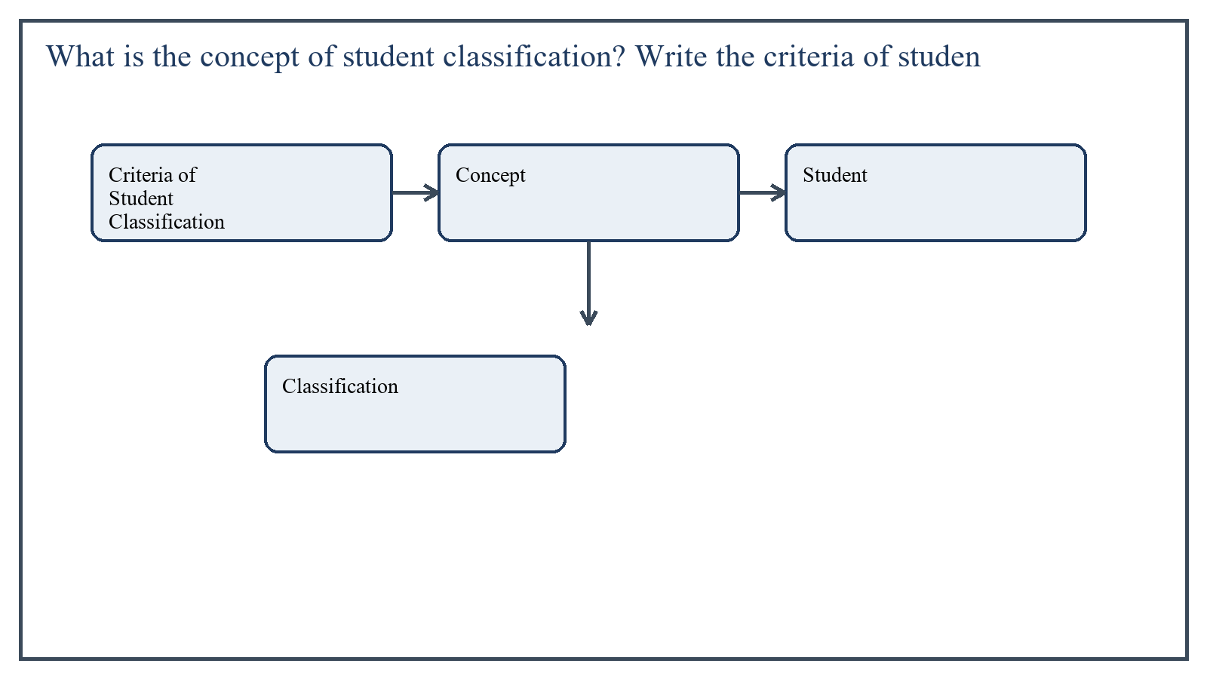
Figure 1: Concept map for Question 1

Criteria of Student Classification
The purpose of classification is not to label students unfairly, but to improve teaching organization and learner support. Good classification should be flexible, fair, and based on educational need.
- Age and grade level
- Achievement level or academic ability
- Interest and aptitude
- Special educational needs or support requirement
- Attendance and behavior pattern where relevant
In the context of Educational Leadership and Management, the theme of criteria of student classification deserves extended attention because assignment-level understanding is expected to move beyond one-line definitions and into explanation, comparison, and application. A strong university answer shows not only what the concept means, but also why it matters, how it appears in practice, and what limitations or challenges may arise when it is implemented in real educational settings.
A mature academic response also connects criteria of student classification with classroom realities, institutional culture, and the Pakistani context wherever relevant. This makes the answer more analytical and more useful because it links conceptual understanding with the needs of teachers, learners, administrators, and communities rather than leaving the idea at a purely theoretical level.
From an examination and assignment-writing perspective, the topic of criteria of student classification should be handled through clear structure, careful terminology, valid examples, and balanced discussion. The strongest responses usually define the idea, explain its major components, illustrate it through educational examples, and then conclude with a reasoned judgment about its significance, usefulness, or limitations.

Applied Illustration and Academic Note
For a stronger B.Ed assignment response, the topic above should be linked with classroom life, institutional practice, and the needs of Pakistani learners. This approach makes the response more analytical and demonstrates that the writer understands both theory and application, which is usually appreciated in AIOU-style academic work.
A good response also avoids unsupported claims. Instead, it explains concepts carefully, gives relevant examples, and ends with a short judgment about educational significance. In this way, the answer to 'What is the concept of student classification? Write the criteria of s...' becomes easier to read, easier to assess, and more academically convincing.

Quick Review Table
Focus Area | Assignment Relevance
Criteria of Student Classification | This area helps answer the question on 'What is the concept of student classification? Write th...' by providing concept clarity, explanation, and applied educational value.

Critical Reflection
At an advanced level, the topic should not be treated as a fixed formula. Most educational concepts work within particular conditions, and their success often depends on planning quality, learner background, institutional support, and the competence of the teacher or manager using them. A reflective assignment therefore acknowledges strengths while also recognizing practical limitations.

Conclusion
Student classification is a practical administrative and instructional process. Its criteria may include age, achievement, aptitude, needs, and behavioral considerations, but it should always be used to support better learning rather than to create stigma.

Q.2 What is the concept and scope of budget? Describe the functions of budget.
Answer: The answer below is organized in an academic assignment style, with conceptual explanation, applied discussion, and concise analytical closing comments designed for a neat and extended university submission.
A budget is a financial plan that estimates expected income and expenditure for a specific period. In educational institutions, it is a basic management tool for planning and control.
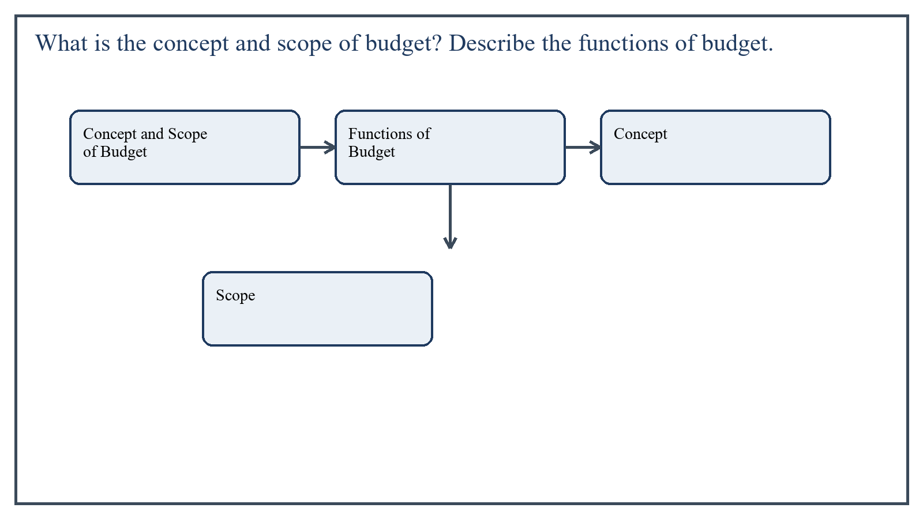
Figure 2: Concept map for Question 2

Concept and Scope of Budget
The concept of budget includes forecasting financial needs, allocating funds to different heads, and ensuring that resources are used according to institutional priorities. Its scope covers salaries, maintenance, learning materials, utilities, development work, and emergency needs.
In the context of Educational Leadership and Management, the theme of concept and scope of budget deserves extended attention because assignment-level understanding is expected to move beyond one-line definitions and into explanation, comparison, and application. A strong university answer shows not only what the concept means, but also why it matters, how it appears in practice, and what limitations or challenges may arise when it is implemented in real educational settings.
A mature academic response also connects concept and scope of budget with classroom realities, institutional culture, and the Pakistani context wherever relevant. This makes the answer more analytical and more useful because it links conceptual understanding with the needs of teachers, learners, administrators, and communities rather than leaving the idea at a purely theoretical level.
From an examination and assignment-writing perspective, the topic of concept and scope of budget should be handled through clear structure, careful terminology, valid examples, and balanced discussion. The strongest responses usually define the idea, explain its major components, illustrate it through educational examples, and then conclude with a reasoned judgment about its significance, usefulness, or limitations.

Functions of Budget
- Planning financial activities in advance
- Allocating resources according to priorities
- Controlling expenditure and preventing waste
- Supporting transparency and accountability
- Providing a basis for review and future decision-making
In the context of Educational Leadership and Management, the theme of functions of budget deserves extended attention because assignment-level understanding is expected to move beyond one-line definitions and into explanation, comparison, and application. A strong university answer shows not only what the concept means, but also why it matters, how it appears in practice, and what limitations or challenges may arise when it is implemented in real educational settings.
A mature academic response also connects functions of budget with classroom realities, institutional culture, and the Pakistani context wherever relevant. This makes the answer more analytical and more useful because it links conceptual understanding with the needs of teachers, learners, administrators, and communities rather than leaving the idea at a purely theoretical level.
From an examination and assignment-writing perspective, the topic of functions of budget should be handled through clear structure, careful terminology, valid examples, and balanced discussion. The strongest responses usually define the idea, explain its major components, illustrate it through educational examples, and then conclude with a reasoned judgment about its significance, usefulness, or limitations.

Applied Illustration and Academic Note
For a stronger B.Ed assignment response, the topic above should be linked with classroom life, institutional practice, and the needs of Pakistani learners. This approach makes the response more analytical and demonstrates that the writer understands both theory and application, which is usually appreciated in AIOU-style academic work.
A good response also avoids unsupported claims. Instead, it explains concepts carefully, gives relevant examples, and ends with a short judgment about educational significance. In this way, the answer to 'What is the concept and scope of budget? Describe the functions of bud...' becomes easier to read, easier to assess, and more academically convincing.

Quick Review Table
Focus Area | Assignment Relevance
Concept and Scope of Budget | This area helps answer the question on 'What is the concept and scope of budget? Describe the f...' by providing concept clarity, explanation, and applied educational value.
Functions of Budget | This area helps answer the question on 'What is the concept and scope of budget? Describe the f...' by providing concept clarity, explanation, and applied educational value.

Critical Reflection
At an advanced level, the topic should not be treated as a fixed formula. Most educational concepts work within particular conditions, and their success often depends on planning quality, learner background, institutional support, and the competence of the teacher or manager using them. A reflective assignment therefore acknowledges strengths while also recognizing practical limitations.

Conclusion
The budget is both a planning and control instrument. Its concept extends across the entire financial life of the institution, and its functions help ensure efficient, transparent, and goal-oriented use of resources.

Q.3 What is a school record? Write why a school record is necessary for better results and discipline in a school.
Answer: The answer below is organized in an academic assignment style, with conceptual explanation, applied discussion, and concise analytical closing comments designed for a neat and extended university submission.
A school record is an official written account of important information related to students, staff, finance, attendance, examinations, property, and administration. It serves as the memory and evidence base of the institution.
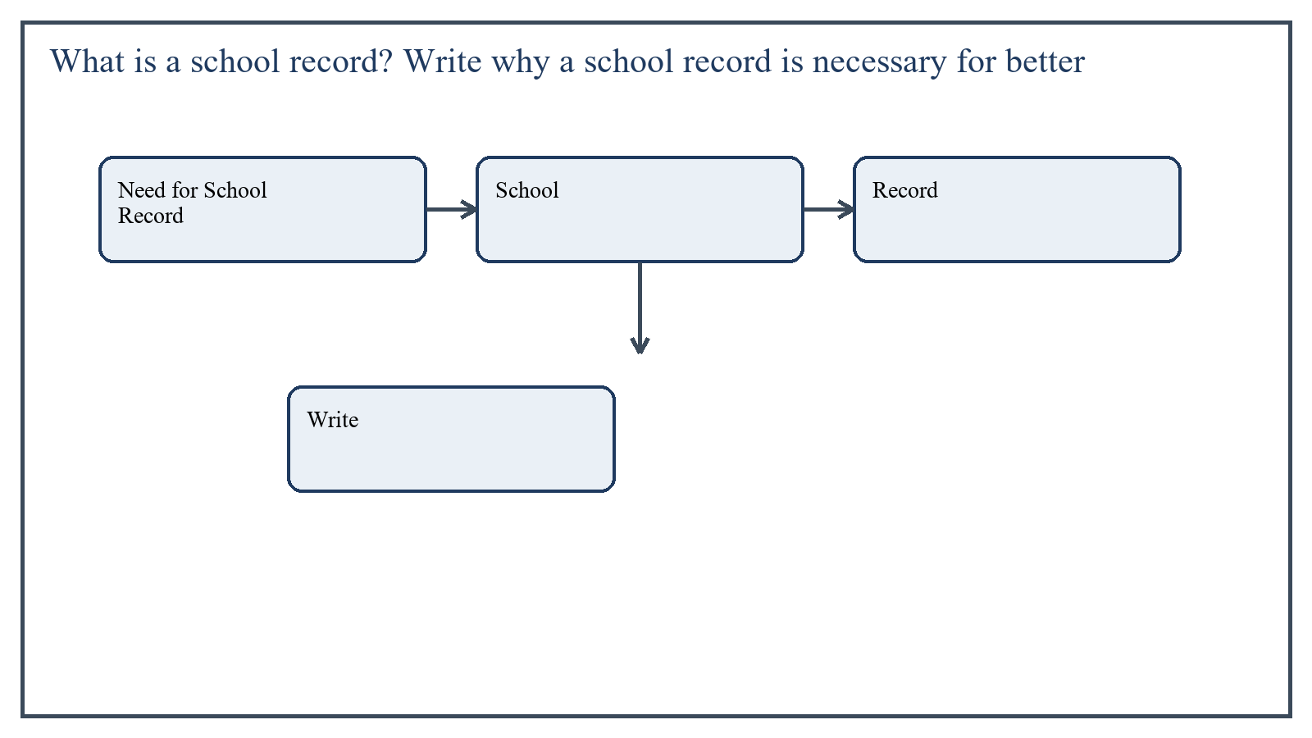
Figure 3: Concept map for Question 3

Need for School Record
For better results, the school needs accurate records of student progress, examination performance, and teacher work. For discipline, records of attendance, behavior, counseling, and follow-up are very important.
- It helps monitor attendance, achievement, and conduct.
- It supports administrative planning and decision-making.
- It provides evidence for accountability and reporting.
- It improves discipline by making rules and actions traceable.
- It helps identify trends, problems, and student needs.
In the context of Educational Leadership and Management, the theme of need for school record deserves extended attention because assignment-level understanding is expected to move beyond one-line definitions and into explanation, comparison, and application. A strong university answer shows not only what the concept means, but also why it matters, how it appears in practice, and what limitations or challenges may arise when it is implemented in real educational settings.
A mature academic response also connects need for school record with classroom realities, institutional culture, and the Pakistani context wherever relevant. This makes the answer more analytical and more useful because it links conceptual understanding with the needs of teachers, learners, administrators, and communities rather than leaving the idea at a purely theoretical level.
From an examination and assignment-writing perspective, the topic of need for school record should be handled through clear structure, careful terminology, valid examples, and balanced discussion. The strongest responses usually define the idea, explain its major components, illustrate it through educational examples, and then conclude with a reasoned judgment about its significance, usefulness, or limitations.

Applied Illustration and Academic Note
For a stronger B.Ed assignment response, the topic above should be linked with classroom life, institutional practice, and the needs of Pakistani learners. This approach makes the response more analytical and demonstrates that the writer understands both theory and application, which is usually appreciated in AIOU-style academic work.
A good response also avoids unsupported claims. Instead, it explains concepts carefully, gives relevant examples, and ends with a short judgment about educational significance. In this way, the answer to 'What is a school record? Write why a school record is necessary for be...' becomes easier to read, easier to assess, and more academically convincing.

Quick Review Table
Focus Area | Assignment Relevance
Need for School Record | This area helps answer the question on 'What is a school record? Write why a school record is n...' by providing concept clarity, explanation, and applied educational value.

Critical Reflection
At an advanced level, the topic should not be treated as a fixed formula. Most educational concepts work within particular conditions, and their success often depends on planning quality, learner background, institutional support, and the competence of the teacher or manager using them. A reflective assignment therefore acknowledges strengths while also recognizing practical limitations.

Conclusion
School record is an essential institutional document system. It improves results by supporting planning and monitoring, and it strengthens discipline by providing continuity, evidence, and organized follow-up.

Q.4 Differentiate between the curriculum council of federal jurisdiction and provincial curriculum departments on their functions and roles.
Answer: The answer below is organized in an academic assignment style, with conceptual explanation, applied discussion, and concise analytical closing comments designed for a neat and extended university submission.
The curriculum council at federal level and provincial curriculum departments both play important roles, but their jurisdiction, scope, and operational focus are different.
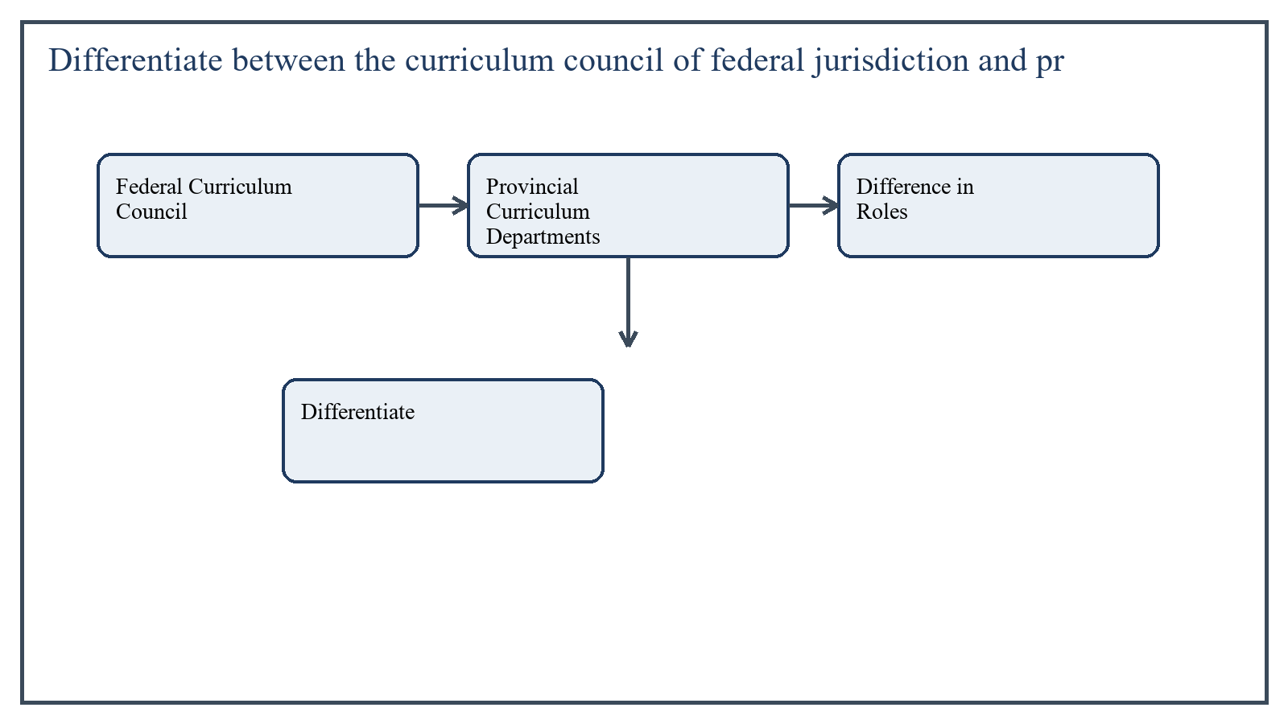
Figure 4: Concept map for Question 4

Federal Curriculum Council
At the federal level, curriculum bodies are more concerned with broad national direction, standard setting, coordination, and policy-level curriculum guidance. Their role includes maintaining national coherence, ensuring alignment with educational priorities, and supporting common standards.
In the context of Educational Leadership and Management, the theme of federal curriculum council deserves extended attention because assignment-level understanding is expected to move beyond one-line definitions and into explanation, comparison, and application. A strong university answer shows not only what the concept means, but also why it matters, how it appears in practice, and what limitations or challenges may arise when it is implemented in real educational settings.
A mature academic response also connects federal curriculum council with classroom realities, institutional culture, and the Pakistani context wherever relevant. This makes the answer more analytical and more useful because it links conceptual understanding with the needs of teachers, learners, administrators, and communities rather than leaving the idea at a purely theoretical level.
From an examination and assignment-writing perspective, the topic of federal curriculum council should be handled through clear structure, careful terminology, valid examples, and balanced discussion. The strongest responses usually define the idea, explain its major components, illustrate it through educational examples, and then conclude with a reasoned judgment about its significance, usefulness, or limitations.

Provincial Curriculum Departments
Provincial curriculum departments are more directly involved in adaptation, implementation support, contextualization, textbook processes, training coordination, and operational curriculum work within their provinces.
In the context of Educational Leadership and Management, the theme of provincial curriculum departments deserves extended attention because assignment-level understanding is expected to move beyond one-line definitions and into explanation, comparison, and application. A strong university answer shows not only what the concept means, but also why it matters, how it appears in practice, and what limitations or challenges may arise when it is implemented in real educational settings.
A mature academic response also connects provincial curriculum departments with classroom realities, institutional culture, and the Pakistani context wherever relevant. This makes the answer more analytical and more useful because it links conceptual understanding with the needs of teachers, learners, administrators, and communities rather than leaving the idea at a purely theoretical level.
From an examination and assignment-writing perspective, the topic of provincial curriculum departments should be handled through clear structure, careful terminology, valid examples, and balanced discussion. The strongest responses usually define the idea, explain its major components, illustrate it through educational examples, and then conclude with a reasoned judgment about its significance, usefulness, or limitations.

Difference in Roles
- Federal bodies provide national direction; provincial bodies operationalize curriculum in local contexts.
- Federal jurisdiction is broader and standard-oriented; provincial departments are more implementation-oriented.
- Provincial departments address local language, context, and execution issues more directly.
In the context of Educational Leadership and Management, the theme of difference in roles deserves extended attention because assignment-level understanding is expected to move beyond one-line definitions and into explanation, comparison, and application. A strong university answer shows not only what the concept means, but also why it matters, how it appears in practice, and what limitations or challenges may arise when it is implemented in real educational settings.
A mature academic response also connects difference in roles with classroom realities, institutional culture, and the Pakistani context wherever relevant. This makes the answer more analytical and more useful because it links conceptual understanding with the needs of teachers, learners, administrators, and communities rather than leaving the idea at a purely theoretical level.
From an examination and assignment-writing perspective, the topic of difference in roles should be handled through clear structure, careful terminology, valid examples, and balanced discussion. The strongest responses usually define the idea, explain its major components, illustrate it through educational examples, and then conclude with a reasoned judgment about its significance, usefulness, or limitations.

Applied Illustration and Academic Note
For a stronger B.Ed assignment response, the topic above should be linked with classroom life, institutional practice, and the needs of Pakistani learners. This approach makes the response more analytical and demonstrates that the writer understands both theory and application, which is usually appreciated in AIOU-style academic work.
A good response also avoids unsupported claims. Instead, it explains concepts carefully, gives relevant examples, and ends with a short judgment about educational significance. In this way, the answer to 'Differentiate between the curriculum council of federal jurisdiction a...' becomes easier to read, easier to assess, and more academically convincing.

Quick Review Table
Focus Area | Assignment Relevance
Federal Curriculum Council | This area helps answer the question on 'Differentiate between the curriculum council of federal...' by providing concept clarity, explanation, and applied educational value.
Provincial Curriculum Departments | This area helps answer the question on 'Differentiate between the curriculum council of federal...' by providing concept clarity, explanation, and applied educational value.
Difference in Roles | This area helps answer the question on 'Differentiate between the curriculum council of federal...' by providing concept clarity, explanation, and applied educational value.

Critical Reflection
At an advanced level, the topic should not be treated as a fixed formula. Most educational concepts work within particular conditions, and their success often depends on planning quality, learner background, institutional support, and the competence of the teacher or manager using them. A reflective assignment therefore acknowledges strengths while also recognizing practical limitations.

Conclusion
Federal and provincial curriculum bodies are complementary rather than identical. The federal level ensures coherence and direction, while provincial departments help translate curriculum into effective local implementation.

Q.5 Identify criteria for evaluation. Give suggestions for improvement of management through evaluation.
Answer: The answer below is organized in an academic assignment style, with conceptual explanation, applied discussion, and concise analytical closing comments designed for a neat and extended university submission.
Evaluation in management means judging the effectiveness of institutional work on the basis of clear criteria and evidence. It helps leaders know whether goals are being achieved efficiently and fairly.
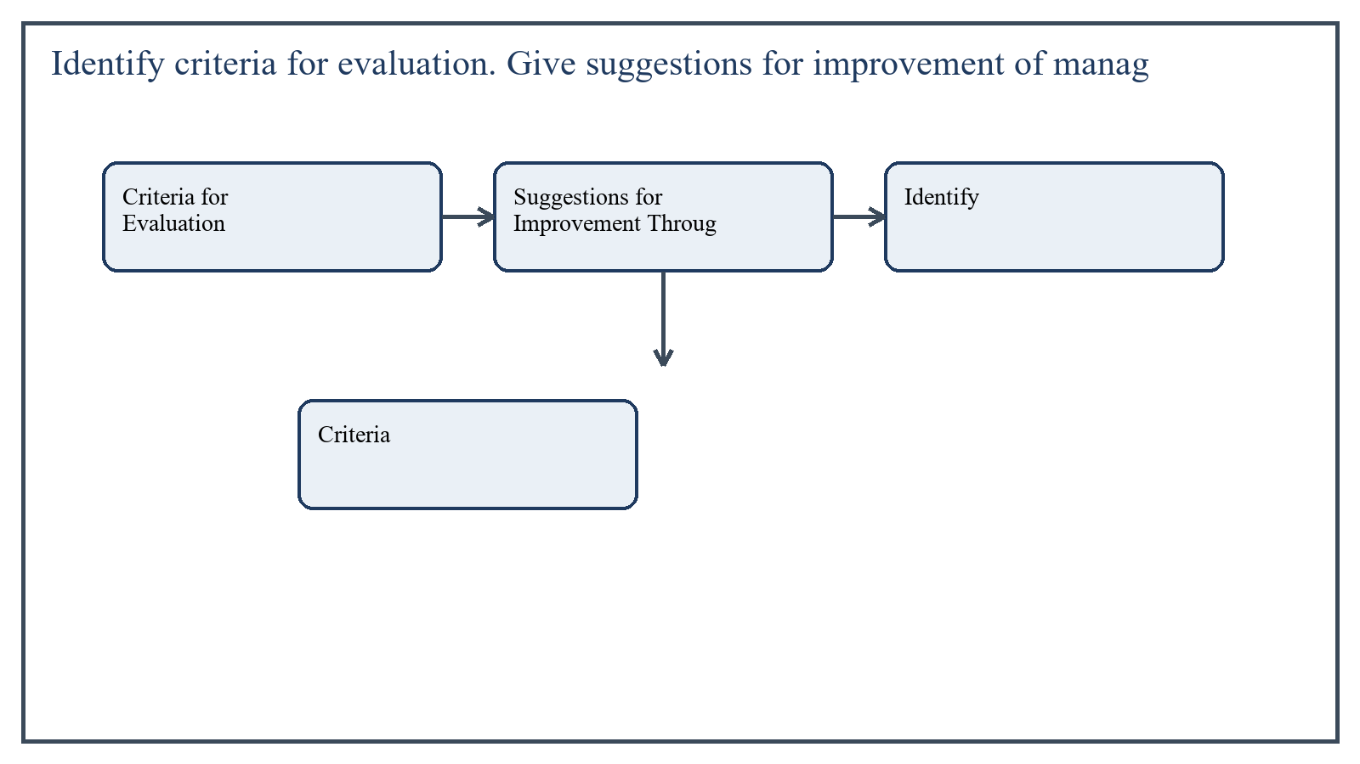
Figure 5: Concept map for Question 5

Criteria for Evaluation
- Achievement of goals and objectives
- Efficiency in use of resources
- Quality of leadership and supervision
- Staff performance and cooperation
- Student outcomes and institutional discipline
- Transparency, communication, and accountability
In the context of Educational Leadership and Management, the theme of criteria for evaluation deserves extended attention because assignment-level understanding is expected to move beyond one-line definitions and into explanation, comparison, and application. A strong university answer shows not only what the concept means, but also why it matters, how it appears in practice, and what limitations or challenges may arise when it is implemented in real educational settings.
A mature academic response also connects criteria for evaluation with classroom realities, institutional culture, and the Pakistani context wherever relevant. This makes the answer more analytical and more useful because it links conceptual understanding with the needs of teachers, learners, administrators, and communities rather than leaving the idea at a purely theoretical level.
From an examination and assignment-writing perspective, the topic of criteria for evaluation should be handled through clear structure, careful terminology, valid examples, and balanced discussion. The strongest responses usually define the idea, explain its major components, illustrate it through educational examples, and then conclude with a reasoned judgment about its significance, usefulness, or limitations.

Suggestions for Improvement Through Evaluation
- Use regular internal evaluation instead of waiting for external inspection only.
- Collect evidence from records, observation, feedback, and results.
- Involve staff in reflective review so evaluation becomes developmental.
- Link evaluation findings with training and corrective planning.
- Use evaluation to improve systems, not merely to blame individuals.
In the context of Educational Leadership and Management, the theme of suggestions for improvement through evaluation deserves extended attention because assignment-level understanding is expected to move beyond one-line definitions and into explanation, comparison, and application. A strong university answer shows not only what the concept means, but also why it matters, how it appears in practice, and what limitations or challenges may arise when it is implemented in real educational settings.
A mature academic response also connects suggestions for improvement through evaluation with classroom realities, institutional culture, and the Pakistani context wherever relevant. This makes the answer more analytical and more useful because it links conceptual understanding with the needs of teachers, learners, administrators, and communities rather than leaving the idea at a purely theoretical level.
From an examination and assignment-writing perspective, the topic of suggestions for improvement through evaluation should be handled through clear structure, careful terminology, valid examples, and balanced discussion. The strongest responses usually define the idea, explain its major components, illustrate it through educational examples, and then conclude with a reasoned judgment about its significance, usefulness, or limitations.

Applied Illustration and Academic Note
For a stronger B.Ed assignment response, the topic above should be linked with classroom life, institutional practice, and the needs of Pakistani learners. This approach makes the response more analytical and demonstrates that the writer understands both theory and application, which is usually appreciated in AIOU-style academic work.
A good response also avoids unsupported claims. Instead, it explains concepts carefully, gives relevant examples, and ends with a short judgment about educational significance. In this way, the answer to 'Identify criteria for evaluation. Give suggestions for improvement of ...' becomes easier to read, easier to assess, and more academically convincing.

Quick Review Table
Focus Area | Assignment Relevance
Criteria for Evaluation | This area helps answer the question on 'Identify criteria for evaluation. Give suggestions for ...' by providing concept clarity, explanation, and applied educational value.
Suggestions for Improvement Through Evaluation | This area helps answer the question on 'Identify criteria for evaluation. Give suggestions for ...' by providing concept clarity, explanation, and applied educational value.

Critical Reflection
At an advanced level, the topic should not be treated as a fixed formula. Most educational concepts work within particular conditions, and their success often depends on planning quality, learner background, institutional support, and the competence of the teacher or manager using them. A reflective assignment therefore acknowledges strengths while also recognizing practical limitations.

Conclusion
Evaluation is meaningful when it is based on clear criteria and used for improvement. Through regular, evidence-based, and participatory evaluation, educational management can become more efficient, transparent, and responsive.

Extended Revision Appendix
This appendix is included to strengthen the assignment as a premium academic submission. It provides recap notes, revision prompts, and concept reinforcement so the document reads like a complete study-ready submission rather than a short-answer sheet only.

Key Revision Points
- Review the central demand of the question 'What is the concept of student classification? Write the crite...' and connect definition, explanation, example, and critical comment in one organized response.
- Review the central demand of the question 'What is the concept and scope of budget? Describe the function...' and connect definition, explanation, example, and critical comment in one organized response.
- Review the central demand of the question 'What is a school record? Write why a school record is necessar...' and connect definition, explanation, example, and critical comment in one organized response.
- Review the central demand of the question 'Differentiate between the curriculum council of federal jurisd...' and connect definition, explanation, example, and critical comment in one organized response.
- Review the central demand of the question 'Identify criteria for evaluation. Give suggestions for improve...' and connect definition, explanation, example, and critical comment in one organized response.

Academic Writing Reminders
- Begin each major answer with a clear conceptual opening.
- Use examples to show understanding instead of repeating definitions only.
- Present advantages, limitations, and contextual realities where relevant.
- Close each answer with a short evaluative conclusion.
- Maintain formal and neat language throughout the assignment.

Concept Reinforcement Notes
The question on 'What is the concept of student classification? Write the criteria of studen...' can be revised further by identifying three things: the main concept involved, the educational importance of that concept, and one example from Pakistani classroom or institutional life. This simple method helps transform memorized content into organized written response.
The question on 'What is the concept and scope of budget? Describe the functions of budget....' can be revised further by identifying three things: the main concept involved, the educational importance of that concept, and one example from Pakistani classroom or institutional life. This simple method helps transform memorized content into organized written response.
The question on 'What is a school record? Write why a school record is necessary for better ...' can be revised further by identifying three things: the main concept involved, the educational importance of that concept, and one example from Pakistani classroom or institutional life. This simple method helps transform memorized content into organized written response.
The question on 'Differentiate between the curriculum council of federal jurisdiction and pr...' can be revised further by identifying three things: the main concept involved, the educational importance of that concept, and one example from Pakistani classroom or institutional life. This simple method helps transform memorized content into organized written response.
The question on 'Identify criteria for evaluation. Give suggestions for improvement of manag...' can be revised further by identifying three things: the main concept involved, the educational importance of that concept, and one example from Pakistani classroom or institutional life. This simple method helps transform memorized content into organized written response.

Source Base and Assignment Support Notes
The following source base was used to keep the answers aligned with AIOU course structure and the exact question wording. The final language and organization were expanded for presentation quality, page-length target, and assignment readability.
- AIOU Soft Book: Educational Leadership and Management (Code 8605), especially units on student classification, budgeting, school record, curriculum administration, and evaluation of management.
- AIOU Spring 2026 assignment sheet for Course 8605.

Extended Analytical Note 1
In extended study of Educational Leadership and Management, the issue raised in 'What is the concept of student classification? Write the criteria of stu...' may also be explored through definition, theoretical explanation, applied example, classroom implication, institutional implication, and critical reflection. This six-part approach helps a learner produce a more complete answer and also improves the academic appearance of the assignment by showing structure and depth.
Another useful strategy in long-form assignment writing is to move carefully from concept to context. First explain what the idea means, then identify its components, then discuss its relevance in teaching or administration, and finally mention any practical limitation. Such movement gives maturity to the answer and helps the examiner follow the logic without difficulty.
In extended study of Educational Leadership and Management, the issue raised in 'What is the concept and scope of budget? Describe the functions of budge...' may also be explored through definition, theoretical explanation, applied example, classroom implication, institutional implication, and critical reflection. This six-part approach helps a learner produce a more complete answer and also improves the academic appearance of the assignment by showing structure and depth.
Another useful strategy in long-form assignment writing is to move carefully from concept to context. First explain what the idea means, then identify its components, then discuss its relevance in teaching or administration, and finally mention any practical limitation. Such movement gives maturity to the answer and helps the examiner follow the logic without difficulty.
In extended study of Educational Leadership and Management, the issue raised in 'What is a school record? Write why a school record is necessary for bett...' may also be explored through definition, theoretical explanation, applied example, classroom implication, institutional implication, and critical reflection. This six-part approach helps a learner produce a more complete answer and also improves the academic appearance of the assignment by showing structure and depth.
Another useful strategy in long-form assignment writing is to move carefully from concept to context. First explain what the idea means, then identify its components, then discuss its relevance in teaching or administration, and finally mention any practical limitation. Such movement gives maturity to the answer and helps the examiner follow the logic without difficulty.
In extended study of Educational Leadership and Management, the issue raised in 'Differentiate between the curriculum council of federal jurisdiction and...' may also be explored through definition, theoretical explanation, applied example, classroom implication, institutional implication, and critical reflection. This six-part approach helps a learner produce a more complete answer and also improves the academic appearance of the assignment by showing structure and depth.
Another useful strategy in long-form assignment writing is to move carefully from concept to context. First explain what the idea means, then identify its components, then discuss its relevance in teaching or administration, and finally mention any practical limitation. Such movement gives maturity to the answer and helps the examiner follow the logic without difficulty.
In extended study of Educational Leadership and Management, the issue raised in 'Identify criteria for evaluation. Give suggestions for improvement of ma...' may also be explored through definition, theoretical explanation, applied example, classroom implication, institutional implication, and critical reflection. This six-part approach helps a learner produce a more complete answer and also improves the academic appearance of the assignment by showing structure and depth.
Another useful strategy in long-form assignment writing is to move carefully from concept to context. First explain what the idea means, then identify its components, then discuss its relevance in teaching or administration, and finally mention any practical limitation. Such movement gives maturity to the answer and helps the examiner follow the logic without difficulty.

Extended Analytical Note 2
In extended study of Educational Leadership and Management, the issue raised in 'What is the concept of student classification? Write the criteria of stu...' may also be explored through definition, theoretical explanation, applied example, classroom implication, institutional implication, and critical reflection. This six-part approach helps a learner produce a more complete answer and also improves the academic appearance of the assignment by showing structure and depth.
Another useful strategy in long-form assignment writing is to move carefully from concept to context. First explain what the idea means, then identify its components, then discuss its relevance in teaching or administration, and finally mention any practical limitation. Such movement gives maturity to the answer and helps the examiner follow the logic without difficulty.
In extended study of Educational Leadership and Management, the issue raised in 'What is the concept and scope of budget? Describe the functions of budge...' may also be explored through definition, theoretical explanation, applied example, classroom implication, institutional implication, and critical reflection. This six-part approach helps a learner produce a more complete answer and also improves the academic appearance of the assignment by showing structure and depth.
Another useful strategy in long-form assignment writing is to move carefully from concept to context. First explain what the idea means, then identify its components, then discuss its relevance in teaching or administration, and finally mention any practical limitation. Such movement gives maturity to the answer and helps the examiner follow the logic without difficulty.
In extended study of Educational Leadership and Management, the issue raised in 'What is a school record? Write why a school record is necessary for bett...' may also be explored through definition, theoretical explanation, applied example, classroom implication, institutional implication, and critical reflection. This six-part approach helps a learner produce a more complete answer and also improves the academic appearance of the assignment by showing structure and depth.
Another useful strategy in long-form assignment writing is to move carefully from concept to context. First explain what the idea means, then identify its components, then discuss its relevance in teaching or administration, and finally mention any practical limitation. Such movement gives maturity to the answer and helps the examiner follow the logic without difficulty.
In extended study of Educational Leadership and Management, the issue raised in 'Differentiate between the curriculum council of federal jurisdiction and...' may also be explored through definition, theoretical explanation, applied example, classroom implication, institutional implication, and critical reflection. This six-part approach helps a learner produce a more complete answer and also improves the academic appearance of the assignment by showing structure and depth.
Another useful strategy in long-form assignment writing is to move carefully from concept to context. First explain what the idea means, then identify its components, then discuss its relevance in teaching or administration, and finally mention any practical limitation. Such movement gives maturity to the answer and helps the examiner follow the logic without difficulty.
In extended study of Educational Leadership and Management, the issue raised in 'Identify criteria for evaluation. Give suggestions for improvement of ma...' may also be explored through definition, theoretical explanation, applied example, classroom implication, institutional implication, and critical reflection. This six-part approach helps a learner produce a more complete answer and also improves the academic appearance of the assignment by showing structure and depth.
Another useful strategy in long-form assignment writing is to move carefully from concept to context. First explain what the idea means, then identify its components, then discuss its relevance in teaching or administration, and finally mention any practical limitation. Such movement gives maturity to the answer and helps the examiner follow the logic without difficulty.

Extended Analytical Note 3
In extended study of Educational Leadership and Management, the issue raised in 'What is the concept of student classification? Write the criteria of stu...' may also be explored through definition, theoretical explanation, applied example, classroom implication, institutional implication, and critical reflection. This six-part approach helps a learner produce a more complete answer and also improves the academic appearance of the assignment by showing structure and depth.
Another useful strategy in long-form assignment writing is to move carefully from concept to context. First explain what the idea means, then identify its components, then discuss its relevance in teaching or administration, and finally mention any practical limitation. Such movement gives maturity to the answer and helps the examiner follow the logic without difficulty.
In extended study of Educational Leadership and Management, the issue raised in 'What is the concept and scope of budget? Describe the functions of budge...' may also be explored through definition, theoretical explanation, applied example, classroom implication, institutional implication, and critical reflection. This six-part approach helps a learner produce a more complete answer and also improves the academic appearance of the assignment by showing structure and depth.
Another useful strategy in long-form assignment writing is to move carefully from concept to context. First explain what the idea means, then identify its components, then discuss its relevance in teaching or administration, and finally mention any practical limitation. Such movement gives maturity to the answer and helps the examiner follow the logic without difficulty.
In extended study of Educational Leadership and Management, the issue raised in 'What is a school record? Write why a school record is necessary for bett...' may also be explored through definition, theoretical explanation, applied example, classroom implication, institutional implication, and critical reflection. This six-part approach helps a learner produce a more complete answer and also improves the academic appearance of the assignment by showing structure and depth.
Another useful strategy in long-form assignment writing is to move carefully from concept to context. First explain what the idea means, then identify its components, then discuss its relevance in teaching or administration, and finally mention any practical limitation. Such movement gives maturity to the answer and helps the examiner follow the logic without difficulty.
In extended study of Educational Leadership and Management, the issue raised in 'Differentiate between the curriculum council of federal jurisdiction and...' may also be explored through definition, theoretical explanation, applied example, classroom implication, institutional implication, and critical reflection. This six-part approach helps a learner produce a more complete answer and also improves the academic appearance of the assignment by showing structure and depth.
Another useful strategy in long-form assignment writing is to move carefully from concept to context. First explain what the idea means, then identify its components, then discuss its relevance in teaching or administration, and finally mention any practical limitation. Such movement gives maturity to the answer and helps the examiner follow the logic without difficulty.
In extended study of Educational Leadership and Management, the issue raised in 'Identify criteria for evaluation. Give suggestions for improvement of ma...' may also be explored through definition, theoretical explanation, applied example, classroom implication, institutional implication, and critical reflection. This six-part approach helps a learner produce a more complete answer and also improves the academic appearance of the assignment by showing structure and depth.
Another useful strategy in long-form assignment writing is to move carefully from concept to context. First explain what the idea means, then identify its components, then discuss its relevance in teaching or administration, and finally mention any practical limitation. Such movement gives maturity to the answer and helps the examiner follow the logic without difficulty.

Extended Analytical Note 4
In extended study of Educational Leadership and Management, the issue raised in 'What is the concept of student classification? Write the criteria of stu...' may also be explored through definition, theoretical explanation, applied example, classroom implication, institutional implication, and critical reflection. This six-part approach helps a learner produce a more complete answer and also improves the academic appearance of the assignment by showing structure and depth.
Another useful strategy in long-form assignment writing is to move carefully from concept to context. First explain what the idea means, then identify its components, then discuss its relevance in teaching or administration, and finally mention any practical limitation. Such movement gives maturity to the answer and helps the examiner follow the logic without difficulty.
In extended study of Educational Leadership and Management, the issue raised in 'What is the concept and scope of budget? Describe the functions of budge...' may also be explored through definition, theoretical explanation, applied example, classroom implication, institutional implication, and critical reflection. This six-part approach helps a learner produce a more complete answer and also improves the academic appearance of the assignment by showing structure and depth.
Another useful strategy in long-form assignment writing is to move carefully from concept to context. First explain what the idea means, then identify its components, then discuss its relevance in teaching or administration, and finally mention any practical limitation. Such movement gives maturity to the answer and helps the examiner follow the logic without difficulty.
In extended study of Educational Leadership and Management, the issue raised in 'What is a school record? Write why a school record is necessary for bett...' may also be explored through definition, theoretical explanation, applied example, classroom implication, institutional implication, and critical reflection. This six-part approach helps a learner produce a more complete answer and also improves the academic appearance of the assignment by showing structure and depth.
Another useful strategy in long-form assignment writing is to move carefully from concept to context. First explain what the idea means, then identify its components, then discuss its relevance in teaching or administration, and finally mention any practical limitation. Such movement gives maturity to the answer and helps the examiner follow the logic without difficulty.
In extended study of Educational Leadership and Management, the issue raised in 'Differentiate between the curriculum council of federal jurisdiction and...' may also be explored through definition, theoretical explanation, applied example, classroom implication, institutional implication, and critical reflection. This six-part approach helps a learner produce a more complete answer and also improves the academic appearance of the assignment by showing structure and depth.
Another useful strategy in long-form assignment writing is to move carefully from concept to context. First explain what the idea means, then identify its components, then discuss its relevance in teaching or administration, and finally mention any practical limitation. Such movement gives maturity to the answer and helps the examiner follow the logic without difficulty.
In extended study of Educational Leadership and Management, the issue raised in 'Identify criteria for evaluation. Give suggestions for improvement of ma...' may also be explored through definition, theoretical explanation, applied example, classroom implication, institutional implication, and critical reflection. This six-part approach helps a learner produce a more complete answer and also improves the academic appearance of the assignment by showing structure and depth.
Another useful strategy in long-form assignment writing is to move carefully from concept to context. First explain what the idea means, then identify its components, then discuss its relevance in teaching or administration, and finally mention any practical limitation. Such movement gives maturity to the answer and helps the examiner follow the logic without difficulty.

Extended Analytical Note 5
In extended study of Educational Leadership and Management, the issue raised in 'What is the concept of student classification? Write the criteria of stu...' may also be explored through definition, theoretical explanation, applied example, classroom implication, institutional implication, and critical reflection. This six-part approach helps a learner produce a more complete answer and also improves the academic appearance of the assignment by showing structure and depth.
Another useful strategy in long-form assignment writing is to move carefully from concept to context. First explain what the idea means, then identify its components, then discuss its relevance in teaching or administration, and finally mention any practical limitation. Such movement gives maturity to the answer and helps the examiner follow the logic without difficulty.
In extended study of Educational Leadership and Management, the issue raised in 'What is the concept and scope of budget? Describe the functions of budge...' may also be explored through definition, theoretical explanation, applied example, classroom implication, institutional implication, and critical reflection. This six-part approach helps a learner produce a more complete answer and also improves the academic appearance of the assignment by showing structure and depth.
Another useful strategy in long-form assignment writing is to move carefully from concept to context. First explain what the idea means, then identify its components, then discuss its relevance in teaching or administration, and finally mention any practical limitation. Such movement gives maturity to the answer and helps the examiner follow the logic without difficulty.
In extended study of Educational Leadership and Management, the issue raised in 'What is a school record? Write why a school record is necessary for bett...' may also be explored through definition, theoretical explanation, applied example, classroom implication, institutional implication, and critical reflection. This six-part approach helps a learner produce a more complete answer and also improves the academic appearance of the assignment by showing structure and depth.
Another useful strategy in long-form assignment writing is to move carefully from concept to context. First explain what the idea means, then identify its components, then discuss its relevance in teaching or administration, and finally mention any practical limitation. Such movement gives maturity to the answer and helps the examiner follow the logic without difficulty.
In extended study of Educational Leadership and Management, the issue raised in 'Differentiate between the curriculum council of federal jurisdiction and...' may also be explored through definition, theoretical explanation, applied example, classroom implication, institutional implication, and critical reflection. This six-part approach helps a learner produce a more complete answer and also improves the academic appearance of the assignment by showing structure and depth.
Another useful strategy in long-form assignment writing is to move carefully from concept to context. First explain what the idea means, then identify its components, then discuss its relevance in teaching or administration, and finally mention any practical limitation. Such movement gives maturity to the answer and helps the examiner follow the logic without difficulty.
In extended study of Educational Leadership and Management, the issue raised in 'Identify criteria for evaluation. Give suggestions for improvement of ma...' may also be explored through definition, theoretical explanation, applied example, classroom implication, institutional implication, and critical reflection. This six-part approach helps a learner produce a more complete answer and also improves the academic appearance of the assignment by showing structure and depth.
Another useful strategy in long-form assignment writing is to move carefully from concept to context. First explain what the idea means, then identify its components, then discuss its relevance in teaching or administration, and finally mention any practical limitation. Such movement gives maturity to the answer and helps the examiner follow the logic without difficulty.

Extended Analytical Note 6
In extended study of Educational Leadership and Management, the issue raised in 'What is the concept of student classification? Write the criteria of stu...' may also be explored through definition, theoretical explanation, applied example, classroom implication, institutional implication, and critical reflection. This six-part approach helps a learner produce a more complete answer and also improves the academic appearance of the assignment by showing structure and depth.
Another useful strategy in long-form assignment writing is to move carefully from concept to context. First explain what the idea means, then identify its components, then discuss its relevance in teaching or administration, and finally mention any practical limitation. Such movement gives maturity to the answer and helps the examiner follow the logic without difficulty.
In extended study of Educational Leadership and Management, the issue raised in 'What is the concept and scope of budget? Describe the functions of budge...' may also be explored through definition, theoretical explanation, applied example, classroom implication, institutional implication, and critical reflection. This six-part approach helps a learner produce a more complete answer and also improves the academic appearance of the assignment by showing structure and depth.
Another useful strategy in long-form assignment writing is to move carefully from concept to context. First explain what the idea means, then identify its components, then discuss its relevance in teaching or administration, and finally mention any practical limitation. Such movement gives maturity to the answer and helps the examiner follow the logic without difficulty.
In extended study of Educational Leadership and Management, the issue raised in 'What is a school record? Write why a school record is necessary for bett...' may also be explored through definition, theoretical explanation, applied example, classroom implication, institutional implication, and critical reflection. This six-part approach helps a learner produce a more complete answer and also improves the academic appearance of the assignment by showing structure and depth.
Another useful strategy in long-form assignment writing is to move carefully from concept to context. First explain what the idea means, then identify its components, then discuss its relevance in teaching or administration, and finally mention any practical limitation. Such movement gives maturity to the answer and helps the examiner follow the logic without difficulty.
In extended study of Educational Leadership and Management, the issue raised in 'Differentiate between the curriculum council of federal jurisdiction and...' may also be explored through definition, theoretical explanation, applied example, classroom implication, institutional implication, and critical reflection. This six-part approach helps a learner produce a more complete answer and also improves the academic appearance of the assignment by showing structure and depth.
Another useful strategy in long-form assignment writing is to move carefully from concept to context. First explain what the idea means, then identify its components, then discuss its relevance in teaching or administration, and finally mention any practical limitation. Such movement gives maturity to the answer and helps the examiner follow the logic without difficulty.
In extended study of Educational Leadership and Management, the issue raised in 'Identify criteria for evaluation. Give suggestions for improvement of ma...' may also be explored through definition, theoretical explanation, applied example, classroom implication, institutional implication, and critical reflection. This six-part approach helps a learner produce a more complete answer and also improves the academic appearance of the assignment by showing structure and depth.
Another useful strategy in long-form assignment writing is to move carefully from concept to context. First explain what the idea means, then identify its components, then discuss its relevance in teaching or administration, and finally mention any practical limitation. Such movement gives maturity to the answer and helps the examiner follow the logic without difficulty.

Extended Analytical Note 7
In extended study of Educational Leadership and Management, the issue raised in 'What is the concept of student classification? Write the criteria of stu...' may also be explored through definition, theoretical explanation, applied example, classroom implication, institutional implication, and critical reflection. This six-part approach helps a learner produce a more complete answer and also improves the academic appearance of the assignment by showing structure and depth.
Another useful strategy in long-form assignment writing is to move carefully from concept to context. First explain what the idea means, then identify its components, then discuss its relevance in teaching or administration, and finally mention any practical limitation. Such movement gives maturity to the answer and helps the examiner follow the logic without difficulty.
In extended study of Educational Leadership and Management, the issue raised in 'What is the concept and scope of budget? Describe the functions of budge...' may also be explored through definition, theoretical explanation, applied example, classroom implication, institutional implication, and critical reflection. This six-part approach helps a learner produce a more complete answer and also improves the academic appearance of the assignment by showing structure and depth.
Another useful strategy in long-form assignment writing is to move carefully from concept to context. First explain what the idea means, then identify its components, then discuss its relevance in teaching or administration, and finally mention any practical limitation. Such movement gives maturity to the answer and helps the examiner follow the logic without difficulty.
In extended study of Educational Leadership and Management, the issue raised in 'What is a school record? Write why a school record is necessary for bett...' may also be explored through definition, theoretical explanation, applied example, classroom implication, institutional implication, and critical reflection. This six-part approach helps a learner produce a more complete answer and also improves the academic appearance of the assignment by showing structure and depth.
Another useful strategy in long-form assignment writing is to move carefully from concept to context. First explain what the idea means, then identify its components, then discuss its relevance in teaching or administration, and finally mention any practical limitation. Such movement gives maturity to the answer and helps the examiner follow the logic without difficulty.
In extended study of Educational Leadership and Management, the issue raised in 'Differentiate between the curriculum council of federal jurisdiction and...' may also be explored through definition, theoretical explanation, applied example, classroom implication, institutional implication, and critical reflection. This six-part approach helps a learner produce a more complete answer and also improves the academic appearance of the assignment by showing structure and depth.
Another useful strategy in long-form assignment writing is to move carefully from concept to context. First explain what the idea means, then identify its components, then discuss its relevance in teaching or administration, and finally mention any practical limitation. Such movement gives maturity to the answer and helps the examiner follow the logic without difficulty.
In extended study of Educational Leadership and Management, the issue raised in 'Identify criteria for evaluation. Give suggestions for improvement of ma...' may also be explored through definition, theoretical explanation, applied example, classroom implication, institutional implication, and critical reflection. This six-part approach helps a learner produce a more complete answer and also improves the academic appearance of the assignment by showing structure and depth.
Another useful strategy in long-form assignment writing is to move carefully from concept to context. First explain what the idea means, then identify its components, then discuss its relevance in teaching or administration, and finally mention any practical limitation. Such movement gives maturity to the answer and helps the examiner follow the logic without difficulty.

Extended Analytical Note 8
In extended study of Educational Leadership and Management, the issue raised in 'What is the concept of student classification? Write the criteria of stu...' may also be explored through definition, theoretical explanation, applied example, classroom implication, institutional implication, and critical reflection. This six-part approach helps a learner produce a more complete answer and also improves the academic appearance of the assignment by showing structure and depth.
Another useful strategy in long-form assignment writing is to move carefully from concept to context. First explain what the idea means, then identify its components, then discuss its relevance in teaching or administration, and finally mention any practical limitation. Such movement gives maturity to the answer and helps the examiner follow the logic without difficulty.
In extended study of Educational Leadership and Management, the issue raised in 'What is the concept and scope of budget? Describe the functions of budge...' may also be explored through definition, theoretical explanation, applied example, classroom implication, institutional implication, and critical reflection. This six-part approach helps a learner produce a more complete answer and also improves the academic appearance of the assignment by showing structure and depth.
Another useful strategy in long-form assignment writing is to move carefully from concept to context. First explain what the idea means, then identify its components, then discuss its relevance in teaching or administration, and finally mention any practical limitation. Such movement gives maturity to the answer and helps the examiner follow the logic without difficulty.
In extended study of Educational Leadership and Management, the issue raised in 'What is a school record? Write why a school record is necessary for bett...' may also be explored through definition, theoretical explanation, applied example, classroom implication, institutional implication, and critical reflection. This six-part approach helps a learner produce a more complete answer and also improves the academic appearance of the assignment by showing structure and depth.
Another useful strategy in long-form assignment writing is to move carefully from concept to context. First explain what the idea means, then identify its components, then discuss its relevance in teaching or administration, and finally mention any practical limitation. Such movement gives maturity to the answer and helps the examiner follow the logic without difficulty.
In extended study of Educational Leadership and Management, the issue raised in 'Differentiate between the curriculum council of federal jurisdiction and...' may also be explored through definition, theoretical explanation, applied example, classroom implication, institutional implication, and critical reflection. This six-part approach helps a learner produce a more complete answer and also improves the academic appearance of the assignment by showing structure and depth.
Another useful strategy in long-form assignment writing is to move carefully from concept to context. First explain what the idea means, then identify its components, then discuss its relevance in teaching or administration, and finally mention any practical limitation. Such movement gives maturity to the answer and helps the examiner follow the logic without difficulty.
In extended study of Educational Leadership and Management, the issue raised in 'Identify criteria for evaluation. Give suggestions for improvement of ma...' may also be explored through definition, theoretical explanation, applied example, classroom implication, institutional implication, and critical reflection. This six-part approach helps a learner produce a more complete answer and also improves the academic appearance of the assignment by showing structure and depth.
Another useful strategy in long-form assignment writing is to move carefully from concept to context. First explain what the idea means, then identify its components, then discuss its relevance in teaching or administration, and finally mention any practical limitation. Such movement gives maturity to the answer and helps the examiner follow the logic without difficulty.

Extended Analytical Note 9
In extended study of Educational Leadership and Management, the issue raised in 'What is the concept of student classification? Write the criteria of stu...' may also be explored through definition, theoretical explanation, applied example, classroom implication, institutional implication, and critical reflection. This six-part approach helps a learner produce a more complete answer and also improves the academic appearance of the assignment by showing structure and depth.
Another useful strategy in long-form assignment writing is to move carefully from concept to context. First explain what the idea means, then identify its components, then discuss its relevance in teaching or administration, and finally mention any practical limitation. Such movement gives maturity to the answer and helps the examiner follow the logic without difficulty.
In extended study of Educational Leadership and Management, the issue raised in 'What is the concept and scope of budget? Describe the functions of budge...' may also be explored through definition, theoretical explanation, applied example, classroom implication, institutional implication, and critical reflection. This six-part approach helps a learner produce a more complete answer and also improves the academic appearance of the assignment by showing structure and depth.
Another useful strategy in long-form assignment writing is to move carefully from concept to context. First explain what the idea means, then identify its components, then discuss its relevance in teaching or administration, and finally mention any practical limitation. Such movement gives maturity to the answer and helps the examiner follow the logic without difficulty.
In extended study of Educational Leadership and Management, the issue raised in 'What is a school record? Write why a school record is necessary for bett...' may also be explored through definition, theoretical explanation, applied example, classroom implication, institutional implication, and critical reflection. This six-part approach helps a learner produce a more complete answer and also improves the academic appearance of the assignment by showing structure and depth.
Another useful strategy in long-form assignment writing is to move carefully from concept to context. First explain what the idea means, then identify its components, then discuss its relevance in teaching or administration, and finally mention any practical limitation. Such movement gives maturity to the answer and helps the examiner follow the logic without difficulty.
In extended study of Educational Leadership and Management, the issue raised in 'Differentiate between the curriculum council of federal jurisdiction and...' may also be explored through definition, theoretical explanation, applied example, classroom implication, institutional implication, and critical reflection. This six-part approach helps a learner produce a more complete answer and also improves the academic appearance of the assignment by showing structure and depth.
Another useful strategy in long-form assignment writing is to move carefully from concept to context. First explain what the idea means, then identify its components, then discuss its relevance in teaching or administration, and finally mention any practical limitation. Such movement gives maturity to the answer and helps the examiner follow the logic without difficulty.
In extended study of Educational Leadership and Management, the issue raised in 'Identify criteria for evaluation. Give suggestions for improvement of ma...' may also be explored through definition, theoretical explanation, applied example, classroom implication, institutional implication, and critical reflection. This six-part approach helps a learner produce a more complete answer and also improves the academic appearance of the assignment by showing structure and depth.
Another useful strategy in long-form assignment writing is to move carefully from concept to context. First explain what the idea means, then identify its components, then discuss its relevance in teaching or administration, and finally mention any practical limitation. Such movement gives maturity to the answer and helps the examiner follow the logic without difficulty.

Extended Analytical Note 10
In extended study of Educational Leadership and Management, the issue raised in 'What is the concept of student classification? Write the criteria of stu...' may also be explored through definition, theoretical explanation, applied example, classroom implication, institutional implication, and critical reflection. This six-part approach helps a learner produce a more complete answer and also improves the academic appearance of the assignment by showing structure and depth.
Another useful strategy in long-form assignment writing is to move carefully from concept to context. First explain what the idea means, then identify its components, then discuss its relevance in teaching or administration, and finally mention any practical limitation. Such movement gives maturity to the answer and helps the examiner follow the logic without difficulty.
In extended study of Educational Leadership and Management, the issue raised in 'What is the concept and scope of budget? Describe the functions of budge...' may also be explored through definition, theoretical explanation, applied example, classroom implication, institutional implication, and critical reflection. This six-part approach helps a learner produce a more complete answer and also improves the academic appearance of the assignment by showing structure and depth.
Another useful strategy in long-form assignment writing is to move carefully from concept to context. First explain what the idea means, then identify its components, then discuss its relevance in teaching or administration, and finally mention any practical limitation. Such movement gives maturity to the answer and helps the examiner follow the logic without difficulty.
In extended study of Educational Leadership and Management, the issue raised in 'What is a school record? Write why a school record is necessary for bett...' may also be explored through definition, theoretical explanation, applied example, classroom implication, institutional implication, and critical reflection. This six-part approach helps a learner produce a more complete answer and also improves the academic appearance of the assignment by showing structure and depth.
Another useful strategy in long-form assignment writing is to move carefully from concept to context. First explain what the idea means, then identify its components, then discuss its relevance in teaching or administration, and finally mention any practical limitation. Such movement gives maturity to the answer and helps the examiner follow the logic without difficulty.
In extended study of Educational Leadership and Management, the issue raised in 'Differentiate between the curriculum council of federal jurisdiction and...' may also be explored through definition, theoretical explanation, applied example, classroom implication, institutional implication, and critical reflection. This six-part approach helps a learner produce a more complete answer and also improves the academic appearance of the assignment by showing structure and depth.
Another useful strategy in long-form assignment writing is to move carefully from concept to context. First explain what the idea means, then identify its components, then discuss its relevance in teaching or administration, and finally mention any practical limitation. Such movement gives maturity to the answer and helps the examiner follow the logic without difficulty.
In extended study of Educational Leadership and Management, the issue raised in 'Identify criteria for evaluation. Give suggestions for improvement of ma...' may also be explored through definition, theoretical explanation, applied example, classroom implication, institutional implication, and critical reflection. This six-part approach helps a learner produce a more complete answer and also improves the academic appearance of the assignment by showing structure and depth.
Another useful strategy in long-form assignment writing is to move carefully from concept to context. First explain what the idea means, then identify its components, then discuss its relevance in teaching or administration, and finally mention any practical limitation. Such movement gives maturity to the answer and helps the examiner follow the logic without difficulty.

Extended Analytical Note 11
In extended study of Educational Leadership and Management, the issue raised in 'What is the concept of student classification? Write the criteria of stu...' may also be explored through definition, theoretical explanation, applied example, classroom implication, institutional implication, and critical reflection. This six-part approach helps a learner produce a more complete answer and also improves the academic appearance of the assignment by showing structure and depth.
Another useful strategy in long-form assignment writing is to move carefully from concept to context. First explain what the idea means, then identify its components, then discuss its relevance in teaching or administration, and finally mention any practical limitation. Such movement gives maturity to the answer and helps the examiner follow the logic without difficulty.
In extended study of Educational Leadership and Management, the issue raised in 'What is the concept and scope of budget? Describe the functions of budge...' may also be explored through definition, theoretical explanation, applied example, classroom implication, institutional implication, and critical reflection. This six-part approach helps a learner produce a more complete answer and also improves the academic appearance of the assignment by showing structure and depth.
Another useful strategy in long-form assignment writing is to move carefully from concept to context. First explain what the idea means, then identify its components, then discuss its relevance in teaching or administration, and finally mention any practical limitation. Such movement gives maturity to the answer and helps the examiner follow the logic without difficulty.
In extended study of Educational Leadership and Management, the issue raised in 'What is a school record? Write why a school record is necessary for bett...' may also be explored through definition, theoretical explanation, applied example, classroom implication, institutional implication, and critical reflection. This six-part approach helps a learner produce a more complete answer and also improves the academic appearance of the assignment by showing structure and depth.
Another useful strategy in long-form assignment writing is to move carefully from concept to context. First explain what the idea means, then identify its components, then discuss its relevance in teaching or administration, and finally mention any practical limitation. Such movement gives maturity to the answer and helps the examiner follow the logic without difficulty.
In extended study of Educational Leadership and Management, the issue raised in 'Differentiate between the curriculum council of federal jurisdiction and...' may also be explored through definition, theoretical explanation, applied example, classroom implication, institutional implication, and critical reflection. This six-part approach helps a learner produce a more complete answer and also improves the academic appearance of the assignment by showing structure and depth.
Another useful strategy in long-form assignment writing is to move carefully from concept to context. First explain what the idea means, then identify its components, then discuss its relevance in teaching or administration, and finally mention any practical limitation. Such movement gives maturity to the answer and helps the examiner follow the logic without difficulty.
In extended study of Educational Leadership and Management, the issue raised in 'Identify criteria for evaluation. Give suggestions for improvement of ma...' may also be explored through definition, theoretical explanation, applied example, classroom implication, institutional implication, and critical reflection. This six-part approach helps a learner produce a more complete answer and also improves the academic appearance of the assignment by showing structure and depth.
Another useful strategy in long-form assignment writing is to move carefully from concept to context. First explain what the idea means, then identify its components, then discuss its relevance in teaching or administration, and finally mention any practical limitation. Such movement gives maturity to the answer and helps the examiner follow the logic without difficulty.

