ALLAMA IQBAL OPEN UNIVERSITY
Premium Typed Assignment
Citizenship Education and Community Engagement
Detail | Course Code: 8606
Detail | Assignment No: 1
Detail | Unit Coverage: Units 1-4
Detail | Program Level: B.Ed
Detail | Formatting Profile: Times New Roman, 14 pt headings, 12 pt body text
Detail | Document Goal: Extended academic response with diagrams, border styling, and premium presentation

Presentation Note
This file has been prepared as a premium typed assignment with extended academic treatment, proper page border styling, inserted diagrams, formal headings, and neat section hierarchy. The content is intentionally expanded so that the assignment remains easy to read while still meeting a high page-length target.

Q.1 Describe your role as an individual in society. Elaborate on types of social structure.
Answer: The answer below is organized in an academic assignment style, with conceptual explanation, applied discussion, and concise analytical closing comments designed for a neat and extended university submission.
Every individual is both a product of society and a contributor to it. Society shapes our values, language, responsibilities, and identity, but at the same time individuals influence social life through behavior, participation, and service.
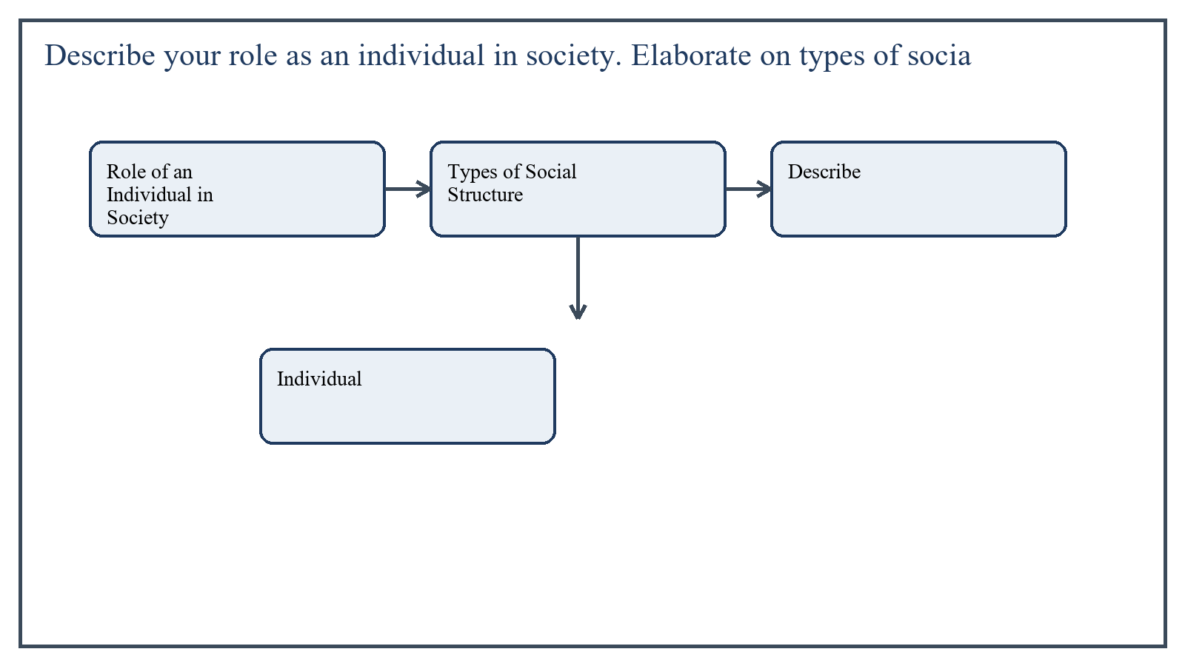
Figure 1: Concept map for Question 1

Role of an Individual in Society
As an individual, my role in society includes behaving responsibly, supporting community welfare, respecting diversity, and participating in constructive social activities. A good individual does not live only for personal interest; he or she recognizes the interdependence of social life.
- To obey laws and respect social norms
- To fulfill family, educational, and civic responsibilities
- To contribute positively through work, honesty, and service
- To respect others' rights and dignity
- To promote peace, cooperation, and social harmony
In the context of Citizenship Education and Community Engagement, the theme of role of an individual in society deserves extended attention because assignment-level understanding is expected to move beyond one-line definitions and into explanation, comparison, and application. A strong university answer shows not only what the concept means, but also why it matters, how it appears in practice, and what limitations or challenges may arise when it is implemented in real educational settings.
A mature academic response also connects role of an individual in society with classroom realities, institutional culture, and the Pakistani context wherever relevant. This makes the answer more analytical and more useful because it links conceptual understanding with the needs of teachers, learners, administrators, and communities rather than leaving the idea at a purely theoretical level.
From an examination and assignment-writing perspective, the topic of role of an individual in society should be handled through clear structure, careful terminology, valid examples, and balanced discussion. The strongest responses usually define the idea, explain its major components, illustrate it through educational examples, and then conclude with a reasoned judgment about its significance, usefulness, or limitations.

Types of Social Structure
Social structure refers to the organized pattern of social relationships, institutions, roles, and statuses that shape society. One type is family-based structure, where kinship and household relations are central.
Another type is class structure, in which society is organized according to economic position and access to resources.
Institutional structure is also important; here roles are organized around institutions such as school, religion, economy, and state.
Traditional and modern structures can also be compared. Traditional structures are usually more kinship-based and role-bound, while modern structures are more complex, formal, and specialized.
In the context of Citizenship Education and Community Engagement, the theme of types of social structure deserves extended attention because assignment-level understanding is expected to move beyond one-line definitions and into explanation, comparison, and application. A strong university answer shows not only what the concept means, but also why it matters, how it appears in practice, and what limitations or challenges may arise when it is implemented in real educational settings.
A mature academic response also connects types of social structure with classroom realities, institutional culture, and the Pakistani context wherever relevant. This makes the answer more analytical and more useful because it links conceptual understanding with the needs of teachers, learners, administrators, and communities rather than leaving the idea at a purely theoretical level.
From an examination and assignment-writing perspective, the topic of types of social structure should be handled through clear structure, careful terminology, valid examples, and balanced discussion. The strongest responses usually define the idea, explain its major components, illustrate it through educational examples, and then conclude with a reasoned judgment about its significance, usefulness, or limitations.

Applied Illustration and Academic Note
For a stronger B.Ed assignment response, the topic above should be linked with classroom life, institutional practice, and the needs of Pakistani learners. This approach makes the response more analytical and demonstrates that the writer understands both theory and application, which is usually appreciated in AIOU-style academic work.
A good response also avoids unsupported claims. Instead, it explains concepts carefully, gives relevant examples, and ends with a short judgment about educational significance. In this way, the answer to 'Describe your role as an individual in society. Elaborate on types of ...' becomes easier to read, easier to assess, and more academically convincing.

Quick Review Table
Focus Area | Assignment Relevance
Role of an Individual in Society | This area helps answer the question on 'Describe your role as an individual in society. Elabora...' by providing concept clarity, explanation, and applied educational value.
Types of Social Structure | This area helps answer the question on 'Describe your role as an individual in society. Elabora...' by providing concept clarity, explanation, and applied educational value.

Critical Reflection
At an advanced level, the topic should not be treated as a fixed formula. Most educational concepts work within particular conditions, and their success often depends on planning quality, learner background, institutional support, and the competence of the teacher or manager using them. A reflective assignment therefore acknowledges strengths while also recognizing practical limitations.

Conclusion
An individual's role in society is to act responsibly, ethically, and cooperatively. Social structure provides the organized framework in which this role is performed through family, class, institutions, and broader social arrangements.

Q.2 Explain any ten cultural elements of Pakistani culture with specific examples.
Answer: The answer below is organized in an academic assignment style, with conceptual explanation, applied discussion, and concise analytical closing comments designed for a neat and extended university submission.
Culture includes the beliefs, values, customs, language, symbols, and practices shared by a society. Pakistani culture is rich, diverse, and deeply influenced by religion, region, history, and family traditions.
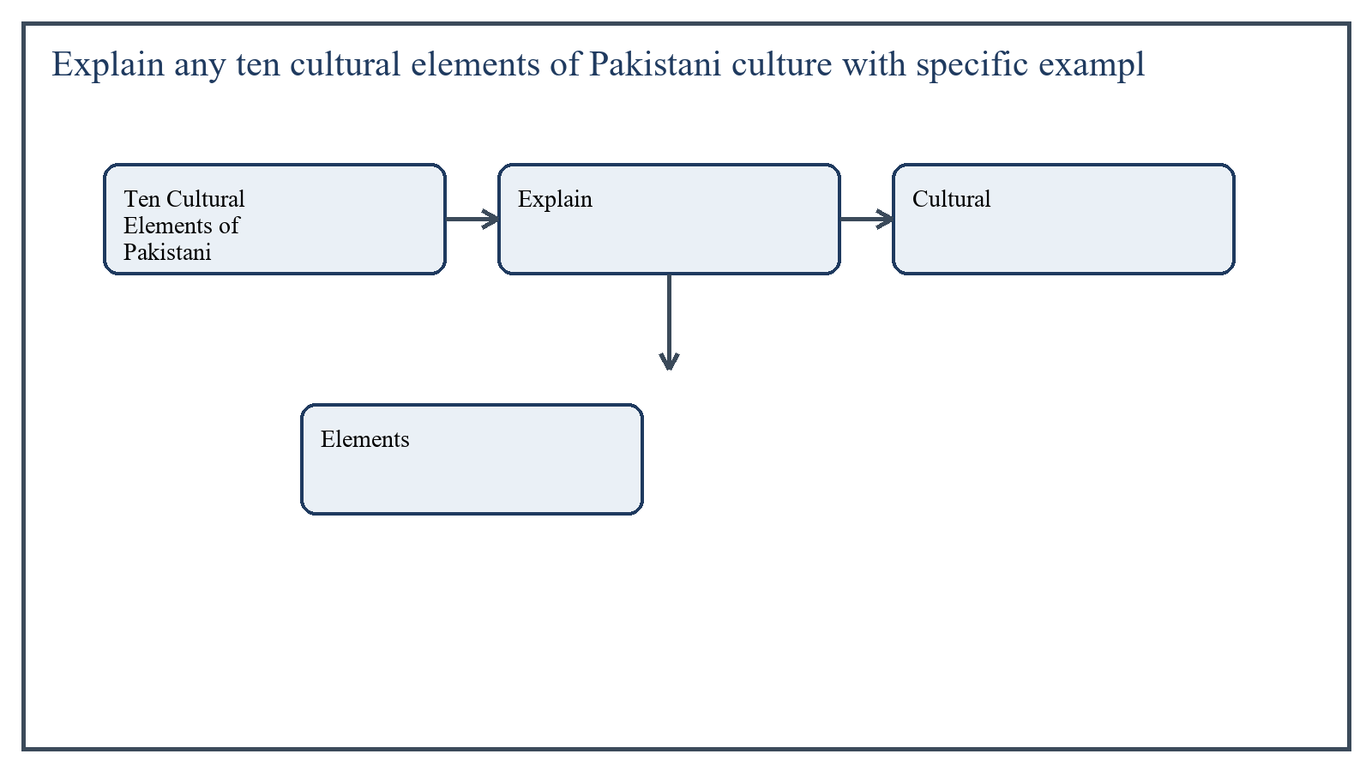
Figure 2: Concept map for Question 2

Ten Cultural Elements of Pakistani Culture
- Language: Urdu is the national language, while Punjabi, Sindhi, Pashto, Balochi, Saraiki, and others reflect regional identity.
- Religion: Islamic beliefs shape festivals, daily practices, charity, and moral values.
- Family system: Joint and extended family traditions remain influential in many areas.
- Dress: Shalwar kameez is a widely recognized national dress, with regional styles adding variation.
- Food: Biryani, saag, roti, karahi, haleem, and regional dishes represent local culinary traditions.
- Festivals: Eid-ul-Fitr, Eid-ul-Azha, and national days create shared cultural experience.
- Respect for elders: Greeting customs and decision-making patterns reflect this value strongly.
- Hospitality: Guests are often treated warmly and generously, especially in family settings.
- Marriage customs: Nikah, rukhsati, mehndi, and walima reflect social and cultural traditions.
- Arts and crafts: Truck art, embroidery, ajrak, pottery, and folk music show cultural creativity.
In the context of Citizenship Education and Community Engagement, the theme of ten cultural elements of pakistani culture deserves extended attention because assignment-level understanding is expected to move beyond one-line definitions and into explanation, comparison, and application. A strong university answer shows not only what the concept means, but also why it matters, how it appears in practice, and what limitations or challenges may arise when it is implemented in real educational settings.
A mature academic response also connects ten cultural elements of pakistani culture with classroom realities, institutional culture, and the Pakistani context wherever relevant. This makes the answer more analytical and more useful because it links conceptual understanding with the needs of teachers, learners, administrators, and communities rather than leaving the idea at a purely theoretical level.
From an examination and assignment-writing perspective, the topic of ten cultural elements of pakistani culture should be handled through clear structure, careful terminology, valid examples, and balanced discussion. The strongest responses usually define the idea, explain its major components, illustrate it through educational examples, and then conclude with a reasoned judgment about its significance, usefulness, or limitations.

Applied Illustration and Academic Note
For a stronger B.Ed assignment response, the topic above should be linked with classroom life, institutional practice, and the needs of Pakistani learners. This approach makes the response more analytical and demonstrates that the writer understands both theory and application, which is usually appreciated in AIOU-style academic work.
A good response also avoids unsupported claims. Instead, it explains concepts carefully, gives relevant examples, and ends with a short judgment about educational significance. In this way, the answer to 'Explain any ten cultural elements of Pakistani culture with specific e...' becomes easier to read, easier to assess, and more academically convincing.

Quick Review Table
Focus Area | Assignment Relevance
Ten Cultural Elements of Pakistani Culture | This area helps answer the question on 'Explain any ten cultural elements of Pakistani culture ...' by providing concept clarity, explanation, and applied educational value.

Critical Reflection
At an advanced level, the topic should not be treated as a fixed formula. Most educational concepts work within particular conditions, and their success often depends on planning quality, learner background, institutional support, and the competence of the teacher or manager using them. A reflective assignment therefore acknowledges strengths while also recognizing practical limitations.

Conclusion
Pakistani culture is made up of many interrelated elements, including language, religion, family values, customs, food, dress, and artistic traditions. These elements give the society its identity and continuity while also showing regional diversity.

Q.3 What are techniques for managing group dynamics? How do these techniques help in learning group behaviors? Give specific examples.
Answer: The answer below is organized in an academic assignment style, with conceptual explanation, applied discussion, and concise analytical closing comments designed for a neat and extended university submission.
Group dynamics refers to the patterns of interaction, influence, communication, and behavior that emerge when people work together. Managing group dynamics is important in classrooms and community settings because effective groups support learning, participation, and cooperation.
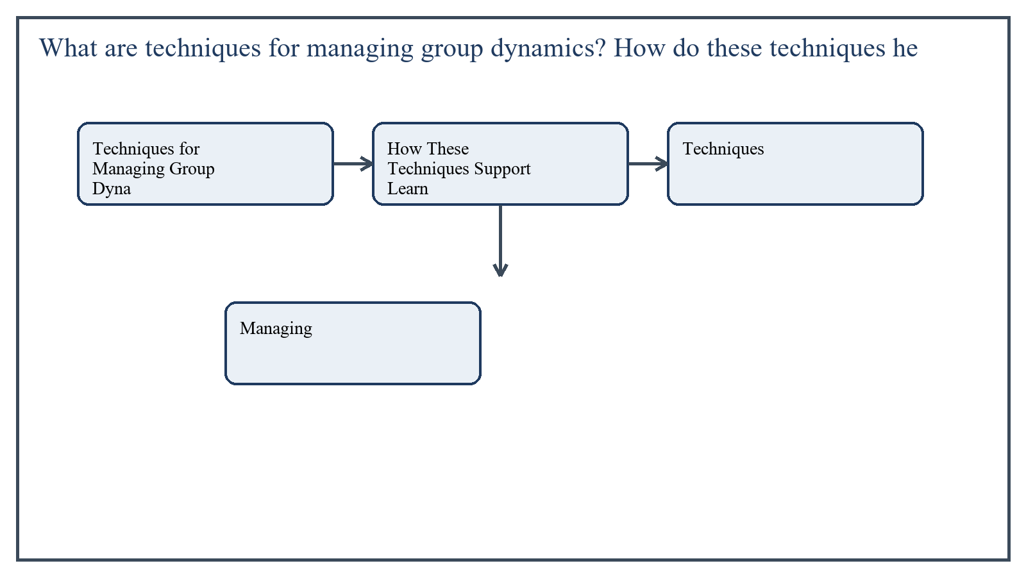
Figure 3: Concept map for Question 3

Techniques for Managing Group Dynamics
These techniques help members understand expectations and work together productively. For example, in a classroom project one student may be assigned as presenter, another as note taker, and another as timekeeper. This reduces confusion and improves responsibility.
- Clear goal setting
- Role assignment within the group
- Establishing group norms
- Encouraging balanced participation
- Conflict resolution and mediation
- Feedback and reflection sessions
In the context of Citizenship Education and Community Engagement, the theme of techniques for managing group dynamics deserves extended attention because assignment-level understanding is expected to move beyond one-line definitions and into explanation, comparison, and application. A strong university answer shows not only what the concept means, but also why it matters, how it appears in practice, and what limitations or challenges may arise when it is implemented in real educational settings.
A mature academic response also connects techniques for managing group dynamics with classroom realities, institutional culture, and the Pakistani context wherever relevant. This makes the answer more analytical and more useful because it links conceptual understanding with the needs of teachers, learners, administrators, and communities rather than leaving the idea at a purely theoretical level.
From an examination and assignment-writing perspective, the topic of techniques for managing group dynamics should be handled through clear structure, careful terminology, valid examples, and balanced discussion. The strongest responses usually define the idea, explain its major components, illustrate it through educational examples, and then conclude with a reasoned judgment about its significance, usefulness, or limitations.

How These Techniques Support Learning of Group Behavior
When roles and norms are clear, students learn cooperation, patience, leadership, and respect for others' views. Conflict resolution techniques help them understand how disagreement can be handled constructively rather than emotionally.
Specific examples include group discussion tasks where each member must contribute one idea, or peer-learning activities where stronger students support weaker students while still respecting them.
In the context of Citizenship Education and Community Engagement, the theme of how these techniques support learning of group behavior deserves extended attention because assignment-level understanding is expected to move beyond one-line definitions and into explanation, comparison, and application. A strong university answer shows not only what the concept means, but also why it matters, how it appears in practice, and what limitations or challenges may arise when it is implemented in real educational settings.
A mature academic response also connects how these techniques support learning of group behavior with classroom realities, institutional culture, and the Pakistani context wherever relevant. This makes the answer more analytical and more useful because it links conceptual understanding with the needs of teachers, learners, administrators, and communities rather than leaving the idea at a purely theoretical level.
From an examination and assignment-writing perspective, the topic of how these techniques support learning of group behavior should be handled through clear structure, careful terminology, valid examples, and balanced discussion. The strongest responses usually define the idea, explain its major components, illustrate it through educational examples, and then conclude with a reasoned judgment about its significance, usefulness, or limitations.

Applied Illustration and Academic Note
For a stronger B.Ed assignment response, the topic above should be linked with classroom life, institutional practice, and the needs of Pakistani learners. This approach makes the response more analytical and demonstrates that the writer understands both theory and application, which is usually appreciated in AIOU-style academic work.
A good response also avoids unsupported claims. Instead, it explains concepts carefully, gives relevant examples, and ends with a short judgment about educational significance. In this way, the answer to 'What are techniques for managing group dynamics? How do these techniqu...' becomes easier to read, easier to assess, and more academically convincing.

Quick Review Table
Focus Area | Assignment Relevance
Techniques for Managing Group Dynamics | This area helps answer the question on 'What are techniques for managing group dynamics? How do...' by providing concept clarity, explanation, and applied educational value.
How These Techniques Support Learning of Group Behavior | This area helps answer the question on 'What are techniques for managing group dynamics? How do...' by providing concept clarity, explanation, and applied educational value.

Critical Reflection
At an advanced level, the topic should not be treated as a fixed formula. Most educational concepts work within particular conditions, and their success often depends on planning quality, learner background, institutional support, and the competence of the teacher or manager using them. A reflective assignment therefore acknowledges strengths while also recognizing practical limitations.

Conclusion
Managing group dynamics through structure, roles, norms, and reflection helps learners develop healthy group behavior. It improves cooperation, communication, and social learning, which are all important for both citizenship and classroom success.

Q.4 Describe the role of school in socialization. Write the specific role teacher in socialization.
Answer: The answer below is organized in an academic assignment style, with conceptual explanation, applied discussion, and concise analytical closing comments designed for a neat and extended university submission.
Socialization is the process through which individuals learn norms, values, roles, and expected behavior in society. After the family, the school is one of the most important agencies of socialization.
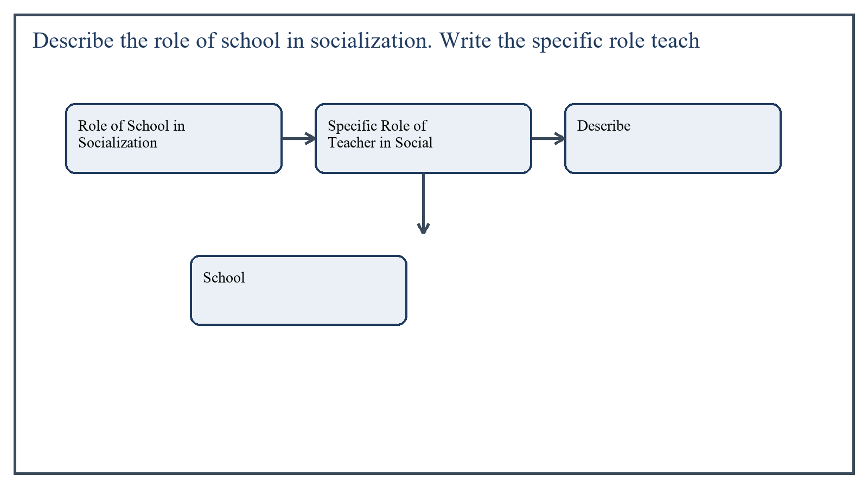
Figure 4: Concept map for Question 4

Role of School in Socialization
The school introduces children to formal rules, collective life, cooperation, punctuality, discipline, and social responsibility. It also exposes them to diversity, teamwork, institutional roles, and shared civic values.
Through curriculum, routines, assembly, classroom interaction, and co-curricular activities, schools help shape attitudes toward work, authority, citizenship, and social coexistence.
In the context of Citizenship Education and Community Engagement, the theme of role of school in socialization deserves extended attention because assignment-level understanding is expected to move beyond one-line definitions and into explanation, comparison, and application. A strong university answer shows not only what the concept means, but also why it matters, how it appears in practice, and what limitations or challenges may arise when it is implemented in real educational settings.
A mature academic response also connects role of school in socialization with classroom realities, institutional culture, and the Pakistani context wherever relevant. This makes the answer more analytical and more useful because it links conceptual understanding with the needs of teachers, learners, administrators, and communities rather than leaving the idea at a purely theoretical level.
From an examination and assignment-writing perspective, the topic of role of school in socialization should be handled through clear structure, careful terminology, valid examples, and balanced discussion. The strongest responses usually define the idea, explain its major components, illustrate it through educational examples, and then conclude with a reasoned judgment about its significance, usefulness, or limitations.

Specific Role of Teacher in Socialization
The teacher's role is especially important because students observe and imitate behavior. A teacher who is just, punctual, respectful, and cooperative teaches these qualities not only through instruction but also through personal example.
- Acts as a role model in speech, fairness, and behavior
- Teaches discipline, mutual respect, and cooperation
- Encourages tolerance and positive interaction among students
- Guides students in resolving conflicts constructively
- Connects moral and civic values with daily practice
In the context of Citizenship Education and Community Engagement, the theme of specific role of teacher in socialization deserves extended attention because assignment-level understanding is expected to move beyond one-line definitions and into explanation, comparison, and application. A strong university answer shows not only what the concept means, but also why it matters, how it appears in practice, and what limitations or challenges may arise when it is implemented in real educational settings.
A mature academic response also connects specific role of teacher in socialization with classroom realities, institutional culture, and the Pakistani context wherever relevant. This makes the answer more analytical and more useful because it links conceptual understanding with the needs of teachers, learners, administrators, and communities rather than leaving the idea at a purely theoretical level.
From an examination and assignment-writing perspective, the topic of specific role of teacher in socialization should be handled through clear structure, careful terminology, valid examples, and balanced discussion. The strongest responses usually define the idea, explain its major components, illustrate it through educational examples, and then conclude with a reasoned judgment about its significance, usefulness, or limitations.

Applied Illustration and Academic Note
For a stronger B.Ed assignment response, the topic above should be linked with classroom life, institutional practice, and the needs of Pakistani learners. This approach makes the response more analytical and demonstrates that the writer understands both theory and application, which is usually appreciated in AIOU-style academic work.
A good response also avoids unsupported claims. Instead, it explains concepts carefully, gives relevant examples, and ends with a short judgment about educational significance. In this way, the answer to 'Describe the role of school in socialization. Write the specific role ...' becomes easier to read, easier to assess, and more academically convincing.

Quick Review Table
Focus Area | Assignment Relevance
Role of School in Socialization | This area helps answer the question on 'Describe the role of school in socialization. Write the...' by providing concept clarity, explanation, and applied educational value.
Specific Role of Teacher in Socialization | This area helps answer the question on 'Describe the role of school in socialization. Write the...' by providing concept clarity, explanation, and applied educational value.

Critical Reflection
At an advanced level, the topic should not be treated as a fixed formula. Most educational concepts work within particular conditions, and their success often depends on planning quality, learner background, institutional support, and the competence of the teacher or manager using them. A reflective assignment therefore acknowledges strengths while also recognizing practical limitations.

Conclusion
School is a major institution of socialization because it prepares learners for organized social life beyond the family. Within this process, the teacher plays a central role as guide, model, and moral influence.

Q.5 Highlight the significance of social institutions with relevant examples from your life.
Answer: The answer below is organized in an academic assignment style, with conceptual explanation, applied discussion, and concise analytical closing comments designed for a neat and extended university submission.
Social institutions are organized patterns of behavior and relationships developed to meet major social needs. They bring stability, direction, and order to society.
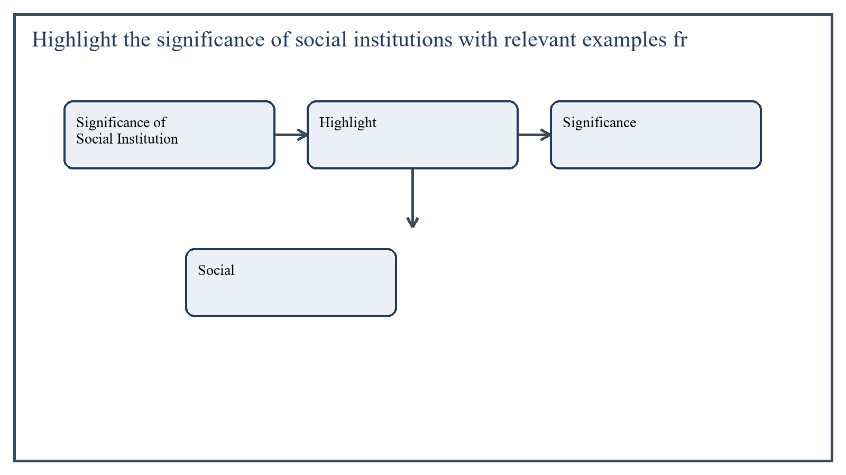
Figure 5: Concept map for Question 5

Significance of Social Institutions
Family is significant because it provides emotional support, early socialization, and moral guidance. Education is significant because it transmits knowledge, discipline, and social responsibility. Religion gives moral orientation and a sense of meaning. Economy helps people meet livelihood needs, while state institutions provide law and order and public administration.
In my own life, family has shaped my manners and values, school has expanded my thinking and discipline, and religious institutions have strengthened ethical awareness and community feeling.
In the context of Citizenship Education and Community Engagement, the theme of significance of social institutions deserves extended attention because assignment-level understanding is expected to move beyond one-line definitions and into explanation, comparison, and application. A strong university answer shows not only what the concept means, but also why it matters, how it appears in practice, and what limitations or challenges may arise when it is implemented in real educational settings.
A mature academic response also connects significance of social institutions with classroom realities, institutional culture, and the Pakistani context wherever relevant. This makes the answer more analytical and more useful because it links conceptual understanding with the needs of teachers, learners, administrators, and communities rather than leaving the idea at a purely theoretical level.
From an examination and assignment-writing perspective, the topic of significance of social institutions should be handled through clear structure, careful terminology, valid examples, and balanced discussion. The strongest responses usually define the idea, explain its major components, illustrate it through educational examples, and then conclude with a reasoned judgment about its significance, usefulness, or limitations.

Applied Illustration and Academic Note
For a stronger B.Ed assignment response, the topic above should be linked with classroom life, institutional practice, and the needs of Pakistani learners. This approach makes the response more analytical and demonstrates that the writer understands both theory and application, which is usually appreciated in AIOU-style academic work.
A good response also avoids unsupported claims. Instead, it explains concepts carefully, gives relevant examples, and ends with a short judgment about educational significance. In this way, the answer to 'Highlight the significance of social institutions with relevant exampl...' becomes easier to read, easier to assess, and more academically convincing.

Quick Review Table
Focus Area | Assignment Relevance
Significance of Social Institutions | This area helps answer the question on 'Highlight the significance of social institutions with ...' by providing concept clarity, explanation, and applied educational value.

Critical Reflection
At an advanced level, the topic should not be treated as a fixed formula. Most educational concepts work within particular conditions, and their success often depends on planning quality, learner background, institutional support, and the competence of the teacher or manager using them. A reflective assignment therefore acknowledges strengths while also recognizing practical limitations.

Conclusion
Social institutions are significant because they organize social life and help individuals meet major needs in an orderly way. Through family, school, religion, economy, and state institutions, people learn values, roles, and responsibilities that support social continuity.

Extended Revision Appendix
This appendix is included to strengthen the assignment as a premium academic submission. It provides recap notes, revision prompts, and concept reinforcement so the document reads like a complete study-ready submission rather than a short-answer sheet only.

Key Revision Points
- Review the central demand of the question 'Describe your role as an individual in society. Elaborate on t...' and connect definition, explanation, example, and critical comment in one organized response.
- Review the central demand of the question 'Explain any ten cultural elements of Pakistani culture with sp...' and connect definition, explanation, example, and critical comment in one organized response.
- Review the central demand of the question 'What are techniques for managing group dynamics? How do these ...' and connect definition, explanation, example, and critical comment in one organized response.
- Review the central demand of the question 'Describe the role of school in socialization. Write the specif...' and connect definition, explanation, example, and critical comment in one organized response.
- Review the central demand of the question 'Highlight the significance of social institutions with relevan...' and connect definition, explanation, example, and critical comment in one organized response.

Academic Writing Reminders
- Begin each major answer with a clear conceptual opening.
- Use examples to show understanding instead of repeating definitions only.
- Present advantages, limitations, and contextual realities where relevant.
- Close each answer with a short evaluative conclusion.
- Maintain formal and neat language throughout the assignment.

Concept Reinforcement Notes
The question on 'Describe your role as an individual in society. Elaborate on types of socia...' can be revised further by identifying three things: the main concept involved, the educational importance of that concept, and one example from Pakistani classroom or institutional life. This simple method helps transform memorized content into organized written response.
The question on 'Explain any ten cultural elements of Pakistani culture with specific exampl...' can be revised further by identifying three things: the main concept involved, the educational importance of that concept, and one example from Pakistani classroom or institutional life. This simple method helps transform memorized content into organized written response.
The question on 'What are techniques for managing group dynamics? How do these techniques he...' can be revised further by identifying three things: the main concept involved, the educational importance of that concept, and one example from Pakistani classroom or institutional life. This simple method helps transform memorized content into organized written response.
The question on 'Describe the role of school in socialization. Write the specific role teach...' can be revised further by identifying three things: the main concept involved, the educational importance of that concept, and one example from Pakistani classroom or institutional life. This simple method helps transform memorized content into organized written response.
The question on 'Highlight the significance of social institutions with relevant examples fr...' can be revised further by identifying three things: the main concept involved, the educational importance of that concept, and one example from Pakistani classroom or institutional life. This simple method helps transform memorized content into organized written response.

Source Base and Assignment Support Notes
The following source base was used to keep the answers aligned with AIOU course structure and the exact question wording. The final language and organization were expanded for presentation quality, page-length target, and assignment readability.
- AIOU Spring 2026 assignment sheet for Course 8606.
- AIOU official related texts used for conceptual grounding: Introduction to Sociology: Culture & Society (Code 9410), Teacher Education in Pakistan (Code 8626), and other AIOU community-engagement-related material where the direct 8606 softbook was not publicly available at the standard softbook URL on July 24, 2026.

Extended Analytical Note 1
In extended study of Citizenship Education and Community Engagement, the issue raised in 'Describe your role as an individual in society. Elaborate on types of so...' may also be explored through definition, theoretical explanation, applied example, classroom implication, institutional implication, and critical reflection. This six-part approach helps a learner produce a more complete answer and also improves the academic appearance of the assignment by showing structure and depth.
Another useful strategy in long-form assignment writing is to move carefully from concept to context. First explain what the idea means, then identify its components, then discuss its relevance in teaching or administration, and finally mention any practical limitation. Such movement gives maturity to the answer and helps the examiner follow the logic without difficulty.
In extended study of Citizenship Education and Community Engagement, the issue raised in 'Explain any ten cultural elements of Pakistani culture with specific exa...' may also be explored through definition, theoretical explanation, applied example, classroom implication, institutional implication, and critical reflection. This six-part approach helps a learner produce a more complete answer and also improves the academic appearance of the assignment by showing structure and depth.
Another useful strategy in long-form assignment writing is to move carefully from concept to context. First explain what the idea means, then identify its components, then discuss its relevance in teaching or administration, and finally mention any practical limitation. Such movement gives maturity to the answer and helps the examiner follow the logic without difficulty.
In extended study of Citizenship Education and Community Engagement, the issue raised in 'What are techniques for managing group dynamics? How do these techniques...' may also be explored through definition, theoretical explanation, applied example, classroom implication, institutional implication, and critical reflection. This six-part approach helps a learner produce a more complete answer and also improves the academic appearance of the assignment by showing structure and depth.
Another useful strategy in long-form assignment writing is to move carefully from concept to context. First explain what the idea means, then identify its components, then discuss its relevance in teaching or administration, and finally mention any practical limitation. Such movement gives maturity to the answer and helps the examiner follow the logic without difficulty.
In extended study of Citizenship Education and Community Engagement, the issue raised in 'Describe the role of school in socialization. Write the specific role te...' may also be explored through definition, theoretical explanation, applied example, classroom implication, institutional implication, and critical reflection. This six-part approach helps a learner produce a more complete answer and also improves the academic appearance of the assignment by showing structure and depth.
Another useful strategy in long-form assignment writing is to move carefully from concept to context. First explain what the idea means, then identify its components, then discuss its relevance in teaching or administration, and finally mention any practical limitation. Such movement gives maturity to the answer and helps the examiner follow the logic without difficulty.
In extended study of Citizenship Education and Community Engagement, the issue raised in 'Highlight the significance of social institutions with relevant examples...' may also be explored through definition, theoretical explanation, applied example, classroom implication, institutional implication, and critical reflection. This six-part approach helps a learner produce a more complete answer and also improves the academic appearance of the assignment by showing structure and depth.
Another useful strategy in long-form assignment writing is to move carefully from concept to context. First explain what the idea means, then identify its components, then discuss its relevance in teaching or administration, and finally mention any practical limitation. Such movement gives maturity to the answer and helps the examiner follow the logic without difficulty.

Extended Analytical Note 2
In extended study of Citizenship Education and Community Engagement, the issue raised in 'Describe your role as an individual in society. Elaborate on types of so...' may also be explored through definition, theoretical explanation, applied example, classroom implication, institutional implication, and critical reflection. This six-part approach helps a learner produce a more complete answer and also improves the academic appearance of the assignment by showing structure and depth.
Another useful strategy in long-form assignment writing is to move carefully from concept to context. First explain what the idea means, then identify its components, then discuss its relevance in teaching or administration, and finally mention any practical limitation. Such movement gives maturity to the answer and helps the examiner follow the logic without difficulty.
In extended study of Citizenship Education and Community Engagement, the issue raised in 'Explain any ten cultural elements of Pakistani culture with specific exa...' may also be explored through definition, theoretical explanation, applied example, classroom implication, institutional implication, and critical reflection. This six-part approach helps a learner produce a more complete answer and also improves the academic appearance of the assignment by showing structure and depth.
Another useful strategy in long-form assignment writing is to move carefully from concept to context. First explain what the idea means, then identify its components, then discuss its relevance in teaching or administration, and finally mention any practical limitation. Such movement gives maturity to the answer and helps the examiner follow the logic without difficulty.
In extended study of Citizenship Education and Community Engagement, the issue raised in 'What are techniques for managing group dynamics? How do these techniques...' may also be explored through definition, theoretical explanation, applied example, classroom implication, institutional implication, and critical reflection. This six-part approach helps a learner produce a more complete answer and also improves the academic appearance of the assignment by showing structure and depth.
Another useful strategy in long-form assignment writing is to move carefully from concept to context. First explain what the idea means, then identify its components, then discuss its relevance in teaching or administration, and finally mention any practical limitation. Such movement gives maturity to the answer and helps the examiner follow the logic without difficulty.
In extended study of Citizenship Education and Community Engagement, the issue raised in 'Describe the role of school in socialization. Write the specific role te...' may also be explored through definition, theoretical explanation, applied example, classroom implication, institutional implication, and critical reflection. This six-part approach helps a learner produce a more complete answer and also improves the academic appearance of the assignment by showing structure and depth.
Another useful strategy in long-form assignment writing is to move carefully from concept to context. First explain what the idea means, then identify its components, then discuss its relevance in teaching or administration, and finally mention any practical limitation. Such movement gives maturity to the answer and helps the examiner follow the logic without difficulty.
In extended study of Citizenship Education and Community Engagement, the issue raised in 'Highlight the significance of social institutions with relevant examples...' may also be explored through definition, theoretical explanation, applied example, classroom implication, institutional implication, and critical reflection. This six-part approach helps a learner produce a more complete answer and also improves the academic appearance of the assignment by showing structure and depth.
Another useful strategy in long-form assignment writing is to move carefully from concept to context. First explain what the idea means, then identify its components, then discuss its relevance in teaching or administration, and finally mention any practical limitation. Such movement gives maturity to the answer and helps the examiner follow the logic without difficulty.

Extended Analytical Note 3
In extended study of Citizenship Education and Community Engagement, the issue raised in 'Describe your role as an individual in society. Elaborate on types of so...' may also be explored through definition, theoretical explanation, applied example, classroom implication, institutional implication, and critical reflection. This six-part approach helps a learner produce a more complete answer and also improves the academic appearance of the assignment by showing structure and depth.
Another useful strategy in long-form assignment writing is to move carefully from concept to context. First explain what the idea means, then identify its components, then discuss its relevance in teaching or administration, and finally mention any practical limitation. Such movement gives maturity to the answer and helps the examiner follow the logic without difficulty.
In extended study of Citizenship Education and Community Engagement, the issue raised in 'Explain any ten cultural elements of Pakistani culture with specific exa...' may also be explored through definition, theoretical explanation, applied example, classroom implication, institutional implication, and critical reflection. This six-part approach helps a learner produce a more complete answer and also improves the academic appearance of the assignment by showing structure and depth.
Another useful strategy in long-form assignment writing is to move carefully from concept to context. First explain what the idea means, then identify its components, then discuss its relevance in teaching or administration, and finally mention any practical limitation. Such movement gives maturity to the answer and helps the examiner follow the logic without difficulty.
In extended study of Citizenship Education and Community Engagement, the issue raised in 'What are techniques for managing group dynamics? How do these techniques...' may also be explored through definition, theoretical explanation, applied example, classroom implication, institutional implication, and critical reflection. This six-part approach helps a learner produce a more complete answer and also improves the academic appearance of the assignment by showing structure and depth.
Another useful strategy in long-form assignment writing is to move carefully from concept to context. First explain what the idea means, then identify its components, then discuss its relevance in teaching or administration, and finally mention any practical limitation. Such movement gives maturity to the answer and helps the examiner follow the logic without difficulty.
In extended study of Citizenship Education and Community Engagement, the issue raised in 'Describe the role of school in socialization. Write the specific role te...' may also be explored through definition, theoretical explanation, applied example, classroom implication, institutional implication, and critical reflection. This six-part approach helps a learner produce a more complete answer and also improves the academic appearance of the assignment by showing structure and depth.
Another useful strategy in long-form assignment writing is to move carefully from concept to context. First explain what the idea means, then identify its components, then discuss its relevance in teaching or administration, and finally mention any practical limitation. Such movement gives maturity to the answer and helps the examiner follow the logic without difficulty.
In extended study of Citizenship Education and Community Engagement, the issue raised in 'Highlight the significance of social institutions with relevant examples...' may also be explored through definition, theoretical explanation, applied example, classroom implication, institutional implication, and critical reflection. This six-part approach helps a learner produce a more complete answer and also improves the academic appearance of the assignment by showing structure and depth.
Another useful strategy in long-form assignment writing is to move carefully from concept to context. First explain what the idea means, then identify its components, then discuss its relevance in teaching or administration, and finally mention any practical limitation. Such movement gives maturity to the answer and helps the examiner follow the logic without difficulty.

Extended Analytical Note 4
In extended study of Citizenship Education and Community Engagement, the issue raised in 'Describe your role as an individual in society. Elaborate on types of so...' may also be explored through definition, theoretical explanation, applied example, classroom implication, institutional implication, and critical reflection. This six-part approach helps a learner produce a more complete answer and also improves the academic appearance of the assignment by showing structure and depth.
Another useful strategy in long-form assignment writing is to move carefully from concept to context. First explain what the idea means, then identify its components, then discuss its relevance in teaching or administration, and finally mention any practical limitation. Such movement gives maturity to the answer and helps the examiner follow the logic without difficulty.
In extended study of Citizenship Education and Community Engagement, the issue raised in 'Explain any ten cultural elements of Pakistani culture with specific exa...' may also be explored through definition, theoretical explanation, applied example, classroom implication, institutional implication, and critical reflection. This six-part approach helps a learner produce a more complete answer and also improves the academic appearance of the assignment by showing structure and depth.
Another useful strategy in long-form assignment writing is to move carefully from concept to context. First explain what the idea means, then identify its components, then discuss its relevance in teaching or administration, and finally mention any practical limitation. Such movement gives maturity to the answer and helps the examiner follow the logic without difficulty.
In extended study of Citizenship Education and Community Engagement, the issue raised in 'What are techniques for managing group dynamics? How do these techniques...' may also be explored through definition, theoretical explanation, applied example, classroom implication, institutional implication, and critical reflection. This six-part approach helps a learner produce a more complete answer and also improves the academic appearance of the assignment by showing structure and depth.
Another useful strategy in long-form assignment writing is to move carefully from concept to context. First explain what the idea means, then identify its components, then discuss its relevance in teaching or administration, and finally mention any practical limitation. Such movement gives maturity to the answer and helps the examiner follow the logic without difficulty.
In extended study of Citizenship Education and Community Engagement, the issue raised in 'Describe the role of school in socialization. Write the specific role te...' may also be explored through definition, theoretical explanation, applied example, classroom implication, institutional implication, and critical reflection. This six-part approach helps a learner produce a more complete answer and also improves the academic appearance of the assignment by showing structure and depth.
Another useful strategy in long-form assignment writing is to move carefully from concept to context. First explain what the idea means, then identify its components, then discuss its relevance in teaching or administration, and finally mention any practical limitation. Such movement gives maturity to the answer and helps the examiner follow the logic without difficulty.
In extended study of Citizenship Education and Community Engagement, the issue raised in 'Highlight the significance of social institutions with relevant examples...' may also be explored through definition, theoretical explanation, applied example, classroom implication, institutional implication, and critical reflection. This six-part approach helps a learner produce a more complete answer and also improves the academic appearance of the assignment by showing structure and depth.
Another useful strategy in long-form assignment writing is to move carefully from concept to context. First explain what the idea means, then identify its components, then discuss its relevance in teaching or administration, and finally mention any practical limitation. Such movement gives maturity to the answer and helps the examiner follow the logic without difficulty.

Extended Analytical Note 5
In extended study of Citizenship Education and Community Engagement, the issue raised in 'Describe your role as an individual in society. Elaborate on types of so...' may also be explored through definition, theoretical explanation, applied example, classroom implication, institutional implication, and critical reflection. This six-part approach helps a learner produce a more complete answer and also improves the academic appearance of the assignment by showing structure and depth.
Another useful strategy in long-form assignment writing is to move carefully from concept to context. First explain what the idea means, then identify its components, then discuss its relevance in teaching or administration, and finally mention any practical limitation. Such movement gives maturity to the answer and helps the examiner follow the logic without difficulty.
In extended study of Citizenship Education and Community Engagement, the issue raised in 'Explain any ten cultural elements of Pakistani culture with specific exa...' may also be explored through definition, theoretical explanation, applied example, classroom implication, institutional implication, and critical reflection. This six-part approach helps a learner produce a more complete answer and also improves the academic appearance of the assignment by showing structure and depth.
Another useful strategy in long-form assignment writing is to move carefully from concept to context. First explain what the idea means, then identify its components, then discuss its relevance in teaching or administration, and finally mention any practical limitation. Such movement gives maturity to the answer and helps the examiner follow the logic without difficulty.
In extended study of Citizenship Education and Community Engagement, the issue raised in 'What are techniques for managing group dynamics? How do these techniques...' may also be explored through definition, theoretical explanation, applied example, classroom implication, institutional implication, and critical reflection. This six-part approach helps a learner produce a more complete answer and also improves the academic appearance of the assignment by showing structure and depth.
Another useful strategy in long-form assignment writing is to move carefully from concept to context. First explain what the idea means, then identify its components, then discuss its relevance in teaching or administration, and finally mention any practical limitation. Such movement gives maturity to the answer and helps the examiner follow the logic without difficulty.
In extended study of Citizenship Education and Community Engagement, the issue raised in 'Describe the role of school in socialization. Write the specific role te...' may also be explored through definition, theoretical explanation, applied example, classroom implication, institutional implication, and critical reflection. This six-part approach helps a learner produce a more complete answer and also improves the academic appearance of the assignment by showing structure and depth.
Another useful strategy in long-form assignment writing is to move carefully from concept to context. First explain what the idea means, then identify its components, then discuss its relevance in teaching or administration, and finally mention any practical limitation. Such movement gives maturity to the answer and helps the examiner follow the logic without difficulty.
In extended study of Citizenship Education and Community Engagement, the issue raised in 'Highlight the significance of social institutions with relevant examples...' may also be explored through definition, theoretical explanation, applied example, classroom implication, institutional implication, and critical reflection. This six-part approach helps a learner produce a more complete answer and also improves the academic appearance of the assignment by showing structure and depth.
Another useful strategy in long-form assignment writing is to move carefully from concept to context. First explain what the idea means, then identify its components, then discuss its relevance in teaching or administration, and finally mention any practical limitation. Such movement gives maturity to the answer and helps the examiner follow the logic without difficulty.

Extended Analytical Note 6
In extended study of Citizenship Education and Community Engagement, the issue raised in 'Describe your role as an individual in society. Elaborate on types of so...' may also be explored through definition, theoretical explanation, applied example, classroom implication, institutional implication, and critical reflection. This six-part approach helps a learner produce a more complete answer and also improves the academic appearance of the assignment by showing structure and depth.
Another useful strategy in long-form assignment writing is to move carefully from concept to context. First explain what the idea means, then identify its components, then discuss its relevance in teaching or administration, and finally mention any practical limitation. Such movement gives maturity to the answer and helps the examiner follow the logic without difficulty.
In extended study of Citizenship Education and Community Engagement, the issue raised in 'Explain any ten cultural elements of Pakistani culture with specific exa...' may also be explored through definition, theoretical explanation, applied example, classroom implication, institutional implication, and critical reflection. This six-part approach helps a learner produce a more complete answer and also improves the academic appearance of the assignment by showing structure and depth.
Another useful strategy in long-form assignment writing is to move carefully from concept to context. First explain what the idea means, then identify its components, then discuss its relevance in teaching or administration, and finally mention any practical limitation. Such movement gives maturity to the answer and helps the examiner follow the logic without difficulty.
In extended study of Citizenship Education and Community Engagement, the issue raised in 'What are techniques for managing group dynamics? How do these techniques...' may also be explored through definition, theoretical explanation, applied example, classroom implication, institutional implication, and critical reflection. This six-part approach helps a learner produce a more complete answer and also improves the academic appearance of the assignment by showing structure and depth.
Another useful strategy in long-form assignment writing is to move carefully from concept to context. First explain what the idea means, then identify its components, then discuss its relevance in teaching or administration, and finally mention any practical limitation. Such movement gives maturity to the answer and helps the examiner follow the logic without difficulty.
In extended study of Citizenship Education and Community Engagement, the issue raised in 'Describe the role of school in socialization. Write the specific role te...' may also be explored through definition, theoretical explanation, applied example, classroom implication, institutional implication, and critical reflection. This six-part approach helps a learner produce a more complete answer and also improves the academic appearance of the assignment by showing structure and depth.
Another useful strategy in long-form assignment writing is to move carefully from concept to context. First explain what the idea means, then identify its components, then discuss its relevance in teaching or administration, and finally mention any practical limitation. Such movement gives maturity to the answer and helps the examiner follow the logic without difficulty.
In extended study of Citizenship Education and Community Engagement, the issue raised in 'Highlight the significance of social institutions with relevant examples...' may also be explored through definition, theoretical explanation, applied example, classroom implication, institutional implication, and critical reflection. This six-part approach helps a learner produce a more complete answer and also improves the academic appearance of the assignment by showing structure and depth.
Another useful strategy in long-form assignment writing is to move carefully from concept to context. First explain what the idea means, then identify its components, then discuss its relevance in teaching or administration, and finally mention any practical limitation. Such movement gives maturity to the answer and helps the examiner follow the logic without difficulty.

Extended Analytical Note 7
In extended study of Citizenship Education and Community Engagement, the issue raised in 'Describe your role as an individual in society. Elaborate on types of so...' may also be explored through definition, theoretical explanation, applied example, classroom implication, institutional implication, and critical reflection. This six-part approach helps a learner produce a more complete answer and also improves the academic appearance of the assignment by showing structure and depth.
Another useful strategy in long-form assignment writing is to move carefully from concept to context. First explain what the idea means, then identify its components, then discuss its relevance in teaching or administration, and finally mention any practical limitation. Such movement gives maturity to the answer and helps the examiner follow the logic without difficulty.
In extended study of Citizenship Education and Community Engagement, the issue raised in 'Explain any ten cultural elements of Pakistani culture with specific exa...' may also be explored through definition, theoretical explanation, applied example, classroom implication, institutional implication, and critical reflection. This six-part approach helps a learner produce a more complete answer and also improves the academic appearance of the assignment by showing structure and depth.
Another useful strategy in long-form assignment writing is to move carefully from concept to context. First explain what the idea means, then identify its components, then discuss its relevance in teaching or administration, and finally mention any practical limitation. Such movement gives maturity to the answer and helps the examiner follow the logic without difficulty.
In extended study of Citizenship Education and Community Engagement, the issue raised in 'What are techniques for managing group dynamics? How do these techniques...' may also be explored through definition, theoretical explanation, applied example, classroom implication, institutional implication, and critical reflection. This six-part approach helps a learner produce a more complete answer and also improves the academic appearance of the assignment by showing structure and depth.
Another useful strategy in long-form assignment writing is to move carefully from concept to context. First explain what the idea means, then identify its components, then discuss its relevance in teaching or administration, and finally mention any practical limitation. Such movement gives maturity to the answer and helps the examiner follow the logic without difficulty.
In extended study of Citizenship Education and Community Engagement, the issue raised in 'Describe the role of school in socialization. Write the specific role te...' may also be explored through definition, theoretical explanation, applied example, classroom implication, institutional implication, and critical reflection. This six-part approach helps a learner produce a more complete answer and also improves the academic appearance of the assignment by showing structure and depth.
Another useful strategy in long-form assignment writing is to move carefully from concept to context. First explain what the idea means, then identify its components, then discuss its relevance in teaching or administration, and finally mention any practical limitation. Such movement gives maturity to the answer and helps the examiner follow the logic without difficulty.
In extended study of Citizenship Education and Community Engagement, the issue raised in 'Highlight the significance of social institutions with relevant examples...' may also be explored through definition, theoretical explanation, applied example, classroom implication, institutional implication, and critical reflection. This six-part approach helps a learner produce a more complete answer and also improves the academic appearance of the assignment by showing structure and depth.
Another useful strategy in long-form assignment writing is to move carefully from concept to context. First explain what the idea means, then identify its components, then discuss its relevance in teaching or administration, and finally mention any practical limitation. Such movement gives maturity to the answer and helps the examiner follow the logic without difficulty.

Extended Analytical Note 8
In extended study of Citizenship Education and Community Engagement, the issue raised in 'Describe your role as an individual in society. Elaborate on types of so...' may also be explored through definition, theoretical explanation, applied example, classroom implication, institutional implication, and critical reflection. This six-part approach helps a learner produce a more complete answer and also improves the academic appearance of the assignment by showing structure and depth.
Another useful strategy in long-form assignment writing is to move carefully from concept to context. First explain what the idea means, then identify its components, then discuss its relevance in teaching or administration, and finally mention any practical limitation. Such movement gives maturity to the answer and helps the examiner follow the logic without difficulty.
In extended study of Citizenship Education and Community Engagement, the issue raised in 'Explain any ten cultural elements of Pakistani culture with specific exa...' may also be explored through definition, theoretical explanation, applied example, classroom implication, institutional implication, and critical reflection. This six-part approach helps a learner produce a more complete answer and also improves the academic appearance of the assignment by showing structure and depth.
Another useful strategy in long-form assignment writing is to move carefully from concept to context. First explain what the idea means, then identify its components, then discuss its relevance in teaching or administration, and finally mention any practical limitation. Such movement gives maturity to the answer and helps the examiner follow the logic without difficulty.
In extended study of Citizenship Education and Community Engagement, the issue raised in 'What are techniques for managing group dynamics? How do these techniques...' may also be explored through definition, theoretical explanation, applied example, classroom implication, institutional implication, and critical reflection. This six-part approach helps a learner produce a more complete answer and also improves the academic appearance of the assignment by showing structure and depth.
Another useful strategy in long-form assignment writing is to move carefully from concept to context. First explain what the idea means, then identify its components, then discuss its relevance in teaching or administration, and finally mention any practical limitation. Such movement gives maturity to the answer and helps the examiner follow the logic without difficulty.
In extended study of Citizenship Education and Community Engagement, the issue raised in 'Describe the role of school in socialization. Write the specific role te...' may also be explored through definition, theoretical explanation, applied example, classroom implication, institutional implication, and critical reflection. This six-part approach helps a learner produce a more complete answer and also improves the academic appearance of the assignment by showing structure and depth.
Another useful strategy in long-form assignment writing is to move carefully from concept to context. First explain what the idea means, then identify its components, then discuss its relevance in teaching or administration, and finally mention any practical limitation. Such movement gives maturity to the answer and helps the examiner follow the logic without difficulty.
In extended study of Citizenship Education and Community Engagement, the issue raised in 'Highlight the significance of social institutions with relevant examples...' may also be explored through definition, theoretical explanation, applied example, classroom implication, institutional implication, and critical reflection. This six-part approach helps a learner produce a more complete answer and also improves the academic appearance of the assignment by showing structure and depth.
Another useful strategy in long-form assignment writing is to move carefully from concept to context. First explain what the idea means, then identify its components, then discuss its relevance in teaching or administration, and finally mention any practical limitation. Such movement gives maturity to the answer and helps the examiner follow the logic without difficulty.

Extended Analytical Note 9
In extended study of Citizenship Education and Community Engagement, the issue raised in 'Describe your role as an individual in society. Elaborate on types of so...' may also be explored through definition, theoretical explanation, applied example, classroom implication, institutional implication, and critical reflection. This six-part approach helps a learner produce a more complete answer and also improves the academic appearance of the assignment by showing structure and depth.
Another useful strategy in long-form assignment writing is to move carefully from concept to context. First explain what the idea means, then identify its components, then discuss its relevance in teaching or administration, and finally mention any practical limitation. Such movement gives maturity to the answer and helps the examiner follow the logic without difficulty.
In extended study of Citizenship Education and Community Engagement, the issue raised in 'Explain any ten cultural elements of Pakistani culture with specific exa...' may also be explored through definition, theoretical explanation, applied example, classroom implication, institutional implication, and critical reflection. This six-part approach helps a learner produce a more complete answer and also improves the academic appearance of the assignment by showing structure and depth.
Another useful strategy in long-form assignment writing is to move carefully from concept to context. First explain what the idea means, then identify its components, then discuss its relevance in teaching or administration, and finally mention any practical limitation. Such movement gives maturity to the answer and helps the examiner follow the logic without difficulty.
In extended study of Citizenship Education and Community Engagement, the issue raised in 'What are techniques for managing group dynamics? How do these techniques...' may also be explored through definition, theoretical explanation, applied example, classroom implication, institutional implication, and critical reflection. This six-part approach helps a learner produce a more complete answer and also improves the academic appearance of the assignment by showing structure and depth.
Another useful strategy in long-form assignment writing is to move carefully from concept to context. First explain what the idea means, then identify its components, then discuss its relevance in teaching or administration, and finally mention any practical limitation. Such movement gives maturity to the answer and helps the examiner follow the logic without difficulty.
In extended study of Citizenship Education and Community Engagement, the issue raised in 'Describe the role of school in socialization. Write the specific role te...' may also be explored through definition, theoretical explanation, applied example, classroom implication, institutional implication, and critical reflection. This six-part approach helps a learner produce a more complete answer and also improves the academic appearance of the assignment by showing structure and depth.
Another useful strategy in long-form assignment writing is to move carefully from concept to context. First explain what the idea means, then identify its components, then discuss its relevance in teaching or administration, and finally mention any practical limitation. Such movement gives maturity to the answer and helps the examiner follow the logic without difficulty.
In extended study of Citizenship Education and Community Engagement, the issue raised in 'Highlight the significance of social institutions with relevant examples...' may also be explored through definition, theoretical explanation, applied example, classroom implication, institutional implication, and critical reflection. This six-part approach helps a learner produce a more complete answer and also improves the academic appearance of the assignment by showing structure and depth.
Another useful strategy in long-form assignment writing is to move carefully from concept to context. First explain what the idea means, then identify its components, then discuss its relevance in teaching or administration, and finally mention any practical limitation. Such movement gives maturity to the answer and helps the examiner follow the logic without difficulty.

Extended Analytical Note 10
In extended study of Citizenship Education and Community Engagement, the issue raised in 'Describe your role as an individual in society. Elaborate on types of so...' may also be explored through definition, theoretical explanation, applied example, classroom implication, institutional implication, and critical reflection. This six-part approach helps a learner produce a more complete answer and also improves the academic appearance of the assignment by showing structure and depth.
Another useful strategy in long-form assignment writing is to move carefully from concept to context. First explain what the idea means, then identify its components, then discuss its relevance in teaching or administration, and finally mention any practical limitation. Such movement gives maturity to the answer and helps the examiner follow the logic without difficulty.
In extended study of Citizenship Education and Community Engagement, the issue raised in 'Explain any ten cultural elements of Pakistani culture with specific exa...' may also be explored through definition, theoretical explanation, applied example, classroom implication, institutional implication, and critical reflection. This six-part approach helps a learner produce a more complete answer and also improves the academic appearance of the assignment by showing structure and depth.
Another useful strategy in long-form assignment writing is to move carefully from concept to context. First explain what the idea means, then identify its components, then discuss its relevance in teaching or administration, and finally mention any practical limitation. Such movement gives maturity to the answer and helps the examiner follow the logic without difficulty.
In extended study of Citizenship Education and Community Engagement, the issue raised in 'What are techniques for managing group dynamics? How do these techniques...' may also be explored through definition, theoretical explanation, applied example, classroom implication, institutional implication, and critical reflection. This six-part approach helps a learner produce a more complete answer and also improves the academic appearance of the assignment by showing structure and depth.
Another useful strategy in long-form assignment writing is to move carefully from concept to context. First explain what the idea means, then identify its components, then discuss its relevance in teaching or administration, and finally mention any practical limitation. Such movement gives maturity to the answer and helps the examiner follow the logic without difficulty.
In extended study of Citizenship Education and Community Engagement, the issue raised in 'Describe the role of school in socialization. Write the specific role te...' may also be explored through definition, theoretical explanation, applied example, classroom implication, institutional implication, and critical reflection. This six-part approach helps a learner produce a more complete answer and also improves the academic appearance of the assignment by showing structure and depth.
Another useful strategy in long-form assignment writing is to move carefully from concept to context. First explain what the idea means, then identify its components, then discuss its relevance in teaching or administration, and finally mention any practical limitation. Such movement gives maturity to the answer and helps the examiner follow the logic without difficulty.
In extended study of Citizenship Education and Community Engagement, the issue raised in 'Highlight the significance of social institutions with relevant examples...' may also be explored through definition, theoretical explanation, applied example, classroom implication, institutional implication, and critical reflection. This six-part approach helps a learner produce a more complete answer and also improves the academic appearance of the assignment by showing structure and depth.
Another useful strategy in long-form assignment writing is to move carefully from concept to context. First explain what the idea means, then identify its components, then discuss its relevance in teaching or administration, and finally mention any practical limitation. Such movement gives maturity to the answer and helps the examiner follow the logic without difficulty.

Extended Analytical Note 11
In extended study of Citizenship Education and Community Engagement, the issue raised in 'Describe your role as an individual in society. Elaborate on types of so...' may also be explored through definition, theoretical explanation, applied example, classroom implication, institutional implication, and critical reflection. This six-part approach helps a learner produce a more complete answer and also improves the academic appearance of the assignment by showing structure and depth.
Another useful strategy in long-form assignment writing is to move carefully from concept to context. First explain what the idea means, then identify its components, then discuss its relevance in teaching or administration, and finally mention any practical limitation. Such movement gives maturity to the answer and helps the examiner follow the logic without difficulty.
In extended study of Citizenship Education and Community Engagement, the issue raised in 'Explain any ten cultural elements of Pakistani culture with specific exa...' may also be explored through definition, theoretical explanation, applied example, classroom implication, institutional implication, and critical reflection. This six-part approach helps a learner produce a more complete answer and also improves the academic appearance of the assignment by showing structure and depth.
Another useful strategy in long-form assignment writing is to move carefully from concept to context. First explain what the idea means, then identify its components, then discuss its relevance in teaching or administration, and finally mention any practical limitation. Such movement gives maturity to the answer and helps the examiner follow the logic without difficulty.
In extended study of Citizenship Education and Community Engagement, the issue raised in 'What are techniques for managing group dynamics? How do these techniques...' may also be explored through definition, theoretical explanation, applied example, classroom implication, institutional implication, and critical reflection. This six-part approach helps a learner produce a more complete answer and also improves the academic appearance of the assignment by showing structure and depth.
Another useful strategy in long-form assignment writing is to move carefully from concept to context. First explain what the idea means, then identify its components, then discuss its relevance in teaching or administration, and finally mention any practical limitation. Such movement gives maturity to the answer and helps the examiner follow the logic without difficulty.
In extended study of Citizenship Education and Community Engagement, the issue raised in 'Describe the role of school in socialization. Write the specific role te...' may also be explored through definition, theoretical explanation, applied example, classroom implication, institutional implication, and critical reflection. This six-part approach helps a learner produce a more complete answer and also improves the academic appearance of the assignment by showing structure and depth.
Another useful strategy in long-form assignment writing is to move carefully from concept to context. First explain what the idea means, then identify its components, then discuss its relevance in teaching or administration, and finally mention any practical limitation. Such movement gives maturity to the answer and helps the examiner follow the logic without difficulty.
In extended study of Citizenship Education and Community Engagement, the issue raised in 'Highlight the significance of social institutions with relevant examples...' may also be explored through definition, theoretical explanation, applied example, classroom implication, institutional implication, and critical reflection. This six-part approach helps a learner produce a more complete answer and also improves the academic appearance of the assignment by showing structure and depth.
Another useful strategy in long-form assignment writing is to move carefully from concept to context. First explain what the idea means, then identify its components, then discuss its relevance in teaching or administration, and finally mention any practical limitation. Such movement gives maturity to the answer and helps the examiner follow the logic without difficulty.

