ALLAMA IQBAL OPEN UNIVERSITY
Premium Typed Assignment
Citizenship Education and Community Engagement
Detail | Course Code: 8606
Detail | Assignment No: 2
Detail | Unit Coverage: Units 5-9
Detail | Program Level: B.Ed
Detail | Formatting Profile: Times New Roman, 14 pt headings, 12 pt body text
Detail | Document Goal: Extended academic response with diagrams, border styling, and premium presentation

Presentation Note
This file has been prepared as a premium typed assignment with extended academic treatment, proper page border styling, inserted diagrams, formal headings, and neat section hierarchy. The content is intentionally expanded so that the assignment remains easy to read while still meeting a high page-length target.

Q.1 For how long are the methods of social control mentioned in this book effective in our society?
Answer: The answer below is organized in an academic assignment style, with conceptual explanation, applied discussion, and concise analytical closing comments designed for a neat and extended university submission.
Methods of social control are effective only as long as they remain socially accepted, morally relevant, and institutionally supported. Social control refers to the means through which society regulates behavior and maintains order.
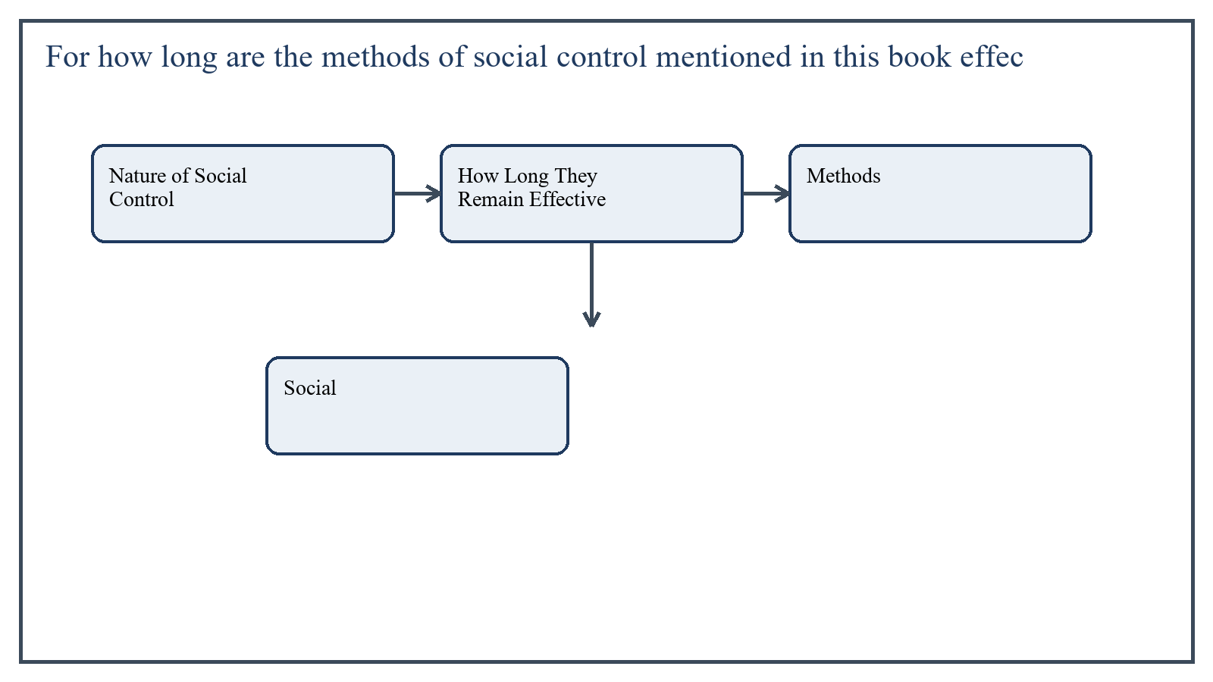
Figure 1: Concept map for Question 1

Nature of Social Control
Social control includes formal methods such as law, regulations, school discipline, and official sanctions, as well as informal methods such as family influence, community opinion, religion, custom, and peer pressure.
In the context of Citizenship Education and Community Engagement, the theme of nature of social control deserves extended attention because assignment-level understanding is expected to move beyond one-line definitions and into explanation, comparison, and application. A strong university answer shows not only what the concept means, but also why it matters, how it appears in practice, and what limitations or challenges may arise when it is implemented in real educational settings.
A mature academic response also connects nature of social control with classroom realities, institutional culture, and the Pakistani context wherever relevant. This makes the answer more analytical and more useful because it links conceptual understanding with the needs of teachers, learners, administrators, and communities rather than leaving the idea at a purely theoretical level.
From an examination and assignment-writing perspective, the topic of nature of social control should be handled through clear structure, careful terminology, valid examples, and balanced discussion. The strongest responses usually define the idea, explain its major components, illustrate it through educational examples, and then conclude with a reasoned judgment about its significance, usefulness, or limitations.

How Long They Remain Effective
These methods remain effective as long as society continues to respect them and as long as they are applied fairly. If laws are ignored, customs lose moral strength, or institutions act unjustly, social control weakens.
In our society, many informal methods such as family influence and community pressure are still effective, but they are changing because urbanization, media, mobility, and technology are transforming social relationships.
In the context of Citizenship Education and Community Engagement, the theme of how long they remain effective deserves extended attention because assignment-level understanding is expected to move beyond one-line definitions and into explanation, comparison, and application. A strong university answer shows not only what the concept means, but also why it matters, how it appears in practice, and what limitations or challenges may arise when it is implemented in real educational settings.
A mature academic response also connects how long they remain effective with classroom realities, institutional culture, and the Pakistani context wherever relevant. This makes the answer more analytical and more useful because it links conceptual understanding with the needs of teachers, learners, administrators, and communities rather than leaving the idea at a purely theoretical level.
From an examination and assignment-writing perspective, the topic of how long they remain effective should be handled through clear structure, careful terminology, valid examples, and balanced discussion. The strongest responses usually define the idea, explain its major components, illustrate it through educational examples, and then conclude with a reasoned judgment about its significance, usefulness, or limitations.

Applied Illustration and Academic Note
For a stronger B.Ed assignment response, the topic above should be linked with classroom life, institutional practice, and the needs of Pakistani learners. This approach makes the response more analytical and demonstrates that the writer understands both theory and application, which is usually appreciated in AIOU-style academic work.
A good response also avoids unsupported claims. Instead, it explains concepts carefully, gives relevant examples, and ends with a short judgment about educational significance. In this way, the answer to 'For how long are the methods of social control mentioned in this book ...' becomes easier to read, easier to assess, and more academically convincing.

Quick Review Table
Focus Area | Assignment Relevance
Nature of Social Control | This area helps answer the question on 'For how long are the methods of social control mentione...' by providing concept clarity, explanation, and applied educational value.
How Long They Remain Effective | This area helps answer the question on 'For how long are the methods of social control mentione...' by providing concept clarity, explanation, and applied educational value.

Critical Reflection
At an advanced level, the topic should not be treated as a fixed formula. Most educational concepts work within particular conditions, and their success often depends on planning quality, learner background, institutional support, and the competence of the teacher or manager using them. A reflective assignment therefore acknowledges strengths while also recognizing practical limitations.

Conclusion
Methods of social control remain effective only while they are trusted, relevant, and supported by social institutions. In modern society their form may change, but the need for social control continues as long as social life requires order and responsibility.

Q.2 Describe the role of teachers towards the success of students as citizens.
Answer: The answer below is organized in an academic assignment style, with conceptual explanation, applied discussion, and concise analytical closing comments designed for a neat and extended university submission.
Teachers contribute to citizenship not only by teaching lessons but by helping students become responsible, ethical, and socially aware members of society.
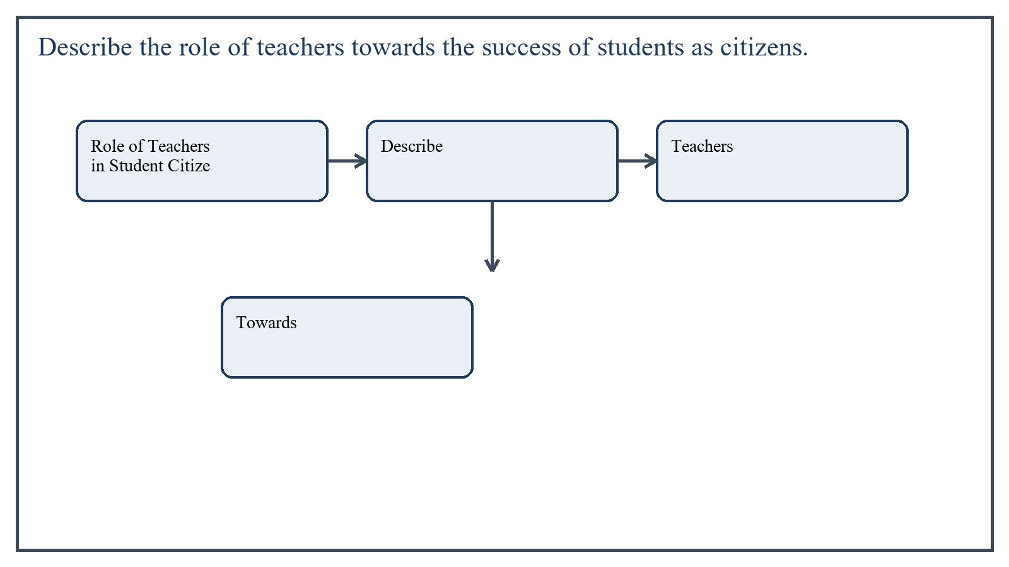
Figure 2: Concept map for Question 2

Role of Teachers in Student Citizenship
A teacher supports successful citizenship by connecting education with real social responsibility. Students learn citizenship better when they experience fairness, participation, and accountability in their daily school environment.
- Teach respect for law, rights, and responsibilities
- Promote honesty, cooperation, and tolerance
- Encourage participation in school and community activities
- Develop critical thinking and social awareness
- Model democratic and respectful behavior in classroom life
In the context of Citizenship Education and Community Engagement, the theme of role of teachers in student citizenship deserves extended attention because assignment-level understanding is expected to move beyond one-line definitions and into explanation, comparison, and application. A strong university answer shows not only what the concept means, but also why it matters, how it appears in practice, and what limitations or challenges may arise when it is implemented in real educational settings.
A mature academic response also connects role of teachers in student citizenship with classroom realities, institutional culture, and the Pakistani context wherever relevant. This makes the answer more analytical and more useful because it links conceptual understanding with the needs of teachers, learners, administrators, and communities rather than leaving the idea at a purely theoretical level.
From an examination and assignment-writing perspective, the topic of role of teachers in student citizenship should be handled through clear structure, careful terminology, valid examples, and balanced discussion. The strongest responses usually define the idea, explain its major components, illustrate it through educational examples, and then conclude with a reasoned judgment about its significance, usefulness, or limitations.

Applied Illustration and Academic Note
For a stronger B.Ed assignment response, the topic above should be linked with classroom life, institutional practice, and the needs of Pakistani learners. This approach makes the response more analytical and demonstrates that the writer understands both theory and application, which is usually appreciated in AIOU-style academic work.
A good response also avoids unsupported claims. Instead, it explains concepts carefully, gives relevant examples, and ends with a short judgment about educational significance. In this way, the answer to 'Describe the role of teachers towards the success of students as citiz...' becomes easier to read, easier to assess, and more academically convincing.

Quick Review Table
Focus Area | Assignment Relevance
Role of Teachers in Student Citizenship | This area helps answer the question on 'Describe the role of teachers towards the success of st...' by providing concept clarity, explanation, and applied educational value.

Critical Reflection
At an advanced level, the topic should not be treated as a fixed formula. Most educational concepts work within particular conditions, and their success often depends on planning quality, learner background, institutional support, and the competence of the teacher or manager using them. A reflective assignment therefore acknowledges strengths while also recognizing practical limitations.

Conclusion
Teachers play a major role in preparing students for citizenship through instruction, example, guidance, and participation opportunities. Their influence extends beyond academic success to civic and moral development.

Q.3 Compare the communication styles of two teachers in a school. You can use a checklist or interview as a tool to measure the communication skills of teachers.
Answer: The answer below is organized in an academic assignment style, with conceptual explanation, applied discussion, and concise analytical closing comments designed for a neat and extended university submission.
Communication style strongly affects classroom climate, student confidence, and learning quality. To compare two teachers, one may use a checklist, observation schedule, or interview tool.
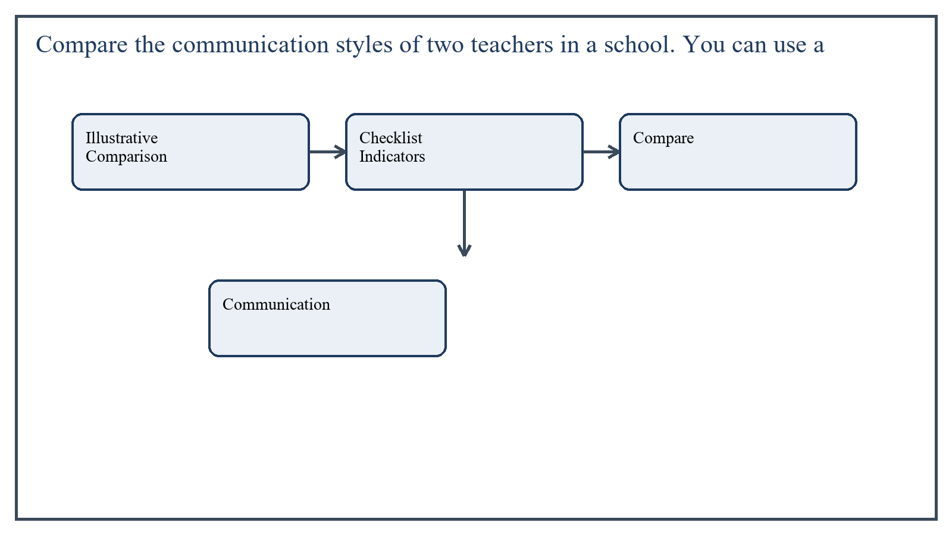
Figure 3: Concept map for Question 3

Illustrative Comparison
Teacher A may use clear, respectful, and encouraging communication. Such a teacher explains instructions step by step, listens to students, uses positive feedback, and maintains eye contact. Students in such a class generally feel more confident and willing to participate.
Teacher B may communicate in a more authoritarian or unclear way, perhaps by speaking too fast, using harsh tone, or giving little opportunity for questions. In such a case students may hesitate to respond and learning interaction becomes weaker.
In the context of Citizenship Education and Community Engagement, the theme of illustrative comparison deserves extended attention because assignment-level understanding is expected to move beyond one-line definitions and into explanation, comparison, and application. A strong university answer shows not only what the concept means, but also why it matters, how it appears in practice, and what limitations or challenges may arise when it is implemented in real educational settings.
A mature academic response also connects illustrative comparison with classroom realities, institutional culture, and the Pakistani context wherever relevant. This makes the answer more analytical and more useful because it links conceptual understanding with the needs of teachers, learners, administrators, and communities rather than leaving the idea at a purely theoretical level.
From an examination and assignment-writing perspective, the topic of illustrative comparison should be handled through clear structure, careful terminology, valid examples, and balanced discussion. The strongest responses usually define the idea, explain its major components, illustrate it through educational examples, and then conclude with a reasoned judgment about its significance, usefulness, or limitations.

Checklist Indicators
Using such a checklist during classroom observation allows the researcher or evaluator to compare teachers systematically instead of relying only on personal impression.
- Clarity of speech and instructions
- Use of respectful tone
- Listening to student responses
- Encouraging participation
- Non-verbal communication such as eye contact and gestures
- Feedback style and patience
In the context of Citizenship Education and Community Engagement, the theme of checklist indicators deserves extended attention because assignment-level understanding is expected to move beyond one-line definitions and into explanation, comparison, and application. A strong university answer shows not only what the concept means, but also why it matters, how it appears in practice, and what limitations or challenges may arise when it is implemented in real educational settings.
A mature academic response also connects checklist indicators with classroom realities, institutional culture, and the Pakistani context wherever relevant. This makes the answer more analytical and more useful because it links conceptual understanding with the needs of teachers, learners, administrators, and communities rather than leaving the idea at a purely theoretical level.
From an examination and assignment-writing perspective, the topic of checklist indicators should be handled through clear structure, careful terminology, valid examples, and balanced discussion. The strongest responses usually define the idea, explain its major components, illustrate it through educational examples, and then conclude with a reasoned judgment about its significance, usefulness, or limitations.

Applied Illustration and Academic Note
For a stronger B.Ed assignment response, the topic above should be linked with classroom life, institutional practice, and the needs of Pakistani learners. This approach makes the response more analytical and demonstrates that the writer understands both theory and application, which is usually appreciated in AIOU-style academic work.
A good response also avoids unsupported claims. Instead, it explains concepts carefully, gives relevant examples, and ends with a short judgment about educational significance. In this way, the answer to 'Compare the communication styles of two teachers in a school. You can ...' becomes easier to read, easier to assess, and more academically convincing.

Quick Review Table
Focus Area | Assignment Relevance
Illustrative Comparison | This area helps answer the question on 'Compare the communication styles of two teachers in a s...' by providing concept clarity, explanation, and applied educational value.
Checklist Indicators | This area helps answer the question on 'Compare the communication styles of two teachers in a s...' by providing concept clarity, explanation, and applied educational value.

Critical Reflection
At an advanced level, the topic should not be treated as a fixed formula. Most educational concepts work within particular conditions, and their success often depends on planning quality, learner background, institutional support, and the competence of the teacher or manager using them. A reflective assignment therefore acknowledges strengths while also recognizing practical limitations.

Conclusion
Communication styles can vary greatly between teachers, and these differences shape student learning and confidence. A checklist or interview makes the comparison more systematic and helps identify strengths and areas for improvement.

Q.4 What are sources of technological change? Explain in detail.
Answer: The answer below is organized in an academic assignment style, with conceptual explanation, applied discussion, and concise analytical closing comments designed for a neat and extended university submission.
Technological change refers to the development and spread of new tools, systems, and methods that alter work, communication, learning, and social life. It is driven by multiple sources rather than a single cause.
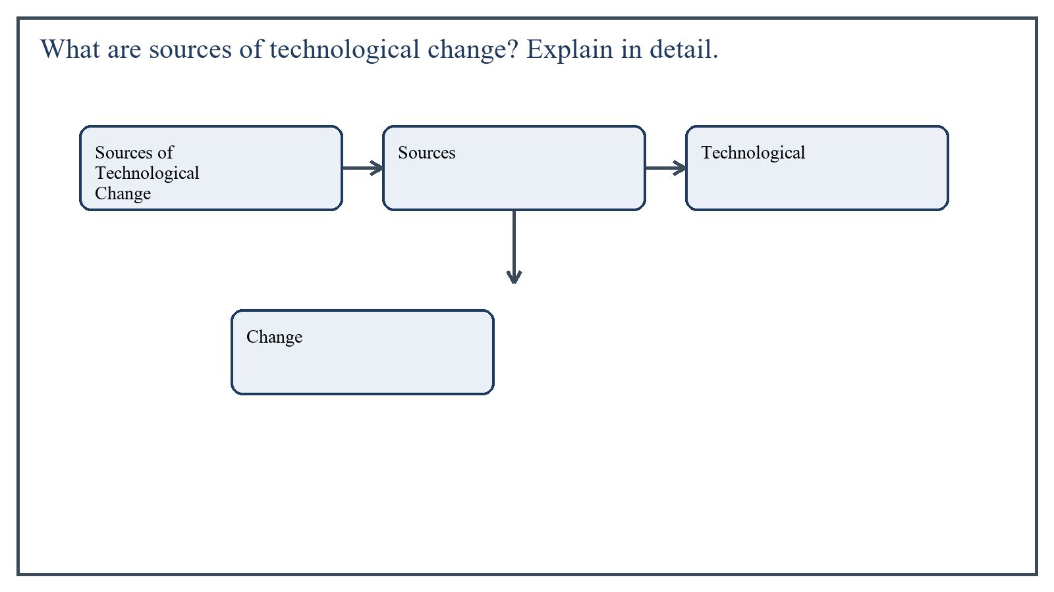
Figure 4: Concept map for Question 4

Sources of Technological Change
Scientific research is a major source because new inventions often grow out of systematic experimentation and discovery. Industrial needs also drive technological change because businesses seek efficiency, productivity, and competitiveness.
Education and training contribute by producing skilled people who can design, adapt, and use new technologies. Communication networks and globalization spread technology rapidly across regions. Social needs, such as health, mobility, security, and learning access, also push societies toward technological innovation.
- Scientific inquiry and invention
- Industrial and economic demand
- Educational and technical training systems
- Global communication and media
- Social and community needs
In the context of Citizenship Education and Community Engagement, the theme of sources of technological change deserves extended attention because assignment-level understanding is expected to move beyond one-line definitions and into explanation, comparison, and application. A strong university answer shows not only what the concept means, but also why it matters, how it appears in practice, and what limitations or challenges may arise when it is implemented in real educational settings.
A mature academic response also connects sources of technological change with classroom realities, institutional culture, and the Pakistani context wherever relevant. This makes the answer more analytical and more useful because it links conceptual understanding with the needs of teachers, learners, administrators, and communities rather than leaving the idea at a purely theoretical level.
From an examination and assignment-writing perspective, the topic of sources of technological change should be handled through clear structure, careful terminology, valid examples, and balanced discussion. The strongest responses usually define the idea, explain its major components, illustrate it through educational examples, and then conclude with a reasoned judgment about its significance, usefulness, or limitations.

Applied Illustration and Academic Note
For a stronger B.Ed assignment response, the topic above should be linked with classroom life, institutional practice, and the needs of Pakistani learners. This approach makes the response more analytical and demonstrates that the writer understands both theory and application, which is usually appreciated in AIOU-style academic work.
A good response also avoids unsupported claims. Instead, it explains concepts carefully, gives relevant examples, and ends with a short judgment about educational significance. In this way, the answer to 'What are sources of technological change? Explain in detail....' becomes easier to read, easier to assess, and more academically convincing.

Quick Review Table
Focus Area | Assignment Relevance
Sources of Technological Change | This area helps answer the question on 'What are sources of technological change? Explain in de...' by providing concept clarity, explanation, and applied educational value.

Critical Reflection
At an advanced level, the topic should not be treated as a fixed formula. Most educational concepts work within particular conditions, and their success often depends on planning quality, learner background, institutional support, and the competence of the teacher or manager using them. A reflective assignment therefore acknowledges strengths while also recognizing practical limitations.

Conclusion
Technological change emerges from scientific, economic, educational, and social forces working together. Understanding these sources helps teachers and citizens respond thoughtfully to technological transformation rather than treating it as an isolated phenomenon.

Q.5 As a teacher, write the complete plan for a teacher-parents meeting. Also mention the objectives of the meeting.
Answer: The answer below is organized in an academic assignment style, with conceptual explanation, applied discussion, and concise analytical closing comments designed for a neat and extended university submission.
A teacher-parents meeting is an organized interaction between school and home to discuss student progress, behavior, support needs, and mutual cooperation. A well-planned meeting strengthens trust and improves educational outcomes.
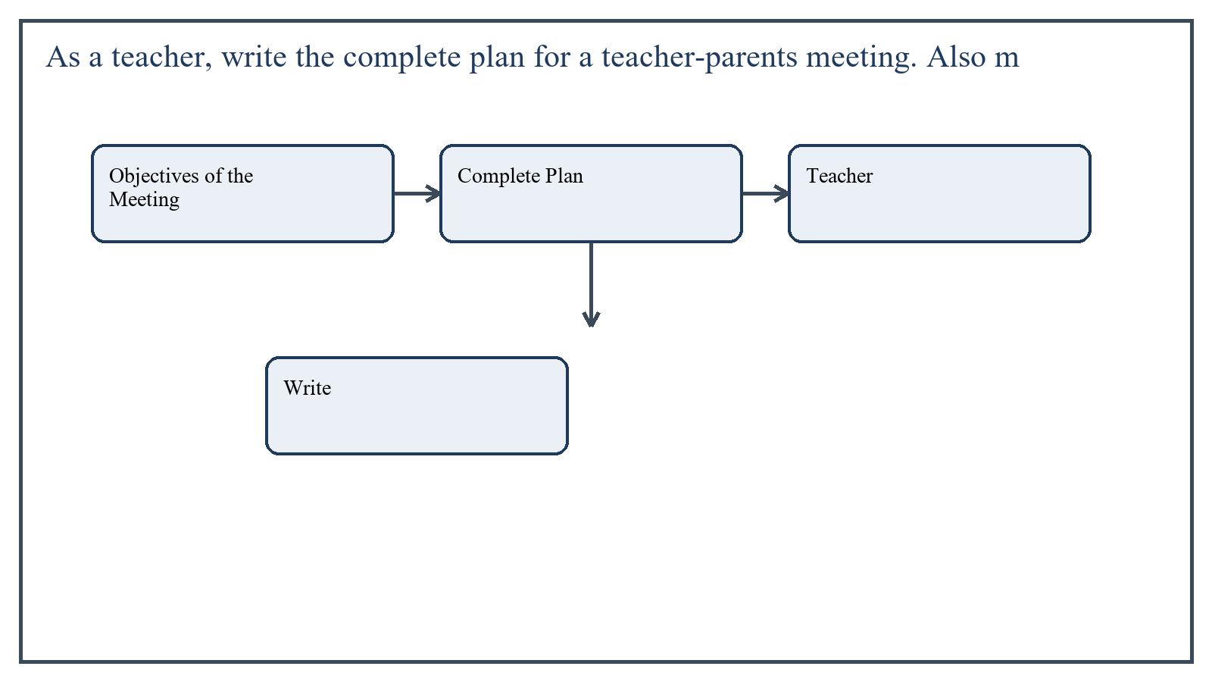
Figure 5: Concept map for Question 5

Objectives of the Meeting
- To share academic progress and classroom behavior of students
- To discuss attendance, discipline, and learning difficulties
- To build cooperation between parents and teachers
- To suggest ways parents can support learning at home
- To strengthen trust and communication between school and family
In the context of Citizenship Education and Community Engagement, the theme of objectives of the meeting deserves extended attention because assignment-level understanding is expected to move beyond one-line definitions and into explanation, comparison, and application. A strong university answer shows not only what the concept means, but also why it matters, how it appears in practice, and what limitations or challenges may arise when it is implemented in real educational settings.
A mature academic response also connects objectives of the meeting with classroom realities, institutional culture, and the Pakistani context wherever relevant. This makes the answer more analytical and more useful because it links conceptual understanding with the needs of teachers, learners, administrators, and communities rather than leaving the idea at a purely theoretical level.
From an examination and assignment-writing perspective, the topic of objectives of the meeting should be handled through clear structure, careful terminology, valid examples, and balanced discussion. The strongest responses usually define the idea, explain its major components, illustrate it through educational examples, and then conclude with a reasoned judgment about its significance, usefulness, or limitations.

Complete Plan
- Decide the date, time, and venue well in advance.
- Prepare invitations or notices for parents.
- Set the agenda clearly, including progress discussion, issues, and suggestions.
- Collect relevant student data such as attendance, marks, class behavior, and teacher observations.
- Arrange seating and a welcoming environment.
- Begin the meeting with purpose and respectful introduction.
- Discuss each student's strengths, weaknesses, and support needs honestly but positively.
- Allow parents to share their observations and concerns.
- Agree on follow-up actions for home and school.
- Record important points and thank parents for cooperation.
In the context of Citizenship Education and Community Engagement, the theme of complete plan deserves extended attention because assignment-level understanding is expected to move beyond one-line definitions and into explanation, comparison, and application. A strong university answer shows not only what the concept means, but also why it matters, how it appears in practice, and what limitations or challenges may arise when it is implemented in real educational settings.
A mature academic response also connects complete plan with classroom realities, institutional culture, and the Pakistani context wherever relevant. This makes the answer more analytical and more useful because it links conceptual understanding with the needs of teachers, learners, administrators, and communities rather than leaving the idea at a purely theoretical level.
From an examination and assignment-writing perspective, the topic of complete plan should be handled through clear structure, careful terminology, valid examples, and balanced discussion. The strongest responses usually define the idea, explain its major components, illustrate it through educational examples, and then conclude with a reasoned judgment about its significance, usefulness, or limitations.

Applied Illustration and Academic Note
For a stronger B.Ed assignment response, the topic above should be linked with classroom life, institutional practice, and the needs of Pakistani learners. This approach makes the response more analytical and demonstrates that the writer understands both theory and application, which is usually appreciated in AIOU-style academic work.
A good response also avoids unsupported claims. Instead, it explains concepts carefully, gives relevant examples, and ends with a short judgment about educational significance. In this way, the answer to 'As a teacher, write the complete plan for a teacher-parents meeting. A...' becomes easier to read, easier to assess, and more academically convincing.

Quick Review Table
Focus Area | Assignment Relevance
Objectives of the Meeting | This area helps answer the question on 'As a teacher, write the complete plan for a teacher-par...' by providing concept clarity, explanation, and applied educational value.
Complete Plan | This area helps answer the question on 'As a teacher, write the complete plan for a teacher-par...' by providing concept clarity, explanation, and applied educational value.

Critical Reflection
At an advanced level, the topic should not be treated as a fixed formula. Most educational concepts work within particular conditions, and their success often depends on planning quality, learner background, institutional support, and the competence of the teacher or manager using them. A reflective assignment therefore acknowledges strengths while also recognizing practical limitations.

Conclusion
A teacher-parents meeting becomes effective when it is well planned, respectful, evidence-based, and solution-oriented. Its objectives should focus on student progress and stronger home-school partnership, while the plan should ensure clear communication and practical follow-up.

Extended Revision Appendix
This appendix is included to strengthen the assignment as a premium academic submission. It provides recap notes, revision prompts, and concept reinforcement so the document reads like a complete study-ready submission rather than a short-answer sheet only.

Key Revision Points
- Review the central demand of the question 'For how long are the methods of social control mentioned in th...' and connect definition, explanation, example, and critical comment in one organized response.
- Review the central demand of the question 'Describe the role of teachers towards the success of students ...' and connect definition, explanation, example, and critical comment in one organized response.
- Review the central demand of the question 'Compare the communication styles of two teachers in a school. ...' and connect definition, explanation, example, and critical comment in one organized response.
- Review the central demand of the question 'What are sources of technological change? Explain in detail....' and connect definition, explanation, example, and critical comment in one organized response.
- Review the central demand of the question 'As a teacher, write the complete plan for a teacher-parents me...' and connect definition, explanation, example, and critical comment in one organized response.

Academic Writing Reminders
- Begin each major answer with a clear conceptual opening.
- Use examples to show understanding instead of repeating definitions only.
- Present advantages, limitations, and contextual realities where relevant.
- Close each answer with a short evaluative conclusion.
- Maintain formal and neat language throughout the assignment.

Concept Reinforcement Notes
The question on 'For how long are the methods of social control mentioned in this book effec...' can be revised further by identifying three things: the main concept involved, the educational importance of that concept, and one example from Pakistani classroom or institutional life. This simple method helps transform memorized content into organized written response.
The question on 'Describe the role of teachers towards the success of students as citizens....' can be revised further by identifying three things: the main concept involved, the educational importance of that concept, and one example from Pakistani classroom or institutional life. This simple method helps transform memorized content into organized written response.
The question on 'Compare the communication styles of two teachers in a school. You can use a...' can be revised further by identifying three things: the main concept involved, the educational importance of that concept, and one example from Pakistani classroom or institutional life. This simple method helps transform memorized content into organized written response.
The question on 'What are sources of technological change? Explain in detail....' can be revised further by identifying three things: the main concept involved, the educational importance of that concept, and one example from Pakistani classroom or institutional life. This simple method helps transform memorized content into organized written response.
The question on 'As a teacher, write the complete plan for a teacher-parents meeting. Also m...' can be revised further by identifying three things: the main concept involved, the educational importance of that concept, and one example from Pakistani classroom or institutional life. This simple method helps transform memorized content into organized written response.

Source Base and Assignment Support Notes
The following source base was used to keep the answers aligned with AIOU course structure and the exact question wording. The final language and organization were expanded for presentation quality, page-length target, and assignment readability.
- AIOU Spring 2026 assignment sheet for Course 8606.
- AIOU official related texts used for conceptual grounding: Introduction to Sociology: Culture & Society (Code 9410), Teacher Education in Pakistan (Code 8626), and other AIOU community-engagement-related material where the direct 8606 softbook was not publicly available at the standard softbook URL on July 24, 2026.

Extended Analytical Note 1
In extended study of Citizenship Education and Community Engagement, the issue raised in 'For how long are the methods of social control mentioned in this book ef...' may also be explored through definition, theoretical explanation, applied example, classroom implication, institutional implication, and critical reflection. This six-part approach helps a learner produce a more complete answer and also improves the academic appearance of the assignment by showing structure and depth.
Another useful strategy in long-form assignment writing is to move carefully from concept to context. First explain what the idea means, then identify its components, then discuss its relevance in teaching or administration, and finally mention any practical limitation. Such movement gives maturity to the answer and helps the examiner follow the logic without difficulty.
In extended study of Citizenship Education and Community Engagement, the issue raised in 'Describe the role of teachers towards the success of students as citizen...' may also be explored through definition, theoretical explanation, applied example, classroom implication, institutional implication, and critical reflection. This six-part approach helps a learner produce a more complete answer and also improves the academic appearance of the assignment by showing structure and depth.
Another useful strategy in long-form assignment writing is to move carefully from concept to context. First explain what the idea means, then identify its components, then discuss its relevance in teaching or administration, and finally mention any practical limitation. Such movement gives maturity to the answer and helps the examiner follow the logic without difficulty.
In extended study of Citizenship Education and Community Engagement, the issue raised in 'Compare the communication styles of two teachers in a school. You can us...' may also be explored through definition, theoretical explanation, applied example, classroom implication, institutional implication, and critical reflection. This six-part approach helps a learner produce a more complete answer and also improves the academic appearance of the assignment by showing structure and depth.
Another useful strategy in long-form assignment writing is to move carefully from concept to context. First explain what the idea means, then identify its components, then discuss its relevance in teaching or administration, and finally mention any practical limitation. Such movement gives maturity to the answer and helps the examiner follow the logic without difficulty.
In extended study of Citizenship Education and Community Engagement, the issue raised in 'What are sources of technological change? Explain in detail....' may also be explored through definition, theoretical explanation, applied example, classroom implication, institutional implication, and critical reflection. This six-part approach helps a learner produce a more complete answer and also improves the academic appearance of the assignment by showing structure and depth.
Another useful strategy in long-form assignment writing is to move carefully from concept to context. First explain what the idea means, then identify its components, then discuss its relevance in teaching or administration, and finally mention any practical limitation. Such movement gives maturity to the answer and helps the examiner follow the logic without difficulty.
In extended study of Citizenship Education and Community Engagement, the issue raised in 'As a teacher, write the complete plan for a teacher-parents meeting. Als...' may also be explored through definition, theoretical explanation, applied example, classroom implication, institutional implication, and critical reflection. This six-part approach helps a learner produce a more complete answer and also improves the academic appearance of the assignment by showing structure and depth.
Another useful strategy in long-form assignment writing is to move carefully from concept to context. First explain what the idea means, then identify its components, then discuss its relevance in teaching or administration, and finally mention any practical limitation. Such movement gives maturity to the answer and helps the examiner follow the logic without difficulty.

Extended Analytical Note 2
In extended study of Citizenship Education and Community Engagement, the issue raised in 'For how long are the methods of social control mentioned in this book ef...' may also be explored through definition, theoretical explanation, applied example, classroom implication, institutional implication, and critical reflection. This six-part approach helps a learner produce a more complete answer and also improves the academic appearance of the assignment by showing structure and depth.
Another useful strategy in long-form assignment writing is to move carefully from concept to context. First explain what the idea means, then identify its components, then discuss its relevance in teaching or administration, and finally mention any practical limitation. Such movement gives maturity to the answer and helps the examiner follow the logic without difficulty.
In extended study of Citizenship Education and Community Engagement, the issue raised in 'Describe the role of teachers towards the success of students as citizen...' may also be explored through definition, theoretical explanation, applied example, classroom implication, institutional implication, and critical reflection. This six-part approach helps a learner produce a more complete answer and also improves the academic appearance of the assignment by showing structure and depth.
Another useful strategy in long-form assignment writing is to move carefully from concept to context. First explain what the idea means, then identify its components, then discuss its relevance in teaching or administration, and finally mention any practical limitation. Such movement gives maturity to the answer and helps the examiner follow the logic without difficulty.
In extended study of Citizenship Education and Community Engagement, the issue raised in 'Compare the communication styles of two teachers in a school. You can us...' may also be explored through definition, theoretical explanation, applied example, classroom implication, institutional implication, and critical reflection. This six-part approach helps a learner produce a more complete answer and also improves the academic appearance of the assignment by showing structure and depth.
Another useful strategy in long-form assignment writing is to move carefully from concept to context. First explain what the idea means, then identify its components, then discuss its relevance in teaching or administration, and finally mention any practical limitation. Such movement gives maturity to the answer and helps the examiner follow the logic without difficulty.
In extended study of Citizenship Education and Community Engagement, the issue raised in 'What are sources of technological change? Explain in detail....' may also be explored through definition, theoretical explanation, applied example, classroom implication, institutional implication, and critical reflection. This six-part approach helps a learner produce a more complete answer and also improves the academic appearance of the assignment by showing structure and depth.
Another useful strategy in long-form assignment writing is to move carefully from concept to context. First explain what the idea means, then identify its components, then discuss its relevance in teaching or administration, and finally mention any practical limitation. Such movement gives maturity to the answer and helps the examiner follow the logic without difficulty.
In extended study of Citizenship Education and Community Engagement, the issue raised in 'As a teacher, write the complete plan for a teacher-parents meeting. Als...' may also be explored through definition, theoretical explanation, applied example, classroom implication, institutional implication, and critical reflection. This six-part approach helps a learner produce a more complete answer and also improves the academic appearance of the assignment by showing structure and depth.
Another useful strategy in long-form assignment writing is to move carefully from concept to context. First explain what the idea means, then identify its components, then discuss its relevance in teaching or administration, and finally mention any practical limitation. Such movement gives maturity to the answer and helps the examiner follow the logic without difficulty.

Extended Analytical Note 3
In extended study of Citizenship Education and Community Engagement, the issue raised in 'For how long are the methods of social control mentioned in this book ef...' may also be explored through definition, theoretical explanation, applied example, classroom implication, institutional implication, and critical reflection. This six-part approach helps a learner produce a more complete answer and also improves the academic appearance of the assignment by showing structure and depth.
Another useful strategy in long-form assignment writing is to move carefully from concept to context. First explain what the idea means, then identify its components, then discuss its relevance in teaching or administration, and finally mention any practical limitation. Such movement gives maturity to the answer and helps the examiner follow the logic without difficulty.
In extended study of Citizenship Education and Community Engagement, the issue raised in 'Describe the role of teachers towards the success of students as citizen...' may also be explored through definition, theoretical explanation, applied example, classroom implication, institutional implication, and critical reflection. This six-part approach helps a learner produce a more complete answer and also improves the academic appearance of the assignment by showing structure and depth.
Another useful strategy in long-form assignment writing is to move carefully from concept to context. First explain what the idea means, then identify its components, then discuss its relevance in teaching or administration, and finally mention any practical limitation. Such movement gives maturity to the answer and helps the examiner follow the logic without difficulty.
In extended study of Citizenship Education and Community Engagement, the issue raised in 'Compare the communication styles of two teachers in a school. You can us...' may also be explored through definition, theoretical explanation, applied example, classroom implication, institutional implication, and critical reflection. This six-part approach helps a learner produce a more complete answer and also improves the academic appearance of the assignment by showing structure and depth.
Another useful strategy in long-form assignment writing is to move carefully from concept to context. First explain what the idea means, then identify its components, then discuss its relevance in teaching or administration, and finally mention any practical limitation. Such movement gives maturity to the answer and helps the examiner follow the logic without difficulty.
In extended study of Citizenship Education and Community Engagement, the issue raised in 'What are sources of technological change? Explain in detail....' may also be explored through definition, theoretical explanation, applied example, classroom implication, institutional implication, and critical reflection. This six-part approach helps a learner produce a more complete answer and also improves the academic appearance of the assignment by showing structure and depth.
Another useful strategy in long-form assignment writing is to move carefully from concept to context. First explain what the idea means, then identify its components, then discuss its relevance in teaching or administration, and finally mention any practical limitation. Such movement gives maturity to the answer and helps the examiner follow the logic without difficulty.
In extended study of Citizenship Education and Community Engagement, the issue raised in 'As a teacher, write the complete plan for a teacher-parents meeting. Als...' may also be explored through definition, theoretical explanation, applied example, classroom implication, institutional implication, and critical reflection. This six-part approach helps a learner produce a more complete answer and also improves the academic appearance of the assignment by showing structure and depth.
Another useful strategy in long-form assignment writing is to move carefully from concept to context. First explain what the idea means, then identify its components, then discuss its relevance in teaching or administration, and finally mention any practical limitation. Such movement gives maturity to the answer and helps the examiner follow the logic without difficulty.

Extended Analytical Note 4
In extended study of Citizenship Education and Community Engagement, the issue raised in 'For how long are the methods of social control mentioned in this book ef...' may also be explored through definition, theoretical explanation, applied example, classroom implication, institutional implication, and critical reflection. This six-part approach helps a learner produce a more complete answer and also improves the academic appearance of the assignment by showing structure and depth.
Another useful strategy in long-form assignment writing is to move carefully from concept to context. First explain what the idea means, then identify its components, then discuss its relevance in teaching or administration, and finally mention any practical limitation. Such movement gives maturity to the answer and helps the examiner follow the logic without difficulty.
In extended study of Citizenship Education and Community Engagement, the issue raised in 'Describe the role of teachers towards the success of students as citizen...' may also be explored through definition, theoretical explanation, applied example, classroom implication, institutional implication, and critical reflection. This six-part approach helps a learner produce a more complete answer and also improves the academic appearance of the assignment by showing structure and depth.
Another useful strategy in long-form assignment writing is to move carefully from concept to context. First explain what the idea means, then identify its components, then discuss its relevance in teaching or administration, and finally mention any practical limitation. Such movement gives maturity to the answer and helps the examiner follow the logic without difficulty.
In extended study of Citizenship Education and Community Engagement, the issue raised in 'Compare the communication styles of two teachers in a school. You can us...' may also be explored through definition, theoretical explanation, applied example, classroom implication, institutional implication, and critical reflection. This six-part approach helps a learner produce a more complete answer and also improves the academic appearance of the assignment by showing structure and depth.
Another useful strategy in long-form assignment writing is to move carefully from concept to context. First explain what the idea means, then identify its components, then discuss its relevance in teaching or administration, and finally mention any practical limitation. Such movement gives maturity to the answer and helps the examiner follow the logic without difficulty.
In extended study of Citizenship Education and Community Engagement, the issue raised in 'What are sources of technological change? Explain in detail....' may also be explored through definition, theoretical explanation, applied example, classroom implication, institutional implication, and critical reflection. This six-part approach helps a learner produce a more complete answer and also improves the academic appearance of the assignment by showing structure and depth.
Another useful strategy in long-form assignment writing is to move carefully from concept to context. First explain what the idea means, then identify its components, then discuss its relevance in teaching or administration, and finally mention any practical limitation. Such movement gives maturity to the answer and helps the examiner follow the logic without difficulty.
In extended study of Citizenship Education and Community Engagement, the issue raised in 'As a teacher, write the complete plan for a teacher-parents meeting. Als...' may also be explored through definition, theoretical explanation, applied example, classroom implication, institutional implication, and critical reflection. This six-part approach helps a learner produce a more complete answer and also improves the academic appearance of the assignment by showing structure and depth.
Another useful strategy in long-form assignment writing is to move carefully from concept to context. First explain what the idea means, then identify its components, then discuss its relevance in teaching or administration, and finally mention any practical limitation. Such movement gives maturity to the answer and helps the examiner follow the logic without difficulty.

Extended Analytical Note 5
In extended study of Citizenship Education and Community Engagement, the issue raised in 'For how long are the methods of social control mentioned in this book ef...' may also be explored through definition, theoretical explanation, applied example, classroom implication, institutional implication, and critical reflection. This six-part approach helps a learner produce a more complete answer and also improves the academic appearance of the assignment by showing structure and depth.
Another useful strategy in long-form assignment writing is to move carefully from concept to context. First explain what the idea means, then identify its components, then discuss its relevance in teaching or administration, and finally mention any practical limitation. Such movement gives maturity to the answer and helps the examiner follow the logic without difficulty.
In extended study of Citizenship Education and Community Engagement, the issue raised in 'Describe the role of teachers towards the success of students as citizen...' may also be explored through definition, theoretical explanation, applied example, classroom implication, institutional implication, and critical reflection. This six-part approach helps a learner produce a more complete answer and also improves the academic appearance of the assignment by showing structure and depth.
Another useful strategy in long-form assignment writing is to move carefully from concept to context. First explain what the idea means, then identify its components, then discuss its relevance in teaching or administration, and finally mention any practical limitation. Such movement gives maturity to the answer and helps the examiner follow the logic without difficulty.
In extended study of Citizenship Education and Community Engagement, the issue raised in 'Compare the communication styles of two teachers in a school. You can us...' may also be explored through definition, theoretical explanation, applied example, classroom implication, institutional implication, and critical reflection. This six-part approach helps a learner produce a more complete answer and also improves the academic appearance of the assignment by showing structure and depth.
Another useful strategy in long-form assignment writing is to move carefully from concept to context. First explain what the idea means, then identify its components, then discuss its relevance in teaching or administration, and finally mention any practical limitation. Such movement gives maturity to the answer and helps the examiner follow the logic without difficulty.
In extended study of Citizenship Education and Community Engagement, the issue raised in 'What are sources of technological change? Explain in detail....' may also be explored through definition, theoretical explanation, applied example, classroom implication, institutional implication, and critical reflection. This six-part approach helps a learner produce a more complete answer and also improves the academic appearance of the assignment by showing structure and depth.
Another useful strategy in long-form assignment writing is to move carefully from concept to context. First explain what the idea means, then identify its components, then discuss its relevance in teaching or administration, and finally mention any practical limitation. Such movement gives maturity to the answer and helps the examiner follow the logic without difficulty.
In extended study of Citizenship Education and Community Engagement, the issue raised in 'As a teacher, write the complete plan for a teacher-parents meeting. Als...' may also be explored through definition, theoretical explanation, applied example, classroom implication, institutional implication, and critical reflection. This six-part approach helps a learner produce a more complete answer and also improves the academic appearance of the assignment by showing structure and depth.
Another useful strategy in long-form assignment writing is to move carefully from concept to context. First explain what the idea means, then identify its components, then discuss its relevance in teaching or administration, and finally mention any practical limitation. Such movement gives maturity to the answer and helps the examiner follow the logic without difficulty.

Extended Analytical Note 6
In extended study of Citizenship Education and Community Engagement, the issue raised in 'For how long are the methods of social control mentioned in this book ef...' may also be explored through definition, theoretical explanation, applied example, classroom implication, institutional implication, and critical reflection. This six-part approach helps a learner produce a more complete answer and also improves the academic appearance of the assignment by showing structure and depth.
Another useful strategy in long-form assignment writing is to move carefully from concept to context. First explain what the idea means, then identify its components, then discuss its relevance in teaching or administration, and finally mention any practical limitation. Such movement gives maturity to the answer and helps the examiner follow the logic without difficulty.
In extended study of Citizenship Education and Community Engagement, the issue raised in 'Describe the role of teachers towards the success of students as citizen...' may also be explored through definition, theoretical explanation, applied example, classroom implication, institutional implication, and critical reflection. This six-part approach helps a learner produce a more complete answer and also improves the academic appearance of the assignment by showing structure and depth.
Another useful strategy in long-form assignment writing is to move carefully from concept to context. First explain what the idea means, then identify its components, then discuss its relevance in teaching or administration, and finally mention any practical limitation. Such movement gives maturity to the answer and helps the examiner follow the logic without difficulty.
In extended study of Citizenship Education and Community Engagement, the issue raised in 'Compare the communication styles of two teachers in a school. You can us...' may also be explored through definition, theoretical explanation, applied example, classroom implication, institutional implication, and critical reflection. This six-part approach helps a learner produce a more complete answer and also improves the academic appearance of the assignment by showing structure and depth.
Another useful strategy in long-form assignment writing is to move carefully from concept to context. First explain what the idea means, then identify its components, then discuss its relevance in teaching or administration, and finally mention any practical limitation. Such movement gives maturity to the answer and helps the examiner follow the logic without difficulty.
In extended study of Citizenship Education and Community Engagement, the issue raised in 'What are sources of technological change? Explain in detail....' may also be explored through definition, theoretical explanation, applied example, classroom implication, institutional implication, and critical reflection. This six-part approach helps a learner produce a more complete answer and also improves the academic appearance of the assignment by showing structure and depth.
Another useful strategy in long-form assignment writing is to move carefully from concept to context. First explain what the idea means, then identify its components, then discuss its relevance in teaching or administration, and finally mention any practical limitation. Such movement gives maturity to the answer and helps the examiner follow the logic without difficulty.
In extended study of Citizenship Education and Community Engagement, the issue raised in 'As a teacher, write the complete plan for a teacher-parents meeting. Als...' may also be explored through definition, theoretical explanation, applied example, classroom implication, institutional implication, and critical reflection. This six-part approach helps a learner produce a more complete answer and also improves the academic appearance of the assignment by showing structure and depth.
Another useful strategy in long-form assignment writing is to move carefully from concept to context. First explain what the idea means, then identify its components, then discuss its relevance in teaching or administration, and finally mention any practical limitation. Such movement gives maturity to the answer and helps the examiner follow the logic without difficulty.

Extended Analytical Note 7
In extended study of Citizenship Education and Community Engagement, the issue raised in 'For how long are the methods of social control mentioned in this book ef...' may also be explored through definition, theoretical explanation, applied example, classroom implication, institutional implication, and critical reflection. This six-part approach helps a learner produce a more complete answer and also improves the academic appearance of the assignment by showing structure and depth.
Another useful strategy in long-form assignment writing is to move carefully from concept to context. First explain what the idea means, then identify its components, then discuss its relevance in teaching or administration, and finally mention any practical limitation. Such movement gives maturity to the answer and helps the examiner follow the logic without difficulty.
In extended study of Citizenship Education and Community Engagement, the issue raised in 'Describe the role of teachers towards the success of students as citizen...' may also be explored through definition, theoretical explanation, applied example, classroom implication, institutional implication, and critical reflection. This six-part approach helps a learner produce a more complete answer and also improves the academic appearance of the assignment by showing structure and depth.
Another useful strategy in long-form assignment writing is to move carefully from concept to context. First explain what the idea means, then identify its components, then discuss its relevance in teaching or administration, and finally mention any practical limitation. Such movement gives maturity to the answer and helps the examiner follow the logic without difficulty.
In extended study of Citizenship Education and Community Engagement, the issue raised in 'Compare the communication styles of two teachers in a school. You can us...' may also be explored through definition, theoretical explanation, applied example, classroom implication, institutional implication, and critical reflection. This six-part approach helps a learner produce a more complete answer and also improves the academic appearance of the assignment by showing structure and depth.
Another useful strategy in long-form assignment writing is to move carefully from concept to context. First explain what the idea means, then identify its components, then discuss its relevance in teaching or administration, and finally mention any practical limitation. Such movement gives maturity to the answer and helps the examiner follow the logic without difficulty.
In extended study of Citizenship Education and Community Engagement, the issue raised in 'What are sources of technological change? Explain in detail....' may also be explored through definition, theoretical explanation, applied example, classroom implication, institutional implication, and critical reflection. This six-part approach helps a learner produce a more complete answer and also improves the academic appearance of the assignment by showing structure and depth.
Another useful strategy in long-form assignment writing is to move carefully from concept to context. First explain what the idea means, then identify its components, then discuss its relevance in teaching or administration, and finally mention any practical limitation. Such movement gives maturity to the answer and helps the examiner follow the logic without difficulty.
In extended study of Citizenship Education and Community Engagement, the issue raised in 'As a teacher, write the complete plan for a teacher-parents meeting. Als...' may also be explored through definition, theoretical explanation, applied example, classroom implication, institutional implication, and critical reflection. This six-part approach helps a learner produce a more complete answer and also improves the academic appearance of the assignment by showing structure and depth.
Another useful strategy in long-form assignment writing is to move carefully from concept to context. First explain what the idea means, then identify its components, then discuss its relevance in teaching or administration, and finally mention any practical limitation. Such movement gives maturity to the answer and helps the examiner follow the logic without difficulty.

Extended Analytical Note 8
In extended study of Citizenship Education and Community Engagement, the issue raised in 'For how long are the methods of social control mentioned in this book ef...' may also be explored through definition, theoretical explanation, applied example, classroom implication, institutional implication, and critical reflection. This six-part approach helps a learner produce a more complete answer and also improves the academic appearance of the assignment by showing structure and depth.
Another useful strategy in long-form assignment writing is to move carefully from concept to context. First explain what the idea means, then identify its components, then discuss its relevance in teaching or administration, and finally mention any practical limitation. Such movement gives maturity to the answer and helps the examiner follow the logic without difficulty.
In extended study of Citizenship Education and Community Engagement, the issue raised in 'Describe the role of teachers towards the success of students as citizen...' may also be explored through definition, theoretical explanation, applied example, classroom implication, institutional implication, and critical reflection. This six-part approach helps a learner produce a more complete answer and also improves the academic appearance of the assignment by showing structure and depth.
Another useful strategy in long-form assignment writing is to move carefully from concept to context. First explain what the idea means, then identify its components, then discuss its relevance in teaching or administration, and finally mention any practical limitation. Such movement gives maturity to the answer and helps the examiner follow the logic without difficulty.
In extended study of Citizenship Education and Community Engagement, the issue raised in 'Compare the communication styles of two teachers in a school. You can us...' may also be explored through definition, theoretical explanation, applied example, classroom implication, institutional implication, and critical reflection. This six-part approach helps a learner produce a more complete answer and also improves the academic appearance of the assignment by showing structure and depth.
Another useful strategy in long-form assignment writing is to move carefully from concept to context. First explain what the idea means, then identify its components, then discuss its relevance in teaching or administration, and finally mention any practical limitation. Such movement gives maturity to the answer and helps the examiner follow the logic without difficulty.
In extended study of Citizenship Education and Community Engagement, the issue raised in 'What are sources of technological change? Explain in detail....' may also be explored through definition, theoretical explanation, applied example, classroom implication, institutional implication, and critical reflection. This six-part approach helps a learner produce a more complete answer and also improves the academic appearance of the assignment by showing structure and depth.
Another useful strategy in long-form assignment writing is to move carefully from concept to context. First explain what the idea means, then identify its components, then discuss its relevance in teaching or administration, and finally mention any practical limitation. Such movement gives maturity to the answer and helps the examiner follow the logic without difficulty.
In extended study of Citizenship Education and Community Engagement, the issue raised in 'As a teacher, write the complete plan for a teacher-parents meeting. Als...' may also be explored through definition, theoretical explanation, applied example, classroom implication, institutional implication, and critical reflection. This six-part approach helps a learner produce a more complete answer and also improves the academic appearance of the assignment by showing structure and depth.
Another useful strategy in long-form assignment writing is to move carefully from concept to context. First explain what the idea means, then identify its components, then discuss its relevance in teaching or administration, and finally mention any practical limitation. Such movement gives maturity to the answer and helps the examiner follow the logic without difficulty.

Extended Analytical Note 9
In extended study of Citizenship Education and Community Engagement, the issue raised in 'For how long are the methods of social control mentioned in this book ef...' may also be explored through definition, theoretical explanation, applied example, classroom implication, institutional implication, and critical reflection. This six-part approach helps a learner produce a more complete answer and also improves the academic appearance of the assignment by showing structure and depth.
Another useful strategy in long-form assignment writing is to move carefully from concept to context. First explain what the idea means, then identify its components, then discuss its relevance in teaching or administration, and finally mention any practical limitation. Such movement gives maturity to the answer and helps the examiner follow the logic without difficulty.
In extended study of Citizenship Education and Community Engagement, the issue raised in 'Describe the role of teachers towards the success of students as citizen...' may also be explored through definition, theoretical explanation, applied example, classroom implication, institutional implication, and critical reflection. This six-part approach helps a learner produce a more complete answer and also improves the academic appearance of the assignment by showing structure and depth.
Another useful strategy in long-form assignment writing is to move carefully from concept to context. First explain what the idea means, then identify its components, then discuss its relevance in teaching or administration, and finally mention any practical limitation. Such movement gives maturity to the answer and helps the examiner follow the logic without difficulty.
In extended study of Citizenship Education and Community Engagement, the issue raised in 'Compare the communication styles of two teachers in a school. You can us...' may also be explored through definition, theoretical explanation, applied example, classroom implication, institutional implication, and critical reflection. This six-part approach helps a learner produce a more complete answer and also improves the academic appearance of the assignment by showing structure and depth.
Another useful strategy in long-form assignment writing is to move carefully from concept to context. First explain what the idea means, then identify its components, then discuss its relevance in teaching or administration, and finally mention any practical limitation. Such movement gives maturity to the answer and helps the examiner follow the logic without difficulty.
In extended study of Citizenship Education and Community Engagement, the issue raised in 'What are sources of technological change? Explain in detail....' may also be explored through definition, theoretical explanation, applied example, classroom implication, institutional implication, and critical reflection. This six-part approach helps a learner produce a more complete answer and also improves the academic appearance of the assignment by showing structure and depth.
Another useful strategy in long-form assignment writing is to move carefully from concept to context. First explain what the idea means, then identify its components, then discuss its relevance in teaching or administration, and finally mention any practical limitation. Such movement gives maturity to the answer and helps the examiner follow the logic without difficulty.
In extended study of Citizenship Education and Community Engagement, the issue raised in 'As a teacher, write the complete plan for a teacher-parents meeting. Als...' may also be explored through definition, theoretical explanation, applied example, classroom implication, institutional implication, and critical reflection. This six-part approach helps a learner produce a more complete answer and also improves the academic appearance of the assignment by showing structure and depth.
Another useful strategy in long-form assignment writing is to move carefully from concept to context. First explain what the idea means, then identify its components, then discuss its relevance in teaching or administration, and finally mention any practical limitation. Such movement gives maturity to the answer and helps the examiner follow the logic without difficulty.

Extended Analytical Note 10
In extended study of Citizenship Education and Community Engagement, the issue raised in 'For how long are the methods of social control mentioned in this book ef...' may also be explored through definition, theoretical explanation, applied example, classroom implication, institutional implication, and critical reflection. This six-part approach helps a learner produce a more complete answer and also improves the academic appearance of the assignment by showing structure and depth.
Another useful strategy in long-form assignment writing is to move carefully from concept to context. First explain what the idea means, then identify its components, then discuss its relevance in teaching or administration, and finally mention any practical limitation. Such movement gives maturity to the answer and helps the examiner follow the logic without difficulty.
In extended study of Citizenship Education and Community Engagement, the issue raised in 'Describe the role of teachers towards the success of students as citizen...' may also be explored through definition, theoretical explanation, applied example, classroom implication, institutional implication, and critical reflection. This six-part approach helps a learner produce a more complete answer and also improves the academic appearance of the assignment by showing structure and depth.
Another useful strategy in long-form assignment writing is to move carefully from concept to context. First explain what the idea means, then identify its components, then discuss its relevance in teaching or administration, and finally mention any practical limitation. Such movement gives maturity to the answer and helps the examiner follow the logic without difficulty.
In extended study of Citizenship Education and Community Engagement, the issue raised in 'Compare the communication styles of two teachers in a school. You can us...' may also be explored through definition, theoretical explanation, applied example, classroom implication, institutional implication, and critical reflection. This six-part approach helps a learner produce a more complete answer and also improves the academic appearance of the assignment by showing structure and depth.
Another useful strategy in long-form assignment writing is to move carefully from concept to context. First explain what the idea means, then identify its components, then discuss its relevance in teaching or administration, and finally mention any practical limitation. Such movement gives maturity to the answer and helps the examiner follow the logic without difficulty.
In extended study of Citizenship Education and Community Engagement, the issue raised in 'What are sources of technological change? Explain in detail....' may also be explored through definition, theoretical explanation, applied example, classroom implication, institutional implication, and critical reflection. This six-part approach helps a learner produce a more complete answer and also improves the academic appearance of the assignment by showing structure and depth.
Another useful strategy in long-form assignment writing is to move carefully from concept to context. First explain what the idea means, then identify its components, then discuss its relevance in teaching or administration, and finally mention any practical limitation. Such movement gives maturity to the answer and helps the examiner follow the logic without difficulty.
In extended study of Citizenship Education and Community Engagement, the issue raised in 'As a teacher, write the complete plan for a teacher-parents meeting. Als...' may also be explored through definition, theoretical explanation, applied example, classroom implication, institutional implication, and critical reflection. This six-part approach helps a learner produce a more complete answer and also improves the academic appearance of the assignment by showing structure and depth.
Another useful strategy in long-form assignment writing is to move carefully from concept to context. First explain what the idea means, then identify its components, then discuss its relevance in teaching or administration, and finally mention any practical limitation. Such movement gives maturity to the answer and helps the examiner follow the logic without difficulty.

Extended Analytical Note 11
In extended study of Citizenship Education and Community Engagement, the issue raised in 'For how long are the methods of social control mentioned in this book ef...' may also be explored through definition, theoretical explanation, applied example, classroom implication, institutional implication, and critical reflection. This six-part approach helps a learner produce a more complete answer and also improves the academic appearance of the assignment by showing structure and depth.
Another useful strategy in long-form assignment writing is to move carefully from concept to context. First explain what the idea means, then identify its components, then discuss its relevance in teaching or administration, and finally mention any practical limitation. Such movement gives maturity to the answer and helps the examiner follow the logic without difficulty.
In extended study of Citizenship Education and Community Engagement, the issue raised in 'Describe the role of teachers towards the success of students as citizen...' may also be explored through definition, theoretical explanation, applied example, classroom implication, institutional implication, and critical reflection. This six-part approach helps a learner produce a more complete answer and also improves the academic appearance of the assignment by showing structure and depth.
Another useful strategy in long-form assignment writing is to move carefully from concept to context. First explain what the idea means, then identify its components, then discuss its relevance in teaching or administration, and finally mention any practical limitation. Such movement gives maturity to the answer and helps the examiner follow the logic without difficulty.
In extended study of Citizenship Education and Community Engagement, the issue raised in 'Compare the communication styles of two teachers in a school. You can us...' may also be explored through definition, theoretical explanation, applied example, classroom implication, institutional implication, and critical reflection. This six-part approach helps a learner produce a more complete answer and also improves the academic appearance of the assignment by showing structure and depth.
Another useful strategy in long-form assignment writing is to move carefully from concept to context. First explain what the idea means, then identify its components, then discuss its relevance in teaching or administration, and finally mention any practical limitation. Such movement gives maturity to the answer and helps the examiner follow the logic without difficulty.
In extended study of Citizenship Education and Community Engagement, the issue raised in 'What are sources of technological change? Explain in detail....' may also be explored through definition, theoretical explanation, applied example, classroom implication, institutional implication, and critical reflection. This six-part approach helps a learner produce a more complete answer and also improves the academic appearance of the assignment by showing structure and depth.
Another useful strategy in long-form assignment writing is to move carefully from concept to context. First explain what the idea means, then identify its components, then discuss its relevance in teaching or administration, and finally mention any practical limitation. Such movement gives maturity to the answer and helps the examiner follow the logic without difficulty.
In extended study of Citizenship Education and Community Engagement, the issue raised in 'As a teacher, write the complete plan for a teacher-parents meeting. Als...' may also be explored through definition, theoretical explanation, applied example, classroom implication, institutional implication, and critical reflection. This six-part approach helps a learner produce a more complete answer and also improves the academic appearance of the assignment by showing structure and depth.
Another useful strategy in long-form assignment writing is to move carefully from concept to context. First explain what the idea means, then identify its components, then discuss its relevance in teaching or administration, and finally mention any practical limitation. Such movement gives maturity to the answer and helps the examiner follow the logic without difficulty.

