**Practical-2**

**Deploying the RAG Model with knowledge base using AWS bedrock:**

Step1:Creating a knowledge base in AWS Bedrock.

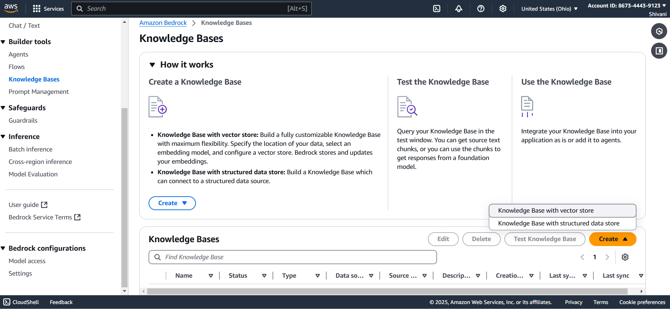

Step2: Select vector store in knowledge base.

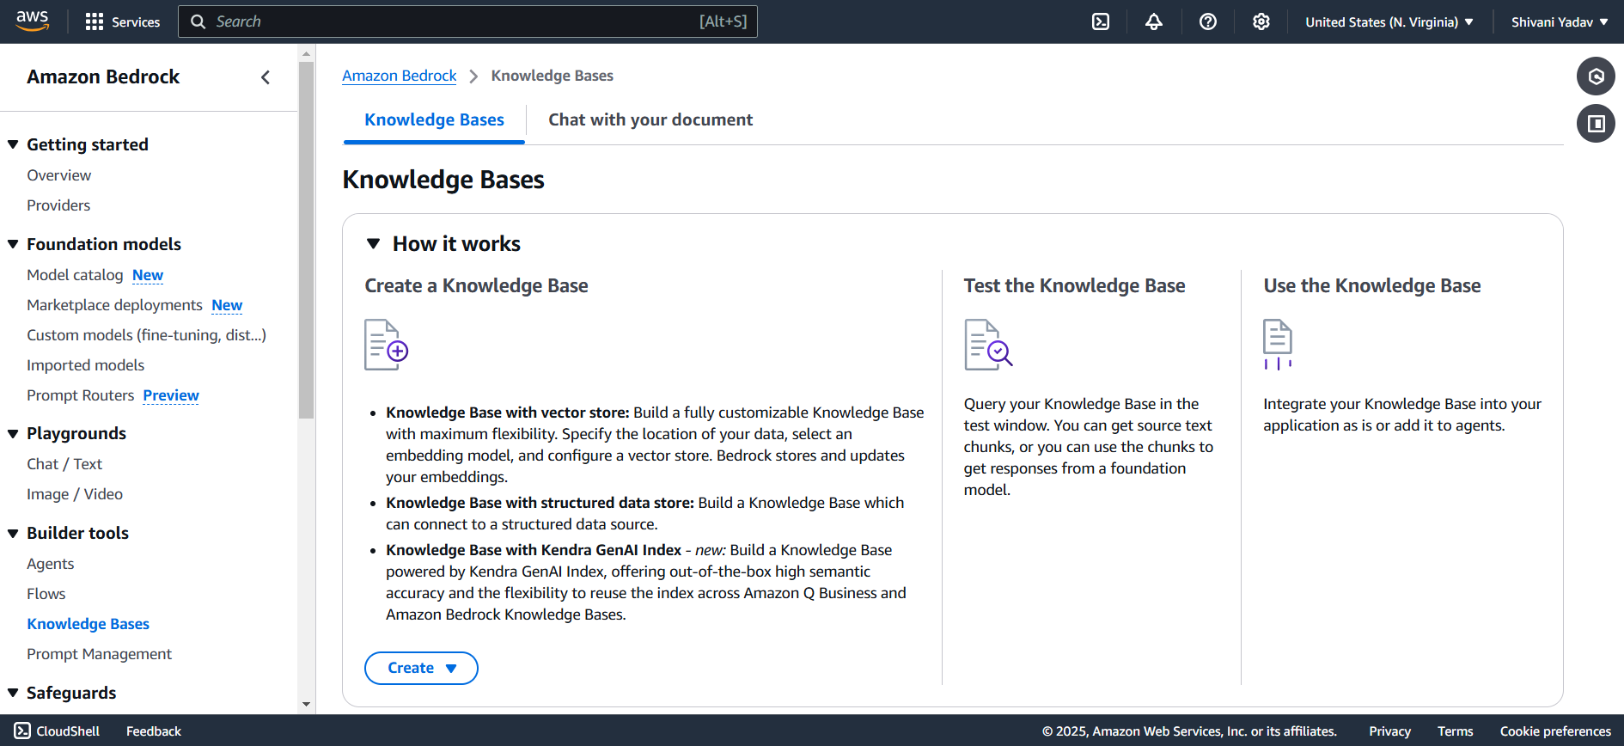

Step3: Configuring the knowledge base.

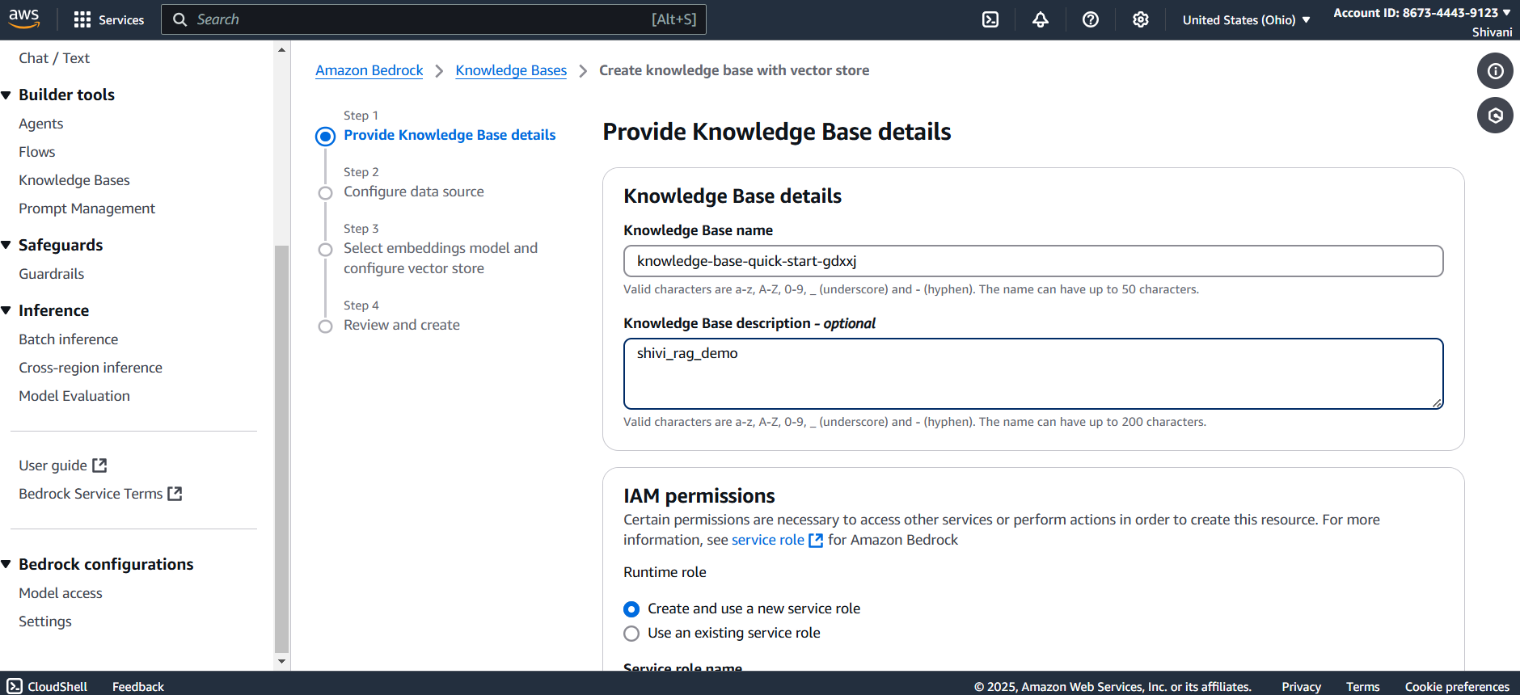

Step4: creating S3 bucket.

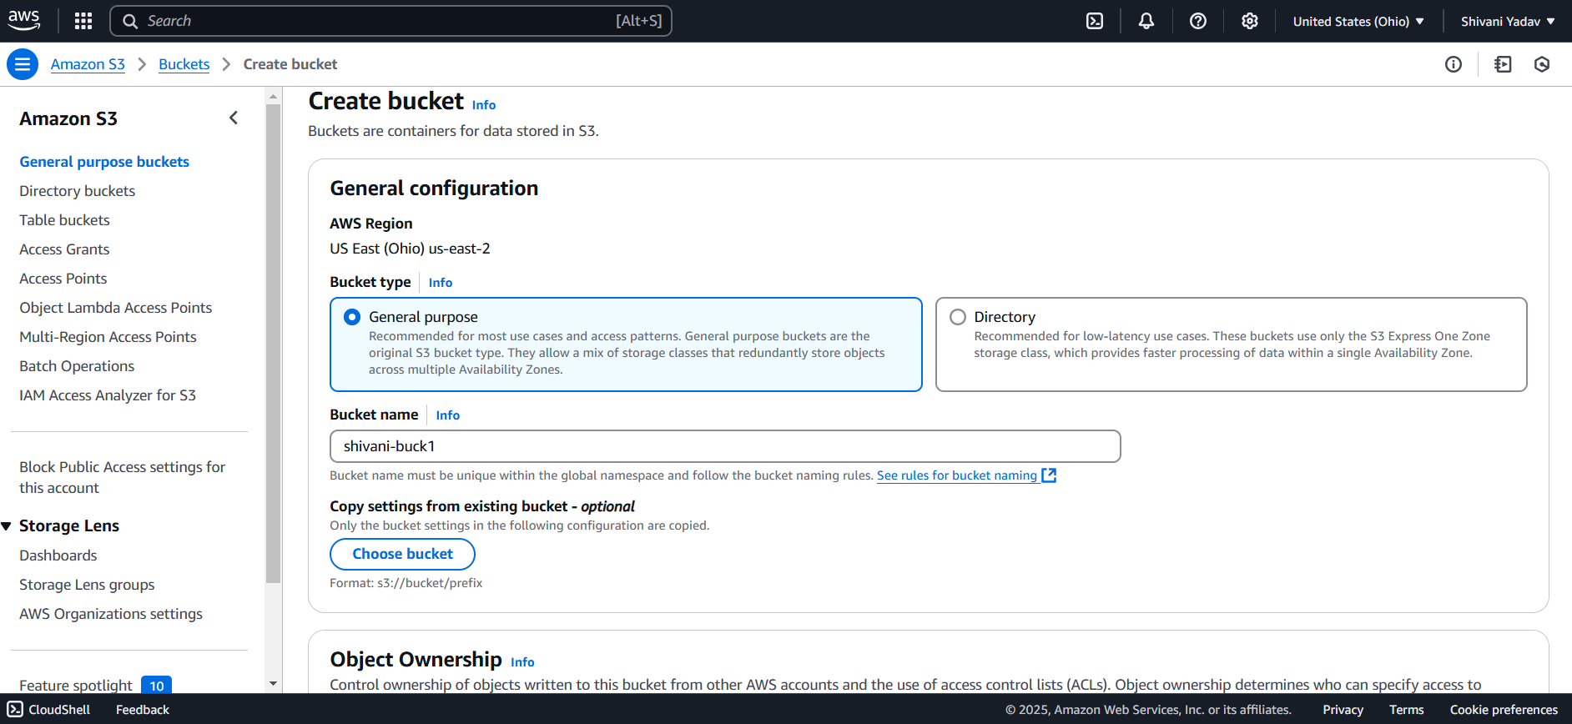

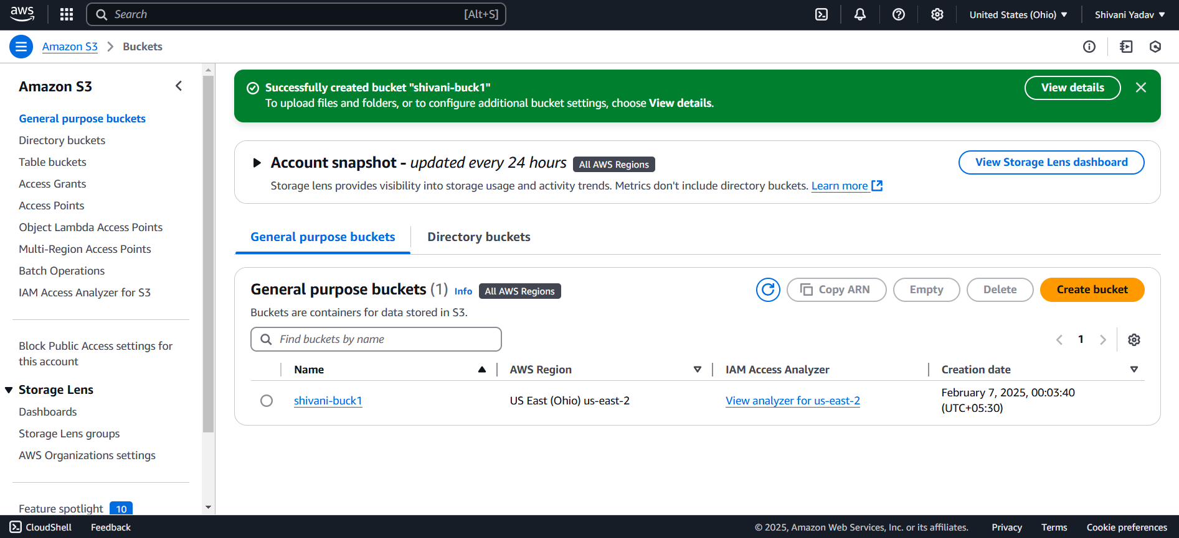

Step5: upload the knowledge base pdf to S3 bucket.

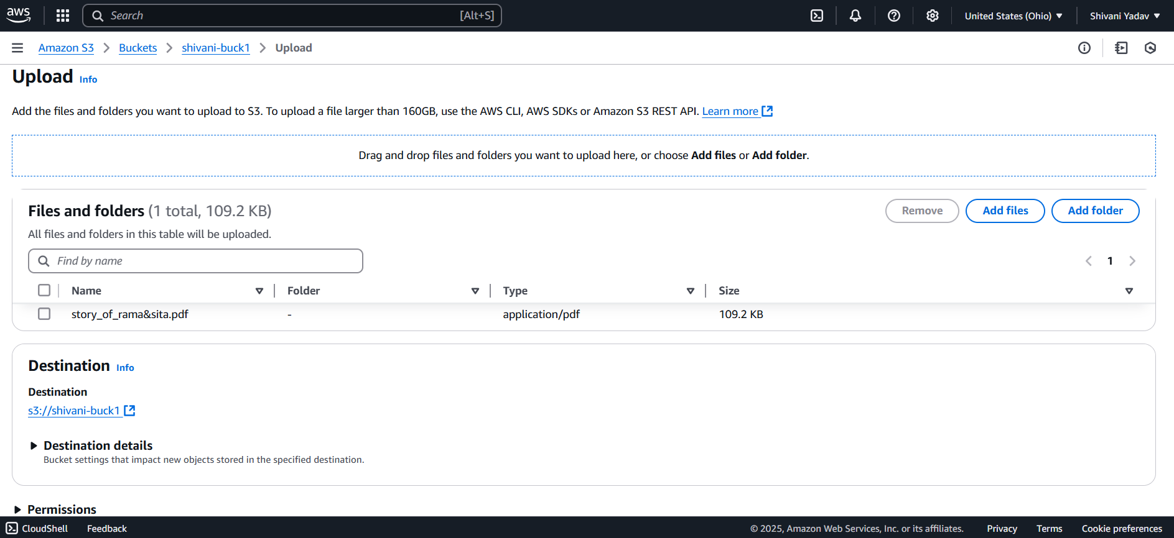

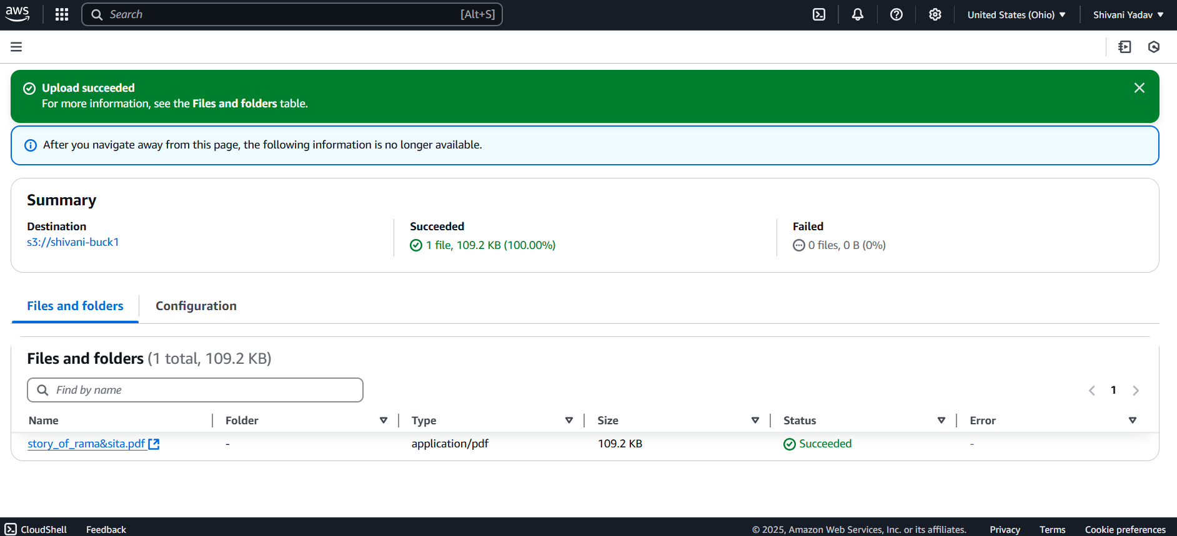

Step6: Enabled Titan text Embeddings V2 in bedrock.

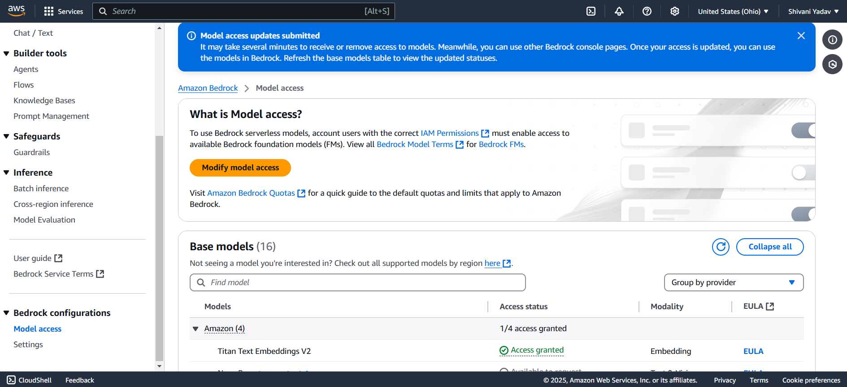

Step7: Choose the required S3 Bucket.

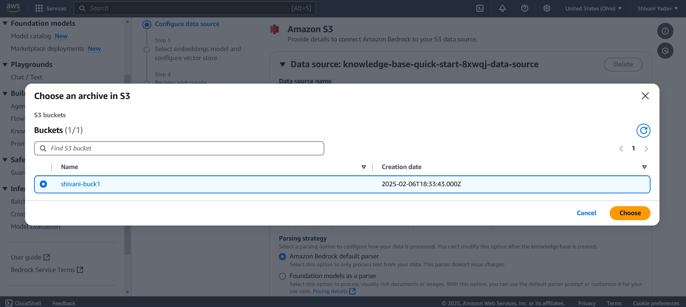

Step8: Create a Vector database out of knowledge base.

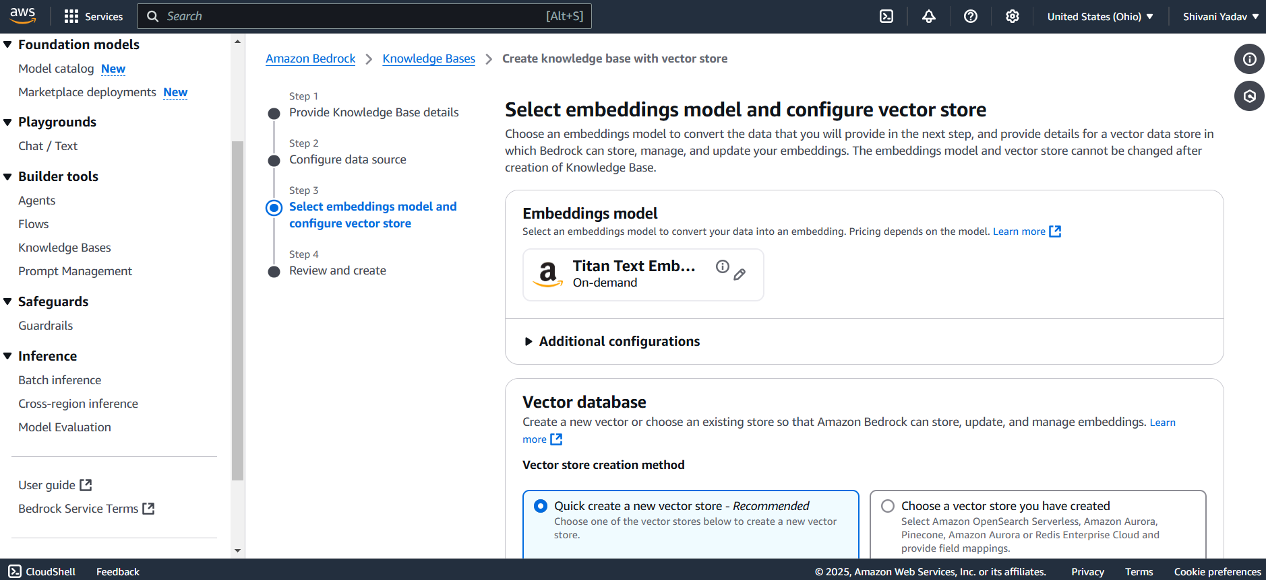Step8: Configure the knowledge base.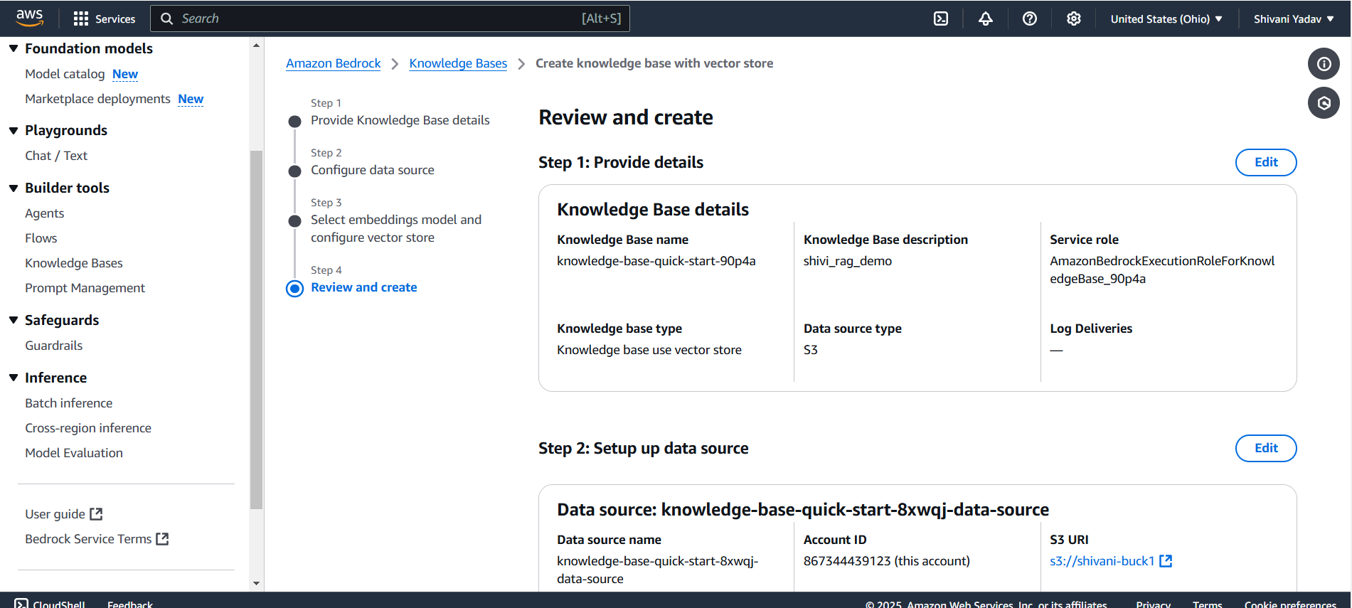

Step9: Add the required authorizations using IAM service.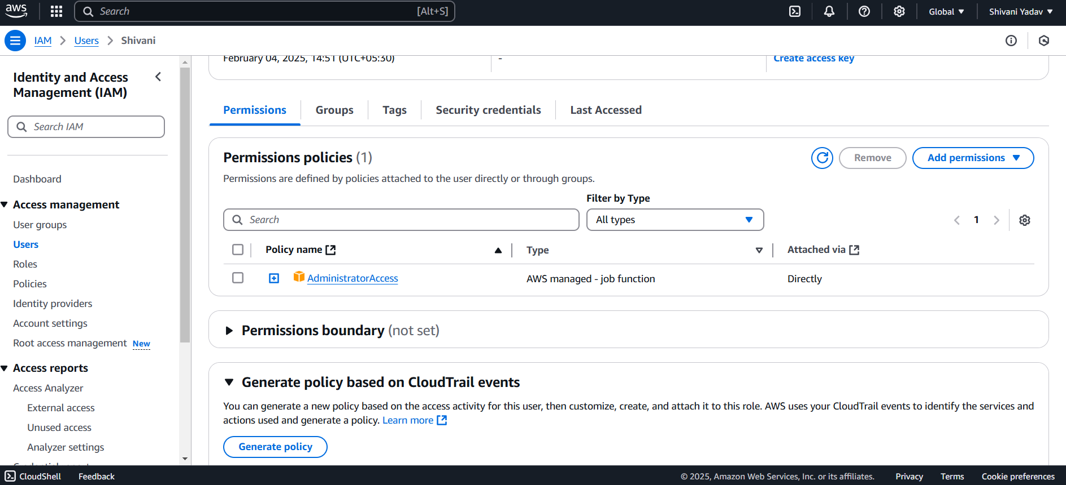

Step10: Add the required permissions and policies.

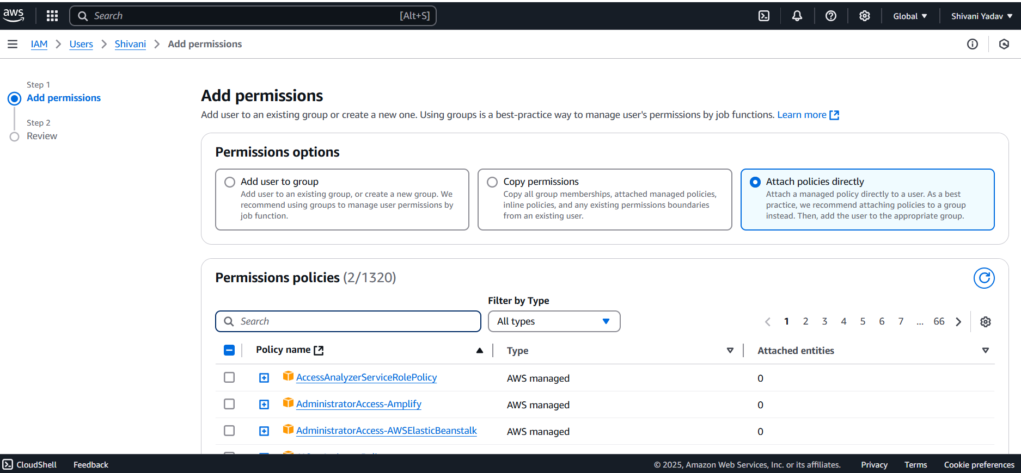

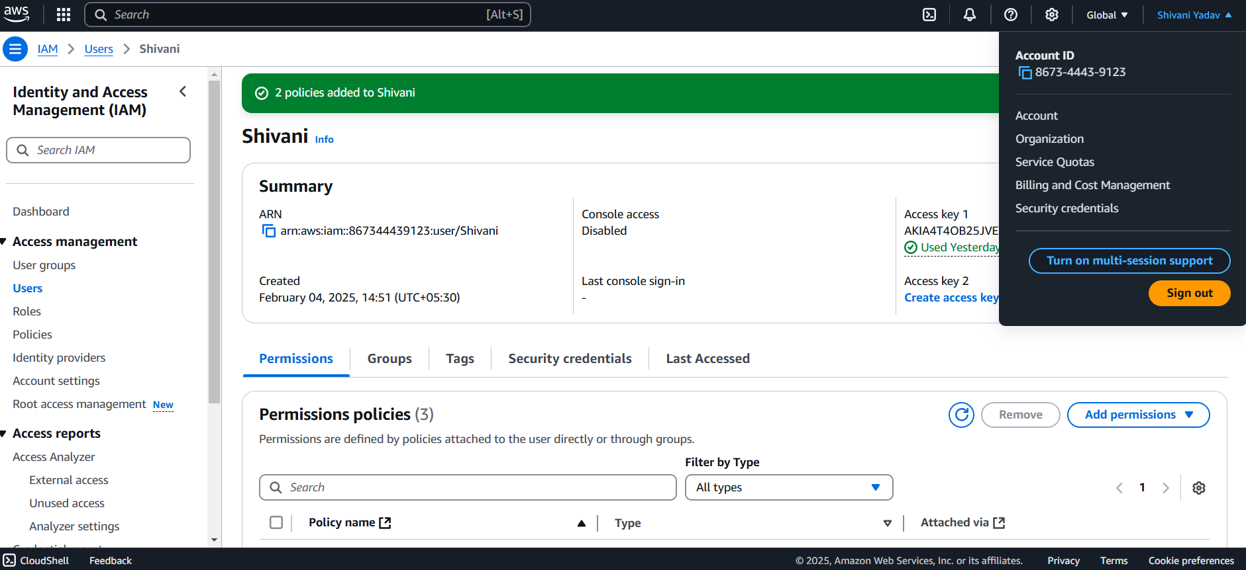

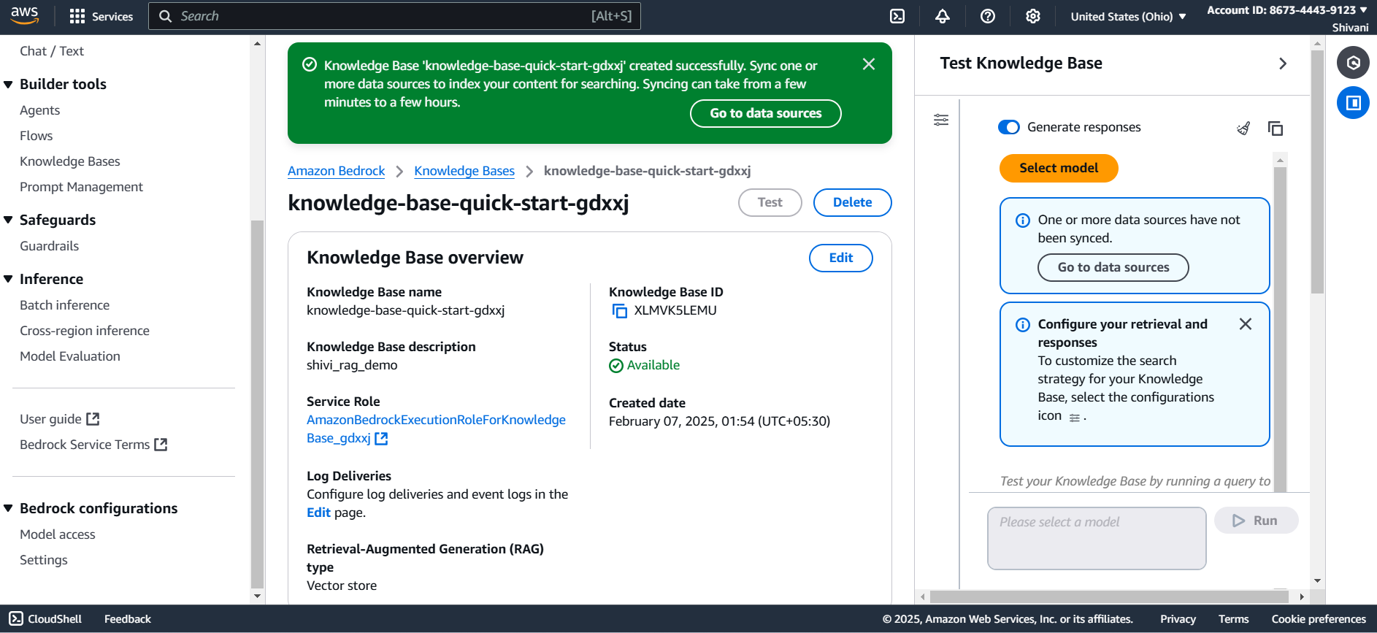

Step11: Sync that data source to the index of content for searching.

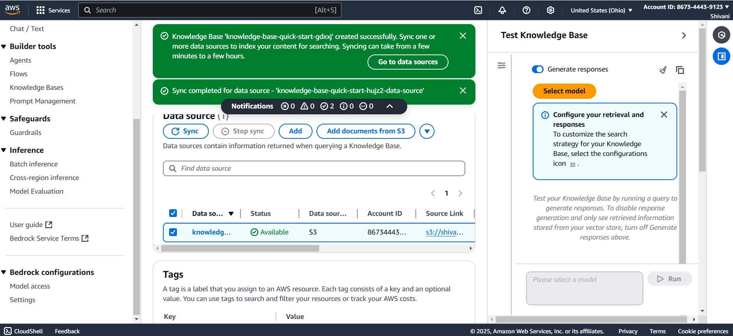

Step12: Quering the bedrock instance using web interface.

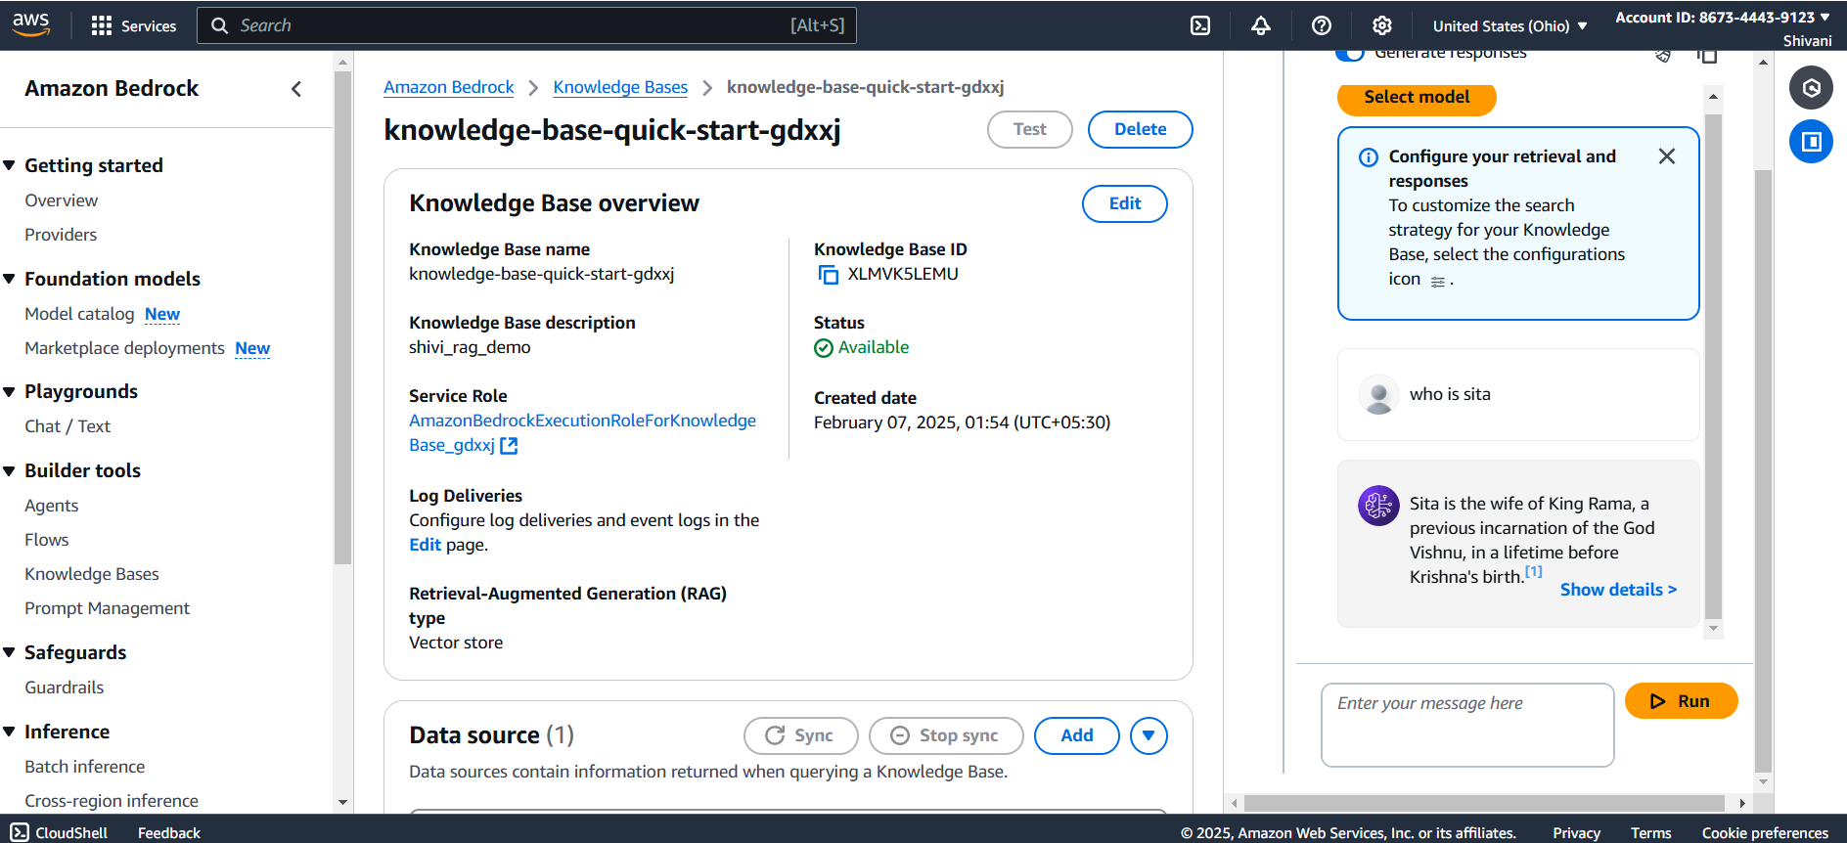

Step13: Set the environment using conda and installing all the dependencies.

