PYTHON BASIC --------------------------------

ASSIGNMENT -1 -----

1. In the below elements which of them are values or an expression? eg:- values can be integer or string and expressions will be mathematical operators.
2. * = is an expression representing the mathematical operator for multiplication.
3. "hello"= is a value and it appears to be a string.
4. -87.8 = is a value and it appears to be a floating-point number.
5. - = is an expression representing the operator for subtraction.
6. "/" is an expression representing the operator for division.
7. "+" is an expression representing the operator for addition.
8. "6" is a value and it appears to be an integer.
9. What is the difference between string and variable?

Variable String

|  |  |
| --- | --- |
| 1. variable is created the moment you first assign a value to it. | 1. string is a sequence of characters enclosed within either single quotes ('') or double quotes ("") |
| 1. variable is a named reference that can store any type of data including strings | 1. string is a specific type of data in Python used to represent textual information |
| 1. x = 4 # x is a variable   x = "kashish"  print(x) | 1. x = "kashish" # x is now of type str |
| 1. variable name are case sensitive | 1. string are already case sensitive |
| 1. One Value to Multiple Variables | 5. it can use multiline string in var |

1. Describe three different data types.

Ans – 1. Integer (int): The integer data type represents whole numbers without any fractional or decimal part. Integers can be positive or negative. In Python, integers are denoted by the int keyword.

Eg. a= 25

ii. Floating-Point (float): The floating-point data type represents numbers with a fractional part. Floats are used to represent real numbers. In Python, floating-point numbers are denoted by the float keyword.

Eg. B= 2.5

iii. String (str): The string data type represents a sequence of characters. Strings are used to store textual information such as words, sentences, or even arbitrary sequences of characters. In Python, strings are denoted by enclosing the characters in either single quotes ('') or double quotes ("").

Eg. C = “kashish”;

1. What is an expression made up of? What do all expressions do?

Ans - expression is a combination of values, variables, operators, and function calls that evaluates to a single value

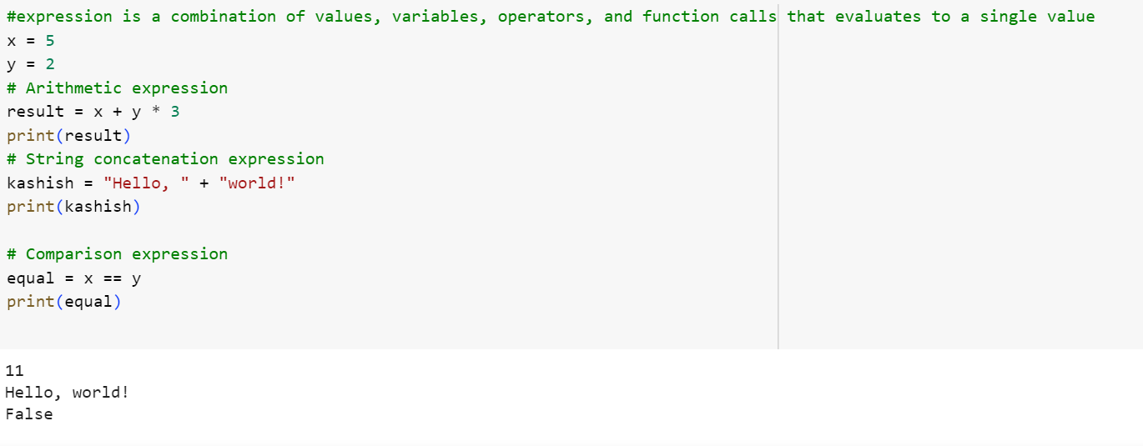

1. This assignment statements, like spam = 10. What is the difference between an expression and a statement?

Ans - Expressions: An expression is a combination of values, variables, operators, and function calls that evaluates to a single value. Expressions are meant to produce a value. They can be as simple as a single value or more complex involving multiple values and operators. Examples of expressions include 42, 2 + 3 * 4, and x + y.

Statements: A statement is a unit of code that performs an action or a series of actions. Unlike expressions, statements do not produce a value. Instead, they execute a specific operation. Examples of statements include variable assignments (spam = 10), function definitions, conditional statements (if-else), loops (for, while), and more.

1. After running the following code, what does the variable bacon contain?

bacon = 22

bacon + 1

Ans - After running the provided code, the variable bacon would still contain the original value assigned to it, which is 22

The expression bacon + 1

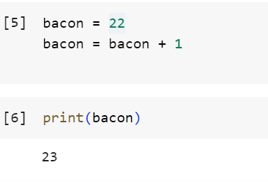

7. What should the values of the following two term

'spam'+ 'spamspam'

'spam' * 3

Ans - Both expressions yield the same result, which is the string 'spamspamspam'.

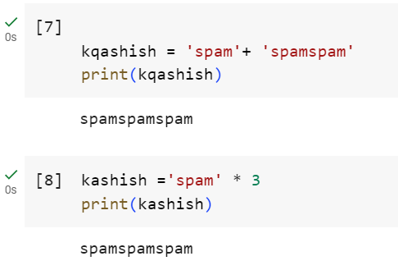

1. Why is eggs a valid variable name while 100 is invalid?

Ans - Variable names can consist of letters (both uppercase and lowercase), digits, and underscores (_). However, a variable name cannot start with a digit.

'eggs' is a valid variable name because it starts with a letter and contains only letters.

'100' is an invalid variable name because it starts with a digit.

1. What three functions can be used to get the integer, floating-point number, or string

version of a value?

Ans - int(): This function can be used to convert a value to an integer. It takes a parameter and returns the integer representation of that value. If the value is a floating-point number, it will be truncated towards zero.

float(): This function can be used to convert a value to a floating-point number. It takes a parameter and returns the floating-point representation of that value.

str(): This function can be used to convert a value to a string. It takes a parameter and returns the string representation of that value.

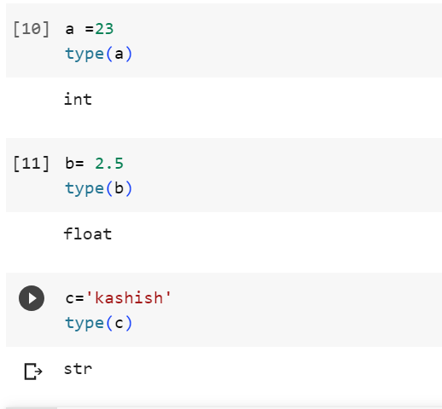

1. Why does this expression cause an error? How can you fix it?

'I have eaten' + 99 + 'burritos'

Ans –

The expression 'I have eaten' + 99 + 'burritos' causes an error because it tries to concatenate a string ('I have eaten') with an integer (99) directly. In Python, the concatenation operator (+) can only concatenate two operands of the same type, either both strings or both numbers.

To fix the error, you need to convert the integer 99 to a string before concatenating it with the other strings. Here's an example to fix the expression:

