**FDIC (Federal Deposit Insurance Corporation)**

The **Federal Deposit Insurance Corporation** (FDIC) is **an independent agency created by the United States Congress to maintain stability and public confidence in the nation’s financial system**. The FDIC insures deposits, examines and supervises financial institutions for safety and soundness and consumer protection, makes large and complex financial institutions resolvable, and manages the resolution of failed banks.

**Key Functions:**

* **Deposit Insurance:** The FDIC insures deposits in banks and thrift institutions up to at least $250,000 per ownership category.
* **Examination and Supervision:** The FDIC examines and supervises financial institutions for safety and soundness and consumer protection.
* **Resolution of Failed Banks:** The FDIC manages the resolution of failed banks to limit the effect on the economy and the financial system.
* **Consumer Protection:** The FDIC provides tools, education, and news updates to help consumers make informed decisions and protect their assets.

**History:**

The FDIC was created by the Banking Act of 1933, enacted during the Great Depression to restore trust in the American banking system. The insurance limit was initially $2,500 per ownership category and has been increased several times over the years.

**Notable Facts:**

* The FDIC is an independent agency, not a government agency.
* The FDIC insures deposits in over 5,000 banks and thrift institutions.
* The FDIC has a total of 6,089 employees as of 2023.
* The FDIC’s annual budget is $1.96 billion as of 2024.

**Overview**

* The FDIC is an independent agency created by the Congress to maintain stability and public confidence in the US financial system.
* The FDIC insures deposits, examines and supervises financial institutions for safety, soundness, and consumer protection, makes large and complex financial institutions resolvable, and manages receiverships.

**Statistics**

* As of 2023, the FDIC insures deposits at over 4,500 institutions, including commercial banks, thrifts, and savings associations.
* The FDIC has insured deposits totaling over $8.9 trillion.
* The FDIC’s Deposit Insurance Fund (DIF) has a balance of over $125 billion.
* The FDIC has never paid a dollar of insured deposits to a depositor, since its creation in 1933.

**Insurance Coverage**

* The FDIC **insures deposits up to $250,000 per depositor, per insured bank**.
* The FDIC insures a wide range of deposit accounts, including checking, savings, money market deposit accounts, and certificates of deposit (CDs).
* The FDIC does not insure investments in stocks, bonds, mutual funds, or other securities.

**Bank Failures**

* Since its creation, the FDIC has resolved over 550 bank failures, with no depositor losing a single penny of insured funds.
* In 2020, the FDIC resolved 26 bank failures, with no depositor losses.

**Financial Performance**

* The FDIC’s **net income for 2023 was $1.96 billion**.
* The FDIC’s net worth ratio was 2.45% as of 2023.

**Employment**

* The FDIC has over 6,000 employees, with offices in over 100 locations across the United States.

**Budget**

* **The FDIC’s budget for 2024 is $1.96 billion**.
* The FDIC’s budget is funded through insurance premiums paid by its member institutions.

**Key data are as follows:**

This table presents key financial data for various types of U.S. financial institutions for the first quarter of 2023 and 2024. The data is organized by the type of institution, including commercial banks, savings institutions, credit card lenders, international banks, agricultural banks, and others. Here is a detailed interpretation of the key points:

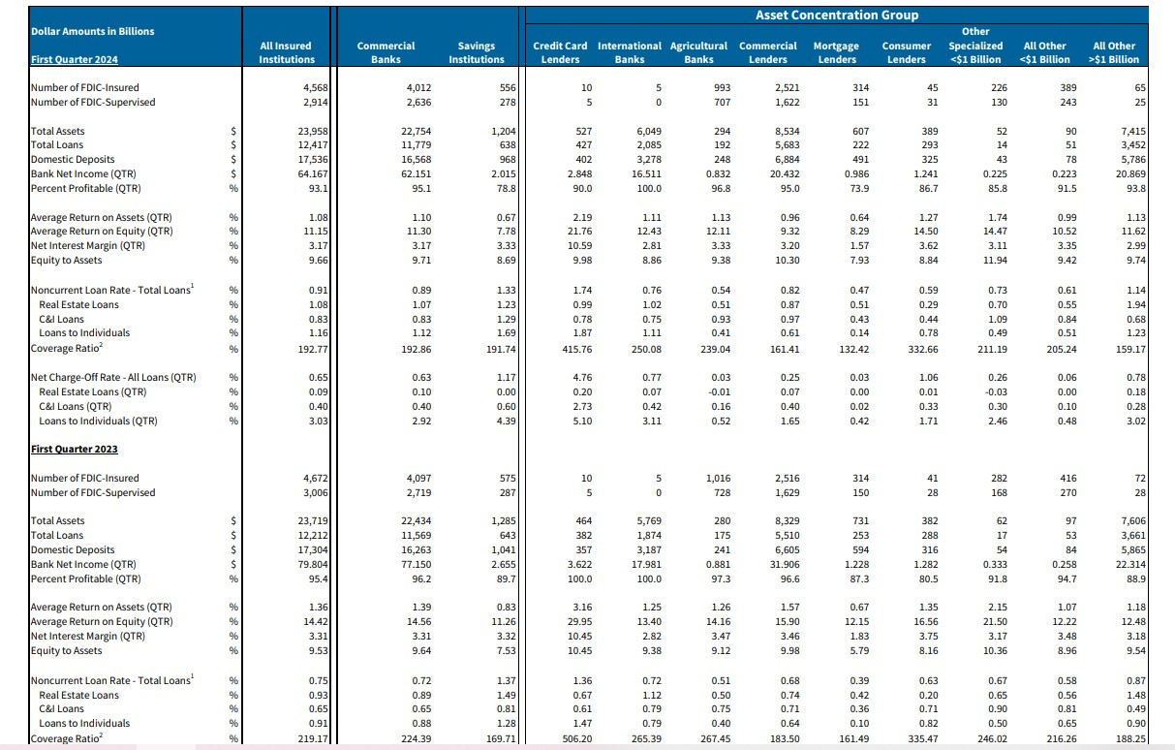

**General Overview (All Insured Institutions)**

**First Quarter 2024**

* **Number of FDIC-Insured Institutions**: 4,568
* **Total Assets**: $23,955 billion
* **Total Loans**: $12,374 billion
* **Domestic Deposits**: $19,533 billion
* **Bank Net Income (QTR)**: $64.167 billion
* **Percent Profitable (QTR)**: 93.1%

**First Quarter 2023**

* **Number of FDIC-Insured Institutions**: 4,672
* **Total Assets**: $23,719 billion
* **Total Loans**: $12,212 billion
* **Domestic Deposits**: $17,304 billion
* **Bank Net Income (QTR)**: $77.150 billion
* **Percent Profitable (QTR)**: 96.2%

**Key Financial Metrics**

**First Quarter 2024 vs. 2023**

* **Average Return on Assets (QTR)**: Decreased from 1.39% to 1.08%
* **Average Return on Equity (QTR)**: Decreased from 14.56% to 11.15%
* **Net Interest Margin (QTR)**: Increased slightly from 3.21% to 3.17%
* **Equity to Assets**: Increased from 9.64% to 9.66%

**Asset Concentration Groups**

**Commercial Banks**

* **Total Assets (2024)**: $22,754 billion
* **Total Loans (2024)**: $11,779 billion
* **Bank Net Income (2024)**: $62.151 billion
* **Percent Profitable (2024)**: 95.1%

**Savings Institutions**

* **Total Assets (2024)**: $1,204 billion
* **Total Loans (2024)**: $638 billion
* **Bank Net Income (2024)**: $2.015 billion
* **Percent Profitable (2024)**: 91.4%

**Specialized Lenders**

**Credit Card Lenders**

* **Total Assets (2024)**: $527 billion
* **Total Loans (2024)**: $487 billion
* **Bank Net Income (2024)**: $2.848 billion
* **Percent Profitable (2024)**: 90.0%

**International Banks**

* **Total Assets (2024)**: $6,049 billion
* **Total Loans (2024)**: $5,285 billion
* **Bank Net Income (2024)**: $16.511 billion
* **Percent Profitable (2024)**: 100.0%

**Agricultural Banks**

* **Total Assets (2024)**: $294 billion
* **Total Loans (2024)**: $201 billion
* **Bank Net Income (2024)**: $0.842 billion
* **Percent Profitable (2024)**: 100.0%

**Nonperforming Loans and Charge-Off Rates**

**Noncurrent Loan Rate (Total Loans)**

* **All Insured Institutions (2024)**: 0.91%
* **Commercial Banks (2024)**: 0.89%
* **Savings Institutions (2024)**: 1.33%
* **Credit Card Lenders (2024)**: 1.74%
* **International Banks (2024)**: 0.76%
* **Agricultural Banks (2024)**: 0.54%

**Net Charge-Off Rate (Total Loans)**

* **All Insured Institutions (2024)**: 0.65%
* **Commercial Banks (2024)**: 0.63%
* **Savings Institutions (2024)**: 1.17%
* **Credit Card Lenders (2024)**: 4.76%
* **International Banks (2024)**: 0.20%
* **Agricultural Banks (2024)**: 0.25%

**Key Changes from 2023 to 2024**

* **Total assets and loans** saw a slight increase across all insured institutions.
* **Bank net income** showed a decrease, reflecting changes in profitability.
* **Average return on assets and equity** declined, indicating reduced profitability metrics.
* **Noncurrent loan rates** increased slightly, suggesting a minor uptick in loan delinquencies.
* **Net charge-off rates** remained stable overall, with some variations among specialized lenders.

Overall, the data suggests that while the U.S. banking sector has seen growth in assets and loans, there are signs of declining profitability and slight increases in nonperforming loans. The sector remains highly profitable, but the trends indicate caution with potential challenges in maintaining high profitability levels.

the FDIC plays a crucial role in the US market price by providing deposit insurance to protect depositors in the event of bank failures.

**Key Points:**

* The FDIC insures deposits in US banks and thrifts up to $250,000 per depositor, per insured bank.
* The FDIC’s deposit insurance fund is backed by the full faith and credit of the US government.
* The FDIC’s mission is to maintain stability and public confidence in the US financial system by insuring deposits, examining and supervising financial institutions, and managing receiverships.
* The FDIC’s deposit insurance fund is funded by premiums paid by participating banks and thrifts, as well as interest on the fund’s investments.

**Market Impact:**

The FDIC’s activities have a significant impact on the US market price, particularly in the banking and financial sectors. The FDIC’s deposit insurance fund serves as a safety net for depositors, providing confidence in the stability of the financial system. This, in turn, helps to maintain liquidity and stability in the market, allowing banks and thrifts to operate more efficiently and effectively.

**Recent Developments:**

* In 2022, the FDIC’s deposit insurance fund balance stood at $128.2 billion, up from $123.4 billion in 2021.
* The FDIC has implemented several initiatives to strengthen its deposit insurance fund, including increasing premiums paid by participating banks and thrifts, and investing in higher-yielding assets.
* The FDIC has also taken steps to address the impact of the COVID-19 pandemic on the financial system, including providing relief to banks and thrifts and increasing its deposit insurance coverage limits.