**Linux**

**What is linux?**

Just like Windows, iOS, and Mac OS, Linux is an operating system. In fact, one of the most popular platforms on the planet, Android, is powered by the Linux operating system.

**Kernel**

The kernel is **the essential center of a computer operating system (OS)**. It is the core that provides basic services for all other parts of the OS. It is the main layer between the OS and hardware, and it helps with process and memory management, file systems, device control and networking.

But Linux is different from them. Different parts of Linux are developed by different organizations.

A Linux distribution, often shortened to [Linux](https://susedefines.suse.com/definition/linux/) distro, is an operating system compiled from components developed by various [open source project](https://susedefines.suse.com/definition/open-source/)s and programmers.

Linux distributions list

1. Ubuntu
2. Fedora
3. Linux mint
4. Debian
5. Red Hat Enterprise Linux

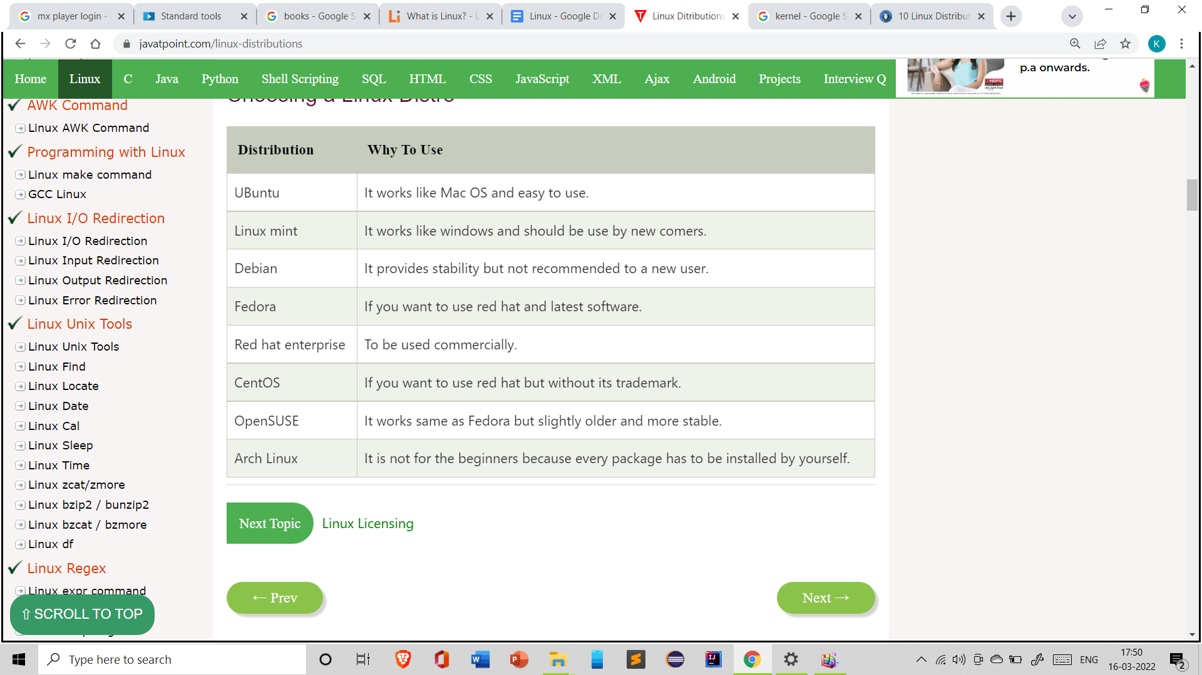

**Overview And installation of linux**

Open source And Closed source

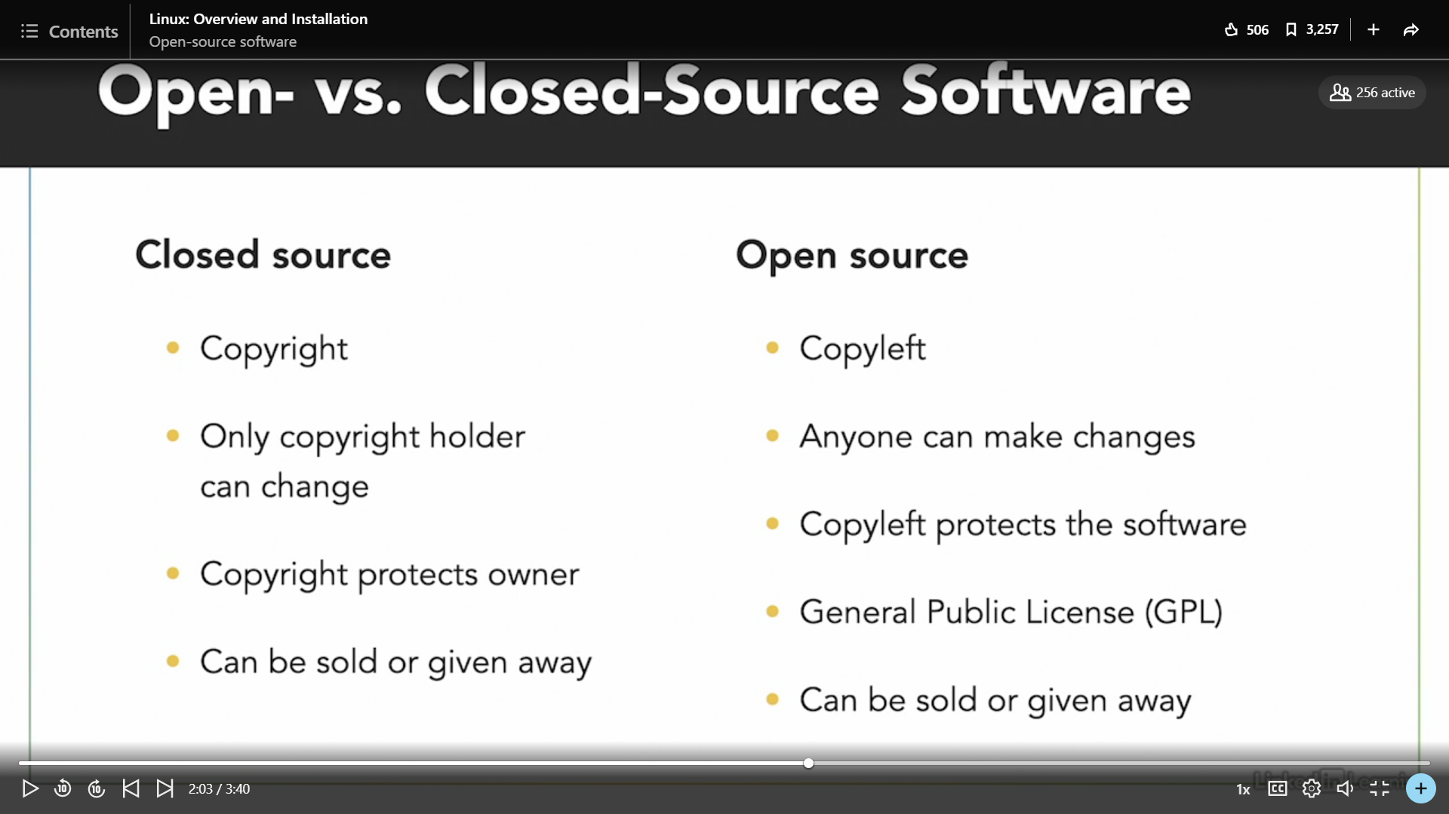

**How Linux built?**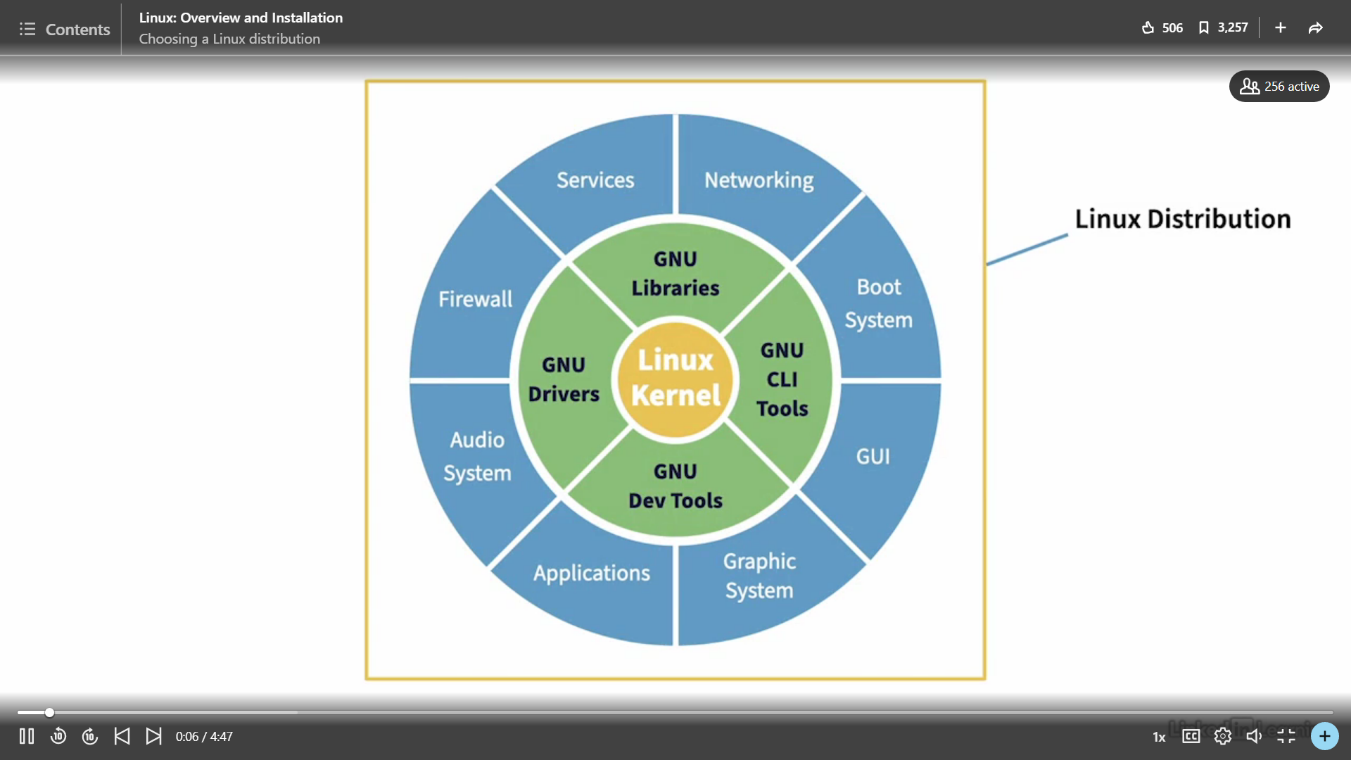

**Linux Distribution**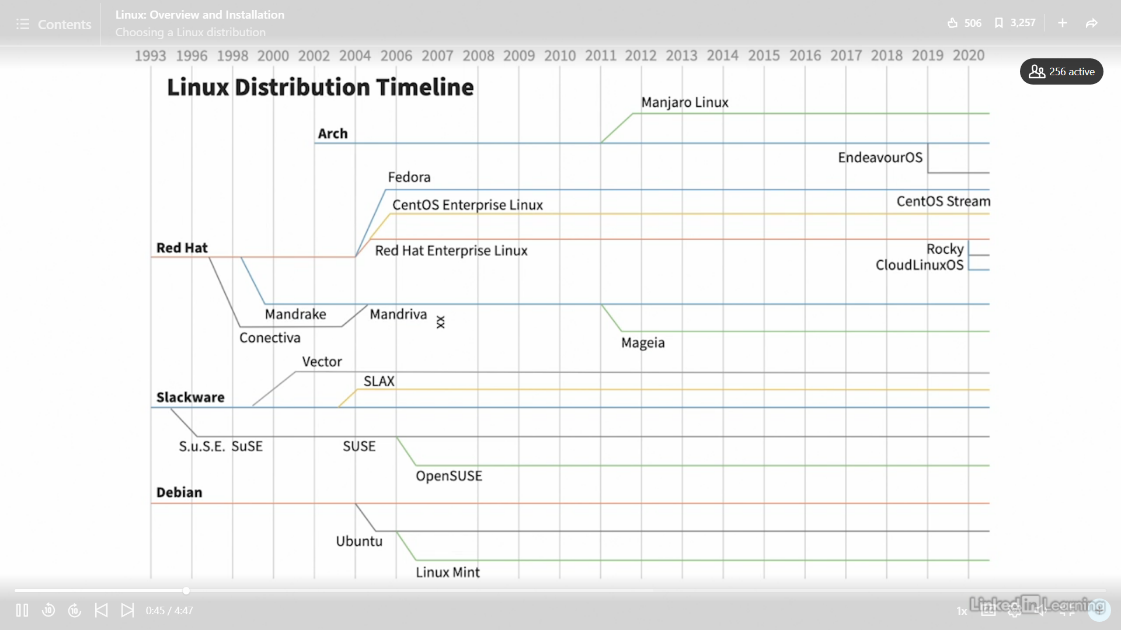

**What is Virtualization?**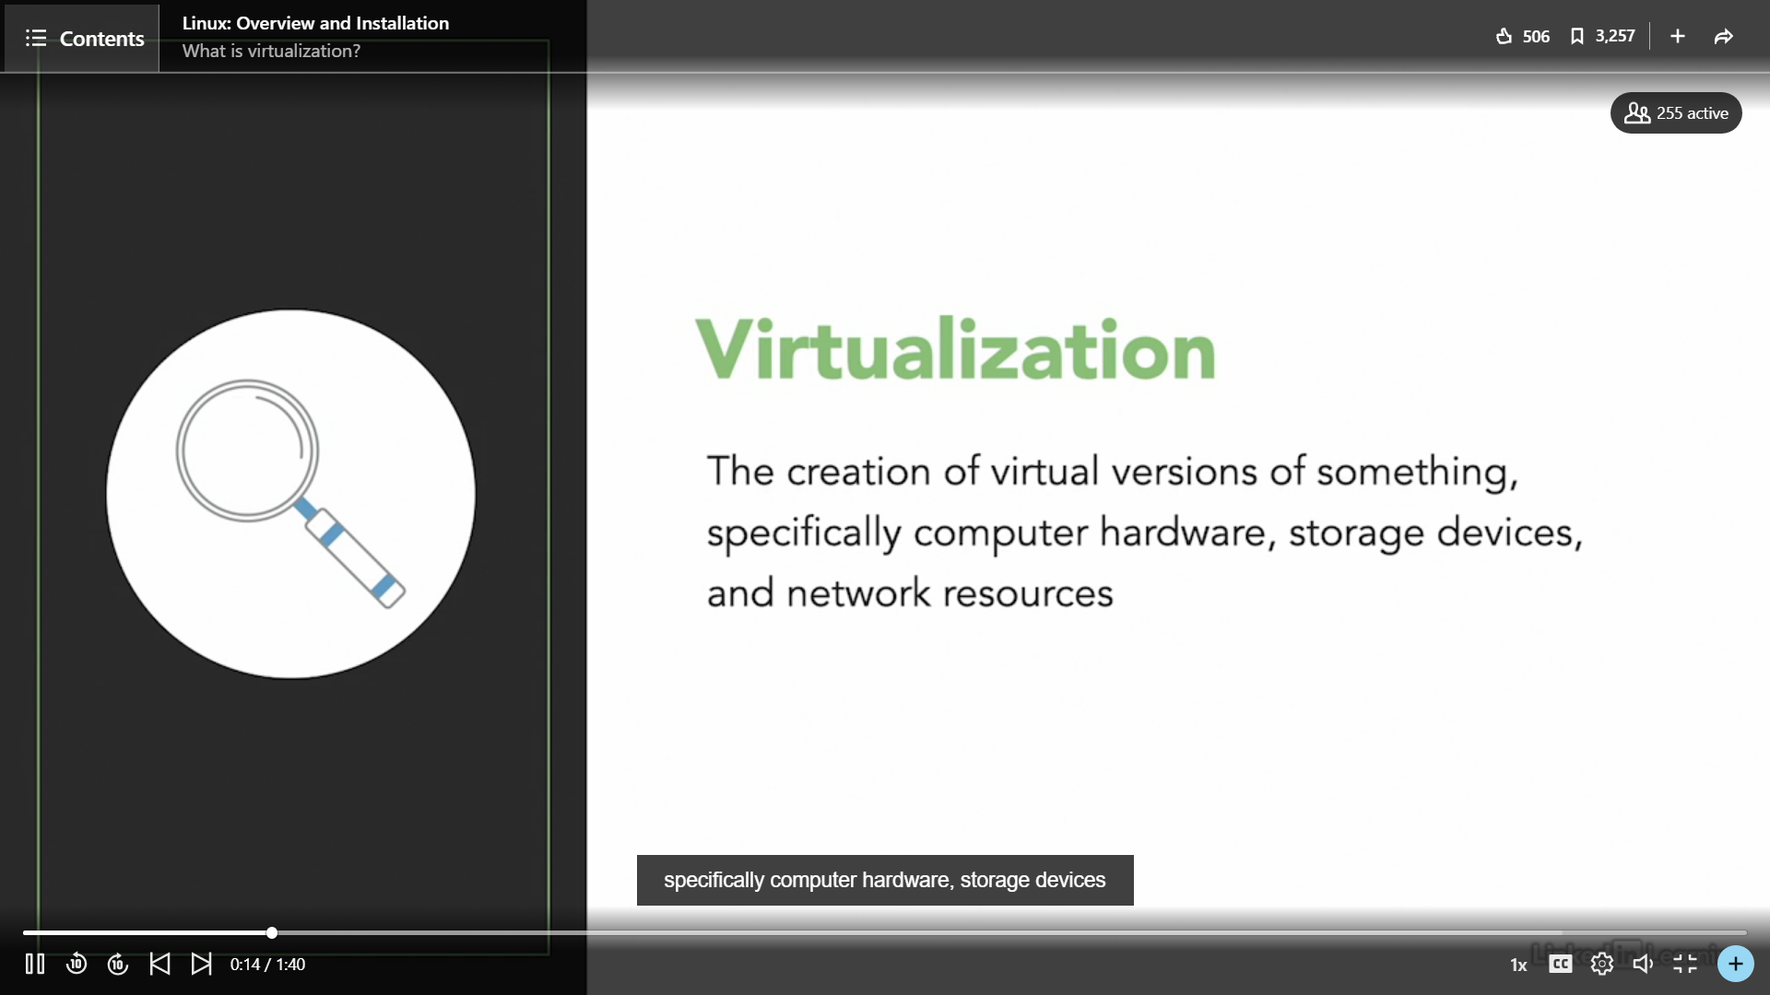

Installed Virtual Box for using Linux

