**Jira Software**

Jira is a software application used for issue tracking and project management.

Use Jira to Plan, Track, and Work faster. Jira is an issue-tracking tool that's mainly used by software developers to track, organize, and prioritize bugs, new features, and improvements for certain software releases.

## **What is JIRA used for?**

Jira software can be used for the following purposes:

* Requirements and Test case management
* In Agile Methodology
* Project Management
* Software Development
* Product Management
* Task Management
* Bug Tracking

## **How to Use JIRA?**

Here is a step by step process on how to use Jira software:

* **Step 1)** Open Jira software and navigate to the Jira Home icon
* **Step 2)** Select Create project option
* **Step 3)** Choose a template from the library
* **Step 4)** Set up the columns as per your need from Board settings
* **Step 5)** Create an issue

**Step 1) Open Jira software and login with your ID and password**

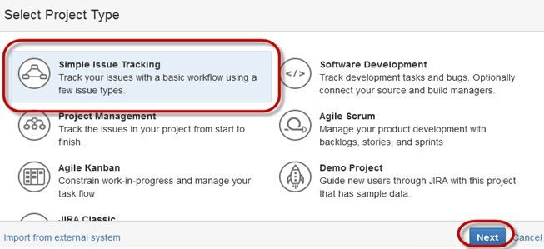

**Step 2) Provide issue details**

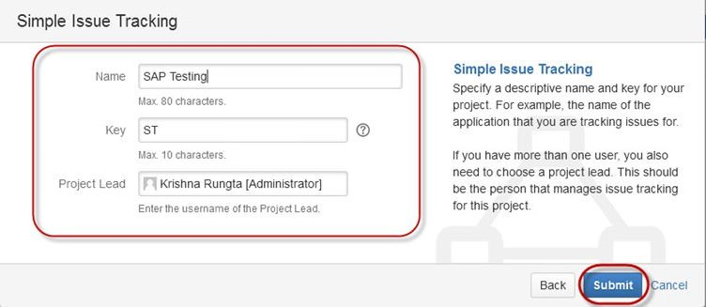

**Step 3) Provide detailed information to create an issue**

**Step 4) Open the Issues menu to search and perform multiple functions on issues**

**Boards**

JIRA provides Kanban and Scrum Boards.

**Creates an issue**

Edit update can be done easily.

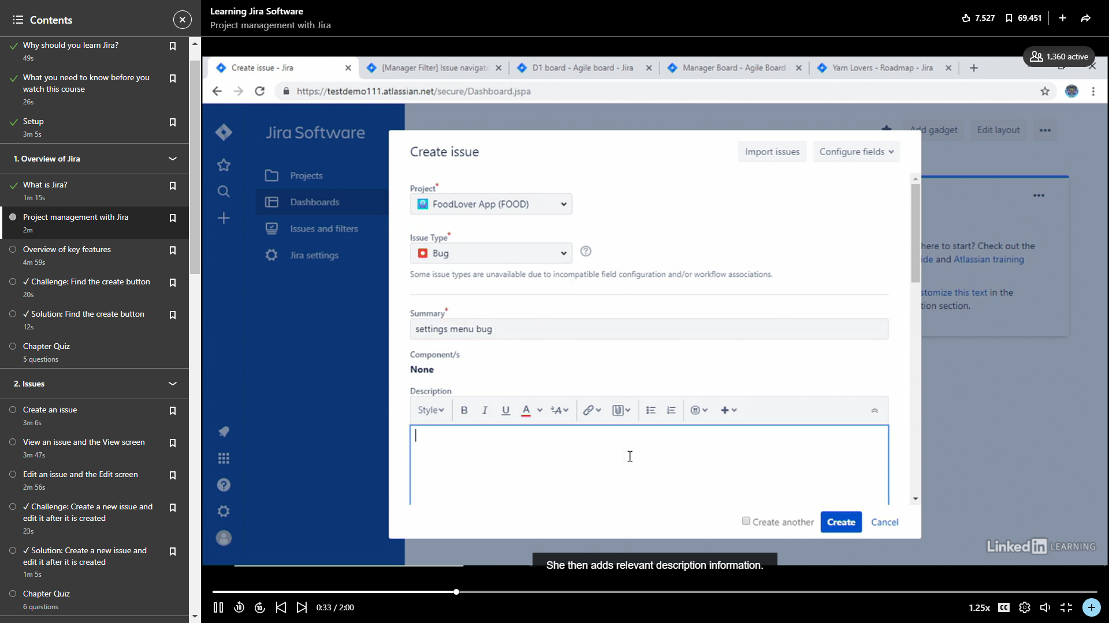

**Basic Search**

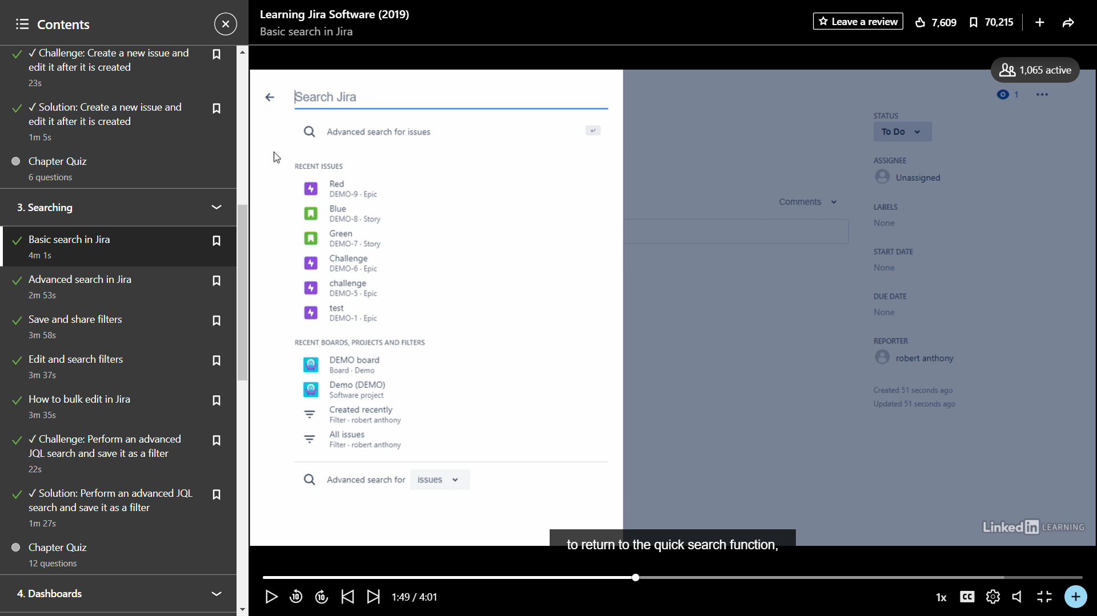

**Edit and search Filters**

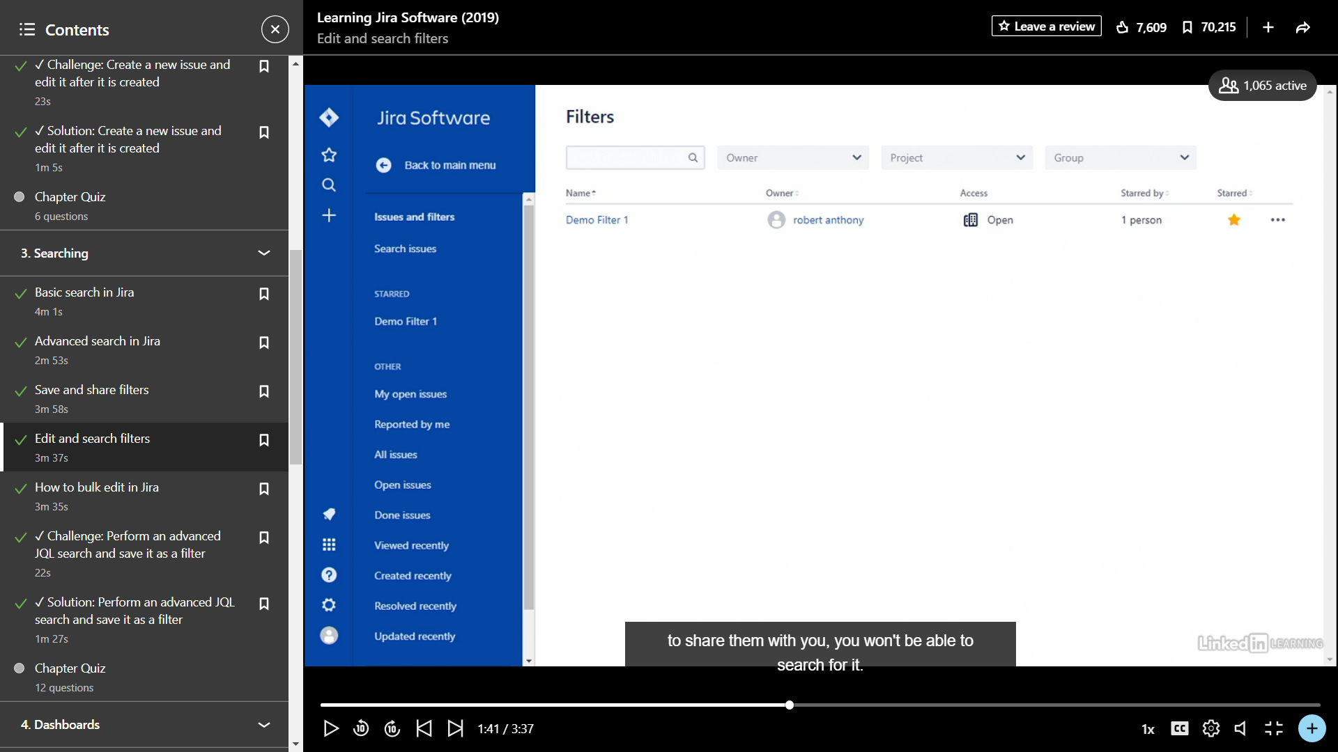

**Creating dashboard**

