Intelligent Text Summarizer App



**UNIVERSITY OF ENGINEERING**

**& MANAGEMENT, JAIPUR**

**Intelligent Text Summarizer App**

Submitted in the partial fulfillment of the degree of

## BACHELOR OF TECHNOLOGY

In

## COMPUTER SCIENCE & ENGINEERING

Under

## UNIVERSITY OF ENGINEERING & MANAGEMENT, JAIPUR

BY

## Kashish Banerjee

**University Roll no: 12020002001141**

UNDER THE GUIDANCE OF

## Prof. Hriday Banerjee

COMPUTER SCIENCE & ENGINEERING



UNIVERSITY OF ENGINEERING & MANAGEMENT, JAIPUR

**Approval Certificate**

This is to certify that the project report entitled “**Intelligent Text Summarizer App**” submitted by **Kashish Banerjee** (Enrollment No.:**12020002001141**) in partial fulfillment of the requirements of the degree of **Bachelor of Technology** in **Computer Science & Engineering** from University **of Engineering and Management, Jaipur** was carried out in a systematic and procedural manner to the best of our knowledge. It is a bona fide work of the candidate and was carried out under our supervision and guidance during the academic session of 2020-2024.

### Prof. Hriday Banerjee

Project Guide, Assistant Professor (CSE) UEM, JAIPUR

### Prof. G. Uma Devi Prof. A Mukherjee

HOD (CSE AIML) Dean

UEM, JAIPUR UEM, JAIPUR

**ACKNOWLEDGEMENT**

The endless thanks goes to Lord Almighty for all the blessings he has showered onto us, which has enabled us to write this last note in our research work. During the period of our research, as in the rest of our life, we have been blessed by Almighty with some extraordinary people who have spun a web of support around us. Words can never be enough in expressing how grateful we to those incredible people in our life who made this thesis possible. We would like an attempt to thank them for making time during our research in the Institute a period We will treasure. We are deeply indebted to our research supervisor, Professor Hriday Banerjee such an interesting thesis topic. Each meeting with him added in valuable aspects to the implementation and broadened us perspective. He has guided us with his invaluable suggestions, lightened up the way in my darkest times and encouraged us a lot in the academic life.

Kashish Banerjee

**ABSTRACT**

In the ever-expanding digital landscape, the volume of textual information available poses a significant challenge for users seeking quick and effective content consumption. The Intelligent Text Summarizer app addresses this challenge by employing advanced natural language processing techniques to automatically generate concise and coherent summaries of lengthy texts.

This text summarization application leverages state-of-the-art algorithms to analyze and understand the context, key concepts, and essential information within a given document. The app not only identifies critical sentences but also ensures a coherent flow and maintains the intended meaning of the original text. Users can customize the summarization process by adjusting parameters such as summary length and emphasis on specific content elements.

By offering a solution that combines cutting-edge technology with user-centric design, the Intelligent Text Summarizer app empowers individuals to efficiently navigate the vast sea of information, ultimately enhancing their ability to stay informed in an increasingly information-rich world.

**Table of Contents**

|  |  |  |
| --- | --- | --- |
| **Table of Contents** |  | VI |
| **List of figures** |  | **VIII** |
| **1. CHAPTER** |  | **1** |
| **INTRODUCTION** |  | **1** |
| **2. CHAPTER** |  | **2** |
| **Background Study** |  | **2** |
| **3. CHAPTER** |  | **3** |
| **OBJECTIVE** |  | **3** |
| **4. CHAPTER** |  | **4** |
| **FLOW CHART** |  | **4** |
| **5. CHAPTER**  **METHODOLOGY** |  | **6** |
| **5.1 Need of NLP for Text Summarization** |  | **7** |
| **5.2 Flask application for Text Summarization** |  | **7** |
| **5.3 Working of Hugging Face** |  | **9** |
| **5.4 Need of spaCy in Text Summarization** |  | **9** |
| **6. CHAPTER** |  | **11** |
| **APPRATUS** |  | **11** |
| **6.1 Hardware Requirement** |  | **11** |
| **6.2 Software Requirement** |  | **12** |
| **7. CHAPTER** |  | **13** |
| **Experimental Setup** |  | **13** |

RESULTS & DISCUSSION 14

CONCLUSION & FUTURE SCOPE 19

REFERENCE 21

# LIST OF FIGURES

### Figure 4.1: Working of Text Summarizer App 6

**Figure 4.2: Flowchart of Text Summarizer App 7**

### Figure 4.3: Working of Login Page 8

**Figure 5.1: OText Summarization 10**

**Figure 5.4: spaCy work 12**

**Figure 6.1: Flask Work 14**

**Figure : User Login Page 17**

**Figure : User Sign-up 17**

**Figure : Text Summarizer App 18**

**Figure : Summary 18**

# 1. CHAPTER

## INTRODUCTION

In an era characterized by an unprecedented influx of information, the ability to distill and comprehend vast amounts of text efficiently has become a crucial skill. Recognizing this challenge, we present the Intelligent Text Summarizer, an innovative application designed to revolutionize the way we consume textual content. Whether you're a professional striving to stay abreast of industry trends, a student grappling with extensive research materials, or an avid reader navigating the digital expanse, our intelligent summarizer app is crafted to be your indispensable companion.

The Intelligent Text Summarizer goes beyond conventional text summarization tools, employing cutting-edge natural language processing techniques to understand the nuances of language, context, and key concepts within documents. It is engineered to not only extract pivotal information but also to generate coherent and contextually rich summaries that capture the essence of the original content.

In an age where time is a precious commodity, the Intelligent Text Summarizer emerges as a beacon of efficiency, offering users a streamlined pathway to glean insights from lengthy texts swiftly. This introduction provides a glimpse into the transformative capabilities of our app, setting the stage for a closer exploration of its features, customization options, and the seamless integration that makes it an invaluable asset in navigating the information landscape. Embrace the future of text comprehension with the Intelligent Text Summarizer—an application that empowers you to extract knowledge, save time, and stay ahead in a world inundated with information.

# CHAPTER

## BACKGROUND STUDY

In the ever-expanding digital age, the exponential growth of textual information has presented a formidable challenge for individuals seeking to extract meaningful insights efficiently. The surge in content across diverse domains, from academic research to online news articles, demands innovative solutions to streamline the process of information consumption. Recognizing this need, the Intelligent Text Summarizer app project was conceptualized to address the inherent complexities of navigating vast textual landscapes and empower users with a tool that distills information intelligently.

**1. Information Overload:**

The advent of the internet and digital communication has ushered in an era of unparalleled information accessibility. However, the sheer volume of available data often overwhelms users, hindering their ability to extract relevant knowledge from extensive texts. The Intelligent Text Summarizer aims to tackle this information overload by providing a sophisticated solution for automated text summarization.

**2. Advancements in Natural Language Processing (NLP):**

The rapid progress in Natural Language Processing (NLP) and machine learning has paved the way for more nuanced language understanding. Leveraging these advancements, the Intelligent Text Summarizer utilizes state-of-the-art algorithms to not only identify key sentences but also to comprehend the contextual relationships and nuances present in the original text.

**3. User-Centric Design:**

A comprehensive review of existing text summarization tools revealed a need for a more user-centric approach. Many available solutions lack customization options and may sacrifice coherence in summarization. The Intelligent Text Summarizer addresses these shortcomings by offering users the ability to tailor the summarization process according to their preferences, ensuring a personalized and meaningful summary.

**4. Increased Productivity and Accessibility:**

With professionals, students, and researchers facing time constraints, an intelligent summarizer becomes a critical tool for increasing productivity. By automating the summarization process, the app enables users to digest information quickly, facilitating more efficient decision-making and knowledge acquisition.

**5. Integration with Modern Workflows:**

The Intelligent Text Summarizer project recognizes the importance of seamless integration with existing workflows. The app is designed to be user-friendly and compatible with various platforms, allowing individuals to incorporate text summarization effortlessly into their daily routines.

The background study establishes the contextual landscape that led to the conceptualization and development of the Intelligent Text Summarizer app. By addressing the challenges posed by information overload and leveraging advancements in NLP, the project aims to redefine how users engage with and extract value from extensive textual content.

# CHAPTER

## OBJECTIVE

In the age of information abundance, where the digital landscape is saturated with an ever-expanding sea of textual content, the ability to distill crucial insights efficiently has become a paramount necessity. It is within this context that the Intelligent Text Summarizer app project emerges—a groundbreaking initiative designed to revolutionize the way we engage with and extract meaning from voluminous textual information.

**The Information Dilemma:**

The pervasive growth of digital content across diverse domains, from academic literature to online articles, has given rise to a profound challenge: information overload. As individuals navigate this vast expanse, the Intelligent Text Summarizer seeks to address the fundamental question of how we can transform overwhelming volumes of text into succinct, coherent, and meaningful summaries.

**Harnessing Technological Advancements:**

At the heart of this project lies a fusion of cutting-edge Natural Language Processing (NLP) techniques and machine learning algorithms. These technologies empower the Intelligent Text Summarizer to not only identify key information but also comprehend the contextual intricacies and nuances embedded within the original text. The convergence of these advancements forms the backbone of an intelligent system poised to enhance the efficiency of information consumption.

**User-Centric Design Philosophy:**

Understanding the varied needs and preferences of our users, the Intelligent Text Summarizer adopts a user-centric design philosophy. Far from offering a one-size-fits-all solution, the app allows customization, ensuring that summarization aligns with individual preferences. This commitment to personalization aims to provide a more meaningful and tailored user experience.

**Elevating Productivity and Accessibility:**

By automating the summarization process, the Intelligent Text Summarizer is not merely a tool; it is a catalyst for increased productivity. Professionals, students, and researchers alike can now navigate the information landscape more efficiently, saving valuable time and empowering them to make informed decisions.

**Seamless Integration with Workflows:**

Recognizing the importance of integration in the modern workflow, the Intelligent Text Summarizer is designed to seamlessly merge with existing platforms and routines. This ensures that users can effortlessly incorporate intelligent summarization into their daily practices, without disrupting their established work habits.

Embark on a journey with us as we unveil the Intelligent Text Summarizer app—a testament to the convergence of technology, user-centric design, and the pursuit of more efficient and meaningful information consumption. Join us in reshaping the narrative of information engagement in the digital era.

# 4. CHAPTER

## FLOWCHART

## Working of Text Summarizer App:

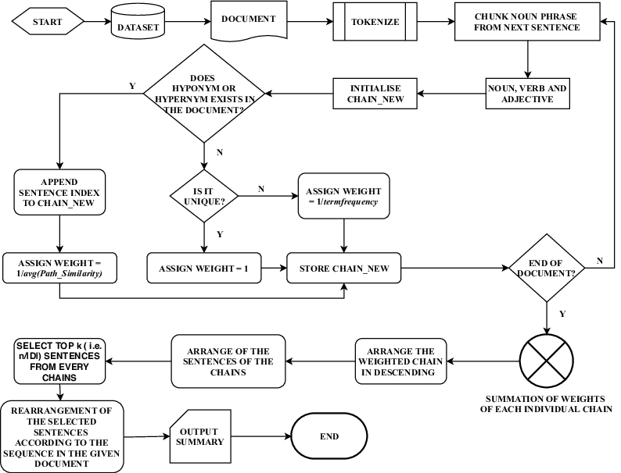

**4.1 Figure:** **Working of Text Summarizer App**

## Flowchart of Text Summarizer App

* 1. **Figure:** **Flowchart of Text Summarizer App**

## 3. Working of Login Page:

## 

**4.3 Figure: Working of Login Page**

## CHAPTER

# Methodology

**5.1 Need of NLP for Text Summarization**

Natural Language Processing (NLP) plays a crucial role in text summarization for several reasons, as it enables the development of more sophisticated and context-aware summarization techniques. Here are some key reasons why NLP is essential in text summarization:

1. Understanding Language Structure:
   * NLP tools, such as tokenization, part-of-speech tagging, and syntactic parsing, help in understanding the structure of the input text. This structural analysis is essential for identifying key sentences, phrases, or words that contribute to the overall meaning.
2. Named Entity Recognition (NER):
   * NER is a subtask of NLP that involves identifying and classifying entities such as persons, organizations, locations, dates, etc. In summarization, recognizing and preserving important entities can enhance the quality and relevance of the summary.
3. Coreference Resolution:
   * Coreference resolution is the process of determining when different words or expressions in a text refer to the same entity. Resolving coreferences is crucial for creating coherent and contextually accurate summaries.
4. Sentiment Analysis:
   * Understanding the sentiment of the text can be important in summarization. For example, a sentiment-aware summarization system might prioritize positive or negative sentiments based on user preferences or specific applications.
5. Contextual Understanding:
   * NLP models can capture contextual information, allowing summarization systems to generate summaries that are contextually relevant. Context-aware summarization is particularly important when dealing with documents or articles that cover multiple topics or evolve over time.
6. Abstractive Summarization:
   * NLP enables the development of abstractive summarization techniques, where the system generates summaries in a more human-like manner by paraphrasing and rephrasing content. This goes beyond extractive summarization, which selects and combines existing sentences.
7. Handling Ambiguity:
   * NLP tools help in handling linguistic ambiguity, which is prevalent in natural language. Summarization systems can leverage semantic analysis to resolve ambiguities and ensure that the summary accurately reflects the intended meaning of the original text.
8. Multilingual Summarization:
   * NLP techniques are crucial for building summarization systems that can work across multiple languages. Models trained with NLP approaches can understand and process text in different languages, facilitating global applications of summarization.
9. Customization and Adaptability:
   * NLP allows for the customization and fine-tuning of summarization models based on specific domains, genres, or user preferences. This adaptability is essential for creating summarization systems that perform well in diverse contexts.

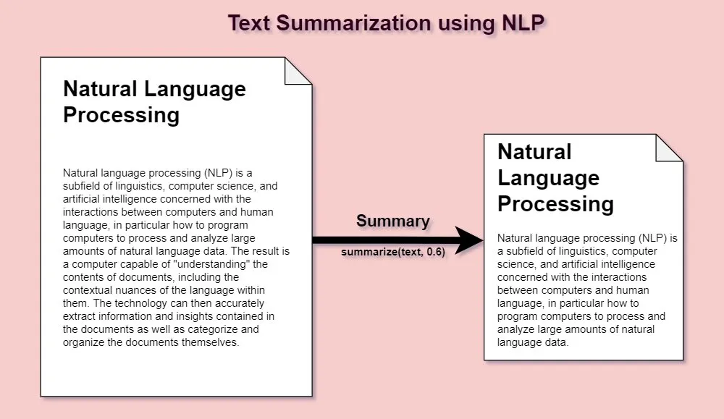

**5.1 Figure: Text Summarization**

**5.2 Flask application for Text Summarization**

Creating a Flask application for text summarization involves using a summarization model and integrating it into a web interface using Flask. In this example, I'll use the Hugging Face Transformers library and the BART model for text summarization

Flask is a lightweight web application framework written in Python. Its simplicity and flexibility make it an excellent choice for building web applications and APIs. Here's a brief overview of how Flask works in making applications:

1. **Routing:**
   * In Flask, you define routes to specify how the application should respond to different URLs.
   * Routes are defined using the **@app.route()** decorator, and they associate a function with a specific URL.
2. **Views/Handlers:**
   * Each route is associated with a view or handler function that is executed when the corresponding URL is accessed.
   * The view function processes the request and returns an HTTP response.
3. **Templates:**
   * Flask supports HTML templates for rendering dynamic content.
   * Templates allow you to separate the application logic from the presentation.
4. **Request and Response Handling:**
   * Flask provides request and response objects to handle incoming requests and generate responses.
   * The **request** object contains information about the current request, and the view function returns a response.
5. **Static Files:**
   * Flask can serve static files such as CSS, JavaScript, and images.
   * The **static** folder is used to store these files, and they can be referenced in templates.
6. **Middleware:**
   * Flask supports middleware, allowing you to modify requests and responses globally.
   * Middleware functions can be applied to the entire application or specific routes.
7. **Extensions:**
   * Flask has a modular architecture, and you can use extensions to add additional functionality.
   * Extensions are third-party packages that integrate seamlessly with Flask.
8. **Deployment:**
   * Flask applications can be deployed on various web servers, such as Gunicorn or uWSGI.
   * Deployment options include traditional hosting, cloud platforms, and containerization.

Flask's simplicity makes it easy to get started, and its flexibility allows developers to choose components and libraries based on their specific needs. As your application grows, Flask provides the foundation for building more complex web applications and APIs.

**5.3 Working of Hugging Face**

Hugging Face is a company and an open-source community that focuses on natural language processing (NLP) and provides a library called Transformers. The Transformers library is widely used for working with state-of-the-art pre-trained models, including those for tasks such as text classification, named entity recognition, text summarization, translation, and more. Here's an overview of how the Hugging Face library works:

1. **Model Hub:**
   * Hugging Face operates a Model Hub, which is a repository of pre-trained models. These models cover a wide range of NLP tasks and are trained on massive datasets. Users can easily access and download these models from the Hugging Face Model Hub.
2. **Transformers Library:**
   * The Transformers library, provided by Hugging Face, is a Python library that facilitates working with pre-trained models for various NLP tasks. It abstracts away the complexities of model loading, tokenization, and inference, making it easy for developers to incorporate these models into their applications.
3. **Pre-trained Models:**
   * Hugging Face provides pre-trained models for tasks such as text classification (e.g., BERT, GPT), summarization (e.g., BART), translation (e.g., T5), and more. These models have been trained on large datasets and have achieved state-of-the-art performance on a variety of benchmarks.
4. **Tokenization:**
   * Tokenization is a crucial step in working with NLP models. The Transformers library provides tokenizers that can convert raw text into tokenized sequences suitable for input to the pre-trained models. Tokenization is necessary to handle variable-length input and ensure compatibility with the model's architecture.
5. **Model Loading:**
   * With the Transformers library, loading a pre-trained model is a simple process. Users can choose a specific model architecture and load it with just a few lines of code. This process involves fetching the pre-trained model's weights and configuration.
6. **Inference:**
   * Once a model is loaded, it can be used for inference on new data. Users can pass input text through the model to obtain predictions or generate outputs, depending on the task the model was trained for.
7. **Pipeline API:**
   * Hugging Face's Transformers library includes a high-level API called the Pipeline API. This API simplifies the process of using pre-trained models for specific tasks, such as text generation, sentiment analysis, summarization, and more. It streamlines the entire workflow from loading the model to generating predictions.

**5.4 Need of spaCy in Text Summarization:**

spaCy is a popular open-source library for natural language processing (NLP) in Python. While spaCy itself doesn't include specific models for text summarization out of the box, it provides several features that can be useful in the process of text summarization. Here are some ways spaCy can be utilized in text summarization:

1. **Text Processing:**
   * spaCy includes robust text processing capabilities, such as tokenization, sentence segmentation, and part-of-speech tagging. These features are essential for breaking down a document into its constituent parts, which is a fundamental step in summarization.
2. **Named Entity Recognition (NER):**
   * spaCy's NER capabilities can identify and classify entities such as persons, organizations, locations, etc. This information can be useful in summarization to extract key entities from the text, which may be important for understanding the main topics.
3. **Dependency Parsing:**
   * Dependency parsing in spaCy helps analyze the grammatical structure of sentences by identifying the relationships between words. This can be valuable in understanding the relationships between different parts of the text, assisting in the extraction of meaningful information.
4. **Sentence Importance Ranking:**
   * While spaCy itself doesn't provide a summarization model, you can use its features to implement a simple extractive summarization approach. For example, you can calculate sentence importance scores based on criteria like sentence length, presence of important entities, and syntactic structure.
5. **Integration with Custom Models:**
   * If you have a pre-trained summarization model or a custom model, spaCy can be used in conjunction with it. You can use spaCy for preprocessing, tokenization, and then pass the processed text to your summarization model.
   * While spaCy itself doesn't provide text summarization models, it can be used in conjunction with other machine learning models for summarization. For example, you can use spaCy for pre-processing and then feed the processed text into a summarization model.

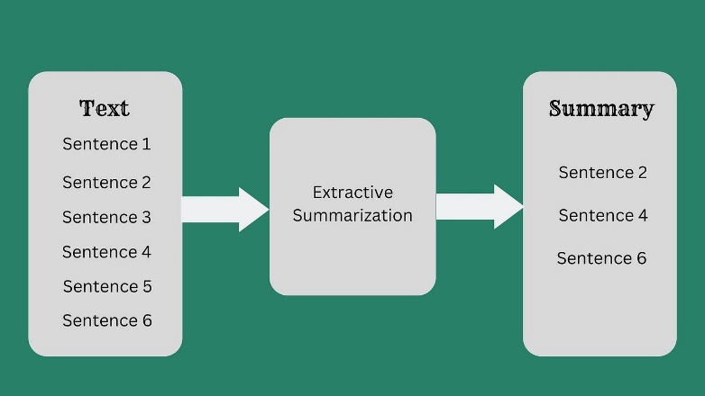

**5.4 Figure:** **spaCy work**

# CHAPTER

## APPRATUS

**Hardware Requirement**

The Text Summarizer application requires the following hardware for development and execution:

**Laptop or Computer Desktop**

To display what the webcam has taken, the virtual software will be started on the laptop or

computer desktop.

The system will make use of (minimum requirements) Core2Duo processor (2nd generation)

2 GB RAM (Main Memory) 320 GB hard drive

14-inch LCD monitor

**Internet**

The image is acquired with a camera that will continue to take photos

endlessly so that the application may process the image and calculate pixel position.

Resolution: 1.3 megapixels is the minimum required.

**Software Requirement**

The following software is required for the development and execution of the Text Summarizer application:

**Python Language**

The Text Summarizer application is coded in Python with the help of Microsoft Visual Studio Code, an integrated development environment (IDE) for programming computer applications.

Basic arithmetic, bit manipulation, indirection, comparisons, logical operations, and more are all available in the Python library.

**spaCy Library**

spaCy is a natural language processing (NLP) library in Python that is widely used for various text processing tasks. spaCy's efficiency, feature-rich capabilities, and ease of integration make it a valuable tool for tasks such as preprocessing, entity recognition, and syntactic analysis, contributing to the overall effectiveness of summarization workflows.

Software will be using:

OS: Window 10 64-bit Language: Python

Tool Used: spaCy and Flask

**Flask**

This software is also created with the help of Flask.

Flask is a web framework for Python that is widely used due to its simplicity and flexibility. Its need in various applications, including text summarization. Flask is valuable for creating a web-based interface, allowing users to input text and receive summaries interactively. It simplifies the deployment of summarization models, making the technology more accessible to a broader audience. Flask's simplicity, flexibility, and features make it a suitable choice for creating a login page and building web applications with user authentication. It's particularly well-suited for projects where a lightweight and customizable framework is preferred.

Software will be using:

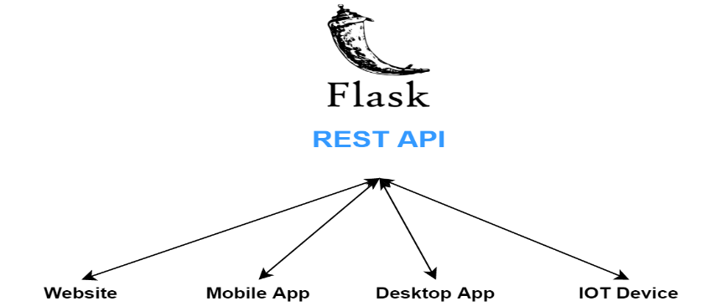

**6.1 Figure: Flask Work**

# CHAPTER

## EXPERIMENTAL SETUP

Setting up an experimental environment for a text summarizer app involves several steps, from choosing the right tools and libraries to defining the hardware and software requirements. Below is a generalized guide for setting up an experimental environment for a text summarizer app using Flask, Hugging Face Transformers, and spaCy. Keep in mind that specific details may vary based on your project's requirements and technology stack.

**1. Define Requirements:**

Hardware Requirements:

* Specify the computing resources required, considering factors like the size of the dataset and the complexity of the summarization model.
* Decide whether you'll run the application locally or deploy it on a cloud platform.

Software Requirements:

* Choose the programming language (e.g., Python).
* Specify the libraries and frameworks you'll use (e.g., Flask, Hugging Face Transformers, spaCy).
* Define the dependencies and versions for reproducibility.

**2. Set Up Virtual Environment:**

# Create a virtual environment python -m venv venv

# Activate the virtual environment

# On Windows venv\Scripts\activate

# On Unix or MacOS source venv/bin/activate

# Install required packages pip install flask transformers torch spacy

**3. Get Model and Language Resources:**

Hugging Face Transformers Model:

* Choose a summarization model from Hugging Face's Model Hub (e.g., BART, T5).
* Install the model using the **transformers** library.

spaCy Language Model:

* Download and install a spaCy language model for tokenization and other NLP tasks.

**5. Run the Flask App:**

# python app.py

Visit **http://127.0.0.1:5000/** in your web browser to use the text summarization application.

This is a basic setup, and you may need to adjust and expand it based on your specific requirements and the summarization model you choose. Additionally, consider deploying the app to a production environment if needed.

Top of Form

# RESULT

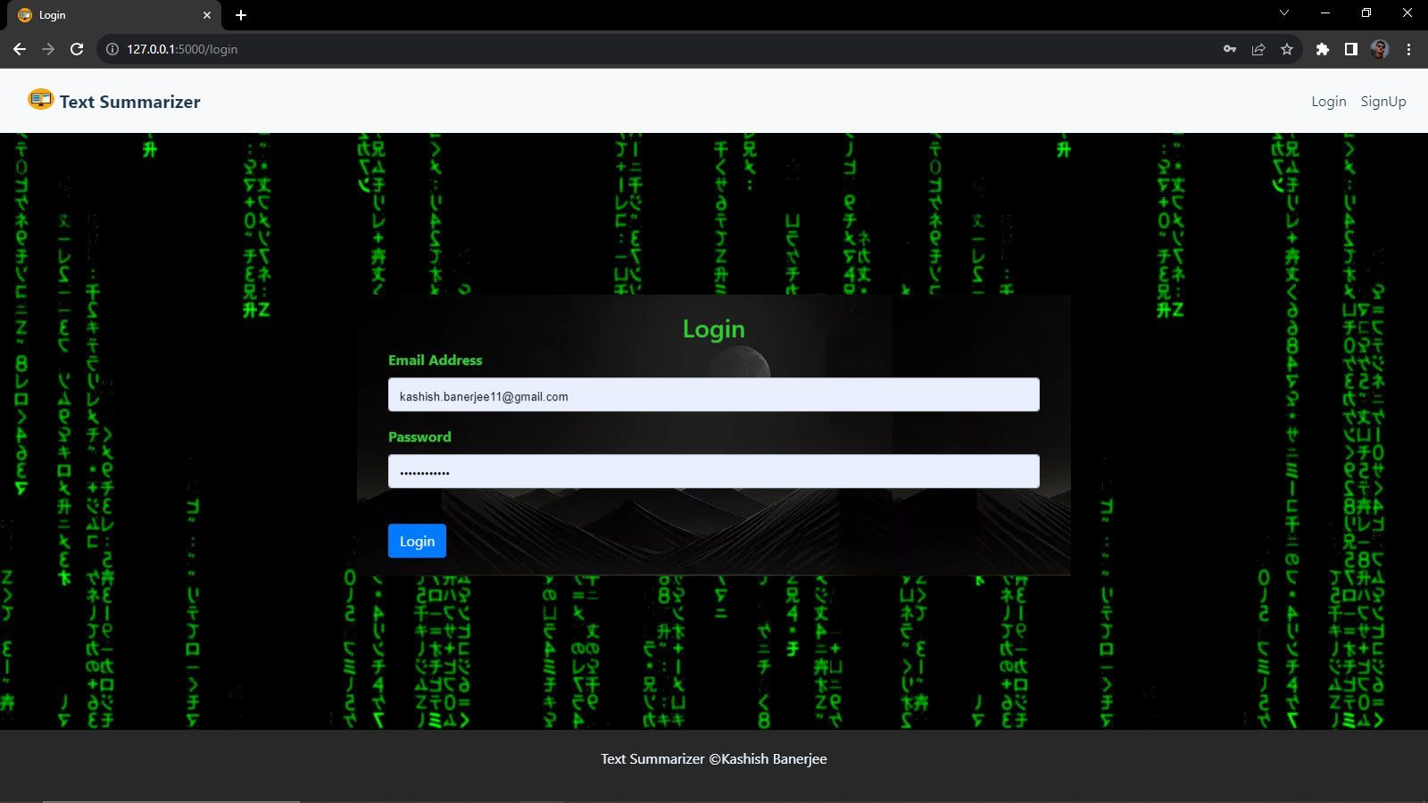

**Figure: User Login Page**

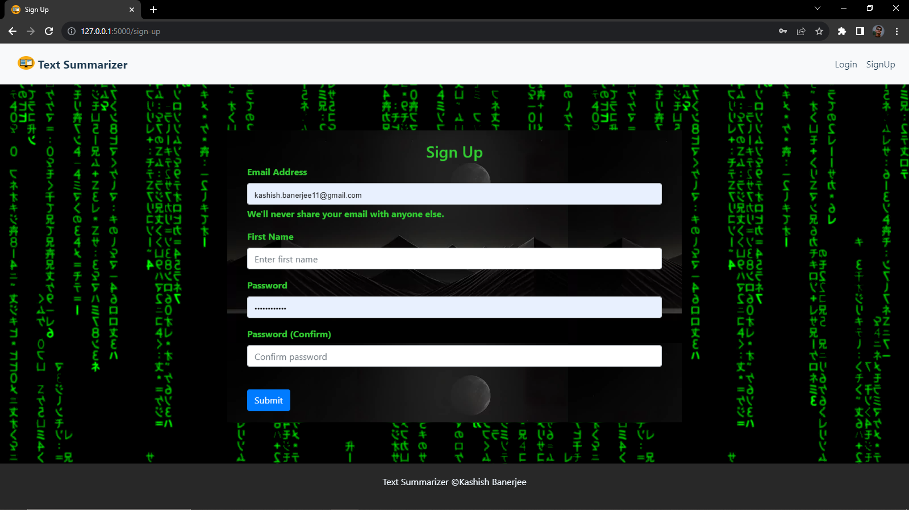

**Figure: User Signup**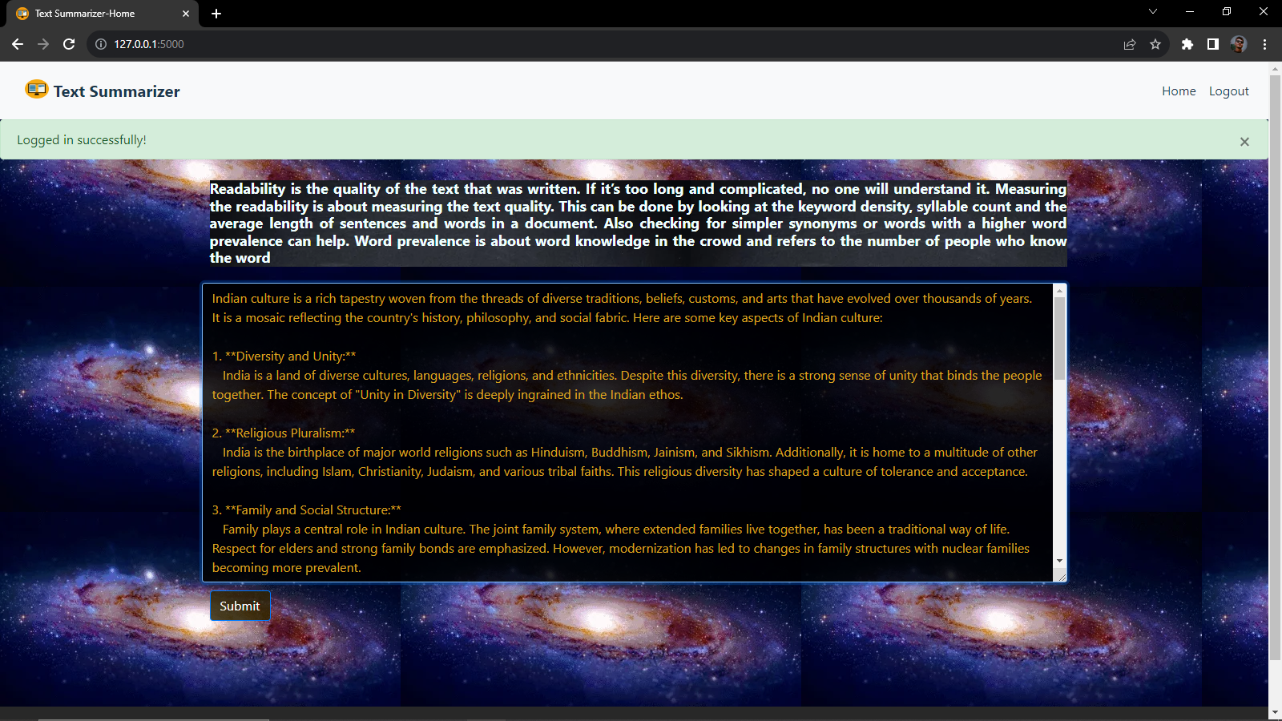

**Figure: Text Summarizer App**

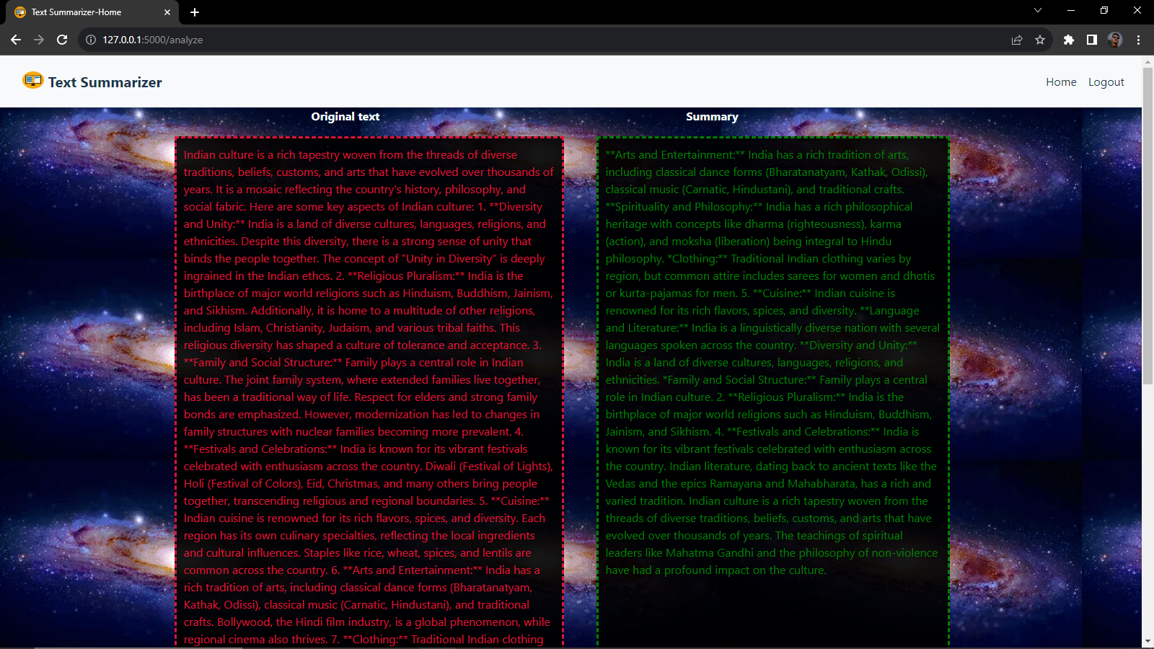

**Figure: Summary**

# CONCLUSION

Text Summarizer App built using Flask, Hugging Face Transformers, and spaCy offers a versatile and accessible solution for summarizing textual content. The combination of these technologies provides a user-friendly web interface, efficient natural language processing, and state-of-the-art pre-trained models for text summarization. Here are key takeaways:

1. **User-Friendly Interface:**
   * Flask facilitates the creation of a user-friendly web interface, allowing users to input text and receive concise summaries. The web-based application enhances accessibility and ease of use.
2. **NLP Capabilities:**
   * The integration of spaCy enhances the app's NLP capabilities. Features such as tokenization, part-of-speech tagging, and dependency parsing contribute to a deeper understanding of the input text, which can be beneficial in refining the summarization process.
3. **Hugging Face Transformers:**
   * Leveraging Hugging Face Transformers provides access to powerful pre-trained models specifically designed for text summarization. The app benefits from the advancements in transformer-based architectures, enabling state-of-the-art summarization performance.
4. **Adaptability and Customization:**
   * The Flask framework allows for easy customization and expansion of the application. Developers can enhance the app's features, integrate additional models, or modify the user interface based on specific requirements.
5. **Scalability and Deployment:**
   * The app can be deployed on various platforms, including cloud services, to handle varying levels of demand. This scalability ensures that the summarization service can accommodate a growing user base.
6. **Educational and Research Value:**
   * The app has educational and research value, serving as a practical tool for students, researchers, and professionals interested in exploring text summarization techniques, natural language processing, and web application development.
7. **Open Source and Collaboration:**
   * The use of open-source technologies, including Flask, spaCy, and Hugging Face Transformers, encourages collaboration and community contributions. The app can serve as a starting point for further development and experimentation in the broader NLP community.
8. **Considerations for Improvement:**
   * Continuous improvement and optimization can be achieved by exploring different summarization models, fine-tuning approaches, and incorporating user feedback. Additionally, addressing specific use-case requirements may involve further customization.

Text Summarizer App provides a practical and accessible solution for users seeking an efficient and accurate summarization tool. With a solid foundation in web development and advanced NLP techniques, the app demonstrates the potential for creating sophisticated, user-centric applications in the field of natural language processing.

Top of Form

**Future Scope Of Text Summarizer App**

The future scope of a Text Summarizer App is promising, with ongoing advancements in natural language processing (NLP) and machine learning. Here are some potential future directions and trends for text summarization applications:

1. **Advanced Summarization Models:**
   * Continued development and improvement of pre-trained language models for summarization, potentially achieving better performance in terms of accuracy, coherence, and context understanding.
2. **Customizable and Domain-Specific Models:**
   * More emphasis on domain-specific summarization models that can be easily fine-tuned for specific industries or subject areas, allowing users to generate summaries tailored to their needs.
3. **Multimodal Summarization:**
   * Integration of text summarization with other modalities such as images, audio, and video, providing a more comprehensive summarization experience for content that spans multiple formats.
4. **Real-Time Summarization:**
   * Advancements in real-time summarization techniques, enabling applications to generate summaries on-the-fly as new content becomes available, such as in news updates, social media, and live events.
5. **Interactive Summarization:**
   * Development of interactive summarization tools that allow users to provide feedback on generated summaries, influencing the system to refine future summarization outputs based on user preferences.
6. **Enhanced Abstractive Summarization:**
   * Improvement of abstractive summarization techniques that generate more coherent and human-like summaries by understanding and generating content in a more abstract manner, going beyond extractive methods.
7. **Cross-Lingual Summarization:**
   * Advances in cross-lingual summarization models that can effectively summarize content in multiple languages, breaking down language barriers and catering to a global audience.
8. **Ethical and Bias Mitigation:**
   * A focus on developing summarization models that are more conscious of biases in data and language. Ethical considerations will play a significant role in designing systems that minimize biases in summarization outputs.
9. **Explainability and Trustworthiness:**
   * Incorporation of explainability features in summarization models to provide users with insights into how the model arrived at a particular summary. This is crucial for building trust in AI-driven summarization systems.
10. **Deployment in Industry-Specific Applications:**
    * Integration of text summarization in various industry-specific applications, such as legal document summarization, medical record summarization, and technical document summarization, enhancing productivity in professional domains.
11. **Mobile and Edge Computing Integration:**
    * Optimizing text summarization models for deployment on mobile devices and edge computing environments, enabling users to access summarization capabilities on-the-go and in resource-constrained settings.
12. **Human-AI Collaboration:**
    * Collaboration between humans and AI systems for content curation, where AI assists users in summarizing large volumes of information, allowing humans to make more informed decisions.
13. **Education and Learning Applications:**
    * Integration of summarization tools in educational platforms to help students quickly grasp key concepts from academic texts, lecture notes, and research papers.
14. **Open Source Development and Collaboration:**
    * Continued collaboration within the open-source community, leading to the development of shared resources, benchmarks, and best practices for text summarization.

# REFERENCE

Google: [www.google.com](http://www.google.com/) Youtube: [www.youtube.com](http://www.youtube.com/) Wikipedia: [www.wikipedia.com](http://www.wikipedia.com/)