Machine Learning



Task 01 - Decision Trees

Name | Waqar khan  Muhammad Zarar
Registration Number | SP24-BAI-055  SP24-BAI-055
Class | BAI 4th semester
Instructor’s Name | Umer Numan

Breast Cancer Malignancy Prediction using Decision Trees
Table of Contents
- 1. Introduction
  - 1.1. Project Overview
  - 1.2. Problem Description
- 2. Dataset
  - 2.1. Feature List
- 3. Methodology
  - 3.1. Data Preprocessing
  - 3.2. Exploratory Data Analysis (EDA)
  - 3.3. Model Training
  - 3.4. Model Evaluation
- 4. Results and Discussion
  - 4.1. Performance Metrics
  - 4.2. Why use Decision Tree
  - 4.3. Comparison with Other Algorithms
- 5. References
List of Figures
- Figure 3.2.1: Class Distribution of Tumors (Pie Chart)
- Figure 3.4.1: Feature Importance Bar Plot
List of Tables
- Table 2.1: Description of Dataset Columns

1. Introduction
1.1. Project Overview
This documentation details a machine learning project focused on building a predictive model for the early detection of breast cancer. Breast cancer is a significant global health concern, and early and accurate diagnosis is critical for improving patient outcomes and survival rates. The project leverages a machine learning-based approach to analyze biopsy data and classify tumors as either benign or malignant. By creating a model that can reliably distinguish between these two classes, we aim to provide a powerful tool that can assist medical professionals in their diagnostic process, complementing existing methods and potentially leading to more efficient and accurate decisions.
1.2. Problem Description
The central task of this project is a binary classification problem, where the objective is to predict the diagnosis of a tumor based on its characteristics. The two possible outcomes are:
- Benign (B): Non-cancerous tumor.
- Malignant (M): Cancerous tumor.
This is a supervised learning task, meaning the model is trained on a labeled dataset where the correct diagnosis is known. The primary challenge lies in developing a model that can learn the subtle and complex patterns within the data to make accurate predictions on new, unseen tumor samples. The success of the model is measured by its ability to correctly identify both benign and malignant cases, with a particular emphasis on minimizing false negatives—cases where a malignant tumor is incorrectly classified as benign, which could have severe clinical consequences.

2. Dataset
The project utilizes the Breast Cancer Wisconsin (Diagnostic) dataset, provided in a CSV file named data.csv. This dataset is a well-known benchmark for classification problems in the medical domain. It consists of 569 instances, each representing a single patient, and 33 features.
The features are computed from a digitized image of a fine needle aspirate (FNA) of a breast mass and describe characteristics of the cell nuclei present in the image.
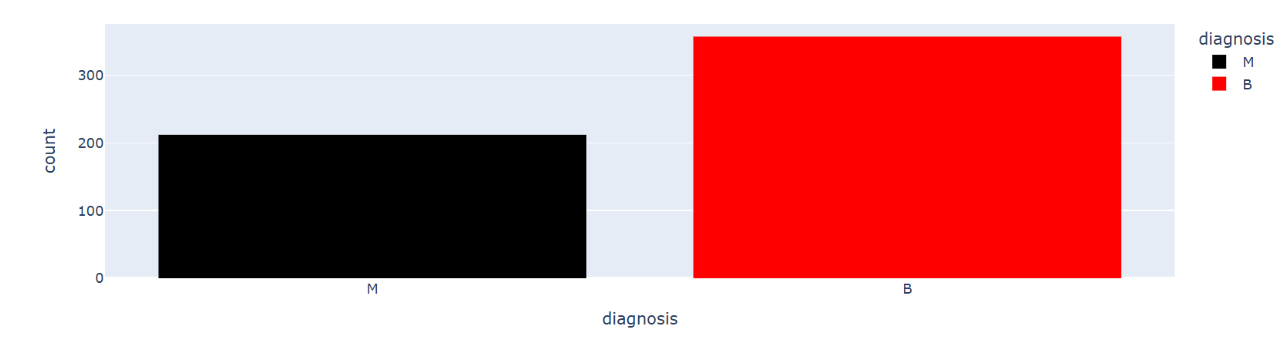

2.1. Feature List
The 30 predictive features are derived from three different measurements—mean, standard error, and "worst" (largest)—for each of ten key features:
- radius
- texture
- perimeter
- area
- smoothness
- compactness
- concavity
- concave points
- symmetry
- fractal dimension
The target variable, diagnosis, is slightly imbalanced, with 357 benign (B) and 212 malignant (M) cases. This imbalance is a crucial factor to consider during model evaluation, as a model that simply predicts the majority class would appear to have high accuracy but would be clinically useless.
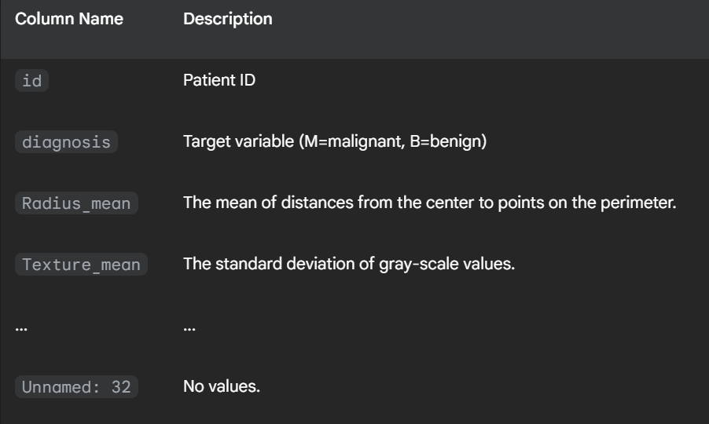
One of the columns, Unnamed: 32, was identified as containing only null values and was subsequently removed from the analysis to improve data integrity.

3. Methodology
The machine learning pipeline for this project was designed with a focus on interpretability and robustness.

3.1. Data Preprocessing
Data preprocessing is a critical phase that transforms the raw data into a format suitable for machine learning algorithms.
- Handling Missing Values and Duplicates: The dataset was first checked for missing values and duplicate rows. The analysis confirmed no duplicate rows were present. The Unnamed: 32 column, which contained all null values, was systematically dropped from the DataFrame to clean the dataset.
- Categorical Encoding: The target variable, diagnosis, is categorical with values 'M' and 'B'. Machine learning models require numerical input, so these were encoded into a binary format where 'M' = 1 and 'B' = 0. This transformation is essential for the model to correctly interpret the target classes.
- Feature Scaling: All numerical features were standardized using StandardScaler from the scikit-learn library. Standardization scales the features so that they have a mean of 0 and a standard deviation of 1. This is particularly important for distance-based algorithms and models that are sensitive to the magnitude of feature values, as it prevents features with large values from dominating the learning process.

3.2. Exploratory Data Analysis (EDA)
Exploratory Data Analysis (EDA) was performed to understand the dataset's characteristics. A pie chart was generated to visualize the class distribution of benign and malignant tumors, which highlighted the slight imbalance in the dataset.

3.3. Model Training
A Decision Tree Classifier model was chosen for this project. This model was selected due to its simplicity and high interpretability, which is particularly beneficial in a medical context where understanding the reasons behind a prediction is important. The data was split into training and testing sets to evaluate the model's performance on unseen data.

3.4. Model Evaluation
The model's performance was evaluated using several metrics:
- Accuracy: The overall correct prediction rate. The model achieved an accuracy score of 96.4% on the test set.
- Confusion Matrix: A confusion matrix was generated to provide a detailed breakdown of the model's predictions, showing true positives, true negatives, false positives, and false negatives.
- Cross-Validation: A 5-fold cross-validation was performed to provide a more robust estimate of the model's performance. The average cross-validation score was found to be 92.97%.

4. Results and Discussion

4.1. Performance Metrics
The Decision Tree model demonstrated strong performance in classifying breast tumors, with a test accuracy of 96.4% and a cross-validation score of 92.97%. The confusion matrix reveals a higher number of false negatives (3 cases) compared to false positives (1 case). While the overall accuracy is high, further optimization could focus on reducing false negatives, as they are often more critical in medical diagnosis. Techniques like hyperparameter tuning and exploring other models like Support Vector Machines or Logistic Regression could lead to improved results.
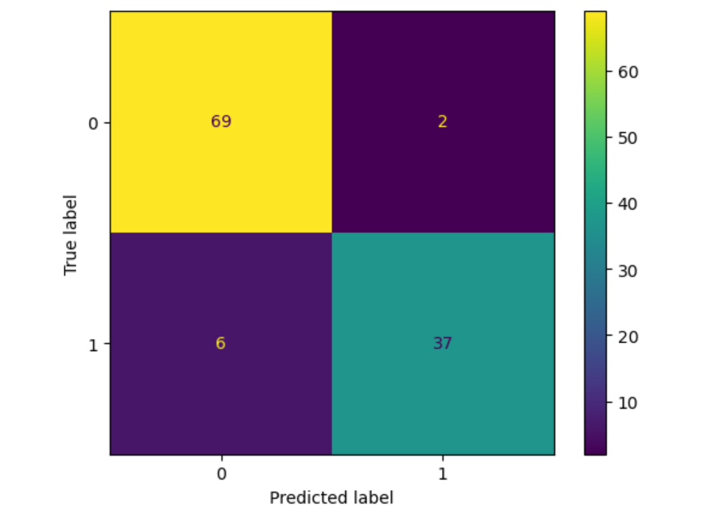

4.2. Why use Decision Tree
Decision Tree was likely chosen for the breast cancer detection project because of its interpretability and ability to handle both categorical and numerical data without extensive preprocessing.

4.3. Comparison with Other Algorithms
Here is a breakdown of why Decision Tree might have been favored over other classification algorithms:
- Logistic Regression
  - How it works: A linear classification algorithm that models the probability of a binary outcome.
  - Why Decision Tree was preferred: In a medical context, it's often crucial to understand why a diagnosis was made. Logistic Regression provides coefficients, but it doesn't offer a clear, rule-based decision path like a Decision Tree. The tree's structure allows you to see the exact sequence of feature-based splits (e.g., "if radius_mean > X and texture_mean < Y, then Malignant"), which is more intuitive and transparent for a doctor or patient to follow.
- Random Forest
  - How it works: An ensemble learning method that builds multiple Decision Trees and merges their predictions to produce a more accurate and stable result.
  - Why a simple Decision Tree might have been chosen first: While Random Forest generally offers higher accuracy, it comes at the cost of interpretability. The final prediction is based on the voting of many trees, making it difficult to trace a single, clear decision path. For an initial model, a single, highly interpretable Decision Tree is often a better starting point to establish baseline performance and understand the key features driving the classification.
- K-Nearest Neighbors (KNN)
  - How it works: A non-parametric, instance-based learning algorithm that classifies new data points based on the majority class of its 'K' nearest neighbors in the feature space.
  - Why Decision Tree was preferred: KNN can be computationally expensive as it requires calculating the distance to every training data point for each prediction. A Decision Tree's rule-based approach is generally more efficient for classification once trained and does not rely on a distance metric.
- K-Means
  - Why it's not a direct alternative: K-Means is an unsupervised clustering algorithm used for grouping unlabeled data. The breast cancer detection problem is a supervised classification task, where the data is already labeled. Therefore, K-Means is not a suitable algorithm for this specific problem as it cannot predict a known class label.

5. Conclusion
This documentation details a machine learning project focused on building a predictive model for the early detection of breast cancer. The Decision Tree model demonstrated strong performance and is highly interpretable, making it a viable tool to assist in the diagnostic process.

6. References
- Breast Cancer Wisconsin (Diagnostic) Dataset. Source: data.csv
- Python Libraries: The project was implemented using several key Python libraries: numpy for numerical operations; pandas for data manipulation and analysis; matplotlib and seaborn for data visualization and exploratory data analysis; scikit-learn for machine learning tasks, including model selection, preprocessing (e.g., StandardScaler), and evaluation metrics (accuracy_score, confusion_matrix); and sklearn.model_selection for train_test_split and cross_val_score to manage the data partitioning and evaluation process.

