**Assignment – 1**

**Report View**

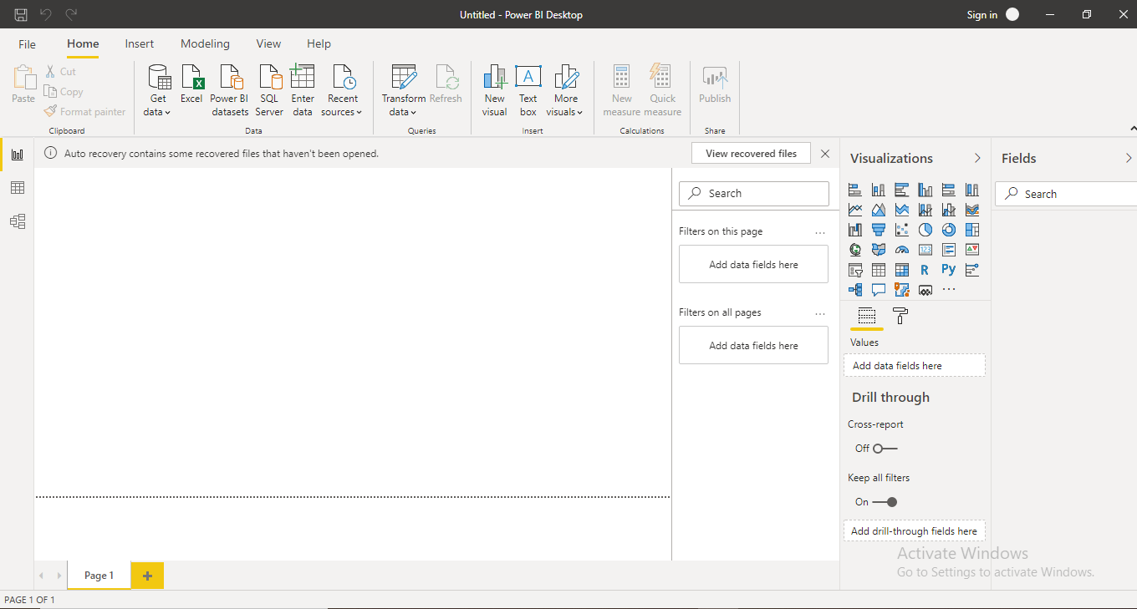

**Data View**

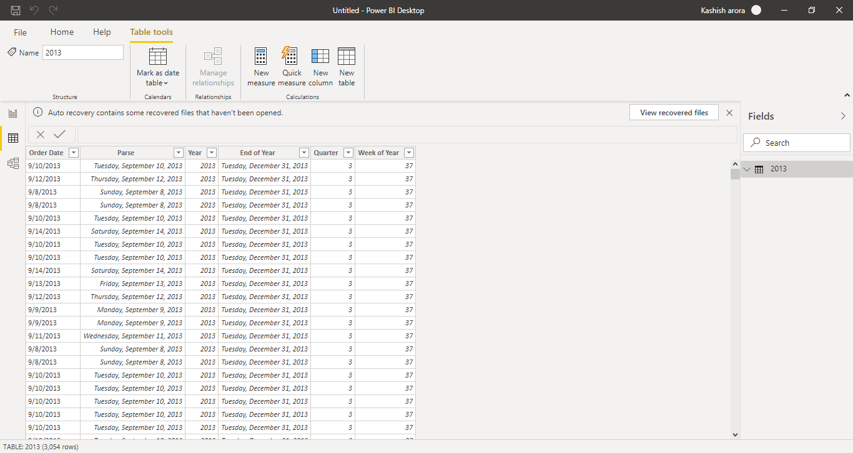

**Model View**

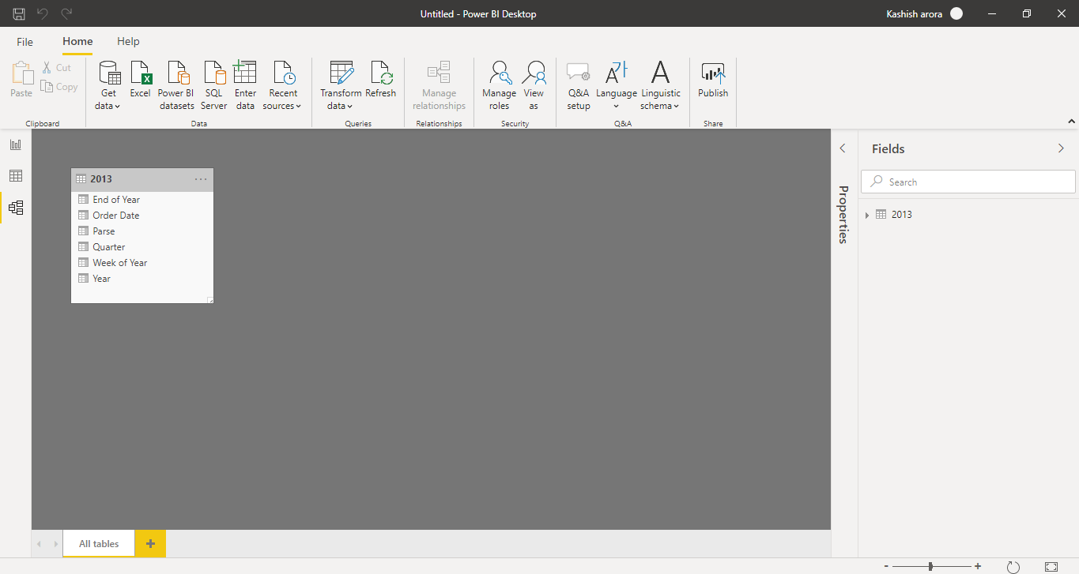

**Power Query Editor**

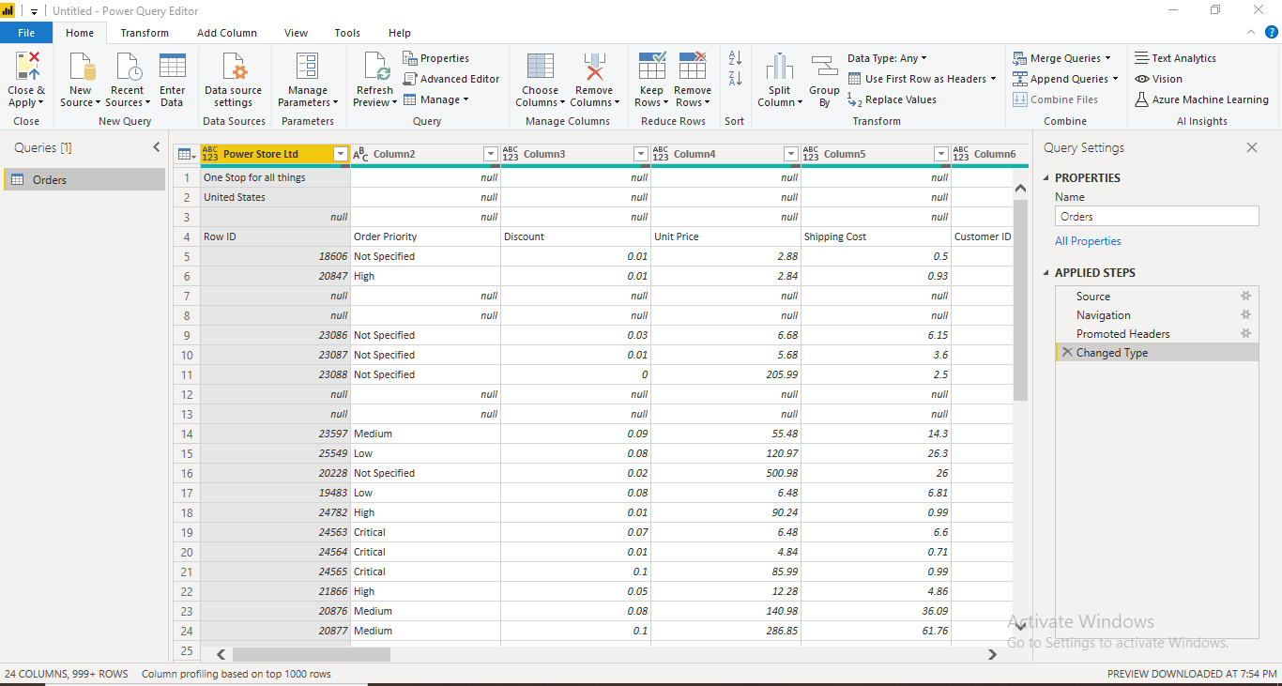

**Advance Editor**

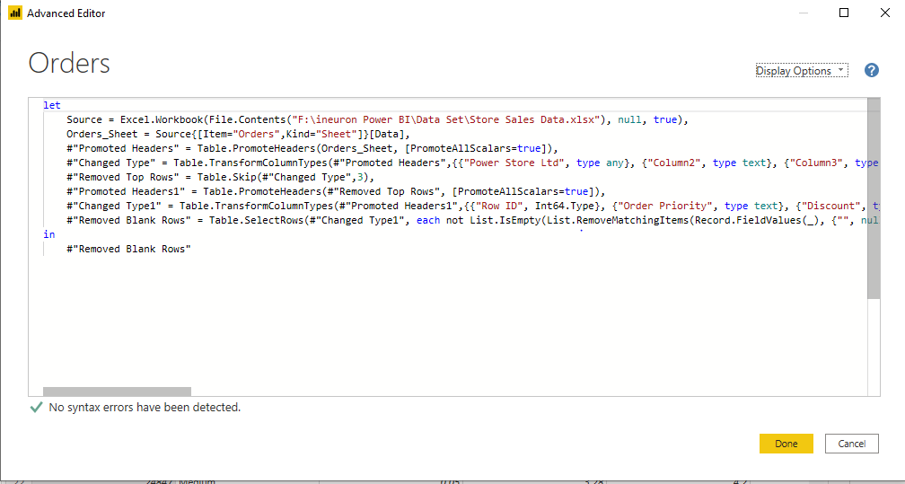

**Comparison between Power BI Desktop, Power BI Pro and Power BI Premium**

|  |  |  |  |
| --- | --- | --- | --- |
| COMPARISION | | | |
|  | **Power BI Desktop** | **Power BI Pro** | **Power BI Premium** |
| Pricing | Free | INR 660 M/User | INR 330190 M/dedicated cloud compute & storage resource with annual subscription |
| Included with Office 365 |  | Yes | It can be added to any Power BI pro deployment |
| Licensed Per | User | User | by dedicated cloud compute & storage resources |
| Data Refresh Rate | 8/day | 8/day | 48/day |
| Unrestricted Report Sharing | Yes | Yes | Yes |
| Export to CSV,XLS, PDF & PPTX |  | Yes | Yes |
| Embed Visuals into Apps(Teams,SharePoint,etc) |  | Yes | Yes |
| Storage Limit | 10GB | 10GB | 100TB |
| Fixed paginated layout for printing |  |  | Yes |
| Incremental data refresh |  |  | Yes |
| Analyze data in Microsoft Excel | Yes | Yes | Yes |
| View and interact with Power BI content | Yes | Yes | Yes |
| View and interact with Power BI content through the Power BI mobile app for iOS, Android, and Windows | Yes | Yes | Yes |