1. Pick any two apps you use daily (like Instagram, Zomato, or Flipkart) and identify one online marketing technique each app uses to attract new users. Write a short explanation (2-3 lines) for each technique.
- Instagram – Influencer Marketing
Instagram uses influencers and creators to promote the app and its features. Popular creators encourage their followers to join Instagram, helping the platform attract new users.
- Zomato – Referral Marketing
Zomato uses referral codes and offers to encourage existing users to invite friends. New users may receive discounts, while existing users can get rewards for successful referrals.
2. Create a simple digital flyer (image or PDF) for a new food delivery app launch, highlighting at least three online marketing concepts such as referral codes, limited-time offers, or influencer shoutouts.Hint: Use Canva or any free online design tool to make your flyer look engaging.
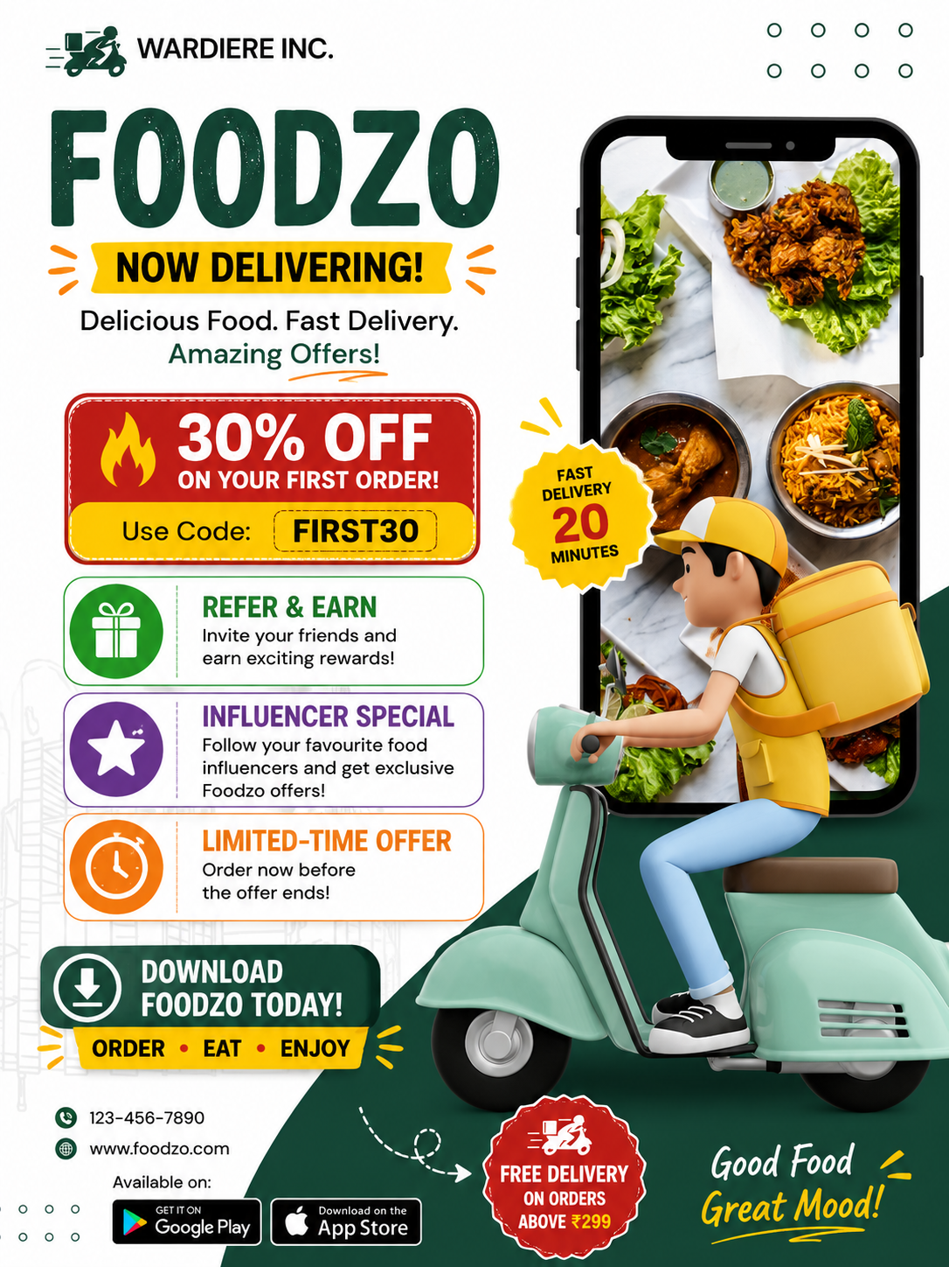
3. List five types of online ads you’ve seen while using YouTube, Instagram, or any other app. For each, mention which platform you saw it on and what made it noticeable or skippable.
No. | Type of Ad | Platform | Noticeable / Skippable Because
1 | Video Ad | YouTube | Attractive visuals make it noticeable, but it can be skipped after a few seconds.
2 | Story Ad | Instagram | Short videos and bright designs make it noticeable.
3 | Sponsored Post | Instagram | Looks like a normal post but has a “Sponsored” label.
4 | Banner Ad | Websites/Apps | Images and discount offers attract attention, but users may ignore them.
5 | Influencer Ad | YouTube | Trusted creators make the ad interesting, but long promotions can be skipped.

4. Imagine you are launching a new playlist feature for a music app like Spotify. Write a short plan (5-6 lines) describing how you would use online marketing concepts (SEO, social media posts, email campaigns, influencer partnerships) to promote this feature.
- Marketing Plan for a New Playlist Feature
- I would use SEO with keywords such as “best music playlists” and “create playlists” to attract users through search engines.
- I would create Instagram, Facebook, and YouTube posts showing the new playlist feature.
- I would send email campaigns to existing users with personalized playlist recommendations.
- I would collaborate with popular music influencers to demonstrate the new feature.
- Influencers could share the feature with their followers using special links or promotional codes.
- I would track clicks, downloads, shares, and new users to measure the success of the campaign.

