- Pick any one app you use daily (Instagram, Zomato, Flipkart, etc.) and list 3 ways the app keeps you engaged (for example: notifications, daily streaks, personalized recommendations).

- App Engagement – Instagram
I use Instagram daily. Instagram keeps users engaged in these 3 ways:
- Personalized Recommendations: Instagram shows Reels, posts, and accounts based on my interests and previous activity.
- Notifications: It sends notifications about likes, comments, messages, and new posts from followed accounts.
- Stories & Reels: Short and entertaining content encourages users to keep scrolling and spend more time on the app.
- Design a simple Instagram-style poll for a story: create a question and two answer options, then write a short plan for how you would collect and display the number of votes for each option.

- Which food do you like more?
Option 1: 🍔 Burger
Option 2: 🍕 Pizza
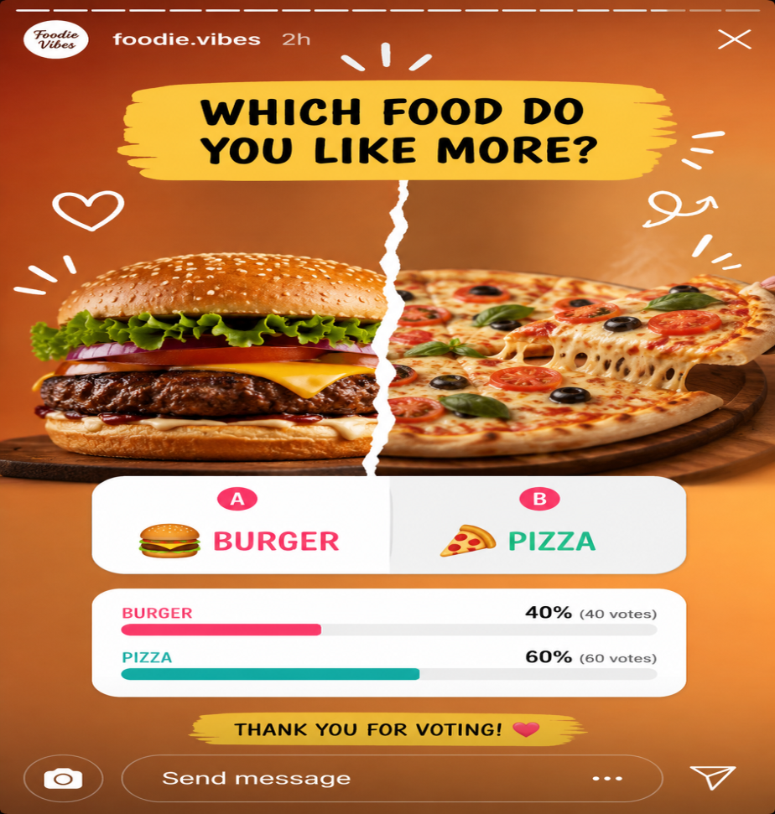

- Write a sample push notification message that would encourage a user to return to a food delivery app like Swiggy or Zomato after 3 days of inactivity.Hint: Think about using offers, reminders, or new menu items to make it engaging.
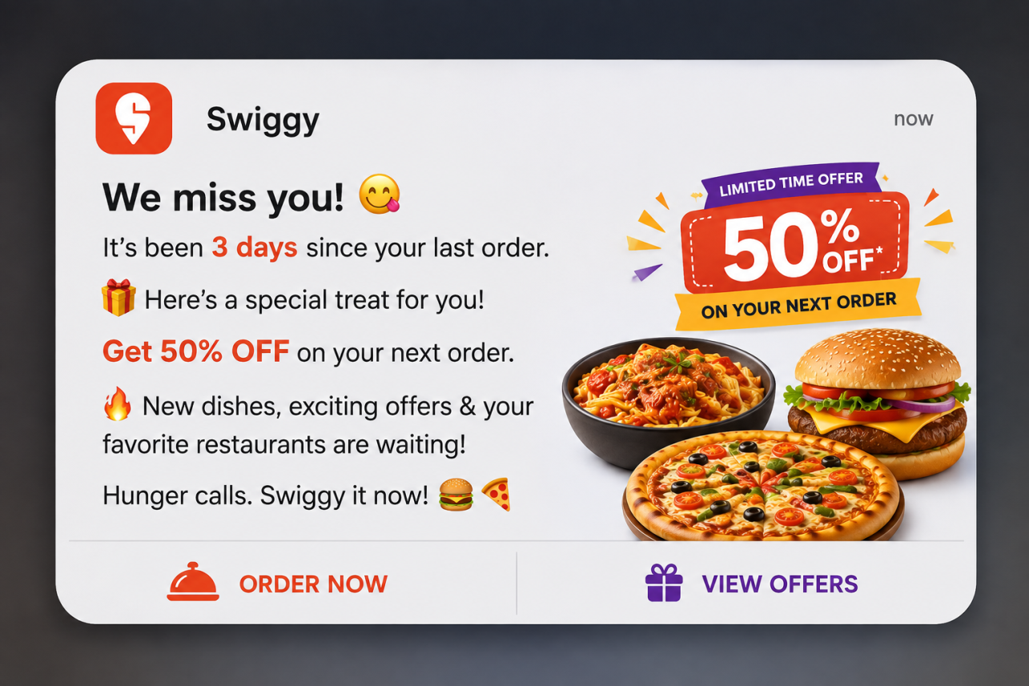

- Analyze the Flipkart app's product page and identify 2 engagement features (such as wishlist, ratings, or 'people also bought') and explain in 2-3 lines how each feature encourages users to spend more time on the app.

Flipkart Product Page – Engagement Features
1. Wishlist
Wishlist allows users to save products they like for later. Users can come back to check the saved products, prices, and discounts, which keeps them engaged with the app.
2. Ratings and Reviews
Ratings and reviews help users know about the quality of a product. Users spend more time reading reviews and comparing customer opinions before making a purchase.
5. Use ChatGPT or any AI tool to generate 3 creative ideas for increasing user engagement in a music streaming app like Spotify, and write them down in your own words.

  - Personalized Music Challenge
Create weekly challenges such as “Listen to 5 new songs this week.” Users can complete challenges and earn badges.

  - Friend Listening Rooms
Allow friends to create a shared listening room where everyone can listen to songs together and vote for the next song.

  - Mood-Based Playlists
Create playlists based on the user's mood, such as “Happy,” “Relax,” “Workout,” or “Study.” This makes music discovery more personalized and encourages users to spend more time listening.

