- Create a simple Google Form to collect leads for a new food delivery app — include fields for name, email, phone number, and favorite cuisine, then share the form link and submit one test entry.
- Google Form Lead Collection
I created a Google Form for a new food delivery app with fields for Name, Email, Phone Number, and Favorite Cuisine. I also submitted one test entry and copied the form link for sharing.
- https://forms.gle/qLodWPPdY6X7anUFA

- Design a landing page mockup (using Canva or Figma) for a Zomato-style offer, highlighting a special deal and a clear call-to-action button for users to sign up with their email.
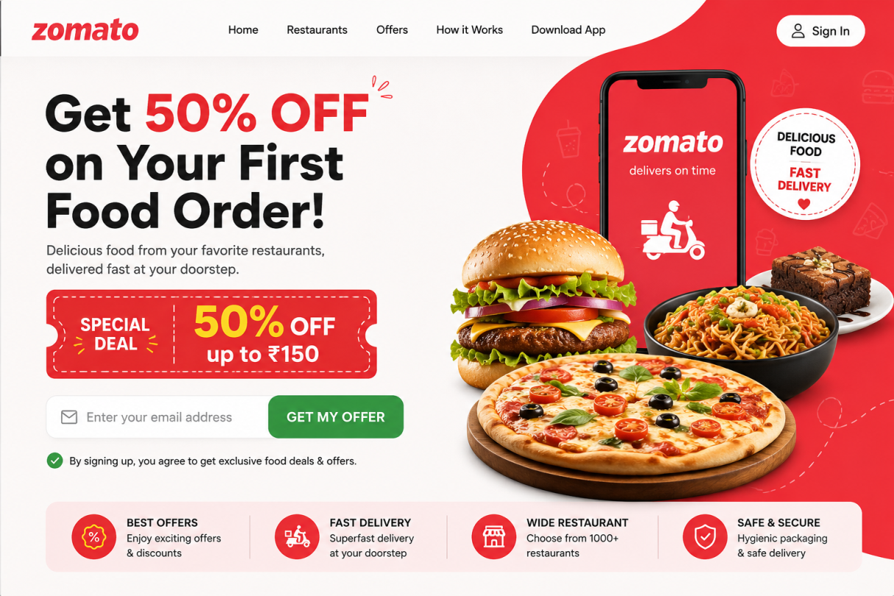

- List 3 different lead magnets you could use to attract users for a music streaming app like Spotify (for example: free trial, exclusive playlist, discount coupon), and explain in one line how each would collect user info.
- Free Trial – Users provide their email and basic details to activate the free trial.
- Exclusive Playlist – Users enter their email to unlock an exclusive playlist.
- Discount Coupon – Users submit their email or phone number to receive a discount coupon.
- Write a short WhatsApp message template you could use to follow up with a lead who filled out your form for a cricket IPL fantasy league app — include a greeting, mention the app, and a call to action.
- Message Template:
Hi Kashish!
Thanks for signing up for our IPL Fantasy League App
Create your fantasy team, compete with friends, and enjoy exciting rewards!
Join now: [App Link]
Good luck!
- Use ChatGPT or any AI writing tool to generate 5 catchy headlines for a Flipkart-style landing page aimed at collecting leads for a new electronics sale.<br><br><em><strong>Hint:</strong> Give the AI a prompt like 'Write 5 headlines to attract users to sign up for early access to a big online electronics sale.'</em>
Headlines:
- Mega Electronics Sale Is Coming – Get Early Access!
- Sign Up Now & Unlock Exclusive Electronics Deals!
- Big Savings on Mobiles, Laptops & More – Join Now!
- Be the First to Grab the Best Electronics Deals!
- Early Access Starts Here – Don’t Miss the Mega Sale!

